1. **Topology**

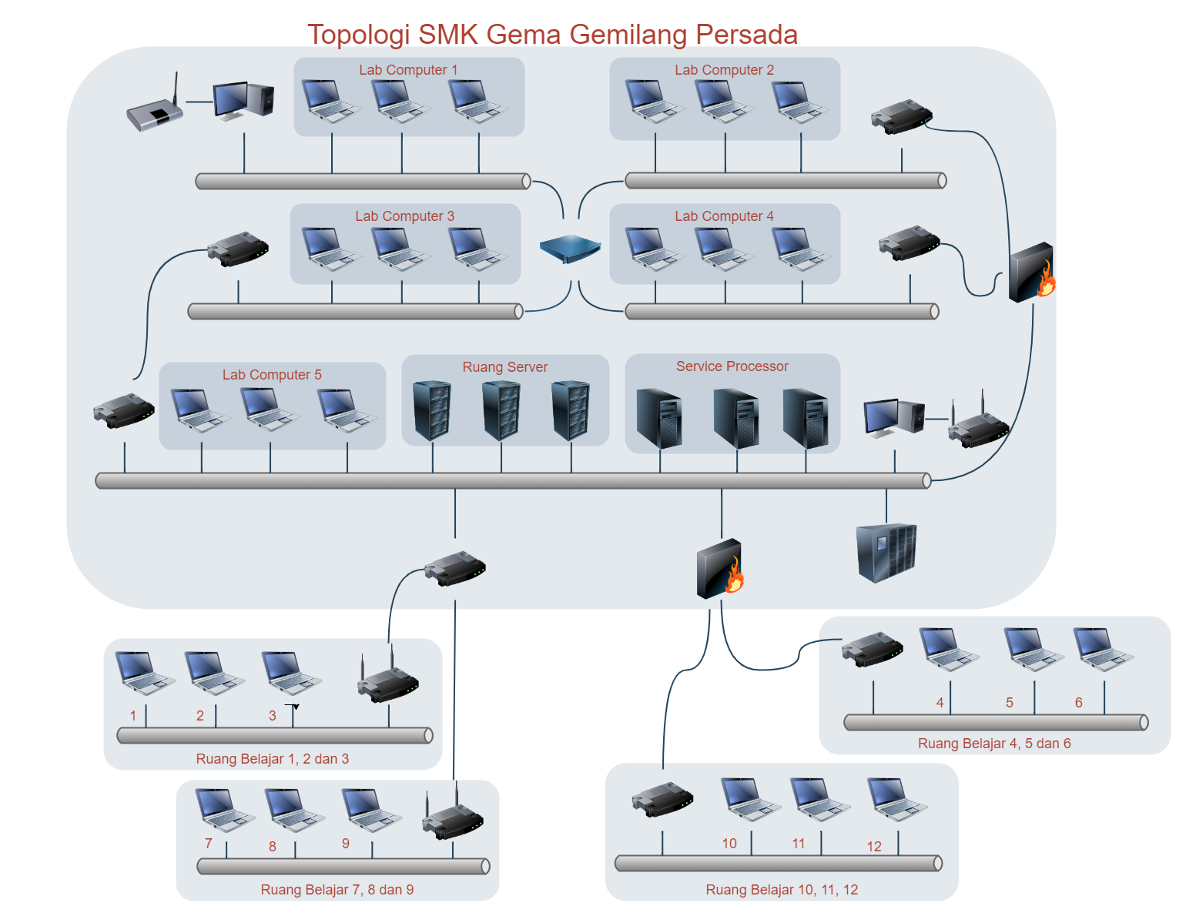

1. **IP Address**

|  |  |  |  |  |  |  |
| --- | --- | --- | --- | --- | --- | --- |
| **No** | **Ruang** | **IP Address** |  | **No** | **Ruang** | **Ip Address** |
| 1 | Server | 192.168.1.1 |  | 16 | Ruang Belajar 10 | 192.168.1.16 |
| 2 | Lab Komputer 1 | 192.168.1.2 |  | 17 | Ruang Belajar 11 | 192.168.1.17 |
| 3 | Lab Komputer 2 | 192.168.1.3 |  | 18 | Ruang Belajar 12 | 192.168.1.18 |
| 4 | Lab Komputer 3 | 192.168.1.4 |  |  |  |  |
| 5 | Lab Komputer 4 | 192.168.1.5 |  |  |  |  |
| 6 | Lab Komputer 5 | 192.168.1.6 |  |  |  |  |
| 7 | Ruang Belajar 1 | 192.168.1.7 |  |  |  |  |
| 8 | Ruang Belajar 2 | 192.168.1.8 |  |  |  |  |
| 9 | Ruang Belajar 3 | 192.168.1.9 |  |  |  |  |
| 10 | Ruang Belajar 4 | 192.168.1.10 |  |  |  |  |
| 11 | Ruang Belajar 5 | 192.168.1.11 |  |  |  |  |
| 12 | Ruang Belajar 6 | 192.168.1.12 |  |  |  |  |
| 13 | Ruang Belajar 7 | 192.168.1.13 |  |  |  |  |
| 14 | Ruang Belajar 8 | 192.168.1.14 |  |  |  |  |
| 15 | Ruang Belajar 9 | 192.168.1.15 |  |  |  |  |

1. **Anggaran agar perangkat saling berkomunikasi**

|  |  |  |  |  |  |
| --- | --- | --- | --- | --- | --- |
| **Jaringan Server (Backbone)** | | | | | |
| Switch 16 port (fitur PoE) | 4 | Rp3.500.000 | Rp14.000.000 | |
| Kabel UTP CAT6 (8 port) | 300 meter | Rp12.000/meter | Rp3.600.000 | |
|  |  |  |  | |
| **Jaringan Lokal** | | | | | |
| Switch 8 port (fitur PoE) | 9 | Rp2.000.000 | Rp18.000.000 | |
| Kabel UTP CAT6 (40 port) | 700 meter | Rp12.000/meter | Rp8.400.000 | |
| **Total** | | | | **Rp44.000.000** | |