**Title: Keystroke Biometric System for Enhanced Healthcare Security**

**Abstract:**

This report outlines the development of a keystroke biometric system designed to improve security within healthcare facilities. By analyzing the unique typing patterns of individuals, the system provides a secure and efficient method of user authentication. The research encompasses the creation of a dataset, the selection and training of machine learning models, and the development of a web application for practical deployment.

Table of Contents

1. Introduction: 3

2. Problem Statement: 3

3. Objectives: 3

4. Dataset Description: 3

5. Analysis Results: 4

6. Model Selection and Evaluation: 5

7. Development Environment: 5

8. Future Work: 6

9. Conclusion: 7

# Introduction:

In the realm of healthcare, where the sanctity of patient information is paramount, traditional authentication methods are proving inadequate. The reliance on passwords and codes, susceptible to breaches, poses a significant threat to the confidentiality of patient data. As healthcare increasingly integrates technology into its core operations, the demand for a seamless yet secure authentication process becomes critical. Current methodologies fall short in providing robust protection without compromising ease of access. This research is driven by the urgent need for an innovative solution that fortifies security while maintaining user convenience.

# Problem Statement:

The escalating cyber threats and the vulnerabilities of conventional authentication mechanisms necessitate a paradigm shift in how we verify identities within healthcare systems. The existing protocols are not only prone to exploitation but also hinder the fluidity of accessing essential services. This research posits that the key to resolving this conundrum lies in a novel approach: utilizing keystroke biometrics as a means of identification. By focusing on the unique typing patterns of individuals, this system aspires to offer a dual benefit—a formidable barrier against unauthorized access and a streamlined process for legitimate users. The objective is to engineer a solution tailored for healthcare applications, one that upholds the integrity of sensitive information while simplifying the authentication process for users.

# Objectives:

The research aims to address the critical need for enhanced security in healthcare systems through the following objectives:

* **Objective 1**: To engineer a robust keystroke biometric system tailored for healthcare environments, leveraging the unique typing dynamics of users for secure identification.
* **Objective 2**: To seamlessly integrate the keystroke biometric system with existing healthcare infrastructures, ensuring a cohesive and non-disruptive user authentication experience across various platforms.
* **Objective 3**: To rigorously assess the security fortifications offered by keystroke biometric technology against traditional authentication methods, thereby validating its effectiveness in safeguarding patient data and privacy.
* **Objective 4**: To formulate comprehensive and accessible guidelines for healthcare practitioners, facilitating the adoption of keystroke biometric authentication while emphasizing best practices for security.

# Dataset Description:

The dataset at the core of this research encapsulates the keystroke dynamics of individuals typing the keyword "roberto," a predetermined passphrase. Each entry in the dataset is a representation of the typing pattern for the users. The dataset is structured into several columns, each capturing distinct metrics that collectively form a biometric signature based on keystroke dynamics:

* **Usuario (User)**: This column identifies the user, with all entries labeled with multiple user names, providing a consistent baseline for the keystroke biometric analysis.
* **Keystroke Hold Times (r_H, o_H, b_H, e_H, r_H, t_H, o_H)**: Each of these columns records the hold time for the corresponding letter in the keyword "roberto." The hold time is the duration from when a key is pressed to when it is released, reflecting the unique rhythm and cadence of the user's typing.
* **Key Transition Durations (or_DD, bo_DD, eb_DD, re_DD, tr_DD, ot_DD)**: These columns measure the latency between key transitions, specifically the interval from pressing one key to pressing the subsequent key in the sequence. For instance, 'or_DD' captures the time from the release of 'r' to the press of 'o', and 'bo_DD' from the release of 'o' to the press of 'b', delineating the user's typing flow and pace.

The dataset's structure is meticulously designed to capture the nuanced aspects of typing behavior, which are pivotal for the keystroke biometric system. The hold times and transition durations are critical in forming a distinctive typing pattern that can be used for user authentication, aiming to enhance security in healthcare information systems.

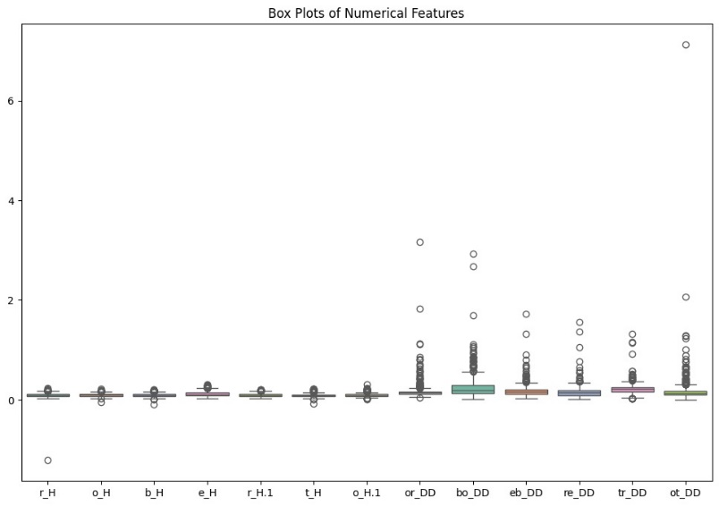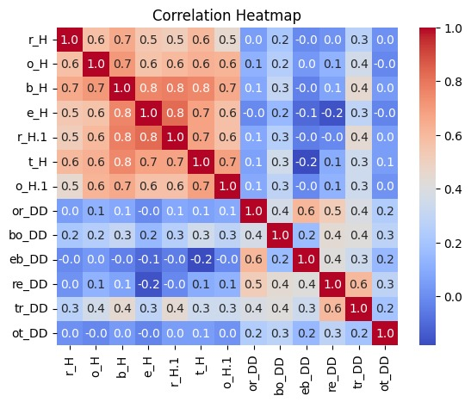

# Analysis Results:

The keystroke biometric dataset underwent a rigorous machine learning pipeline to identify the most effective model for user authentication. The following models were selected for their diverse approaches to classification and their potential for high accuracy in pattern recognition tasks:

* **KNeighborsClassifier**: An instance-based learning model that classifies new instances based on a similarity measure (e.g., distance functions).
* **GradientBoostingClassifier**: A powerful ensemble technique that builds one tree at a time, where each new tree helps to correct errors made by previously trained trees.
* **LogisticRegression**: A foundational statistical method that models the probabilities for classification problems with two possible outcomes.
* **Linear SVC (Support Vector Classifier)**: A linear model for classification that separates data points using a hyperplane with the largest amount of margin.
* **RandomForestClassifier**: An ensemble of decision trees, typically trained with the "bagging" method, that improves the predictive accuracy and controls over-fitting.

The target variable, 'Usuario', was encoded to transform the categorical user identifiers into a numerical format suitable for machine learning algorithms. This preprocessing step is crucial as it allows the models to process the input data effectively.

# Model Selection and Evaluation:

Each model was trained using the encoded features and evaluated based on its performance across several metrics, such as accuracy, precision, recall, and F1 score. The evaluation process involved a careful analysis of the models' ability to generalize and accurately classify new data points as they would in a live healthcare environment.

After a comprehensive assessment, the model that exhibited the highest performance metrics was selected as the optimal solution for the keystroke biometric system. This model's ability to discern the unique typing patterns of individuals with high accuracy made it the standout choice for deployment in healthcare settings.

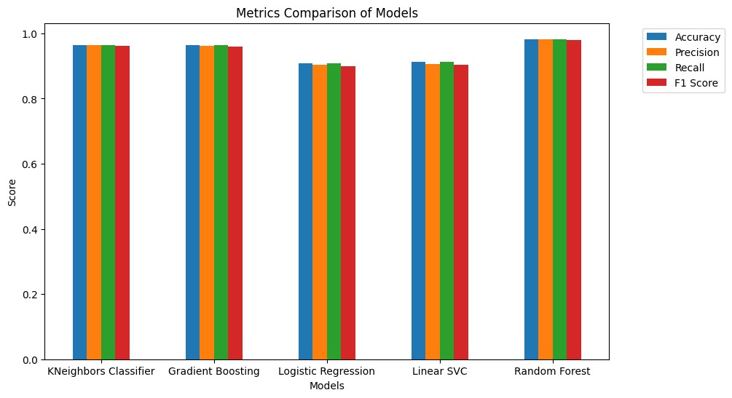

# Development Environment:

The deployment of the keystroke biometric system was accomplished through the development of a web application, structured into two main components: the backend, which handles data processing and model inference, and the frontend, which provides the user interface.

* **Backend (Flask API)**: - The backend of the web application was built using Flask, a lightweight and flexible micro web framework for Python. Flask was chosen for its ease of use and its ability to quickly set up a RESTful API, which is essential for handling authentication requests and serving model predictions. - The Flask API interacts with the machine learning model, processing incoming keystroke data, and encoding it using the pre-trained encoder. It then feeds the processed data to the model to predict the user identity and returns the authentication result to the frontend.
* **Frontend (HTML, CSS, JavaScript)**: - The frontend was developed using standard web technologies: HTML for the markup, CSS for styling, and JavaScript for interactivity. These technologies were utilized to create a user-friendly interface that allows healthcare professionals to input their typing patterns. - JavaScript plays a critical role in capturing the keystroke dynamics and sending this data to the Flask API for real-time authentication. The frontend design ensures that the application is intuitive and accessible, minimizing the learning curve for new users.

The combination of Flask for the backend and traditional web technologies for the frontend ensures that the web application is not only functional but also scalable and maintainable. This setup allows for future enhancements and easy integration with existing healthcare systems.



# Future Work:

The research conducted lays the groundwork for several avenues of advancement in keystroke biometric technology within healthcare. Future work may encompass:

* **Expansion of Biometric Parameters**: Exploring additional biometric factors that can be combined with keystroke dynamics to further enhance security and identification accuracy.
* **Machine Learning Enhancements**: Utilizing advanced machine learning algorithms to improve the adaptability and learning capabilities of the system, allowing it to evolve with changing user behavior and emerging threats.
* **Cross-Platform Compatibility**: Ensuring the keystroke biometric system is compatible with a broader range of healthcare applications and devices, including mobile platforms.
* **Real-World Testing**: Conducting extensive field tests in live healthcare settings to gather data on the system's performance in real-world scenarios and user interactions.
* **User Acceptance Studies**: Investigating the acceptance rate and user satisfaction with keystroke biometrics to identify potential resistance and educational needs among healthcare professionals.
* **Regulatory Compliance**: Assessing the system's compliance with global data protection and privacy regulations, and adapting the technology to meet these standards.
* **Scalability**: Developing strategies to scale the system for large healthcare networks, ensuring consistent performance and reliability.

# Conclusion:

The development of a keystroke biometric system represents a significant advancement in healthcare security. By leveraging machine learning and web technologies, this research provides a foundation for secure user authentication that is both efficient and user-friendly.