Game Design Document

Fill up the Following document

1. Write the title of your project.

Infinite Runner Game

1. What is the goal of the game?

Collecting the coins, overcoming the obstacles and increasing score as it is an infinite game.

1. Write a brief story of your game?

A boy has taken a challenge to collect as many coins as he can.

He wants to overcome the all of the obstacles.

1. Which are the playing characters of this game?

* Playing characters are the ones which respond to the user based on the input from the user
* Cars, monkeys, dinos, wizards etc, are the playing characters in the game.

|  |  |  |
| --- | --- | --- |
| Number | Character Name | What can this character do? |
| 1 | A boy | Character can run, jump and fire. |

1. Which are the Non Playing Characters of this game?

* Non Playing characters are the ones which don't have an action or a behaviour when the user interacts with the game.
* Hurdles, stones, bananas, coins, etc are non playing characters in the game.

|  |  |  |
| --- | --- | --- |
| Number | Character Name | What can this character do? |
| 1 | Land monsters | They will be creating obstacles in boy's path. they can take his life. |
| 2 | Dragons | They will be creating obstacles in boy's path. they can take his life. |

Draw your imagination of this game. What does this game look like?

* Draw the game either on your computer or on paper,
* Add images of scenes of the game to show each of the playing and non-playing characters at least once. 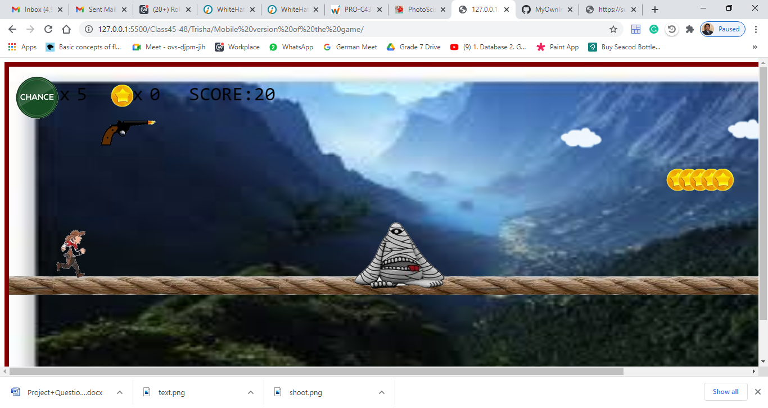

How do you plan to make your game engaging?

Feedback :

Player can earn points.

Player can earn coins.

Player will lose one life if he is attacked by obstacles.

Adaptivity :

Game speed will increase gradually.

Game won't be very difficult or easy.

Challenge vs skills :

Player has to overcome all the challenges to overcome obstacles and collecting coins as well.

Player has to show his skills to jump, fire as well as collect coins at the same time.

Rules :

By clicking UP arrow, player can jump.

By clicking SPACE button, player can fire.

By jumping over the coins, coins can be collected.

There are 5 lives.

Once the lives get over, Game is Over.

Game is an infinite.

Speed will increase gradually to increase the difficulty level.