University of Moratuwa

Faculty of Information Technology

CM3321 - Logic Programming and Artificial Cognitive Systems

Gemstone Identification Assistant

A Rule-Based Expert System for Identifying Sri Lankan Gemstones and Detecting Synthetics and Imitations

Project Report

Name: Sansiluni J.A.S

Index number: 225100T

Submission date: 29 September 2026

Implemented in SWI-Prolog 10.1.16

Abstract
Gem buyers, students and small traders in Sri Lanka frequently struggle to tell a valuable natural gemstone from a cheaper look-alike, a laboratory-grown synthetic or a glass imitation, while professional laboratory testing costs time and money. This project designs and implements the Gemstone Identification Assistant, a rule-based expert system written in SWI-Prolog that gives a quick, explained first opinion. The knowledge base contains 297 facts and 62 production rules, acquired from standard gemmological references and organised in four chained layers: species, variety, origin and treatment, and buying recommendation. The inference engine provides three reasoning modes over the same rule base: forward chaining (data-driven identification), backward chaining (goal-driven verification of a claim, implemented as a meta-interpreter that builds proof trees) and an interactive consultation that asks the user only for the facts it needs. MYCIN-style certainty factors express the confidence of each conclusion and turn incomplete data into a ranked list of candidates. A full explanation facility answers How, Why and Why not, both as a technical trace and in plain language, and animated reasoning diagrams show how each chaining method worked for the user's own input. A web interface, a console interface and a natural-language query box built with a Definite Clause Grammar make the system accessible to non-experts. The web interface checks readings as they are typed, uses pictures for colours, optical effects and inclusions, suggests the most useful next measurement when data is incomplete, and lets users print or save any result. Twenty documented test cases and 47 automated unit tests pass. The report closes with a discussion of how the system models expert cognition, a comparison with machine-learning approaches, and an honest account of its limitations.
Contents
Abstract 2
1. Introduction and Problem Definition 5
1.1 Background 5
1.2 Problem statement 5
1.3 Aim and objectives 5
1.4 What the system specialises in 6
1.5 Conclusions the system provides 6
1.6 Scope and limitations 7
2. Knowledge Engineering 7
2.1 Domain study: gemmology concepts 7
2.2 Domain study: expert system concepts and related work 9
2.3 Knowledge acquisition 11
2.4 Knowledge representation 15
2.5 Representing uncertainty: certainty factors 17
3. System Design and Implementation 18
3.1 Architecture 18
3.2 Forward chaining (Identify mode) 20
3.3 Backward chaining (Verify mode) 20
3.4 Interactive consultation (Consult mode) 21
3.5 Certainty factors and ranked candidates 22
3.6 Natural-language interface 23
3.7 User interface 24
3.8 Logic programming concepts used 28
4. Explanation Facility 28
4.1 How: the reasoning trace 28
4.2 Why: explaining a question 30
4.3 Why not: explaining a rejected alternative 31
4.4 Reasoning diagrams 32
5. Testing and Evaluation 33
5.1 Test strategy 33
5.2 Manual test cases 33
5.3 Automated tests 35
5.4 Defects found and fixed 36
5.5 Evaluation against the objectives 36
6. User Manual 37
7. Discussion 37
7.1 Modelling expert cognition 37
7.2 Symbolic AI compared with machine learning 38
7.3 Limitations 38
7.4 Future work 39
8. Conclusion 39
References 41
Appendix A. Complete Rule Base 44
Appendix B. Automated Test Output 51
Appendix C. Console Consultation Transcript 52

1. Introduction and Problem Definition

1.1 Background
Sri Lanka is one of the world's most important sources of coloured gemstones. Sapphire, ruby, spinel, chrysoberyl (including alexandrite and cat's-eye), garnet, zircon, topaz, tourmaline, quartz and moonstone are mined and traded in large numbers, particularly around Ratnapura. The same trade attracts imitations (coloured glass, cubic zirconia), synthetics (laboratory-grown corundum and spinel) and undisclosed treatments such as heating. Gemmologists separate these materials with a small set of physical and optical tests: refractive index, specific gravity, optic character, optical phenomena and the inclusions seen under magnification [1]-[4]. These tests follow well-documented reasoning, which makes gem identification a good candidate for a rule-based expert system.

1.2 Problem statement
Buyers, students and small traders often cannot tell a valuable natural gem from a cheaper look-alike or a fake, and deception is a known problem in the local trade. Accredited laboratories such as the National Gem and Jewellery Authority (NGJA) of Sri Lanka [7] give reliable answers but cost money and time, so they are not practical for every stone a buyer is offered. There is a need for a tool that takes the observations an informed buyer or student can realistically make and returns a quick, explained first opinion: what the stone probably is, whether it is likely natural, synthetic or an imitation, how confident that opinion is, and what the buyer should do next.

1.3 Aim and objectives
The aim is to build an expert system that identifies common Sri Lankan gemstones and detects synthetics and imitations, and that explains its reasoning. The objectives are:
- O1 - Acquire gemmological knowledge from recognised sources and document how it became facts and rules.
- O2 - Represent the knowledge as Prolog facts and production rules, with at least 20 of each.
- O3 - Implement both forward and backward chaining over the same rule base.
- O4 - Provide an explanation facility that shows user input, facts, rules fired, reasoning and conclusion.
- O5 - Handle incomplete data and express the confidence of conclusions.
- O6 - Provide a user-friendly interface for non-experts.
- O7 - Test the system systematically and document it with a user manual.

1.4 What the system specialises in
The system specialises in ten gem species that are common in Sri Lanka (corundum, spinel, garnet, chrysoberyl, zircon, topaz, tourmaline, quartz, orthoclase feldspar and beryl), eighteen named varieties (for example ruby, blue sapphire, padparadscha, alexandrite, cat's-eye chrysoberyl, moonstone, hessonite and aquamarine) and the two most common imitation materials, glass and cubic zirconia. It reasons from six observable properties: refractive index (RI), specific gravity (SG), optic character, body colour, optical phenomenon and the dominant inclusion type.

1.5 Conclusions the system provides
Table 1. Conclusions produced by the system
Conclusion | Description and example
Species | The mineral species, e.g. corundum, from optic character, RI and SG.
Variety | The trade variety within the species, e.g. corundum + blue gives blue sapphire; chrysoberyl + colour change gives alexandrite.
Imitation | Glass or cubic zirconia, e.g. an isotropic stone with a glass RI and gas bubbles.
Origin and treatment | Likely natural, synthetic (laboratory-grown), imitation, glass-or-synthetic, laboratory test needed, or not determined; and probable heat treatment.
Confidence | A certainty factor for every derived fact (e.g. blue sapphire 90%), a confidence level (strong match / possible match / no match), and a ranked candidate list when data is missing (e.g. Spinel 52%, Garnet 52%).
Recommendation | Practical advice, e.g. "Features are consistent with a natural stone. Obtain an NGJA certificate before purchase."
Next measurement | When data is incomplete, which missing measurement would best separate the remaining candidates, e.g. "Measure the refractive index next: Spinel 1.712-1.736, Garnet 1.730-1.890".
Explanation | How the conclusion was reached, why a question is being asked, and why an alternative was rejected.

1.6 Scope and limitations
The system is a decision-support tool for a first opinion; it is not a replacement for laboratory certification. The knowledge base covers ten species and two imitations. Heat treatment can only be suggested from a visible indicator (discoid fractures), not proven. The system assumes the user can take basic readings (a refractometer, a hydrostatic balance and a polariscope) but works with partial data. Section 7.3 discusses the limitations in detail.

2. Knowledge Engineering
Knowledge engineering was carried out as an iterative process (Figure 1). The domain was studied from recognised sources, individual knowledge statements were extracted into a knowledge acquisition table, encoded as Prolog facts and rules, tested, and refined when tests revealed gaps.
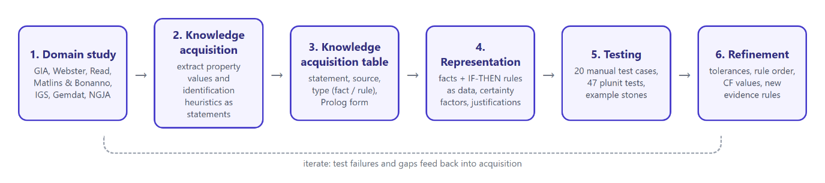
Figure 1. Knowledge engineering process used in the project

2.1 Domain study: gemmology concepts
Refractive index (RI) measures how strongly a gem slows and bends light. It is read on a gem refractometer and is the single most diagnostic test for most transparent gems [3]. Corundum reads about 1.762-1.770, quartz about 1.544-1.553 [1], [3]. Standard refractometers cannot read above about 1.81, so very high-RI materials such as high zircon and cubic zirconia show as "over the limit" (no shadow edge on the scale). This observation is itself useful evidence, and the system accepts it as an input.
Specific gravity (SG) is the density of the stone relative to water, measured by hydrostatic weighing. It separates gems with similar RI; corundum (about 4.00) is much heavier than spinel (about 3.60) [2].
Optic character describes how light passes through the crystal. Isotropic (singly refractive) materials such as spinel, garnet, glass and cubic zirconia transmit light as a single ray. Anisotropic (doubly refractive) materials split it in two; they are uniaxial (one optic axis: corundum, quartz, beryl, tourmaline, zircon) or biaxial (two axes: chrysoberyl, topaz, feldspar) [2], [3]. It is determined with a polariscope and conoscope. Birefringence is the difference between the two RI readings of a doubly refractive gem.
Optical phenomena are special light effects: asterism (a star) and chatoyancy (a cat's-eye) caused by aligned needle-like inclusions, colour change (typical of alexandrite) and adularescence (the floating sheen of moonstone) [1].
Inclusions are the gemmologist's main field evidence for origin. Rutile "silk" and mineral crystals indicate natural growth; curved growth lines (striae) and round gas bubbles indicate flame-fusion (Verneuil) synthetics; swirl marks and bubbles indicate glass; discoid fractures around crystals indicate heat treatment [1], [4], [5].
Synthetic versus imitation. A synthetic has the same chemistry and properties as the natural gem but was grown in a laboratory; an imitation merely looks similar and has different properties [4]. The distinction matters because a synthetic ruby is still corundum and passes the species tests, so only inclusion evidence can reveal it.
Table 2 summarises the property facts acquired for each material. These are refractometer and hydrostatic reading ranges, which are slightly wider than textbook mean values so that normal variation within a species is covered.
Table 2. Property facts held in the knowledge base (generated from knowledge_base.pl)
Material | RI range | SG range | Optic character | Birefringence | Hardness
Corundum | 1.757 - 1.780 | 3.95 - 4.10 | uniaxial | 0.008 | 9
Spinel | 1.712 - 1.736 | 3.55 - 3.70 | isotropic | - | 8
Garnet | 1.730 - 1.890 | 3.57 - 4.30 | isotropic | - | 7
Chrysoberyl | 1.740 - 1.760 | 3.70 - 3.78 | biaxial | 0.009 | 8.5
Zircon | 1.810 - 1.990 | 4.60 - 4.80 | uniaxial | 0.059 | 7.5
Topaz | 1.606 - 1.644 | 3.49 - 3.57 | biaxial | 0.009 | 8
Tourmaline | 1.614 - 1.666 | 3.00 - 3.26 | uniaxial | 0.018 | 7.5
Quartz | 1.540 - 1.558 | 2.60 - 2.70 | uniaxial | 0.009 | 7
Feldspar | 1.515 - 1.530 | 2.55 - 2.63 | biaxial | 0.006 | 6
Beryl | 1.564 - 1.602 | 2.63 - 2.92 | uniaxial | 0.006 | 7.5
Glass | 1.440 - 1.770 | 2.20 - 4.50 | isotropic | - | 5.5
Cubic zirconia | 2.150 - 2.180 | 5.60 - 6.00 | isotropic | - | 8.5

2.2 Domain study: expert system concepts and related work
An expert system captures the specialist knowledge of human experts so that non-experts can apply it [10], [11]. The classic architecture separates a knowledge base (domain facts and heuristics), an inference engine (a domain-independent reasoning procedure), working memory (the facts of the current case) and a user interface with an explanation facility [11]. This separation means the knowledge can be extended without changing the reasoning code.
Production rules (IF conditions THEN conclusion) are the most widely used knowledge representation in expert systems because they match the way experts state heuristics and because each rule can be explained individually [10]. Two inference strategies operate on production rules [11], [17]:
- Forward chaining is data-driven. Starting from the known facts, the engine repeatedly finds a rule whose conditions are all satisfied, adds its conclusion to working memory, and stops when no rule can add anything new. When several rules are applicable, a conflict resolution strategy (for example rule order or specificity) chooses which fires, and refractoriness prevents the same rule instance firing twice.
- Backward chaining is goal-driven. Starting from a hypothesis, the engine looks for rules that conclude it and tries to prove their conditions as sub-goals, recursively, until it reaches known facts. Prolog's own execution model is backward chaining with depth-first search and backtracking [12].
The best-known rule-based expert system, MYCIN, diagnosed bacterial infections using about 450 backward-chained rules [8]. It introduced two ideas this project adopts. The first is certainty factors: each rule carries a measure of belief, and evidence from several rules is combined incrementally [9]. The second is a consultation dialogue that asks the user only for the information a rule needs and can answer "why?" by showing the rule being tried [8], [9]. Later work such as XPLAIN argued that good explanations must justify the reasoning, not merely replay it [20]. That motivated the plain-language explanations and the source-linked rule justifications in this system.
Bratko [12] and Merritt [13] show how to build expert system shells in Prolog: rules are stored as data, a meta-interpreter proves goals and records a proof tree for "how" explanations, and questions are asked lazily during proof. Sterling and Shapiro [14] describe the meta-interpreter technique in depth, and Pereira and Warren [15] introduced Definite Clause Grammars (DCGs), which this project uses for its natural-language interface. SWI-Prolog [16] provides the HTTP and HTML libraries used for the web interface.
Related work on gemstone identification. Most published work on gem identification concentrates on laboratory instruments. Fritsch and Stockton [21] showed how infrared spectroscopy can simplify identification by comparing a stone's spectrum with a library of standard reference spectra. Jenkins and Larsen [23] described identification with Raman spectroscopy, noting that gems are usually examined by trained personnel using a variety of methods. Karampelas et al. [22] review the instruments that help to meet the challenges of the modern gem market, where treatments are widespread and the origin of a gem has become more important than in the past. These methods are accurate, but they need laboratory equipment and specialist training that a buyer in a local market rarely has. More recently, Raheem et al. [24] used convolutional neural networks to improve the accuracy of gemstone identification from images. This is the machine-learning direction discussed in Section 7.2: such models can be accurate on photographs, but they do not explain their decisions and cannot use RI, SG or optic character.
Related work on rule-based expert systems. Buchanan and Duda [25] surveyed the principles of rule-based expert systems and the production-system model on which this project is built. Grosan and Abraham [26] and Abraham [27] describe the architecture of such systems, including the explanation facility that allows a user to understand how the system arrived at a conclusion. Clancey [28], working from MYCIN, asked how domain-independent strategic knowledge can be represented in a rule-based system so that its reasoning can be explained and taught, which supports this project's emphasis on justifying every conclusion.
How this system differs. Compared with the instrumental studies [21]-[23], the Gemstone Identification Assistant works from the basic readings and observations available to a buyer or student (a refractometer, a hydrostatic balance, a polariscope and a loupe) and gives a first opinion rather than a laboratory result. Compared with image-based classification [24], every conclusion is explained step by step and linked to a published source. Building on the rule-based principles in [25]-[28], it adds a focus on Sri Lankan gems and the local trade, three reasoning modes over one rule base (forward chaining, backward chaining and an interactive consultation), certainty factors that turn incomplete data into ranked candidates with a suggested next measurement, and plain-language How, Why and Why-not explanations with reasoning diagrams for non-experts.

2.3 Knowledge acquisition
Knowledge was acquired from documentary sources: the GIA Gem Encyclopedia [1], Webster's Gems [2], Read's Gemmology [3], Matlins and Bonanno's Gem Identification Made Easy [4], the International Gem Society [5], the Gemdat database [6] and the NGJA [7]. Each usable piece of knowledge was written as a short statement, classified as a fact or a rule, and encoded in Prolog. Every rule in the knowledge base stores its justification and source in rule_info(Id, Justification, Source), so the acquisition trail is kept inside the system itself and appears in every explanation. Table 3 shows a representative selection of the 41 main knowledge statements; the complete rule base with justifications is in Appendix A.
Four knowledge engineering decisions were made during acquisition:
- Reading ranges plus tolerance. Published ranges were stored as reading ranges, and the engine adds a measurement tolerance of +/-0.005 for RI and +/-0.03 for SG to allow for instrument and operator error. A reading that fits only because of the tolerance is accepted with reduced certainty (Section 2.5).
- Layered rules. Knowledge was organised by the question it answers (species, variety, origin, advice), so that conclusions of one layer become conditions of the next.
- Explicit uncertainty. Where sources describe evidence as typical rather than conclusive (for example, fingerprints usually indicate a natural stone, but flux-grown synthetics show similar features), the rule was given a lower certainty factor rather than being omitted.
- "Over the limit" as a reading. When a refractometer shows no shadow edge, the only thing known is that the RI is above the instrument's limit (about 1.81). This is stored as the value ri(over_limit), and it matches any material whose RI range extends above the limit (zircon, cubic zirconia, some garnets) with a reduced certainty of 0.85, because the exact value is unknown.
Table 3. Knowledge acquisition table (representative entries; KE = knowledge engineer decision)
# | Knowledge statement (from source) | Source | Type | Prolog form
K1 | Corundum reads about 1.762-1.770 on the refractometer. | [1] | Fact | ri_range(corundum, 1.757, 1.780).
K2 | Corundum has SG about 4.00. | [1] | Fact | sg_range(corundum, 3.95, 4.10).
K3 | Corundum is doubly refractive and uniaxial. | [1] | Fact | optic(corundum, uniaxial).
K4 | Spinel is singly refractive, RI about 1.718, SG about 3.60. | [2] | Fact | optic(spinel, isotropic). ri_range(spinel, 1.712, 1.736).
K5 | Garnets are singly refractive, RI 1.73-1.89, SG 3.6-4.3 depending on type. | [2] | Fact | ri_range(garnet, 1.730, 1.890).
K6 | Chrysoberyl is biaxial, RI about 1.746-1.755, SG about 3.73. | [1] | Fact | optic(chrysoberyl, biaxial).
K7 | High zircon is uniaxial with very high RI and SG about 4.7. | [6] | Fact | sg_range(zircon, 4.60, 4.80).
K8 | Topaz is biaxial, RI about 1.61-1.64, SG about 3.53. | [1] | Fact | ri_range(topaz, 1.606, 1.644).
K9 | Quartz is uniaxial, RI 1.544-1.553, SG 2.65. | [3] | Fact | sg_range(quartz, 2.60, 2.70).
K10 | Moonstone (orthoclase) is biaxial, RI about 1.52, SG about 2.57. | [3] | Fact | ri_range(feldspar, 1.515, 1.530).
K11 | Beryl is uniaxial, RI about 1.57-1.60, SG about 2.7. | [6] | Fact | optic(beryl, uniaxial).
K12 | Glass is singly refractive with a wide range of RI. | [5] | Fact | ri_range(glass, 1.440, 1.770).
K13 | Cubic zirconia is isotropic with SG 5.6-6.0. | [1] | Fact | sg_range(cubic_zirconia, 5.60, 6.00).
K14 | Corundum occurs in red, pink, orange, yellow, green, blue, purple and colourless. | [1] | Fact | colour(corundum, blue).
K15 | Chrysoberyl can show chatoyancy and colour change. | [1] | Fact | phenomenon(chrysoberyl, colour_change).
K16 | Readings vary slightly with instrument and operator. | KE | Fact | tolerance(ri, 0.005). tolerance(sg, 0.03).
K17 | A uniaxial stone with corundum RI and SG is corundum. | [1] | Rule | rule(r1, [optic(uniaxial), ri_in(corundum), sg_in(corundum)], species(corundum)).
K18 | A singly refractive stone with RI about 1.72 and SG about 3.60 is spinel. | [2] | Rule | rule(r2, [optic(isotropic), ri_in(spinel), sg_in(spinel)], species(spinel)).
K19 | An isotropic stone with a glass RI and gas bubbles that matches no species is glass. | [5] | Rule | rule(r11, [optic(isotropic), ri_in(glass), inclusion(gas_bubbles), not(species(_))], imitation(glass)).
K20 | Swirl marks are typical of moulded glass. | [4] | Rule | rule(r12, [inclusion(swirl_marks), not(species(_))], imitation(glass)).
K21 | An isotropic stone with SG 5.6-6.0 is cubic zirconia. | [1] | Rule | rule(r13, [optic(isotropic), sg_in(cubic_zirconia)], imitation(cubic_zirconia)).
K22 | When data is missing, every gem consistent with all supplied properties remains possible. | KE | Rule | rule(r14, [partial_data, ..., optic_ok(G), ri_ok(G), sg_ok(G), colour_ok(G), phenomenon_ok(G)], candidate(G)).
K23 | A matching RI is the strongest single test. | [3] | Rule | rule(r16, [candidate(G), not(missing(ri)), ri_ok(G)], candidate(G)).
K24 | Red corundum is ruby. | [1] | Rule | rule(r21, [species(corundum), observed_colour(red), not(phenomenon(star))], variety(ruby)).
K25 | Blue corundum is blue sapphire. | [1] | Rule | rule(r24, [species(corundum), observed_colour(blue), not(phenomenon(star))], variety(blue_sapphire)).
K26 | Non-red corundum with asterism is star sapphire. | [1] | Rule | rule(r23, [species(corundum), phenomenon(star), not(observed_colour(red))], variety(star_sapphire)).
K27 | Pinkish-orange Sri Lankan corundum is traded as padparadscha. | [1] | Rule | rule(r26, [species(corundum), observed_colour(orange), ...], variety(padparadscha)).
K28 | Chrysoberyl with a daylight/incandescent colour change is alexandrite. | [1] | Rule | rule(r29, [species(chrysoberyl), phenomenon(colour_change)], variety(alexandrite)).
K29 | Orthoclase feldspar showing adularescence is moonstone. | [1] | Rule | rule(r31, [species(feldspar), phenomenon(adularescence)], variety(moonstone)).
K30 | Orange grossular garnet is hessonite. | [1] | Rule | rule(r34, [species(garnet), observed_colour(orange)], variety(hessonite)).
K31 | Curved striae in corundum prove flame-fusion synthesis; natural corundum grows in straight lines. | [1] | Rule | rule(r41, [species(corundum), inclusion(curved_lines)], origin(synthetic)).
K32 | Round gas bubbles in corundum indicate a flame-fusion synthetic. | [1] | Rule | rule(r42, [species(corundum), inclusion(gas_bubbles)], origin(synthetic)).
K33 | Gas bubbles in an unidentified stone indicate glass or a synthetic. | [5] | Rule | rule(r44, [inclusion(gas_bubbles), not(species(_)), not(imitation(_))], origin(glass_or_synthetic)).
K34 | Rutile silk is a natural inclusion in corundum. | [1] | Rule | rule(r46, [species(corundum), inclusion(silk)], origin(likely_natural)).
K35 | Included mineral crystals indicate natural growth. | [4] | Rule | rule(r47, [species(_), inclusion(crystals)], origin(likely_natural)).
K36 | Fingerprints are usually natural, but flux synthetics show similar features. | [4] | Rule (CF 0.6) | rule(r48, [species(_), inclusion(fingerprints)], origin(likely_natural)).
K37 | Discoid fractures form when corundum is heated. | [1] | Rule | rule(r49, [species(corundum), inclusion(discoid_fractures)], treatment(likely_heated)).
K38 | Natural corundum is rarely clean; a clean stone needs a laboratory test. | [5] | Rule | rule(r51, [species(corundum), inclusion(none)], origin(needs_lab_test)).
K39 | Natural stones should be certified before purchase (NGJA). | [7] | Rule | rule(r61, [origin(likely_natural)], advice(get_certificate)).
K40 | Treatments must be disclosed to the buyer. | [7] | Rule | rule(r67, [treatment(likely_heated)], advice(disclose_heat)).
K41 | Alexandrite must be confirmed under daylight and incandescent light. | [1] | Rule | rule(r68, [variety(alexandrite)], advice(check_colour_change)).
[Check every value and statement in Tables 2 and 3 against the cited source before submission, and adjust the source column if needed.]

2.4 Knowledge representation
The knowledge is represented as Prolog facts plus production rules. Prolog suits this because it is declarative (facts and rules are written as logical statements), has pattern matching through unification, and has built-in backtracking, which is already a form of backward chaining [12].
The key design decision is that every rule is stored as a data term, rule(Id, Conditions, Conclusion), rather than as a Prolog clause. This has three benefits. The same rule base can be interpreted by both a forward chainer and a backward chainer. Every rule has an identifier that can be shown in explanations. Rules can be inspected, listed on the knowledge base page and exported for documentation. Conditions are either facts in working memory (for example observed_colour(red)), conclusions of other rules (for example species(corundum)), computed tests (for example ri_in(corundum), which compares the RI reading with the stored range), or negations not(C) evaluated by negation as failure.
Numeric ranges are kept in facts rather than inside rules: rule r1 states ri_in(corundum) and the engine looks up ri_range(corundum, Min, Max). This keeps the property data in one place and lets the explanation say "RI 1.765 lies within the corundum range 1.757-1.780". Table 4 documents the predicates.
Table 4. Main predicates of the knowledge base and working memory
Predicate | Meaning
gem(Name) | A gem species known to the system (10).
imitation_material(Name) | An imitation material (glass, cubic zirconia).
ri_range(Gem, Min, Max) | Refractive index reading range.
sg_range(Gem, Min, Max) | Specific gravity range.
optic(Gem, Type) | Optic character: isotropic, uniaxial or biaxial.
hardness(Gem, H), birefringence(Gem, B) | Mohs hardness and birefringence (information only).
colour(Gem, C), typical_colour(Gem, C) | Possible colours; colours most common in the trade.
phenomenon(Gem, P) | Optical phenomena the species can show.
inclusion_type(I, Description) | Inclusion types the user can report.
rule(Id, Conditions, Conclusion) | Production rule (62).
rule_cf(Id, CF) | Certainty factor of a rule.
rule_info(Id, Text, Source), source(Id, Citation) | Justification and literature source of each rule.
advice_text(Key, Text) | Wording of each recommendation.
fact(F) | Working memory: observed and derived facts of the current case (dynamic, thread-local).
fired(Id, Conds, Concl) | Log of fired rules, used for the How explanation.
cf(F, CF), fired_cf/6 | Certainty of each derived fact and of each rule firing.
The rules are grouped into four layers (Figure 2). Layer 1 identifies the species from the three core measurements, detects imitations, and, when measurements are missing, produces ranked candidates. Layer 2 names the variety. Layer 3 judges origin and treatment from inclusions. Layer 4 turns conclusions into advice. Because each layer uses the conclusions of the one above as conditions, a single identification typically chains three or four rules.
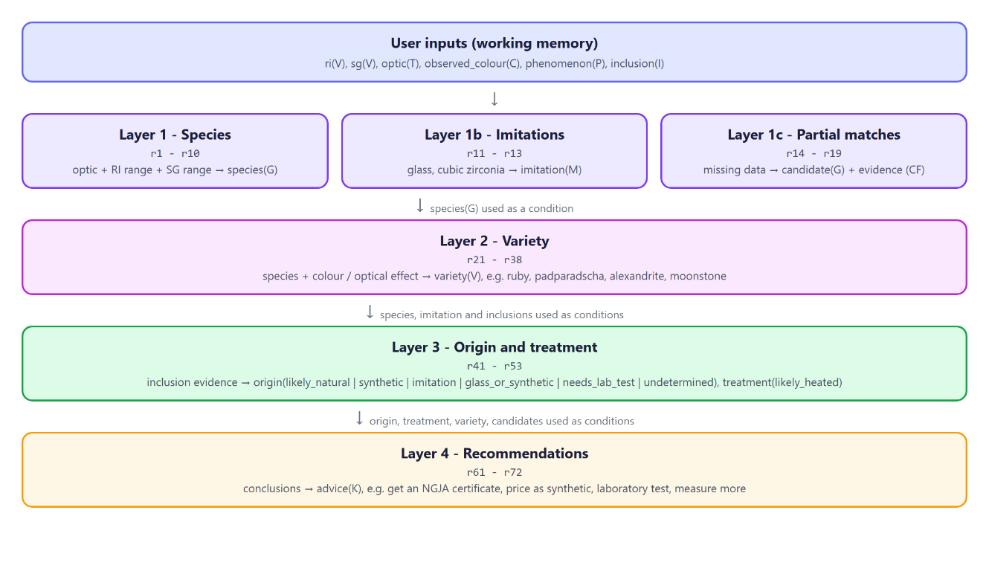
Figure 2. Rule layers and how conclusions chain between them
How to read a rule. Every rule has the form rule(Id, [Condition1, Condition2, ...], Conclusion). The list in square brackets holds the IF part, and all its conditions must be true (they are joined by AND). The last argument is the THEN part: the new fact the rule adds. not(C) means "C has not been established" (negation as failure). Conditions such as ri_in(corundum) are tests that compare the user's reading with the stored range, so rule r1 below reads: IF the stone is uniaxial AND its RI is in the corundum range AND its SG is in the corundum range, THEN it is corundum. Table 5 shows one rule from each layer with its meaning; all 62 rules are listed in Appendix A, with a key to the condition terms.
Table 5. Representative rules from each layer, with their meaning
Layer | Rule in the knowledge base | Meaning in plain English
1. Species | rule(r1, [optic(uniaxial), ri_in(corundum), sg_in(corundum)], species(corundum)). | IF the stone is uniaxial AND its RI is in the corundum range AND its SG is in the corundum range, THEN the species is corundum.
2. Variety | rule(r24, [species(corundum), observed_colour(blue), not(phenomenon(star))], variety(blue_sapphire)). | IF the stone is corundum AND it is blue AND it does not show a star, THEN it is a blue sapphire.
3. Origin | rule(r46, [species(corundum), inclusion(silk)], origin(likely_natural)). | IF the stone is corundum AND it contains rutile silk, THEN it is likely natural.
4. Advice | rule(r61, [origin(likely_natural)], advice(get_certificate)). | IF the stone is likely natural, THEN advise the buyer to obtain a laboratory certificate.
Alternative representations were considered. A decision tree would force a fixed order of questions and could not use whatever subset of data the user has. Frames would describe each gem well but do not naturally express the heuristic IF-THEN knowledge about inclusions and origin. Production rules express both kinds of knowledge, support both chaining directions and give natural explanations, so they were chosen.

2.5 Representing uncertainty: certainty factors
Gem identification is rarely certain: ranges of different species overlap slightly, colour names are judged by eye, and some inclusions occur in both natural and synthetic stones. Following MYCIN [9], each rule has a certainty factor between 0 (no belief) and 1 (certain), stored as rule_cf(Id, CF). The certainty of a conclusion is the rule's certainty multiplied by that of its weakest condition:
CF(conclusion) = CF(rule) × min( CF(condition₁), ..., CF(condition_{n}) )
User inputs have CF 1.0. A reading inside a gem's published range has CF 1.0, while a reading that fits only because of the measurement tolerance has CF 0.7. When a second rule supports a fact that is already believed, the two certainties are combined:
CF_{combined} = CF₁ + CF₂ × (1 - CF₁)
Table 6 summarises the values chosen for each rule group; individual values are listed in Appendix A.
Table 6. Certainty factor ranges by rule group
Rule group | Rules | CF range
Species (layer 1) | r1 - r10 | 0.90 - 0.95
Imitations (layer 1b) | r11 - r13 | 0.80 - 0.95
Partial-match base and evidence (layer 1c) | r14 - r19 | 0.15 - 0.50
Varieties (layer 2) | r21 - r38 | 0.70 - 0.95
Origin and treatment (layer 3) | r41 - r53 | 0.60 - 1.00
Recommendations (layer 4) | r61 - r72 | 1.00 - 1.00
The values encode the knowledge engineer's judgement of how conclusive each piece of evidence is. Species rules are high (0.90-0.95) because three independent measurements agree, but not 1.0 because ranges can overlap. Colour-based varieties are lower where the colour boundary is subjective (padparadscha 0.70). Origin rules range from 0.95 for curved striae, which the literature treats as diagnostic of flame-fusion synthesis [1], down to 0.60 for fingerprints, which can also occur in flux-grown synthetics [4]. The partial-match evidence rules are deliberately weak (0.15-0.50) so that incomplete data never produces a falsely confident answer.
[Be ready to justify these values in the viva; adjust them if your own reading of the sources suggests different weights.]

3. System Design and Implementation

3.1 Architecture
The system follows the classic expert system architecture (Figure 3). The knowledge base (knowledge_base.pl) contains only domain knowledge and no reasoning code. The inference engine (engine.pl) contains only domain-independent reasoning and explanation code. Adding a new gem therefore means adding facts and rules; no engine code changes. Working memory is declared thread_local, so each web request, which runs in its own thread, has a private copy and several users cannot interfere with each other.
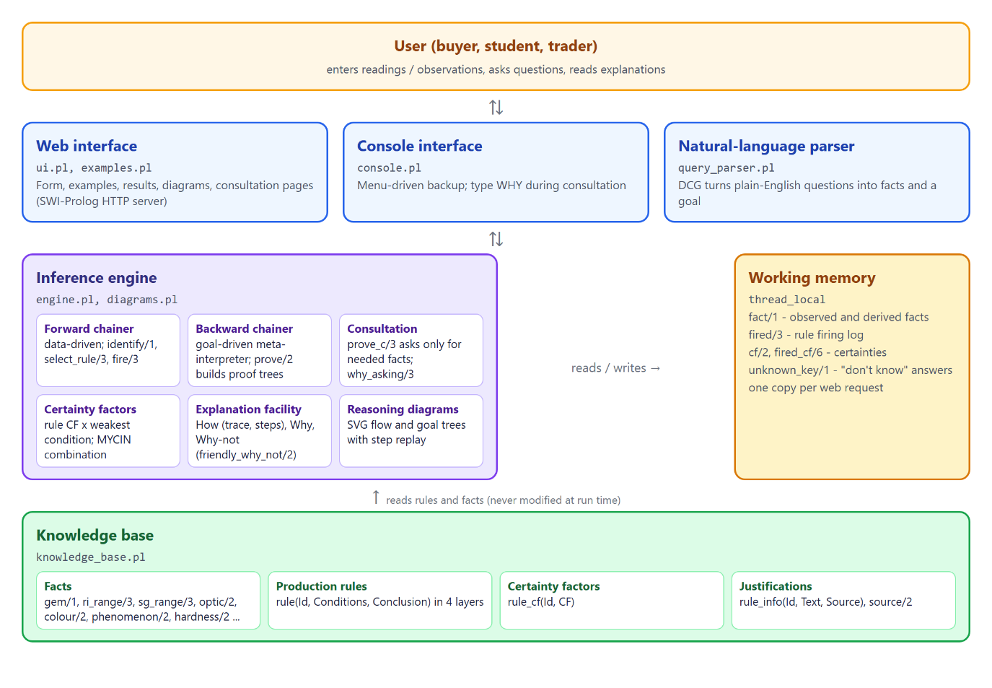
Figure 3. System architecture
Table 7. Source files
File | Responsibility
knowledge_base.pl | Facts, 62 production rules, certainty factors, justifications and sources.
engine.pl | Working memory, forward chaining, backward chaining meta-interpreter, consultation, certainty factors, How/Why/Why-not explanations.
diagrams.pl | Generates the forward-chaining flow diagram and the backward-chaining goal tree as SVG.
query_parser.pl | DCG that parses plain-English questions.
ui.pl, examples.pl | Web interface (SWI-Prolog HTTP server), example stones and gem pictures.
console.pl | Console interface.
tests.pl | 47 automated tests (plunit).
main.pl | Loads all modules.

3.2 Forward chaining (Identify mode)
In Identify mode the user's observations are asserted into working memory and the engine runs the recognise-act cycle until it reaches a fixed point:
forward_chain :-
( select_rule(Id, Conds, Concl) % recognise
-> fire(Id, Conds, Concl), % act
forward_chain % next cycle
; true % no rule can fire: stop
).

select_rule(Id, Conds, Concl) :-
rule(Id, Conds, Concl), % next rule, in knowledge-base order
all_true(Conds), % all its conditions are true
ground(Concl), % conclusion fully known
\+ fired(Id, _, Concl). % not fired before (refractoriness)
Conflict resolution is by rule order: in each cycle the first applicable rule in the knowledge base fires. Because the rules are ordered by layer, all species rules fire before variety rules, which fire before origin and advice rules. This ordering is what makes the negative conditions safe: for example, rule r11 (glass) requires not(species(_)), and by the time it is considered every species rule has already had the chance to fire. Refractoriness prevents a rule from firing twice for the same conclusion; a different rule may still support an existing fact, in which case its certainty is combined into that fact. fire/3 asserts the conclusion, records the firing in fired/3 for the explanation facility, and stores the certainty calculation in fired_cf/6.
For the input RI 1.765, SG 4.00, uniaxial, blue, silk, the engine fires r1 (species corundum), r24 (blue sapphire), r46 (likely natural) and r61 (certificate advice), then stops because no further rule can add a new fact.

3.3 Backward chaining (Verify mode)
In Verify mode the user asks whether the stone is a particular gem, for example "is it a ruby?". The goal variety(ruby) is proved by a meta-interpreter, a Prolog program that interprets the rule base and builds a proof tree as it goes [12], [14]:
% 1. negation as failure: not(C) holds if C cannot be proved
prove(not(C), negated(C)) :- !, \+ prove(C, _).
% 2. a computed test, e.g. ri_in(corundum)
prove(C, test(C)) :- test_condition(C), !, test(C).
% 3. a fact the user entered
prove(C, given(C)) :- input_fact(C), !, fact(C).
% 4. use a rule that concludes C and prove its conditions
prove(C, by(Id, C, Proofs)) :-
rule(Id, Conds, C),
prove_all(Conds, Proofs).
Each clause handles one kind of goal, and the second argument records how it was proved:
- Clause 1: a negated condition such as not(phenomenon(star)) is proved when the inner goal cannot be proved.
- Clause 2: a test such as ri_in(corundum) is proved by computation (comparing the reading with the stored range).
- Clause 3: an input such as observed_colour(red) is proved if the user entered it.
- Clause 4: any other goal is proved by finding a rule that concludes it and proving all of that rule's conditions in turn (prove_all/2 calls prove/2 on each one).
To prove a goal the engine selects a rule whose conclusion unifies with it and recursively proves its conditions as sub-goals, backtracking to the next rule if a condition fails. The proof tree by(r21, variety(ruby), [by(r1, species(corundum), [...]), given(observed_colour(red)), negated(phenomenon(star))]) is the basis of the How explanation and the backward-chaining diagram. When the goal fails, why_not/3 examines every rule that could have concluded it, finds the first failed condition of each, and, if that condition is itself a derived fact, explains recursively why that sub-goal failed.

3.4 Interactive consultation (Consult mode)
The third mode reproduces the MYCIN-style consultation [8]. prove_c/3 is a variant of the meta-interpreter that keeps a stack of the rules being tried. When a condition needs a property the user has not yet supplied, it throws ask(Property, Stack):
ensure_known(Stack, K) :-
input_key(K, F),
( fact(F) -> true % already answered
; unknown_key(K) -> true % user said "don't know"
; throw(ask(K, Stack)) % ask the user now
).
In words: if the property is already known, or the user has said "don't know", the proof simply continues; otherwise the proof is interrupted with a question. The interface asks the question and restarts the consultation with the new answer. Questions are therefore asked only when, and only if, a rule being tested needs them. When the goal is "find the species", backward chaining naturally performs hypothesise-and-test: it tries r1 (is it corundum?), asks for the optic character, and if the answer rules corundum out it abandons that hypothesis and moves on to r2 (is it spinel?) without asking anything about corundum again. The stack gives the answer to "Why are you asking this?" (Section 4.3).

3.5 Certainty factors and ranked candidates
When RI, SG or optic character is missing, no species rule can fire. Rule r14 then makes every gem that is consistent with all supplied properties a candidate with a low base certainty (0.20), and evidence rules r15-r19 add certainty for each supplied property that positively matches. For a red, singly refractive stone the calculation for spinel is:
r14 fits all inputs (rule 0.20) CF = 0.20
r15 optic matches (rule 0.30) CF = 0.20 + 0.30 x (1 - 0.20) = 0.44
r19 typical colour (rule 0.15) CF = 0.44 + 0.15 x (1 - 0.44) = 0.524
Garnet receives the same evidence, so the system ranks "Spinel 52%, Garnet 52%". This tie is honest: these observations genuinely cannot separate the two, and the system advises measuring RI and SG. With uniaxial and blue it ranks corundum, zircon and beryl (52%) above tourmaline (44%), because blue is not a typical tourmaline colour. An evidence rule's own conclusion is excluded from its weakest-condition calculation, since a belief is not evidence for itself.
Most useful next measurement. A ranked list is only a partial answer, so the system also tells the user what to measure next. For each core measurement the user has not given (RI, SG, optic character), next_measurement/4 counts how many pairs of candidates it would tell apart. Two gems are told apart by optic character when their optic characters differ, and by RI or SG when their ranges overlap by less than half of the narrower range. The measurement that separates the most pairs is recommended, together with the range each candidate would show. For the red, singly refractive stone above, the SG ranges of spinel (3.55-3.70) and garnet (3.57-4.30) overlap heavily but their RI ranges hardly do, so the system recommends measuring the refractive index (Figure 4). This mirrors how a gemmologist chooses the test that best discriminates between the remaining hypotheses.
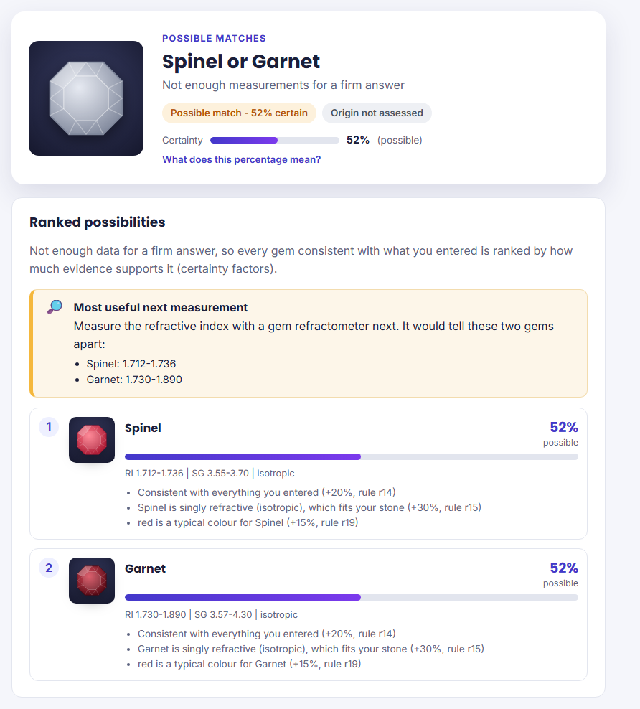
Figure 4. Ranked candidates with certainty factors, and the most useful next measurement

3.6 Natural-language interface
Users can type a question such as "Is my stone a sapphire if the RI is 1.765 and it is blue?". The question is tokenised and parsed by a Definite Clause Grammar [15] in query_parser.pl. The grammar recognises goal phrases ("is my stone a", "could it be"), property phrases ("RI is 1.765", "singly refractive", "curved growth lines") and gem names, and skips words it does not know, so word order is flexible:
items([I|Is]) --> item(I), !, items(Is).
items([skip(W)|Is]) --> [W], !, items(Is). % unknown word: skip it
items([]) --> [].

item(goal(T)) --> goal_phrase(T).
item(fact(F)) --> fact_phrase(F).

goal_phrase(T) --> [is], stone_ref, article, target(T).
fact_phrase(ri(N)) --> ri_word, link, number(N).
In DCG notation, A --> B, C means "an A is a B followed by a C", and words in square brackets such as [is] must appear literally in the sentence. So items reads the sentence one piece at a time: if the next words form a goal or a property phrase it keeps them, otherwise it skips one word and carries on. goal_phrase matches, for example, "is" + "my stone" + "a" + gem name, and fact_phrase matches "RI" + optional linking words ("is", "of", "about") + a number.
The example question is parsed as the goal verify(blue_sapphire) with facts [ri(1.765), observed_colour(blue)] and answered by backward chaining. Gem names are matched longest first, so "star sapphire" is not mistaken for "sapphire".

3.7 User interface
The main interface is a web application served by SWI-Prolog's built-in HTTP library, so nothing beyond SWI-Prolog needs to be installed. The home page introduces the system, explains the two chaining methods in plain terms, and provides a form in which each field explains what the property means and how to measure it (Figures 5 and 6). Result pages present the conclusion, certainty and origin as badges, the recommendation, a reasoning diagram and the plain-language reasoning steps (Figure 7). A menu-driven console interface provides the same functions as a backup. Full instructions are in the separate User Manual.
Several features were added specifically to make the system usable by non-experts:
- Pictures instead of terms. Colour is chosen from swatches, optical effects and inclusions from small drawings of what they look like under a loupe, and the optic character from drawings of what is seen in the polariscope and conoscope ("stays dark", "blinks light and dark", "dark cross", "curved bars"), because a beginner may not know the words "silk", "fingerprint" or "biaxial" (Figure 6).
- Checking readings as they are typed. As an RI or SG value is entered, the page immediately says which gems it fits, warns about unusual values, and blocks impossible ones once the box is left (Figure 8). Under each box a "normal range" line gives the range covered by the knowledge base, with a link to the range of every gem. The ranges are sent from the knowledge base, so the page and the rules always agree.
- Certainty in plain words. Every certainty factor is shown with a phrase such as "90% (very likely)" or "52% (possible)", and the scale is explained on request, including that a certainty factor is not a statistical probability.
- An "over the limit" option for refractometer readings (Section 2.3).
- Guidance when data is missing: ranked candidates and the most useful next measurement (Section 3.5).
- Consultation progress and Back. The step-by-step mode shows "Question 2 of at most 6" with a progress bar, and a Back button to change the previous answer.
- Print / Save as PDF, producing a clean, dated printout that a buyer can take to a seller or a laboratory.
- Recent stones, remembered only in the user's own browser, and a layout with a menu button for phones.
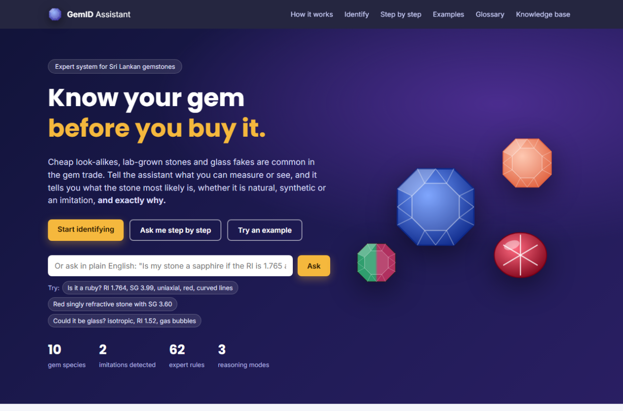
Figure 5. Home page introducing the system, with the plain-English question box
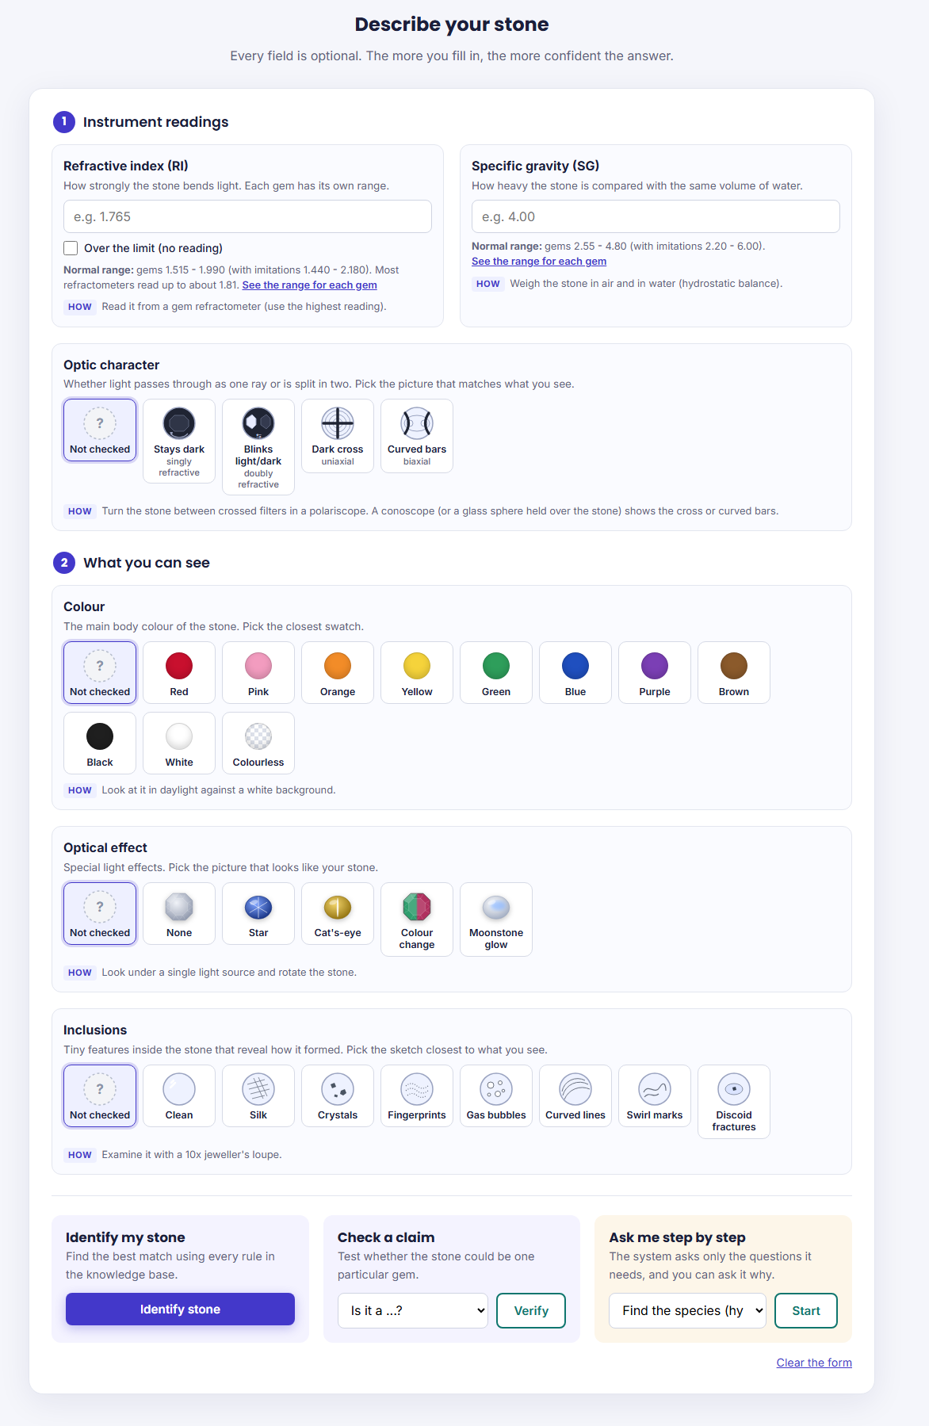
Figure 6. Input form: instrument readings, and picture choices for optic character, colour, optical effect and inclusions
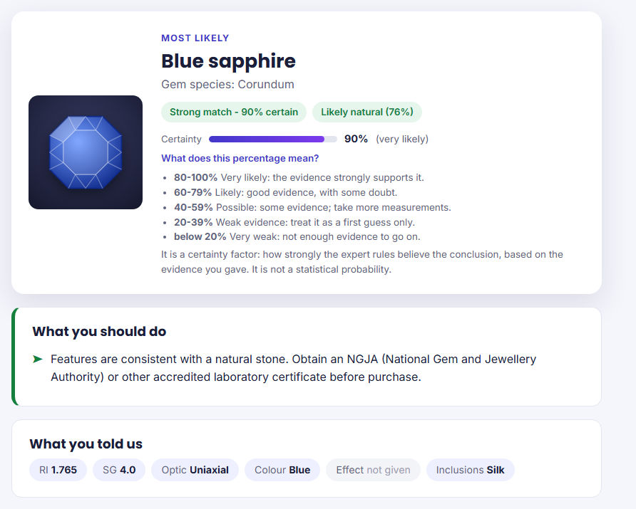
Figure 7. Identification result for a natural blue sapphire, with the certainty scale explained
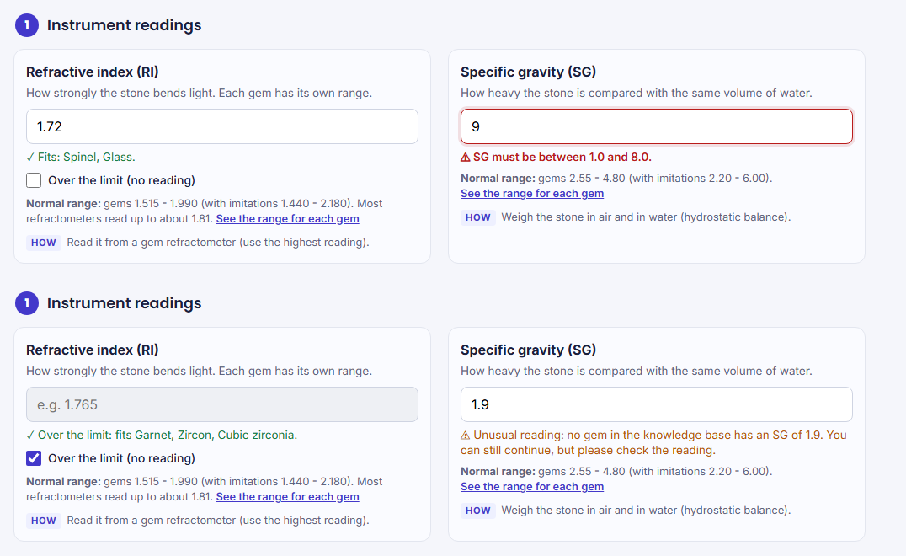
Figure 8. Readings checked as they are typed: an RI that fits spinel and glass, an impossible SG (top); "over the limit" ticked and an unusual SG (bottom)

3.8 Logic programming concepts used
Table 8. Where the system uses core Prolog concepts
Concept | Where and how it is used
Unification | Matching rule conclusions to goals in prove/2 (engine.pl, line 375); a rule with variables, e.g. r14 candidate(G), is instantiated once per matching gem.
Backtracking | select_rule/3 (line 176) backtracks through rules and variable bindings until all conditions hold; prove/2 backtracks to the next rule when a sub-goal fails.
Recursion | forward_chain/0 (line 167) recurses once per cycle; prove_all/2, why_not/3 (line 387) and the DCG items//1 recurse over lists and trees.
Negation as failure | test(not(C)) :- \+ holds(C) (line 114) and prove(not(C), ...) (line 372) implement conditions such as not(phenomenon(star)).
Dynamic database | Working memory fact/1, fired/3, cf/2 is changed with assertz/retract in load_inputs/1 (line 98) and fire/3 (line 183); declared thread_local (lines 37-41).
Meta-interpreter | prove/2 and prove_c/3 interpret rules stored as data and build proof trees.
Exceptions | The consultation throws ask(K, Stack) from inside the proof (line 293) and catches it in consult/4 (line 264).
Definite Clause Grammar | query_parser.pl, items//1 (line 58) and goal_phrase//1 (line 66).
Higher-order predicates | findall/3, maplist/3, convlist/3, foldl/4 for collecting explanations and validating input.
[Line numbers refer to the submitted version of engine.pl and query_parser.pl; re-check them if you edit those files.]

4. Explanation Facility
The brief requires the explanation to show the chain user input → facts → rules fired → reasoning → conclusion. The system provides this chain at two levels of detail, for users and for examiners, and answers the three classic explanation questions: How, Why and Why not [11], [12].

4.1 How: the reasoning trace
The technical trace is generated from the fired/3 log. For each fired rule it lists the rule's conditions as they were satisfied, the justification and source, and the certainty calculation:
USER INPUT
RI = 1.765 / SG = 4.0 / Optic character = uniaxial / Colour = blue / Inclusion = silk
FACTS (WORKING MEMORY AT START)
ri(1.765), sg(4.0), optic(uniaxial), observed_colour(blue), inclusion(silk)
RULES FIRED (IN ORDER)
r1 -> species(corundum)
because: optic character is uniaxial
RI 1.765 lies in the corundum range 1.757-1.780 (+/-0.005)
SG 4.0 lies in the corundum range 3.95-4.10 (+/-0.03)
why: Corundum is doubly refractive (uniaxial) with RI about 1.762-1.770 and SG about 4.00. [source: gia]
certainty: rule CF 0.95 x weakest condition 1.00 = 0.95
r24 -> variety(blue_sapphire)
because: species(corundum) (established earlier); colour is blue; phenomenon(star) is not established
r46 -> origin(likely_natural)
because: species(corundum) (established earlier); inclusion seen: silk
r61 -> advice(get_certificate)
CONCLUSION
Blue sapphire (Corundum) - Strong match; Origin: Likely natural
Recommendation: obtain an NGJA or other accredited laboratory certificate before purchase.
The same information is presented to users as numbered plain-language steps (Figure 9), for example "Its refractive index (1.765) is within the Corundum range of 1.757-1.780", each tagged with its rule, certainty and source.
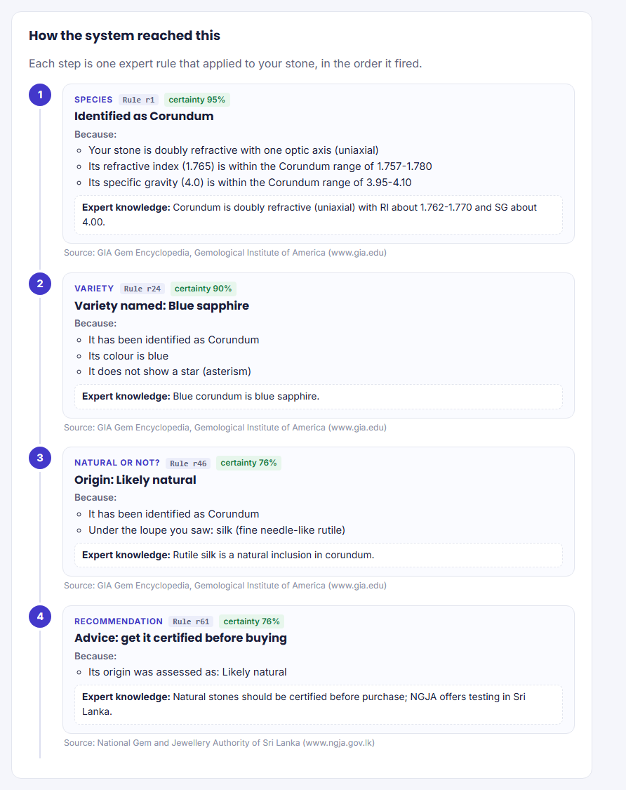
Figure 9. Plain-language How explanation

4.2 Why: explaining a question
During a consultation the user can ask why a question is being asked. The answer is built from the stack of rules being tried (Figure 10):
WHY I AM ASKING:
- I am trying to find out: is it Ruby? Rule r21 says: IF Species: Corundum AND Colour: Red
AND NOT Effect: Star THEN Variety: Ruby.
- To use that rule I first need to establish: is it Corundum? Rule r1 says: IF Optic: Uniaxial
AND RI in Corundum range AND SG in Corundum range THEN Species: Corundum.
- To test rule r1 I need to know: the optic character.
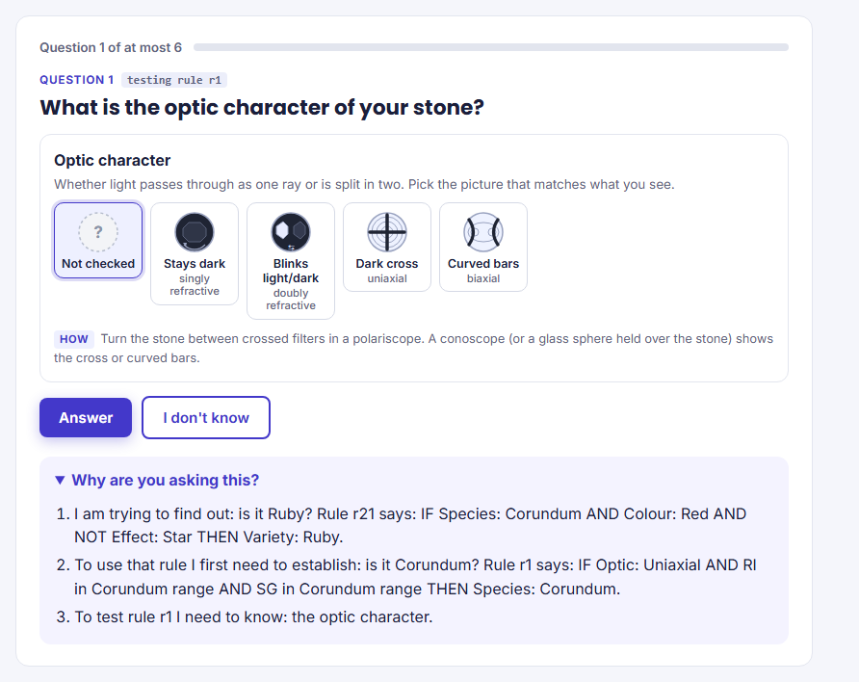
Figure 10. Consultation question with the Why explanation

4.3 Why not: explaining a rejected alternative
When a verification fails, the system names the failed condition and traces it back through the rules. For a red spinel (isotropic, RI 1.718, SG 3.60) checked as a ruby, it answers: "No - your stone does not match Ruby. Main reason: it must be doubly refractive with one optic axis (uniaxial), but you entered singly refractive (isotropic)". It then shows that rule r21 needs corundum and rule r1 failed on the optic character (Figure 11), and adds what the data points to instead (red spinel).
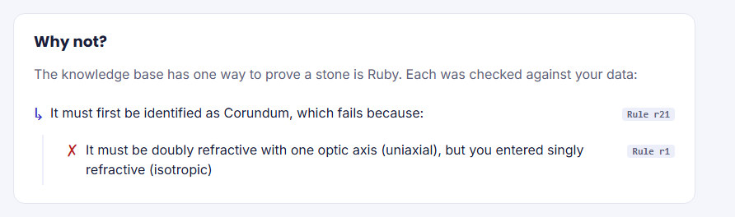
Figure 11. Why-not explanation for a failed verification

4.4 Reasoning diagrams
Each result page includes a diagram generated from the actual reasoning for the user's own input, with Play, Back and Next controls that replay it one step at a time with a caption. The forward-chaining diagram (Figure 12) shows input facts at the top, each fired rule numbered in firing order, and the facts it added. The backward-chaining diagram (Figure 13) shows the goal tree: the question, the rules tried, and each condition marked as proved, failed or never checked, which makes visible that backward chaining abandons a rule at its first failed condition.
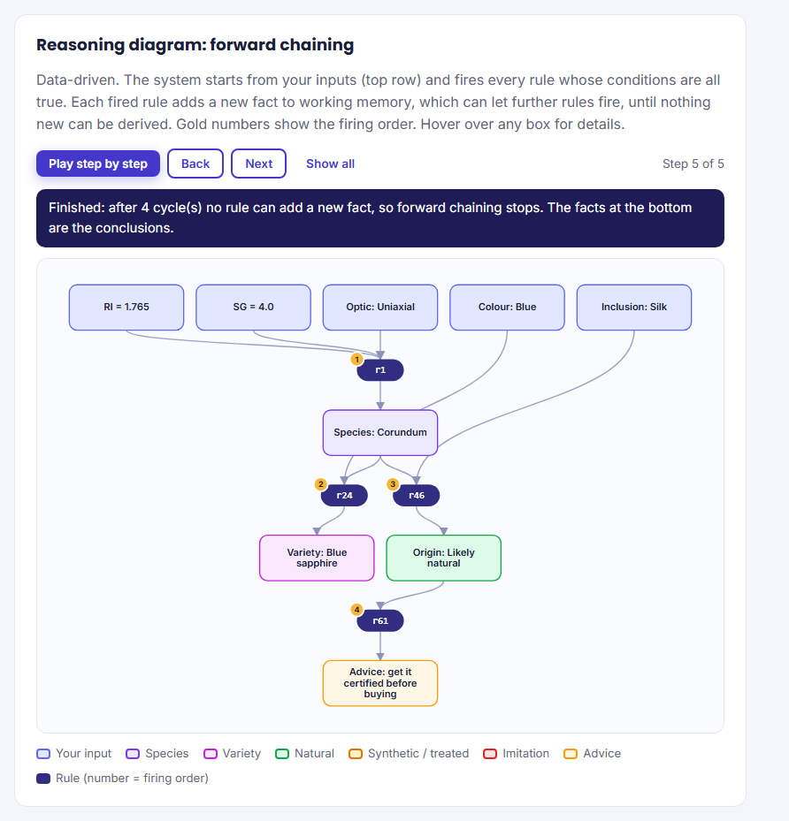
Figure 12. Forward-chaining diagram for a natural blue sapphire
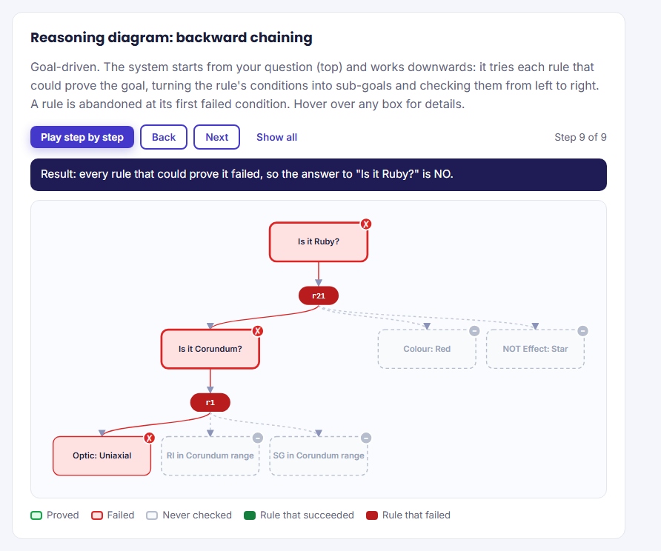
Figure 13. Backward-chaining goal tree for "is it a ruby?" with red spinel data

5. Testing and Evaluation

5.1 Test strategy
Testing was carried out at three levels: (1) documented manual test cases that exercise each type of scenario through the complete system, (2) automated unit tests with SWI-Prolog's plunit library that are re-run after every change, and (3) interface testing of every web page, including invalid input, in a browser. The 15 example stones built into the home page double as a regression set: each was run through both forward and backward chaining and produced its expected result.

5.2 Manual test cases
Table 9 lists the test cases with their expected and actual results. The actual output and fired rules were produced by running the system on each input.
Table 9. Manual test cases
TC | Scenario | Input | Expected output | Actual output | Rules fired | Result
1 | Natural blue sapphire | RI 1.765, SG 4.00, uniaxial, blue, silk | Blue sapphire, likely natural, certificate advice | Blue sapphire (90%); origin: Likely natural | r1, r24, r46, r61 | Pass
2 | Spinel, not garnet | RI 1.718, SG 3.60, isotropic, red | Red spinel; garnet rejected | Red spinel (81%); origin: not determined | r2, r37, r52, r66 | Pass
3 | Garnet whose SG overlaps corundum | RI 1.79, SG 4.05, isotropic | Garnet, not corundum | Garnet (90%); origin: not determined | r3, r52, r66 | Pass
4 | Glass imitation | RI 1.60, isotropic, gas bubbles | Imitation: glass | Glass (85%); origin: Imitation | r11, r45, r63 | Pass
5 | Synthetic ruby | RI 1.765, SG 4.00, uniaxial, red, curved lines | Ruby, synthetic | Ruby (90%); origin: Synthetic | r1, r21, r41, r62 | Pass
6 | Star sapphire | RI 1.765, SG 4.00, uniaxial, blue, star | Star sapphire (not blue sapphire) | Star sapphire (90%) | r1, r23, r52, r66 | Pass
7 | Missing RI and SG | isotropic, red | Ranked candidates, measure more | Ranked: Spinel 52%, Garnet 52% | r14, r15, r19, r70 | Pass
8 | No match | RI 1.40, SG 1.50, uniaxial | Unknown, laboratory test advised | We could not identify this stone | r72 | Pass
9 | Verify - true | "Is it ruby?" with ruby data | Yes, with proof tree | YES (90%) with proof tree | r21, r1 | Pass
10 | Verify - false | "Is it spinel?" with sapphire data | No, names failed condition | NO - must be singly refractive (isotropic), but you entered uniaxial | r2 (failed) | Pass
11 | Alexandrite | RI 1.748, SG 3.73, biaxial, green, colour change | Alexandrite, confirm-colour-change advice | Alexandrite (86%) | r4, r29, r52, r66, r68 | Pass
12 | Moonstone | RI 1.52, SG 2.57, biaxial, colourless, adularescence | Moonstone | Moonstone (86%) | r9, r31, r52, r66 | Pass
13 | Cubic zirconia | SG 5.80, isotropic, colourless | Imitation: cubic zirconia | Cubic zirconia (95%); origin: Imitation | r13, r45, r63 | Pass
14 | Heat-treated sapphire | RI 1.764, SG 4.00, uniaxial, blue, discoid fractures | Blue sapphire, natural, heated, disclosure advice | Blue sapphire (90%); Likely natural | r1, r24, r49, r50, r61, r67 | Pass
15 | Ambiguous spinel/garnet | RI 1.733, SG 3.62, isotropic | Both species, re-measure advice | Ranked: Spinel 90%, Garnet 90% | r2, r3, r52, r66, r71 | Pass
16 | Edge-of-range reading | RI 1.783 (inside tolerance only), SG 4.00, uniaxial, blue | Blue sapphire with reduced certainty | Blue sapphire (63%) | r1, r24, r52, r66 | Pass
17 | Consultation stops early | Goal ruby; answer optic = isotropic | No, without asking RI, SG or colour | Answer NO after 1 question; RI, SG, colour never asked | r21, r1 (failed) | Pass
18 | Plain-English question | "Is my stone a sapphire if the RI is 1.765 and it is blue?" | Goal blue sapphire, facts RI and colour | Parsed as verify(blue_sapphire) with [ri(1.765), observed_colour(blue)] | - | Pass
19 | RI over the refractometer limit | RI over the limit, SG 4.70, uniaxial, blue, crystals | Blue zircon, not corundum | Blue zircon (65%); origin: Likely natural | r5, r38, r47, r61 | Pass
20 | Next-measurement hint | isotropic, red (no RI or SG) | Spinel and garnet; advise measuring RI | Candidates spinel, garnet; suggests measuring RI next | r14, r15, r19, r70 | Pass

5.3 Automated tests
The plunit suite in tests.pl contains 47 tests in five units (Table 10). All 47 pass (Appendix B). The suite is run with run_tests.
Table 10. Automated test suites
Unit | Tests | What is checked
identify_forward_chaining | 18 | Species, varieties, imitations, origin, treatment, partial data, ambiguity, no match, refractoriness, explanation generation.
verify_backward_chaining | 7 | Proof trees, failed goals, nested why-not reasons, plain-language explanations.
certainty_factors | 11 | Rule CF propagation, tolerance penalty, MYCIN combination, ranking, proof certainty, certainty words, "over the limit" RI readings, most useful next measurement.
consultation_why | 6 | Question order, early stopping, "don't know" answers, hypothesise-and-test, Why text.
natural_language_dcg | 5 | Verify and identify questions, longest-name matching, multi-word phrases, unknown words.

5.4 Defects found and fixed
Testing found several real defects, which were fixed and, where possible, covered by a regression test (Table 11).
Table 11. Defects found during testing
Defect | Cause | Fix
Evidence rules added almost no certainty (0.3 x 0.2 = 0.06) | An evidence rule's own conclusion (the candidate) was counted as its weakest condition. | Exclude the conclusion from its own weakest-condition calculation.
Consultation page returned "Internal server error" | A nested list of hidden form fields was misread by the HTML generator as attributes. | Flatten the element list; the same fix restored a missing default option in two drop-down menus.
Navigation bar and example gallery collapsed in the browser | Two CSS class names were shared by unrelated elements. | Rename the conflicting classes.
Console menu looped forever when input ended | End of input was treated as menu choice 1. | Treat end of input as "Quit" in menus.
Diagram coordinates were written as unevaluated expressions | Arithmetic was passed to format/2 without evaluation. | Evaluate with is/2 before formatting.
Pages were wider than a phone screen, hiding the menu | Long example-question chips could not wrap. | Allow wrapping; add a menu button for small screens.
A stray "Fits: ..." message appeared on consultation questions | The live reading check attached itself to a hidden field carrying an earlier answer. | Check only visible input fields.

5.5 Evaluation against the objectives
Table 12. Evaluation against the objectives
Objective | Status | Evidence
O1 Knowledge acquisition documented | Met | Table 3; rule_info/3 stores the source of every rule; Appendix A.
O2 At least 20 facts and 20 rules | Exceeded | 297 facts, 62 rules in four chained layers.
O3 Forward and backward chaining | Met | Identify, Verify and Consult modes over one rule base; TC1-17.
O4 Explanation facility | Met | How, Why and Why-not at technical and plain-language levels; diagrams.
O5 Incomplete data and confidence | Met | Certainty factors, ranked candidates, next-measurement hint, "over the limit" readings; TC7, 15, 16, 19, 20.
O6 User-friendly interface | Met | Web and console interfaces, plain-English questions, example stones, picture choices, live input checks, print/save, phone layout.
O7 Testing and user manual | Met | 20 manual and 47 automated tests; separate User Manual.
The main gap in the evaluation is that all tests use textbook values. The system has not yet been validated against independently certified stones or laboratory reports. Such a validation study, reporting an accuracy table with analysis of any failures, is the most important next step (Section 7.4).

6. User Manual
The installation and operating instructions are provided as a separate document, Gemstone Identification Assistant - User Manual. It covers the required software, installation of SWI-Prolog, starting the web and console interfaces, the meaning of each input field and where to obtain it, worked examples with screenshots, the three reasoning modes, troubleshooting, and how to run the automated tests.

7. Discussion

7.1 Modelling expert cognition
The three reasoning modes correspond to recognisable patterns of expert thinking. When a gemmologist first receives an unknown stone, they gather observations and let the evidence suggest conclusions. This is data-driven reasoning, modelled by forward chaining. Once a hypothesis forms ("this could be a sapphire"), expert reasoning becomes hypothesise-and-test: the expert selects the tests that would confirm or rule out that hypothesis and abandons it as soon as a test contradicts it. Studies of expert diagnostic reasoning describe the same hypothetico-deductive pattern [18]. The consultation mode models it directly. It forms a hypothesis from the rule order, asks only for the evidence that hypothesis needs, and moves to the next hypothesis on failure. Test case 17 shows the effect: an isotropic reading rules out ruby after a single question.
Human experts also reason with uncertain evidence and weigh several weak clues. The certainty factors model this: no single colour observation identifies a gem, but several weak matches together raise one candidate above another. Finally, experts can justify their conclusions. The explanation facility gives the system the same ability to justify, and its explanations cite the source of each piece of knowledge.

7.2 Symbolic AI compared with machine learning
An alternative would be to train a machine-learning model, for example a neural network that classifies gem photographs [17]. Such models can be very accurate on images and can learn patterns no expert has written down. They are, however, largely "black boxes": they cannot say why a stone was classified as a sapphire, they need large labelled data sets that do not exist for Sri Lankan stones and their treatments, and a photograph cannot capture RI, SG or optic character. This rule-based system is transparent. Every conclusion can be traced to named rules and published sources, and it is easy to correct when an expert disagrees. Rudin [19] argues that for high-stakes decisions, interpretable models should be preferred to explaining black boxes after the fact. A buyer deciding whether to spend a large sum on a stone is making exactly that kind of decision, which is why explainability was treated as a core requirement. The weakness of the symbolic approach is the knowledge acquisition bottleneck: every rule must be written and justified by hand, and the system knows nothing outside its rules. A hybrid, in which image recognition proposes candidates that the rule base then checks and explains, is a promising direction.

7.3 Limitations
- No validation on real certified stones. Accuracy on real-world readings, with their measurement noise, is unknown.
- Over-the-limit readings are coarse. An RI "over the limit" only says the RI is above about 1.81, so it cannot separate zircon from cubic zirconia or high-RI garnets on its own; SG and optic character must do that.
- Unused properties. Birefringence is stored but not used as an input; pleochroism, fluorescence and absorption spectra, which gemmologists use to separate overlapping species, are not modelled.
- Treatments. Only heat treatment is indicated, and only from one visible feature. Glass-filled ruby, a significant fraud, is not covered.
- One inclusion per stone. The user can report only the dominant inclusion type.
- Subjective certainty factors. The CF values are the knowledge engineer's judgement and have not been calibrated against data. MYCIN-style certainty factors also lack a full probabilistic foundation [17].
- Rule-order dependence. Rules with negative conditions rely on the layer order for correct conflict resolution. This is documented but would need care if rules were added carelessly.
- Consultation diagram. For "find the species", the diagram shows the successful proof but not the hypotheses rejected before it, although the question sequence and the Why explanations do show them.

7.4 Future work
- Validate on 15-20 certified stones or laboratory reports and report accuracy with an error analysis.
- Add birefringence as an input, and rules for pleochroism, fluorescence and glass-filled ruby.
- Allow several inclusion types per stone, combining their evidence with certainty factors.
- Add a knowledge base consistency checker (conflicting, redundant or unreachable rules) and a knowledge-editing page for experts.
- Explore a hybrid system in which image recognition proposes candidates that the rule base verifies and explains.

8. Conclusion
This project designed and implemented a rule-based expert system that identifies common Sri Lankan gemstones, detects synthetics and imitations, and explains its reasoning. Knowledge from recognised gemmological sources was systematically acquired, documented and represented as 297 facts and 62 production rules in four chained layers, with a certainty factor and a literature source for every rule. One rule base supports three reasoning modes: forward chaining for identification, backward chaining for verifying a claim, and an interactive consultation that asks only for the facts it needs. A full How, Why and Why-not explanation facility, reasoning diagrams, a plain-English question interface and a web interface make the reasoning transparent to non-experts, and features such as picture-based inputs, live checking of readings and the next-measurement hint make it practical for people without gemmological training. All 20 documented test cases and 47 automated tests pass. The system meets its objectives as a tool for a first opinion. Its main limitations, the absence of real-world validation and several unmodelled gemmological properties, define clear next steps. Above all, the project shows why a transparent, explainable system is appropriate when a person's money depends on its answer.

References
[Check each reference, especially edition numbers and years, against the copy you actually used. For [21]-[28], click "Cite" then "IEEE" under each result on Google Scholar and compare; in [24], replace [conference name] with the full conference name.]
[1] Gemological Institute of America, "GIA Gem Encyclopedia." [Online]. Available: https://www.gia.edu/gem-encyclopedia
[2] R. Webster, Gems: Their Sources, Descriptions and Identification, 5th ed., P. G. Read, Ed. Oxford, U.K.: Butterworth-Heinemann, 1994.
[3] P. G. Read, Gemmology, 3rd ed. Oxford, U.K.: Elsevier Butterworth-Heinemann, 2005.
[4] A. Matlins and A. C. Bonanno, Gem Identification Made Easy, 5th ed. Woodstock, VT, USA: GemStone Press, 2013.
[5] International Gem Society, "Gem identification articles." [Online]. Available: https://www.gemsociety.org
[6] Gemdat.org, "Gemstone database." [Online]. Available: https://www.gemdat.org
[7] National Gem and Jewellery Authority of Sri Lanka. [Online]. Available: https://www.ngja.gov.lk
[8] E. H. Shortliffe, Computer-Based Medical Consultations: MYCIN. New York, NY, USA: Elsevier, 1976.
[9] B. G. Buchanan and E. H. Shortliffe, Eds., Rule-Based Expert Systems: The MYCIN Experiments of the Stanford Heuristic Programming Project. Reading, MA, USA: Addison-Wesley, 1984.
[10] P. Jackson, Introduction to Expert Systems, 3rd ed. Harlow, U.K.: Addison-Wesley, 1999.
[11] J. C. Giarratano and G. D. Riley, Expert Systems: Principles and Programming, 4th ed. Boston, MA, USA: Thomson Course Technology, 2005.
[12] I. Bratko, Prolog Programming for Artificial Intelligence, 4th ed. Harlow, U.K.: Pearson Education, 2012.
[13] D. Merritt, Building Expert Systems in Prolog. New York, NY, USA: Springer-Verlag, 1989.
[14] L. Sterling and E. Shapiro, The Art of Prolog, 2nd ed. Cambridge, MA, USA: MIT Press, 1994.
[15] F. C. N. Pereira and D. H. D. Warren, "Definite clause grammars for language analysis - A survey of the formalism and a comparison with augmented transition networks," Artificial Intelligence, vol. 13, no. 3, pp. 231-278, 1980.
[16] J. Wielemaker, T. Schrijvers, M. Triska, and T. Lager, "SWI-Prolog," Theory and Practice of Logic Programming, vol. 12, no. 1-2, pp. 67-96, 2012.
[17] S. Russell and P. Norvig, Artificial Intelligence: A Modern Approach, 4th ed. Hoboken, NJ, USA: Pearson, 2020.
[18] A. S. Elstein, L. S. Shulman, and S. A. Sprafka, Medical Problem Solving: An Analysis of Clinical Reasoning. Cambridge, MA, USA: Harvard University Press, 1978.
[19] C. Rudin, "Stop explaining black box machine learning models for high stakes decisions and use interpretable models instead," Nature Machine Intelligence, vol. 1, no. 5, pp. 206-215, 2019.
[20] W. R. Swartout, "XPLAIN: A system for creating and explaining expert consulting programs," Artificial Intelligence, vol. 21, no. 3, pp. 285-325, 1983.
[21] E. Fritsch and C. M. Stockton, "Infrared spectroscopy in gem identification," Gems & Gemology, vol. 23, no. 1, pp. 18-26, 1987.
[22] S. Karampelas, L. Kiefert, D. Bersani, and P. Vandenabeele, Gems and Gemmology: An Introduction for Archaeologists, Art-Historians and Conservators. Cham, Switzerland: Springer, 2020.
[23] A. L. Jenkins and R. A. Larsen, "Gemstone identification using Raman spectroscopy," Spectroscopy, vol. 19, no. 4, 2004.
[24] R. Raheem, W. Ahmad, and S. M. Adnan, "Improving gemstone identification accuracy using convolutional neural networks," in Proc. International Conference on [conference name], IEEE, 2024.
[25] B. G. Buchanan and R. O. Duda, "Principles of rule-based expert systems," Advances in Computers, vol. 22, pp. 163-216, 1983.
[26] C. Grosan and A. Abraham, "Rule-based expert systems," in Intelligent Systems: A Modern Approach. Berlin, Germany: Springer, 2011, pp. 149-185.
[27] A. Abraham, "Rule-based expert systems," in Handbook of Measuring System Design, P. H. Sydenham and R. Thorn, Eds. Chichester, U.K.: Wiley, 2005.
[28] W. J. Clancey, "The epistemology of a rule-based expert system - A framework for explanation," Artificial Intelligence, vol. 20, no. 3, pp. 215-251, 1983.

Appendix A. Complete Rule Base
Generated from knowledge_base.pl. Each row reads: IF all the conditions (joined by AND) are true, THEN the conclusion is added, with the certainty factor (CF) shown. Source keys: gia [1], webster [2], read [3], matlins [4], igs [5], gemdat [6], ngja [7], design = knowledge engineer decision. Capital letters such as G are variables: they stand for any gem, so a rule like r14 applies to every gem that satisfies it. Table A1 explains the condition terms.
Table A1. Key to the condition terms used in the rules
Term | Meaning
optic(T) | The stone's optic character is T (isotropic, uniaxial or biaxial). "Doubly refractive" fits uniaxial or biaxial.
ri_in(G), sg_in(G) | The RI (or SG) reading lies within gem G's range, allowing ±0.005 for RI and ±0.03 for SG. An RI "over the limit" fits gems whose range goes above about 1.81.
observed_colour(C), phenomenon(P), inclusion(I) | The user reported this colour, optical effect or inclusion.
species(G), variety(V), imitation(M) | Conclusions of earlier rules: the stone has been identified as species G, variety V or imitation material M.
origin(O), treatment(T), candidate(G) | Conclusions of earlier rules: likely origin, probable treatment, or a possible gem when data is incomplete.
not(C) | C has not been established (negation as failure).
missing(K) | The user did not supply property K (e.g. ri, sg, optic, inclusion).
partial_data | At least one of RI, SG or optic character is missing, and at least one property was supplied.
gem_type(G) | G is one of the ten gem species in the knowledge base.
optic_ok(G), ri_ok(G), sg_ok(G), colour_ok(G), phenomenon_ok(G) | The supplied optic character, RI, SG, colour or effect is consistent with gem G (true when that property was not supplied).
typical_colour_ok(G) | The reported colour is one of G's most common colours in the trade.
ambiguous_species | More than one species matched the measurements.
advice(K) | A recommendation is given; K names its wording (e.g. get_certificate).
Table A2. Complete rule base
Id | IF (all conditions true) | THEN (conclusion) | CF | Justification [source]
r1 | optic(uniaxial) AND ri_in(corundum) AND sg_in(corundum) | species(corundum) | 0.95 | Corundum is doubly refractive (uniaxial) with RI about 1.762-1.770 and SG about 4.00. [gia]
r2 | optic(isotropic) AND ri_in(spinel) AND sg_in(spinel) | species(spinel) | 0.90 | Spinel is singly refractive (isotropic) with RI about 1.718 and SG about 3.60. [webster]
r3 | optic(isotropic) AND ri_in(garnet) AND sg_in(garnet) | species(garnet) | 0.90 | Garnets are singly refractive with RI 1.73-1.89 and SG 3.6-4.3 depending on the type. [webster]
r4 | optic(biaxial) AND ri_in(chrysoberyl) AND sg_in(chrysoberyl) | species(chrysoberyl) | 0.95 | Chrysoberyl is biaxial with RI about 1.746-1.755 and SG about 3.73. [gia]
r5 | optic(uniaxial) AND ri_in(zircon) AND sg_in(zircon) | species(zircon) | 0.90 | High zircon is uniaxial with very high RI (often over the refractometer limit) and SG about 4.7. [gemdat]
r6 | optic(biaxial) AND ri_in(topaz) AND sg_in(topaz) | species(topaz) | 0.95 | Topaz is biaxial with RI about 1.61-1.64 and SG about 3.53. [gia]
r7 | optic(uniaxial) AND ri_in(tourmaline) AND sg_in(tourmaline) | species(tourmaline) | 0.90 | Tourmaline is uniaxial with RI about 1.62-1.64 and SG about 3.06. [gia]
r8 | optic(uniaxial) AND ri_in(quartz) AND sg_in(quartz) | species(quartz) | 0.90 | Quartz is uniaxial with RI 1.544-1.553 and SG 2.65. [read]
r9 | optic(biaxial) AND ri_in(feldspar) AND sg_in(feldspar) | species(feldspar) | 0.90 | Orthoclase feldspar (moonstone) is biaxial with RI about 1.52 and SG about 2.57. [read]
r10 | optic(uniaxial) AND ri_in(beryl) AND sg_in(beryl) | species(beryl) | 0.90 | Beryl is uniaxial with RI about 1.57-1.60 and SG about 2.7. [gemdat]
r11 | optic(isotropic) AND ri_in(glass) AND inclusion(gas_bubbles) AND not(species(G)) | imitation(glass) | 0.85 | A singly refractive stone with a glass RI and round gas bubbles, matching no gem species, is glass. [igs]
r12 | inclusion(swirl_marks) AND not(species(G)) | imitation(glass) | 0.80 | Swirl marks (flow lines) are typical of moulded glass. [matlins]
r13 | optic(isotropic) AND sg_in(cubic_zirconia) | imitation(cubic_zirconia) | 0.95 | Cubic zirconia is isotropic with an SG of 5.6-6.0, far heavier than any natural gem in scope. [gia]
r14 | partial_data AND not(species(G)) AND not(imitation(H)) AND gem_type(I) AND optic_ok(I) AND ri_ok(I) AND sg_ok(I) AND colour_ok(I) AND phenomenon_ok(I) | candidate(I) | 0.20 | When RI, SG or optic character is missing, every gem consistent with ALL the supplied properties remains a candidate. [design]
r15 | candidate(G) AND not(missing(optic)) AND optic_ok(G) | candidate(G) | 0.30 | A matching optic character is moderate evidence for a candidate. [design]
r16 | candidate(G) AND not(missing(ri)) AND ri_ok(G) | candidate(G) | 0.50 | A matching refractive index is the strongest single test in gemmology. [read]
r17 | candidate(G) AND not(missing(sg)) AND sg_ok(G) | candidate(G) | 0.40 | A matching specific gravity is good supporting evidence. [read]
r18 | candidate(G) AND not(missing(phenomenon)) AND not(phenomenon(none)) AND phenomenon_ok(G) | candidate(G) | 0.40 | An optical effect the species is known for is good evidence. [gia]
r19 | candidate(G) AND typical_colour_ok(G) | candidate(G) | 0.15 | A colour that is typical for the species is weak supporting evidence. [matlins]
r21 | species(corundum) AND observed_colour(red) AND not(phenomenon(star)) | variety(ruby) | 0.95 | Red corundum is called ruby. [gia]
r22 | species(corundum) AND observed_colour(red) AND phenomenon(star) | variety(star_ruby) | 0.95 | Red corundum showing asterism (a star) is star ruby. [gia]
r23 | species(corundum) AND phenomenon(star) AND not(observed_colour(red)) | variety(star_sapphire) | 0.95 | Non-red corundum showing asterism is star sapphire. [gia]
r24 | species(corundum) AND observed_colour(blue) AND not(phenomenon(star)) | variety(blue_sapphire) | 0.95 | Blue corundum is blue sapphire. [gia]
r25 | species(corundum) AND observed_colour(pink) AND not(phenomenon(star)) | variety(pink_sapphire) | 0.85 | Pink corundum (lighter than ruby) is sold as pink sapphire. [gia]
r26 | species(corundum) AND observed_colour(orange) AND not(phenomenon(star)) | variety(padparadscha) | 0.70 | Pinkish-orange to orange corundum from Sri Lanka is traded as padparadscha. [gia]
r27 | species(corundum) AND observed_colour(yellow) AND not(phenomenon(star)) | variety(yellow_sapphire) | 0.90 | Yellow corundum is yellow sapphire. [gia]
r28 | species(corundum) AND observed_colour(colourless) AND not(phenomenon(star)) | variety(white_sapphire) | 0.90 | Colourless corundum is white sapphire. [gia]
r29 | species(chrysoberyl) AND phenomenon(colour_change) | variety(alexandrite) | 0.90 | Chrysoberyl that changes colour between daylight and incandescent light is alexandrite. [gia]
r30 | species(chrysoberyl) AND phenomenon(cats_eye) | variety(cats_eye_chrysoberyl) | 0.95 | Chrysoberyl showing chatoyancy is cat's-eye chrysoberyl (cymophane). [gia]
r31 | species(feldspar) AND phenomenon(adularescence) | variety(moonstone) | 0.95 | Orthoclase feldspar showing adularescence is moonstone. [gia]
r32 | species(quartz) AND observed_colour(purple) | variety(amethyst) | 0.95 | Purple quartz is amethyst. [gia]
r33 | species(quartz) AND observed_colour(yellow) | variety(citrine) | 0.90 | Yellow quartz is citrine. [gia]
r34 | species(garnet) AND observed_colour(orange) | variety(hessonite) | 0.85 | Orange to brownish-orange garnet is hessonite (grossular). [gia]
r35 | species(garnet) AND observed_colour(red) | variety(pyrope_almandine) | 0.80 | Red garnet is usually of the pyrope-almandine series. [webster]
r36 | species(beryl) AND observed_colour(blue) | variety(aquamarine) | 0.90 | Blue beryl is aquamarine. [gia]
r37 | species(spinel) AND observed_colour(red) | variety(red_spinel) | 0.90 | Red spinel is a valued variety often confused with ruby. [gia]
r38 | species(zircon) AND observed_colour(blue) | variety(blue_zircon) | 0.85 | Blue zircon is almost always produced by heating brown zircon. [gia]
r41 | species(corundum) AND inclusion(curved_lines) | origin(synthetic) | 0.95 | Curved growth lines (striae) are diagnostic of flame-fusion (Verneuil) synthetic corundum; natural corundum grows in straight lines. [gia]
r42 | species(corundum) AND inclusion(gas_bubbles) | origin(synthetic) | 0.90 | Round gas bubbles in corundum indicate a flame-fusion synthetic. [gia]
r43 | species(spinel) AND inclusion(gas_bubbles) | origin(synthetic) | 0.85 | Gas bubbles in spinel indicate flame-fusion synthetic spinel. [webster]
r44 | inclusion(gas_bubbles) AND not(species(G)) AND not(imitation(H)) | origin(glass_or_synthetic) | 0.70 | Round gas bubbles in an unidentified stone indicate glass or a synthetic. [igs]
r45 | imitation(G) | origin(imitation) | 1.00 | An identified imitation material is not a natural gemstone. [design]
r46 | species(corundum) AND inclusion(silk) | origin(likely_natural) | 0.80 | Rutile silk is a natural inclusion in corundum. [gia]
r47 | species(G) AND inclusion(crystals) | origin(likely_natural) | 0.70 | Included mineral crystals are a typical sign of natural growth. [matlins]
r48 | species(G) AND inclusion(fingerprints) | origin(likely_natural) | 0.60 | Fingerprints (healed fractures) are usually natural, although flux synthetics can show similar features. [matlins]
r49 | species(corundum) AND inclusion(discoid_fractures) | treatment(likely_heated) | 0.80 | Discoid fractures around crystals form when corundum is heated. [gia]
r50 | treatment(likely_heated) | origin(likely_natural) | 0.90 | Heat treatment is applied to natural stones, so a heated stone is natural (but treated). [gia]
r51 | species(corundum) AND inclusion(none) | origin(needs_lab_test) | 0.60 | Natural corundum is rarely inclusion-free; a clean stone needs a lab test to rule out a synthetic. [igs]
r52 | species(G) AND missing(inclusion) | origin(undetermined) | 1.00 | Without inclusion evidence the origin cannot be decided. [design]
r53 | species(G) AND inclusion(none) AND not(species(corundum)) | origin(undetermined) | 1.00 | A clean stone of this species gives no origin evidence at loupe level. [design]
r61 | origin(likely_natural) | advice(get_certificate) | 1.00 | Natural stones should be certified before purchase; NGJA offers testing in Sri Lanka. [ngja]
r62 | origin(synthetic) | advice(synthetic_price) | 1.00 | Synthetic gems are far cheaper than natural ones and must be sold as synthetic. [igs]
r63 | origin(imitation) | advice(imitation_value) | 1.00 | Imitations have little gem value. [igs]
r64 | origin(glass_or_synthetic) | advice(lab_test_bubbles) | 1.00 | Stones showing gas bubbles need laboratory confirmation. [igs]
r65 | origin(needs_lab_test) | advice(lab_test_clean) | 1.00 | Clean corundum requires advanced laboratory tests to prove natural origin. [gia]
r66 | origin(undetermined) | advice(check_inclusions) | 1.00 | Inclusions seen with a 10x loupe are the main field test for origin. [matlins]
r67 | treatment(likely_heated) | advice(disclose_heat) | 1.00 | Treatments must be disclosed to the buyer. [ngja]
r68 | variety(alexandrite) | advice(check_colour_change) | 1.00 | Alexandrite is identified by its daylight/incandescent colour change. [gia]
r69 | variety(padparadscha) | advice(padparadscha_cert) | 1.00 | The padparadscha name is reserved for a specific colour range. [gia]
r70 | candidate(G) | advice(measure_more) | 1.00 | Additional measurements are needed to narrow down the candidates. [design]
r71 | ambiguous_species | advice(re_measure) | 1.00 | Overlapping readings must be resolved by more precise measurement. [design]
r72 | not(species(G)) AND not(candidate(H)) AND not(imitation(I)) | advice(no_match) | 1.00 | When no rule identifies the stone, the system must not guess. [design]

Appendix B. Automated Test Output
% Start unit: identify_forward_chaining
% [1/47] identify_forward_..tural_blue_sapphire ..... passed (0.008 sec)
% [2/47] identify_forward_..2_spinel_not_garnet ..... passed (0.000 sec)
% [3/47] identify_forward_..garnet_not_corundum ..... passed (0.000 sec)
% [4/47] identify_forward_..c04_glass_imitation ..... passed (0.000 sec)
% [5/47] identify_forward_..tc05_synthetic_ruby ..... passed (0.000 sec)
% [6/47] identify_forward_..:tc06_star_sapphire ..... passed (0.000 sec)
% [7/47] identify_forward_..ri_gives_candidates ..... passed (0.000 sec)
% [8/47] identify_forward_..ining:tc08_no_match ..... passed (0.000 sec)
% [9/47] identify_forward_..ng:tc11_alexandrite ..... passed (0.000 sec)
% [10/47] identify_forward_..ning:tc12_moonstone .... passed (0.000 sec)
% [11/47] identify_forward_..tc13_cubic_zirconia .... passed (0.000 sec)
% [12/47] identify_forward_..c14_heated_sapphire .... passed (0.000 sec)
% [13/47] identify_forward_..active_unknown_axis .... passed (0.000 sec)
% [14/47] identify_forward_..guous_spinel_garnet .... passed (0.000 sec)
% [15/47] identify_forward_.._corundum_needs_lab .... passed (0.000 sec)
% [16/47] identify_forward_..etic_spinel_bubbles .... passed (0.000 sec)
% [17/47] identify_forward_..for_same_conclusion .... passed (0.000 sec)
% [18/47] identify_forward_..nation_is_generated .... passed (0.002 sec)
% End unit identify_forward_chaining: passed (0.016 sec CPU)
% Start unit: verify_backward_chaining
% [19/47] verify_backward_c..09_verify_ruby_true .... passed (0.000 sec)
% [20/47] verify_backward_c..es_failed_condition .... passed (0.000 sec)
% [21/47] verify_backward_c..false_nested_reason .... passed (0.000 sec)
% [22/47] verify_backward_c..g:tc22_verify_glass .... passed (0.000 sec)
% [23/47] verify_backward_c..fy_explanation_text .... passed (0.000 sec)
% [24/47] verify_backward_c..teps_plain_language .... passed (0.000 sec)
% [25/47] verify_backward_c..why_not_main_reason .... passed (0.000 sec)
% End unit verify_backward_chaining: passed (0.000 sec CPU)
% Start unit: certainty_factors
% [26/47] certainty_factors..pecies_cf_from_rule .... passed (0.000 sec)
% [27/47] certainty_factors..e_reading_lowers_cf .... passed (0.000 sec)
% [28/47] certainty_factors..ombines_mycin_style .... passed (0.000 sec)
% [29/47] certainty_factors.._most_certain_first .... passed (0.001 sec)
% [30/47] certainty_factors:tc30_proof_certainty .... passed (0.000 sec)
% [31/47] certainty_factors..er_the_limit_zircon .... passed (0.000 sec)
% [32/47] certainty_factors..les_out_low_ri_gems .... passed (0.000 sec)
% [33/47] certainty_factors..arse_over_the_limit .... passed (0.000 sec)
% [34/47] certainty_factors..ement_spinel_garnet .... passed (0.000 sec)
% [35/47] certainty_factors..t_when_it_separates .... passed (0.000 sec)
% [36/47] certainty_factors:tc42_certainty_words .... passed (0.000 sec)
% End unit certainty_factors: passed (0.000 sec CPU)
% Start unit: consultation_why
% [37/47] consultation_why:..ptic_first_for_ruby .... passed (0.000 sec)
% [38/47] consultation_why:..en_hypothesis_fails .... passed (0.000 sec)
% [39/47] consultation_why:..ks_next_needed_fact .... passed (0.000 sec)
% [40/47] consultation_why:..se_and_test_species .... passed (0.000 sec)
% [41/47] consultation_why:..t_know_is_respected .... passed (0.000 sec)
% [42/47] consultation_why:..anation_names_rules .... passed (0.000 sec)
% End unit consultation_why: passed (0.000 sec CPU)
% Start unit: natural_language_dcg
% [43/47] natural_language_..c37_verify_question .... passed (0.000 sec)
% [44/47] natural_language_..dentify_description .... passed (0.000 sec)
% [45/47] natural_language_..ngest_gem_name_wins .... passed (0.000 sec)
% [46/47] natural_language_..0_multiword_phrases .... passed (0.000 sec)
% [47/47] natural_language_..nown_words_reported .... passed (0.000 sec)
% End unit natural_language_dcg: passed (0.000 sec CPU)
% All 47 tests passed in 0.041 seconds (0.031 cpu)

Appendix C. Console Consultation Transcript
Consult mode, goal "find the species". The user types why at the first question, then answers isotropic, RI 1.718 and SG 3.60.
What is the optic character?
0. Don't know
1. Isotropic
2. Uniaxial
3. Biaxial
4. Doubly refractive
(type a number, or WHY)
> WHY I AM ASKING:
- I am trying to find out: is it Corundum? Rule r1 says: IF Optic: Uniaxial AND RI in Corundum range AND SG in Corundum range THEN Species: Corundum.
- To test rule r1 I need to know: the optic character.

What is the optic character?
0. Don't know
1. Isotropic
2. Uniaxial
3. Biaxial
4. Doubly refractive
(type a number, or WHY)
>
What is the refractive index (RI)? (type OTL if the refractometer shows no reading)
(type a number, press Enter if you don't know, or type WHY)
>
What is the specific gravity (SG)?
(type a number, press Enter if you don't know, or type WHY)
>
Backward chaining asked 3 of the 6 possible questions.
---------------------------------------------------
YES - your stone is consistent with Spinel (certainty 90% - very likely).
Every condition the expert rules require is met.
---------------------------------------------------

HOW IT WAS CHECKED
1. [Species] Identified as Spinel (rule r2; certainty 90%)
- Your stone is singly refractive (isotropic)
- Its refractive index (1.718) is within the Spinel range of 1.712-1.736
- Its specific gravity (3.6) is within the Spinel range of 3.55-3.70
Expert knowledge: Spinel is singly refractive (isotropic) with RI about 1.718 and SG about 3.60.

