Gemstone Identification Assistant

User Manual

Installation, operation and worked examples
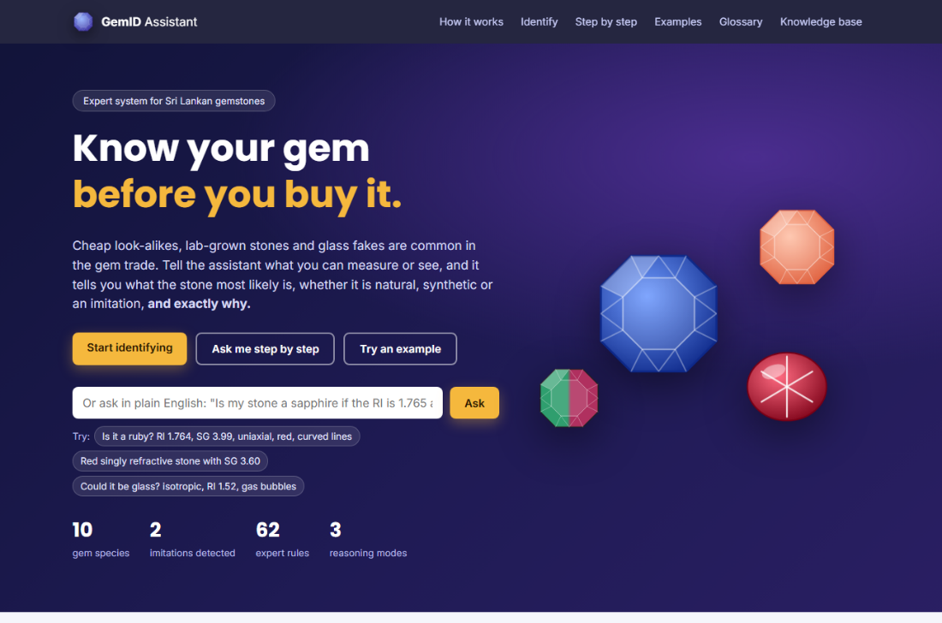

Sansiluni J.A.S - 225100T

CM3321 - Logic Programming and Artificial Cognitive Systems

Faculty of Information Technology, University of Moratuwa

Version 1.0 - 29 September 2026
Contents
1. About the system 4
1.1 Three ways to use it 4
2. What you need 5
3. Installation 5
3.1 Install SWI-Prolog 5
3.2 Copy the project folder 5
3.3 Check the installation 6
4. Starting and stopping the system 6
4.1 Start the web interface (recommended) 6
4.2 Stop the system 7
5. A tour of the home page 7
6. Describing your stone 8
6.1 Instant checks on your readings 10
7. Identifying a stone 11
7.1 Steps 11
7.2 Reading the result 12
7.3 Using the reasoning diagram 13
7.4 When some data is missing 14
8. Checking a claim (Verify) 14
9. Step-by-step consultation 15
10. Asking in plain English 16
11. Worked examples 17
11.1 Example 1: a natural blue sapphire 18
11.2 Example 2: a glass imitation 18
11.3 Example 3: checking a claim that fails 18
11.4 Example 4: a refractometer reading over the limit 18
12. Printing or saving a result 19
13. Your recent stones 20
14. Using the system on a phone or tablet 20
15. Troubleshooting 21
16. Console mode (without a browser) 22
17. Running the automated tests 23
18. Quick reference 23
Appendix A. Gem property facts for testing 25

1. About the system
The Gemstone Identification Assistant is an expert system that helps buyers, students and small traders identify common Sri Lankan gemstones. You describe a stone (its measurements and what you can see) and the system tells you:
- what the stone most likely is (species and variety, for example corundum - blue sapphire);
- whether it is likely natural, synthetic (laboratory-grown) or an imitation such as glass;
- how certain it is, as a percentage;
- what you should do next, for example obtain a laboratory certificate before buying;
- exactly how it reached its answer.
It knows ten gem species (corundum, spinel, garnet, chrysoberyl, zircon, topaz, tourmaline, quartz, feldspar/moonstone and beryl), their main varieties, and two imitation materials (glass and cubic zirconia).
Important: the system gives a first opinion only. It does not replace a certificate from the National Gem and Jewellery Authority (NGJA) or another accredited gem laboratory. Always obtain a certificate before a significant purchase.

1.1 Three ways to use it
Mode | Use it when... | What it does
Identify | "I don't know what this stone is." | Takes everything you enter and works forwards to the most likely answer (forward chaining).
Verify | "The seller says it's a ruby. Is it?" | Starts from the claim and checks every condition it needs; if the claim fails it tells you exactly why (backward chaining).
Step by step | "I want to be guided." | Asks you one question at a time, only when needed, and explains why it is asking.
You can also type a question in plain English, for example "Is my stone a sapphire if the RI is 1.765 and it is blue?"

2. What you need
Table 1. Requirements
Item | Requirement
Computer | Windows 10 or 11, macOS or Linux, with about 100 MB of free disk space.
SWI-Prolog | Version 9 or later (free). The system was developed and tested with SWI-Prolog 10.1.16 (64-bit).
Web browser | Any modern browser: Microsoft Edge, Google Chrome, Firefox or Safari.
Project files | The gem_expert folder.
Internet | Only for downloading SWI-Prolog. The system itself runs offline; without internet the page simply uses standard fonts.
Gem instruments (optional) | Refractometer, hydrostatic balance, polariscope and a 10x loupe give the best results, but the system also works with only what you can see.

3. Installation

3.1 Install SWI-Prolog
- Open https://www.swi-prolog.org/download/stable in your browser.
- Download the installer for your computer. On Windows choose the 64-bit installer (swipl-...-1.x64.exe).
- Run the installer and accept the default settings.
- Windows only: on the "Install Options" page select "Add swipl to the system PATH for all users" (or "for the current user"). This lets you start SWI-Prolog from a terminal.
- Finish the installation. On macOS you can alternatively install with Homebrew (brew install swi-prolog); on Ubuntu Linux use sudo apt install swi-prolog.

3.2 Copy the project folder
- Copy or unzip the gem_expert folder to a convenient place, for example Documents\gem_expert.
- Check that the folder contains these files: main.pl, knowledge_base.pl, engine.pl, ui.pl, console.pl, diagrams.pl, examples.pl, query_parser.pl, tests.pl and an images folder.

3.3 Check the installation
- Open a terminal: on Windows, open the gem_expert folder in File Explorer, click the address bar, type cmd and press Enter. On macOS or Linux, open Terminal and use cd to go to the folder.
- Type swipl --version and press Enter. You should see a line such as SWI-Prolog version 10.1.16 for x64-win64.
If you see "'swipl' is not recognized", SWI-Prolog is not on the PATH. See Troubleshooting (Section 15).

4. Starting and stopping the system

4.1 Start the web interface (recommended)
- In the terminal, inside the gem_expert folder, type:
swipl main.pl
You will see:
=== Gemstone Identification Assistant loaded ===
server(8080). start web interface, then open http://localhost:8080
start. console interface
demo. worked example
run_tests. run automated tests

?-
- At the ?- prompt type the following, including the full stop, and press Enter:
server(8080).
The system replies Web interface running: open http://localhost:8080 in your browser.
- Open your web browser and go to http://localhost:8080. The home page appears (Figure 1).
On Windows the first time you start the server, Windows Defender Firewall may ask whether to allow SWI-Prolog to communicate. Choose Allow for private networks. The system only listens on your own computer.
Every Prolog command ends with a full stop. If nothing happens after pressing Enter, type . and press Enter again.

4.2 Stop the system
- In the terminal type stop_server(8080). to stop the web server.
- Type halt. to leave SWI-Prolog. (Closing the terminal window also stops everything.)

5. A tour of the home page
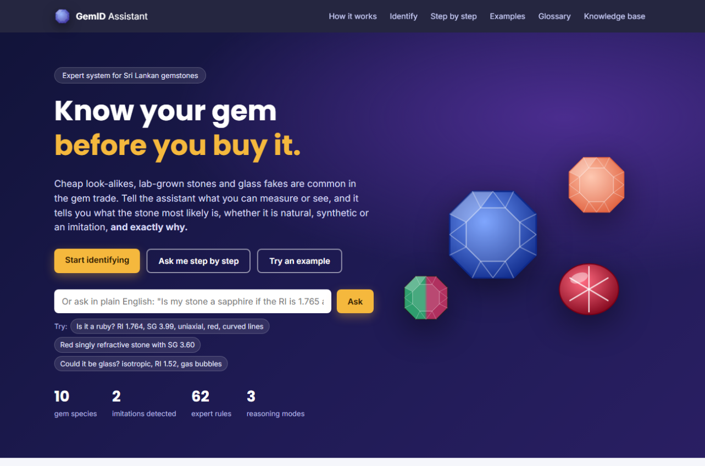
Figure 1. Home page
The top bar links to every part of the system: How it works, Identify (the input form), Step by step, Examples, Glossary and Knowledge base. The introduction offers three buttons: Start identifying, Ask me step by step and Try an example, plus a box for plain-English questions. Scrolling down you will find a summary of what the system tells you, an explanation of how it works and of the two reasoning methods (Figure 2), the input form, example stones and a glossary of gem terms.
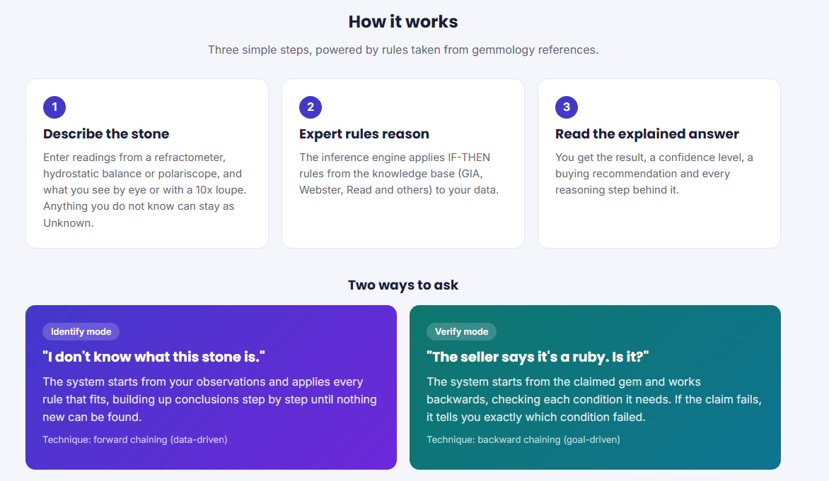
Figure 2. "How it works" section

6. Describing your stone
The form (Figure 3) has two groups of fields. Every field is optional. Fill in what you know and leave the rest as Unknown / not checked. The more you fill in, the more certain the answer. Each field shows what the property means (grey text) and how to measure it (HOW).
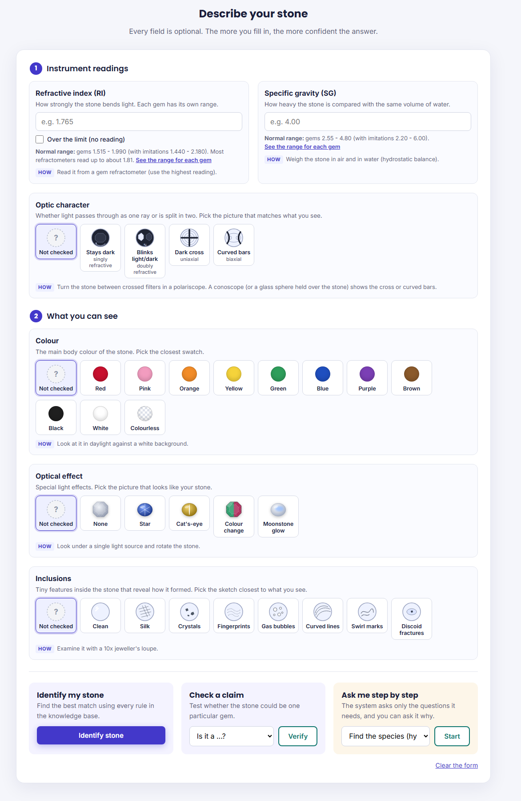
Figure 3. The input form: instrument readings with normal ranges, and picture choices for the optic character and for what you can see
Table 2. Input fields
Field | What it is | How to obtain it | Tips
Refractive index (RI) | How strongly the stone bends light. Each gem has its own range. | Gem refractometer with contact liquid; use the highest reading. | Enter three decimals, e.g. 1.765. Allowed range 1.3-3.0. If the scale shows no shadow edge at all, tick Over the limit (no reading) instead. Leave it blank if you have no refractometer.
Specific gravity (SG) | How heavy the stone is compared with the same volume of water. | Hydrostatic balance: SG = weight in air / (weight in air - weight in water). | Enter two decimals, e.g. 4.00. Allowed range 1.0-8.0.
Optic character | Whether light passes as one ray (singly refractive) or is split in two (doubly refractive). | Polariscope: rotate the stone between crossed filters. A conoscope (or a glass sphere held over the stone) shows the interference figure. | Click the picture that matches what you see: Stays dark (singly refractive), Blinks light/dark (doubly refractive, figure not checked), Dark cross (uniaxial) or Curved bars (biaxial).
Colour | The main body colour. | Look in daylight against a white background. | Click the swatch closest to your stone.
Optical effect | Star, cat's-eye, colour change or moonstone glow. | Look under a single light source and rotate the stone; compare daylight and lamp light for colour change. | Click the picture that looks like your stone. Choose None if you looked and saw no effect.
Inclusions | Tiny features inside the stone that reveal how it formed. | Examine with a 10x jeweller's loupe. | Click the sketch closest to what you see. Clean means you looked and saw nothing inside.
Optic character, colour, optical effect and inclusions are chosen by clicking a picture tile; the chosen tile is outlined in blue. Leave the Not checked tile selected if you did not look. Hover over a tile to see its full description.

6.1 Instant checks on your readings
As soon as you type an RI or SG value, a short note appears under the box (Figure 4):
- Green "Fits: ..." lists the gems whose range includes your reading.
- Orange warning: the value is unusual (no gem in the system has it, or it is above what most refractometers can read). Check your measurement.
- Red error: the value is impossible (outside the allowed range). It appears when you leave the box, and the form will not be sent until you correct it.
Under each box a Normal range line shows the range of readings covered by the system (for example RI 1.515 - 1.990 for gems). The link See the range for each gem opens the ranges of every gem in a new tab, so your form is kept.
Ticking Over the limit (no reading) greys out the RI box and shows which gems read above the refractometer's limit (zircon, cubic zirconia and some garnets).
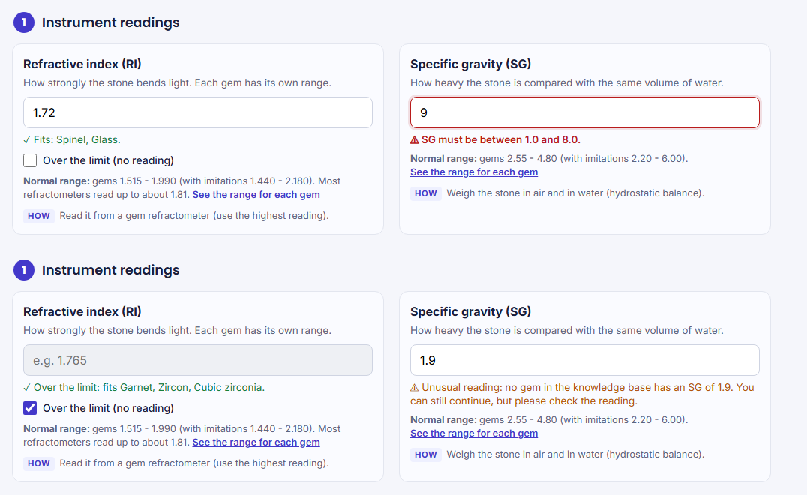
Figure 4. Readings checked as you type (top) and the "Over the limit" option (bottom)
Below the fields are three action panels: Identify my stone, Check a claim (choose a gem in the list, then Verify) and Ask me step by step. Clear the form empties all fields.

7. Identifying a stone

7.1 Steps
- Fill in the fields you know (Section 6).
- Press Identify stone.
- Read the result page (Figure 5).

7.2 Reading the result
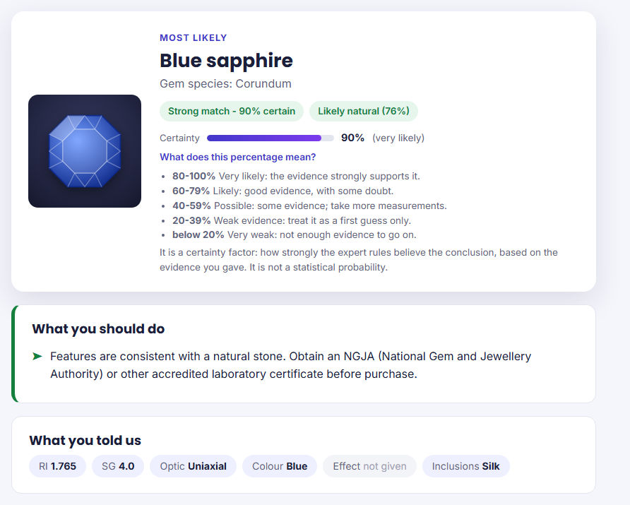
Figure 5. Result for a natural blue sapphire, with the certainty scale opened
Table 3. Parts of the result page
Part | Meaning
Title (e.g. Blue sapphire) | The most likely identification, with the species underneath.
Confidence badge | Strong match (green): optic character, RI and SG all agree. Possible match (amber): data is incomplete or fits more than one gem. No match (grey): nothing in the knowledge base fits.
Certainty bar | How strongly the expert rules believe the conclusion, with a word that explains it: very likely (80-100%), likely (60-79%), possible (40-59%), weak evidence (20-39%), very weak (below 20%). Click What does this percentage mean? to see the scale. It is a certainty factor, not a statistical probability.
Origin badge | Likely natural (green), Synthetic or laboratory test recommended (amber), Imitation or Glass or synthetic (red), Not determined (grey, usually because no inclusions were reported). A Probably heat-treated badge appears when heat indicators were seen.
What you should do | Practical recommendations.
What you told us | Your inputs; fields you left empty show "not given".
Reasoning diagram | A picture of how the rules fired (Section 7.3).
How the system reached this | Each reasoning step in plain English, with the rule number, its certainty, the expert knowledge behind it and its source.
About (gem) | Reference facts about the identified gem.
Technical trace | Click to open the full list of facts and fired rules (for gemmologists and examiners).
Buttons | Edit my inputs returns to the form with your values filled in; Print / Save as PDF prints the result (Section 12); Start a new stone clears the form.

7.3 Using the reasoning diagram
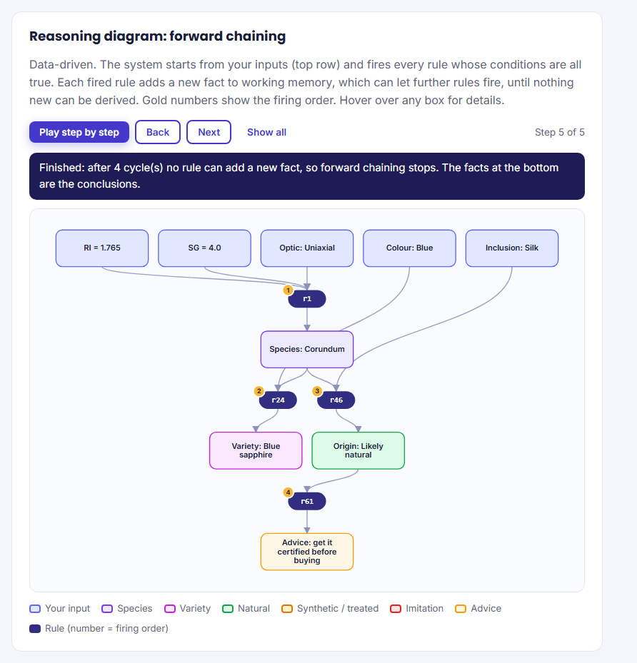
Figure 6. Forward-chaining diagram
Your inputs are the blue boxes at the top. Each dark oval is a rule; its gold number shows the order in which it fired. Arrows show which facts made the rule fire and which new fact it added. Use the buttons:
- Play step by step: replays the reasoning automatically, one rule at a time, with a caption explaining each step.
- Back / Next: move one step at a time yourself.
- Show all: shows the complete diagram again.
Hover the mouse over any box to see its full details.

7.4 When some data is missing
If you leave out the RI, SG or optic character, the system cannot confirm a species. Instead it lists Ranked possibilities (Figure 7): every gem consistent with what you entered, ordered by certainty, with the evidence for each.
Above the list, the yellow Most useful next measurement box tells you which missing measurement would narrow the list down best, and what each candidate would read. For example, for a red, singly refractive stone it advises measuring the refractive index, because spinel reads 1.712-1.736 and garnet 1.730-1.890.
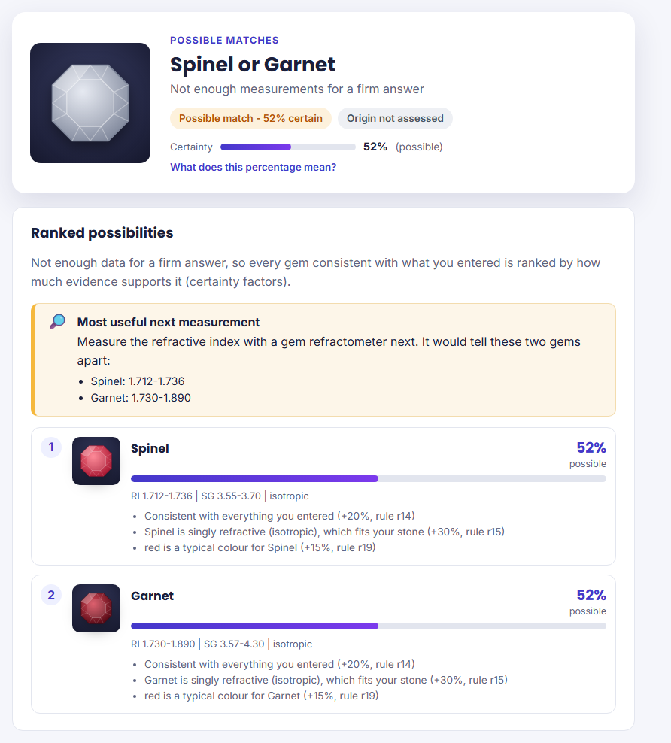
Figure 7. Ranked possibilities and the most useful next measurement for a red, singly refractive stone

8. Checking a claim (Verify)
- Fill in the fields you know.
- In the Check a claim panel choose the gem the seller claims, e.g. Ruby.
- Press Verify.
The answer is a clear Yes (green tick) or No (red cross). For a No, the page shows the main reason, what your data points to instead, and a Why not? list tracing the failure back through the rules (Figure 8). The backward-chaining diagram shows the question at the top, the rules tried below it, and each condition marked proved (green), failed (red) or never checked (dashed grey).
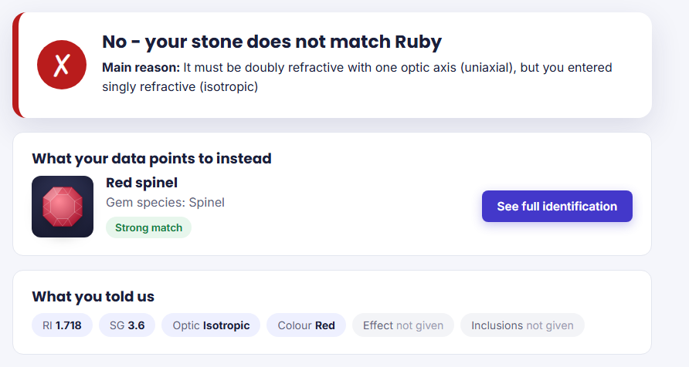
Figure 8. A failed verification: a red spinel offered as a ruby

9. Step-by-step consultation
- Click Step by step in the top bar (or Ask me step by step on the home page).
- Choose what you want to find out. Find the species lets the system test one gem hypothesis after another. You can also choose a particular gem.
- Answer each question and press Answer, or press I don't know. The bar at the top shows how far you are ("Question 2 of at most 6").
- Made a mistake? Press Back to return to the previous question and change your answer.
- Open Why are you asking this? at any time to see which rule the system is testing and why it needs the answer (Figure 9).
- When the system has enough information it shows the answer, how many questions it needed, and a diagram of its reasoning. Change my last answer takes you back one step.
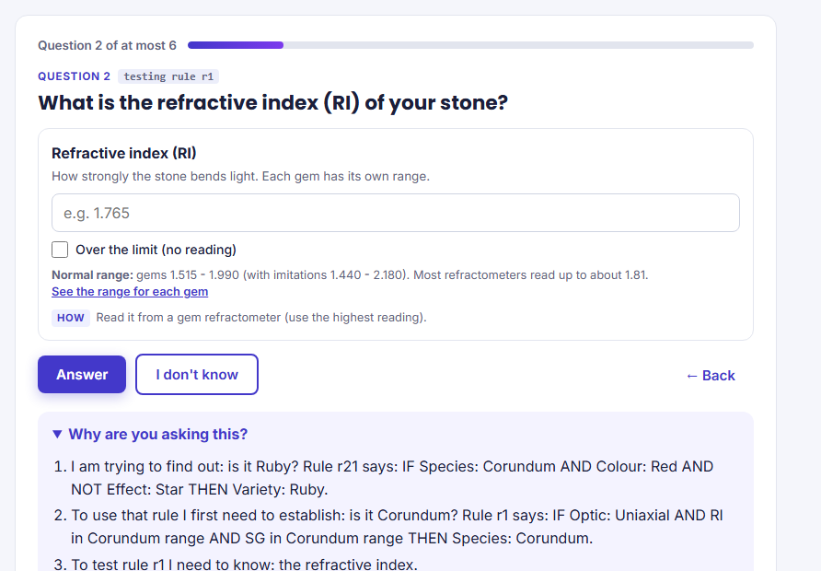
Figure 9. A consultation question with the progress bar, the Back button and the explanation
The system asks only what it needs. For example, when checking for ruby, answering Isotropic to the first question ends the consultation immediately, because a ruby must be doubly refractive.

10. Asking in plain English
Type a question into the box on the home page and press Ask. The system shows what it understood (Figure 10) and then answers. Examples:
- Is my stone a sapphire? RI 1.765, SG 4.00, uniaxial and blue
- What is a singly refractive red stone with SG 3.60?
- Could it be glass? isotropic, RI 1.52, gas bubbles
- Blue stone, RI over the limit, SG 4.70, uniaxial
Understood words include RI / refractive index, "over the limit", SG / specific gravity, singly or doubly refractive, uniaxial, biaxial, colour names, star, cat's eye, colour change, adularescence, silk, crystals, fingerprints, gas bubbles, curved lines, swirl marks, discoid fractures, clean, and gem names. Words the system did not use are listed so you can rephrase.
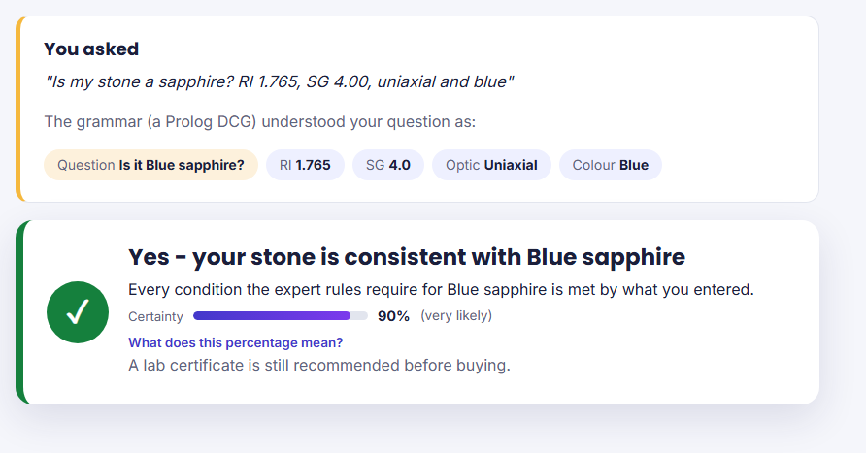
Figure 10. A plain-English question and how it was understood

11. Worked examples
The Example stones to try section of the home page has 15 ready-made stones (Figure 11). Press Try it on any card to copy its readings into the form, then press Identify stone or Verify.
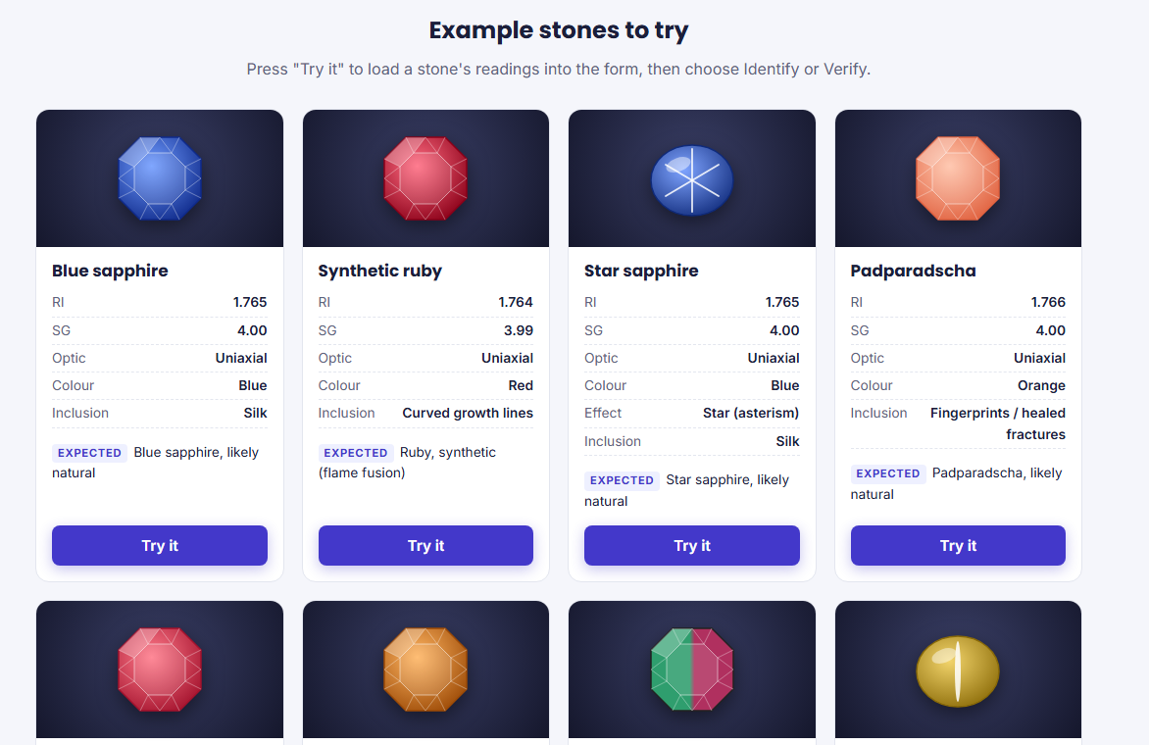
Figure 11. Example stones
To test every gem in the system with your own inputs, use the readings in Appendix A: each gem's facts, a sample reading to type, and the result the system gives.

11.1 Example 1: a natural blue sapphire
Input | RI 1.765, SG 4.00, Uniaxial, Blue, Silk
Result | Blue sapphire (species corundum) - Strong match, 90% certain (very likely); origin Likely natural (76%).
Recommendation | Obtain an NGJA or other accredited laboratory certificate before purchase.
Why | Rule r1 identified corundum from the optic character, RI and SG; rule r24 named the blue variety; rule r46 used the rutile silk as evidence of natural origin.

11.2 Example 2: a glass imitation
Input | RI 1.60, Isotropic, Gas bubbles (SG not measured)
Result | Imitation: Glass - 85% certain; origin Imitation (not a natural gemstone) (Figure 12).
Recommendation | This is an imitation with little gem value; do not pay gemstone prices.
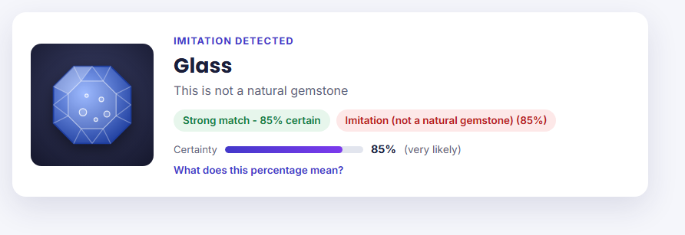
Figure 12. A glass imitation is detected

11.3 Example 3: checking a claim that fails
Input | RI 1.718, SG 3.60, Isotropic, Red; claim: Ruby
Result | No - the stone does not match ruby. Main reason: a ruby must be doubly refractive (uniaxial) but the stone is singly refractive. The data points to Red spinel instead (Figure 8).

11.4 Example 4: a refractometer reading over the limit
Input | RI Over the limit (ticked), SG 4.70, Uniaxial, Blue, Crystals
Result | Blue zircon (species zircon) - Strong match, 65% certain (likely); origin Likely natural (Figure 13).
Why | Only zircon, cubic zirconia and some garnets read above the refractometer's limit; of those, only zircon is uniaxial with an SG of about 4.7. The certainty is lower than for a measured RI because the exact value is unknown.
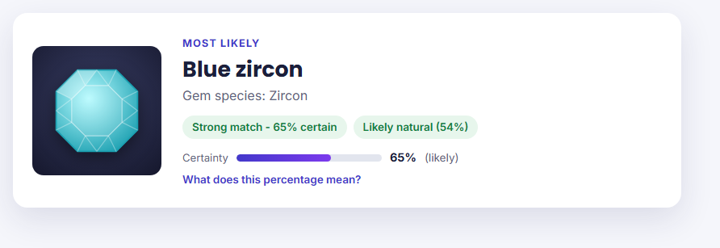
Figure 13. A blue zircon identified with an RI over the refractometer limit

12. Printing or saving a result
Every result page has a Print / Save as PDF button at the bottom. It opens your browser's print window: choose a printer, or choose Save as PDF as the printer to keep a file. The printout (Figure 14) has a header with the date and time and a reminder that it is a first opinion, leaves out the menu and buttons, and includes the full diagram and technical trace. You can take it to a seller or a gem laboratory.
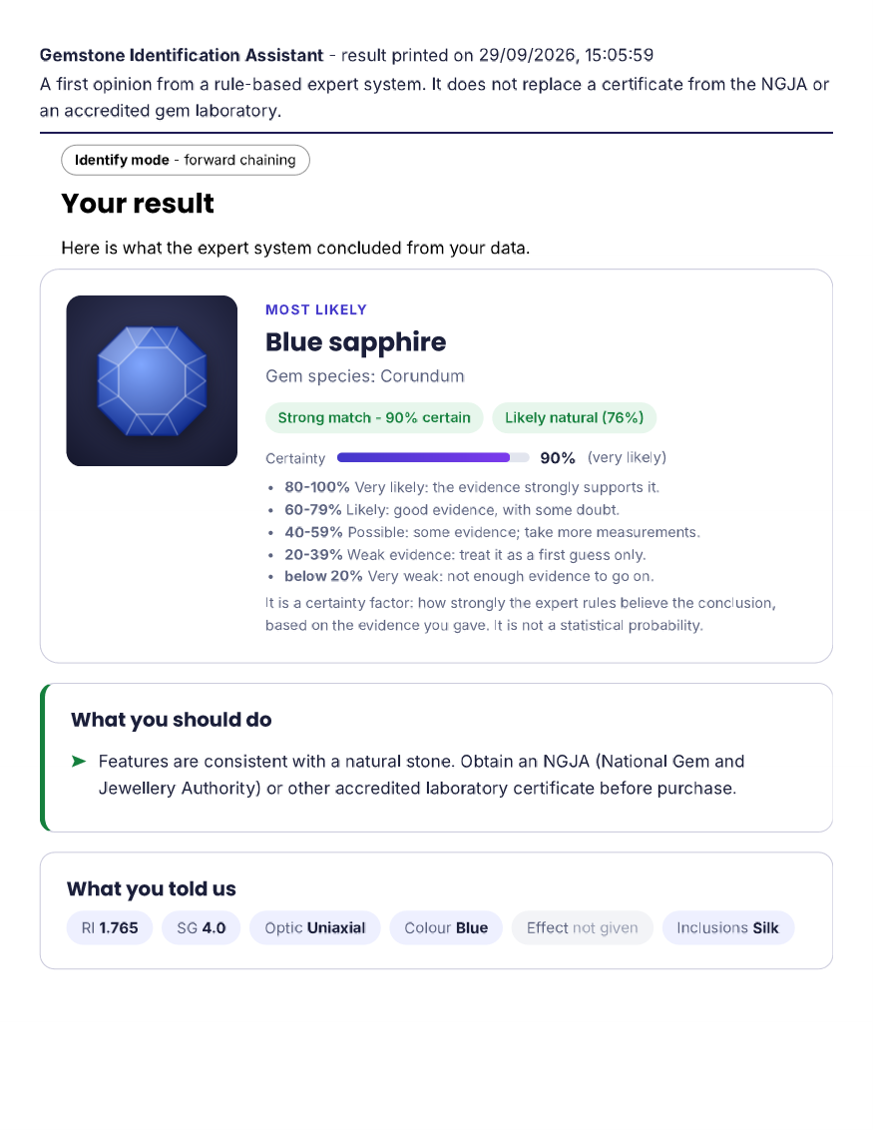
Figure 14. First page of a printed result

13. Your recent stones
The system remembers the last eight results you looked at. They appear at the top of the form on the home page under Your recent stones (Figure 15). Click one to open its result again, or press Clear list to remove them.
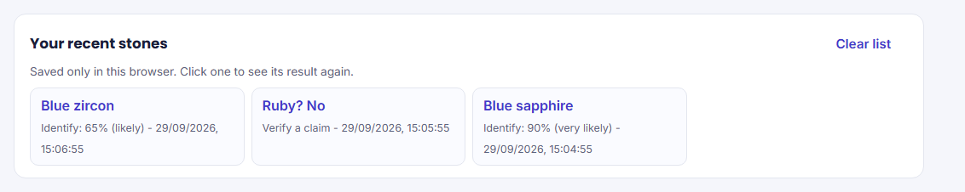
Figure 15. Your recent stones on the home page
The list is stored only in your own browser on your computer; nothing is sent anywhere. It will be empty in a private window, in a different browser, or after clearing your browsing data.

14. Using the system on a phone or tablet
The pages adapt to small screens (Figure 16). On a narrow screen the links in the top bar are replaced by a menu button (three lines) in the top right corner: tap it to open the menu, and tap a link or press it again to close. To use a phone on the same network, start the server on the computer and open http://<computer's IP address>:8080 on the phone; Windows Firewall must allow SWI-Prolog on private networks.
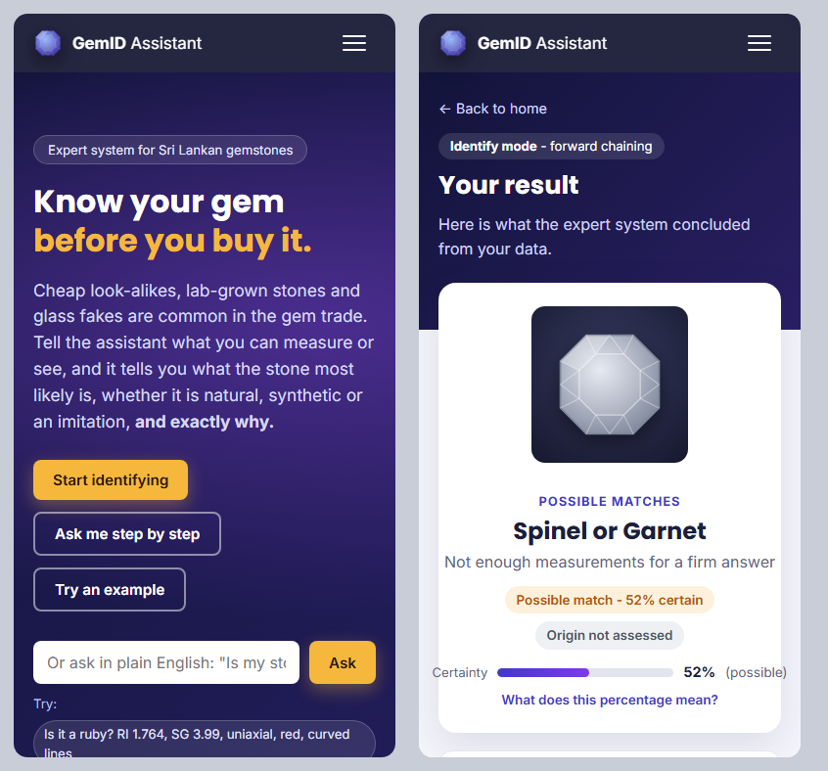
Figure 16. Home page and a result on a phone-sized screen

15. Troubleshooting
Table 4. Common problems and solutions
Problem | Solution
"'swipl' is not recognized as an internal or external command" | SWI-Prolog is not on the PATH. Re-run the installer and select "Add swipl to the system PATH", then open a new terminal. Alternatively run it with its full path: "C:\Program Files\swipl\bin\swipl.exe" main.pl.
Error "port 8080 is already in use" (or similar) after server(8080). | Another program uses that port. Start on a different port, e.g. server(8081)., and open http://localhost:8081.
Browser shows "This site can't be reached" | The server is not running. Check that you typed server(8080). with the full stop, and that the terminal window is still open. Check the port number in the address.
Nothing happens after typing a command | Prolog is waiting for the full stop. Type . and press Enter.
Error messages about files not found when running swipl main.pl | The terminal is not in the gem_expert folder. Use cd to move into it, or open the terminal from that folder.
"Please check your input" page, or a red message under a box | A value is outside the allowed range (RI 1.3-3.0, SG 1.0-8.0) or is not a number. Correct it (or press Go back and fix it) and try again.
The RI box is greyed out | Over the limit (no reading) is ticked. Untick it to type an RI value.
"Your recent stones" is missing or empty | It only appears once you have looked at a result in this browser. It is empty in private windows, in another browser, or after clearing browsing data.
The print button prints extra pages or no colours | In the print window, turn on Background graphics and choose Save as PDF or your printer; the result normally fits on a few pages.
Result says "We could not identify this stone" | Re-check the readings (RI usually has three decimals, SG two) and the optic character. The stone may also be outside the system's scope; seek a laboratory test.
Changes to the program files do not appear | In the Prolog terminal type make. to reload changed files, then refresh the browser (Ctrl+F5). Or stop and restart the system.
Windows Firewall message on first start | Choose Allow for private networks.
The page fonts look plain | You are offline; the page falls back to standard fonts. Everything still works.

16. Console mode (without a browser)
If the web interface cannot be used, the same functions are available in the terminal.
Step 1. Start SWI-Prolog with swipl main.pl.
Step 2. Type start. A menu appears:
What would you like to do?
1. Identify a stone - "I don't know what it is" (forward chaining)
2. Check a claim - "The seller says it's a ruby" (backward chaining)
3. Step by step - asks only what it needs; type WHY at any question
4. Ask in English - e.g. is it a ruby if the RI is 1.765 and it is red
5. Run the demo - natural blue sapphire example
6. Quit
Choose 1-6:
Step 3. Type a number and press Enter (no full stop is needed inside the menu). Answer each question by typing a number or a value; press Enter on its own if you do not know. For the RI, type OTL if the refractometer shows no reading (over the limit).
Step 4. In step-by-step mode, type why at any question to see why it is being asked:
What is the optic character?
0. Don't know
1. Isotropic
2. Uniaxial
...
> why
WHY I AM ASKING:
- I am trying to find out: is it Corundum? Rule r1 says: IF Optic: Uniaxial AND RI in
Corundum range AND SG in Corundum range THEN Species: Corundum.
- To test rule r1 I need to know: the optic character.
Step 5. After each result you can type y to see the technical trace.
Step 6. Choose 6 to leave the menu, then type halt.
The command demo. runs the worked blue sapphire example directly.

17. Running the automated tests
Step 1. Start SWI-Prolog with swipl main.pl.
Step 2. Type run_tests. The last line should read:
% All 47 tests passed
The rule base can also be exported to a spreadsheet file with export_rules_csv('rules_table.csv').

18. Quick reference
Table 5. Commands
Command (type at the ?- prompt) | Effect
swipl main.pl | (in the terminal) Load the system.
server(8080). | Start the web interface at http://localhost:8080.
stop_server(8080). | Stop the web interface.
start. | Start the console interface.
demo. | Run the worked blue sapphire example.
run_tests. | Run the 47 automated tests.
make. | Reload program files after editing them.
halt. | Leave SWI-Prolog.
Table 6. Web pages
Address | Page
http://localhost:8080/ | Home page, form, examples, glossary
http://localhost:8080/consult | Step-by-step consultation
http://localhost:8080/rules | Knowledge base: gem facts and all rules

Appendix A. Gem property facts for testing
This table lists the facts the system holds for every material in its knowledge base, so the system can be tested with any gem. For each one:
- RI and SG are the reading ranges the rules use. The system also accepts readings slightly outside them (RI ±0.005, SG ±0.03) to allow for measurement error, but with lower certainty.
- Try this reading is a sample input from the middle of the ranges. Enter it in the form (Section 6) and press Identify stone. For "RI over the limit", tick Over the limit (no reading) instead of typing an RI.
- System result is what the system concludes for that reading, with its certainty. These results were produced by running the system on each sample.
- Source is the reference the values were taken from (full references are in the project report).
Adding a colour from the list names the variety (for example corundum + red gives Ruby, chrysoberyl + colour change gives Alexandrite), and adding an inclusion lets the system judge whether the stone is natural or synthetic. Trying values outside the ranges, or a different optic character, shows how the system rejects a gem and explains why.
Table A1. Gem property facts, sample readings and results
 | Material and colours | RI | SG | Optic | Mohs | Try this reading | System result | Source
 | Corundum  Red, Pink, Orange, Yellow, Green, Blue, Purple, Colourless | 1.757 -  1.780 | 3.95 -  4.10 | Uniaxial | 9 | RI 1.769, SG 4.03, Uniaxial | Corundum (95%) | GIA Gem Encyclopedia
 | Spinel  Red, Pink, Orange, Blue, Purple | 1.712 -  1.736 | 3.55 -  3.70 | Isotropic | 8 | RI 1.724, SG 3.63, Isotropic | Spinel (90%) | Webster, Gems
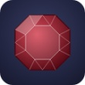 | Garnet  Red, Orange, Green, Purple, Brown | 1.730 -  1.890 | 3.57 -  4.30 | Isotropic | 7 | RI 1.770, SG 3.93, Isotropic | Garnet (90%) | Webster, Gems
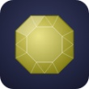 | Chrysoberyl  Yellow, Green, Brown | 1.740 -  1.760 | 3.70 -  3.78 | Biaxial | 8.5 | RI 1.750, SG 3.74, Biaxial | Chrysoberyl (95%) | GIA Gem Encyclopedia
 | Zircon  Red, Orange, Yellow, Green, Blue, Brown, Colourless | 1.810 -  1.990 | 4.60 -  4.80 | Uniaxial | 7.5 | RI over the limit, SG 4.70, Uniaxial | Zircon (77%) | Gemdat.org
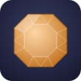 | Topaz  Pink, Orange, Yellow, Blue, Brown, Colourless | 1.606 -  1.644 | 3.49 -  3.57 | Biaxial | 8 | RI 1.625, SG 3.53, Biaxial | Topaz (95%) | GIA Gem Encyclopedia
 | Tourmaline  Red, Pink, Yellow, Green, Blue, Brown, Black | 1.614 -  1.666 | 3.00 -  3.26 | Uniaxial | 7.5 | RI 1.640, SG 3.13, Uniaxial | Tourmaline (90%) | GIA Gem Encyclopedia
 | Quartz  Pink, Yellow, Purple, Brown, Colourless | 1.540 -  1.558 | 2.60 -  2.70 | Uniaxial | 7 | RI 1.549, SG 2.65, Uniaxial | Quartz (90%) | Read, Gemmology
 | Feldspar  White, Colourless | 1.515 -  1.530 | 2.55 -  2.63 | Biaxial | 6 | RI 1.523, SG 2.59, Biaxial | Feldspar (90%) | Read, Gemmology
 | Beryl  Pink, Yellow, Green, Blue, Colourless | 1.564 -  1.602 | 2.63 -  2.92 | Uniaxial | 7.5 | RI 1.583, SG 2.78, Uniaxial | Beryl (90%) | Gemdat.org
 | Glass  Made in any colour | 1.440 -  1.770 | 2.20 -  4.50 | Isotropic | 5.5 | RI 1.605, SG 3.35, Isotropic, gas bubbles | Glass (85%) | International Gem Society
 | Cubic zirconia  Usually colourless; also dyed colours | 2.150 -  2.180 | 5.60 -  6.00 | Isotropic | 8.5 | RI over the limit, SG 5.80, Isotropic | Cubic zirconia (95%) | GIA Gem Encyclopedia
These values are for testing the system. Real stones vary; always rely on a certificate from the NGJA or an accredited laboratory for a purchase.

