CAMPUSCONNECT
Student Management System

INTERNSHIP TECHNICAL REPORT

Full Stack Development Internship

Technology Stack: Java Spring Boot 3 | Angular 19 | MySQL 8 | JWT Security
Version 1.0 | 2026

CHAPTER 1
1. KEY LEARNINGS

This chapter presents the key concepts, core principles, and technical knowledge acquired during the internship period. The learning journey covered full-stack software development principles, enterprise Java backend engineering with Spring Boot 3, RESTful API design, database management with MySQL and Hibernate ORM, client-side application development using Angular 19 Standalone Components, stateless authentication using JSON Web Tokens (JWT), Role-Based Access Control (RBAC), and version control using Git and GitHub.

1.1. FULL-STACK SOFTWARE ARCHITECTURE
Full-stack software development encompasses both client-side (frontend) and server-side (backend) application development. During the internship, I learned how modern enterprise applications decouple the presentation layer from business logic using a RESTful API architecture. The three-tier architecture consists of: (1) Presentation Layer — Angular 19 SPA with dynamic data binding and reactive forms. (2) Business Logic Layer — Spring Boot REST controllers, services, DTO mappers, and validation logic. (3) Data Layer — MySQL relational database accessed via Spring Data JPA and Hibernate.

1.2. ENTERPRISE JAVA & SPRING BOOT 3
Spring Boot is an open-source Java-based framework for creating production-ready web services. Key concepts learned include Dependency Injection, Spring Data JPA, Hibernate ORM, DTO pattern, Jakarta Bean Validation (@NotBlank, @Min, @PastOrPresent), and Global Exception Handling via @RestControllerAdvice. The backend base package is com.sms.backend running on Spring Boot 3.5.3 with Java 17 and Apache Tomcat 10.

1.3. RESTFUL API DESIGN & ARCHITECTURE
REST (Representational State Transfer) is an architectural style for networked applications. I designed stateless endpoints using HTTP GET (fetch), POST (create), PUT (update), and DELETE (remove). Standard HTTP status codes used: 200 OK, 201 Created, 400 Bad Request, 401 Unauthorized, 403 Forbidden, 404 Not Found, 409 Conflict. The backend exposes 40+ REST endpoints under /api/v1/.

1.4. ANGULAR 19 & STANDALONE COMPONENTS
Angular is a TypeScript-based SPA framework. I used Angular 19 Standalone Components (no NgModule). Key concepts: Client-Side Routing (app.routes.ts), Functional Guards (authGuard, adminGuard, studentGuard), HTTP Interceptors (authInterceptor for JWT Bearer headers), Reactive Forms with Validators, and RxJS BehaviorSubject for auth state management. Bootstrap 5 provides responsive grid, cards, modals, and table components.

1.5. MYSQL DATABASE & JPA ORM
MySQL 8 serves as the relational RDBMS. Spring Data JPA with Hibernate ORM maps Java entities to database tables. The abstract BaseEntity class provides createdAt and updatedAt audit timestamps via @PrePersist and @PreUpdate lifecycle hooks. Nine database tables: users, departments, faculties, students, courses, student_courses, attendance, marks, announcements.

1.6. SPRING SECURITY & JWT AUTHENTICATION
Security is enforced via Spring Security 6 with stateless JWT authentication. BCryptPasswordEncoder hashes all passwords before persistence. JwtService uses JJWT library to issue and validate HMAC-SHA256 signed tokens. JwtAuthenticationFilter intercepts all requests, validates the Bearer token, and sets the SecurityContext. RestAuthenticationEntryPoint returns JSON 401 responses. RestAccessDeniedHandler returns JSON 403 responses.

1.7. GIT & GITHUB VERSION CONTROL
Git and GitHub were used throughout the internship for code versioning, commit history management, and project collaboration. Key practices include branching strategies, meaningful commit messages, and maintaining a clean repository structure.

1.8. DEVELOPMENT TOOLS & ENVIRONMENT
Backend: Java 17 JDK, Maven 3.9.16, Spring Boot 3.5.3, MySQL 8. Frontend: Node.js, Angular CLI 19, TypeScript 5, Bootstrap 5. Tools: Postman for REST API testing, MySQL Workbench for database management, Git for version control, VS Code and IntelliJ IDEA as IDEs.

CHAPTER 2
2. PROJECTS

This chapter provides an exhaustive breakdown of the project development lifecycle carried out during the one-month internship. The learning progressed from environment setup and backend architecture design to entity mapping, REST API implementation, Spring Security integration, Angular UI construction, and final system deployment validation.

2.1. TASK ON FIRST WEEK
PROJECT INITIALIZATION & CORE BACKEND ARCHITECTURE

The first week focused on environment configuration, establishing the development stack, configuring the MySQL database, and building the foundational backend layer using Java Spring Boot 3. The Angular frontend project was also initialized with Bootstrap 5 integration. Key JPA entities were defined: User, Department, Faculty, Student, Course, Attendance, Marks, Announcement, and StudentCourse. The abstract BaseEntity was created to handle audit timestamps.

WHAT I LEARNED
- Spring Boot 3 Project Setup — Configured Maven pom.xml with Web, Security, JPA, MySQL, Lombok, and Validation dependencies.
- Database Configuration — Set up MySQL database campusconnect_db and configured spring.datasource properties.
- Entity Design — Created @MappedSuperclass BaseEntity with @PrePersist and @PreUpdate lifecycle hooks.
- Enum Design — Defined Role, Gender, ExamType, AttendanceStatus, EnrollmentStatus, AnnouncementTarget enums.
- JPA Relationships — Implemented @OneToOne, @ManyToOne, @OneToMany associations with FetchType.LAZY.
- Angular Initialization — Created Angular 19 Standalone Application with Bootstrap 5 and TypeScript models.

CONCLUSION
The first week established a complete understanding of project structure, database schema design, and Spring Boot JPA entity mapping. All domain entities were correctly mapped to MySQL tables with proper relational foreign keys.

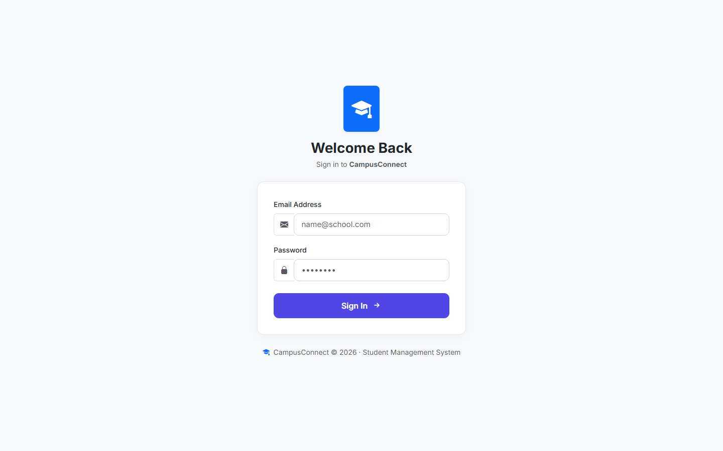
Figure 2.1: CampusConnect Login Page - Secure Authentication Interface

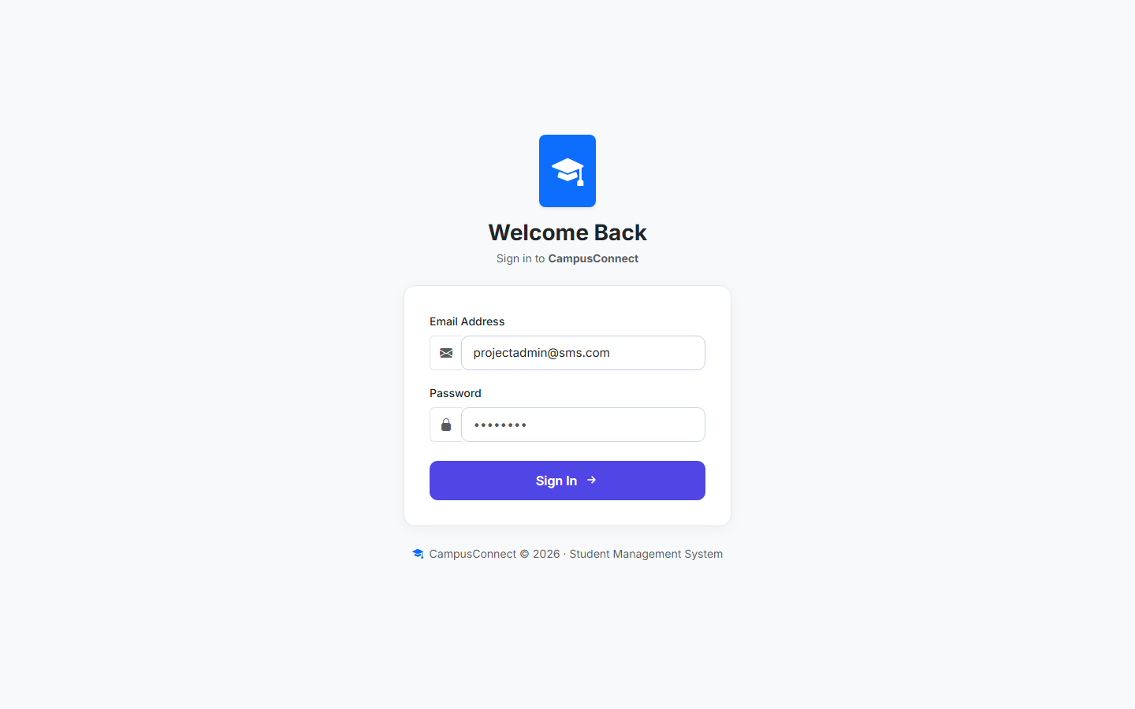
Figure 2.2: Login Form with Credentials - Email and Password Input

2.2. TASK ON SECOND WEEK
REPOSITORY, SERVICE & REST API IMPLEMENTATION

During the second week, I developed the complete backend service layer including Repository interfaces, Data Transfer Objects (DTOs), Mapper utility classes, Service implementations, REST Controllers, and Global Exception Handling. The CampusConnect backend now exposed fully functional CRUD APIs for all campus entities accessible via HTTP.

WHAT I LEARNED
- Repository Interfaces — Created JpaRepository interfaces with custom finder methods (findByEmail, findByRollNumber).
- DTO Pattern — Built separate request DTOs (with @Valid annotations) and response DTOs for each module.
- Mapper Classes — Implemented static mapper utilities (StudentMapper, FacultyMapper, CourseMapper, etc.).
- Service Layer — Implemented transactional @Service classes containing core business logic and duplicate-check rules.
- REST Controllers — Exposed /api/v1/* endpoints with proper HTTP method handlers and @Valid request validation.
- GlobalExceptionHandler — Created @RestControllerAdvice mapping ResourceNotFoundException (404), DuplicateResourceException (409), BadRequestException (400).
- Admin Dashboard UI — Built Angular admin pages for Departments, Faculty, Students, Courses with Bootstrap tables and modal dialogs.

CONCLUSION
The second week completed all fundamental CRUD APIs, robust backend validation, and the core Angular admin UI pages. The Admin role could now perform complete Create, Read, Update, Delete operations across all campus entities through the web interface.

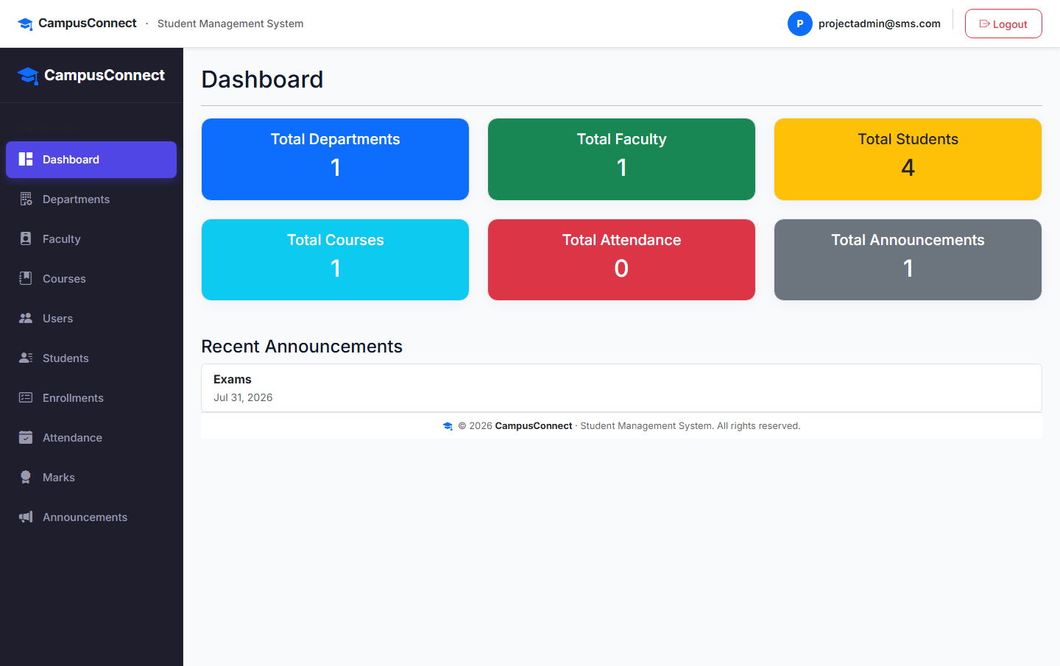
Figure 2.3: Admin Dashboard - Aggregate Statistics Overview

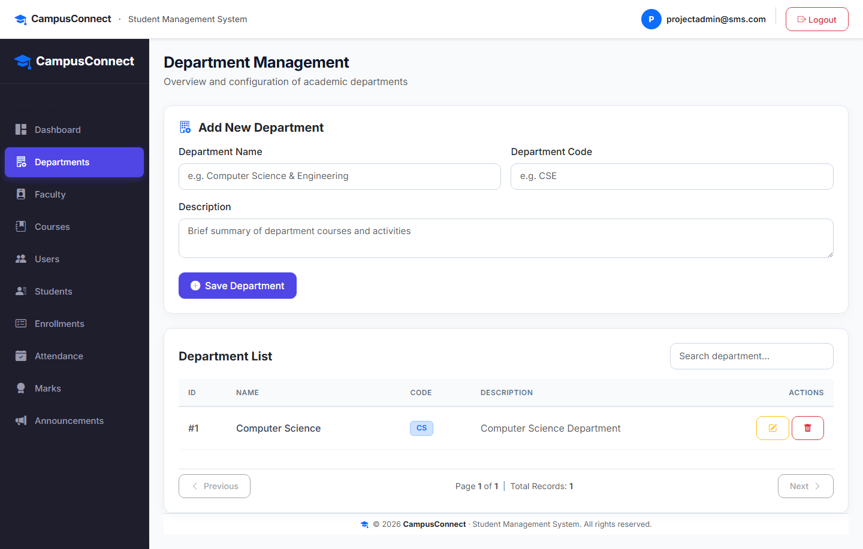
Figure 2.4: Department Management - CRUD Interface for Academic Departments

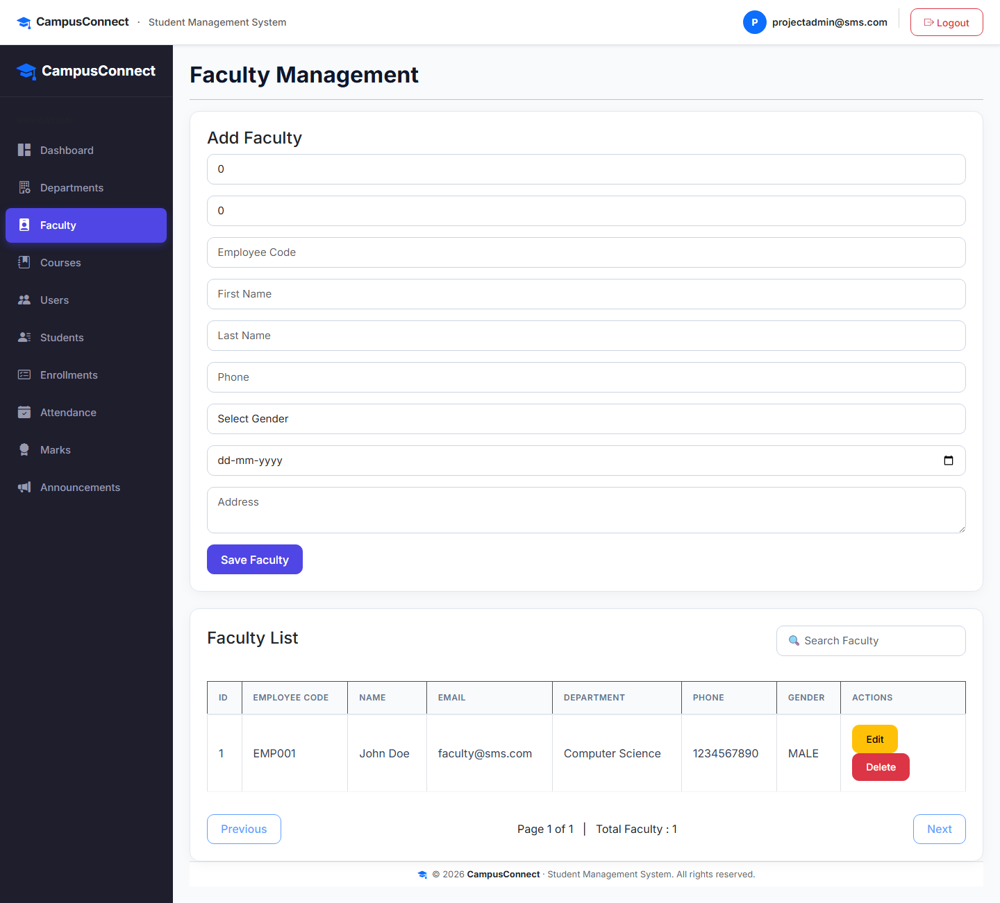
Figure 2.5: Faculty Management - Teaching Staff Records and Assignments

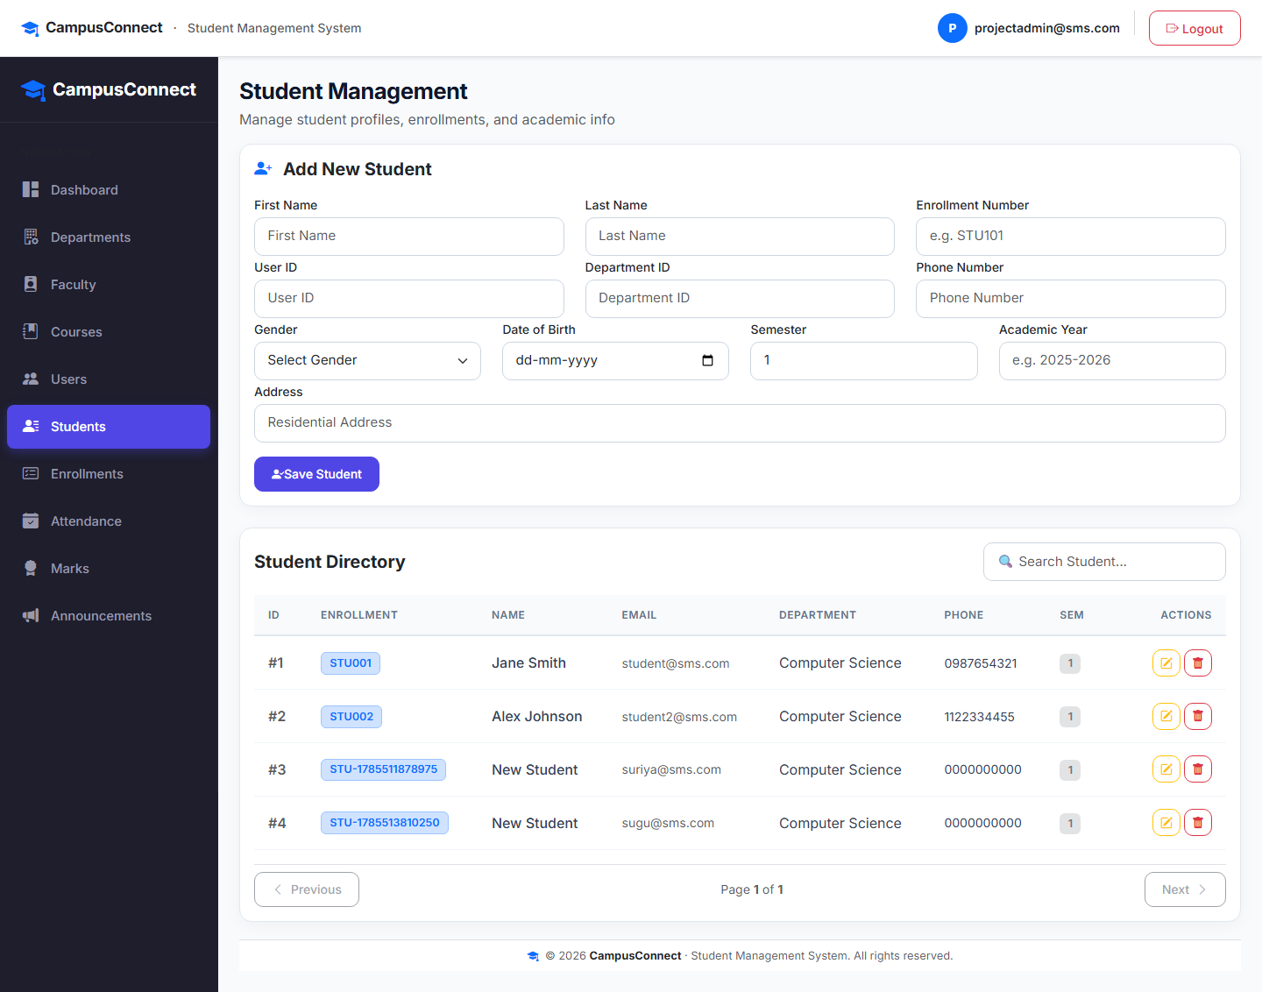
Figure 2.6: Student Management - Enrolled Student Directory and Profiles

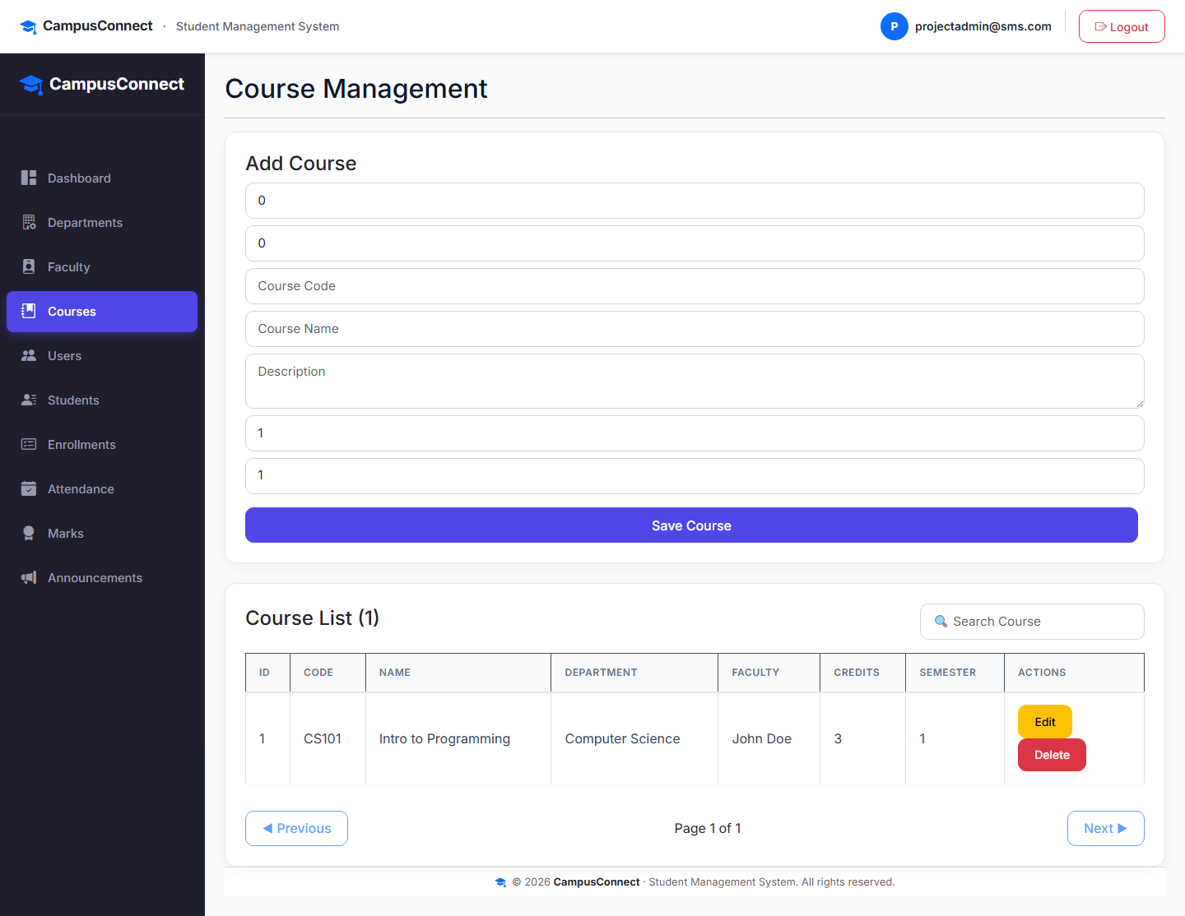
Figure 2.7: Course Management - Academic Course Catalog and Credit Details

2.3. TASK ON WEEK THREE
SPRING SECURITY, JWT AUTHENTICATION & RBAC

The third week focused on securing the entire backend API using Spring Security 6 with stateless JWT token authentication and Role-Based Access Control (RBAC). Three roles were enforced: ADMIN (full access), FACULTY (attendance/marks management), and STUDENT (self-service read-only access). Custom JSON 401/403 error handlers were implemented. The Angular frontend was integrated with authInterceptor and role-aware route guards.

WHAT I LEARNED
- JWT Service — Implemented JwtService using JJWT library for HMAC-SHA256 token generation, parsing, and expiry validation.
- Security Filter Chain — Configured SecurityConfig with stateless session, CORS for localhost:4200, and URL-level role matchers.
- JwtAuthenticationFilter — Built OncePerRequestFilter extracting Bearer token and setting SecurityContextHolder.
- Custom Error Handlers — RestAuthenticationEntryPoint (401 JSON) and RestAccessDeniedHandler (403 JSON).
- @PreAuthorize — Applied method-level security on Announcement mutations (ADMIN only).
- /me Endpoints — Added self-service endpoints (GET /api/v1/students/me, /attendance/me, /marks/me, /courses/me).
- Angular Guards — Implemented authGuard, guestGuard, adminGuard, facultyGuard, studentGuard as functional CanActivateFn.
- authInterceptor — Attaches Authorization: Bearer <token> to all outgoing HTTP requests and intercepts 401/403 responses.

CONCLUSION
The third week established a complete, production-grade security layer. All APIs were protected with role-based URL matchers and method-level annotations. Students could only access their own data via /me endpoints. JWT tokens controlled all authenticated sessions.

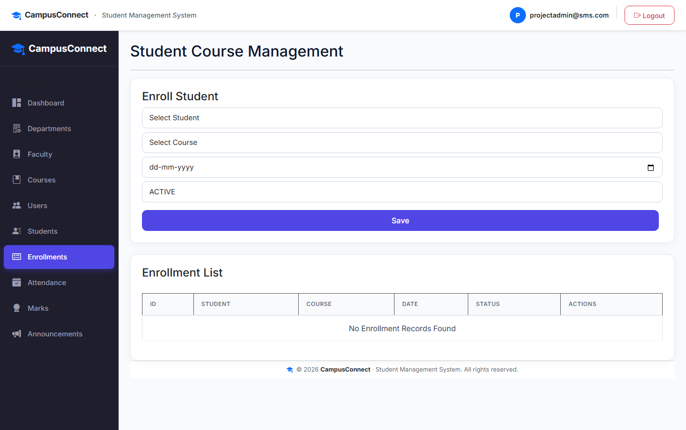
Figure 2.8: Student-Course Enrollment - Course Registration Management

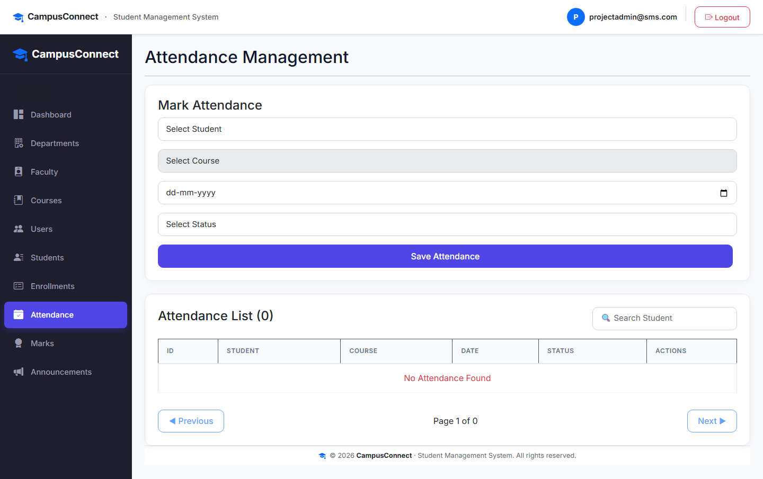
Figure 2.9: Attendance Management - Daily Attendance Logging Interface

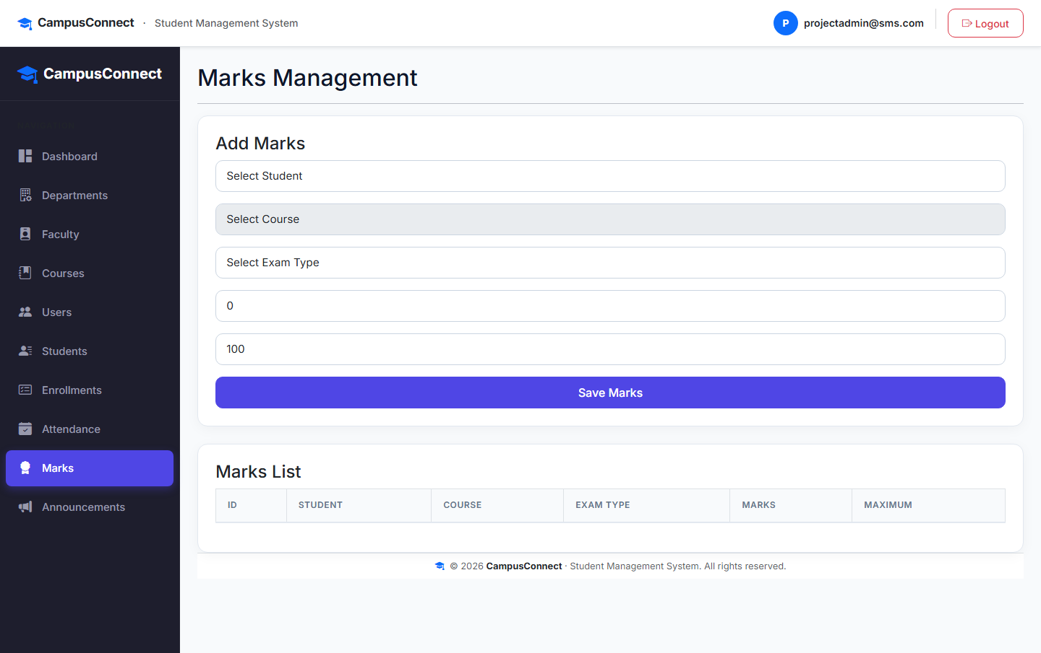
Figure 2.10: Marks Management - Examination Results Entry Interface

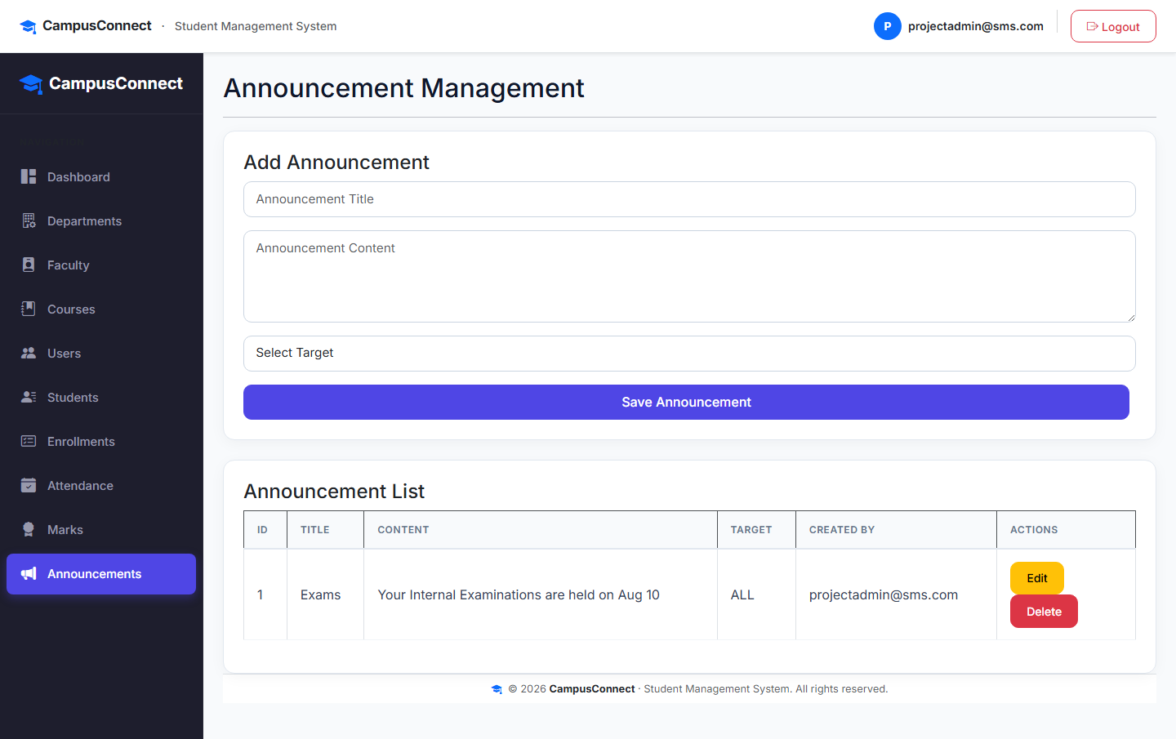
Figure 2.11: Announcement Board - System-wide Notice Broadcasting

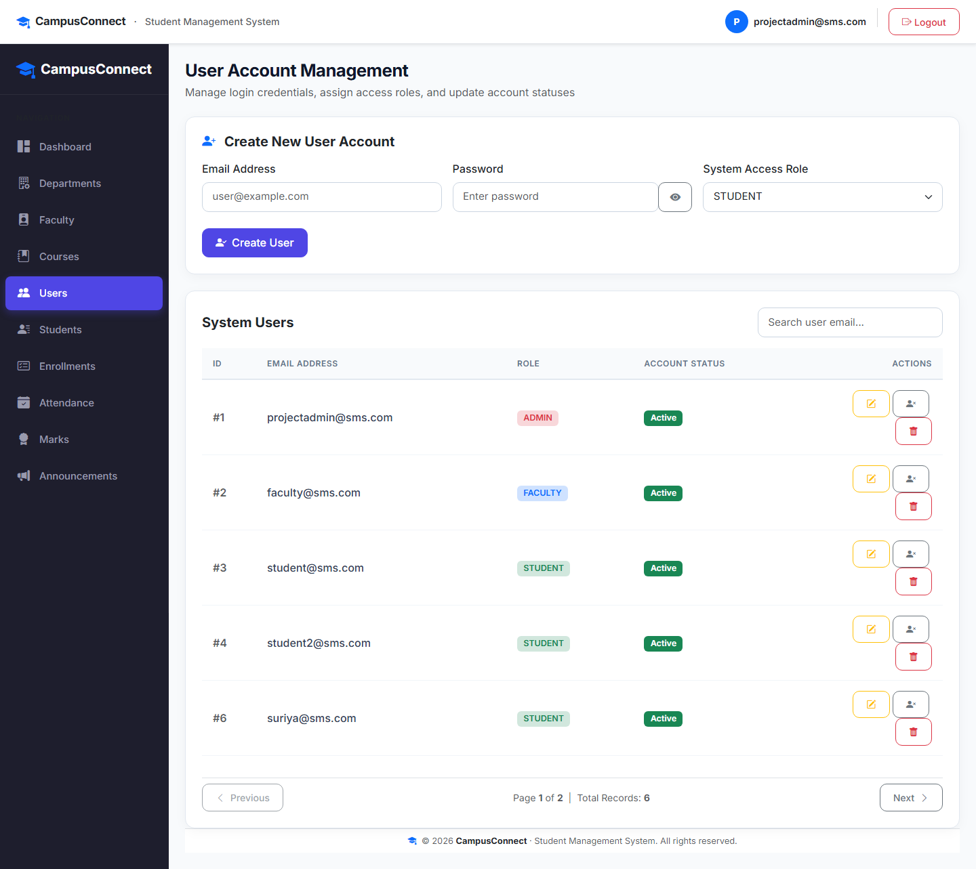
Figure 2.12: User Management - System User Accounts and Role Assignment

2.4. TASK ON WEEK FOUR
CAMPUSCONNECT COMPLETE SYSTEM — STUDENT PORTAL, DASHBOARDS & FINAL VALIDATION

In week four, I completed the full CampusConnect system by building the Student self-service portal, role-aware dashboards, sidebar navigation, and performing end-to-end validation across all three user roles. A DataSeeder class was implemented to automatically provision seed data (Admin, Faculty, Student accounts, Department, Course, and Enrollments) on application startup. Full backend mvn compile and frontend npm run build validations were completed.

WHAT I LEARNED
- Student Self-Service Portal — Built /student/profile, /student/courses, /student/attendance, /student/marks views.
- Role-Aware Dashboard — Dashboard dynamically renders different metric cards based on ADMIN, FACULTY, or STUDENT role.
- DataSeeder — Spring Boot CommandLineRunner seeds default admin@sms.com, faculty@sms.com, student@sms.com accounts.
- Sidebar Navigation — Role-filtered sidebar menus hide unauthorized sections from Faculty and Student roles.
- Form Validation — Added @Min(0), @AssertTrue marks <= maxMarks in MarksRequest; @PastOrPresent in AttendanceRequest.
- Frontend Route Guards — Fixed role guard redirects; registered student and faculty routes in app.routes.ts.
- End-to-End Testing — Validated all three roles login flow, CRUD operations, /me self-service views, and dashboard metrics.

Comparison: Existing System vs. Proposed CampusConnect System

Parameter | Existing (Manual / Legacy) | Proposed (CampusConnect)
Data Storage | Paper / Fragmented Excel | Centralized MySQL + JPA
Authentication | None / Physical Signatures | Stateless JWT + BCrypt
Access Control | Manual oversight | Role-Based Access Control (RBAC)
Data Consistency | Prone to duplicates & errors | Relational Integrity & JPA
Student Access | Notice board visits | Self-Service Web Portal (/me)
Dashboard Analytics | Manual term-end calculations | Real-time dynamic metrics
Scalability | Low / Labor intensive | High / Modular REST architecture
Table 2.1: Comparison between Existing and Proposed Systems

CONCLUSION
The fourth week completed the CampusConnect Version 1 system. All three user roles function correctly with appropriate data access boundaries. The complete backend and frontend compile and run without errors. The system is ready for institutional deployment.

Figure 2.13: Login Page - Role-Based Redirect After Logout

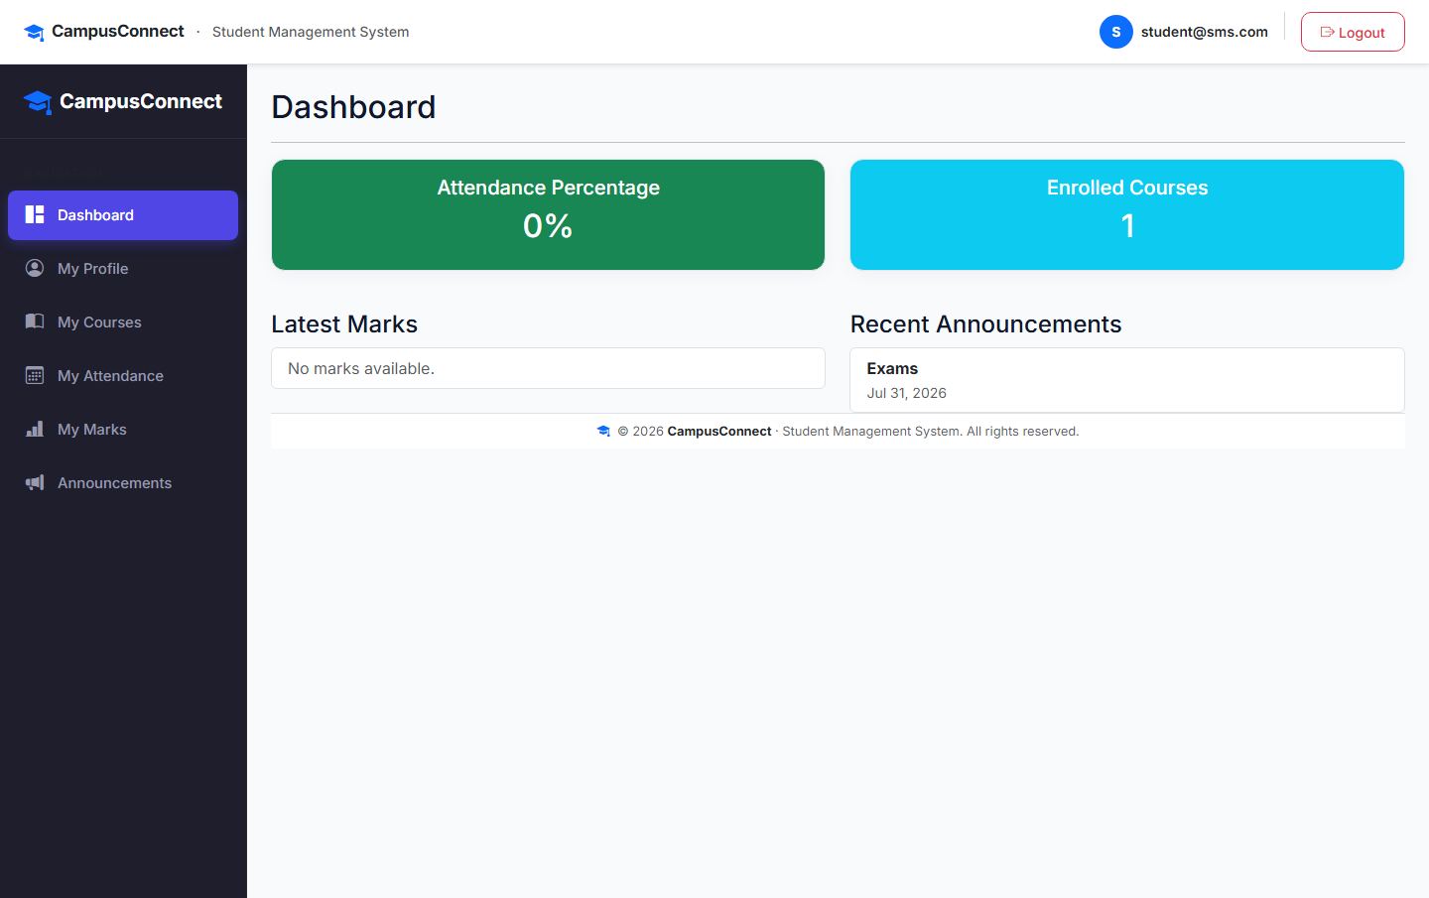
Figure 2.14: Student Dashboard - Personalized Academic Summary

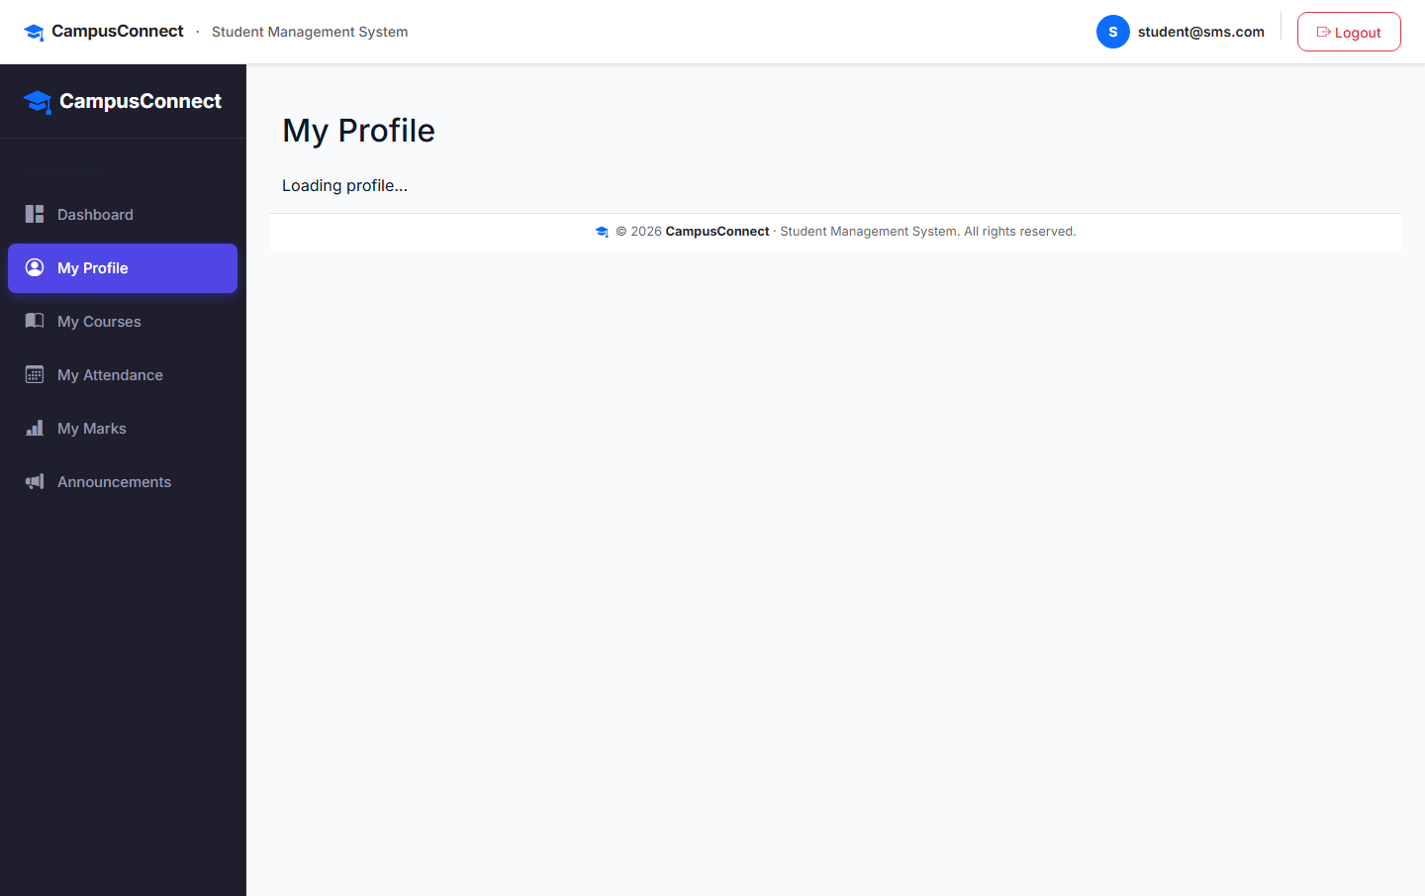
Figure 2.15: Student Profile - Self-Service Personal Information View

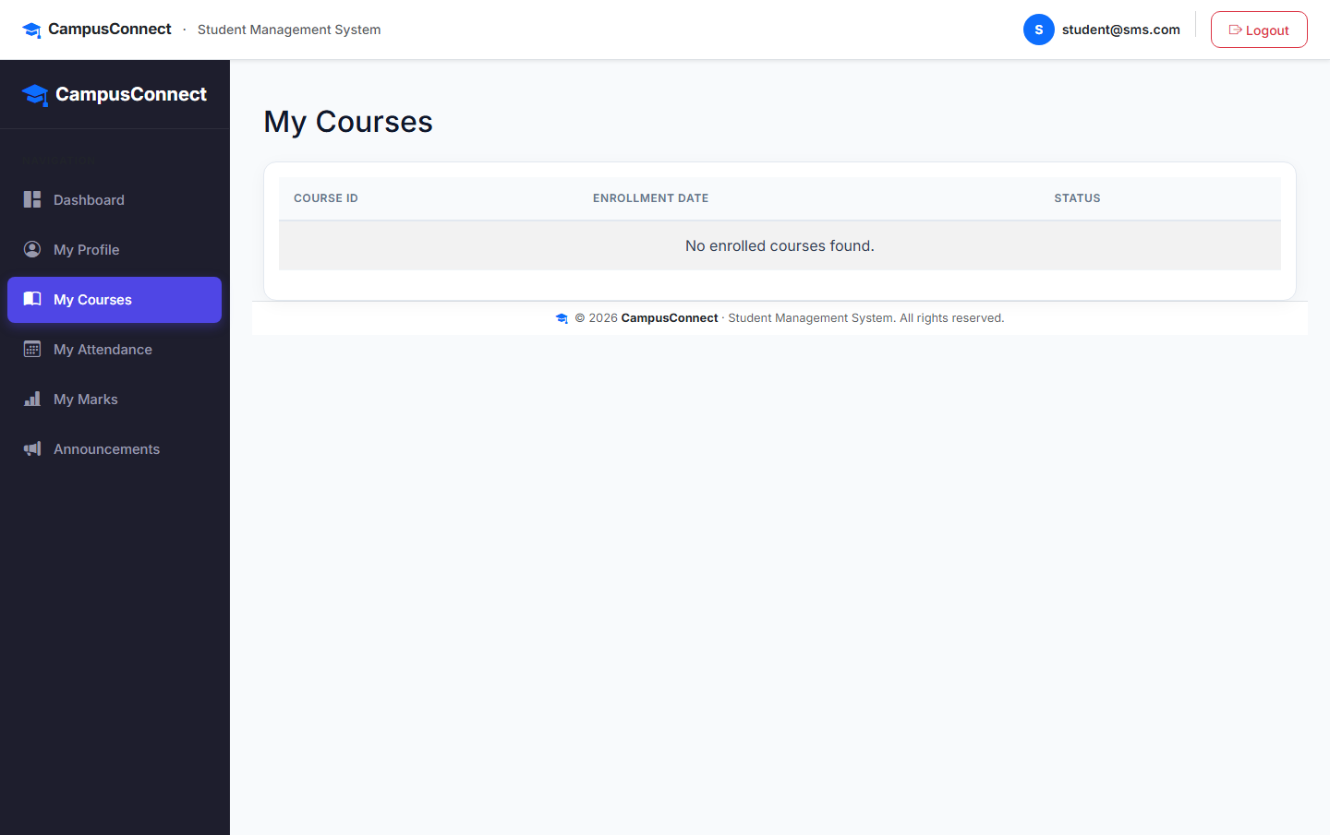
Figure 2.16: Student Enrolled Courses - Course Registration View

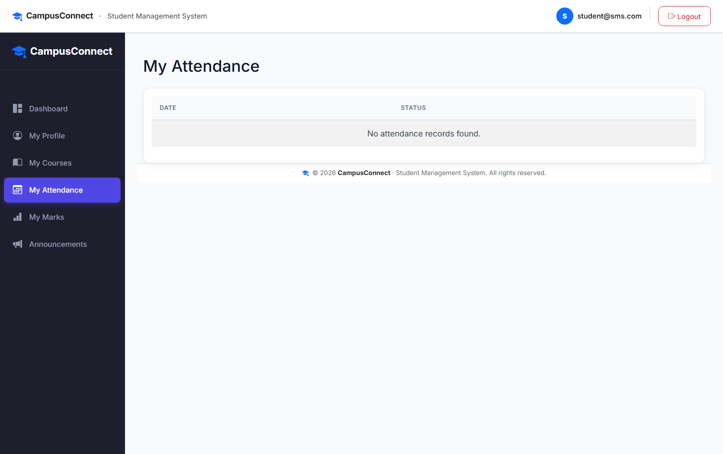
Figure 2.17: Student Attendance View - Personal Attendance History

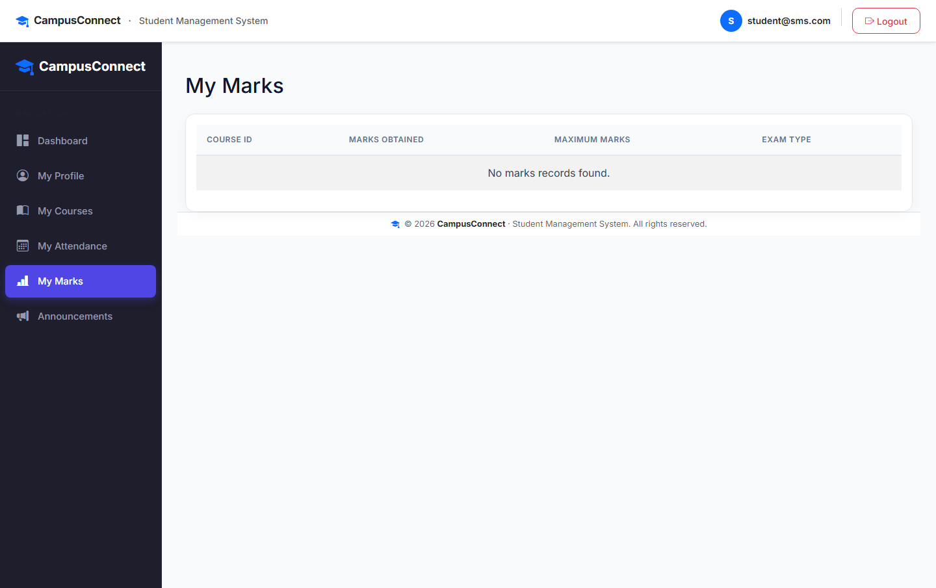
Figure 2.18: Student Marks View - Examination Results and Grades

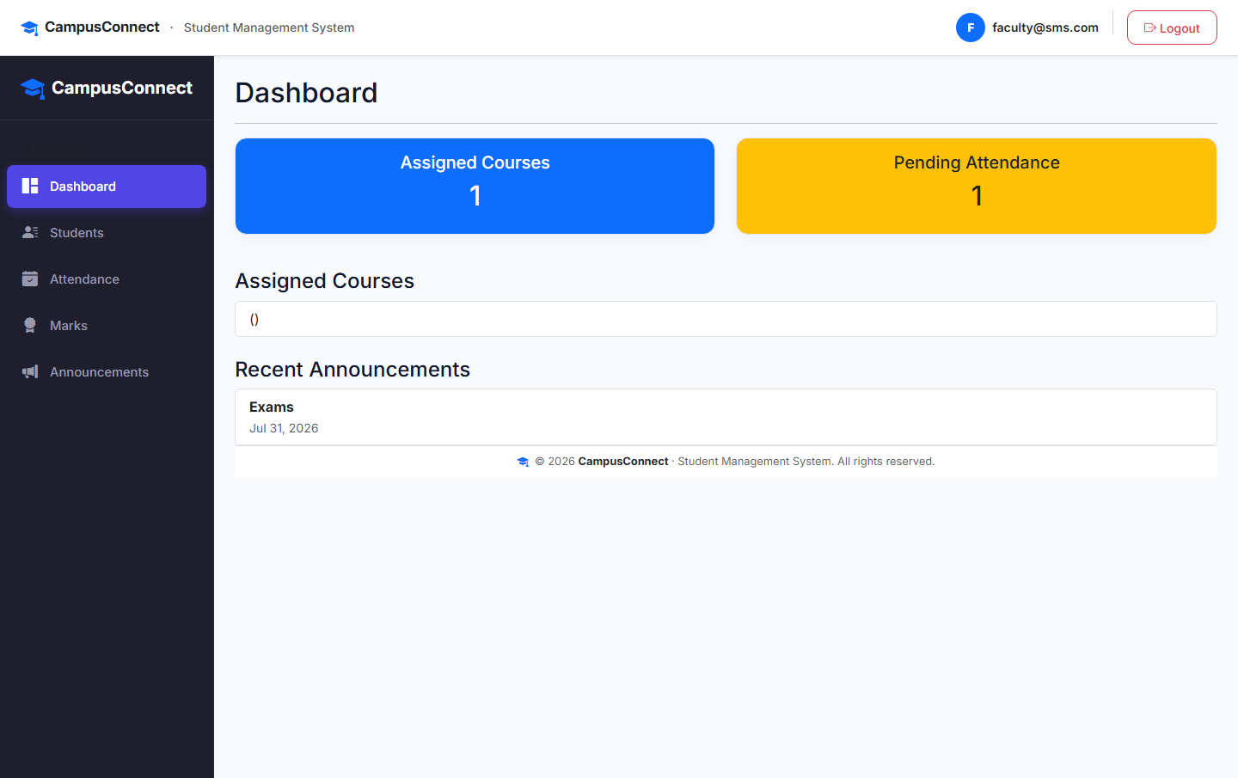
Figure 2.19: Faculty Dashboard - Assigned Courses and Teaching Overview

