CHAPTER 1

1. KEY LEARNINGS

This chapter presents the key concepts, core principles, and technical knowledge acquired during the internship period. The learning journey covered cybersecurity fundamentals, artificial intelligence, machine learning, static malware analysis, PE file structure, feature extraction, web application development using Flask, database management using SQLite, and version control using Git and GitHub.

1.1.CYBERSECURITY FUNDAMENTALS

Cybersecurity is the practice of protecting computer systems, networks, applications, and data from unauthorized access, attacks, damage, and theft. During the internship, I learned the fundamental concepts of cybersecurity and understood the importance of protecting digital systems against continuously evolving cyber threats.

The CIA Triad is one of the fundamental concepts of cybersecurity. Confidentiality – ensures that information is accessible only to authorized individuals or systems. Encryption and access control mechanisms are commonly used to maintain confidentiality.

Integrity – ensures that data remains accurate, consistent, and protected from unauthorized modification. Hashing and checksums are commonly used to verify data integrity.
Availability – ensures that authorized users can access systems and resources whenever required. Redundancy, backups, and fault-tolerant systems help maintain availability.
During the internship, I also learned about common types of malware, including viruses, worms, trojans, ransomware, spyware, adware, and rootkits. Understanding these malware categories helped establish the foundation for developing an automated malware detection system.

1.2.ARTIFICIAL INTELLIGENCE AND MACHINE LEARNING
Artificial Intelligence enables computer systems to perform tasks that normally require human intelligence, such as recognizing patterns, analyzing data, and making decisions.Machine Learning is a subset of Artificial Intelligence in which systems learn patterns from data and use the learned patterns to make predictions on new data.
In the malware detection project, supervised machine learning was used. The model was trained using labelled examples of benign and malicious files. After training, the model learned the structural and statistical patterns associated with different classes of executable files.The major benefits of applying machine learning to malware detection include:
Ability to identify previously unseen malware variants based on learned patterns.
Reduced dependence on manually created signatures.
Ability to analyze multiple file characteristics simultaneously.
Faster classification after model training.
Possibility of detecting patterns associated with zero-day malware.
I also learned that machine learning-based cybersecurity systems have limitations, including the requirement for high-quality labelled datasets, the risk of overfitting, adversarial evasion, computational requirements, and model interpretability challenges.

1.3. STATIC MALWARE ANALYSIS AND PE FILES
Static malware analysis is the process of examining a file without executing it. This approach is safer than executing unknown malware and can provide useful information about the internal structure of executable files.
Windows executable files commonly use the Portable Executable (PE) format. PE files include executable files such as .exe files and other related formats.
During the internship, I learned how the PEFile Python library can be used to parse PE files and extract useful structural information.
The extracted information includes:
PE header information
Number of sections
Code and data sizes
Address of entry point
Image base
Section entropy
Import information
Export information
Resource information
Characteristics and header flags
These features can be represented as numerical values and provided as input to a machine learning model for malware classification.

1.4. PYTHON PROGRAMMING
Python is a high-level programming language known for its readability and extensive library ecosystem. During the internship, Python was used as the primary programming language for machine learning, PE file analysis, backend development, database integration, and application development.
The project used several Python libraries, including:
NumPy – numerical operations and feature processing
Pandas – dataset organization and data manipulation
Scikit-learn – machine learning model development and evaluation
PEFile – Portable Executable file parsing
Joblib – serialization and loading of the trained machine learning model
Flask – web application development
Matplotlib – visualization and evaluation plots
Seaborn – statistical visualization

1.5. MACHINE LEARNING MODEL DEVELOPMENT
During the internship, I gained practical experience in developing and evaluating machine learning classification models.
The following algorithms were implemented and compared:
Random Forest
Decision Tree
Support Vector Machine (SVM)
The dataset was divided into training and testing portions using an 80:20 stratified split.
The models were evaluated using accuracy, precision, recall, F1-score, ROC-AUC, and confusion matrices.
Among the evaluated algorithms, Random Forest provided the best overall performance and was selected as the primary production classifier.
The Random Forest model achieved:
Accuracy – 97.23%
Precision – 97.46%
Recall – 97.00%
F1-score – 97.23%
ROC-AUC – 0.991
1.6. FLASK WEB FRAMEWORK
Flask is a lightweight Python web framework used to develop web applications.
In the project, Flask was used to connect the trained machine learning model with the web interface. The application provides pages for file uploading, prediction results, and scan history.
The main workflow of the Flask application is:
User opens the web application.
User uploads a Windows executable file.
The uploaded file is validated.
PE features are extracted using PEFile.
The extracted features are passed to the trained Random Forest model.
The model predicts whether the file is Benign or Malware.
The confidence score is calculated.
The result is displayed to the user.
The scan information is stored in SQLite.

1.7. SQLITE DATABASE MANAGEMENT
SQLite is a lightweight, serverless, file-based relational database system.
SQLite was used in the project to store scan history. The database maintains information such as:
Filename
Prediction
Confidence score
Scan timestamp
The stored records can be retrieved and displayed on the history page of the Flask application. This provided practical experience in connecting a web application with a database and implementing data persistence.

1.8. GIT AND GITHUB
Git is a distributed version control system used to track changes during software development. GitHub provides remote repository hosting and collaboration features.
During the internship, Git and GitHub were used for:
Repository management
Tracking project changes
Creating commits
Maintaining project versions
Managing source code
Collaborating and sharing project files
Using Git and GitHub helped improve the development workflow and provided experience with industry-standard version control practices.

1.9.JUPYTER NOTEBOOK AND DEVELOPMENT TOOLS
Jupyter Notebook was used for interactive data analysis, feature exploration, model training, and experimentation.
Visual Studio Code was used as the primary development environment for developing and debugging the Flask web application.
The major development tools used during the project were:
Jupyter Notebook
Visual Studio Code
Git
GitHub
Python
Flask
SQLite

CHAPTER 2

2. PROJECTS
This chapter provides a detailed overview of the projects and tasks carried out during the internship. The learning process progressed from understanding Python and cybersecurity fundamentals to machine learning, PE file analysis, and finally the development of the complete SHILD-AI malware detection web application.

2.1. TASK ON FIRST WEEK

PYTHON PROGRAMMING AND CYBERSECURITY FUNDAMENTALS
The first week of the internship focused on strengthening programming fundamentals using Python and understanding the basic concepts of cybersecurity.
Python was selected as the primary programming language because of its simplicity and extensive ecosystem for machine learning, data analysis, cybersecurity, and web development.
During this stage, I learned the fundamentals of Python programming and explored basic cybersecurity concepts such as threats, vulnerabilities, malware, confidentiality, integrity, and availability.

WHAT I LEARNED
Python Programming Fundamentals – I learned Python syntax, variables, data types, operators, conditional statements, loops, functions, lists, tuples, dictionaries, and basic file handling.
Data Handling – I learned how to organize and process data using Python data structures and libraries such as NumPy and Pandas.
Cybersecurity Fundamentals – I learned about the CIA Triad and the importance of confidentiality, integrity, and availability in cybersecurity.
Malware Classification – I studied different types of malware, including viruses, worms, trojans, ransomware, spyware, adware, and rootkits.
Static and Dynamic Analysis – I learned the difference between static analysis, where files are examined without execution, and dynamic analysis, where suspicious files are observed while running in a controlled environment.

CONCLUSION
The first week provided a strong foundation in Python programming and cybersecurity. The concepts learned during this stage were useful for understanding the later stages of machine learning-based malware detection.

2.2. TASK ON SECOND WEEK

MACHINE LEARNING AND DATASET PREPARATION FOR MALWARE DETECTION
During the second week of the internship, I focused on machine learning concepts and their application in cybersecurity. The main objective was to understand how machine learning models can learn patterns from benign and malicious executable files.
The training data combined the EMBER dataset with supplementary Kaggle PE samples. The dataset contained approximately 15,000 files, with 7,500 benign samples and 7,500 malware samples.
WHAT I LEARNED

Dataset Collection – I learned how labelled datasets can be used to train supervised machine learning models for classification tasks.
Data Cleaning – Rows containing excessive missing values were removed, while minor missing values were handled using median-based imputation.
Feature Engineering – I learned how relevant features can be selected based on their ability to distinguish between benign and malicious samples.
Train-Test Splitting – The dataset was divided using an 80:20 stratified split, ensuring that both classes were appropriately represented in the training and testing datasets.
Machine Learning Algorithms – I learned and implemented Random Forest,
Decision Tree, and Support Vector Machine algorithms for malware classification.
Model Evaluation – The models were evaluated using accuracy, precision, recall, F1-score, ROC-AUC, and confusion matrices.

CONCLUSION
The second week provided practical experience in preparing datasets and developing machine learning classification models. The comparison of multiple algorithms helped identify Random Forest as the most suitable model for the proposed malware detection system.

2.3. TASK ON WEEK THREE

PE FILE FEATURE EXTRACTION AND MALWARE CLASSIFICATION
During the third week of the internship, I worked on static analysis of Windows Portable Executable files. The primary objective was to extract meaningful structural and statistical features from executable files without executing them.
The PEFile Python library was used to parse PE files and obtain information from different parts of the executable structure.

WHAT I LEARNED
PE File Structure – I learned about the Portable Executable format used by Windows executable files.
Feature Extraction – I learned to extract features such as the number of sections, code size, entry point, import information, export information, and section entropy.
Section Entropy – Section entropy was used as an important statistical feature. Higher entropy can be associated with packing or encryption and may provide useful information for malware classification.
Feature Vector Creation – The extracted PE attributes were converted into numerical feature vectors suitable for machine learning models.
Model Integration – The extracted feature vector was passed to the trained machine learning model to obtain a Benign or Malware classification.
Model Serialization – The best-performing model was saved using Joblib so that it could later be loaded into the Flask web application.

CONCLUSION
The third week helped me understand the connection between cybersecurity and machine learning. I gained practical knowledge of PE file structures, static feature extraction, feature engineering, model prediction, and model serialization.

2.4.TASK ON WEEK FOUR
SHILD-AI Based Malware Detection Using Flask Framework
INTRODUCTION
In week four , I started to build our own project in our cybersecurity domain. The AI Based Malware Detection System is a full-stack web application combining static malware analysis with supervised machine learning to classify Windows executables as Benign or Malware. It has three major components: a feature-extraction pipeline that parses the PE structure of an uploaded file, a trained Random Forest classifier that performs the prediction, and a Flask web application that handles the interface, upload workflow and result persistence. Unlike signature-based tools, it relies entirely on structural and statistical characteristics of the PE header (imports, section entropy, size, header flags), executing the full pipeline — upload to prediction and history logging — in seconds. The interface uses a dark, cybersecurity-themed, fully responsive design, with all scans logged to an SQLite history database.
Objectives
Design a machine learning system to classify PE files as Benign or Malware.
Implement static feature extraction using PEFile (headers, sections, import/export tables).
Train, evaluate and compare Random Forest, Decision Tree and SVM classifiers.
Maximize accuracy while minimizing false positives.
Build a Flask web app for upload and real-time prediction, with an SQLite scan history.
Create a responsive, cybersecurity-themed UI, and evaluate models on accuracy, precision, recall, F1 and ROC-AUC.
Document the full development lifecycle and identify directions for future enhancement.

Existing System
Traditional antivirus software matches a file's hash or byte pattern against a database of known malware signatures — fast, cheap and low false-positive for known threats, but with key limitations:
Cannot detect zero-day malware until a vendor analyzes and catalogues a sample.
Evaded by polymorphic/metamorphic malware that alters its own signature.
Requires frequent database updates and constant connectivity.
Signature databases become unwieldy to search as they grow into the hundreds of millions.
Purely reactive — detection only follows prior identification of a threat.

Proposed SystemThe proposed system replaces exact signature matching with a classifier trained on structural/statistical PE features (section entropy, import anomalies, header metadata), learning generalizable patterns rather than exact matches. It detects unseen variants without connectivity, returns a confidence score for transparency, keeps a searchable scan history, and is built entirely from open-

source tools.
Parameter | Existing (Signature-Based) | Proposed (AI-Based)
Detection Basis | Exact hash/signature match | Statistical/structural patterns
Zero-Day Detection | Not possible | Possible via generalization
Updates | Frequent signature updates | Periodic model retraining
Polymorphic Malware | Easily evaded | More resilient
Transparency | Binary match/no match | Confidence score provided
Table 2.1: Comparison between Existing and Proposed Systems

System Architecture
The pipeline flows linearly: the user accesses the web app → uploads an .exe file → features are extracted via PEFile (headers, sections, imports, entropy) → preprocessed (scaling/encoding) → passed to the trained Random Forest model → a Benign/Malware prediction with confidence score is returned → displayed to the user → and stored in the SQLite history table.
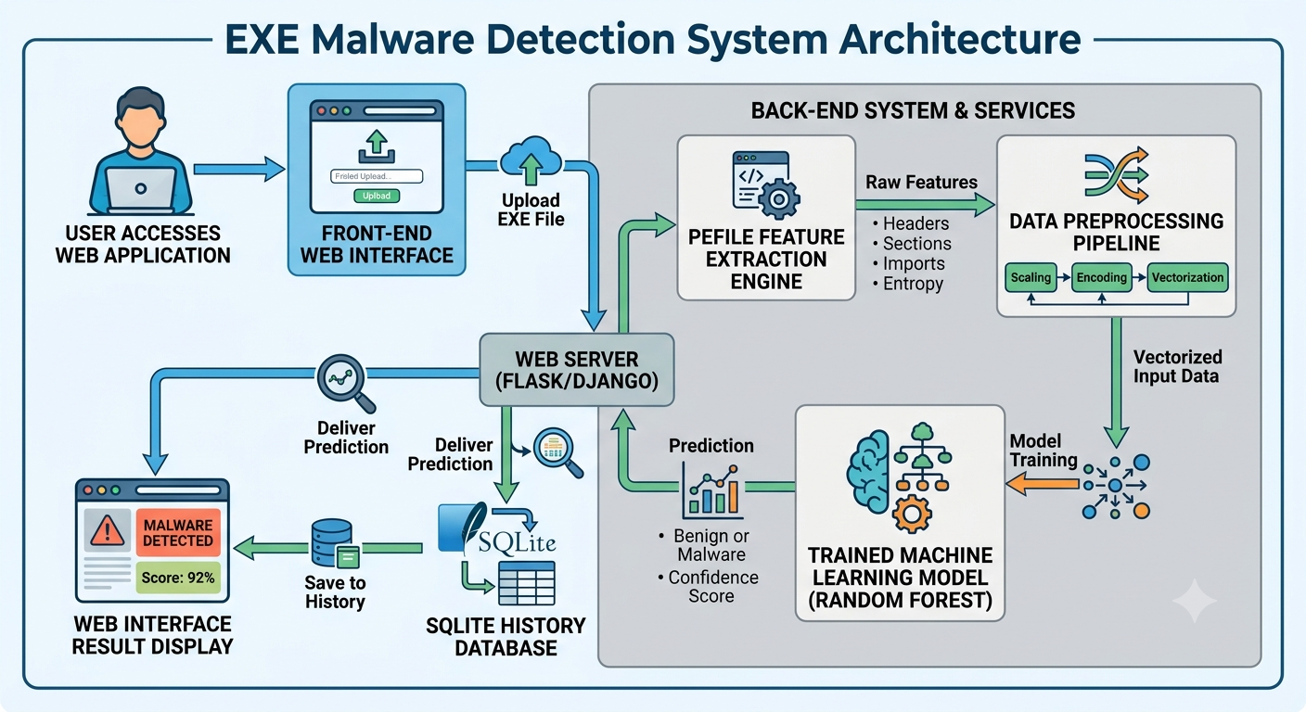

Figure 2.1: System Architecture / Workflow Diagram

Module Descriptions
User Interface – HTML5/CSS3/Jinja2 pages for home, upload, results and history.
File Upload – validates and safely stores uploaded files (Flask request.files, secure_filename).
Feature Extraction – parses PE structure with PEFile (headers, sections, imports/exports).
Preprocessing – converts raw features into the numerical vector expected by the model.
Prediction – loads model.pkl via Joblib and returns class + confidence.
Database – SQLite3 persists filename, prediction, confidence and timestamp for the history page.

Methodology
Data Collection – EMBER dataset plus supplementary Kaggle PE samples, pre-labelled benign/malicious.
Data Cleaning – removed rows with excessive missing values; imputed minor gaps with medians.
Feature Engineering – selected discriminative header/section attributes; dropped correlated or low-variance ones.
Model Training – 80:20 stratified split; Random Forest, Decision Tree and SVM trained via Scikit-learn with grid-search tuning.
Model Testing – evaluated with accuracy, precision, recall, F1 and ROC-AUC; confusion matrix per model
Model Saving – best model (Random Forest) serialized with Joblib alongside its feature-column order.Flask Integration – model loaded once at startup; routes handle upload, prediction and history.
Deployment – run locally via Flask's dev server, portable to Gunicorn/Docker for production.

TOOLS AND TECHNOLOGIES USED

Python
Python, created by Guido van Rossum (1991), is a high-level, readable, dynamically typed language with an extensive package ecosystem, making it the natural choice here thanks to its mature ML stack (Scikit-learn, Pandas, NumPy), native PE parsing (PEFile) and lightweight web framework (Flask).

Flask Framework

Flask is a lightweight WSGI micro-framework that provides only the essentials, leaving other choices (ORM, auth) to the developer — well suited to a project of this size. It follows an MVC-like pattern: routes act as controllers, Jinja2 templates as views. Routes are bound to URL paths via decorators for the home page, upload/prediction endpoint and history page (GET/POST as appropriate), with Jinja2 rendering dynamic content using {{ }} / {% %} syntax.

SQLite
SQLite is a lightweight, serverless, file-based database included in Python's standard library, chosen for its zero-configuration setup. It stores a single scan_history table (filename, prediction, confidence, timestamp).

PEFile
PEFile parses the Portable Executable format used by Windows .exe/.dll/.sys files, exposing the DOS header, NT headers, section table, and import/export/resource directories — the raw source of every feature used for classification.

Pandas, NumPy, Matplotlib and Seaborn
Pandas' DataFrame structure organizes extracted features and prepares training data; NumPy provides the underlying numerical operations. Matplotlib and Seaborn were used during model development to generate confusion matrices, ROC curves and correlation heatmaps.

Output Analysis

Login Page
Provides secure user authentication, allowing authorized users to access the AI-Based Malware Detection System with a modern cybersecurity-themed interface
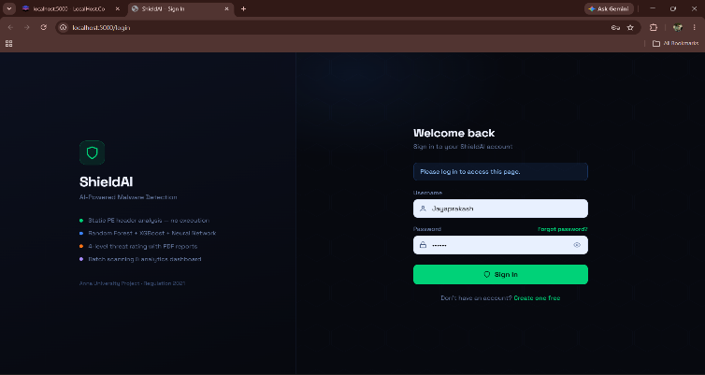

Figure 2.1: Login page of the Application

Home Page
Introduces the application and links to the upload and history pages, with a dark, cybersecurity-themed design.

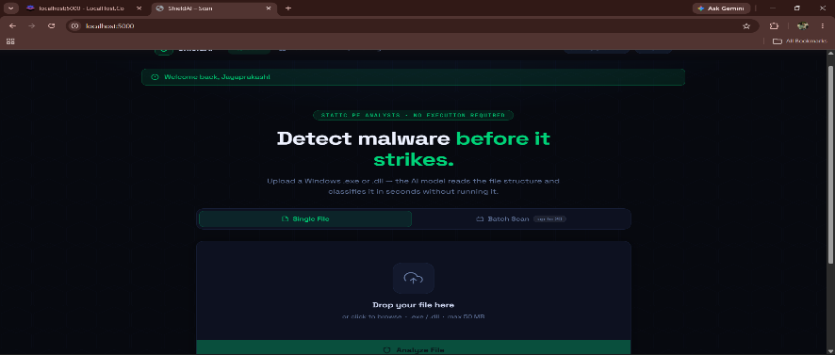
Figure 2.2: Home Page of the Application

Upload Page

Lets the user select and submit a .exe file, with client-side validation and a loading indicator during analysis.
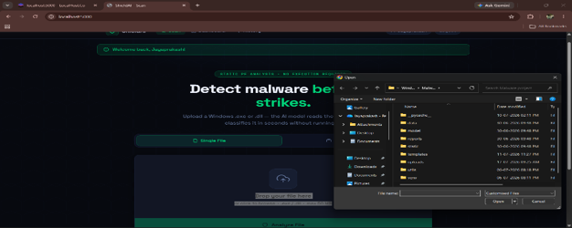

Figure 2.3: File Upload Interface

Prediction Page
Displays the classification, confidence percentage and key extracted features, color-coded green (benign) or red (malicious).

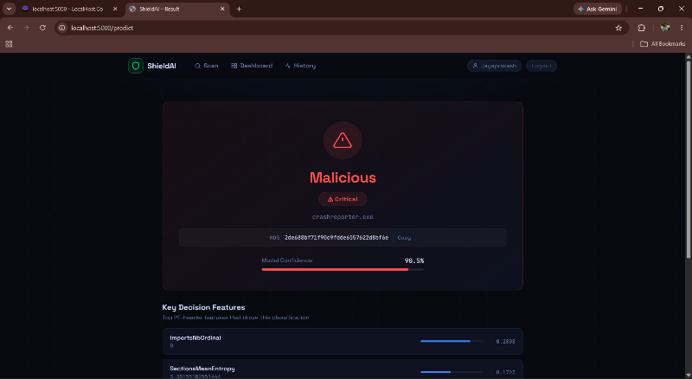

Figure 2.4: Prediction Result Page

History Page
Lists all past scans — filename, prediction, confidence, timestamp — pulled from SQLite.

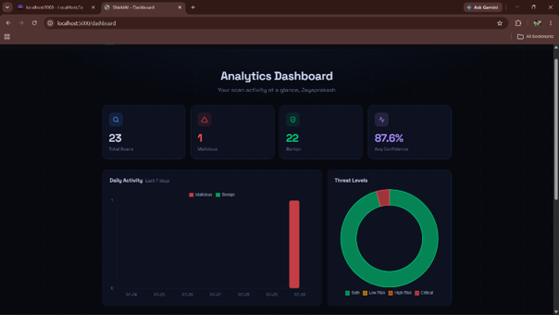
Figure 2.5: Scan History Page
Dashboard page
Provides an overview of the AI-Based Malware Detection System, displaying key features, scan statistics, and quick access to the upload and scan history pages through a modern, cybersecurity-themed dashboard.
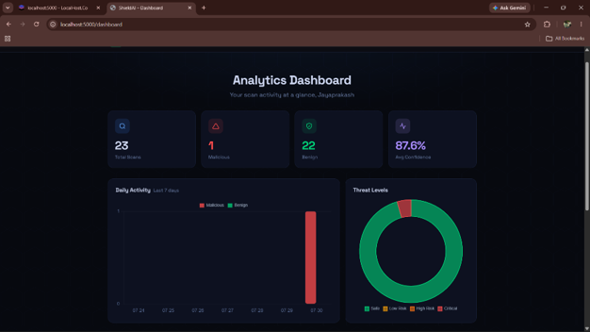
Figure 2.5: Dashboard Page

Conclusion
This chapter described the system's objectives, its comparison with traditional signature-based antivirus systems, its architecture, module design, and methodology. The SHILD-AI system provides a machine learning-based approach for detecting potentially malicious Windows Portable Executable (PE) files through static analysis. The system uses PE file features extracted using the PEFile library and classifies files as Benign or Malware using machine learning techniques. The Random Forest model demonstrated effective performance and was integrated with a Flask-based web application to provide a simple and user-friendly malware detection interface. The application also stores scan results using SQLite, allowing users to review previous detection activities. Overall, the project demonstrates how Artificial Intelligence, Machine Learning, Cybersecurity, and Web Application Development can be combined to build an effective malware detection solution.

