HR Analytics - Amazon and Google Reviews

Suyash Tiwari

01/13/18

Table of Contents

#Text Mining Case Study:  
#----Loading all Required Packages---------------------------------  
library("qdap")

## Warning: package 'qdap' was built under R version 3.4.3

## Loading required package: qdapDictionaries

## Loading required package: qdapRegex

## Warning: package 'qdapRegex' was built under R version 3.4.3

## Loading required package: qdapTools

## Warning: package 'qdapTools' was built under R version 3.4.3

## Loading required package: RColorBrewer

##   
## Attaching package: 'qdap'

## The following object is masked from 'package:base':  
##   
## Filter

library("tm")

## Warning: package 'tm' was built under R version 3.4.3

## Loading required package: NLP

##   
## Attaching package: 'NLP'

## The following object is masked from 'package:qdap':  
##   
## ngrams

##   
## Attaching package: 'tm'

## The following objects are masked from 'package:qdap':  
##   
## as.DocumentTermMatrix, as.TermDocumentMatrix

library("wordcloud")

## Warning: package 'wordcloud' was built under R version 3.4.3

library("dendextend")

## Warning: package 'dendextend' was built under R version 3.4.3

##   
## ---------------------  
## Welcome to dendextend version 1.6.0  
## Type citation('dendextend') for how to cite the package.  
##   
## Type browseVignettes(package = 'dendextend') for the package vignette.  
## The github page is: https://github.com/talgalili/dendextend/  
##   
## Suggestions and bug-reports can be submitted at: https://github.com/talgalili/dendextend/issues  
## Or contact: <tal.galili@gmail.com>  
##   
## To suppress this message use: suppressPackageStartupMessages(library(dendextend))  
## ---------------------

##   
## Attaching package: 'dendextend'

## The following object is masked from 'package:qdap':  
##   
## %>%

## The following object is masked from 'package:stats':  
##   
## cutree

library("RColorBrewer")  
library("plotrix")

## Warning: package 'plotrix' was built under R version 3.4.3

library("RWeka")

## Warning: package 'RWeka' was built under R version 3.4.3

library("readr")

## Warning: package 'readr' was built under R version 3.4.2

#------1. Load readr package and Read csv files of Amazon and Google  
  
amzn <- read_csv("C:/Users/suyas/Downloads/TwitteR/Datacamp/Text Mining/Amazon.csv")

## Parsed with column specification:  
## cols(  
## pg_num = col_integer(),  
## url = col_character(),  
## pros = col_character(),  
## cons = col_character()  
## )

goog <- read_csv("C:/Users/suyas/Downloads/TwitteR/Datacamp/Text Mining/google.csv")

## Parsed with column specification:  
## cols(  
## pg_num = col_integer(),  
## url = col_character(),  
## pros = col_character(),  
## cons = col_character()  
## )

head(goog)

## # A tibble: 6 x 4  
## pg_num url  
## <int> <chr>  
## 1 1 https://www.glassdoor.com/Reviews/Google-Reviews-E9079_P1.htm  
## 2 1 https://www.glassdoor.com/Reviews/Google-Reviews-E9079_P1.htm  
## 3 1 https://www.glassdoor.com/Reviews/Google-Reviews-E9079_P1.htm  
## 4 1 https://www.glassdoor.com/Reviews/Google-Reviews-E9079_P1.htm  
## 5 1 https://www.glassdoor.com/Reviews/Google-Reviews-E9079_P1.htm  
## 6 1 https://www.glassdoor.com/Reviews/Google-Reviews-E9079_P1.htm  
## # ... with 2 more variables: pros <chr>, cons <chr>

#-----2. Examine the text sources-------  
# Print the structure of amzn  
str(amzn)

## Classes 'tbl_df', 'tbl' and 'data.frame': 500 obs. of 4 variables:  
## $ pg_num: int 50 50 50 50 50 50 50 50 50 50 ...  
## $ url : chr "https://www.glassdoor.com/Reviews/Amazon-com-Reviews-E6036_P50.htm" "https://www.glassdoor.com/Reviews/Amazon-com-Reviews-E6036_P50.htm" "https://www.glassdoor.com/Reviews/Amazon-com-Reviews-E6036_P50.htm" "https://www.glassdoor.com/Reviews/Amazon-com-Reviews-E6036_P50.htm" ...  
## $ pros : chr "You're surrounded by smart people and the projects are interesting, if a little daunting." "Brand name is great. Have yet to meet somebody who is unfamiliar with Amazon. Hours weren't as bad as I had pre"| __truncated__ "Good money.Interaction with some great minds in the world during internal conferences and sessions.Of course th"| __truncated__ "nice pay and overtime and different shifts" ...  
## $ cons : chr "Internal tools proliferation has created a mess for trying to get to basic information. Most people are require"| __truncated__ "not the most stimulating work. Good brand name to work for but the work itself is mundane as it can get. As a f"| __truncated__ "No proper growth plan for employees.Difficult promotion process requiring a lot more documentation than your ac"| __truncated__ "didn't last quite long enough" ...  
## - attr(*, "spec")=List of 2  
## ..$ cols :List of 4  
## .. ..$ pg_num: list()  
## .. .. ..- attr(*, "class")= chr "collector_integer" "collector"  
## .. ..$ url : list()  
## .. .. ..- attr(*, "class")= chr "collector_character" "collector"  
## .. ..$ pros : list()  
## .. .. ..- attr(*, "class")= chr "collector_character" "collector"  
## .. ..$ cons : list()  
## .. .. ..- attr(*, "class")= chr "collector_character" "collector"  
## ..$ default: list()  
## .. ..- attr(*, "class")= chr "collector_guess" "collector"  
## ..- attr(*, "class")= chr "col_spec"

# Create amzn_pros  
amzn_pros <- amzn$pros  
  
# Create amzn_cons  
amzn_cons <- amzn$cons  
  
# Print the structure of goog  
str(goog)

## Classes 'tbl_df', 'tbl' and 'data.frame': 501 obs. of 4 variables:  
## $ pg_num: int 1 1 1 1 1 1 1 1 1 1 ...  
## $ url : chr "https://www.glassdoor.com/Reviews/Google-Reviews-E9079_P1.htm" "https://www.glassdoor.com/Reviews/Google-Reviews-E9079_P1.htm" "https://www.glassdoor.com/Reviews/Google-Reviews-E9079_P1.htm" "https://www.glassdoor.com/Reviews/Google-Reviews-E9079_P1.htm" ...  
## $ pros : chr "* If you're a software engineer, you're among the kings of the hill at Google. It's an engineer-driven company "| __truncated__ "1) Food, food, food. 15+ cafes on main campus (MTV) alone. Mini-kitchens, snacks, drinks, free breakfast/lunch/"| __truncated__ "You can't find a more well-regarded company that actually deserves the hype it gets." "#NAME?" ...  
## $ cons : chr "* It *is* becoming larger, and with it comes growing pains: bureaucracy, slow to respond to market threats, blo"| __truncated__ "1) Work/life balance. What balance? All those perks and benefits are an illusion. They keep you at work and the"| __truncated__ "I live in SF so the commute can take between 1.5 hours to 1.75 hours each way on the shuttle - sometimes 2 hour"| __truncated__ "- Google is a big company. So there are going to be winners and losers when it comes to career growth. Due to t"| __truncated__ ...  
## - attr(*, "spec")=List of 2  
## ..$ cols :List of 4  
## .. ..$ pg_num: list()  
## .. .. ..- attr(*, "class")= chr "collector_integer" "collector"  
## .. ..$ url : list()  
## .. .. ..- attr(*, "class")= chr "collector_character" "collector"  
## .. ..$ pros : list()  
## .. .. ..- attr(*, "class")= chr "collector_character" "collector"  
## .. ..$ cons : list()  
## .. .. ..- attr(*, "class")= chr "collector_character" "collector"  
## ..$ default: list()  
## .. ..- attr(*, "class")= chr "collector_guess" "collector"  
## ..- attr(*, "class")= chr "col_spec"

# Create goog_pros  
goog_pros <- goog$pros  
  
  
# Create goog_cons  
goog_cons <- goog$cons  
  
#---------3. Text Organization-------  
  
#qdap Cleaning function  
qdap_clean <- function(x){  
 x <- replace_abbreviation(x)  
 x <- replace_contraction(x)  
 x <- replace_number(x)  
 x <- replace_ordinal(x)  
 x <- replace_symbol(x)  
 x <- tolower(x)  
 return(x)  
}  
  
# tm cleaning function  
tm_clean <- function(corpus){  
 corpus <- tm_map(corpus, removePunctuation)  
 corpus <- tm_map(corpus, stripWhitespace)  
 corpus <- tm_map(corpus, removeWords, c(stopwords("en"),"Google","Amazon","company"))  
 return(corpus)  
}  
  
  
#Clean up Amazon Reviews  
# Alter amzn_pros  
amzn_pros <- qdap_clean(amzn_pros)  
amzn_pros <- na.omit(amzn_pros)  
  
# Alter amzn_cons  
amzn_cons <- qdap_clean(amzn_cons)  
amzn_cons <- na.omit(amzn_cons)  
  
# Create az_p_corp   
az_p_corp <- VCorpus(VectorSource(amzn_pros))  
  
# Create az_c_corp  
az_c_corp <- VCorpus(VectorSource(amzn_cons))  
  
# Create amzn_pros_corp  
amzn_pros_corp <- tm_clean(az_p_corp)  
  
# Create amzn_cons_corp  
amzn_cons_corp <- tm_clean(az_c_corp)  
  
# Clean up Google Reviews  
# Apply qdap_clean to goog_pros  
goog_pros <- qdap_clean(goog_pros)  
goog_pros <- na.omit(goog_pros)  
  
# Apply qdap_clean to goog_cons  
goog_cons <- qdap_clean(goog_cons)  
goog_cons <- na.omit(goog_cons)  
  
# Create goog_p_corp  
goog_p_corp <- VCorpus(VectorSource(goog_pros))  
  
# Create goog_c_corp  
goog_c_corp <- VCorpus(VectorSource(goog_cons))  
  
# Create goog_pros_corp  
goog_pros_corp <- tm_clean(goog_p_corp)  
  
# Create goog_cons_corp  
goog_cons_corp <- tm_clean(goog_c_corp)  
  
  
#---4 & 5. Feature Extraction and Analysis----  
  
#define tokenizer function to create bigrams:  
tokenizer <- function(x)  
 NGramTokenizer(x, Weka_control(min = 2, max = 2))  
  
#--Word Cloud of Amazon Pros Comment---  
# Create amzn_p_tdm  
amzn_p_tdm <- TermDocumentMatrix(amzn_pros_corp, control = list(tokenize = tokenizer))  
  
# Create amzn_p_tdm_m  
amzn_p_tdm_m <- as.matrix(amzn_p_tdm)  
  
  
# Create amzn_p_freq  
amzn_p_freq <- rowSums(amzn_p_tdm_m)  
  
# Plot a wordcloud using amzn_p_freq values  
wordcloud(names(amzn_p_freq),amzn_p_freq, max.words = 25, color = "blue")

## Warning in wordcloud(names(amzn_p_freq), amzn_p_freq, max.words = 25, color  
## = "blue"): smart people could not be fit on page. It will not be plotted.

## Warning in wordcloud(names(amzn_p_freq), amzn_p_freq, max.words = 25, color  
## = "blue"): unpaid time could not be fit on page. It will not be plotted.

## Warning in wordcloud(names(amzn_p_freq), amzn_p_freq, max.words = 25, color  
## = "blue"): pay benefits could not be fit on page. It will not be plotted.

## Warning in wordcloud(names(amzn_p_freq), amzn_p_freq, max.words = 25,  
## color = "blue"): work environment could not be fit on page. It will not be  
## plotted.

## Warning in wordcloud(names(amzn_p_freq), amzn_p_freq, max.words = 25, color  
## = "blue"): great benefits could not be fit on page. It will not be plotted.

## Warning in wordcloud(names(amzn_p_freq), amzn_p_freq, max.words = 25, color  
## = "blue"): great pay could not be fit on page. It will not be plotted.

## Warning in wordcloud(names(amzn_p_freq), amzn_p_freq, max.words = 25, color  
## = "blue"): good work could not be fit on page. It will not be plotted.

## Warning in wordcloud(names(amzn_p_freq), amzn_p_freq, max.words = 25, color  
## = "blue"): great work could not be fit on page. It will not be plotted.

## Warning in wordcloud(names(amzn_p_freq), amzn_p_freq, max.words = 25, color  
## = "blue"): great place could not be fit on page. It will not be plotted.

## Warning in wordcloud(names(amzn_p_freq), amzn_p_freq, max.words = 25, color  
## = "blue"): people work could not be fit on page. It will not be plotted.

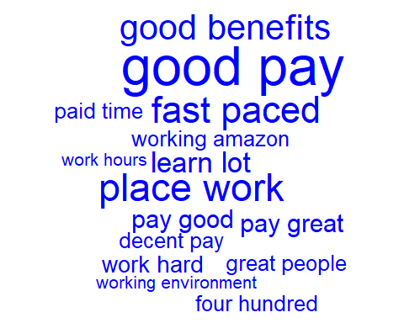

#--Word Cloud of Amazon Cons Comment---  
# Create amzn_c_tdm  
amzn_c_tdm <- TermDocumentMatrix(amzn_cons_corp, control = list(tokenize = tokenizer))  
  
# Create amzn_c_tdm_m  
amzn_c_tdm_m <- as.matrix(amzn_c_tdm)  
  
# Create amzn_c_freq   
amzn_c_freq <- rowSums(amzn_c_tdm_m)  
  
# Plot a wordcloud of negative Amazon bigrams  
wordcloud(names(amzn_c_freq), amzn_c_freq, max.words = 25, color = "red")

## Warning in wordcloud(names(amzn_c_freq), amzn_c_freq, max.words = 25,  
## color = "red"): worklife balance could not be fit on page. It will not be  
## plotted.

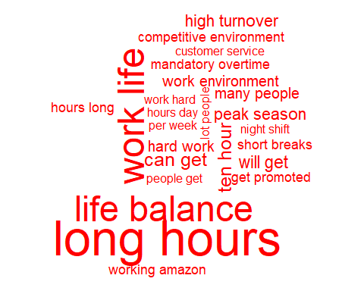

#----Dendrogram for Amazon Cons-------------------  
  
# Create amzn_c_tdm2 by removing sparse terms   
amzn_c_tdm2 <- removeSparseTerms(amzn_c_tdm , sparse = 0.993)  
  
# Create hc as a cluster of distance values  
hc <- hclust(dist(amzn_c_tdm2, method = "euclidean"), method = "complete")  
  
# Produce a plot of hc  
plot(hc)

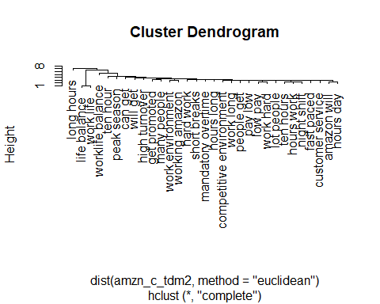

#----Word Association for Amazon Pros--------  
  
# Create term_frequency for Amazon Pros Reviews sorted in descending order  
amz_p_term_frequency <- sort(amzn_p_freq , decreasing = TRUE)  
   
# Print the 5 most common terms  
print(amz_p_term_frequency[1:5])

## good pay great benefits smart people place work fast paced   
## 25 24 20 17 16

# Find associations with fast paced  
findAssocs(amzn_p_tdm,"fast paced", 0.2)

## $`fast paced`  
## paced environment environments ever learn fast   
## 0.49 0.35 0.35   
## paced friendly paced work able excel   
## 0.35 0.35 0.25   
## activity ample advance one also well   
## 0.25 0.25 0.25   
## amazon fast amazon noting amazon one   
## 0.25 0.25 0.25   
## amount time ample opportunity assistance ninety   
## 0.25 0.25 0.25   
## benefits including break computer call activity   
## 0.25 0.25 0.25   
## can choose catchy cheers center things   
## 0.25 0.25 0.25   
## challenging expect cheers opportunity choose success   
## 0.25 0.25 0.25   
## combined encouragement competitive environments computer room   
## 0.25 0.25 0.25   
## cool things deliver results dock makes   
## 0.25 0.25 0.25   
## driven deliver easy learn emphasis shipping   
## 0.25 0.25 0.25   
## encouragement innovation environment benefits environment catchy   
## 0.25 0.25 0.25   
## environment center environment fast environment help   
## 0.25 0.25 0.25   
## environment smart ever known ever witnessed   
## 0.25 0.25 0.25   
## everchanging fast everyones preferences excel advance   
## 0.25 0.25 0.25   
## excel everchanging exciting environment expect learn   
## 0.25 0.25 0.25   
## extremely fast facility top fail successful   
## 0.25 0.25 0.25   
## fantastic able fired part five percent   
## 0.25 0.25 0.25   
## freindly place friendly atmosphere friendly management   
## 0.25 0.25 0.25   
## full medical get fired go extremely   
## 0.25 0.25 0.25   
## great plenty great teamwork happening technology   
## 0.25 0.25 0.25   
## hassle benefits help get help workers   
## 0.25 0.25 0.25   
## high quality high volume including full   
## 0.25 0.25 0.25   
## innovation owning job requirements leader can   
## 0.25 0.25 0.25   
## line break lot responsibility maintaining high   
## 0.25 0.25 0.25   
## makes time management nice nice facility   
## 0.25 0.25 0.25   
## ninety five noting short offers opportunity   
## 0.25 0.25 0.25   
## one competitive one fast opportunity overtime   
## 0.25 0.25 0.25   
## opportunity yell ownership fast owning work   
## 0.25 0.25 0.25   
## paced emphasis paced exciting paced high   
## 0.25 0.25 0.25   
## paced never paced rewarding paced ship   
## 0.25 0.25 0.25   
## paced software paid upfront people focused   
## 0.25 0.25 0.25   
## percent paid plenty shifts position fast   
## 0.25 0.25 0.25   
## possible still preferences fast products quickly   
## 0.25 0.25 0.25   
## quality bar quickly possible readily available   
## 0.25 0.25 0.25   
## requirements easy responsibility ownership results great   
## 0.25 0.25 0.25   
## results team rewarding people shifts everyones   
## 0.25 0.25 0.25   
## ship dock shipping products short amount   
## 0.25 0.25 0.25   
## short fantastic smart coworkers still maintaining   
## 0.25 0.25 0.25   
## success fail successful also team driven   
## 0.25 0.25 0.25   
## technology today things happening things lot   
## 0.25 0.25 0.25   
## time fast time go top line   
## 0.25 0.25 0.25   
## upfront experience vision well volume call   
## 0.25 0.25 0.25   
## well rewarded well tuition witnessed combined   
## 0.25 0.25 0.25   
## work can work cool work environments   
## 0.25 0.25 0.25   
## work fast work job workers readily   
## 0.25 0.25 0.25   
## yell leader   
## 0.25

#----Comparison Cloud for Google Pros and Cons Reviews------  
all_pros_goog <- paste(goog_pros, collapse = " ")  
all_cons_goog <- paste(goog_cons, collapse = " ")  
  
all_goog_reviews <- c(all_pros_goog,all_cons_goog)  
  
# Create Corpus and Clean all google reviews:  
all_goog_reviews_source <- VectorSource(all_goog_reviews)  
all_goog_corp <- VCorpus(all_goog_reviews_source)  
all_goog_corp <- tm_clean(all_goog_corp)  
  
# Create TDM of all Google Reviews  
all_goog_tdm <- TermDocumentMatrix(all_goog_corp)  
  
# Name the columns of all_goog_tdm  
colnames(all_goog_tdm) <- c("Goog_Pros", "Goog_Cons")  
  
  
# Create all_goog_m  
all_goog_m <- as.matrix(all_goog_tdm)  
  
# Build a comparison cloud  
comparison.cloud(all_goog_m, colors = c("#F44336", "#2196f3"), max.words = 100)

## Warning in comparison.cloud(all_goog_m, colors = c("#F44336", "#2196f3"), :  
## awesome could not be fit on page. It will not be plotted.

## Warning in comparison.cloud(all_goog_m, colors = c("#F44336", "#2196f3"), :  
## interesting could not be fit on page. It will not be plotted.

## Warning in comparison.cloud(all_goog_m, colors = c("#F44336", "#2196f3"), :  
## opportunities could not be fit on page. It will not be plotted.

## Warning in comparison.cloud(all_goog_m, colors = c("#F44336", "#2196f3"), :  
## compensation could not be fit on page. It will not be plotted.

## Warning in comparison.cloud(all_goog_m, colors = c("#F44336", "#2196f3"), :  
## exciting could not be fit on page. It will not be plotted.

## Warning in comparison.cloud(all_goog_m, colors = c("#F44336", "#2196f3"), :  
## flexible could not be fit on page. It will not be plotted.

## Warning in comparison.cloud(all_goog_m, colors = c("#F44336", "#2196f3"), :  
## number could not be fit on page. It will not be plotted.

## Warning in comparison.cloud(all_goog_m, colors = c("#F44336", "#2196f3"), :  
## balance could not be fit on page. It will not be plotted.



#------Pyramid Cloud for Pros of Amazon and Google Reviews-----  
  
all_pros_amzn <- paste(amzn_pros, collapse = " ")  
all_pros_goog <- paste(goog_pros, collapse = " ")  
  
all_pros_reviews <- c(all_pros_amzn,all_pros_goog)  
  
# Create Corpus and Clean all google and amazon pros reviews:  
all_pros_reviews_source <- VectorSource(all_pros_reviews)  
all_pros_corp <- VCorpus(all_pros_reviews_source)  
all_pros_corp <- tm_clean(all_pros_corp)  
  
# Create TDM of all Google and Amazon pros Reviews  
all_pros_tdm <- TermDocumentMatrix(all_pros_corp, control = list(tokenize = tokenizer))  
  
# Name the columns of all_pros_tdm  
colnames(all_pros_tdm) <- c("Amazon Pro", "Google Pro")  
  
  
# Create all_pros_tdm_m  
all_pros_tdm_m <- as.matrix(all_pros_tdm)  
  
head(all_pros_tdm_m)

## Docs  
## Terms Amazon Pro Google Pro  
## <U+0085> show 0 1  
## ability customer 1 0  
## ability iterate 1 0  
## ability make 1 1  
## ability see 1 0  
## ability switch 0 1

# Create common_words  
common_words <- subset(all_pros_tdm_m, all_pros_tdm_m[, 1] > 0 & all_pros_tdm_m[, 2] > 0)  
  
# Create difference  
difference <- abs(common_words[,1] - common_words[,2] )  
  
# Add difference to common_words  
common_words <- cbind(common_words,difference)  
  
# Order the data frame from most differences to least  
common_words <- common_words[order(common_words[, 3], decreasing = TRUE),]  
  
# Create top15_df  
top15_df <- data.frame(x = common_words[1:15, 1],   
 y = common_words[1:15, 2],   
 labels = rownames(common_words[1:15, ]))  
  
# Create the pyramid plot  
pyramid.plot(top15_df$x, top15_df$y, labels = top15_df$labels, gap = 12,   
 top.labels = c("Amzn", "Pro Words", "Google"),   
 main = "Words in Common", unit = NULL)

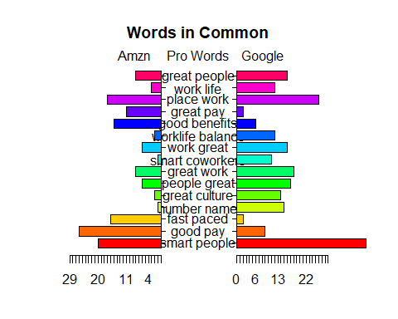

## [1] 5.1 4.1 4.1 2.1

#------Pyramid Cloud for Cons of Amazon and Google Reviews-----  
  
all_cons_amzn <- paste(amzn_cons, collapse = " ")  
all_cons_goog <- paste(goog_cons, collapse = " ")  
  
all_cons_reviews <- c(all_cons_amzn,all_cons_goog)  
  
# Create Corpus and Clean all google and amazon pros reviews:  
all_cons_reviews_source <- VectorSource(all_cons_reviews)  
all_cons_corp <- VCorpus(all_cons_reviews_source)  
all_cons_corp <- tm_clean(all_cons_corp)  
  
# Create TDM of all Google and Amazon pros Reviews  
all_cons_tdm <- TermDocumentMatrix(all_cons_corp, control = list(tokenize = tokenizer))  
  
# Name the columns of all_pros_tdm  
colnames(all_cons_tdm) <- c("Amazon Con", "Google Con")  
  
  
# Create all_pros_tdm_m  
all_cons_tdm_m <- as.matrix(all_cons_tdm)  
  
head(all_cons_tdm_m)

## Docs  
## Terms Amazon Con Google Con  
## <U+0085> show 0 5  
## abandon open 0 1  
## ability advance 1 0  
## able sacrifice 1 0  
## able sit 1 0  
## able work 1 1

# Create common_words  
common_words_cons <- subset(all_cons_tdm_m, all_cons_tdm_m[, 1] > 0 & all_cons_tdm_m[, 2] > 0)  
  
# Create difference  
difference_cons <- abs(common_words_cons[,1] - common_words_cons[,2] )  
  
# Add difference to common_words  
common_words_cons <- cbind(common_words_cons,difference_cons)  
  
# Order the data frame from most differences to least  
common_words_cons <- common_words_cons[order(common_words_cons[, 3], decreasing = TRUE),]  
  
# Create top15_df  
top15_df_cons <- data.frame(x = common_words_cons[1:15, 1],   
 y = common_words_cons[1:15, 2],   
 labels = rownames(common_words_cons[1:15, ]))  
  
# Create the pyramid plot  
pyramid.plot(top15_df_cons$x, top15_df_cons$y, labels = top15_df_cons$labels, gap = 12,   
 top.labels = c("Amzn", "Con Words", "Google"),   
 main = "Words in Common", unit = NULL)

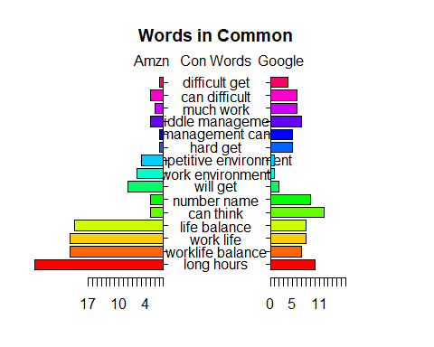

## [1] 4 2 4 2