III. EXPLORATORY DATA ANALYSIS
The exploratory data analysis (EDA) was performed on the approved Google Cloud Platform (GCP) billing dataset to examine the statistical characteristics of cloud expenditure, identify cost concentration and outliers, evaluate relationships between resource variables and cost, and identify temporal patterns relevant to subsequent Bayesian forecasting.
A. Dataset Overview
The approved dataset contains 1,000 resource-level GCP billing records and 15 attributes covering resource identification, service information, usage quantity, utilization, network activity, usage period, unit cost, and total cost. The dataset contains no missing values or duplicate observations. Total Cost (INR) is used as the primary expenditure measure for the descriptive analysis.
TABLE I
DATASET SUMMARY
Attribute | Value
Number of records | 1,000
Number of attributes | 15
Missing values | 0
Duplicate records | 0
Usage units | Requests, GB, Hours
Services represented | 25
Regions/Zones represented | 12

B. Descriptive Statistics
Descriptive statistical analysis was performed to examine central tendency and dispersion in the main numerical variables. The analysis considered usage quantity, CPU utilization, memory utilization, cost per quantity, and total cost.
TABLE II
DESCRIPTIVE STATISTICS OF SELECTED VARIABLES
Variable | Mean | Median | Std. Dev.
Usage Quantity | 383.34 | 336.72 | 299.82
CPU Utilization (%) | 50.94 | 52.03 | 28.82
Memory Utilization (%) | 51.63 | 51.64 | 28.37
Cost per Quantity ($) | 5.52 | — | —
Unrounded Cost ($) | 2,135.22 | 1,251.16 | —
Total Cost (INR) | 177,222.85 | 103,833 | 172,685.90

The total cost exhibits substantial variability, with a mean of ₹177,222.85 and a median of ₹103,833. The difference between the mean and median indicates a right-skewed expenditure distribution and suggests the presence of relatively high-cost observations. Usage quantity also shows considerable variation, with a mean of 383.34 and a standard deviation of 299.82.

C. Distribution of Cloud Cost
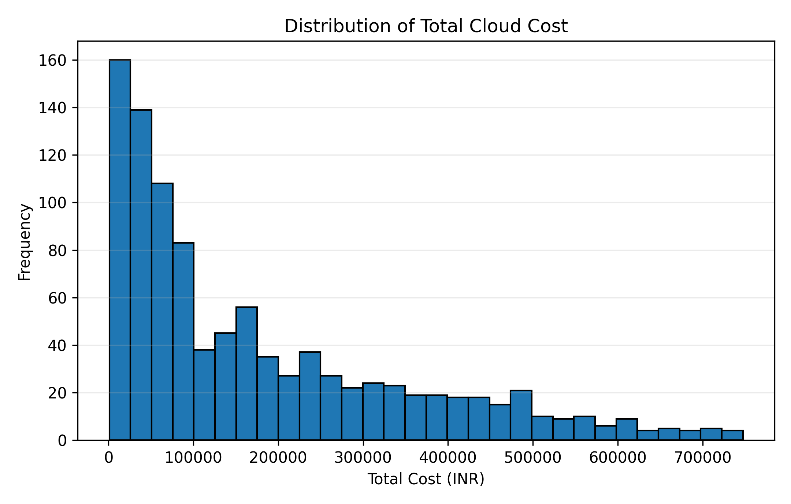
Fig. 1. Distribution of total cloud cost.
Fig. 1 shows the distribution of total cloud cost across the 1,000 observations. The distribution is positively skewed, with most observations concentrated at comparatively lower cost values and a smaller number of observations exhibiting substantially higher costs. This indicates that cloud expenditure is not uniformly distributed across resources and motivates further investigation of high-cost services and observations.
D. Cost Outlier Analysis
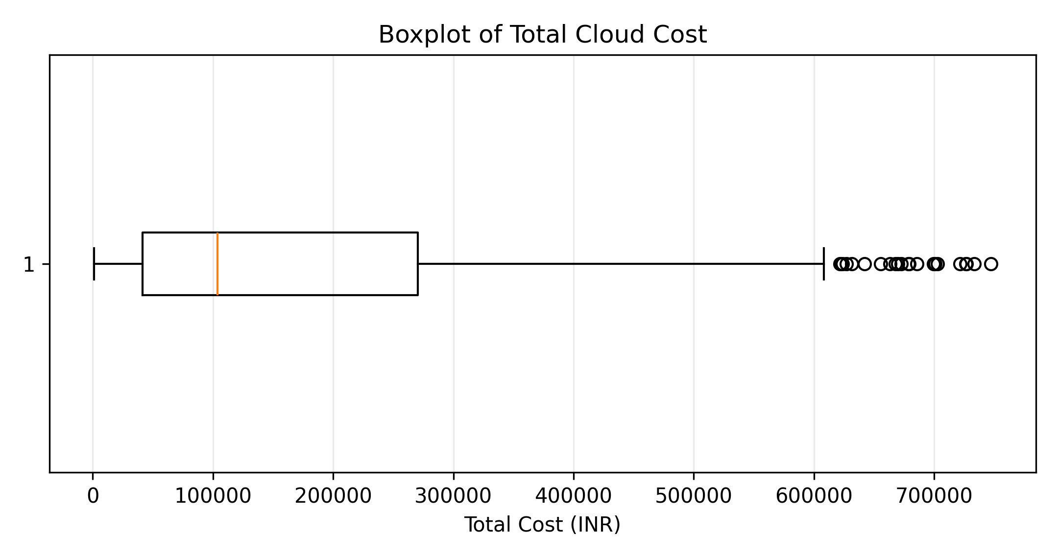
Fig. 2. Boxplot of total cloud cost.
The boxplot identifies the spread and potential outliers in the total cost variable. The IQR-based analysis identified 24 observations as cost outliers, corresponding to approximately 2.4% of the dataset. The upper IQR boundary for total cost was approximately ₹613,619. These high-cost observations are important for cloud cost optimization because a relatively small number of observations may contribute disproportionately to overall expenditure.

E. Service-Wise Cost Analysis
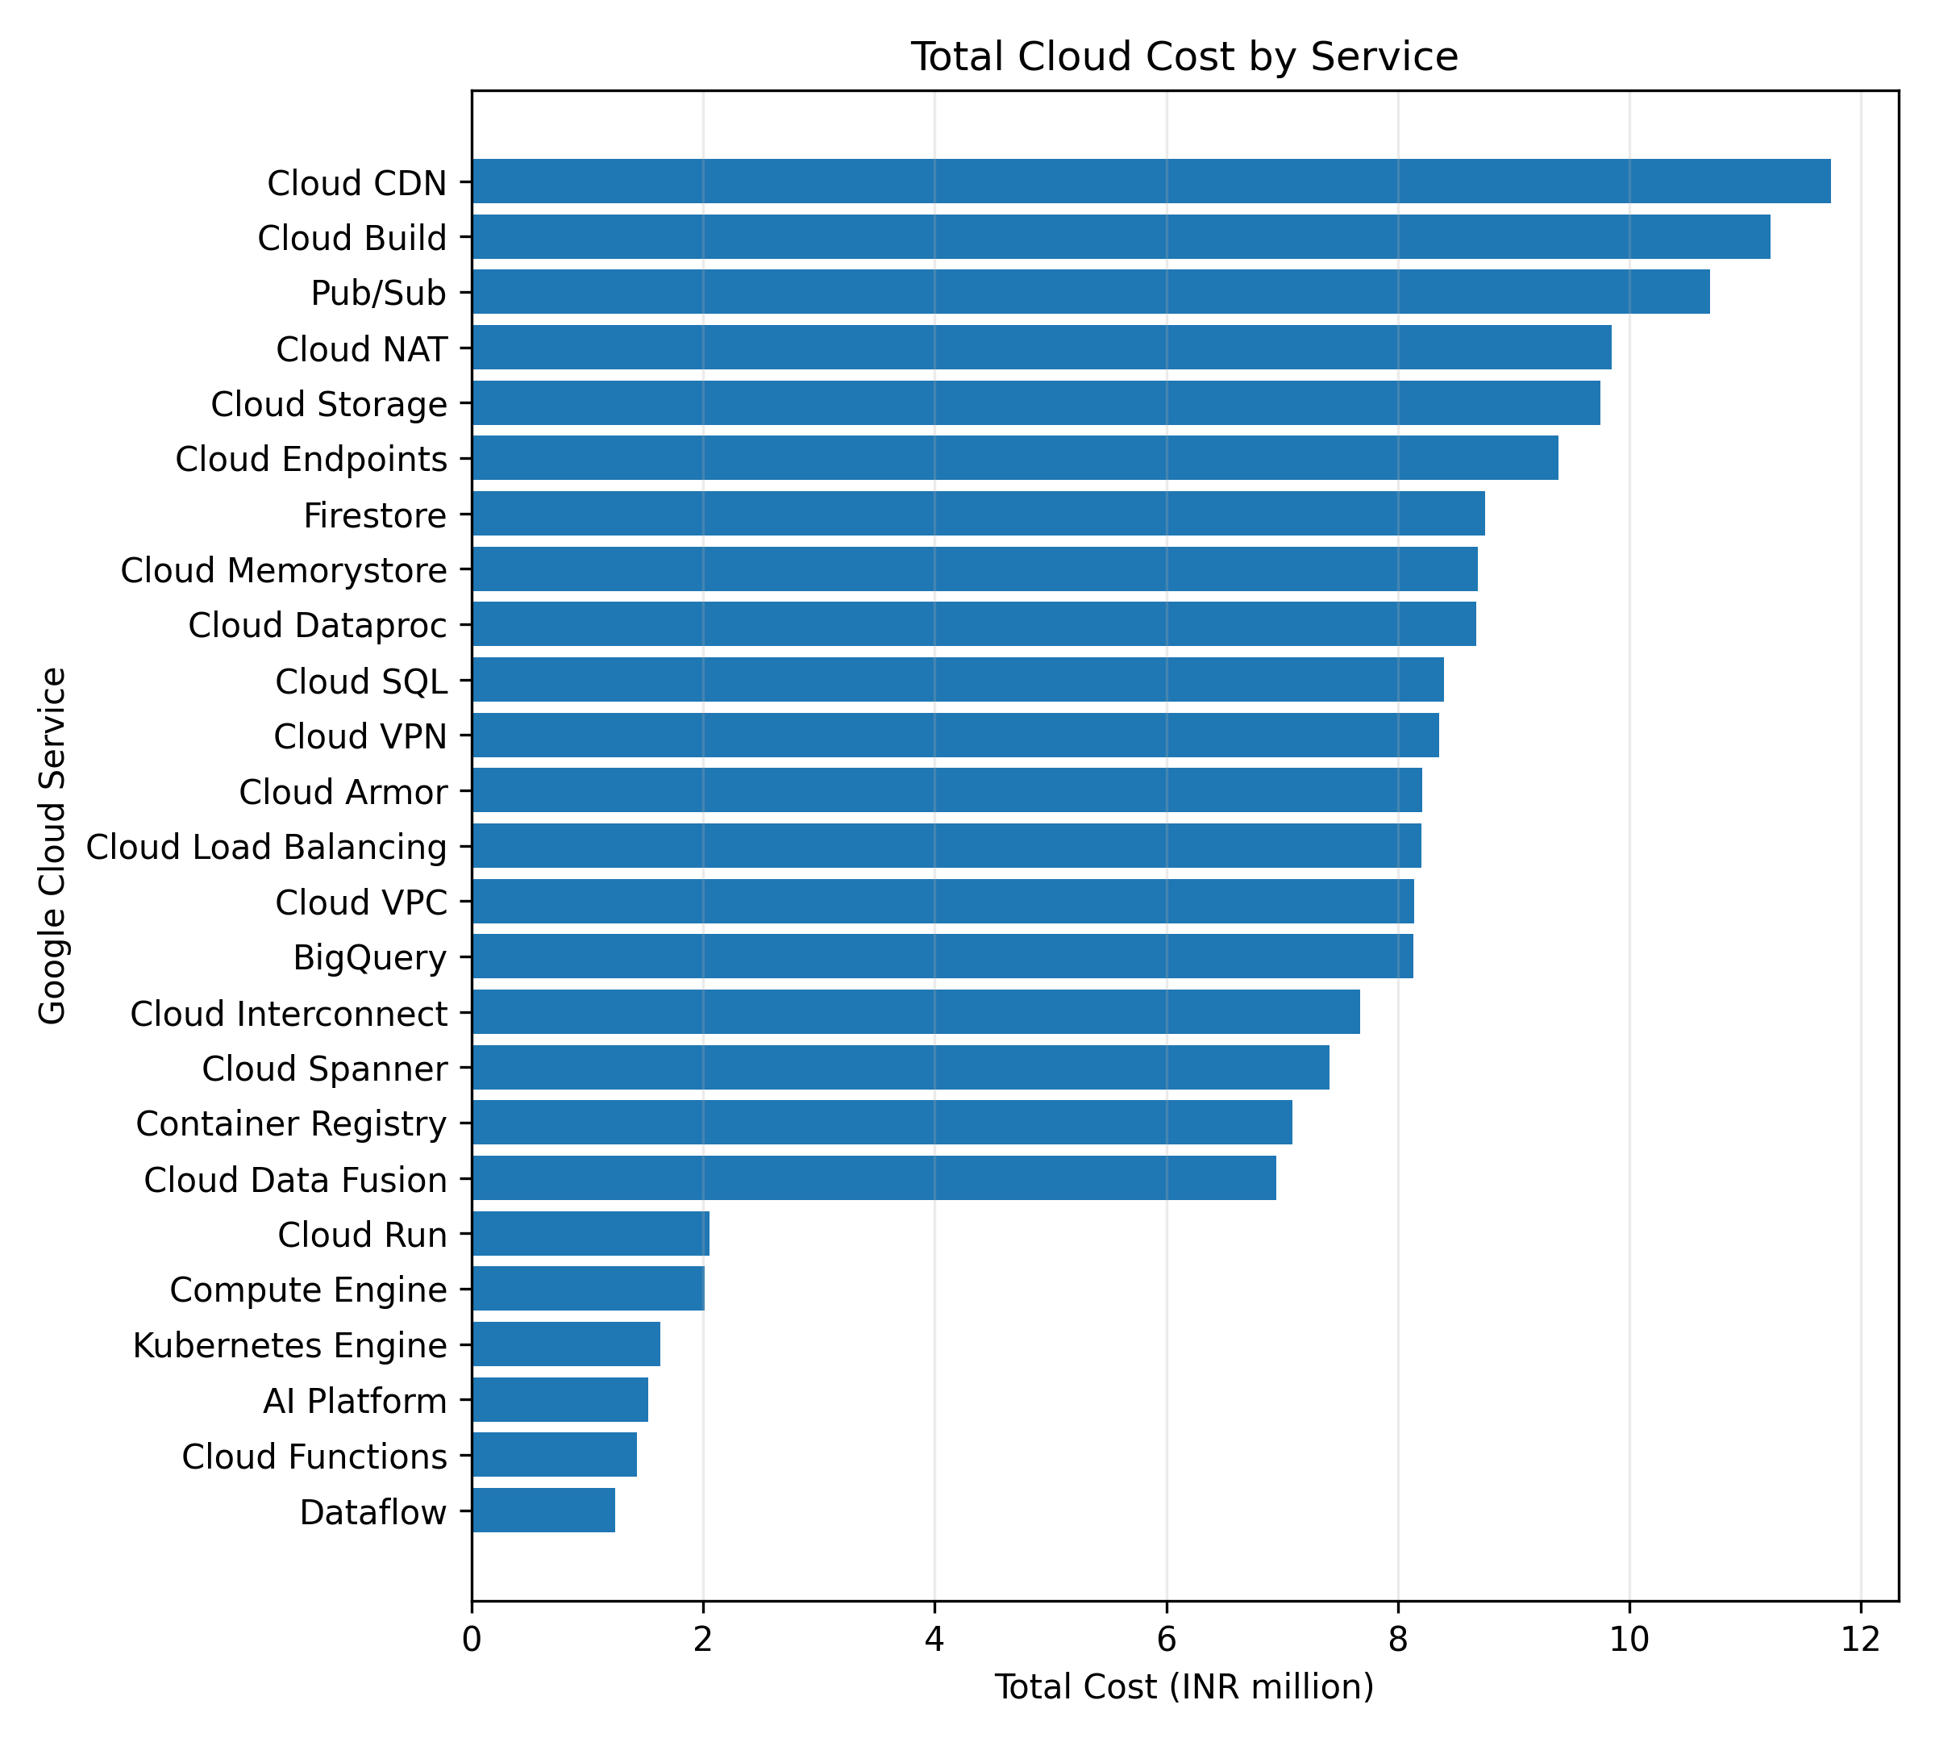
Fig. 3. Service-wise total cloud cost.
Fig. 3 presents aggregate cloud expenditure across services. Cloud CDN recorded the highest aggregate cost at approximately ₹11.74 million, followed by Cloud Build at approximately ₹11.22 million and Pub/Sub at approximately ₹10.70 million. The results demonstrate that expenditure is concentrated across specific GCP services, providing a basis for service-level cost optimization and subsequent probabilistic risk analysis.

F. Region-Wise Cost Analysis
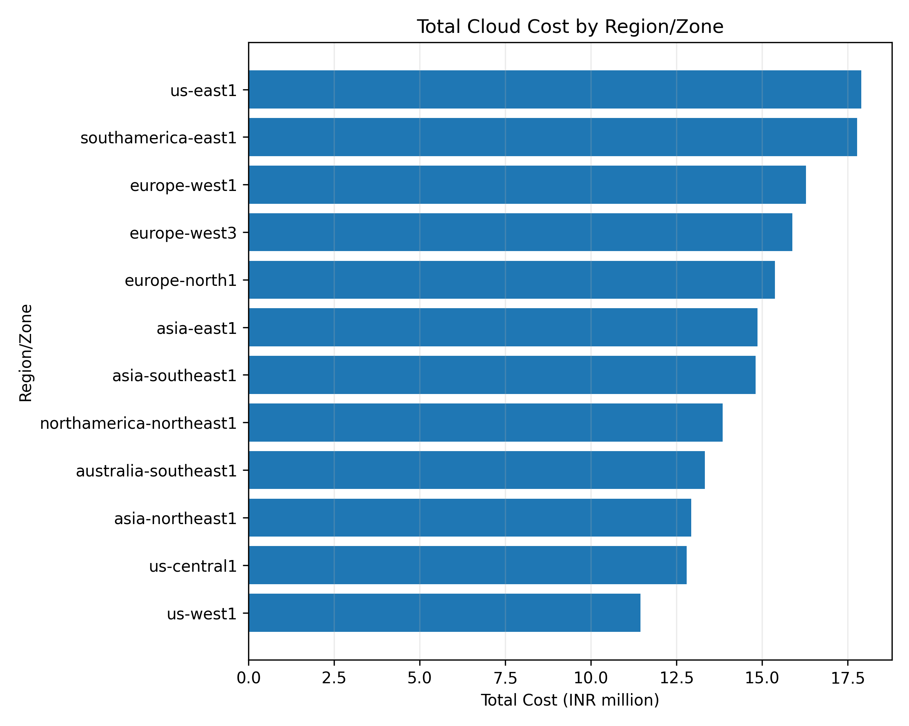
Fig. 4. Region-wise total cloud cost.
The regional analysis shows variation in total expenditure across GCP regions. The highest aggregate cost was observed in us-east1 at approximately ₹17.90 million, followed by southamerica-east1 at approximately ₹17.77 million and europe-west1 at approximately ₹16.28 million. Such regional differences provide an additional dimension for identifying cost concentration and optimization opportunities.

G. Resource Utilization and Cost Relationship
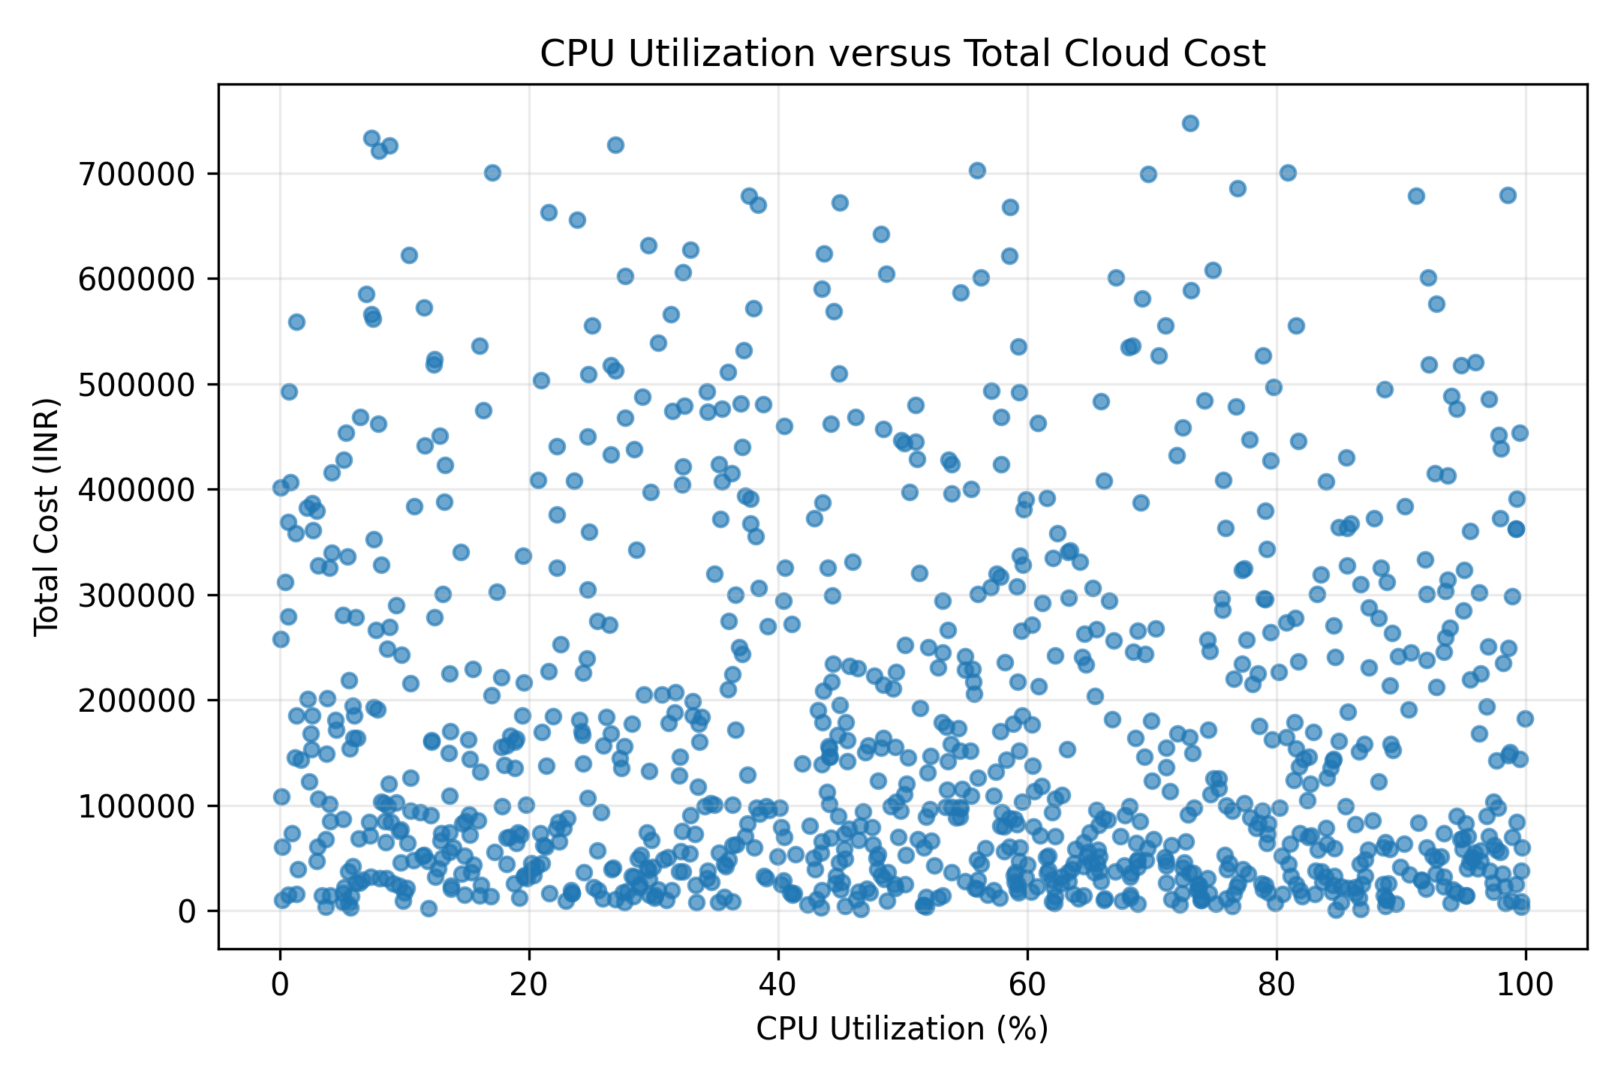
Fig. 5. Relationship between CPU utilization and total cloud cost.
The relationship between CPU utilization and total cost is weak, with a Pearson correlation coefficient of approximately −0.050. The scatter plot also shows no clear linear relationship between CPU utilization and expenditure. Therefore, CPU utilization alone does not appear to be a strong explanatory variable for total cost in this dataset.

H. Correlation Analysis
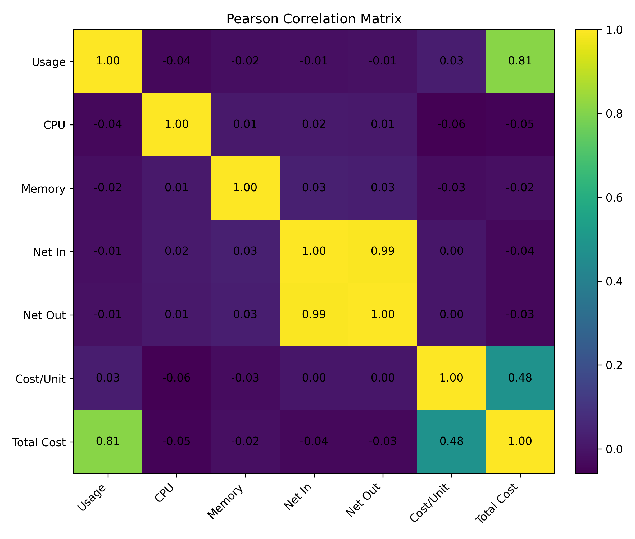
Fig. 6. Pearson correlation matrix of selected numerical variables.
The correlation analysis indicates that usage quantity has the strongest positive linear relationship with total cost, with a Pearson correlation coefficient of 0.811. Cost per quantity also exhibits a positive relationship with total cost (r = 0.482). In contrast, CPU utilization (r = −0.050) and memory utilization (r = −0.015) have very weak linear associations with expenditure. Network inbound and outbound traffic are strongly correlated with each other (r = 0.995), but both exhibit weak correlations with total cost.

I. Monthly Cost Trend
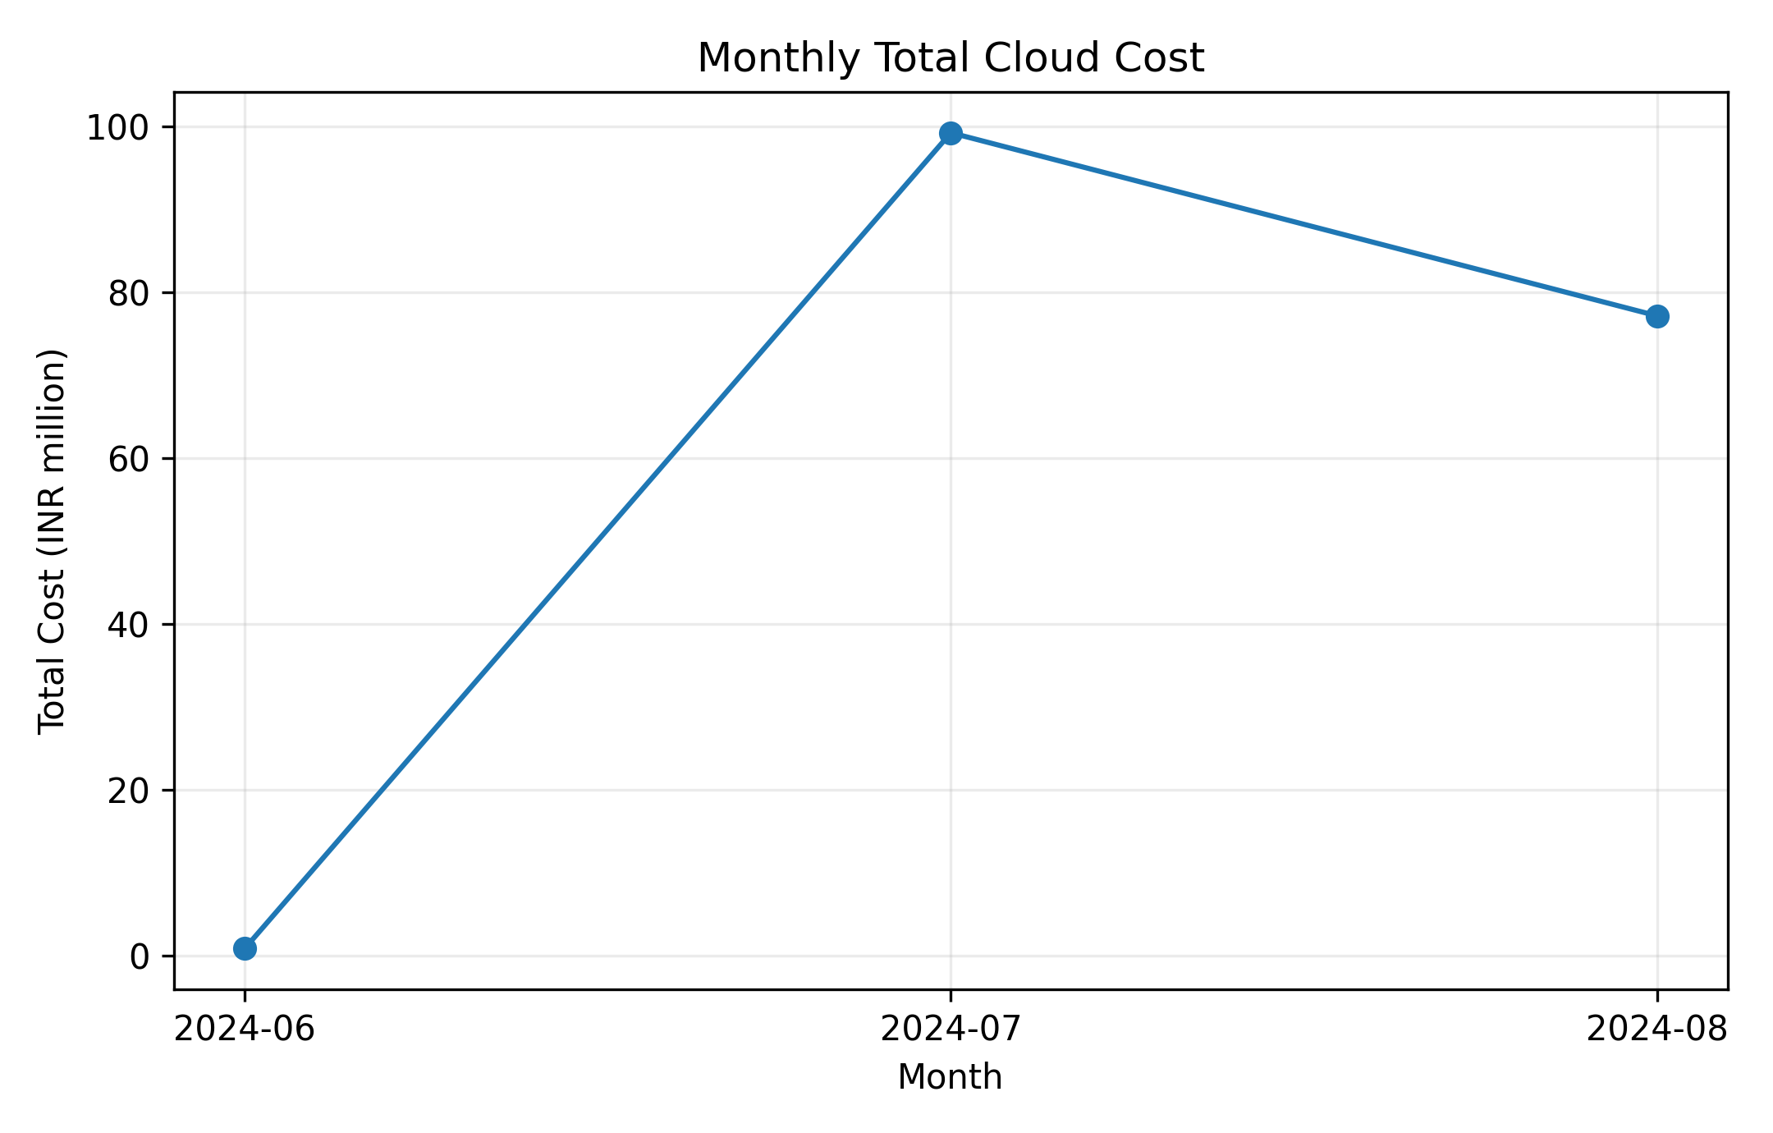
Fig. 7. Monthly total cloud cost based on usage start date.
The monthly aggregation shows substantial variation in total cloud expenditure during the observed period. The dataset records approximately ₹0.88 million in June 2024, ₹99.20 million in July 2024, and ₹77.14 million in August 2024. The large difference between monthly totals indicates temporal variation in cloud expenditure and supports the use of a time-based forecasting approach.
J. EDA Findings
The exploratory analysis identified several characteristics relevant to subsequent forecasting and probabilistic modelling. First, total cloud cost is positively skewed and contains a small number of high-cost observations. Second, usage quantity has a strong positive association with total cost, whereas CPU and memory utilization show weak linear relationships with expenditure. Third, expenditure varies considerably across services and regions, indicating cost concentration. Finally, monthly aggregation demonstrates temporal variation in expenditure. These findings provide the statistical basis for applying Bayesian forecasting and probabilistic risk analysis to future cloud expenditure.

K. Supplementary EDA Analysis
Additional exploratory visualizations were examined to assess the relationship between memory utilization and cost and the relationship between network inbound and outbound traffic. These analyses are included here to provide a more complete assessment of the numerical variables in the approved dataset.
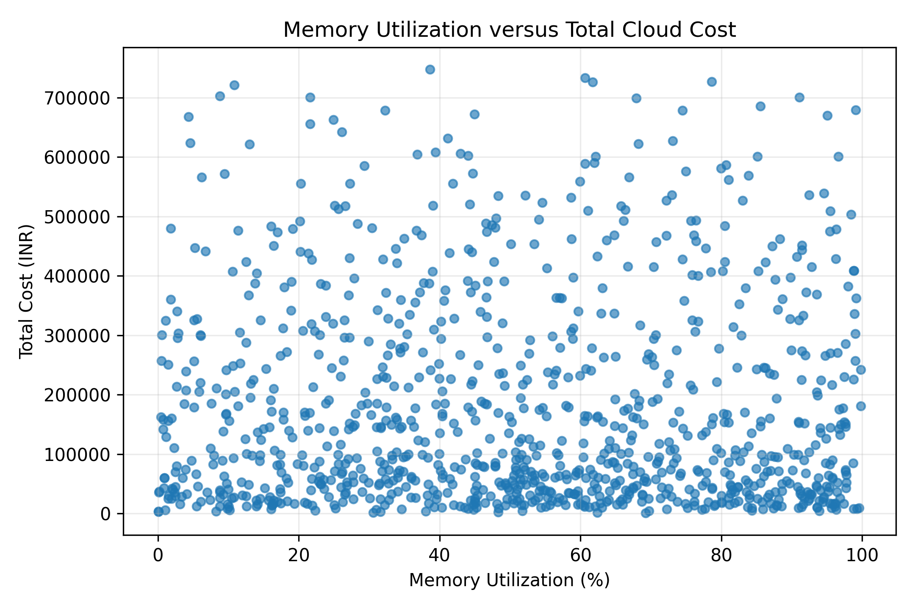
Fig. 8. Relationship between memory utilization and total cloud cost.
The relationship between memory utilization and total cost is very weak, with a Pearson correlation coefficient of approximately −0.015. The scatter plot does not show a meaningful linear association, indicating that memory utilization alone is not a strong predictor of total cloud expenditure in the analyzed dataset.
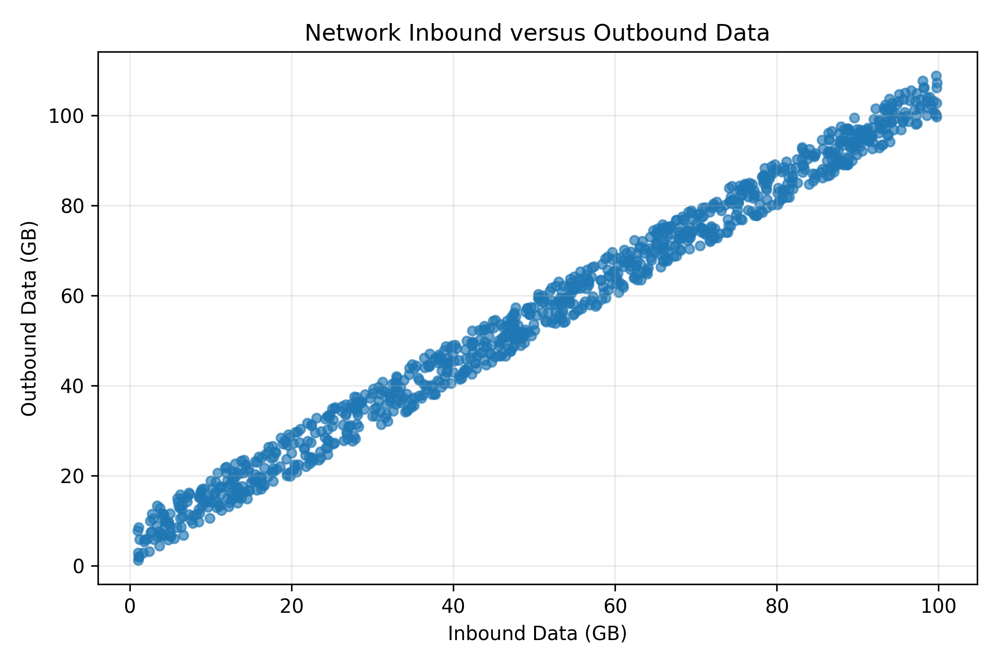
Fig. 9. Relationship between network inbound and outbound data.
The network analysis shows a very strong positive relationship between inbound and outbound network traffic, with a Pearson correlation coefficient of approximately 0.995. This indicates that the two network variables vary closely together in the dataset. However, their individual correlations with total cost are weak, suggesting that network traffic alone does not explain a substantial proportion of the observed cost variation.

