MODEL COMPARISON: ARIMA, MOVING AVERAGE, AND BAYESIAN FORECASTING

1. ARIMA AND MOVING-AVERAGE COMPARISON
To evaluate the forecasting performance of the Bayesian approach, two conventional time-series baselines were considered: ARIMA and a 7-day moving average. The same daily cloud-cost series used for the Bayesian time-series analysis was used for the comparison. The modelling series contains 59 daily observations from 1 July 2024 to 28 August 2024. A chronological 80/20 split was used, with the first 47 days used for training and the final 12 days used as the held-out test period (17–28 August 2024).
The ARIMA model selected for the comparison was ARIMA(1,1,3). The second conventional baseline was a 7-day moving average. Both models produced one-step-ahead predictions for the same 12 held-out observations, allowing a direct comparison with the Bayesian Model 1 predictions.

Date | Actual Cost (USD) | Bayesian Model 1 (USD) | ARIMA(1,1,3) (USD) | Moving Average (7-day) (USD)
2024-08-17 | 26,043.10 | 33,368.65 | 36,789.64 | 42,380.98
2024-08-18 | 44,052.62 | 33,516.37 | 30,495.80 | 41,472.39
2024-08-19 | 30,418.88 | 35,042.83 | 38,342.58 | 43,099.86
2024-08-20 | 17,885.32 | 33,857.62 | 35,602.84 | 41,328.15
2024-08-21 | 47,070.55 | 36,014.44 | 36,559.43 | 43,359.00
2024-08-22 | 16,982.60 | 35,409.99 | 36,225.43 | 42,186.57
2024-08-23 | 36,208.13 | 34,434.69 | 36,342.05 | 41,913.76
2024-08-24 | 22,185.81 | 32,515.59 | 36,301.33 | 42,248.67
2024-08-25 | 27,575.69 | 32,742.92 | 36,315.55 | 42,229.77
2024-08-26 | 16,908.47 | 34,327.50 | 36,310.59 | 42,337.97
2024-08-27 | 32,029.51 | 33,096.95 | 36,312.32 | 42,229.13
2024-08-28 | 16,027.76 | 35,299.53 | 36,311.71 | 42,357.84

2. EVALUATION METRICS
Forecast accuracy was evaluated using Mean Absolute Error (MAE) and Root Mean Square Error (RMSE). Lower values indicate better predictive accuracy.
MAE = (1/n) Σ |yₜ − ŷₜ|
RMSE = √[(1/n) Σ (yₜ − ŷₜ)²]
MAE measures the average absolute forecasting error and is expressed in the same currency unit as the observations. RMSE also uses the same unit but gives greater weight to larger errors because the errors are squared before averaging.

3. MAE RESULTS
The MAE values obtained on the 12-day held-out test period are shown in Table I.
Model | MAE (USD) | Rank
Bayesian Model 1 | $10,247.52 | 1
ARIMA(1,1,3) | $12,221.39 | 2
Moving Average (7-day) | $15,528.27 | 3
TABLE I
MAE PERFORMANCE ON THE 12-DAY HELD-OUT TEST PERIOD
The Bayesian Model 1 achieved the lowest MAE of $10,247.52. ARIMA(1,1,3) produced an MAE of $12,221.39, while the 7-day moving average produced the highest MAE of $15,528.27. Therefore, based on MAE, Bayesian Model 1 provided the most accurate point predictions among the three evaluated methods.
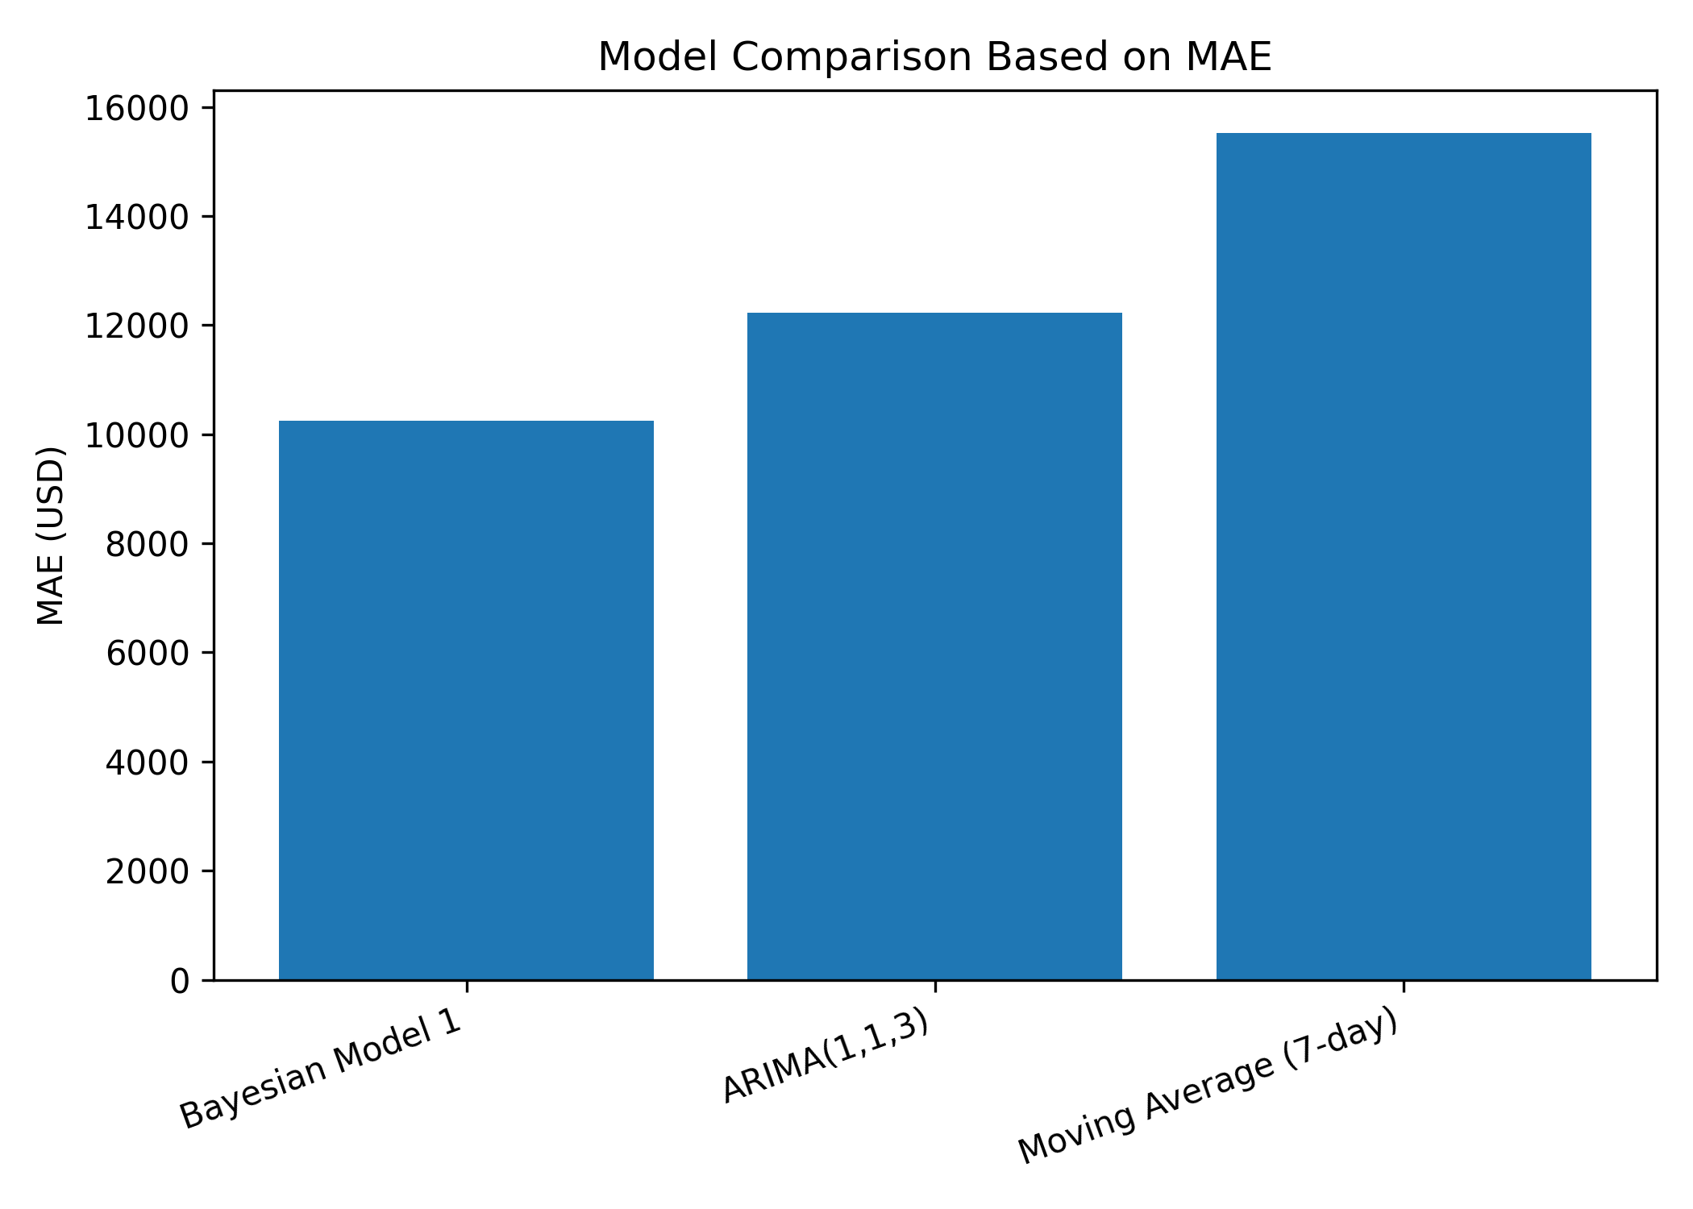
Fig. 1. MAE comparison of Bayesian Model 1, ARIMA(1,1,3), and 7-day moving average.

4. RMSE RESULTS
RMSE was calculated on exactly the same 12 held-out observations. This provides a second measure of predictive accuracy and is particularly useful for identifying whether a model is affected by large forecasting errors.
Model | RMSE (USD) | Rank
Bayesian Model 1 | $11,956.49 | 1
ARIMA(1,1,3) | $13,658.38 | 2
Moving Average (7-day) | $17,622.79 | 3
TABLE II
RMSE PERFORMANCE ON THE 12-DAY HELD-OUT TEST PERIOD
Bayesian Model 1 again achieved the best result, with an RMSE of $11,956.49. ARIMA(1,1,3) obtained $13,658.38, whereas the 7-day moving average obtained $17,622.79. The consistent ranking across MAE and RMSE indicates that the Bayesian model was the strongest of the three methods on this particular held-out test period.
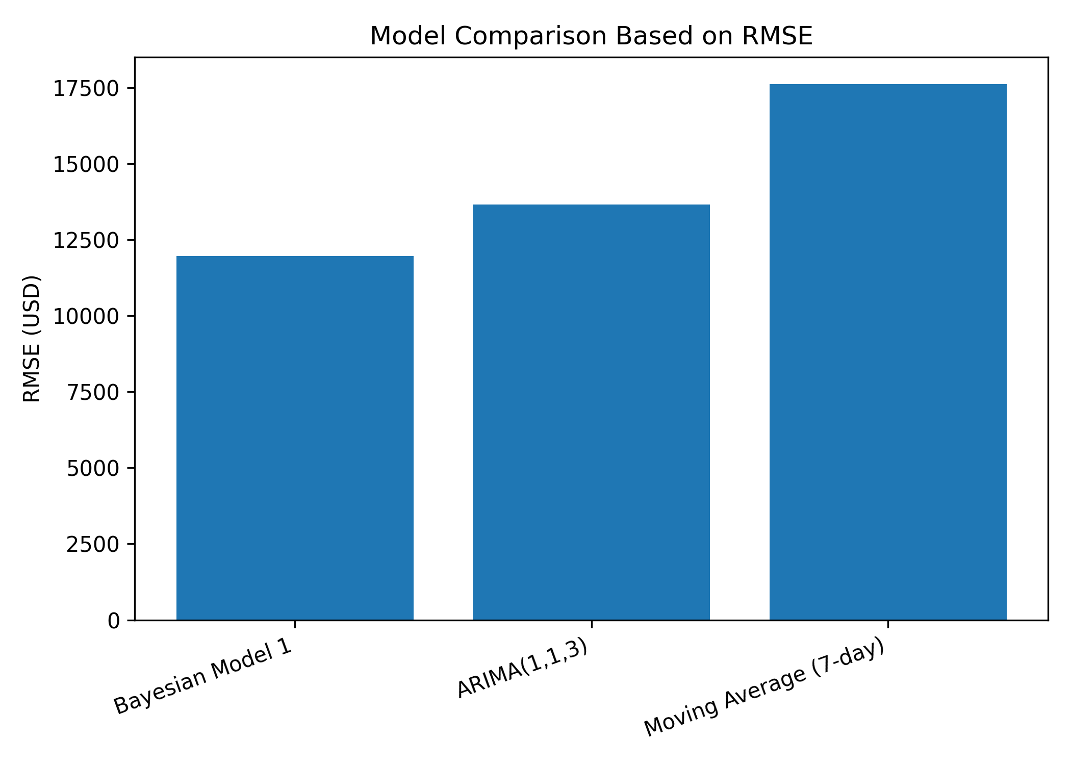
Fig. 2. RMSE comparison of Bayesian Model 1, ARIMA(1,1,3), and 7-day moving average.

5. MODEL COMPARISON
Table III summarizes the final point-forecasting comparison. All three methods were evaluated against the same observed daily cloud costs over the same 12-day test period.
Model | MAE (USD) | RMSE (USD) | Overall Rank
Bayesian Model 1 | $10,247.52 | $11,956.49 | 1
ARIMA(1,1,3) | $12,221.39 | $13,658.38 | 2
Moving Average (7-day) | $15,528.27 | $17,622.79 | 3
TABLE III
FINAL FORECASTING MODEL COMPARISON
The final ranking is: (1) Bayesian Model 1, (2) ARIMA(1,1,3), and (3) 7-day moving average. Bayesian Model 1 reduced the MAE by approximately 16.2% relative to ARIMA(1,1,3) and by approximately 34.0% relative to the 7-day moving average. Its RMSE was approximately 12.5% lower than ARIMA(1,1,3) and approximately 32.1% lower than the moving-average baseline.
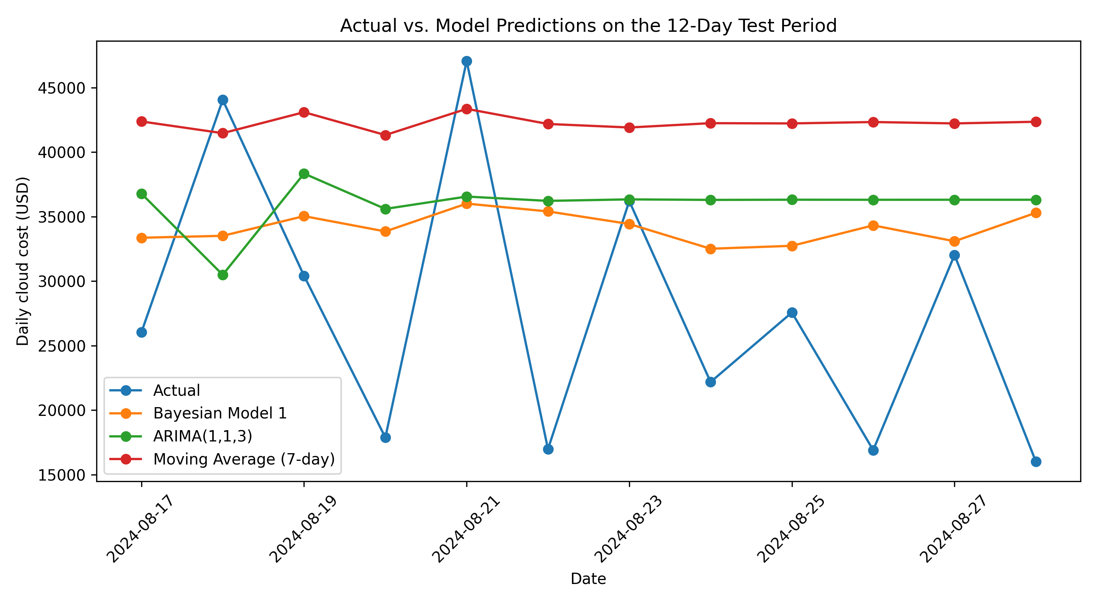
Fig. 3. Actual daily cloud cost versus predictions during the 12-day held-out test period.

6. INTERPRETATION AND LIMITATION
The comparison indicates that the Bayesian model produced the lowest point-prediction errors for the evaluated test period. However, this result should be interpreted as an empirical comparison on the available 12-day hold-out sample rather than as evidence that Bayesian forecasting will consistently outperform ARIMA or moving-average methods on other datasets or future periods.
The Bayesian held-out evaluation followed the same mathematical Model 1 structure documented for the project, including a Student-t likelihood, linear time trend, and day-of-week effects. The full-data posterior used for the project's 30-day forecasting stage was not used to calculate the held-out accuracy metrics. Therefore, the test-period observations were not incorporated into the model estimation used for this comparison, avoiding data leakage.

7. CONCLUSION
The forecasting comparison demonstrates that Bayesian Model 1 achieved the best point-prediction accuracy among the three evaluated approaches on the 12-day held-out test period. It obtained the lowest MAE of $10,247.52 and RMSE of $11,956.49, compared with an MAE of $12,221.39 and RMSE of $13,658.38 for ARIMA(1,1,3), and an MAE of $15,528.27 and RMSE of $17,622.79 for the 7-day moving-average model. Thus, the Bayesian model provided the most accurate predictions for the evaluated test period. The results also show that the Bayesian approach can complement conventional forecasting methods by providing a probabilistic modelling framework in addition to point predictions. However, the performance difference should be interpreted specifically for the available dataset and test period and should not be generalized to all cloud-cost forecasting scenarios.
Data basis: Approved GCP billing dataset and the project's documented 59-day daily-cost modelling series. All monetary values in this comparison are reported in USD.

