Bayesian Forecasting for Cloud Cost Optimization:
Probabilistic Forecasting and Budget-Risk Analysis on GCP Billing Data
Suyash Batra  School of Computer Science Engineering and Information Systems.  Vellore Institute of Technology Vellore, India  26MCA0005 | School of Computer Science Engineering and Information Systems.  Vellore Institute of Technology Vellore, India  26MCA0004 | Revathi Rajesh  School of Computer Science Engineering and Information Systems.  Vellore Institute of Technology Vellore, India  26MCA0006 | Irine Mary  School of Computer Science Engineering and Information Systems.  Vellore Institute of Technology Vellore, India  26MCA0007 | School of Computer Science Engineering and Information Systems.  Vellore Institute of Technology Vellore, India  26MCA0008

Abstract—Cloud billing under the pay-as-you-go model is hard to budget, because a single point forecast says nothing about how likely an overrun is. This report develops a Bayesian framework for forecasting and optimizing cloud cost on a public Google Cloud Platform (GCP) billing dataset of 1,000 resource-level records covering 25 services and 12 regions. After an exploratory analysis, two models are fitted in PyMC with the No-U-Turn Sampler: a Student-t time-series model of 59 daily total costs with a linear trend and day-of-week effects, and a hierarchical lognormal model that ranks the 25 services by cost per record. Posterior predictive simulation of 4,000 future scenarios gives a median 30-day cost of $793,267.40 and a 3.17% probability of exceeding a data-based planning budget of $1,073,313.26. The posterior probability of an increasing daily trend is only 0.01, and 26 potentially idle resources account for 2.95% of historical cost, which gives scenario savings of $11,703 to $23,407. On a 12-day held-out period the Bayesian model attains an MAE of $10,247.52, against $12,221.39 for ARIMA(1,1,3) and $15,528.27 for a 7-day moving average. The main limitation is the short 59-day history, which makes trend extrapolation uncertain.
Index Terms—Bayesian forecasting, cloud cost optimization, credible interval, GCP billing, hierarchical model, PyMC, Student-t, time series.

I. INTRODUCTION
Cloud computing has become a core part of modern IT infrastructure. Platforms such as Google Cloud Platform (GCP) supply computing, storage, networking, database and analytics services on demand, without the cost of owning equivalent hardware [1]. The pay-as-you-use pricing model that makes this flexible also makes spending hard to control, because cost varies with resource consumption, service type, region, usage duration and pricing rates. Organizations therefore need methods to understand past expenditure and to estimate how likely a future cost increase or budget overrun is.
Conventional forecasts return a single predicted value. For budgeting, an expected cost is of limited use unless decision makers also know the probability that the actual cost will exceed a planned budget. Bayesian statistics provides a natural framework for this, because it combines prior information with observed data to obtain posterior distributions [2], from which a range of plausible outcomes and the probability of events such as a budget overrun can be read directly. The research question of this report is therefore: how can Bayesian methods be used to model cloud expenditure, quantify the uncertainty of cost predictions and estimate the probability of exceeding a predefined budget?
This report describes “Bayesian Forecasting for Cloud Cost Optimization”, developed as an MCA Probability and Statistics course project. It uses a public GCP billing dataset [3] and a Bayesian workflow written in Python with PyMC. Every model, prior and decision quantity is stated explicitly, and the code is available in the project repository [4]. The contributions of the project are:
- an exploratory and statistical analysis of 1,000 GCP billing records, covering distributions, outliers, correlations and service-, region- and month-level cost;
- two Bayesian models: a Student-t time-series model of daily cost and a hierarchical lognormal model of service-level cost;
- a 30-day posterior predictive forecast with predictive intervals and the probability of exceeding a planning budget;
- an analysis of potentially idle resources with what-if optimization scenarios; and
- a held-out comparison of the Bayesian model with ARIMA and a 7-day moving average.
Because the data cover only about two months, the report does not claim long-term seasonal forecasting. It builds and evaluates a probabilistic framework on the available observations.
The rest of this report is organized as follows. Section II reviews related work. Section III describes the dataset and Section IV presents the exploratory analysis. Section V presents the methodology, Section VI the implementation and Section VII the experimental setup. Results are discussed in Section VIII, limitations and future work in Section IX, and Section X concludes.

II. RELATED WORK
Time-series forecasting of cost or demand is classically done with the autoregressive integrated moving-average (ARIMA) family introduced by Box and Jenkins [5], and with simple benchmarks such as moving averages; both are treated in standard textbooks [6]. These methods give a point forecast, and their prediction intervals rest on assumptions such as Gaussian errors. This report uses ARIMA and a 7-day moving average as baselines.
Bayesian inference treats unknown parameters as random variables and reports their posterior distributions [2]. Forecasts follow from the posterior predictive distribution, so uncertainty in the parameters and in future noise is carried into the forecast. The Prophet model of Taylor and Letham is a widely used example of an additive trend-and-seasonality forecasting model that reports uncertainty intervals [7]. Gelman et al. describe a complete Bayesian workflow of prior predictive checks, sampling, convergence diagnostics and posterior predictive checks [8], which this report follows.
Practical Bayesian modelling relies on Markov chain Monte Carlo (MCMC). The No-U-Turn Sampler (NUTS) adapts the path length of Hamiltonian Monte Carlo automatically [9] and is available through the PyMC probabilistic programming library [10]. Hierarchical models partially pool group effects towards a common mean, which stabilises estimates for groups with few observations [2], and weakly informative priors for scale parameters are recommended by Gelman [11]. This work combines these tools for a cloud-cost setting, in which a point forecast is replaced by a distribution of future costs and a budget-overrun probability.

III. DATASET

A. Source
The dataset is the public GCP Cloud Billing Data collection on Kaggle [3]. Each of its 1,000 rows is one cloud resource usage record, with service, usage, region, utilization, network, usage period, pricing and cost information. The records cover 30 June 2024 to 3 September 2024, about 64 days, so the data give a cross-sectional and short-period temporal view of consumption rather than a long billing history. Table I summarizes the dataset.
TABLE I
DATASET SUMMARY
Attribute | Value
Source | Kaggle GCP billing data [3]
Number of records | 1,000
Number of attributes | 15
Missing values | 0
Duplicate records | 0
Usage units | Requests, GB, Hours
Services represented | 25
Regions/zones represented | 12
Usage period | 30 Jun – 3 Sep 2024
Usage duration | 24–144 h (mean ≈ 84 h)

B. Variables
The 15 variables are described in Table II. Cost is given in US dollars (unrounded and rounded) and as Total Cost in Indian rupees (INR).
TABLE II
DATASET VARIABLES
Variable | Description
Resource ID | Unique cloud resource identifier
Service Name | GCP service of the record
Usage Quantity | Quantity of resource consumed
Usage Unit | GB, Hours or Requests
Region/Zone | GCP region of the resource
CPU Utilization (%) | CPU utilization percentage
Memory Utilization (%) | Memory utilization percentage
Network Inbound (Bytes) | Incoming network data
Network Outbound (Bytes) | Outgoing network data
Usage Start Date | Start of the usage period
Usage End Date | End of the usage period
Cost per Quantity ($) | Price of one unit of usage
Unrounded Cost ($) | Usage × price, before rounding
Rounded Cost ($) | Cost after rounding
Total Cost (INR) | Total expenditure in Indian rupees

C. Data Characteristics and Quality
The 25 services include Compute Engine, Cloud Storage, Cloud Run, Cloud CDN, Pub/Sub, Cloud Build, Firestore, Cloud Interconnect, Cloud Endpoints and Kubernetes Engine. The records are spread over 12 regions: asia-east1, asia-southeast1, asia-northeast1, australia-southeast1, europe-west1, europe-west3, europe-north1, northamerica-northeast1, southamerica-east1, us-central1, us-east1 and us-west1. Fig. 1 shows the 374 Requests-based, 370 GB-based and 256 Hours-based records.
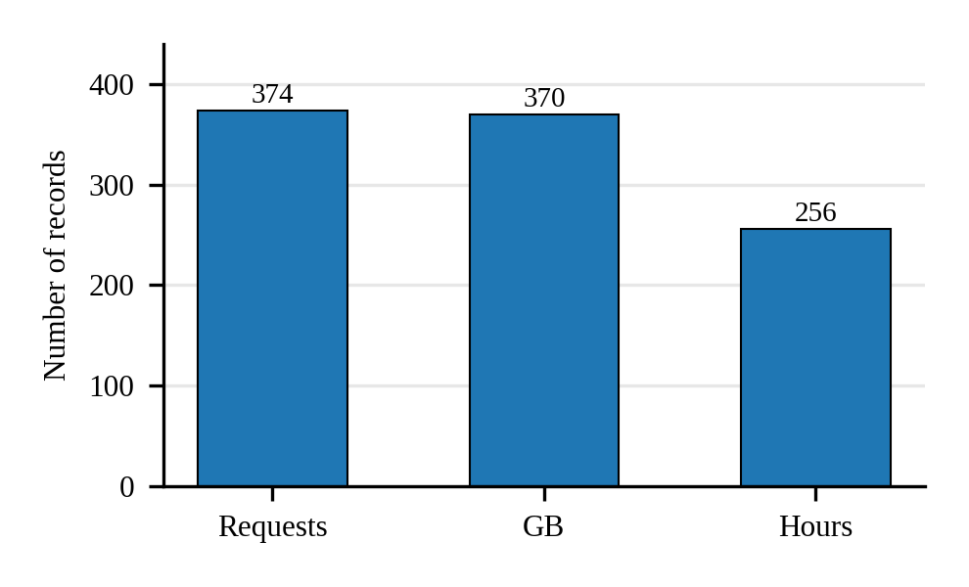
Fig. 1. Number of records by usage unit.
No missing values and no duplicate records were found. The cost columns are mathematically related: cost was verified to equal usage quantity × unit price (maximum discrepancy $0.005), and Total Cost (INR) equals 83 × the rounded USD cost. Unrounded Cost, Rounded Cost and Total Cost are therefore the same quantity in different forms and are not treated as independent predictors, which would introduce redundancy and data leakage. Each of the 1,000 Resource IDs also appears only once, so the data are not a per-resource time series.

D. Preparation for Modelling
Two modelling datasets are derived. For the time-series model, records are grouped by the calendar day of their start time and summed to daily totals. The partial first and last days are dropped, which leaves 59 days from 1 July to 28 August 2024; any missing calendar day would be filled with zero. Costs are expressed in thousands of dollars and then standardised (mean subtracted, divided by the standard deviation), so that unit-scale priors are sensible and the sampler behaves well. For the hierarchical model, all 1,000 records are used with the natural logarithm of cost as the outcome. Section IV reports Total Cost in INR, whereas all modelling results in Sections V–VIII are in USD, using the fixed rate of 83 INR per USD of the source file.

IV. EXPLORATORY DATA ANALYSIS
Exploratory data analysis (EDA) was performed to examine the statistical characteristics of expenditure, identify cost concentration and outliers, evaluate the relationships between resource variables and cost, and identify temporal patterns relevant to the Bayesian forecasting that follows.

A. Descriptive Statistics
Table III reports the mean, median, standard deviation and skewness of the main numerical variables. Total Cost has a mean of ₹177,222.85 and a median of ₹103,833. The mean is well above the median, so a small number of high-cost records pull the average upward. The standard deviation of ₹172,685.90 is almost as large as the mean, which shows large variation between individual records. Usage Quantity has a mean of 383.34 and a standard deviation of 299.82. CPU and memory utilization are centred near 50% (means 50.94% and 51.63%) with standard deviations of about 28 percentage points. Network inbound and outbound traffic average about 5.15×10¹⁰ and 5.65×10¹⁰ bytes.
TABLE III
DESCRIPTIVE STATISTICS OF SELECTED VARIABLES
Variable | Mean | Median | Std. Dev. | Skew.
Usage Quantity | 383.34 | 336.72 | 299.82 | 0.513
CPU Utilization (%) | 50.94 | 52.03 | 28.82 | −0.057
Memory Utilization (%) | 51.63 | 51.64 | 28.37 | −0.046
Cost per Quantity ($) | 5.52 | 5.56 | 2.54 | 0.004
Unrounded Cost ($) | 2,135.22 | 1,251.16 | 2,080.53 | 1.185
Total Cost (INR) | 177,222.85 | 103,833.00 | 172,685.90 | 1.185

B. Distribution and Outliers
Fig. 2 shows the distribution of Total Cost. Most records have low or moderate cost and a smaller number have much higher cost, which gives a skewness of 1.185 and an excess kurtosis of 0.557 (strong right skew). Usage Quantity is moderately skewed (0.513), whereas CPU utilization (−0.057), memory utilization (−0.046), network traffic and cost per quantity are approximately symmetric, with excess kurtosis between −1.21 and −1.05, close to the value of −1.2 of a uniform distribution.
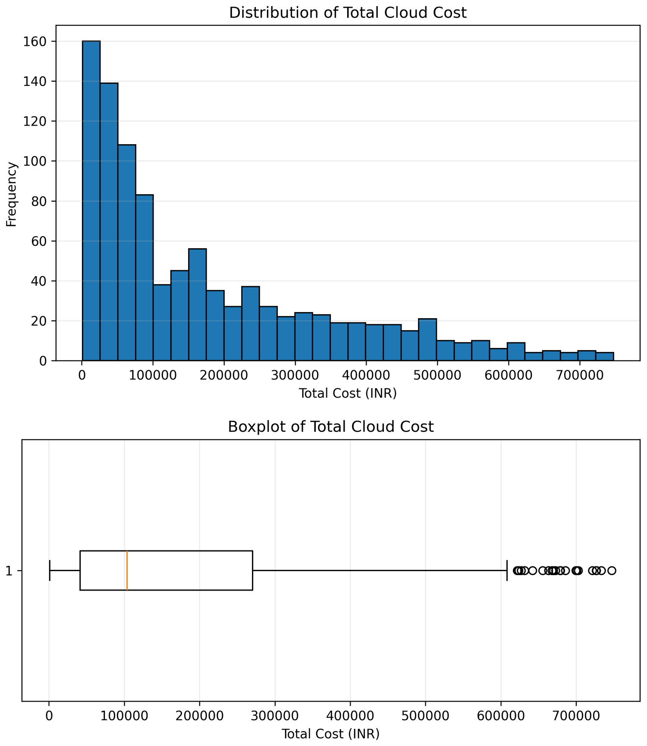
Fig. 2. Distribution (top) and boxplot (bottom) of Total Cost (INR).
Outliers were identified with the interquartile range (IQR) rule: observations outside [Q1 − 1.5 IQR, Q3 + 1.5 IQR] are outliers. No outliers were found in the usage, utilization, network or cost-per-quantity variables, but 24 records (2.4%) are outliers in the cost variables. The upper boundary for Total Cost is about ₹613,619, whereas the maximum is ₹747,332. These records may represent unusually expensive usage and are relevant for cost optimization, because a small number of records can contribute disproportionately to total expenditure.

C. Service-Wise Cost
Fig. 3 presents aggregate cost by service. Cloud CDN has the highest total cost, ₹11,738,109, followed by Cloud Build at ₹11,220,023 and Pub/Sub at ₹10,696,044. Cloud NAT has the highest average cost per record, about ₹281,261, so high total expenditure does not always result only from a large number of records. Expenditure is concentrated in particular services.
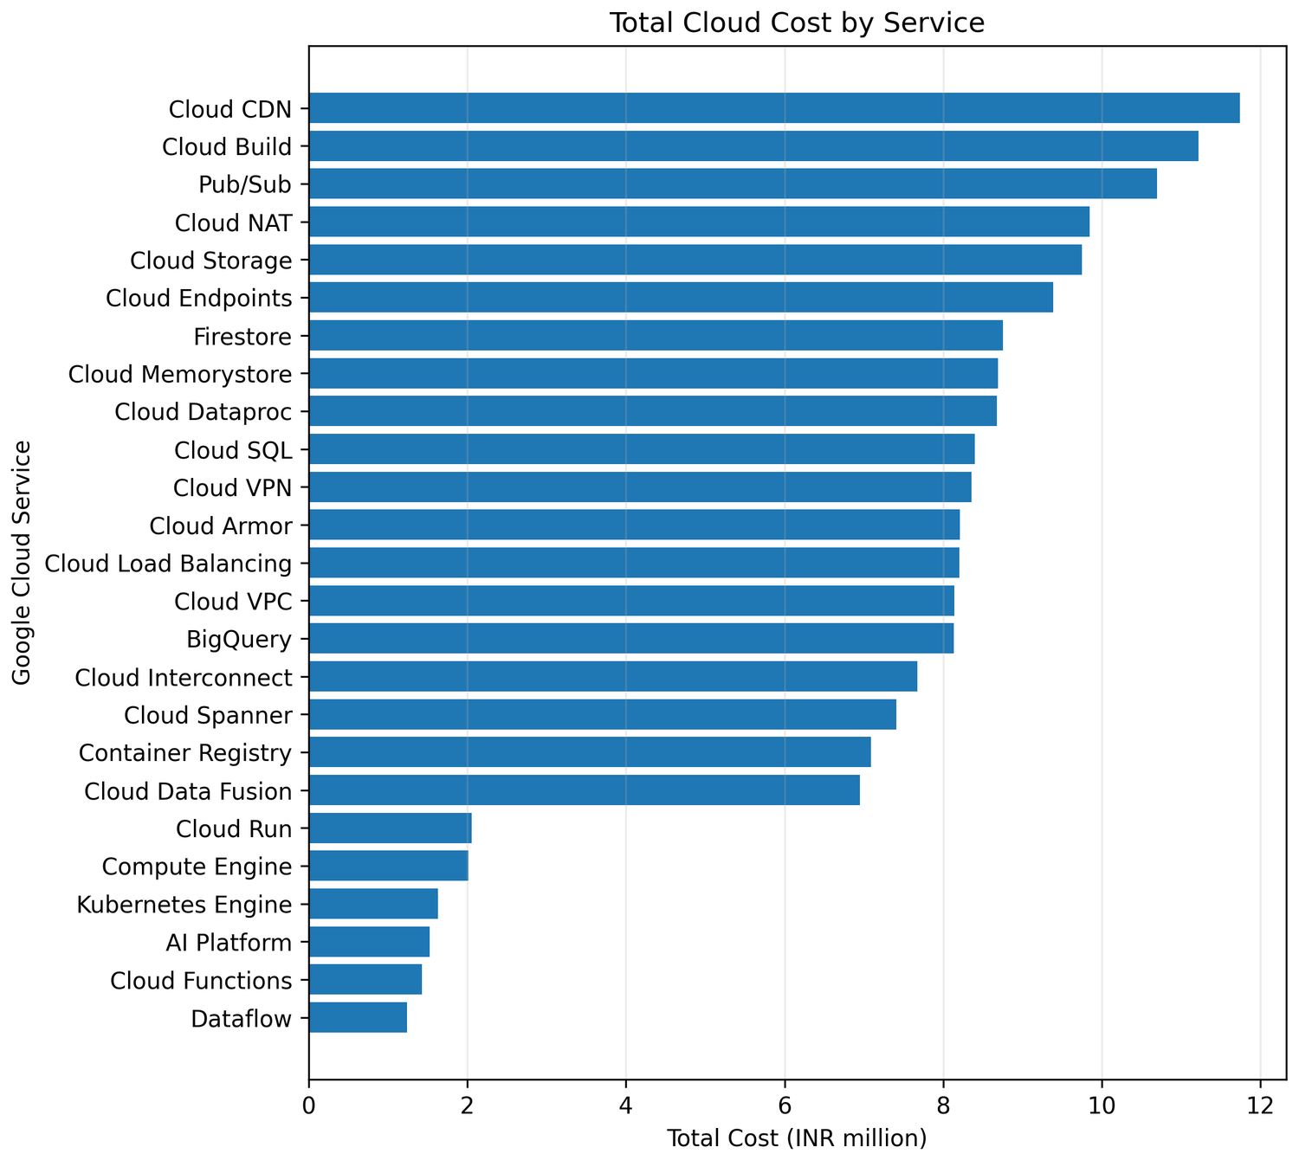
Fig. 3. Total cloud cost by GCP service.

D. Region-Wise Cost
Fig. 4 shows that expenditure is not evenly distributed across regions. us-east1 has the highest total cost, ₹17,896,377, followed by southamerica-east1 at ₹17,769,636 and europe-west1 at ₹16,280,533.
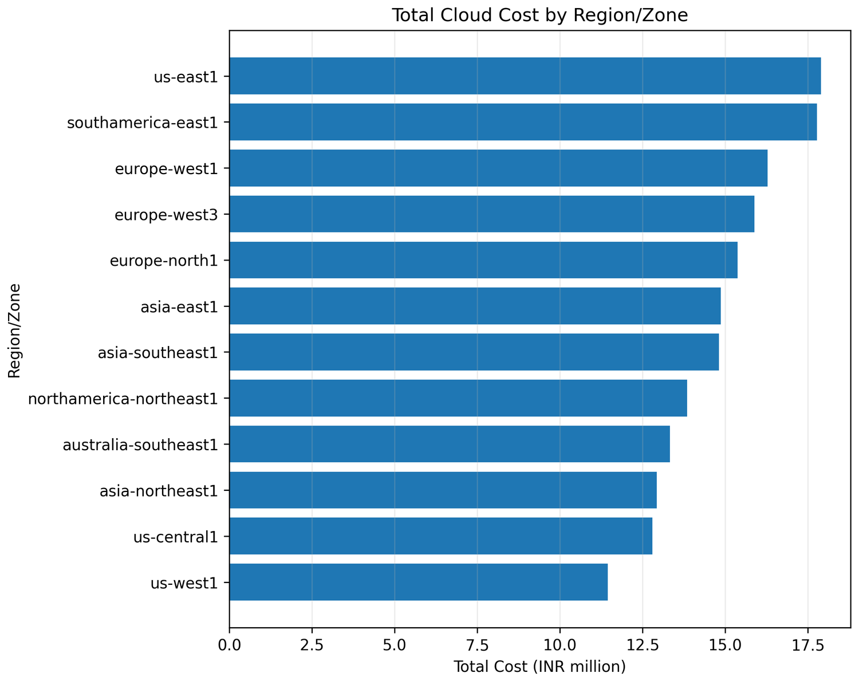
Fig. 4. Total cloud cost by region/zone.

E. Resource Utilization and Cost
Fig. 5 plots Total Cost against CPU and memory utilization. Neither plot shows a clear linear pattern, in agreement with Pearson correlations of −0.050 and −0.015. CPU or memory utilization alone is therefore not a useful linear explanation of cost in this dataset.
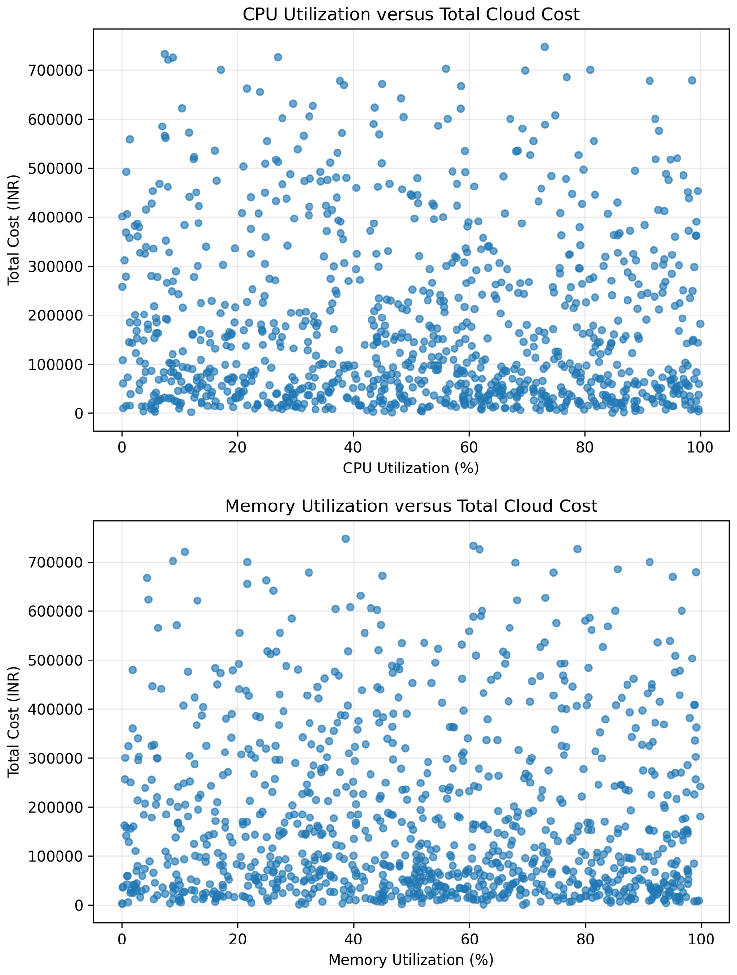
Fig. 5. Total cost versus CPU utilization (top) and memory utilization (bottom).

F. Correlation Analysis
Pearson correlation measures the strength and direction of a linear relationship on a scale from −1 to +1. Table IV and Fig. 6 show the relationships with Total Cost. Usage Quantity has the strongest relationship (r = 0.8115), cost per quantity a moderate one (r = 0.4822), and the CPU, memory and network variables negligible ones. Network inbound and outbound traffic are almost perfectly correlated (r = 0.9949, Fig. 6, bottom), yet both are weakly related to cost. The correlations among Unrounded, Rounded and Total Cost are essentially 1.00 because they are the same billing amount, and must not be read as independent relationships. Correlation describes linear association only and does not prove causation.
TABLE IV
CORRELATIONS WITH TOTAL COST
Variable | r | Strength
Usage Quantity | 0.8115 | Strong positive
Cost per Quantity ($) | 0.4822 | Moderate positive
CPU Utilization (%) | −0.0502 | Negligible
Memory Utilization (%) | −0.0150 | Negligible
Network Inbound Data | −0.0362 | Negligible
Network Outbound Data | −0.0348 | Negligible
Inbound vs. outbound data | 0.9949 | Very strong positive

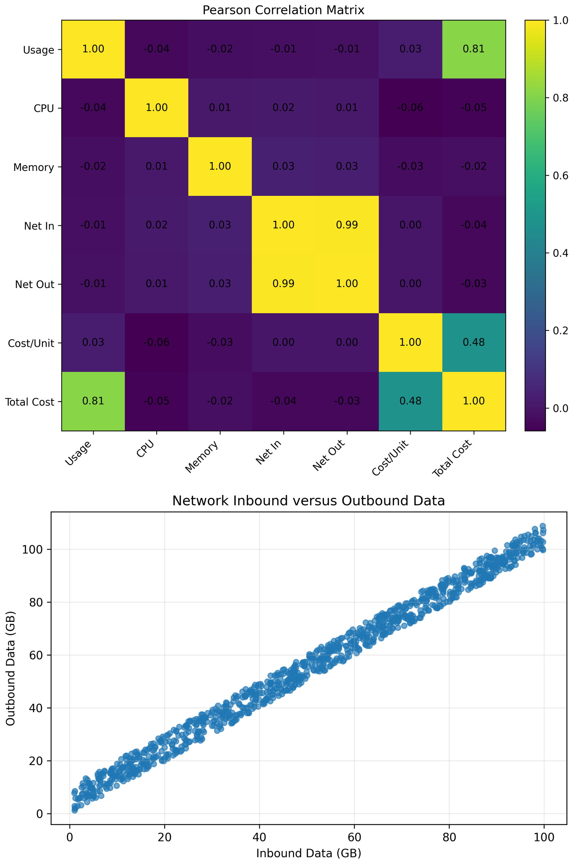
Fig. 6. Pearson correlation matrix (top) and network inbound versus outbound data (bottom).

G. Monthly Cost Trend
Fig. 7 aggregates Total Cost by usage start month. The total is about ₹0.88 million in June 2024 (only six records, because the data begin on 30 June), ₹99.20 million (₹99,201,683) in July and ₹77.14 million (₹77,137,959) in August. The marked differences between months indicate temporal variation in expenditure and motivate a time-based forecasting approach.
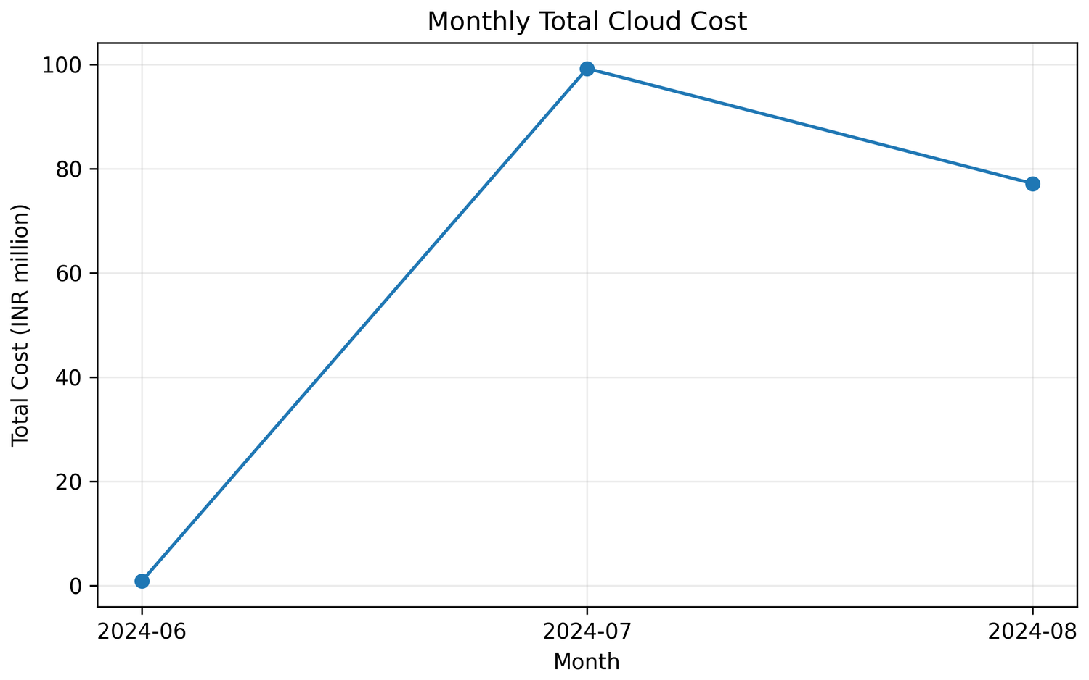
Fig. 7. Monthly total cloud cost by usage start date.

H. Summary of EDA Findings
The EDA gives four findings that shape the modelling. First, cost is strongly right-skewed with 24 high-cost outliers, so a Normal likelihood on raw cost is unsuitable and a log transform or a robust likelihood is preferable. Second, Usage Quantity is the main numerical driver of cost (r = 0.8115), whereas CPU and memory utilization show almost no linear relationship with cost; utilization is therefore not used as a predictor of cost and is instead used to define idle resources. Third, cost is concentrated in particular services and regions. Fourth, monthly totals vary substantially, which supports a time-series model of daily cost. Billing optimization should therefore focus on usage quantity, service-level and regional expenditure and high-cost records.

V. METHODOLOGY

A. Bayesian Inference and Workflow
Bayesian inference updates beliefs about unknown parameters θ after observing data, through Bayes’ theorem:
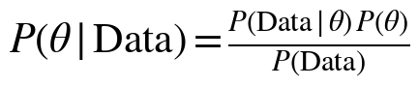 (1)
Here P(θ) is the prior, P(Data | θ) the likelihood and P(θ | Data) the posterior. Because P(Data) does not depend on θ, the posterior is proportional to likelihood × prior. Where the posterior has no closed form it is approximated by MCMC sampling with NUTS [9]. Forecasts use the posterior predictive distribution, and uncertainty is reported as equal-tailed 94% credible intervals computed from posterior draws.
The modelling follows the standard Bayesian workflow [8]: choose a sensible likelihood; specify priors and check them with a prior predictive simulation; fit the model with MCMC; check convergence diagnostics; check the model against the data with posterior predictive checks; and use the posterior to forecast and answer decision questions. Two models are built, each answering a different question (Table V).
TABLE V
THE TWO BAYESIAN MODELS
Aspect | Model 1: time series | Model 2: hierarchical
Data used | 59 daily total costs | 1,000 resource-level records
Question | How is daily spend trending, and what will the next 30 days cost? | Which of the 25 services cost most per record, and how certain are we?
Outcome | Standardised daily cost | Log of record cost
Likelihood | Student-t | Normal on log scale (lognormal cost)

B. Problem Formulation
Let C be the cost associated with a usage record, X = {X₁, …, X_{k}} explanatory variables such as usage quantity, service, region, duration, price and utilization, and D the observed data. The aim is the predictive distribution P(C | X, D), from which the probability that cost exceeds a predefined budget B follows:
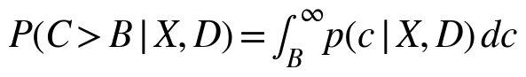 (2)
This is more informative than a point value. A result such as “expected cost ₹200,000, 95% credible interval [₹170,000, ₹235,000], probability of exceeding ₹220,000 equal to 18%” (an illustration only) lets administrators judge risk directly. In the implemented forecasting stage, the same idea is applied to the total cost of the next 30 days (Section V-G).

C. Prior Sensitivity Warm-Up
Two small examples show Bayes’ theorem at work and test sensitivity to the prior. In Example A, daily cost is Normal(μ, σ²) with σ fixed at the sample standard deviation, and the posterior of μ is computed numerically on a grid of 2,000 values between 0 and 80 ($ thousands). In Example B, a resource is defined as idle if both CPU and memory utilization are below 20%; k = 26 of n = 1,000 resources are idle (2.6%). With a Beta(a, b) prior the posterior is conjugate:
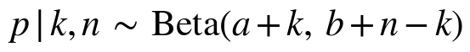 (3)
Table VI and Fig. 8 show the results. With a weak or flat prior the posterior essentially equals the data-driven estimate, whereas a strong prior at the wrong place, Normal(10, 2), drags the posterior mean to 25.09 against a sample mean of 35.78. For the idle fraction, the uniform and mild priors give the same posterior mean of 0.027, and even a strongly wrong Beta(20, 5) prior is largely overridden by the 1,000 observations (posterior mean 0.045). This motivates weakly informative priors that are justified rather than arbitrary.
TABLE VI
PRIOR SENSITIVITY OF THE WARM-UP EXAMPLES
Quantity | Prior | Post. mean | Note / 94% interval
A: mean daily cost ($k) | Normal(30, 15) | 35.71 | sample mean 35.78
 | Uniform(0, 80) | 35.78 | flat prior
 | Normal(10, 2) | 25.09 | strong, wrong prior
B: idle fraction | Beta(1, 1) | 0.027 | [0.018, 0.037]
 | Beta(2, 18) | 0.027 | [0.019, 0.038]
 | Beta(20, 5) | 0.045 | [0.033, 0.058]

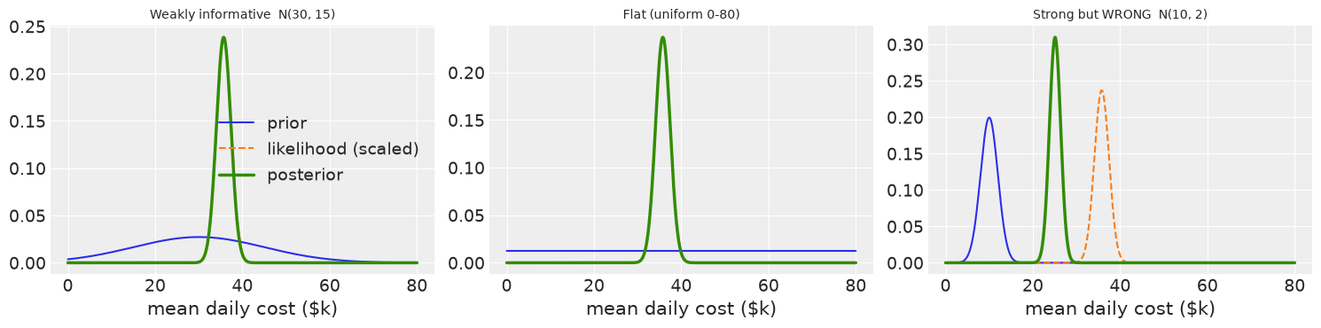
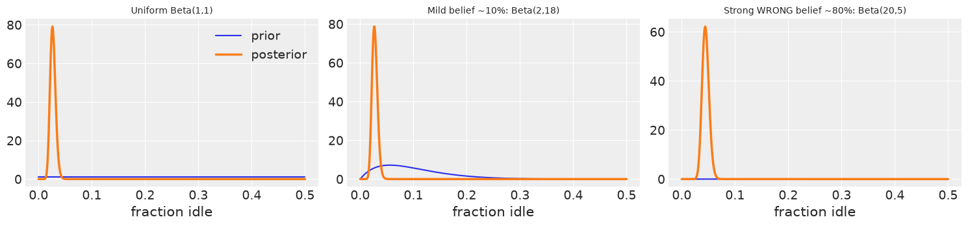
Fig. 8. Prior, likelihood and posterior for the mean daily cost under the three priors (Example A) and for the idle fraction (Example B).

D. Choice of Likelihood
A Normal and a Student-t distribution fitted to the daily totals gave almost identical log-likelihoods (both about −234.2), so there is no strong evidence of heavy tails. A Student-t likelihood [12] is still used for the time-series model because it is robust: an unusually high or low day is absorbed without distorting the other parameters, and the model reduces to nearly Normal if the data call for it. Record-level costs are strongly right-skewed (skewness 1.19), which conflicts with a Normal assumption and would allow negative costs. After a log transform the skewness falls to −0.48, so log cost is modelled as Normal, that is, cost as lognormal.

E. Model 1: Bayesian Time-Series Model
Let z_{t} be the standardised daily cost on day t, t_{scaled} = (day index)/(T − 1), which runs from 0 to 1 across the observed window, and d(t) the day of the week (0 = Monday … 6 = Sunday). The model is
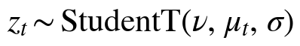 (4)
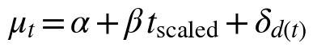 (5)
where α is the baseline level of standardised cost at the start of the window, β the change in standardised cost over the whole window (the trend), δ_{d} the day-of-week effect, σ the noise scale and ν the degrees of freedom. The day-of-week effects use a non-centred parametrisation [13],
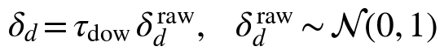 (6)
which avoids the funnel-shaped geometry that makes hierarchical models hard for NUTS; no divergent transitions occurred. Table VII lists the priors. Because the data are standardised, Normal(0, 1) on α and β is weakly informative and does not force a direction on the trend. HalfNormal priors keep the scale parameters positive [11], and the tighter HalfNormal(0.5) on τ_{dow} expresses a mild expectation that weekday effects are modest. Gamma(2, 0.1) for ν has mean 20 and a wide spread, so it allows both heavy tails (small ν) and near-Normal behaviour (large ν). Before fitting, 300 series were simulated from the priors alone and 50 were plotted against the observed series (Fig. 9); they cover a plausible range around the data without being absurdly wide.
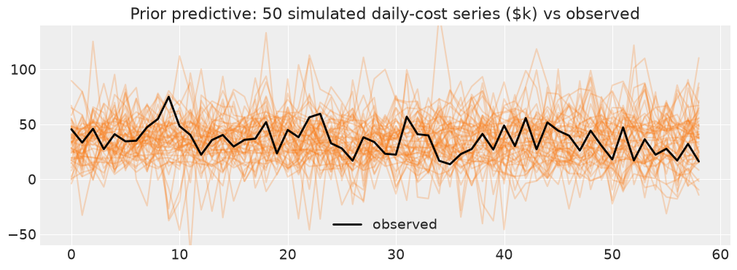
Fig. 9. Prior predictive check: 50 series simulated from the priors against the observed daily cost ($ thousands).

F. Model 2: Hierarchical Service Model
Let i index the 1,000 records and s(i) the service of record i (25 services). The model is
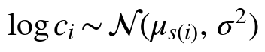 (7)
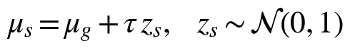 (8)
where μ_{g} is the overall mean log cost, τ the between-service variation and σ the within-service variation (priors in Table VII). The model-implied mean cost per record of a service follows from the lognormal mean:
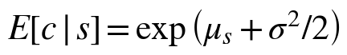 (9)
Evaluating this for every posterior draw gives a full posterior for each service’s mean cost and allows probabilistic ranking: in each draw the services are ranked, and the share of draws in which a service is among the five most expensive is its probability of being a top-five cost driver.
TABLE VII
PRIORS OF THE TWO MODELS
Model | Parameter | Prior | Role
1 | α | Normal(0, 1) | Baseline level
1 | β | Normal(0, 1) | Trend over window
1 | τ_{dow} | HalfNormal(0.5) | Weekday-effect scale
1 | δ^{raw}_{d} | Normal(0, 1) | Raw weekday effect
1 | σ | HalfNormal(1) | Noise scale
1 | ν | Gamma(2, 0.1) | Degrees of freedom
2 | μ_{g} | Normal(mean log cost, 2) | Overall mean log cost
2 | τ | HalfNormal(1.5) | Between-service SD
2 | σ | HalfNormal(2) | Within-service SD
2 | z_{s} | Normal(0, 1) | Raw service effect

G. Forecasting from the Posterior
For each posterior draw m = 1, …, M (M = 4,000) and each future day t* (with t_{scaled} continuing beyond 1), the mean and the simulated cost are
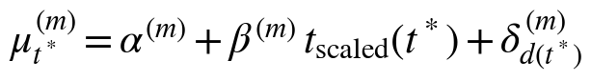 (10)
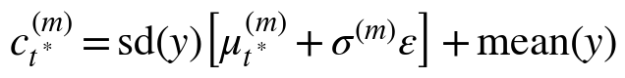 (11)
where ε is a Student-t draw with ν^{(m)} degrees of freedom, and sd(y) and mean(y) undo the standardisation. Summing over a 30-day horizon gives
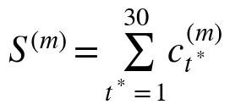 (12)
so that 4,000 possible 30-day futures are obtained. Their distribution gives the median, predictive intervals and, for a budget B, the exceedance probability
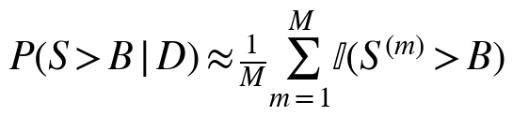 (13)
The planning budget is B = 30 × (historical mean daily cost). It is an analytical assumption, because an externally specified organizational budget was not available.

H. Resource Optimization Scenarios
Resources with CPU utilization below 20% and memory utilization below 20% are classified as potentially idle. Let s_{idle} be the share of historical cost associated with these resources and S̃ the median 30-day forecast. If a fraction f of the idle-resource cost is eliminated, the scenario saving is
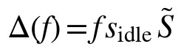 (14)
These are what-if estimates rather than guaranteed savings.

VI. SYSTEM IMPLEMENTATION

A. Overview
The system is implemented in Python in a project notebook, with the random seed fixed at 42 for reproducibility [4]. Fig. 10 shows the pipeline. The billing records are loaded and checked, two modelling datasets are derived, the two models are sampled, diagnostics and posterior predictive checks are run, and the posterior draws feed the forecasting, risk and optimization analysis and the held-out comparison.
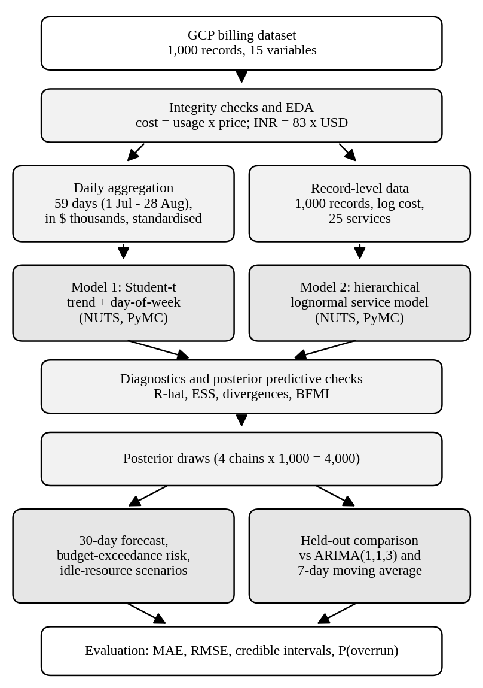
Fig. 10. Processing pipeline of the Bayesian cost-forecasting system.

B. Software Environment
pandas and NumPy handle data and numerical work; SciPy provides the grid posterior and the Beta and Student-t distributions; PyMC 6.3.1 [10] defines and samples the models with NUTS through the nutpie backend; ArviZ 1.3.0 [14] produces posterior summaries and diagnostics; and Matplotlib and Seaborn produce the figures.

C. Data Loading and Preparation
The Excel dataset is loaded, the 15 columns are renamed and integrity checks are run (no missing values; cost equals usage × price; fixed INR/USD rate of 83). Records are then aggregated to daily totals, restricted to full days, converted to $ thousands and standardised, and the 25 service categories are coded and the log cost prepared for Model 2.

D. Sampling and Forecasting
Both models use the same sampler settings: 4 chains, 1,000 tuning draws and 1,000 posterior draws per chain (4,000 posterior draws in total) and target_accept = 0.9, with non-centred day-of-week and service effects. After sampling, posterior predictive samples were drawn and pointwise log-likelihoods stored for possible model comparison. Algorithm 1 summarises fitting and forecasting, and Algorithm 2 the optimization scenarios.
Algorithm 1: FIT-AND-FORECAST(D, B)
1 y <- daily_totals(D); drop partial days
2 z <- (y - mean(y)) / sd(y) # $ thousands
3 post1 <- NUTS(Model1(z)) # 4 x 1,000
4 post2 <- NUTS(Model2(log cost, service))
5 check R-hat, ESS, divergences, BFMI, PPC
6 for each draw m in post1 (M = 4,000):
7 for t* in 1..30: simulate c[m,t*] (Eqs. 10-11)
8 S[m] <- sum over t* of c[m,t*]
9 return median(S), interval(S), mean(S > B)

Algorithm 2: IDLE-SCENARIOS(D, S_med)
1 idle <- {r : cpu(r) < 20 and mem(r) < 20}
2 s <- cost(idle) / cost(all)
3 for f in {0, 0.5, 1}:
4 savings[f] <- f * s * S_med
5 return savings

VII. EXPERIMENTAL SETUP

A. Convergence and Model Checking
Sampling quality is judged by the rank-normalised R-hat [15] (target < 1.01), the bulk and tail effective sample size, ESS (target > 400), the number of divergent transitions (target 0) and the Bayesian fraction of missing information, BFMI (target > 0.3 per chain). The fit is checked by comparing posterior predictive samples with the observed data.

B. Held-Out Evaluation
To compare forecasting accuracy, the same 59-day daily series was split chronologically 80/20 (Table VIII): the first 47 days are used for training and the final 12 days are the test period. The Bayesian model in this comparison has the same structure as Model 1 (Student-t likelihood, linear trend, day-of-week effects) but was estimated on the training days only. The full-data posterior used for the 30-day forecast was not used to compute the held-out metrics, so the test days did not leak into the estimation.
TABLE VIII
CHRONOLOGICAL TRAIN/TEST SPLIT
Set | Days | Period
Training (80%) | 47 | 1 Jul – 16 Aug 2024
Test (20%) | 12 | 17 – 28 Aug 2024

C. Baselines
Two conventional baselines are used: ARIMA(1,1,3) [5] and a 7-day moving average. All three methods predict the same 12 held-out days.

D. Evaluation Metrics
Accuracy is measured with the mean absolute error (MAE) and the root mean square error (RMSE) [16]:
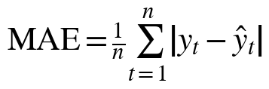 (15)
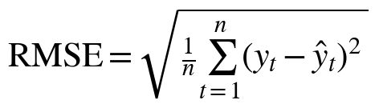 (16)
where y_{t} is the actual and ŷ_{t} the predicted daily cost and n = 12. Both are in USD, and lower values indicate better accuracy. RMSE gives more weight to large errors. These point metrics do not assess the credible intervals and exceedance probabilities of the Bayesian model.

VIII. RESULTS AND DISCUSSION

A. Model 1: Daily Cost Trend
Table IX gives the posterior summary on the standardised scale (94% equal-tailed intervals, 4 chains × 1,000 draws), and Fig. 11 shows the posterior distributions. The posterior of β lies almost entirely below zero, with P(β > 0 | Data) = 0.01. In dollars, the implied change in daily cost over the 59-day window has a median of about −$11.6k (94% interval −$21.1k to −$2.2k): within this dataset daily spend was falling, not rising. The noise scale σ ≈ 0.92 shows that a large amount of day-to-day variation remains after accounting for trend and weekday. The posterior mean of ν is 23.5 with a wide interval (5.9 to 56); values above about 30 make a Student-t practically Normal, so the data do not demand heavy tails, which is consistent with the nearly equal Normal and Student-t log-likelihoods.
TABLE IX
MODEL 1 POSTERIOR SUMMARY
Parameter | Mean | SD | 94% interval | R-hat | ESS
α (baseline) | 0.42 | 0.243 | [−0.041, 0.88] | 1.00 | 1,789
β (trend) | −0.91 | 0.39 | [−1.6, −0.17] | 1.00 | 2,057
σ (scale) | 0.92 | 0.099 | [0.75, 1.1] | 1.00 | 3,709
ν (d.o.f.) | 23.5 | 14 | [5.9, 56] | 1.00 | 3,714
τ_{dow} | 0.198 | 0.158 | [0.0095, 0.58] | 1.00 | 1,337

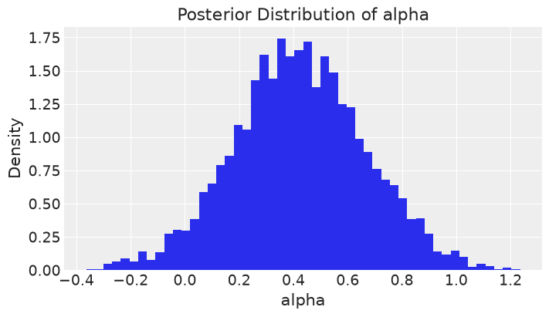
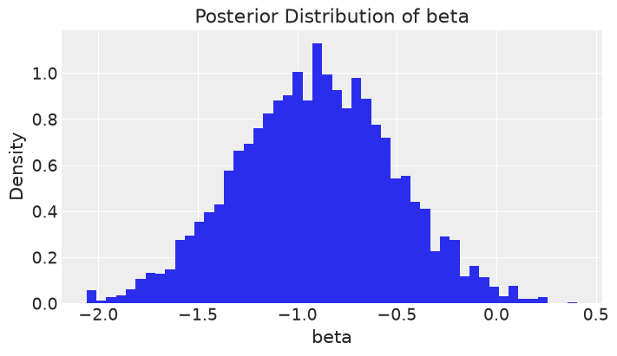
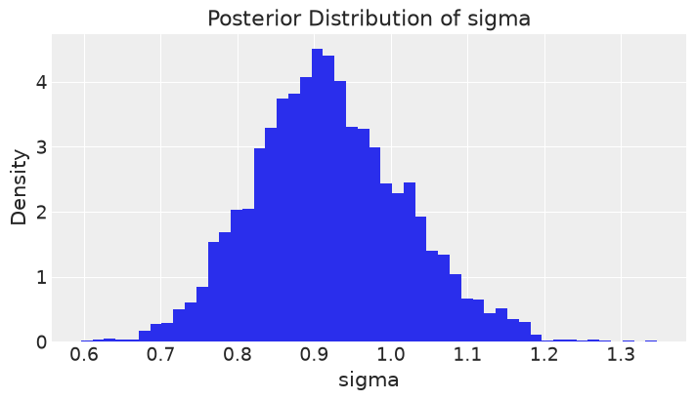
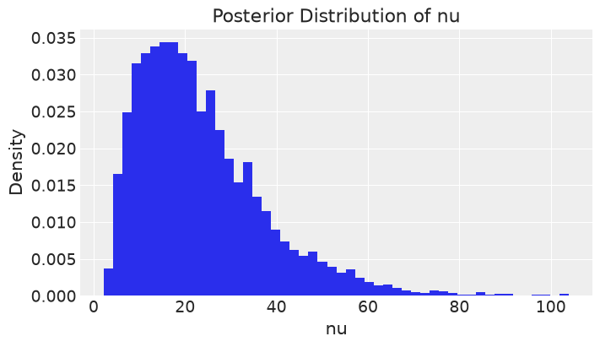
Fig. 11. Posterior distributions of α, β, σ and ν for Model 1.
All seven day-of-week effects have 94% intervals that include zero (Table X). Saturday is slightly lowest (−0.128) and Wednesday slightly highest (0.131), but both are well within the uncertainty, so there is no convincing evidence of a weekly cycle in this data.
TABLE X
DAY-OF-WEEK EFFECTS (STANDARDISED)
Day | Mean | 94% interval | Day | Mean | 94% interval
Mon | 0.003 | [−0.35, 0.40] | Thu | 0.047 | [−0.28, 0.46]
Tue | −0.063 | [−0.49, 0.26] | Fri | 0.055 | [−0.27, 0.47]
Wed | 0.131 | [−0.16, 0.66] | Sat | −0.128 | [−0.62, 0.16]
Sun | −0.017 | [−0.38, 0.35]

B. Model 2: Service-Level Cost
Table XI summarises Model 2. The between-service SD τ ≈ 0.72 is large relative to the within-service SD σ ≈ 1.0, so service identity explains a meaningful part of the cost variation. Table XII lists the five services with the highest cost per record, with the posterior mean, interval, raw observed mean and probability of being in the top five (Fig. 12). Cloud NAT is very likely (0.84) but not certain to be a top-five driver, and the wide intervals show that neighbouring services at the top are not statistically separable.
TABLE XI
MODEL 2 POSTERIOR SUMMARY
Parameter | Mean | SD | 94% interval | R-hat | ESS
μ_{g} (mean log cost) | 7.1 | 0.144 | [6.8, 7.4] | 1.02 | 318
τ (between-service SD) | 0.72 | 0.113 | [0.54, 0.96] | 1.01 | 437
σ (within-service SD) | 1.015 | 0.0235 | [0.97, 1.1] | 1.00 | 4,668

TABLE XII
SERVICES WITH THE HIGHEST COST PER RECORD
Service | Post. mean ($) | 94% interval ($) | Raw mean ($) | P(top 5)
Cloud NAT | 4,011 | [2,849, 5,445] | 3,389 | 0.84
Cloud Data Fusion | 3,793 | [2,573, 5,404] | 3,351 | 0.71
Cloud Load Balancing | 3,534 | [2,479, 4,946] | 3,089 | 0.58
Container Registry | 3,402 | [2,398, 4,707] | 2,846 | 0.49
Cloud CDN | 3,341 | [2,542, 4,293] | 2,773 | 0.46

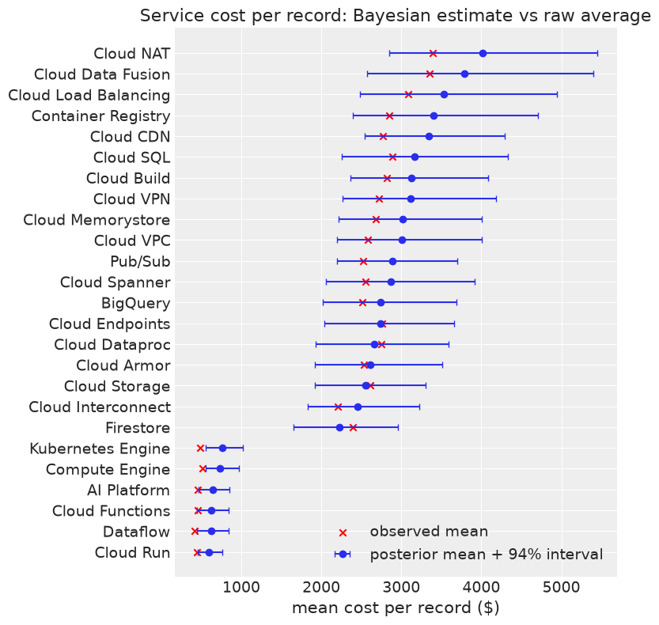
Fig. 12. Posterior mean and 94% interval of the cost per record of each service, compared with the observed mean.
The six cheapest services (Cloud Run, Dataflow, Cloud Functions, AI Platform, Compute Engine and Kubernetes Engine) have posterior mean costs of about $595 to $764 per record, a clear gap to the other 19 services, whose means range from about $2,200 to $4,000. The model-implied means exceed the raw means for most services (for example Cloud NAT $4,011 against $3,389), because log cost retains some left skew (−0.48) and the lognormal form slightly overstates the mean. Model 2 is therefore best used to rank services and quantify relative differences rather than as an exact cost estimate. Note also that the ranking by cost per record differs from the ranking by total cost in Section IV: totals combine the number of records with the cost per record, so Cloud CDN has the highest total whereas Cloud NAT has the highest cost per record.

C. Convergence and Model Checking
Table XIII gives the convergence diagnostics, and Fig. 13 the trace plots. Model 1 converged cleanly on every criterion. Model 2 has no divergences and good energy, but its group-level parameters μ_{g} and τ mix more slowly (R-hat 1.02 for μ_{g}, bulk ESS 318), which is common in hierarchical models because μ_{g} and the service effects trade off against each other. The service-level conclusions are not sensitive to this, but a final run with 2,000 tuning and 2,000 draws per chain is recommended so that all targets are met. The posterior predictive distributions of daily cost (Model 1) and of log record cost (Model 2) cover the observed data range and have the same general shape (Fig. 14).
TABLE XIII
CONVERGENCE DIAGNOSTICS
Diagnostic | Target | Model 1 | Model 2
Max. R-hat | < 1.01 | 1.004 (met) | 1.017 (slightly above)
Min. bulk ESS | > 400 | 1,337 (met) | 318 (slightly below)
Min. tail ESS | > 400 | 1,350 (met) | 575 (met)
Divergences | 0 | 0 (met) | 0 (met)
BFMI per chain | > 0.3 | 0.85–0.93 (met) | 0.70–0.73 (met)

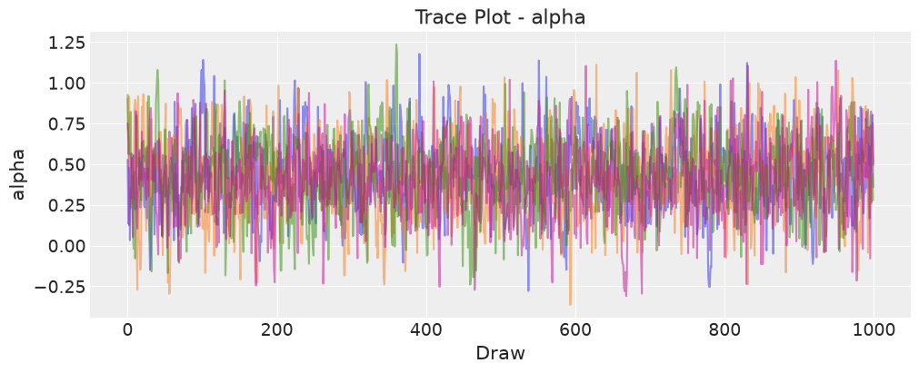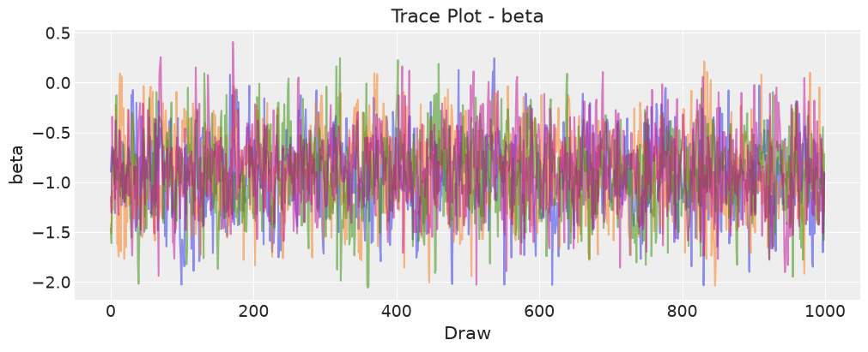
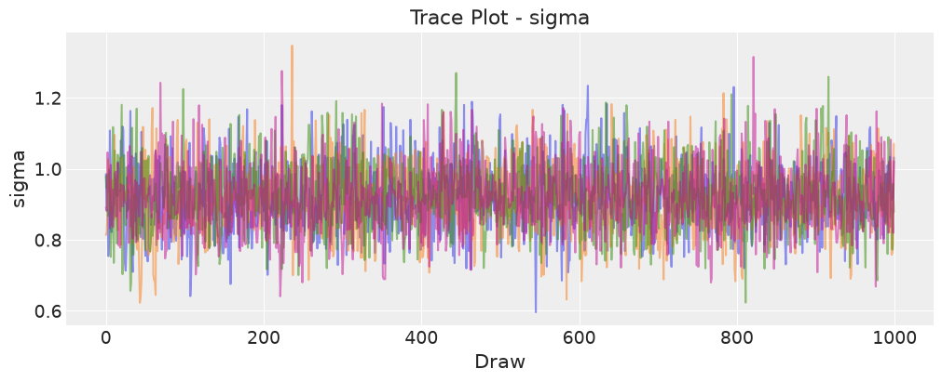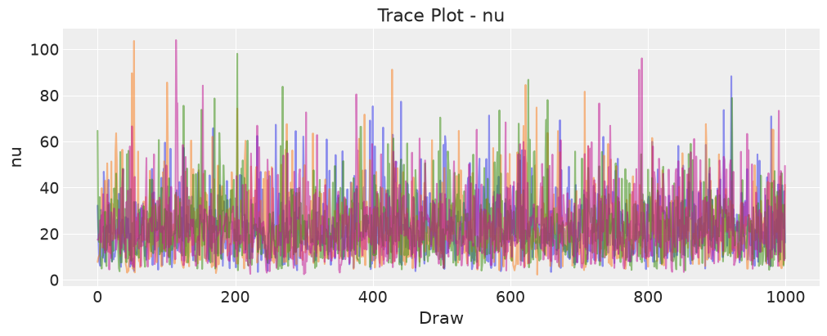
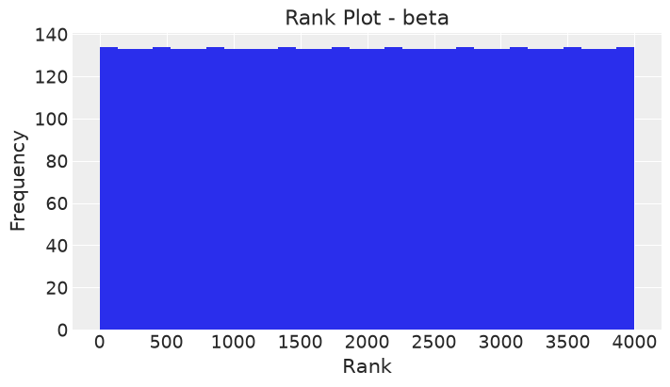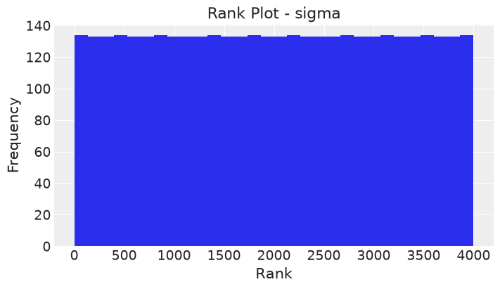
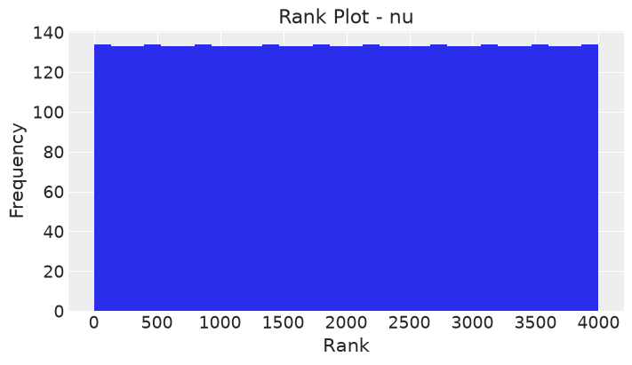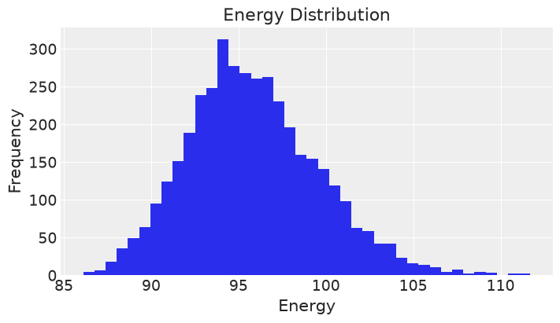
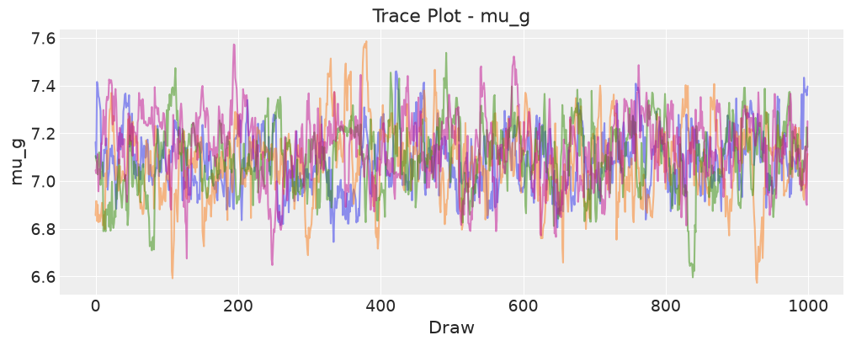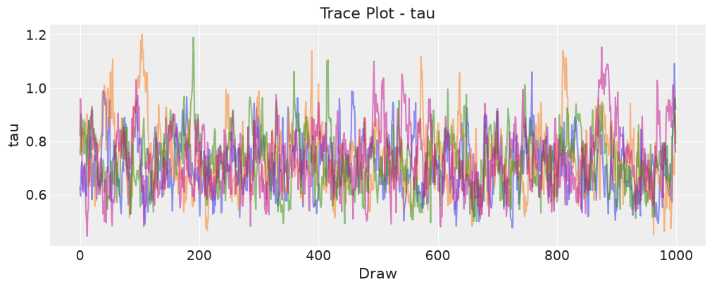
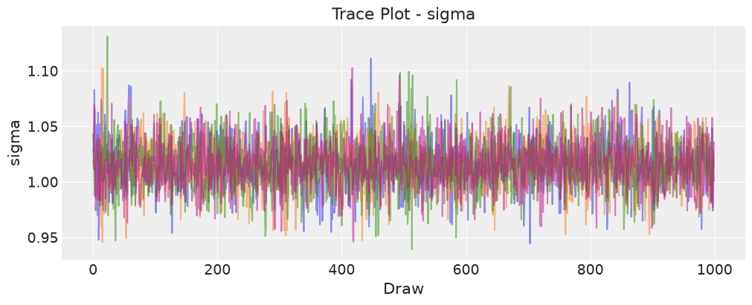
Fig. 13. Trace plots of the main parameters of Models 1 and 2.
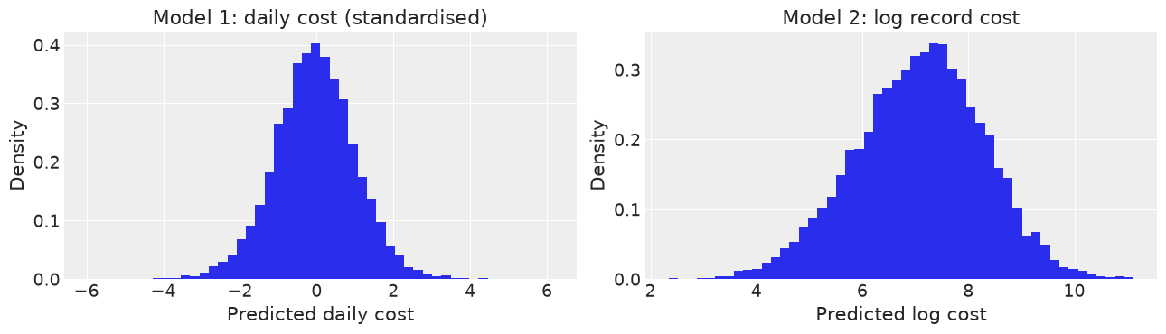
Fig. 14. Posterior predictive checks: daily cost (Model 1, $ thousands) and log record cost (Model 2).

D. 30-Day Forecast and Budget Risk
Posterior samples of Model 1 were used to simulate 4,000 possible 30-day cost scenarios as described in Section V-G; Table XIV and Fig. 15 summarise the result. The median predicted cost for the next 30 days is $793,267.40, and the 94% predictive interval is approximately $518,123 to $1,077,778. The planning budget, the historical mean daily cost times 30 days, is $1,073,313.26, and the estimated probability of exceeding it is 3.17%. The median forecast lies well below the planning budget because the fitted trend is negative, so under the stated assumption the estimated probability of a budget overrun is relatively low. The forecast should be read as “if the observed trend continues”.
TABLE XIV
30-DAY BAYESIAN FORECAST AND BUDGET RISK
Quantity | Value
Median 30-day cost | $793,267.40
94% predictive interval | $518,123-$1,077,778
Planning budget (30 × mean daily cost) | $1,073,313.26
P(30-day cost > planning budget) | 3.17%
Simulated scenarios | 4,000

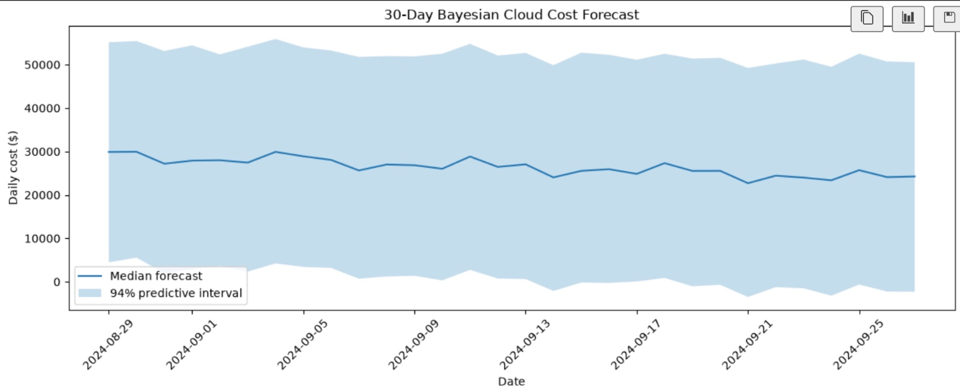
Fig. 15. Distribution of simulated 30-day total cost with the median, 94% interval and planning budget.

E. Idle Resources and Optimization
Of the 1,000 resources, 26 (2.6%) have both CPU and memory utilization below 20%. The posterior mean of the idle fraction is 0.027 (94% interval 0.018 to 0.037 under a uniform prior). Their mean cost is $2,423 per resource, compared with $2,135 for all resources, and their historical cost is $63,003.67, which is 2.95% of the total. A small but measurable part of expenditure is therefore associated with under-utilized resources. Table XV gives two what-if scenarios based on the historical idle-resource cost share: eliminating half of the idle cost lowers the median 30-day cost to $781,563.95 (saving $11,703.45), and eliminating all of it to $769,860.51 (saving $23,406.90). These are scenario estimates, not guaranteed savings.
TABLE XV
OPTIMIZATION SCENARIOS
Scenario | Median 30-day cost | Potential savings
No optimization | $793,267.40 | —
50% idle-resource optimization | $781,563.95 | $11,703.45
100% idle-resource optimization | $769,860.51 | $23,406.90

Five practical recommendations follow. First, monitor the high-cost services first, particularly Cloud NAT, Cloud Data Fusion, Cloud Load Balancing, Container Registry and Cloud CDN. Second, investigate the 26 potentially idle resources and consider rightsizing, scheduling or decommissioning where appropriate. Third, use the predictive interval rather than the median alone when setting a financial buffer. Fourth, use the exceedance probability of 3.17% as a quantitative measure of budget risk under the assumed planning budget. Fifth, re-run the forecast regularly, because the model rests on a limited history.

F. Comparison with ARIMA and Moving Average
Table XVI lists the predictions for the 12 held-out days, and Table XVII and Fig. 16 compare the three methods. The Bayesian model has the lowest MAE ($10,247.52) and RMSE ($11,956.49), followed by ARIMA(1,1,3) ($12,221.39 and $13,658.38) and the 7-day moving average ($15,528.27 and $17,622.79). Relative to ARIMA, the Bayesian model reduces MAE by about 16.2% and RMSE by about 12.5%; relative to the moving average, by about 34.0% and 32.1%. The ranking is the same on both metrics.
TABLE XVI
HELD-OUT DAILY PREDICTIONS (USD)
Date | Actual | Bayesian | ARIMA | MA (7-day)
2024-08-17 | 26,043.10 | 33,368.65 | 36,789.64 | 42,380.98
2024-08-18 | 44,052.62 | 33,516.37 | 30,495.80 | 41,472.39
2024-08-19 | 30,418.88 | 35,042.83 | 38,342.58 | 43,099.86
2024-08-20 | 17,885.32 | 33,857.62 | 35,602.84 | 41,328.15
2024-08-21 | 47,070.55 | 36,014.44 | 36,559.43 | 43,359.00
2024-08-22 | 16,982.60 | 35,409.99 | 36,225.43 | 42,186.57
2024-08-23 | 36,208.13 | 34,434.69 | 36,342.05 | 41,913.76
2024-08-24 | 22,185.81 | 32,515.59 | 36,301.33 | 42,248.67
2024-08-25 | 27,575.69 | 32,742.92 | 36,315.55 | 42,229.77
2024-08-26 | 16,908.47 | 34,327.50 | 36,310.59 | 42,337.97
2024-08-27 | 32,029.51 | 33,096.95 | 36,312.32 | 42,229.13
2024-08-28 | 16,027.76 | 35,299.53 | 36,311.71 | 42,357.84

TABLE XVII
FINAL FORECASTING MODEL COMPARISON
Model | MAE (USD) | RMSE (USD) | Rank
Bayesian Model 1 | 10,247.52 | 11,956.49 | 1
ARIMA(1,1,3) | 12,221.39 | 13,658.38 | 2
Moving average (7-day) | 15,528.27 | 17,622.79 | 3

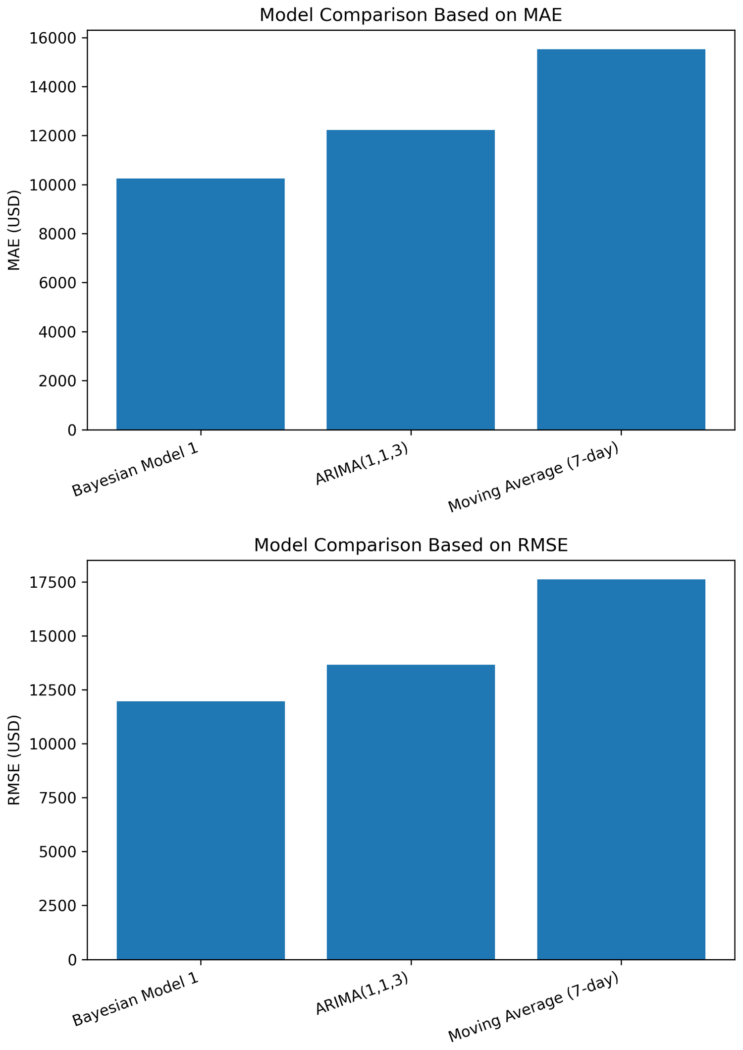
Fig. 16. MAE (top) and RMSE (bottom) of the three models on the 12-day test period.
Fig. 17 shows that the ARIMA and moving-average predictions are almost constant over most of the test period (about $36.3k for ARIMA from 22 August onward, and $41.3k–$43.4k for the moving average), while the Bayesian predictions vary between about $32.5k and $36.0k. None of the models captures the large day-to-day swings in the actual cost. The result is an empirical comparison on 12 days. It does not show that Bayesian forecasting always outperforms ARIMA or moving averages on other data or periods; its main advantage is that, beyond a competitive point forecast, it supplies full predictive distributions and budget-risk probabilities.
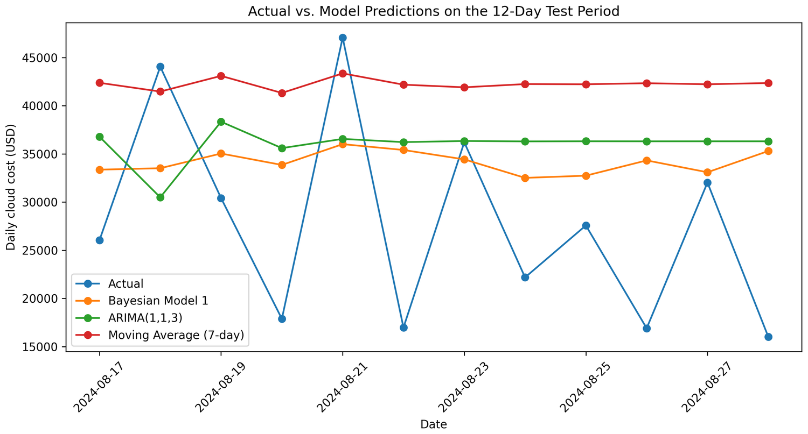
Fig. 17. Actual daily cloud cost versus model predictions during the 12-day test period.

G. Discussion
Together the results show how Bayesian forecasting, uncertainty analysis and scenario-based optimization support cost management. Rather than a single estimate, the model produces thousands of possible futures and quantifies uncertainty and budget risk. The EDA and the models agree that billing is driven by usage volume, service and unusually high-cost records, not by CPU or memory percentages, which is why idle resources are analysed separately and utilization is not used as a predictor. The predictive intervals are wide because only 59 days are available; this width is a statement of the real uncertainty, and it should be used when setting a financial buffer instead of relying on the median alone.

IX. LIMITATIONS AND FUTURE WORK
- Short history. Only 59 daily observations are available, so trend and seasonality are weakly identified and the intervals are wide. No long-term seasonal forecast is claimed.
- Linear trend extrapolation. Model 1 assumes a straight-line trend. The estimated trend is strongly negative, and extending a falling line 30 days is risky because cost cannot fall below zero and trends rarely continue unchanged. Local-level or random-walk components should be tested.
- No autocorrelation. Daily costs are treated as conditionally independent given trend and weekday. An autoregressive or local-level component is a natural extension.
- Weak weekly pattern. The day-of-week effects cannot be distinguished from zero in this data.
- Lognormal assumption. The model-implied mean is higher than the raw mean for most services, so Model 2 should be used for ranking rather than exact cost estimates.
- Dataset structure. Each Resource ID appears once and utilization has almost no correlation with cost (−0.05 and −0.015), so utilization is not used as a predictor. Usage quantity, region and unit price could be added to an extended hierarchical model.
- Convergence of Model 2. R-hat of 1.017 and a bulk ESS of 318 are slightly outside the targets; a longer run is recommended.
- Planning-budget assumption. The 3.17% exceedance probability is conditional on an analytical budget equal to the historical mean daily cost × 30, not on an organizational budget. A real budget should be used in practice.
- Small test set. The comparison uses 12 held-out days, and the baseline predictions are nearly constant. Rolling-origin evaluation on longer data and interval-based scores are needed.
- Scenario savings. The idle-resource scenarios assume that the historical idle cost share carries over to the forecast and are not guaranteed savings.
- Fixed exchange rate and priors. All INR figures use a constant 83 INR per USD. The priors are weakly informative and checked by prior predictive simulation, but remain modelling assumptions; a prior sensitivity analysis of the full models is future work.

X. CONCLUSION
This project applied Bayesian methods to cloud cost forecasting and optimization on a GCP billing dataset of 1,000 records. The exploratory analysis showed right-skewed cost with 24 high-cost outliers, a strong link between cost and usage quantity (r = 0.8115) and negligible links with CPU and memory utilization. A Student-t time-series model and a hierarchical lognormal service model were fitted with NUTS in PyMC. The time-series model gave a median 30-day cost of $793,267.40, a 3.17% probability of exceeding a planning budget of $1,073,313.26 and a posterior probability of only 0.01 for an increasing trend. The hierarchical model identified Cloud NAT, Cloud Data Fusion, Cloud Load Balancing, Container Registry and Cloud CDN as the leading services by cost per record, and 26 idle resources representing 2.95% of historical cost gave scenario savings of $11,703 to $23,407. On the 12-day held-out period, the Bayesian model achieved an MAE of $10,247.52 and an RMSE of $11,956.49, better than ARIMA(1,1,3) and the 7-day moving average. The results are limited by the 59-day history, and the model should be re-run as new billing data become available. The project shows that a Bayesian approach provides not only a forecast but also its uncertainty and the risk of a budget overrun, which supports more informed cloud cost-management decisions.

REFERENCES
[1] M. Armbrust et al., “A view of cloud computing,” Commun. ACM, vol. 53, no. 4, pp. 50–58, Apr. 2010.
[2] A. Gelman, J. B. Carlin, H. S. Stern, D. B. Dunson, A. Vehtari and D. B. Rubin, Bayesian Data Analysis, 3rd ed. Boca Raton, FL, USA: CRC Press, 2013.
[3] “GCP cloud billing data,” Kaggle dataset by sairamn19. [Online]. Available: https://www.kaggle.com/datasets/sairamn19/gcp-cloud-billing-data
[4] “Bayesian forecasting for cloud cost optimization: project code and notebook,” project repository. [Online]. Available: repository URL to be added
[5] G. E. P. Box, G. M. Jenkins, G. C. Reinsel and G. M. Ljung, Time Series Analysis: Forecasting and Control, 5th ed. Hoboken, NJ, USA: Wiley, 2015.
[6] R. J. Hyndman and G. Athanasopoulos, Forecasting: Principles and Practice, 3rd ed. Melbourne, Australia: OTexts, 2021.
[7] S. J. Taylor and B. Letham, “Forecasting at scale,” Amer. Statistician, vol. 72, no. 1, pp. 37–45, 2018.
[8] A. Gelman et al., “Bayesian workflow,” arXiv:2011.01808, 2020.
[9] M. D. Hoffman and A. Gelman, “The No-U-Turn Sampler: Adaptively setting path lengths in Hamiltonian Monte Carlo,” J. Mach. Learn. Res., vol. 15, pp. 1593–1623, 2014.
[10] J. Salvatier, T. V. Wiecki and C. Fonnesbeck, “Probabilistic programming in Python using PyMC3,” PeerJ Comput. Sci., vol. 2, p. e55, 2016.
[11] A. Gelman, “Prior distributions for variance parameters in hierarchical models,” Bayesian Anal., vol. 1, no. 3, pp. 515–534, 2006.
[12] K. L. Lange, R. J. A. Little and J. M. G. Taylor, “Robust statistical modeling using the t distribution,” J. Amer. Statist. Assoc., vol. 84, no. 408, pp. 881–896, 1989.
[13] M. Betancourt and M. Girolami, “Hamiltonian Monte Carlo for hierarchical models,” in Current Trends in Bayesian Methodology with Applications. Boca Raton, FL, USA: CRC Press, 2015, pp. 79–101.
[14] R. Kumar, C. Carroll, A. Hartikainen and O. Martin, “ArviZ a unified library for exploratory analysis of Bayesian models in Python,” J. Open Source Softw., vol. 4, no. 33, p. 1143, 2019.
[15] A. Vehtari, A. Gelman, D. Simpson, B. Carpenter and P.-C. Bürkner, “Rank-normalization, folding, and localization: An improved R-hat for assessing convergence of MCMC,” Bayesian Anal., vol. 16, no. 2, pp. 667–718, 2021.
[16] R. J. Hyndman and A. B. Koehler, “Another look at measures of forecast accuracy,” Int. J. Forecasting, vol. 22, no. 4, pp. 679–688, 2006.

