EDS

Activity No:-1

**Name:- Suyash Sanjay Hadole Class:- CS7**

**PRN:- 202401110055**

**Roll No:-CS7-73**

Q1.Top 5 Movies with Highest IMDb rating.

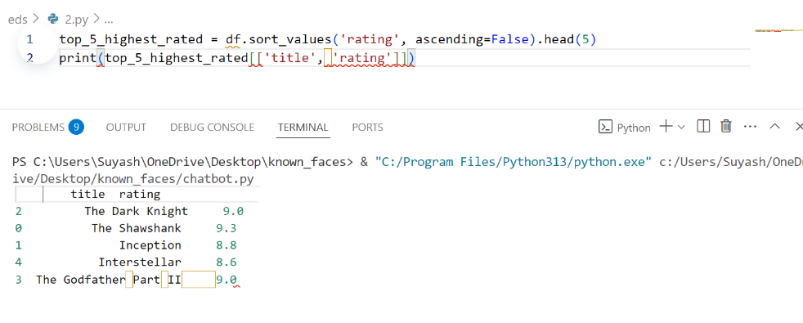

Q2.Avg Movies Duration

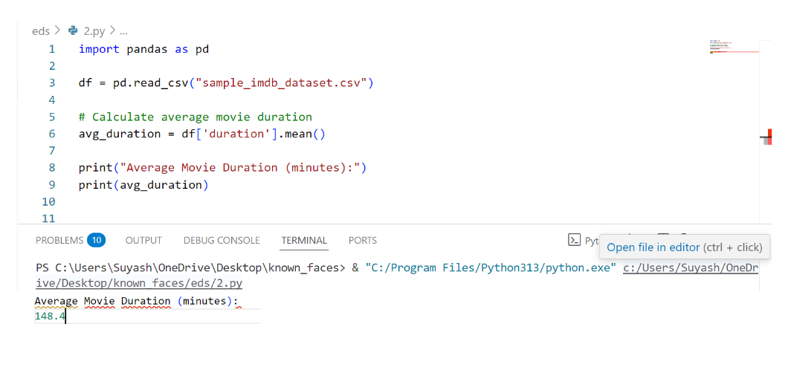

Q3.Total no. of movies relese after 2010

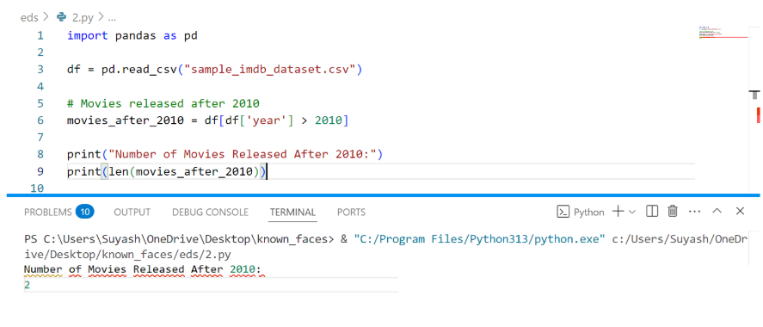

Q4.movies grouped by Genre

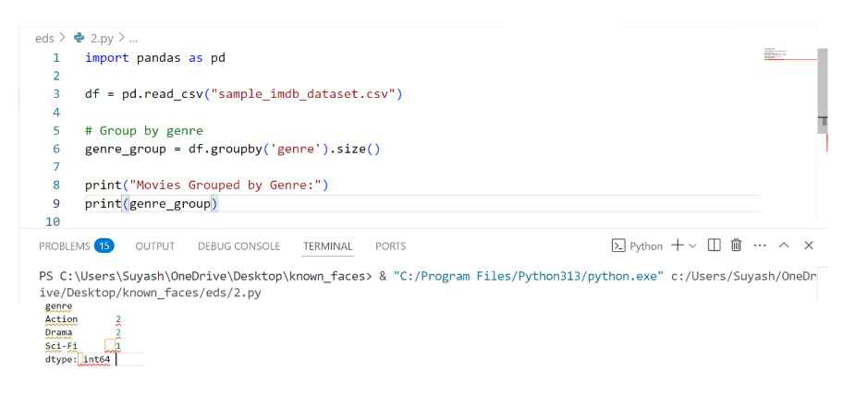

Q5.highest Grossing Movie

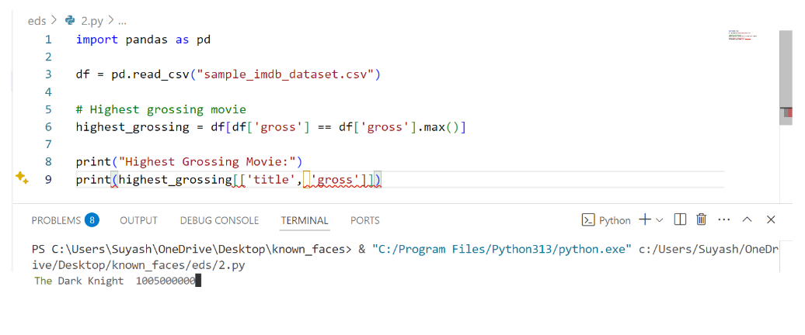

Q6.No. of Movies for Every year

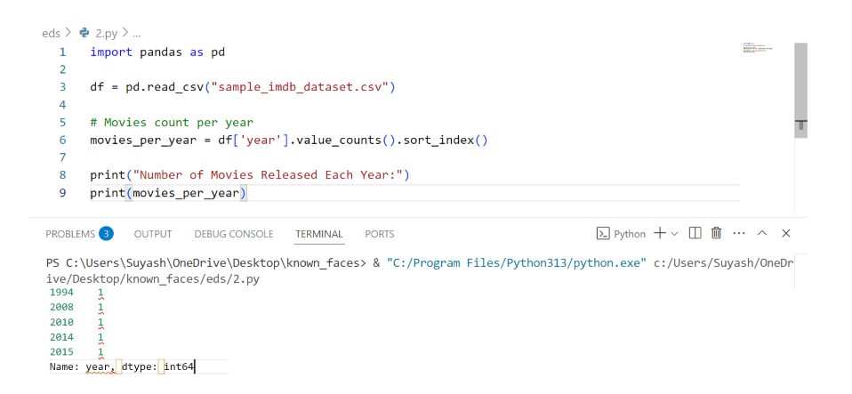

Q7.Movies having duration more than 2.5 hrs.

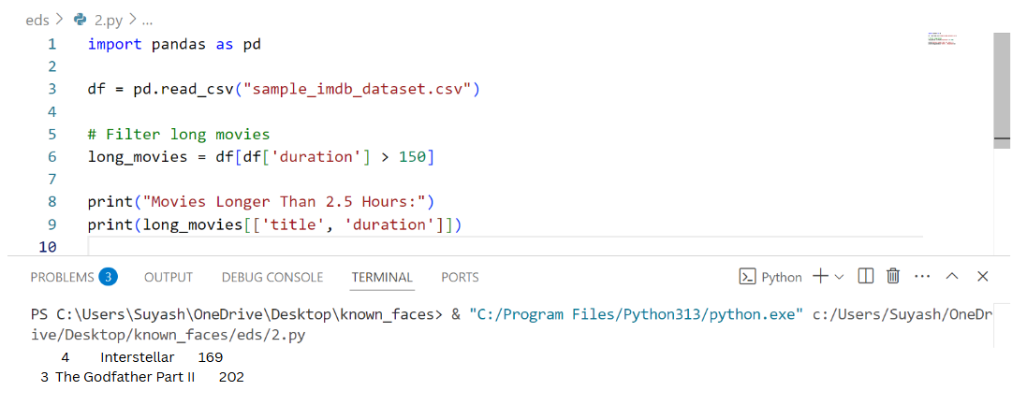

Q8.name of movie start with “The”

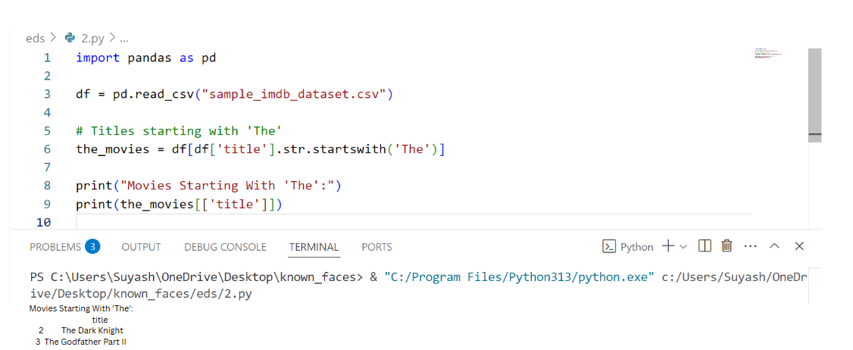

Q9.Calculate Revenue per minute

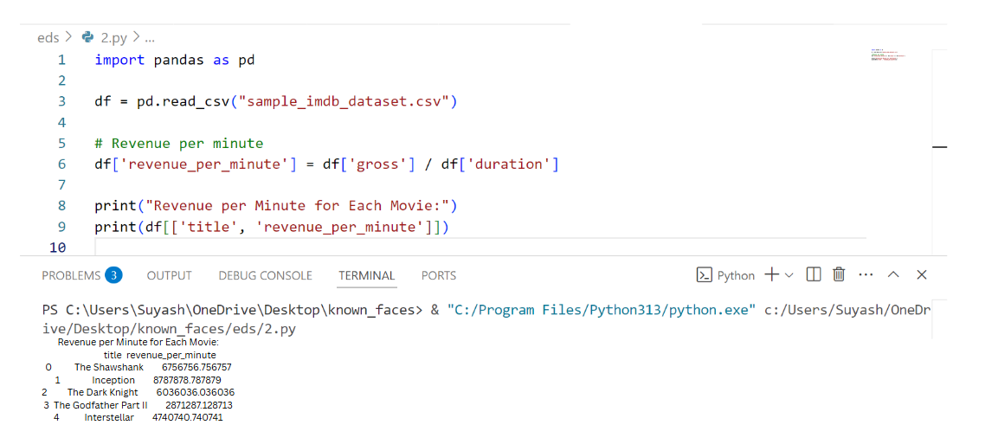

Q10.Sort Movie by Duration descending

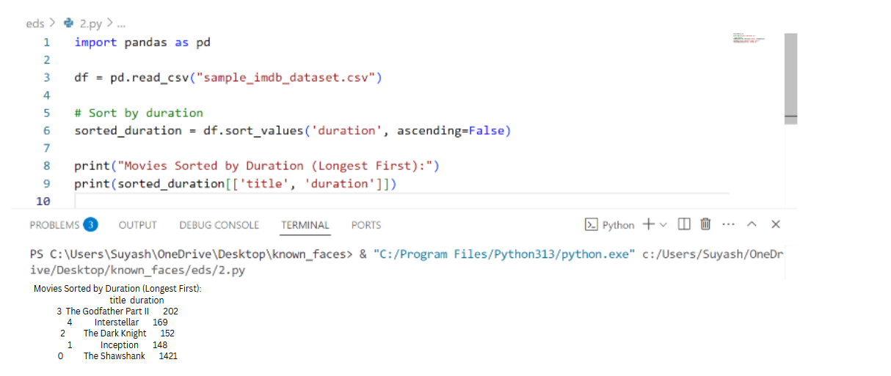

Q11.Find the Movie with Minimum IMDb Rating

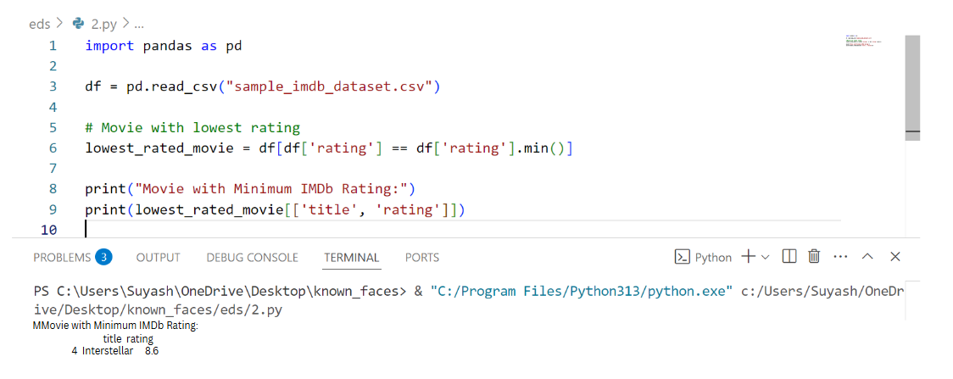

Q12.Median Duration of Movie

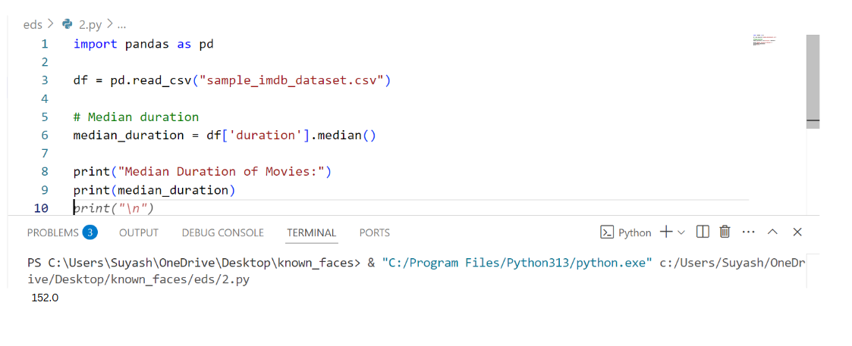

Q13.Number of Movie per Genre

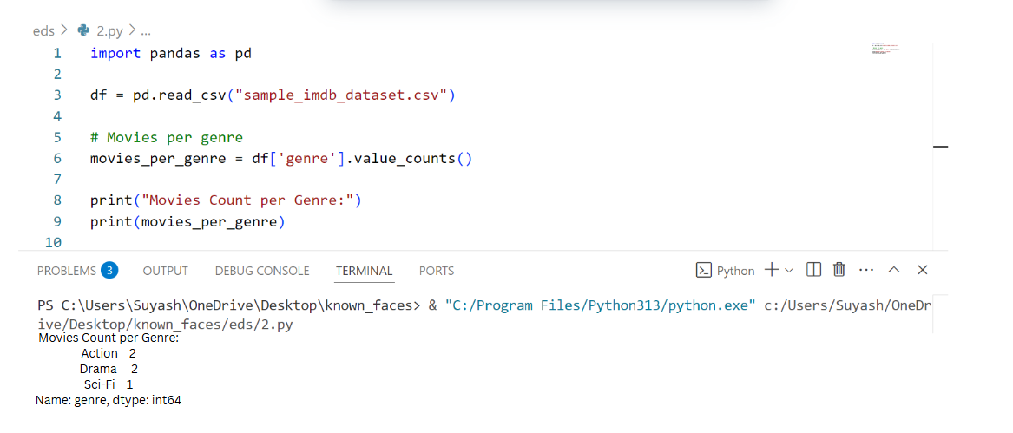

Q14.Avg Gross Collection by genre

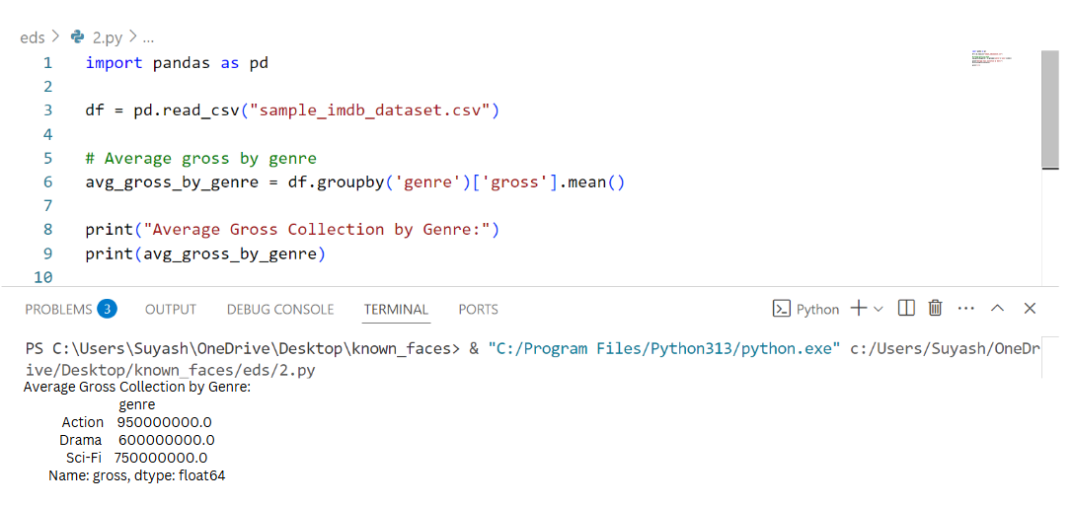

Q15.List All Unique Genre

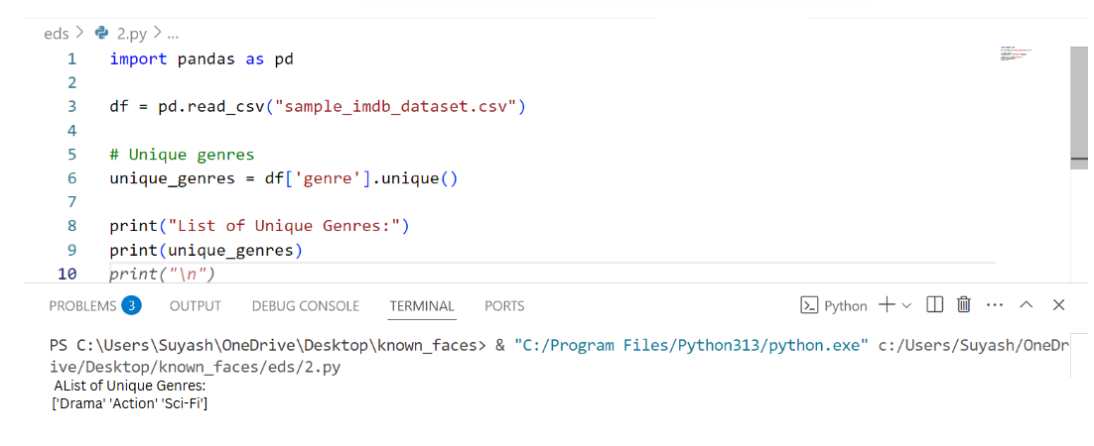

Q16.Movies With 8.8+ rating

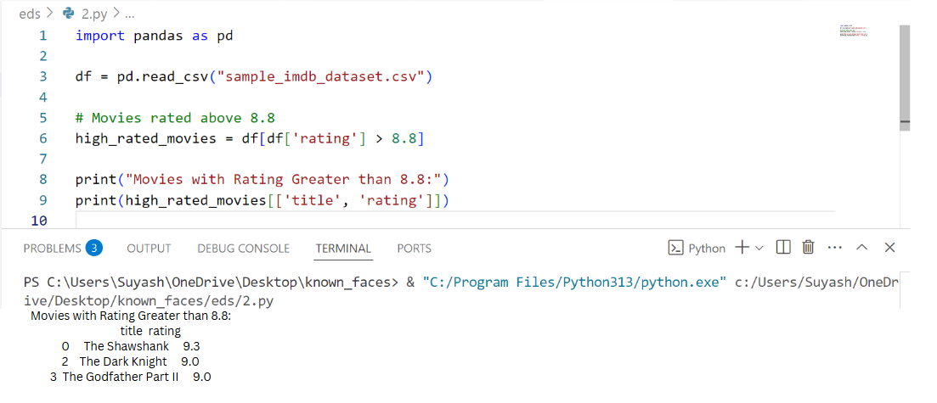

Q17.Display only Title and Year

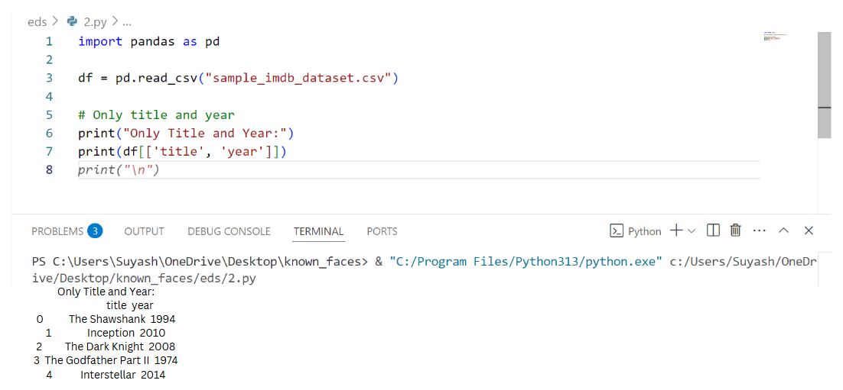

Q18.Calculate Total Gross Collection

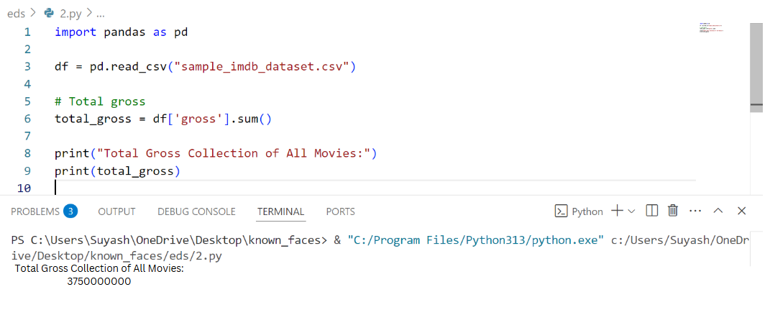

Q19.Find Movies Releses Before 2000

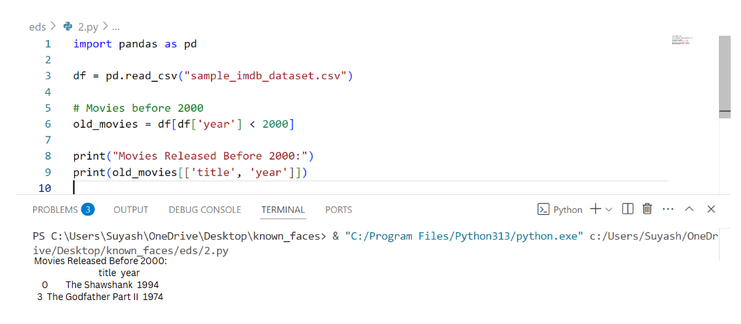

Q20.Find Movies Title With Word “Dark”

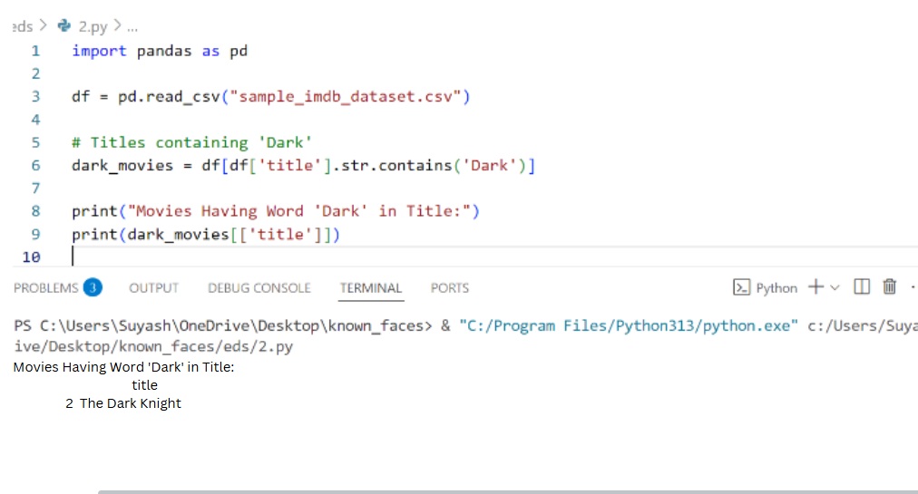

THANK YOU!!!

By Suyash Hadole(202401110055)