LECTURE 18
AI Application Evaluation
Building an E-commerce Support Agent with RAG, Tools,
Execution Tracing, Deterministic Evals and LLM-as-a-Judge

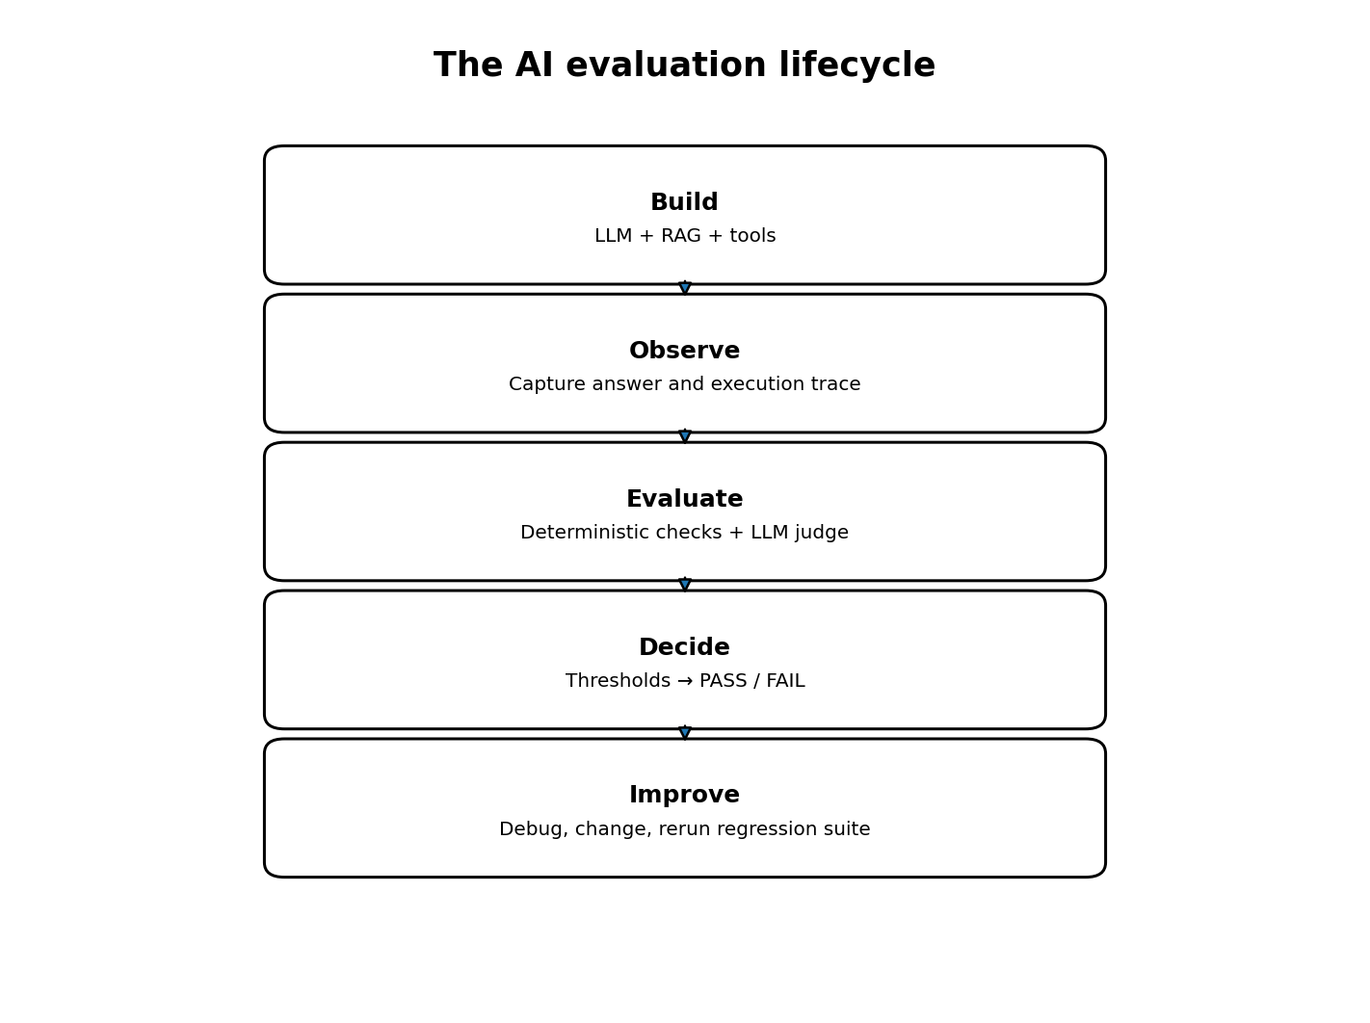
Detailed study notes • Concepts • Java and Python examples • Flow diagrams

How to use these notes
These notes explain the lecture's end-to-end idea: build an AI support application, observe what it actually does, evaluate both its execution and its answer quality, and produce a repeatable PASS / FAIL result.
The examples below are illustrative teaching examples that explain the concepts. They are not represented as verbatim copies of the instructor's source code or complete project.
Central idea
Do not judge an AI application only by the final text it returns. Inspect the retrieval, tool selection, tool arguments, tool results and answer—and evaluate each with the right method.

Learning outcomes
- Understand the role of a Golden Dataset and how it supports repeatable evaluation.
- Understand why the real application should execute during an end-to-end evaluation.
- Implement deterministic checks for response existence, tool selection, arguments and retrieved sources.
- Understand LLM-as-a-Judge and the five semantic quality dimensions.
- Combine both evaluation layers into a threshold-based PASS / FAIL pipeline.
- Recognize limitations of a small demo and how to strengthen it for production.

1. The application being tested
The lecture builds an E-commerce AI Support Chatbot using Spring AI. It answers company-policy questions with Retrieval-Augmented Generation (RAG), fetches live order information through tools, and combines RAG and tools when a question needs both.
Three broad question categories appear:
Question type | Example | Expected system behaviour
Knowledge / policy | How many days can I return a product? | Retrieve the return policy and answer from it.
Live data / tool | Where is order ORD-101? | Call the order-status tool with ORD-101.
Combined RAG + tool | Can I get a refund for ORD-101 under this policy? | Retrieve the relevant policy, fetch order information, and reason over both.

RAG and tools solve different problems. RAG retrieves relevant information from a knowledge base, such as policy documents. A tool performs an action or fetches live information from an external system, such as an order database or API.
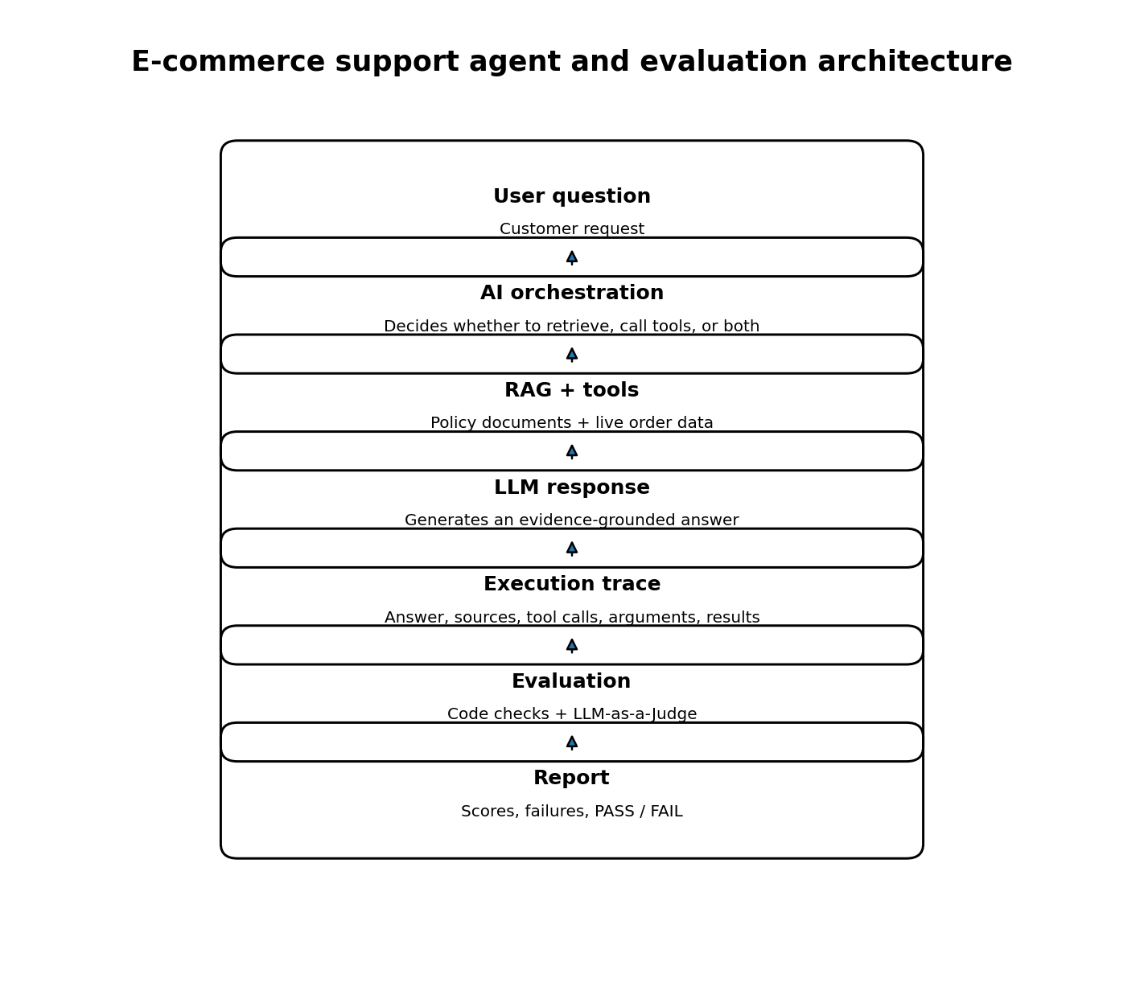

2. What is a Golden Dataset?
A Golden Dataset is a collection of test cases for which expected behaviour has been defined in advance. It is the AI application's equivalent of a known set of software test cases.
A test case should describe more than the desired final sentence. It can define the question, expected tool, expected tool argument, expected RAG source, reference answer and expected behaviour.

2. What is a Golden Dataset?
A Golden Dataset is a collection of test cases for which expected behaviour has been defined in advance. It is the AI application's equivalent of a known set of software test cases. A case can define the question, expected tool, expected tool argument, expected RAG source, reference answer and expected behaviour.

2.1 Example golden dataset entry
{
"id": "TEST-003",
"question": "Where is ORD-101?",
"expectedTool": "getOrderStatus",
"expectedToolArgument": "ORD-101",
"expectedSource": null,
"goldenAnswer": "Your order has been shipped.",
"expectedBehaviour": "Retrieve the order status."
}
Field | Meaning
id | Unique identifier for the test case.
question | Input sent to the AI application.
expectedTool | Tool expected to execute; null means no tool is expected.
expectedToolArgument | Expected value passed to the tool, such as an order ID.
expectedSource | Expected RAG document or source; null means no specific source is expected.
goldenAnswer | Reference answer used to assess semantic correctness.
expectedBehaviour | Human-readable description of desired behaviour.

A possible Spring Boot test-data location is src/test/resources/golden-dataset.json. Keeping test data under test resources separates it from runtime business logic.
src/
main/
java/com/example/support/
controller/ service/ tools/ models/ tracker/
resources/
application.properties
policies/return-policy.txt
refund-policy.txt
shipping-policy.txt
test/
java/com/example/support/SupportAgentEvaluationTest.java
resources/golden-dataset.json

2.2 Why it matters: regression testing
A prompt, model, retriever or tool change can improve one question and break another. Re-running the same Golden Dataset helps detect regressions: previously working behaviour that has stopped working.
Remember
The Golden Dataset defines what the system should do. The execution trace records what it actually did. Evaluation compares the two.

3. Execute the real application
For an end-to-end evaluation, the instructor runs the actual support service rather than mocking the LLM response. A mocked answer can test surrounding Java code, but it cannot establish whether the real model chooses the correct tool or retrieves the right information.
AgentResponse response =
supportService.chat(evalCase.getQuestion());
The real execution can involve the LLM, RAG retriever, vector store, tool functions, external services and response generation. The returned answer should be accompanied by an execution trace.

3.1 Example execution trace
{
"answer": "Products may be returned within 30 days.",
"retrievedDocuments": ["return-policy"],
"toolsUsed": [],
"toolArguments": {},
"toolResults": {},
"context": "Products may be returned within 30 days of delivery."
}
The evaluator can now check that the answer exists, the expected policy was retrieved and no tool was used.

4. Deterministic evaluation
Principle: anything that can be checked reliably using ordinary code should be checked using ordinary code. Do not spend another LLM call checking an exact tool name or exact argument.

4.1 Response exists
boolean responsePass =
response.getAnswer() != null
&& !response.getAnswer().isBlank();
This verifies that a response exists. It does not prove that the response is correct.

4.2 Correct tool
boolean toolPass;

if (evalCase.getExpectedTool() == null) {
toolPass = response.getToolsUsed().isEmpty();
} else {
toolPass = response.getToolsUsed()
.contains(evalCase.getExpectedTool());
}
A stricter production check should compare the complete expected and actual tool-call set or sequence. Checking contains() alone can allow extra unexpected calls.

4.3 Correct tool argument
boolean argumentPass;

if (evalCase.getExpectedToolArgument() == null) {
argumentPass = true;
} else {
String actualArgument =
response.getToolArguments().get(
evalCase.getExpectedTool()
);

argumentPass =
evalCase.getExpectedToolArgument()
.equals(actualArgument);
}
For real systems, compare structured arguments against a schema. Verify that the expected tool was called before reading its arguments.

4.4 Expected RAG source
boolean sourcePass;

if (evalCase.getExpectedSource() == null) {
sourcePass = true;
} else {
sourcePass = response.getRetrievedDocuments()
.contains(evalCase.getExpectedSource());
}
This checks whether an expected source appears in the retrieved list. It does not fully measure retrieval ranking, chunk relevance or whether the model received the useful passage.

4.5 Combine deterministic checks
boolean deterministicPass =
responsePass
&& toolPass
&& argumentPass
&& sourcePass;
Response | Tool | Argument | Source | Result
PASS | PASS | PASS | PASS | PASS
PASS | FAIL | PASS | PASS | FAIL
PASS | PASS | FAIL | PASS | FAIL
FAIL | PASS | PASS | PASS | FAIL
PASS | PASS | PASS | FAIL | FAIL

Important
A correct final answer does not compensate for incorrect internal execution. If the agent queried ORD-999 when the expected order was ORD-101, the test should fail even if the generated sentence looks plausible.

5. LLM-as-a-Judge
Deterministic checks are excellent for exact, objective behaviour. They are not sufficient for judging meaning. “Your order has been shipped” and “Good news—your package is on its way” can be semantically equivalent even though the strings differ.
LLM-as-a-Judge uses an LLM to assess the response generated by the main AI application. The judge receives the question, reference answer, expected behaviour, retrieved context, tool results and actual answer.
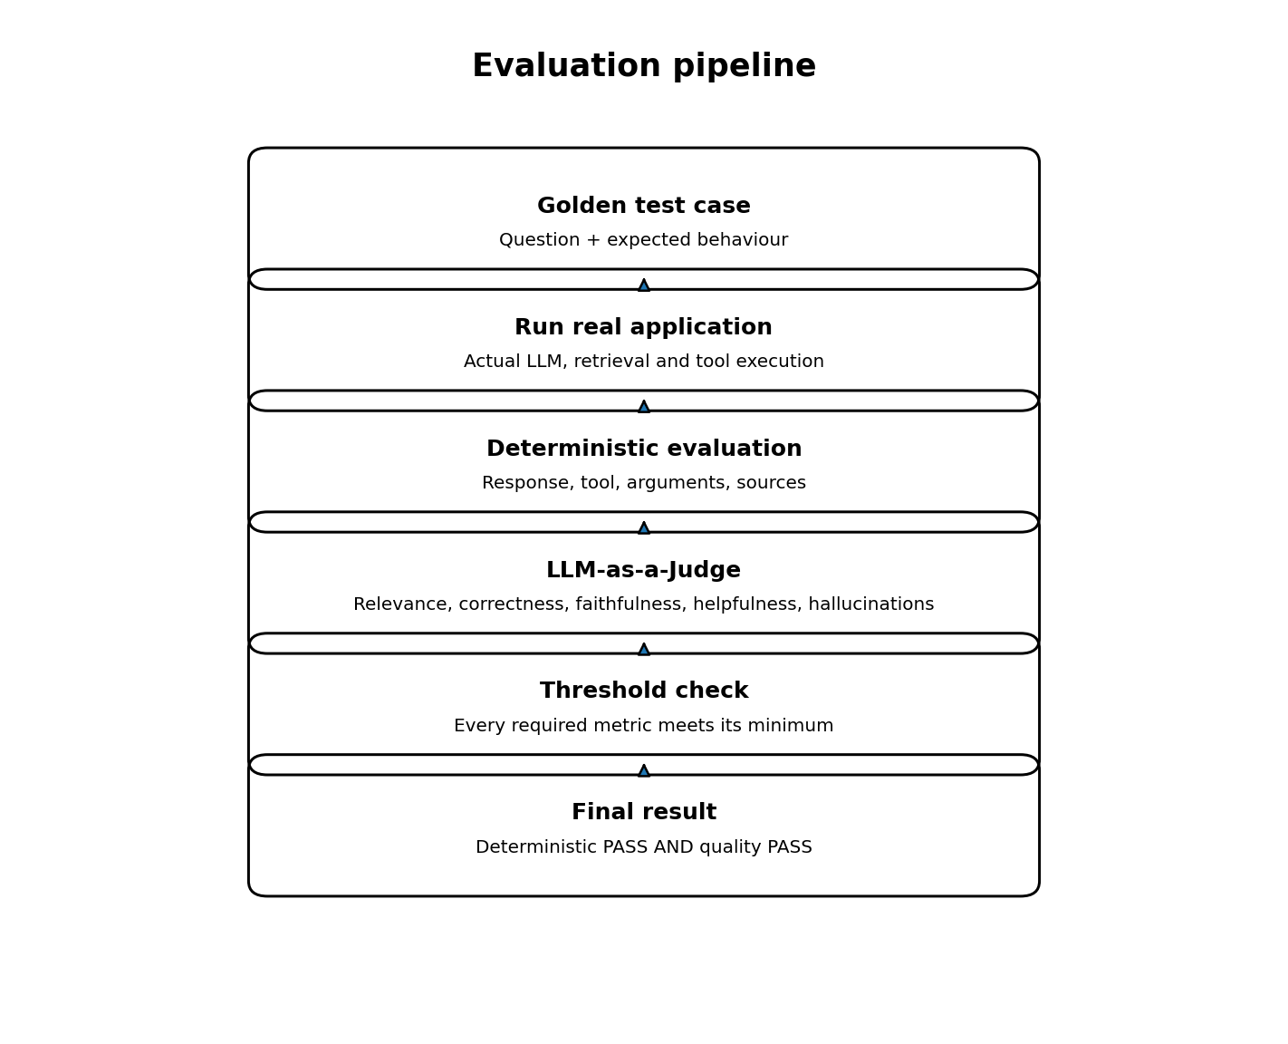

5.1 Same model or different model?
The demo uses the same underlying model for generation and judging, with different instructions. One prompt makes it a support assistant; another makes it a strict evaluator. This is possible, but production evaluations should consider correlated bias: a model may approve the same kinds of mistakes it tends to make. An independently selected judge, human-reviewed examples or multiple evaluation methods can improve confidence.

5.2 What the judge should receive
USER QUESTION:
How many days do I have to return a product?

GOLDEN ANSWER:
Products can be returned within 30 days.

EXPECTED BEHAVIOUR:
Answer using the return policy.

RETRIEVED CONTEXT:
Products may be returned within 30 days of delivery.

TOOL RESULTS:
No tools used.

ACTUAL ANSWER:
You can return products within 60 days.
The judge should use supplied evidence and expected behaviour, not general world knowledge. If the company's policy says 15 days, the judge must not approve 30 days merely because that is common elsewhere.

6. The five quality metrics

6.1 Relevance
Did the answer address what the user asked? If the user asks where an order is and the response describes free shipping, it may be true but irrelevant.

6.2 Correctness
Is the answer factually correct compared with expected behaviour and trusted reference? If the tool says SHIPPED but the answer says DELIVERED, it is relevant but incorrect.

6.3 Faithfulness
Are the answer's factual claims supported by evidence available to the model? If the policy says returns are allowed within 30 days, adding free pickup and a 24-hour refund promise without evidence is unfaithful.

6.4 Helpfulness
Is the answer clear and useful? “Yes” may be correct but less helpful than explaining the 30-day window and the next action the customer can take.

6.5 Hallucination-free
Did the model avoid inventing unsupported information? If a tool only reports SHIPPED but the answer promises delivery tomorrow at 10 AM, it has added an unsupported claim.
Metric | A higher score means
Relevance | More responsive to the question.
Correctness | More factually accurate.
Faithfulness | More grounded in supplied evidence.
Helpfulness | More useful and actionable.
Hallucination-free | Fewer unsupported or invented claims.

6.6 1–5 scoring scale
Score | General interpretation
5 | Excellent; criterion fully met.
4 | Good; only a minor issue.
3 | Moderate; noticeable issue.
2 | Poor; significant issue.
1 | Very poor; criterion largely unmet.

The lecture uses 5 for good and 1 for bad. The intermediate descriptions above are a practical rubric; the actual judge prompt should define the scale precisely.
{
"relevance": 5,
"correctness": 5,
"faithfulness": 4,
"helpfulness": 5,
"hallucinationFree": 5,
"reason": "The answer uses the supplied policy correctly but could be clearer."
}

7. Structured judge output
The judge should return machine-readable structured data rather than an unstructured paragraph. Java can deserialize the result into a model and read each score.
public class JudgeResult {
private int relevance;
private int correctness;
private int faithfulness;
private int helpfulness;
private int hallucinationFree;
private String reason;
}

7.1 Spring AI structured response concept
JudgeResult result = judgeClient.prompt()
.system("You are a strict evaluator...")
.user(judgePrompt)
.call()
.entity(JudgeResult.class);
The key idea is mapping the model response to a Java entity. Structured conversion is not automatically a guarantee that every model response conforms perfectly to the schema. Validate that fields exist and scores are integers within the permitted range.

7.2 Example judge prompt
You are a strict evaluator of AI application responses.
Use only the information in the evaluation input.
Do not use outside knowledge.

Evaluate:
1. Relevance: Does the answer address the question?
2. Correctness: Does it agree with expected behaviour?
3. Faithfulness: Are claims supported by supplied context or tool results?
4. Helpfulness: Is it clear and useful?
5. Hallucination-free: Does it avoid unsupported claims?

Give integer scores from 1 to 5.
Return relevance, correctness, faithfulness, helpfulness,
hallucinationFree, and a concise reason.
Do not invent evidence.
Judge limitation
An LLM judge is still an LLM. Structured JSON makes output easier to process; it does not make the judgement ground truth. Calibrate it against human-reviewed examples and monitor consistency.

8. The complete evaluation pipeline
The test class loads the Golden Dataset, runs the actual application for each case, performs deterministic checks, asks the judge to score semantic quality, checks thresholds and records the final result.

8.1 Load the dataset
ObjectMapper mapper = new ObjectMapper();

InputStream input =
getClass().getResourceAsStream(
"/golden-dataset.json"
);

List<EvalCase> evalCases =
mapper.readValue(
input,
new TypeReference<List<EvalCase>>() {}
);
Jackson reads the JSON and converts each object into an EvalCase Java object. Validate that the resource stream is not null and handle malformed test data clearly.

8.2 Initialize judge and accumulators
ChatClient judgeClient =
ChatClient.builder(chatModel).build();

List<String> failures = new ArrayList<>();

double relevanceTotal = 0;
double correctnessTotal = 0;
double faithfulnessTotal = 0;
double helpfulnessTotal = 0;
double hallucinationFreeTotal = 0;

int totalTests = 0;
The accumulators calculate average scores across all cases. The failure list stores IDs that did not meet the required criteria.

8.3 Execute each test case
for (EvalCase evalCase : evalCases) {
AgentResponse response =
supportService.chat(evalCase.getQuestion());

// 1. Deterministic evaluation
// 2. LLM-as-a-Judge
// 3. Threshold checks
// 4. Final PASS / FAIL
}

8.4 Apply quality thresholds
The demo uses a minimum score of 4 for each of the five quality dimensions. This is an example product decision, not a universal standard.
boolean qualityPass =
judgeResult.getRelevance() >= 4
&& judgeResult.getCorrectness() >= 4
&& judgeResult.getFaithfulness() >= 4
&& judgeResult.getHelpfulness() >= 4
&& judgeResult.getHallucinationFree() >= 4;
This is a per-metric threshold. A high average does not hide a low score in one critical dimension.

8.5 Final PASS / FAIL
boolean finalPass =
deterministicPass && qualityPass;
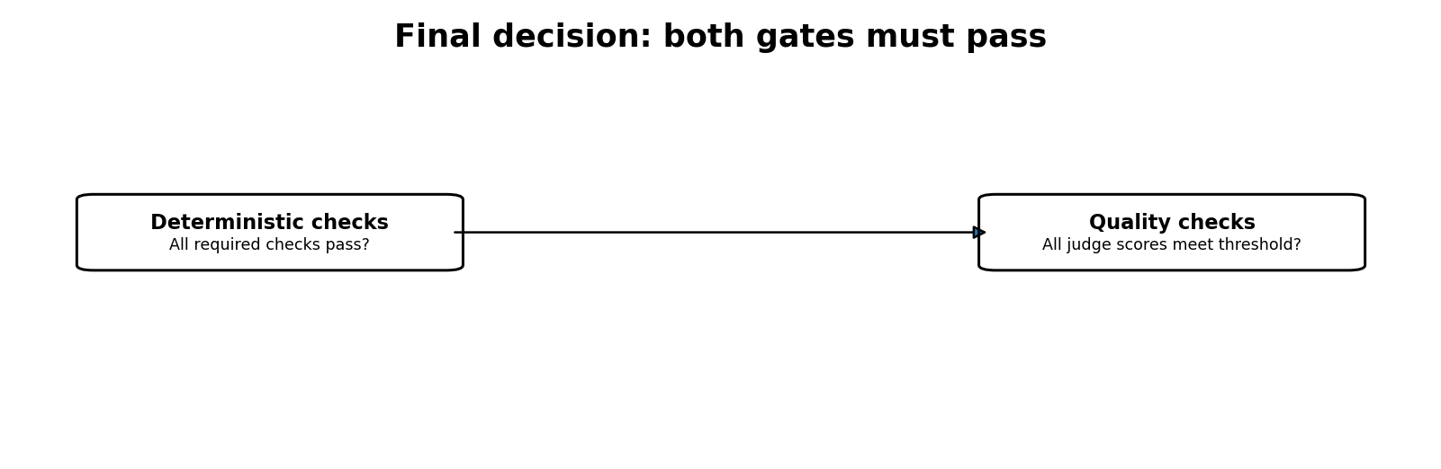
Both layers must pass. A wrong tool argument fails deterministic evaluation. Correct retrieval followed by a misinterpreted answer can fail quality evaluation.

9. Aggregating and reporting results
For each metric, calculate the average over N test cases.
Average Relevance =
(R1 + R2 + ... + RN) / N

Average Helpfulness =
(H1 + H2 + ... + HN) / N
If helpfulness scores are 4, 5, 5, 5, 5, 5, 5 and 5, the average is 39 / 8 = 4.875, approximately 4.88 out of 5.
A useful report includes total tests, passed tests, failed tests, failed test IDs, average scores for all five metrics, deterministic failure details, judge explanations and model/prompt/version metadata.
The lecture's demonstration ran eight test cases. One combined-return case initially failed due to unexpected tool-selection/argument behaviour; a later run passed all eight. The demo also showed average helpfulness around 4.88 while the other average scores were 5. This illustrates that LLM behaviour can vary across runs.
Do not over-interpret one successful rerun
Eight cases passing once does not prove production reliability. Run representative cases repeatedly and measure failure rates, not just one green test run.

10. Engineering review: limitations and improvements

10.1 Trace maps can overwrite repeated calls
If a tracker stores arguments and results in a map keyed only by tool name, two calls to the same tool can overwrite one another. Prefer an ordered list of invocation records.

10.2 Isolate traces per request
A shared mutable tracker can mix data from concurrent user requests. Create a separate trace context for each execution and propagate it safely through the orchestration flow.

10.3 Measure retrieval beyond source presence
Check whether the expected document was retrieved, whether it ranked highly, whether irrelevant documents were retrieved, whether the chunk contained the required information, and whether the evidence was passed to the model. Source-name presence alone is not a complete RAG evaluation.

10.4 Validate tool results
Correct tool selection and arguments do not guarantee correct business data. A database could return stale or incorrect information. In controlled tests, compare tool results against trusted fixtures or a test database.

10.5 Calibrate the judge
The judge can approve incorrect answers, misunderstand a reference, overlook unsupported claims or score equivalent answers inconsistently. Compare its results against human-reviewed examples and monitor agreement.

10.6 Expand the test set
Include normal and paraphrased questions, ambiguity, missing or invalid IDs, multiple tool calls, no relevant RAG document, conflicting policies, tool timeouts, partial failures and prompt-injection attempts.

10.7 Do not rely only on quality scores
Security, authorization, privacy and business rules need independent deterministic controls. A judge score of 5/5 cannot make cross-customer data exposure acceptable.

11. Important terminology
Term | Meaning
Testing | Checking whether software behaves as expected.
Evaluation / Evals | Measuring AI system behaviour and quality.
Deterministic evaluation | Checking objectively verifiable properties with code.
LLM-as-a-Judge | Using an LLM to assess semantic response quality.
Golden Dataset | Known questions and expected behaviour.
Execution Trace | Record of what happened during one execution.
Observability | Ability to inspect and understand system behaviour.
Faithfulness | Whether claims are supported by supplied evidence.
Hallucination | Unsupported or invented information.
Regression testing | Checking that changes have not broken previously working behaviour.

Key distinction
Observability tells you what happened. Evaluation tells you whether what happened was good or bad.

12. Applying the same architecture to insurance

12.1 Policy question (RAG)
User: “Does my health insurance policy cover hospitalization?” The system retrieves the relevant policy section. Evaluation checks whether the right document and passage were retrieved and whether the answer avoids unsupported coverage promises.

12.2 Claim status (tool)
get_claim_status("CLM-101")

{
"claim_id": "CLM-101",
"status": "UNDER_REVIEW"
}
Evaluation checks the selected tool, claim ID, tool result and whether the response accurately reports UNDER_REVIEW without inventing approval.

12.3 Policy plus claim (RAG + tool)
User: “My claim CLM-101 is under review. According to my policy, am I eligible for reimbursement?” The system needs policy evidence from RAG and live claim information from a tool. The answer must combine both without promising reimbursement unless the evidence supports it.

13. Mapping the concepts to Python / FastAPI
The concepts are framework-independent. The instructor uses Spring AI and Java, but a similar design can be implemented with FastAPI, an LLM SDK or orchestration framework, Pydantic, pytest and a vector database.
Spring / Java concept | Python equivalent
Spring Boot | FastAPI
Spring AI ChatClient | LLM SDK / model interface
VectorStore | Vector database client
Java tool functions | Python functions / tool definitions
AgentResponse | Pydantic BaseModel
ToolTracker | Execution trace collector
EvalCase | Pydantic model
JudgeResult | Pydantic model
Jackson ObjectMapper | Pydantic / JSON parsing
JUnit | pytest
mvn test | pytest

13.1 Example Pydantic models
from pydantic import BaseModel
from typing import Any

class ToolCallTrace(BaseModel):
tool_name: str
arguments: dict[str, Any]
result: Any

class AgentResponse(BaseModel):
answer: str
retrieved_documents: list[str]
context: str
tool_calls: list[ToolCallTrace]

class EvalCase(BaseModel):
id: str
question: str
expected_tool: str | None = None
expected_tool_argument: str | None = None
expected_source: str | None = None
golden_answer: str
expected_behaviour: str

class JudgeResult(BaseModel):
relevance: int
correctness: int
faithfulness: int
helpfulness: int
hallucination_free: int
reason: str

13.2 Simplified deterministic evaluator
def evaluate_deterministic(case, response) -> bool:
response_pass = bool(response.answer.strip())

expected_sources = (
{case.expected_source}
if case.expected_source else set()
)
actual_sources = set(response.retrieved_documents)
source_pass = expected_sources.issubset(actual_sources)

if case.expected_tool is None:
tool_pass = len(response.tool_calls) == 0
argument_pass = True
else:
matching = [
call for call in response.tool_calls
if call.tool_name == case.expected_tool
]
tool_pass = len(matching) == 1
argument_pass = (
tool_pass
and matching[0].arguments.get("order_id")
== case.expected_tool_argument
)

return (
response_pass
and source_pass
and tool_pass
and argument_pass
)
This is a teaching example. A production evaluator should support expected call sequences and counts, structured argument schemas, multi-tool workflows and case-specific retrieval expectations. It should distinguish “no source expected” from “source retrieval must be empty” where necessary.

14. Practical implementation exercise
Build a small AI Support Agent Evaluation System. Implement each layer and make the behaviour inspectable.
- Create a FastAPI or Spring Boot chat endpoint.
- Create three policy documents and implement RAG.
- Create getOrderStatus and getRefundAmount tools.
- Create an AgentResponse model.
- Record tool names, arguments and results for every invocation.
- Create a golden-dataset.json with 8–10 cases.
- Implement deterministic evaluation.
- Implement an LLM judge with structured output.
- Add score thresholds and final PASS / FAIL.
- Intentionally introduce three failures and debug them.

15. Final mental model
Build the AI application. Observe its behaviour. Evaluate objectively verifiable execution with code. Evaluate semantic quality with an LLM judge. Apply thresholds. Produce a report. Fix failures and rerun the same regression suite.
The most important takeaway
Do not just build an AI application that can answer questions. Build an AI application whose behaviour you can inspect, measure, test and improve.

16. Self-check questions
Why do we store an execution trace?
Answer: Because the final answer alone does not reveal which documents were retrieved, which tools were called, what arguments were passed or what results were returned.
Why not use an LLM for every evaluation?
Answer: Exact, objectively verifiable behaviour is cheaper and more reliable to check with ordinary code.
Why do we need an LLM judge?
Answer: Semantic properties such as relevance, helpfulness and faithfulness cannot always be judged with exact string comparison.
Why do we need a Golden Dataset?
Answer: It provides repeatable questions and expected behaviour for regression testing and comparison.
What makes an AI application production-ready?
Answer: Observable execution, reliable tools, grounded responses, systematic evaluation, security controls and measurable quality.

Closing perspective
Integrating an LLM API is only one part of AI engineering. Reliable AI systems require retrieval quality, tool correctness, execution observability, grounded generation, repeatable evaluation, security and regression control. Treat RAG, tool calling, observability, deterministic evaluation and LLM-as-a-Judge as connected parts of one engineering discipline.

