**Gla University, Mathura**



**TOPIC: MINI PROJECT SYNOPSIS ON STOCK MARKET PREDICTION APP**

**Submitted by: Submitted to:**

Faculty Name: Mr. Vinay Agarwal

Name: Suyash Srivastava Technical Trainer

Id: 191500835

Name: Shreya Yadav

Id: 191500784

Name: Yashraj Singh

Id: 191500940

**INDEX**

1. **Abstract**
2. **Introduction** 
   1. Definition
   2. Description
3. **Problem definition**
4. **Objectives**
5. **Module Description**
6. **Data flow diagram’s**
7. **References**

**Abstract**

This report lays out a project plan for the development of the “Stock Market App” open-source repository system.

The intended readers of this document are current developers working on “Stock Market”. The plan will include but is not restricted to, a summary of the system functionality, the scope of the project from the perspective of the “Stock Market” team (Our team and my mentors), the process by which we will develop the project, and metrics and measurements that will be recorded throughout the project.

**Introduction**

Definition: A stock market is a place where shares of pubic listed companies are traded. The primary market is where companies float shares to the general public in an initial public offering (IPO) to raise capital.  
  
Description: Once new securities have been sold in the primary market, they are traded in the secondary market—where one investor buys shares from another investor at the prevailing market price or whatever price both the buyer and seller agree upon. The secondary market or the stock exchanges are regulated by the regulatory authority. In India, the secondary and primary markets are governed by the Security and Exchange Board of India (SEBI).

A stock exchange facilitates stock brokers to trade company stocks and other securities. A stock may be bought or sold only if it is listed on an exchange. Thus, it is the meeting place of the stock buyers and sellers. India's premier stock exchanges are the Bombay Stock Exchange and the National Stock Exchange.

There are two such applications available:

1.Stock market predictor: -

This application tries to determine the future price of company stock. The successful prediction of the stock future price leads to significant profit. It works with the past values of the company and gives the approximate range for the stock price.

FEATURES: -

1. It gives an approximate range of stock prices.
2. Users can get significant profits easily.

2.Stock Market: NSE Price Prediction:

NSE price prediction is simple and easy to use in stock market applications. Users can easily track stock prices, create a portfolio, and search stocks by symbols. Users can easily get predicted closing prices before 3 hours later. The application's interface is very simple and the user can easily access all the features.

FEATURES: -

1. Simple and easy interface.
2. Easy to create a portfolio.
3. Easy to search.

3. Grow Application:

This application is simplest Demand and stock trading application that allows you to open Demat account & trade BSE, NSE stocks in the share market at Rs. 0 brokerage on investments.

FEATURES:

1. Very simple and easy application.
2. You can invest in readymade collection of mutual funds which is recommended by top experts.
3. It shows complete information about all companies that let you make informed decisions.
4. A high level of encryption standards is used for all transactions which make Grow application safer as compared to bank.

App design & develop:

Having you're App designed and built professionally will improve your company image and help to enforce your brand.

**About the Project**

**A) WHAT DO WE WANT TO CREATE?**

A stock market prediction android application.

**B) WHAT IS OUR IDEA ABOUT?**

It is an android based application that predicts the stock market by analysing the company's statistics and the shares bought by it, by using Machine Learning.

**1) WHO?**

**1.1) Who does our application target?**

Our application targets the budding stock market enthusiasts as well as the investors. Whether they know about the market or not people can easily see the predictions made by the app and use the knowledge accordingly.

**2) WHAT?**

**2.1) What is the boundary of the problem?**

Every investor weather the day traders or the long-term traders, they both have this common problem of not being able to predict the stocks correctly.

**2.2) What is the issue?**

The issue is that according to popular estimates, nearly 90% of people lose their money in stock markets, and this includes both the new and seasoned investors.

Before investing in shares of a company the investors always study and do thorough research on the company. Even after researching by themselves, they are not sure that they will earn or lose their money.

**2.3) What is the impact of the issue?**

There's a constant fear in the mind of the investor that he might lose his money altogether.

**2.4) What impact is this issue causing?**

Due to constant fear of losing the money altogether, the investors are avoiding investing their money on the companies which directly affect the GDP of a country. A fall in the share price of a company negatively impacts the economic growth of a county.

**2.5) What will happen if this problem is fixed?**

As soon as the problem is fixed the people will start earning with a much lower chance of risk.

**2.6) What would happen if we don't solve the problem?**

The present digital scenario has brought up so many new Companies/ Startups which are increasing day by day, and if the number of investors will decrease the company will not be able to support itself, thus downgrading our GDP.

**3) WHEN?**

**3.1) When did the issue start to occur?**

This issue started during the stock market establishment.

**3.2) When does it need to be fixed?**

It needs to be fixed right now! As many companies are establishing day by day and month by month and in the future, they need stocks/money to scale up their business, and without money, it is very difficult to scale up.

**4) WHERE?**

**4.1) Where does this issue occur?**

This issue occurs in every county where the stock market is prevalent.

**5) WHY?**

**5.1) Why is it important that we fix the problem?**

It is important because most people cannot predict the market as accurately as our program does.

**5.2) What impact does it have on the business or customer?**

The application will have a drastic impact on companies/businesses as well as investors. Businesses will be getting money to raise their capital as the investor count will increase and the investors who are our regular users will increase their profit ratio and their losses will be reduced. So, it's a win-win situation here.

**6) Our Solution**

Our Solution is to make an android based application that will predict the value of a company's stock soon with an accuracy of approximately 70%. So that users may take the correct decision of when to buy a stock or when to sell it to attain maximum profit.

**Android Technical Support**

**Technologies Languages:**

XML, KOTLIN, FIREBASE

**Android app development platform:**

Android Studio, Virtual device

**Server platform:**

Windows 7

Windows 8

Windows 10

Windows 11

**Introduction to the Development tool “Android Studio”**

Android Studio is the official integrated development environment (IDE) for Android platform development. Android Studio is freely available under the Apache license. Android Studio is designed specifically for Android development. Android application development can be started on either of the following operating systems – Microsoft® Windows® 8/7/Vista/2003 (32 or 64-bit). Mac® OS X® 10.8.5 or higher, up to 10.9 (Mavericks). GNOME or KDE desktop. All the required tools to develop Android applications are open source and can be downloaded from the Web. Following is the list of software's that is needed before starting Android application programming. Java JDK5 or later version Java Runtime Environment (JRE) 6 Android Studio.

**Stock Market Price Prediction App: “module description”**

**Front Page: -**

Sign-in tab

Sign-up tab

**Second Page: -**

Sign-in page

**Third Page: -**

Sign-up page

**Other page’s: -**

Home-page UI

Side Bar (Profile – About – Help – Update)

Search page UI

**Data Flow Diagrams**

**DFD: -**

A data flow diagram (DFD) illustrates how data is processed by a system in terms of inputs and outputs. As its name indicates its focus is on the flow of information, where data comes from, where it goes and how it gets stored.

**Level Zero: -**

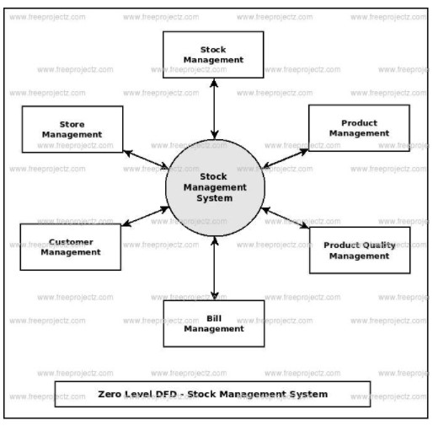

**Level One: -**

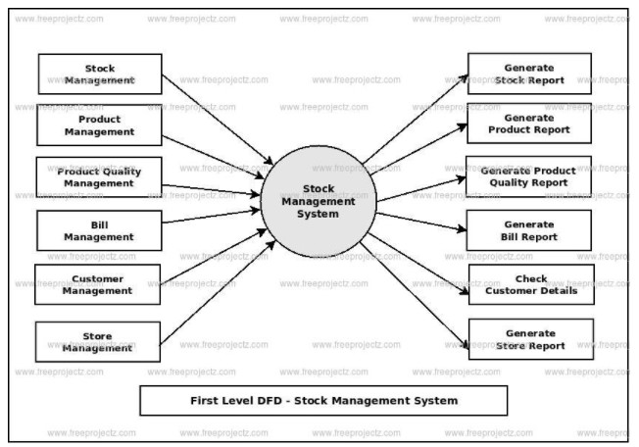

**Level two: -**

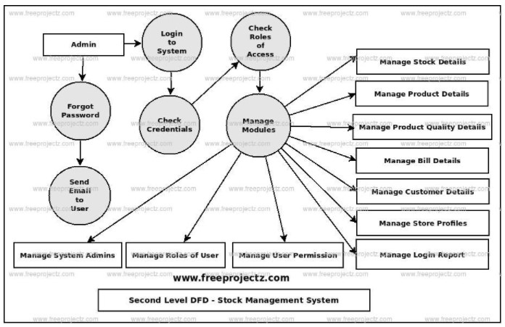

**Conclusion**

**Conclusion**

In conclusion we believe this project if properly utilized will save time, reduce the amount of work the administration has to do, and will replace the stationery material with electronic apparatus. The system should also serve as a major tool to improving the efficiency in Stock Analysis. Hence a system with expected results has been developed but there is still room for improvement.

In terms of experience gained through the duration of this project study, the students have been able to have broader knowledge about the management of Stock Prediction using manual and automated procedures. The students have also been able to improve their knowledge in developing enterprise applications. We believe this project will serve the university efficiently in their efforts to automate the Stock Prediction Procedure.

**REFERENCE :**

• [www.wikipedia.org/](http://www.wikipedia.org/•)

[•](http://www.wikipedia.org/•) [www.udemy.com/](http://www.udemy.com/)

• www.google.com/