**Framework description**: created a TestNG framework with Page Object Model structure. The framework contains 15 java classes. .The framework uses an external xls file as an input so the tester can run various test scenarios. Here are the class details of each package:

Utils: the utils package holds the classes with reusable methods such as fetching the values from excel, objects for each input record, translating cell values and assigning to variables.

Page Objects: this package contains the classes of each page element’s xpath, methods to select the elements. Also to identify the lowest price value and second highest price product’s xpath.

Page Events: package contains the controller methods of each page, such as input or clicking buttons etc.

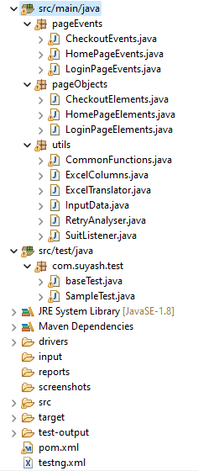

**TesnNG.XML**

the testing xml basically passes three important parameters:

ParameterNValue – the parameter identifies how many test cases tester wishes to run. In case you want to run multiple cases together, the value can be set as 2-5. For single cases, it can be written as 3-3, 4-4. It actually indicates the Row number of the input file.

browserName – This is to select the browser for the test. For now the framework covers only chrome but it can be enhanced to include multiple browsers.

Inputsheet – this is the path and name of input file.

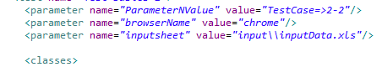

Once the test completed, tester can verify the report in the report folder. I have used basic extent report for reporting.

**How to run the test**

1. This framework uses chromedriver version 98. Please use the correct version of chromedriver if it is not compatible.
2. Make sure input file name and path is correct before running the test.
3. Below is the input file format:



1. User, Password and sort option are case sensitive, please make sure it matches the actual data.
2. Setup the TestNg XML
3. User can add more rows in the input file to test with different users. Update the ParameterNValue accordingly.
4. Keep the browser name setup as chrome.
5. Run the TestNG.XML
6. Once the test completed, please check the test status in extent report in report folder.