CareCompanion: Assistive Companion Mobile Application for Elderly and Disabled Users
Devanshi Pandey¹, Suyash Humne²*, Deon Menezes², Sonali Wankhede³, Balwant Kumar Singh¹
¹ Department of Electronics and Computer Engineering, K. J. Somaiya School of Engineering, Somaiya Vidyavihar University, Mumbai, India
² Department of Artificial Intelligence and Data Science, K. J. Somaiya School of Engineering, Somaiya Vidyavihar University, Mumbai, India
³ Department of Information Technology, K. J. Somaiya School of Engineering, Somaiya Vidyavihar University, Mumbai, India
devanshi.pandey@somaiya.edu, suyash.humne@somaiya.edu, deon.m@somaiya.edu, sonali.w@somaiya.edu, balwantkumar@somaiya.edu
*Corresponding author: Suyash Humne (suyash.humne@somaiya.edu)
Running head: CareCompanion: assistive app for elders
ABSTRACT
Mobile applications that help older adults manage medication and summon help are usually judged on how legible the older adult's screen is. A second property matters as much and is rarely examined: whether the system tells the truth when it fails. We present CareCompanion, an implemented Android system for caregiver-mediated elder care built on three commitments. An asymmetric dual-surface architecture places all configuration on the caregiver's device, leaving the older adult a zero-configuration surface; measured from source, that surface has a median declared text size of 20 sp against 13 sp on the caregiver surface, and every primary control is at least 64 dp against a 48 dp platform minimum. Out-of-band device binding closes an identity gap created by federated sign-in, using a single-use short-lived code in place of phone-number matching. Fail-honest alerting requires that the interface never assert an outcome it has not observed, so an undelivered emergency alert says so and offers a user-mediated fallback. A structured audit found 13 defects, of which 8, or 62 percent, would have failed with no signal to the user, including two features stored correctly and delivered to nobody. We report the taxonomy and what remains unevaluated.
Keywords: elder care, mobile health, medication adherence, caregiver-mediated systems, accessibility, dependability, Android, human-centered design
1. Introduction
India is aging quickly, and the support infrastructure is not keeping pace. The United Nations Population Fund projects that the population aged 60 and over will grow by 134 percent between 2022 and 2050, and the population aged 80 and over by 279 percent [1]. Digital access, however, remains uneven across age groups. Mobile phone use is widespread nationally, but internet use declines sharply with age [2], and among older adults in rural India, particularly women, shared handsets and limited digital literacy are the norm rather than the exception [3], [4].
Medication non-adherence is a significant concern among older adults managing chronic conditions and polypharmacy. Randomized evidence suggests that mobile reminder tools help without solving the problem: a trial of a drug-management application among older adults with polypharmacy reported improved adherence and reduced hospital readmission [5], while a systematic review of reminder technologies for home-dwelling older citizens reports beneficial effects for some outcomes but emphasizes that the overall evidence remains heterogeneous [6].
The usability literature is clear about what makes an interface hard for an older adult. Small text is repeatedly the most-cited barrier; touch targets are too small for reduced dexterity; icons are misread; and navigation depth exceeds working memory [7], [8], [9]. Design guideline syntheses converge on enlarged type, enlarged targets, shallow navigation and error tolerance [10], [11].
What this literature largely assumes is that the older adult is the person configuring the system. In practice, care is dyadic. Quinn et al. found in a dyad usability study that most interaction occurred between caregiver and older adult rather than the older adult alone [12], and dyadic digital health modules are now designed explicitly around shared care [13]. If the caregiver is doing the configuring, the older adult's surface does not need to be a simplified version of a management application. It can be a different application altogether.
A second assumption is more consequential and, we argue, under-examined: that when the system reports success, it has succeeded. Emergency and reminder paths on mobile platforms are unreliable in ways the application can observe but frequently does not check. The Android Doze and App Standby mechanisms defer alarms and network access during idle [14], and manufacturer power management is more aggressive still. Push delivery depends on connectivity that an older adult at home may not have. An interface that shows a green confirmation on an emergency alert it never delivered is not merely unhelpful; in the one situation the system exists for, it is harmful.
This paper makes four contributions. The first is an asymmetric dual-surface architecture for caregiver-mediated elder care, in which configuration authority and interface complexity are deliberately unequal across two clients over one care record, with the asymmetry measured from the implementation rather than asserted. The second is out-of-band device binding, a single-use short-lived code that binds a device to a care profile; we show that migrating to federated identity silently breaks phone-number-based linking, and that an out-of-band code is a simple and auditable repair. The third is fail-honest alerting, a discipline in which the interface never asserts an unobserved outcome, together with a permission-minimal degradation path that keeps the application distributable under current application store policy. The fourth is an empirical defect taxonomy from a structured audit of the feature-complete system, showing that silent failures dominate.
We are explicit about scope. This is a systems and design-contribution paper. We report conformance, interaction cost and defect data measured from the artifact. No user study has yet been conducted, and we make no usability or clinical claims.
2. Related Work
2.1 Age-friendly mobile interface design
Systematic reviews of mobile design for older adults consistently identify text size, target size, icon interpretability and navigation complexity as the dominant barriers. Awan et al. applied an analytical hierarchy process to prioritize usability barriers and ranked small font and screen size highest [7]. Elguera Paez and Zapata Del Rio catalog challenges across the literature [8]. Gomez-Hernandez et al. derive design guidelines through thematic synthesis [10], and Amouzadeh et al. provide a recent consolidation of age-friendly design recommendations [11]. Liu et al. review interface and persuasive feature design in mobile health applications for older adults [9]. Our elder surface is an implementation of this consensus; the contribution here is not the guidelines but the demonstration that offloading configuration to a second surface is what makes conformance affordable.
2.2 Medication reminder and adherence systems
Poorcheraghi et al. report a randomized controlled trial of a mobile drug management application among older adults with polypharmacy, finding improved adherence and reduced hospital readmission [5]. Salmensuu et al. systematically review reminder technologies for home-dwelling older citizens [6]. Wiecek et al. report real-world engagement and adherence evidence for older adults [15]. These studies evaluate outcomes; they do not generally report whether reminders were delivered by the operating system as scheduled, which Section 3.4 treats as a first-class engineering problem.
2.3 Dyadic and caregiver-mediated health systems
Quinn et al. conducted a dyad usability study of a mobile application used by older adults together with informal caregivers, observing that interaction was predominantly caregiver-mediated [12]. Benmessaoud et al. designed a dyadic digital health module for chronic disease shared care, identifying disease-invariant features for patient and caregiver dyads [13]. Nimmanterdwong et al. review human-centered design practice in mobile health for older adults [16]. This work establishes the dyad as the unit of design. We extend it architecturally: rather than one application used by two people, we build two surfaces of deliberately unequal complexity over one access-controlled record.
2.4 Personal emergency response systems
Personal emergency response systems have a long history and a well-documented failure mode: Hamill et al. report call-center estimates attributing as much as 85 percent of calls to false alarms, largely accidental activations [17]. This motivates the cancellable grace period described in Section 3.3. The complementary failure, an alarm the user believes was raised but which never reached anyone, is less discussed in that literature, and is what fail-honest alerting addresses.
Across these strands, interface legibility for the older adult and outcome efficacy are well covered; delivery honesty and deployability under platform policy are not. Few studies in the reviewed elder-care literature explicitly report a taxonomy of silent implementation failures, or treat application store permission policy as an architectural design constraint on the emergency path.
3. Research Methodology
This section describes the system as built, in enough detail to let the design be reproduced. Figure 1 shows the overall structure.
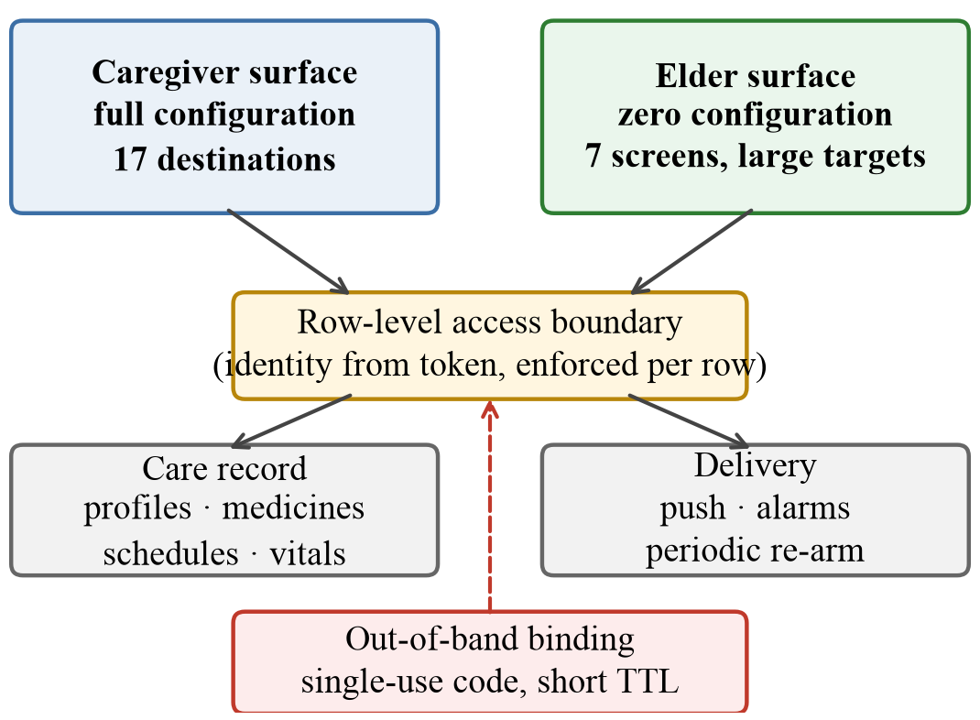
Figure 1: System structure. Two clients of deliberately unequal complexity share one care record behind a per-row access boundary that derives identity from the caller's token. The out-of-band binding step establishes which physical device belongs to which older adult.
3.1 Asymmetric dual-surface architecture
The system presents two Android surfaces backed by one record. The caregiver surface carries the full management vocabulary across seventeen navigation destinations: profiles, medicines, schedules, reminders, contacts, vital signs, adherence history, media shortcuts, shared access and an emergency monitor. The elder surface carries seven: a home screen, an alarm control, today's medicines, contacts, vital-sign entry, media shortcuts and a settings screen containing three controls, plus a one-time binding screen seen only at setup.
The asymmetry is the design. Because no configuration occurs on the elder surface, that surface has no forms to validate, no destructive actions to guard, no navigation deeper than two levels and no state the older adult can corrupt. This is what makes generous type and target sizing affordable: a screen that must accommodate a scheduling form cannot also give every control 96 dp of height. Section 4.1 quantifies the resulting difference. Contacts on the elder surface are photograph-first, so recognition does not depend on reading a name.
Both surfaces authenticate with a federated identity provider and address the same record through a per-row access boundary. Thirty-three row-level policies across seventeen tables derive the caller's identity from the verified token rather than from any client-supplied parameter, so a modified client cannot widen its own visibility. All privileged transitions, such as creating a profile, issuing a code, redeeming one or changing another member's access, are server-side routines rather than client writes.
3.2 Out-of-band device binding
Elder-care systems must answer a question ordinary applications do not: which physical device belongs to the person being cared for? The caregiver creates the profile, so the profile cannot identify its subject by who created it.
Our first implementation matched on phone number. The caregiver entered the older adult's number; when a device signed in with that number, the two were linked. This works under telephone-number-based authentication and fails completely under federated sign-in, which returns an email address and a provider subject identifier and no telephone number at all. After migrating to federated sign-in, the stored telephone number for every account was the empty string, and the matching predicate could never be satisfied. The failure was silent: links were recorded in a pending state, and the resolution routine compared an empty string against a real number indefinitely.
The repair is an out-of-band binding primitive. The caregiver requests a six-digit code bound to the profile; the code is single-use and expires after seven days. On the older adult's device, after federated sign-in, entering the code claims the profile for that account. The channel by which the code travels is deliberately unspecified, because the caregiver is usually present during setup [12]. Three properties matter. The code is single-use, so a shared code cannot be replayed. It is short-lived, bounding the window in which a guessed code is useful. Responses are indistinguishable between an unknown code and an expired one, so the endpoint cannot be used to enumerate which codes exist. A profile already bound to one account cannot be silently rebound to another. The same primitive, parameterized by an access level, later replaced the equally broken caregiver-invitation path, which depended on the same assumption.
3.3 Fail-honest alerting
We adopt a single rule: the interface never asserts an outcome it has not observed. Applied to the emergency path, this produces the state machine in Figure 2.
Pressing the alarm control begins a five-second cancellable grace period. This is a direct response to the dominant failure mode of personal emergency response systems, where Hamill et al. report estimates of up to 85 percent of call-center traffic arising from accidental activation [17], and it costs a genuine emergency five seconds.
If the period expires, the client records the alarm on the server, which is what reaches caregivers, using bounded retry with an increasing delay between attempts. The terminal state is then selected by whether that record was acknowledged, not by whether it was attempted. On acknowledgement the interface confirms delivery. On failure it states plainly that the alarm was not delivered and presents two large controls: one opens the device's own messaging application with the emergency text and a location link already composed, and one dials the primary contact.
An earlier revision of this screen displayed a success confirmation unconditionally. It was possible for an older adult to be shown a green confirmation and the words your family has been notified when the emergency event had not in fact reached the caregiver-facing system. We regard this class of defect as the most serious a care system can contain, because it converts a recoverable failure into an unrecoverable one: a user who believes help is coming stops seeking it.
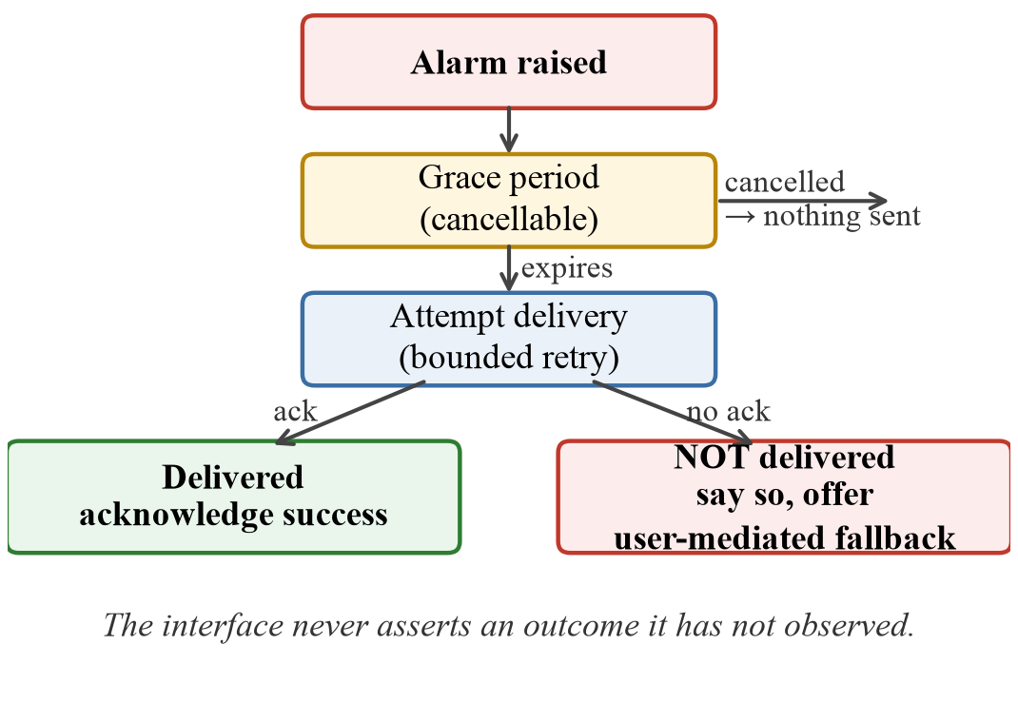
Figure 2: The emergency path. A cancellable grace period addresses accidental activation, which dominates personal emergency response system traffic. The terminal states are distinguished by observed delivery, not by having attempted it.
3.4 Redundant reminder arming
Medication reminders must fire on a device the application may not be running on, under an operating system actively suppressing background work. Android Doze and App Standby defer alarms, jobs and network access during idle, and manufacturer power management layers are typically more aggressive [14].
An early revision armed the day's alarms only when the older adult opened the application. The consequence is easy to state and was easy to miss: an older adult who did not open the application received no reminders that day, precisely the user for whom the reminders exist. The system now arms through three independent paths: on application open; from a periodic background worker that re-arms the current day every four hours and skips doses already answered; and from a boot-completed receiver that re-arms from a persisted set, since alarms do not survive a restart. Exact alarms are requested where the platform grants them for medication reminders, with a windowed fallback when the permission is unavailable.
Two correctness properties proved necessary in implementation. Alarm keys must be namespaced by source, because the hash of the key is used as both the pending intent request code and the notification identifier; an un-namespaced key allowed a general reminder and a medication dose to silently replace one another. Answering a dose must cancel its pending alarm, or an older adult who takes a tablet early is told to take it again at the scheduled time, a prompt toward double-dosing generated by an adherence tool.
3.5 Permission-minimal degradation
Emergency features in the research literature routinely assume the application may send a short message directly. Current application store policy substantially restricts this: messaging and call-log permissions are limited to applications whose primary function is messaging or telephony, and a care application declaring them is likely to face review or rejection [18], [19].
We therefore removed direct message sending and direct dialing entirely. The emergency path reaches caregivers over the network; where a message is warranted, the application hands a pre-composed message to the device's own messaging application through a standard intent, and the user presses send. This costs one additional interaction in the degraded path and removes two restricted permissions. We report it because deployability is a research-relevant property: a prototype that cannot be distributed cannot be evaluated at scale, and this constraint is rarely stated in the elder-care literature.
3.6 Implementation
Both clients are native Android applications written in Kotlin using Jetpack Compose, targeting application programming interface level 36 with a minimum of level 24. Persistence and access control are provided by Supabase-hosted PostgreSQL with row-level security, reached over its generated representational state transfer interface; privileged operations are database routines executing with definer rights. Push delivery uses Firebase Cloud Messaging with data-only messages, because notification-payload messages bypass the application's own handler when the application is backgrounded and would prevent the client from applying its own delivery rules, including the rule that emergency alerts are exempt from the application's general notification preference.
The elder surface is localized into English, Hindi, Marathi and Gujarati, offers three type scales, and provides a high-contrast mode that composes with the operating system's own accessibility scaling rather than overriding it. Language matters here beyond convenience: interfaces presented only in English are a documented barrier for older adults in India, particularly older women with lower English literacy [3], [4].
Table 1 reports the size of the implementation, measured from the repository. The test suite comprises 147 automated tests executing on the Java virtual machine with a shadowed Android runtime, requiring no device or emulator. Coverage is concentrated where silent failure is most likely: alarm scheduling and cancellation, offline durability of adherence records, delivery-contract behavior of the push path, translation-table integrity across the four languages, and a regression test for each defect in Section 4.3. Static analysis reports no errors at release configuration.
Table 1: Implementation size, measured from the repository.
Component | Files | Lines
Caregiver surface | 27 | 3,942
Elder surface | 6 | 1,271
Data access and models | 12 | 1,082
Reminder and alarm engine | 4 | 329
Notification and push | 2 | 147
Authentication | 1 | 79
Application total (Kotlin) | 83 | 13,473
Automated tests (Kotlin) | 26 | 3,010
Database migrations (SQL) | 15 | 1,121

4. Results and Discussion
We evaluate three properties measurable from the artifact: conformance of the elder surface to age-friendly sizing guidance, interaction cost for core tasks, and the defect profile of the feature-complete system. Every quantitative figure in this section is generated by a script that parses the application source directly, so the reported measurements cannot drift from the implementation.
4.1 Conformance of the elder surface
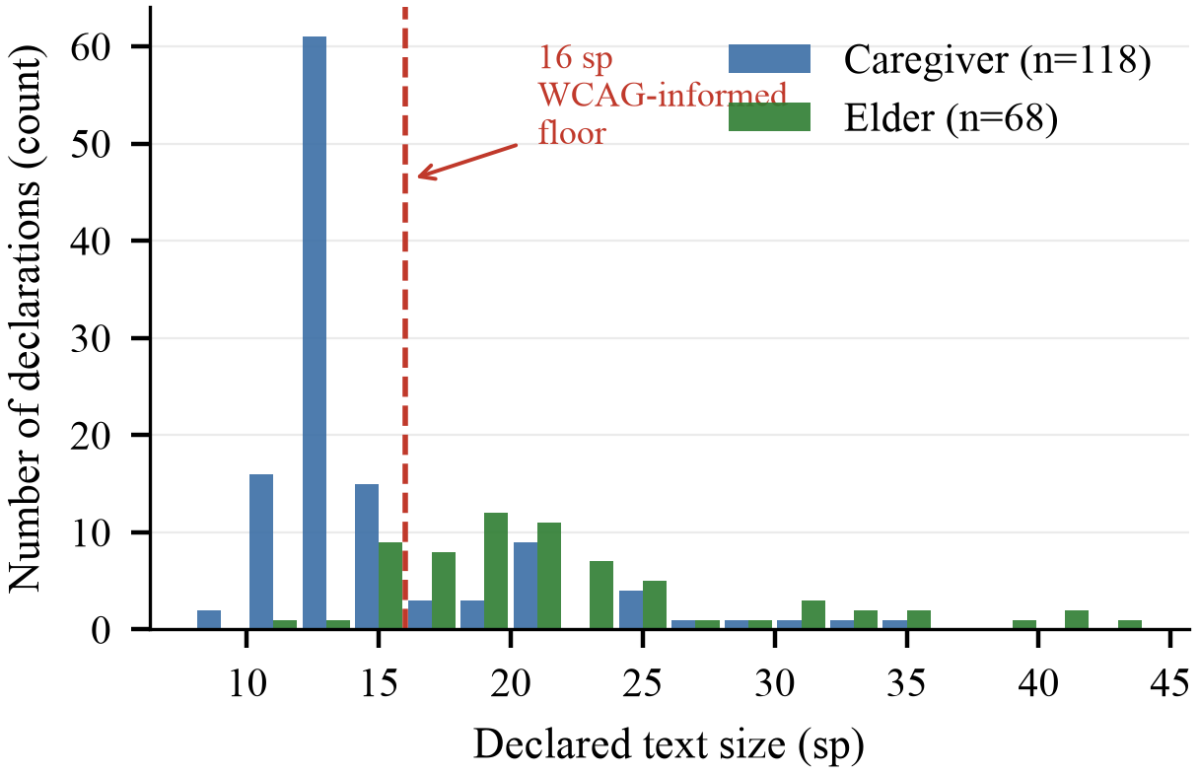
Figure 3: Distribution of declared text sizes across the two surfaces, parsed from source. The caregiver surface concentrates at 12 to 13 sp; the elder surface is shifted upward with a long tail to 72 sp for the alarm control.
Figure 3 shows every declared text size on each surface. The elder surface has a median of 20 sp against 13 sp for the caregiver surface, and 16.4 percent of its declarations fall below 16 sp against 79.7 percent on the caregiver surface. The residual small sizes on the elder surface are supporting captions rather than primary content. Because the elder surface additionally composes a user-selected scale of 1.0, 1.15 or 1.3 with the operating system's own font scaling, the effective floor rises further when either is increased.
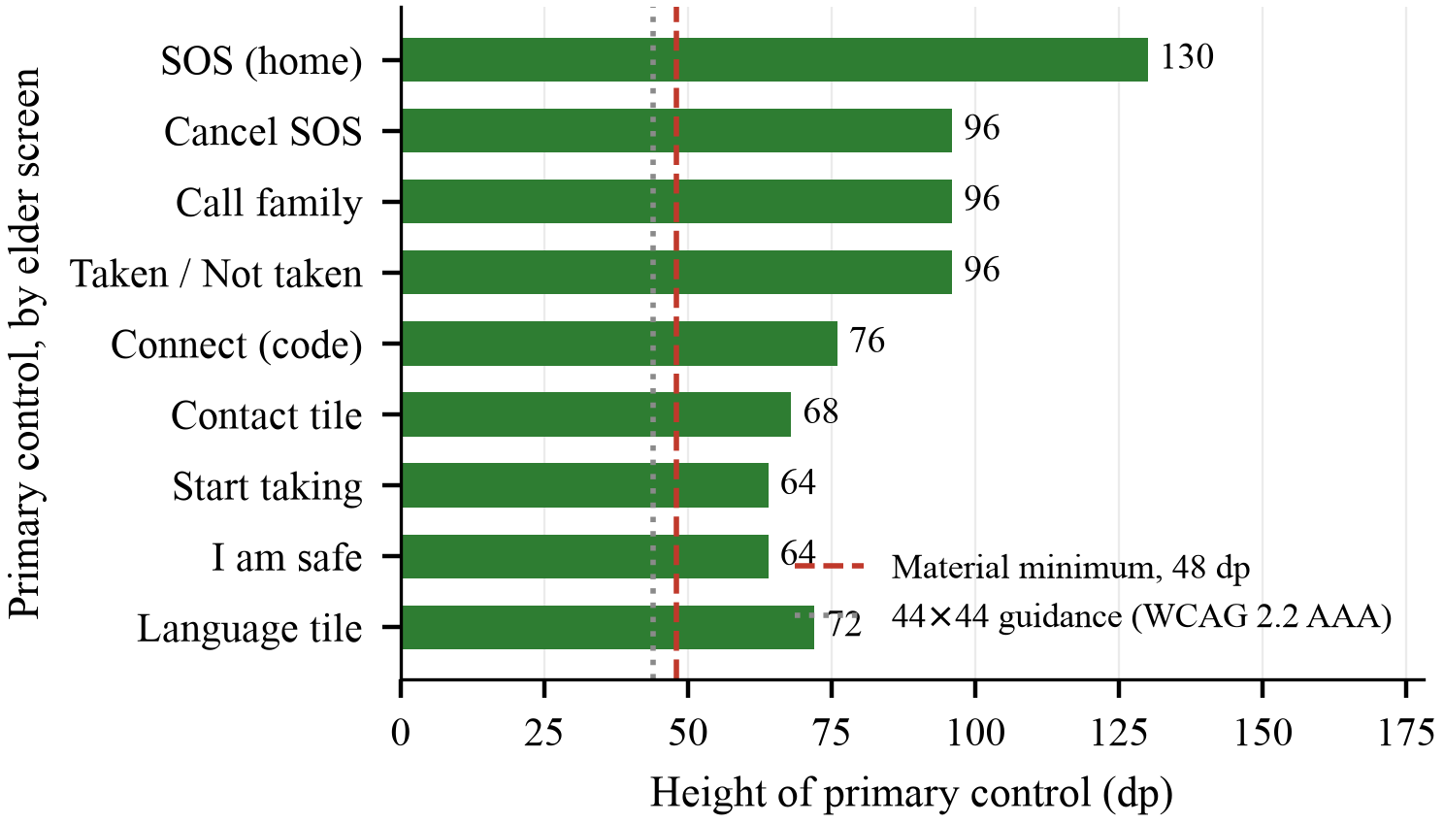
Figure 4: Height of the primary control on each elder screen, parsed from source. Every primary control exceeds the 48 dp platform minimum; the median is 76 dp and the emergency control is 130 dp.
Figure 4 reports the height of the primary control on each elder screen. The smallest is 64 dp, one third above the 48 dp platform minimum [20], and comfortably above the widely cited 44 by 44 target-size recommendation associated with the Web Content Accessibility Guidelines [21]. Note that those guidelines are specified in cascading style sheet pixels rather than Android density-independent pixels, so the comparison is indicative rather than exact. The median is 76 dp, and the emergency control is 130 dp, roughly 2.7 times the platform minimum, reflecting its priority. We report this as conformance evidence, not as a usability result: meeting a sizing guideline is necessary, not sufficient, and only a study with older adults can establish sufficiency.
4.2 Task interaction cost
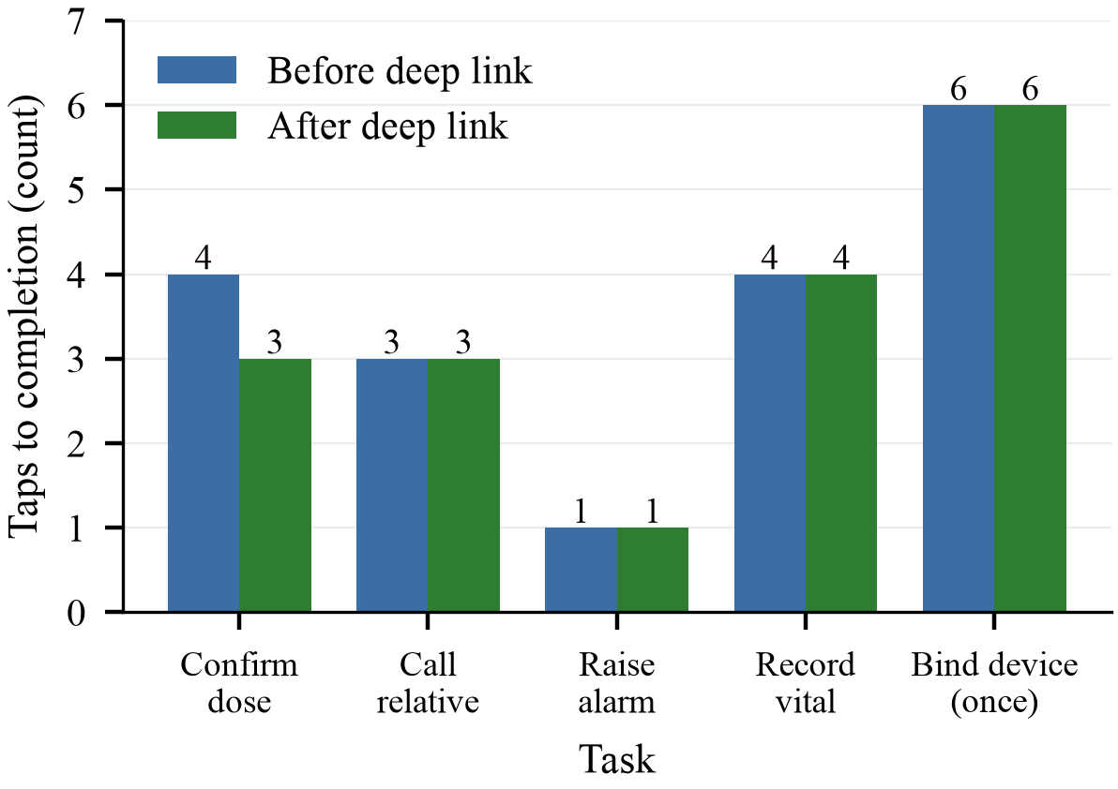
Figure 5: Interactions to completion for core tasks on the elder surface, counted from the notification or from the home screen.
Figure 5 counts interactions to completion for the elder surface's core tasks. Raising an alarm costs one tap. Confirming a dose from its reminder costs three, following a change that routes the notification directly to the medication screen rather than to the home screen; previously it cost four. The saving is one tap, which sounds trivial and is not: each intermediate screen is an opportunity for an older adult to lose the thread, and an unconfirmed dose is recorded as missed and shown to the caregiver as a possible non-adherence event. Interaction cost on this surface is therefore coupled to data quality, not only to convenience.
4.3 Defect study
After the system was feature-complete and had been exercised on physical devices, we conducted a structured audit: a line-by-line review of all 83 source files together with targeted inspection of the database schema and access policies. We recorded every defect found and classified each by whether a user could have detected it from the interface alone. Every defect reported here was subsequently corrected, and each correction is traceable to a commit in the project's version-control history together with the regression test added for it.
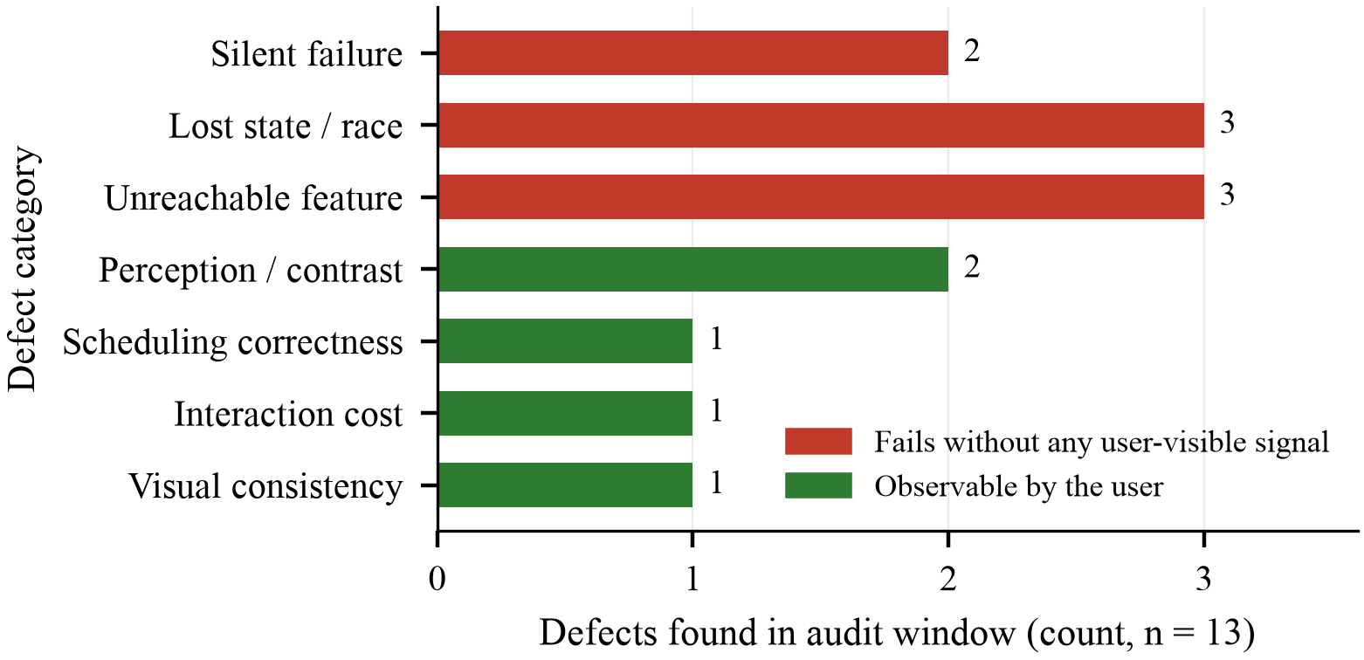
Figure 6: Defects found in the audit window, by class. Eight of thirteen would have failed with no user-visible signal.
Thirteen distinct defects were found, distributed as shown in Figure 6. The dominant finding is that 8 of 13, or 62 percent, were silent: the operation failed, or never occurred, while the interface reported success or reported nothing. Three classes deserve comment.
Unreachable features accounted for three. Two complete features, general reminders for hydration and activity and the caregiver invitation path, were written, exercised by the caregiver, stored correctly in the database and delivered to nobody. General reminders were never armed as alarms on the older adult's device and no server job scanned for them. The invitation path depended on the telephone-number assumption broken by federated sign-in, described in Section 3.2. In both cases the caregiver's interface behaved as though the feature worked. Both were subsequently repaired.
Lost state accounted for three. Three view models rebuilt their state object when a background refresh completed, discarding a transient completion flag that the screen used to navigate. A save that had already succeeded on the server therefore appeared to do nothing. The defect is timing-dependent, which is why it survived manual testing: it reproduces only when the refresh completes after the save, most likely on a slow connection.
Null failure messages accounted for one class spanning seventeen call sites. Every repository write terminates in taking the first element of the server's response. When access policy hides the returned row, that list is empty and the resulting exception carries no message. Seventeen call sites propagated that null message directly to the interface, rendering an empty error and presenting as an unresponsive button.
Two observations generalize beyond this system. First, identity-model migration produces latent dead features. Moving from telephone-number authentication to federated sign-in silently invalidated every code path that used a telephone number as a join key. Nothing failed loudly; two features simply stopped being reachable. Any system migrating to federated identity should audit its non-authentication uses of the prior identifier. Second, test suites do not detect unreachable features. The suite passed throughout the period in which two features delivered nothing, because each tested component behaved correctly in isolation. The defect lay in the absence of a caller. Detection required tracing each data type from producer to consumer, a check we recommend as routine practice and for which we found no substitute.
4.4 Discussion
The audit's central result is that most defects in a feature-complete care application were invisible from the interface. This has a specific consequence for elder care that it does not have for, say, a photo application. The older adult often cannot diagnose a silent failure, and the caregiver, the person who could, is looking at a different device that is also reporting success. A missing reminder produces no artifact at all; its absence is indistinguishable from a day with no medication due. The system's own adherence record, which the caregiver trusts, will attribute the gap to the older adult. We therefore propose that care systems adopt an explicit honesty discipline: acknowledge only observed outcomes; give every failure path a message a lay reader can act on; and, for any feature whose value is delivery, test the delivery rather than the storage.
The measured gap between the two surfaces is not the result of applying guidelines harder on one screen. It is a consequence of removing work from that screen. Type size and target size compete with information density; a surface that must present a scheduling form cannot also give every control 96 dp. By moving all configuration to the caregiver, the elder surface gains an accessibility budget it can spend on sizing and shallow navigation. We suggest this reframing, asymmetry as a budget rather than as simplification, is the transferable idea.
Application store permission policy determined the architecture of our emergency path. This is unusual to state in a research paper and, we think, ought not to be. A design that cannot be distributed cannot accumulate the longitudinal evidence the field needs. Treating policy as a constraint at design time, rather than discovering it at submission time, is a practical contribution of this work.
On scalability, the architecture is designed to support independent care circles: circles are disjoint, queries are scoped to a profile, and no routine operation requires a cross-tenant scan, so growth in the number of circles should be horizontal. Reminder scheduling is performed on the device, so the server is not a timing authority and carries no per-dose timer. Adherence writes are small, append-only and queue locally when offline. Large-scale performance has not been benchmarked; this is architectural analysis rather than measurement.
Several limitations bound these results. No user study has been conducted: no older adult or caregiver outside the development team has used the system under observation, so we make no usability, adherence or clinical claim, and every conformance number above is a static property of the implementation. Reminder delivery has been verified on physical devices anecdotally and in a shadowed runtime exhaustively, but we have no distribution of delivery latency across manufacturers and power-management regimes. The defect taxonomy comes from one application audited by its own developers, with a single observer and no inter-rater agreement; it is a case study, not a population estimate. The four language tables are complete and machine-checked for structural integrity but have not been reviewed by native speakers for register or clarity for older readers. Finally, the system is not a medical device and provides no diagnostic or dosing advice; vital-sign banding is presented as general reference information only.
5. Conclusions
We presented CareCompanion, a caregiver-mediated elder-care system built on three commitments. An asymmetric dual-surface architecture buys the older adult an accessibility budget by removing configuration from their device entirely, so that generous type and large targets become affordable rather than aspirational. Out-of-band device binding repairs an identity gap that federated sign-in introduces, using a single-use short-lived code in place of the telephone number that federated identity does not supply. Fail-honest alerting requires that the interface never assert an outcome it has not observed, so that an undelivered emergency alert says so and degrades to a user-mediated fallback.
Our measurements show the asymmetry is real. Parsed directly from the source, the elder surface has a median declared text size of 20 sp against 13 sp on the caregiver surface, and every primary control is at least 64 dp against a 48 dp platform minimum, with the emergency control at 130 dp. Interaction cost for the most frequent task, confirming a dose from its reminder, is three taps.
The audit result is the one we consider most transferable. Of thirteen defects found in a feature-complete system, eight would have failed with no user-visible signal, including two features that were stored faithfully and delivered to nobody, and a passing test suite did not detect either. For software whose purpose is to be relied upon in an emergency, we argue that honesty about failure is not a secondary quality attribute but a primary design requirement, and that it should be evaluated explicitly rather than assumed.
These results suggest that elder-care systems should be assessed not only for accessibility and functionality, but also for whether users receive truthful feedback when critical operations fail. Future work falls into three parts. The immediate priority is a dyad field deployment with older adults and their caregivers, measuring the delivery-level outcomes the literature usually assumes: the proportion of scheduled reminders actually presented by the device, the time from alarm activation to caregiver acknowledgement, and the frequency of the degraded emergency path. These are precisely the quantities the fail-honest instrumentation can record truthfully, which is the point of building it that way. Second, a spoken interaction layer in the four supported languages has since been implemented, allowing an older adult to confirm a dose by speaking rather than tapping; initial verification against synthesized speech is encouraging, but it remains untested with speakers of the target age. Third, medication stock tracking would let the system warn a caregiver before a medicine runs out, which is a failure mode as consequential as forgetting a dose and one the present system does not address.
Acknowledgements
The authors thank the Department of Artificial Intelligence and Data Science and the Department of Electronics and Computer Engineering at K. J. Somaiya School of Engineering for their guidance and support throughout this project.
Funding source
This research did not receive any specific grant from funding agencies in the public, commercial, or not-for-profit sectors.
Conflict of Interest
The authors declare that they have no known competing financial interests or personal relationships that could have appeared to influence the work reported in this paper.
References
[1] United Nations Population Fund, India Ageing Report 2023: Caring for Our Elders, Institutional Responses. New Delhi, India: UNFPA India, 2023.
[2] Data for India, “Access to phones and the internet,” 2025. [Online]. Available: https://www.dataforindia.com/comm-tech/. Accessed: Oct. 1, 2026.
[3] D. Chakraborty and C. Garg, “Navigating technology: Mobile media usage and reticence among older adults in rural India,” Mobile Media and Communication, vol. 14, pp. 31–49, 2025, doi: 10.1177/20501579251378548.
[4] A. Khare, R. Mukherjee, and M. Bedarkar, “Beyond digital literacy: A structural model analysis of technology acceptance among elderly persons,” Humanities and Social Sciences Communications, vol. 13, art. 794, 2026, doi: 10.1057/s41599-026-07146-7.
[5] H. Poorcheraghi, R. Negarandeh, S. Pashaeypoor, and J. Jorian, “Effect of using a mobile drug management application on medication adherence and hospital readmission among elderly patients with polypharmacy: A randomized controlled trial,” BMC Health Services Research, vol. 23, art. 1192, 2023, doi: 10.1186/s12913-023-10177-4.
[6] O. Salmensuu, J. Isotalo, M. Rijken, V. Hyttinen-Huotari, M. Kaarakainen, and I. Linnosmaa, “Effects of using medication reminder technologies by home-dwelling older citizens: A systematic review,” Age and Ageing, vol. 55, no. 2, art. afag007, 2026, doi: 10.1093/ageing/afag007.
[7] M. Awan, S. Ali, M. Ali, M. F. Abrar, H. Ullah, and D. Khan, “Usability barriers for elderly users in smartphone app usage: An analytical hierarchical process-based prioritization,” Scientific Programming, vol. 2021, art. 2780257, 2021, doi: 10.1155/2021/2780257.
[8] L. Elguera Paez and C. Zapata Del Rio, “Elderly users and their main challenges usability with mobile applications: A systematic review,” in Design, User Experience, and Usability, Lecture Notes in Computer Science. Cham, Switzerland: Springer, 2019, pp. 423–438, doi: 10.1007/978-3-030-23570-3_31.
[9] N. Liu, J. Yin, S. S.-L. Tan, K. Y. Ngiam, and H. H. Teo, “Mobile health applications for older adults: A systematic review of interface and persuasive feature design,” Journal of the American Medical Informatics Association, vol. 28, pp. 2483–2501, 2021, doi: 10.1093/jamia/ocab151.
[10] M. Gomez-Hernandez, X. Ferre, C. Moral, and E. Villalba-Mora, “Design guidelines of mobile apps for older adults: Systematic review and thematic analysis,” JMIR mHealth and uHealth, vol. 11, art. e43186, 2023, doi: 10.2196/43186.
[11] E. Amouzadeh, I. Dianat, J. Faradmal, and M. Babamiri, “Optimizing mobile app design for older adults: Systematic review of age-friendly design,” Aging Clinical and Experimental Research, vol. 37, art. 248, 2025, doi: 10.1007/s40520-025-03157-7.
[12] C. C. Quinn, S. Staub, E. Barr, and A. Gruber-Baldini, “Mobile support for older adults and their caregivers: Dyad usability study,” JMIR Aging, vol. 2, no. 1, art. e12276, 2019, doi: 10.2196/12276.
[13] C. Benmessaoud, K. J. Pfisterer, A. De Leon, A. Saragadam, N. El-Dassouki, K. G. M. Young, R. Lohani, and T. Xiong, “Design of a dyadic digital health module for chronic disease shared care: Development study,” JMIR Human Factors, vol. 10, art. e45035, 2023, doi: 10.2196/45035.
[14] Android Developers, “Optimize for Doze and App Standby,” Android Documentation. [Online]. Available: https://developer.android.com/training/monitoring-device-state/doze-standby. Accessed: Oct. 1, 2026.
[15] E. Wiecek, S. Taylor, H. Rourke, F. Hammond, and N. Amador-Fernandez, “Mobile health apps for older adults: Real-world evidence on engagement and medication adherence,” Frontiers in Digital Health, vol. 8, art. 1716880, 2026, doi: 10.3389/fdgth.2026.1716880.
[16] Z. Nimmanterdwong, S. Boonviriya, and P. Tangkijvanich, “Human-centered design of mobile health apps for older adults: Systematic review and narrative synthesis,” JMIR mHealth and uHealth, vol. 10, no. 1, art. e29512, 2022, doi: 10.2196/29512.
[17] M. Hamill, V. Young, J. Boger, and A. Mihailidis, “Development of an automated speech recognition interface for personal emergency response systems,” Journal of NeuroEngineering and Rehabilitation, vol. 6, art. 26, 2009, doi: 10.1186/1743-0003-6-26.
[18] Google Play Console Help, “Use of SMS or Call Log permission groups,” Google Play. [Online]. Available: https://support.google.com/googleplay/android-developer/answer/10208820. Accessed: Oct. 1, 2026.
[19] Android Developers Blog, “Reminder: SMS/Call Log policy changes,” Jan. 2019. [Online]. Available: https://android-developers.googleblog.com/2019/01/reminder-smscall-log-policy-changes.html. Accessed: Oct. 1, 2026.
[20] Material Design 3, “Accessibility and touch target size,” Google. [Online]. Available: https://m3.material.io/foundations/accessible-design/patterns. Accessed: Oct. 1, 2026.
[21] Web Content Accessibility Guidelines (WCAG) 2.2, W3C Recommendation, World Wide Web Consortium, 2023. [Online]. Available: https://www.w3.org/TR/WCAG22/. Accessed: Oct. 1, 2026.

