**Task 1. Database Design:**

1. **Create the database named "SISDB”.**

CREATE DATABASE SISDB;

**2. Define the schema for the Students, Courses, Enrolments, Teacher, and Payments tables based on the provided schema. Write SQL scripts to create the mentioned tables with appropriate data types, constraints, and relationships.**

1. **Students Table**

CREATE TABLE students (

student_id INT NOT NULL AUTO_INCREMENT,

first_name VARCHAR (30),

last_name VARCHAR (30),

date_of_birth DATE,

email VARCHAR (30) UNIQUE,

phone_number VARCHAR (10),

PRIMARY KEY (student_id)

);

1. **Courses Table**

CREATE TABLE courses (

course_id INT NOT NULL AUTO_INCREMENT,

course_name VARCHAR (30),

credits INT,

teacher_id INT,

FOREIGN KEY (teacher_id) REFERENCES teacher(teacher_id) ON DELETE CASCADE,

PRIMARY KEY(course_id)

);

**c. Enrolments Table**

CREATE TABLE enrollments (

enrollment_id INT NOT NULL AUTO_INCREMENT,

student_id INT,

course_id INT,

enrollment_date DATE,

FOREIGN KEY (student_id) REFERENCES student (student_id) ON DELETE CASCADE,

FOREIGN KEY (course_id) REFERENCES course (course_id) ON DELETE CASCADE,

PRIMARY KEY(enrollment_id)

);

**d. Teacher table**

CREATE TABLE teacher (

teacher_id INT NOT NULL AUTO_INCREMENT,

first_name VARCHAR(30),

last_name VARCHAR(30),

email VARCHAR(30) UNIQUE,

PRIMARY KEY(teacher_id)

);

**e. Payments**

CREATE TABLE payments (

payment_id INT NOT NULL AUTO_INCREMENT,

student_id INT,

amount INT,

payment_date DATE,

FOREIGN KEY (student_id) REFERENCES student (student_id) ON DELETE CASCADE,

PRIMARY KEY(payment_id)

);

**3. Create an ERD (Entity Relationship Diagram) for the database.**

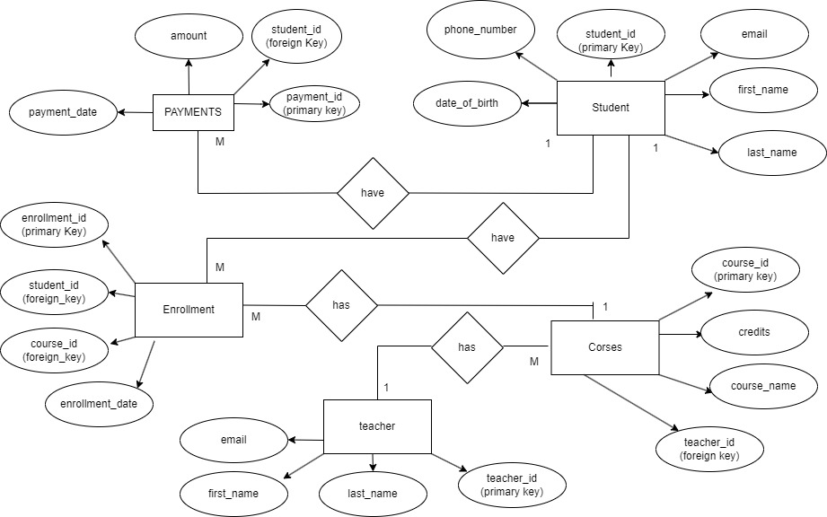

**Student Information System**

**5. Insert at least 10 sample records into each of the following tables.**

**i. Students**

INSERT INTO students (

first_name,last_name,email,phone_number,date_of_birth)

VALUES

("Adarsh","Sharma","as93052533@gmail.com","9919425844","2000-19-27"),

("Amit","Kumar","amitk9696@gmail.com","7275193188","1996-11-01"),

("Ankur","Hupta","ankur569@gmail.com","1234567895","1970-07-10"),

("Ranjana","singh","ranjsing456@gmail.com","983698569","2002-19-21"),

("Suyash","Singh","aps89889@gmail.com","9369558899","1997-01-08");

**ii. Courses**

INSERT INTO courses (

course_name,credits,teacher_id)

VALUES

("Hindi",7,28),

("English",7,1),

("Math",47,5),

("Science",21,32),

("Java",21,4);

**iii. Enrolments**

INSERT INTO enrolments (

student_id,course_id,enrollment_date)

VALUES

(3,8,"2021-12-17"),

(8,1,"2022-02-08"),

(2,2,"2023-10-10"),

(3,1,"2023-11-16"),

(5,8,"2022-17-6"),

(54,12,"2025-1-18"),

(21,51,"2021-11-07");

**iv. Teachers**

INSERT INTO teachers (

first_name,last_name,email)

VALUES

("Kamal","Pardesi","kamal@gmail.com"),

("Bala","Chandra","bala@gmail.com"),

("mahesh","babu","mahesh@gmail.com"),

("Allu","Arjun","allu@gmail.com"),

("Vijay","Thalapaty","vijay@gmail.com");

**v. Payments**

INSERT INTO payment (

student_id,amount,payment_date)

VALUES

(2,7000,"2021-08-07"),

(3,120000,"2019-06-20"),

(8,57000,"2023-07-01"),

(8,80000,"2022-11-11");

**Tasks 2: Select, Where, Between, LIKE, AND:**

**1. Write an SQL query to insert a new student into the "Students" table with the following details:**

a. First Name: John

b. Last Name: Doe

c. Date of Birth: 1995-08-15

d. Email: [john.doe@example.com](mailto:john.doe@example.com)

e. Phone Number: 1234567890

**Query Answer –**

INSERT INTO Students (

first_name,last_name,email,phone_number,date_of_birth)

VALUES

("John","Doe","john.doe@example.com","1234567890","1995-08-15");

**2. Write an SQL query to enroll a student in a course. Choose an existing student and course and insert a record into the "Enrollments" table with the enrollment date.**

INSERT INTO enrollment(

student_id,course_id,enrollment_date)

VALUES

(1,1,"2023-12-01");

**3. Update the email address of a specific teacher in the "Teacher" table. Choose any teacher and modify their email address.**

UPDATE teacher

 set email="abc@gmail.com"

where teacher_id=5;

**4. Write an SQL query to delete a specific enrollment record from the "Enrollments" table. Select an enrollment record based on the student and course.**

DELETE FROM enrollment

WHERE enrollment_id=1;

**5. Update the "Courses" table to assign a specific teacher to a course. Choose any course and teacher from the respective tables.**

UPDATE courses

SET teacher_id=2

 where course_id=5;

**6. Delete a specific student from the "Students" table and remove all their enrollment records from the "Enrollments" table. Be sure to maintain referential integrity.**

DELETE FROM students

 WHERE student_id=6;

**7. Update the payment amount for a specific payment record in the "Payments" table. Choose any payment record and modify the payment amount.**

UPDATE payment

SET AMOUNT=99

WHERE payment_id=1;

**Task 3. Aggregate functions, Having, Order By, Group By and Joins:**

**1.Write an SQL query to calculate the total payments made by a specific student. You will need to join the "Payments" table with the "Students" table based on the student's ID.**

SELECT DISTINCT CONCAT(s.first_name," ",s.last_name) AS Name,

sum(p.amount)

FROM students s JOIN payment p

ON s.student_id = p.student_id

GROUP BY p.student_id;

**2. Write an SQL query to retrieve a list of courses along with the count of students enrolled in each course. Use a JOIN operation between the "Courses" table and the "Enrollments" table.**

SELECT c.course_name as course,count(e.course_id) AS count

FROM course c JOIN enrollment e

ON c.course_id = e.course_id

GROUP BY e.course_id;

**3. Write an SQL query to find the names of students who have not enrolled in any course. Use a LEFT JOIN between the "Students" table and the "Enrollments" table to identify students without enrollments.**

SELECT DISTINCT CONCAT (first_name, " ", last_name) AS Name

FROM student

WHERE student_id NOT IN (

SELECT student_id

FROM enrollment

);

SELECT CONCAT (s.first_name, " ", s.last_name) AS Name

FROM student s LEFT JOIN enrollment e

ON s.student_id = e.student_id

WHERE e.student_id IS NULL;

**4. Write an SQL query to retrieve the first name, last name of students, and the names of the courses they are enrolled in. Use JOIN operations between the "Students" table and the "Enrollments" and "Courses" tables.**

SELECT s.first_name,s.last_name,c.course_name

FROM enrollment e JOIN student s

ON e.student_id = s.student_id

JOIN course c

ON e.course_id = c.course_id;

**5. Create a query to list the names of teachers and the courses they are assigned to. Join the "Teacher" table with the "Courses" table.**

SELECT CONCAT (t.first_name," ",t.last_name) AS Name,c.course_name

FROM teacher t JOIN course c

ON t.teacher_id = c.teacher_id;

**6. Retrieve a list of students and their enrollment dates for a specific course. You'll need to join the "Students" table with the "Enrollments" and "Courses" tables.**

SELECT CONCAT (s.first_name," ",s.last_name) AS Name,c.course_name AS course,e.enrollment_date

FROM enrollment e JOIN student s

ON e.student_id = s.student_id

JOIN course c

ON e.course_id = c.course_id;

**7. Find the names of students who have not made any payments. Use a LEFT JOIN between the "Students" table and the "Payments" table and filter for students with NULL payment records.**

SELECT student_id,first_name,last_name

FROM student WHERE student_id NOT IN(

SELECT student_id FROM payment);

SELECT s.student_id, s.first_name,s.last_name

FROM student s LEFT JOIN payment p

ON s.student_id = p.student_id

WHERE p.student_id IS NULL;

**8. Write a query to identify courses that have no enrollments. You'll need to use a LEFT JOIN between the "Courses" table and the "Enrollments" table and filter for courses with NULL enrollment records.**

SELECT course_id,course_name

FROM course

WHERE course_id NOT IN(

SELECT course_id FROM enrollment);

SELECT c.course_id, c.course_name

FROM course c LEFT JOIN enrollment e

ON c.course_id = e.course_id

WHERE e.course_id IS NULL;

**9. Identify students who are enrolled in more than one course. Use a self-join on the "Enrollments" table to find students with multiple enrollment records.**

SELECT student_id,COUNT(course_id)

FROM enrollment

GROUP BY student_id

HAVING COUNT(course_id) > 1;

SELECT e1.student_id AS StudentId, COUNT(e1.course_id) AS NumberOfStudent

FROM enrollment e1 JOIN enrollment e2

ON e1.student_id=e2.student_id AND e1.course_id<>e2.course_id

GROUP BY e1.student_id

HAVING COUNT(e1.course_id) > 1;

**10. Find teachers who are not assigned to any courses. Use a LEFT JOIN between the "Teacher" table and the "Courses" table and filter for teachers with NULL course assignments.**

SELECT t.teacher_id,CONCAT(t.first_name," ",t.last_name) AS teacherName

FROM teacher t LEFT JOIN course c

ON t.teacher_id = c.teacher_id

WHERE c.teacher_id IS NULL;

**Task 4. Subquery and its type:**

**1.Write an SQL query to calculate the average number of students enrolled in each course. Use aggregate functions and subqueries to achieve this.**

SELECT course_id, AVG(student_count) AS average_students_per_course

FROM (

SELECT course_id, COUNT(DISTINCT student_id) AS student_count

FROM enrollment

GROUP BY course_id

) AS course_counts

GROUP BY course_id;

**2. Identify the student(s) who made the highest payment. Use a subquery to find the maximum payment amount and then retrieve the student(s) associated with that amount.**

SELECT student_id

FROM payment

where amount = (

SELECT MAX(amount)

FROM payment

);

**3. Retrieve a list of courses with the highest number of enrollments. Use subqueries to find the course(s) with the maximum enrollment count.**

SELECT course_id, COUNT(*) AS enrollment_count

FROM enrollment

GROUP BY course_id

HAVING COUNT(*) = (

SELECT MAX(enrollment_count)

FROM (

SELECT COUNT(*) AS enrollment_count

FROM enrollment

GROUP BY course_id

) AS counts

);

**4. Calculate the total payments made to courses taught by each teacher. Use subqueries to sum payments for each teacher's courses.**

SELECT enrollment.course_id, course.course_name, COUNT(*) AS enrollment_count

FROM enrollment

JOIN course ON enrollment.course_id = course.course_id

GROUP BY course_id, course_name

HAVING COUNT(*) = (

SELECT MAX(enrollment_count)

FROM (

SELECT COUNT(*) AS enrollment_count

FROM enrollment

GROUP BY course_id

) AS counts

);

**5. Identify students who are enrolled in all available courses. Use subqueries to compare a student's enrollments with the total number of courses.**

SELECT student_id, first_name, last_name

FROM student

WHERE student_id IN (

SELECT e.student_id

FROM enrollment e

GROUP BY e.student_id

HAVING COUNT(DISTINCT e.course_id) = (

SELECT COUNT(*)

FROM course

)

);

**6. Retrieve the names of teachers who have not been assigned to any courses. Use subqueries to find teachers with no course assignments.**

SELECT teacher_id, first_name, last_name

FROM teacher

WHERE teacher_id NOT IN (

SELECT DISTINCT teacher_id

FROM course

);

**7. Calculate the average age of all students. Use subqueries to calculate the age of each student based on their date of birth.**

SELECT AVG(age) AS average_age

FROM (

SELECT TIMESTAMPDIFF(YEAR, date_of_birth, CURDATE()) AS age

FROM student

) AS student_ages;

**8. Identify courses with no enrollments. Use subqueries to find courses without enrollment records.**

SELECT course_id, course_name

FROM course

WHERE course_id NOT IN (

SELECT DISTINCT course_id

FROM enrollment

);

**9. Calculate the total payments made by each student for each course they are enrolled in. Use subqueries and aggregate functions to sum payments.**

SELECT e.student_id, e.course_id,

COALESCE(SUM(p.amount), 0) AS total_payments_for_course

FROM enrollment e

LEFT JOIN payment p ON e.student_id = p.student_id

GROUP BY e.student_id, e.course_id;

**10. Identify students who have made more than one payment. Use subqueries and aggregate functions to count payments per student and filter for those with counts greater than one.**

SELECT student_id

FROM payment

GROUP BY student_id

HAVING COUNT (*) > 1;

**11. Write an SQL query to calculate the total payments made by each student. Join the "Students" table with the "Payments" table and use GROUP BY to calculate the sum of payments for each student.**

SELECT s.student_id, s.first_name, s.last_name, COALESCE(SUM(p.amount), 0) AS total_payments

FROM student s

LEFT JOIN payment p ON s.student_id = p.student_id

GROUP BY s.student_id, s.first_name, s.last_name;

**12. Retrieve a list of course names along with the count of students enrolled in each course. Use JOIN operations between the "Courses" table and the "Enrollments" table and GROUP BY to count enrollments.**

SELECT c.course_id, c.course_name, COUNT(e.student_id) AS enrolled_students_count

FROM course c

LEFT JOIN enrollment e ON c.course_id = e.course_id

GROUP BY c.course_id, c.course_name;

**13. Calculate the average payment amount made by students. Use JOIN operations between the "Students" table and the "Payments" table and GROUP BY to calculate the average.**

SELECT s.student_id, s.first_name, s.last_name, AVG(p.amount) AS average_payment_amount

FROM student s

LEFT JOIN payment p ON s.student_id = p.student_id

GROUP BY s.student_id, s.first_name, s.last_name;