Suyash Bhagat

Aviation management system

Group-9

April 23, 2023

ER Diagram

Relation Schema

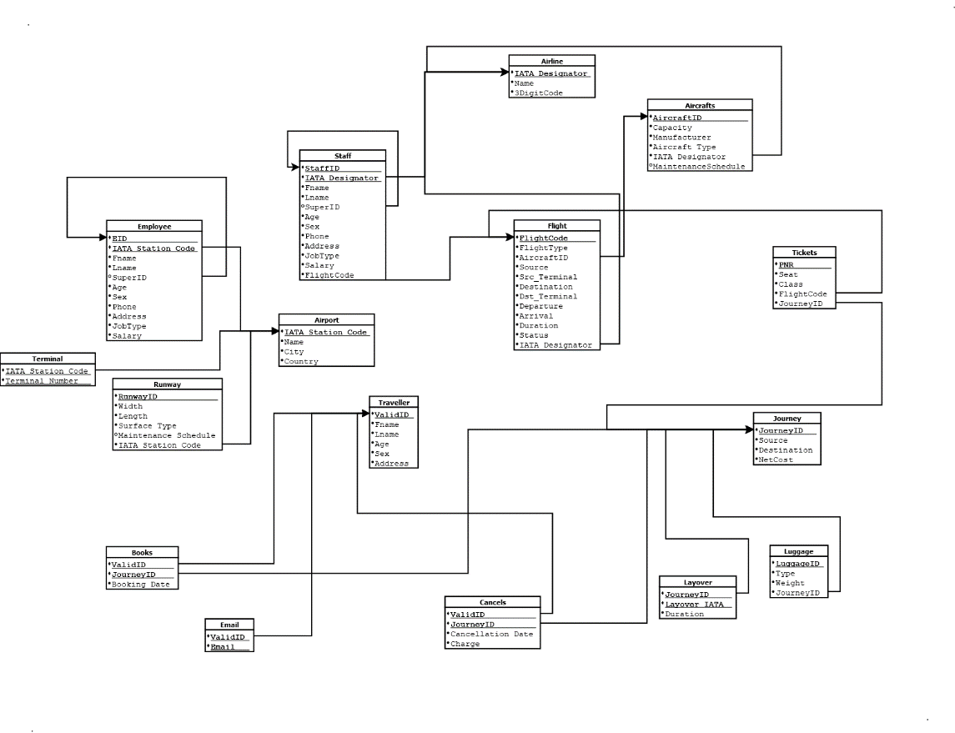

Minimal FD Set

IATA Station Code → Name

IATA Station Code → City

IATA Station Code → Country

RunwayID → Width

RunwayID → Length

RunwayID → Surface Type

RunwayID → Maintenance Schedule

RunwayID → IATA Station Code

{EID, IATA Station Code} → Fname

{EID, IATA Station Code} → Lname

{EID, IATA Station Code} → SuperID

{EID, IATA Station Code} → Age

{EID, IATA Station Code} → Sex

{EID, IATA Station Code} → Phone

{EID, IATA Station Code} → Address

{EID, IATA Station Code} → JobType

{EID, IATA Station Code} → Salary

IATA Designator → Name

IATA Designator → 3DigitCode

AircraftID → Capacity

AircraftID → Manufacturer

AircraftID → Aircraft Type

AircraftID → IATA Designator

AircraftID → Maintenance Schedule

{StaffID, IATA Designator} → Fname

{StaffID, IATA Designator} → Lname

{StaffID, IATA Designator} → SuperID

{StaffID, IATA Designator} → Age

{StaffID, IATA Designator} → Sex

{StaffID, IATA Designator} → Phone

{StaffID, IATA Designator} → Address

{StaffID, IATA Designator} → JobType

{StaffID, IATA Designator} → Salary

{StaffID, IATA Designator} → Flight Code

FlightCode → FlightType

FlightCode →AircraftID

FlightCode → Source

FlightCode → Destination

FlightCode → SRC_Terminal

FlightCode → DST_Terminal

FlightCode → Departure

FlightCode → Arrival

FlightCode → Duration

FlightCode → Status

FlightCode → IATA Designator

PNR → Seat

PNR → Class

PNR → FlightCode

PNR → Journey

JourneyID → Source

JourneyID → Destination

JourneyID → NetCost

{JourneyID, Layover IATA} → Duration

Luggage ID → Type

Luggage ID → Weight

Luggage ID → JourneyID

ValidID → Fname

ValidID → Lname

ValidID → Age

ValidID → Sex

ValidID → Address

{ValidID, JourneyID} → Booking Date

{ValidID, JourneyID} → Cancellation Date

{ValidID, JourneyID} → Charge

BCNF Normalization Broof

Airport:

IATA Station Code → Name

IATA Station Code → City

IATA Station Code → Country

Since, in every FD X → Y, X is the key, the given relation is in BCNF.

Runway:

RunwayID → Width

RunwayID → Length

RunwayID → Surface Type

RunwayID → Maintenance Schedule

RunwayID → IATA Station Code

Since, in every FD X → Y, X is the key, the given relation is in BCNF.

Terminal:

Since the relation only has Key attributes, the given relation is in BCNF.

Employee:

{EID, IATA Station Code} → Fname

{EID, IATA Station Code} → Lname

{EID, IATA Station Code} → SuperID

{EID, IATA Station Code} → Age

{EID, IATA Station Code} → Sex

{EID, IATA Station Code} → Phone

{EID, IATA Station Code} → Address

{EID, IATA Station Code} → JobType

{EID, IATA Station Code} → Salary

Since, in every FD X → Y, X is the key, the given relation is in BCNF.

Airline:

IATA Designator → Name

IATA Designator → 3DigitCode

Since, in every FD X → Y, X is the key, the given relation is in BCNF.

Aircraft:

AircraftID → Capacity

AircraftID → Manufacturer

AircraftID → Aircraft Type

AircraftID → IATA Designator

AircraftID → Maintenance Schedule

Since, in every FD X → Y, X is the key, the given relation is in BCNF.

Staff:

{StaffID, IATA Designator} → Fname

{StaffID, IATA Designator} → Lname

{StaffID, IATA Designator} → SuperID

{StaffID, IATA Designator} → Age

{StaffID, IATA Designator} → Sex

{StaffID, IATA Designator} → Phone

{StaffID, IATA Designator} → Address

{StaffID, IATA Designator} → JobType

{StaffID, IATA Designator} → Salary

{StaffID, IATA Designator} → Flight Code

Since, in every FD X → Y, X is the key, the given relation is in BCNF.

Flight:

FlightCode → FlightType

FlightCode →AircraftID

FlightCode → Source

FlightCode → Destination

FlightCode → SRC_Terminal

FlightCode → DST_Terminal

FlightCode → Departure

FlightCode → Arrival

FlightCode → Duration

FlightCode → Status

FlightCode → IATA Desginator

Since, in every FD X → Y, X is the key, the given relation is in BCNF

Ticket:

PNR → Seat

PNR → Class

PNR → FlightCode

PNR → Journey

Since, in every FD X → Y, X is the key, the given relation is in BCNF.

Journey:

JourneyID → Source

JourneyID → Destination

JourneyID → NetCost

Since, in every FD X → Y, X is the key, the given relation is in BCNF.

Layover:

{JourneyID, Layover IATA} → Duration

Since, in every FD X → Y, X is the key, the given relation is in BCNF.

Luggage:

Luggage ID → Type

Luggage ID → Weight

Luggage ID → JourneyID

Since, in every FD X → Y, X is the key, the given relation is in BCNF.

Traveller:

ValidID → Fname

ValidID → Lname

ValidID → Age

ValidID → Sex

ValidID → Address

Since, in every FD X → Y, X is the key, the given relation is in BCNF.

Books:

{ValidID, JourneyID} → Booking Date

Since, in every FD X → Y, X is the key, the given relation is in BCNF.

Cancels:

{ValidID, JourneyID} → Cancellation Date

{ValidID, JourneyID} → Charge

Since, in every FD X → Y, X is the key, the given relation is in BCNF.