**CRC Diagram**

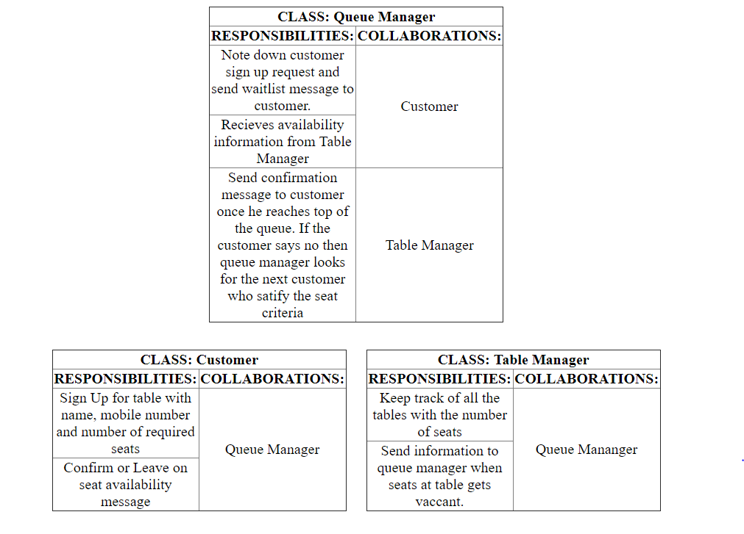

**Problem approach**

* I have used chain of responsibility design pattern for the problem.
* The customer signup with the Queue manager with name, mobile and number of seats request.
* The table manager send the information when a table with specified number of seat is available.
* The queue manager acts as the handler who pass on the information to the top most customer satisfying the number of seats criteria. If the customer confirms then the table is allocated otherwise the information is passed to the next customer in queue.
* Thus, the customers are in chain in this problem.