Worksheet 5

Student Name:Suyash UID:25MCI10054
Branch:MCA (AI&ML) Section/Group:MAM-1 A
Semester:2nd Date of Performance:03/03/2026
Subject Name:- Technical Training -I Subject Code: 25CAP-652

Implementation of Cursors for Row-by-Row Processing in PostgreSQL

Aim

To gain hands-on experience in creating and using cursors for sequential row-by-row processing and applying procedural logic for complex business operations in PostgreSQL.

Tools Used

● PostgreSQL

Objectives

● To understand sequential data access using cursors

● To perform row-level manipulation using procedural logic

● To learn the lifecycle of a cursor (DECLARE → OPEN → FETCH → CLOSE)

● To handle exceptions and cursor termination conditions

● To relate cursor concepts with real-world enterprise applications

Theory

While SQL is generally set-oriented, certain tasks require a procedural approach where we process one row at a time. This is where Cursors are used:
- Cursor Types: Cursors can be Implicit (managed by the system) or Explicit (defined by the developer). They can also be Forward-Only (moving only toward the end) or Scrollable (moving back and forth).
- The Lifecycle: * DECLARE: Defines the SQL query for the cursor.

OPEN: Executes the query and establishes the result set.

FETCH: Retrieves a specific row into variables for processing.

CLOSE: Releases the current result set.

DEALLOCATE: Removes the cursor definition from memory.
- Use Case: Cursors are ideal for generating row-specific reports, updating balances based on complex historical data, or migrating data where each record needs individual validation

Experiment Steps

Step 1 : Simple Forward-Only Cursor

CREATE TABLE employees (
emp_id INT PRIMARY KEY,
emp_name VARCHAR(50),
experience INT,
salary INT,
performance_rating INT
);
INSERT INTO employees VALUES
(101, 'Sumit', 3, 40000, 4),
(102, 'Neha', 6, 50000, 5),
(103, 'Rahul', 2, 32000, 3),
(104, 'Priya', 8, 65000, 5),
(105, 'Karan', 5, 48000, 4);

Table

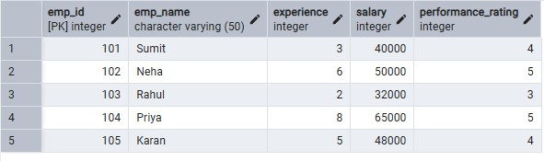

DO $$
DECLARE
emp_record RECORD;
emp_cursor CURSOR FOR
SELECT emp_id, emp_name, salary FROM employees;
BEGIN
OPEN emp_cursor;
LOOP
FETCH emp_cursor INTO emp_record;
EXIT WHEN NOT FOUND;
RAISE NOTICE 'Employee ID: %, Name: %, Salary: %',
emp_record.emp_id, emp_record.emp_name, emp_record.salary;
END LOOP;
CLOSE emp_cursor;
END;
$$;

Output

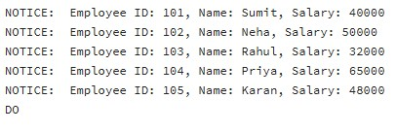

Step 2: Salary Update Using Cursor (Experience + Performance Logic)

DO $$
DECLARE
emp_record RECORD;
emp_cursor CURSOR FOR
SELECT * FROM employees;
bonus NUMERIC;
BEGIN
OPEN emp_cursor;
LOOP
FETCH emp_cursor INTO emp_record;
EXIT WHEN NOT FOUND;
bonus := emp_record.salary *
(emp_record.experience * 0.02 +
emp_record.performance_rating * 0.03);
UPDATE employees
SET salary = salary + bonus
WHERE emp_id = emp_record.emp_id;
RAISE NOTICE 'Salary updated for Employee ID: %',
emp_record.emp_id;
END LOOP;
CLOSE emp_cursor;
END;
$$;

Output

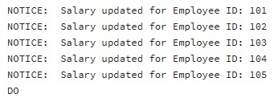

Table after step 2:

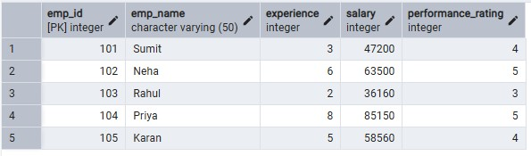

Step 3: Exception Handling for Empty Result Set

DO $$
DECLARE
emp_record RECORD;
emp_cursor CURSOR FOR
SELECT * FROM employees WHERE salary > 100000;
BEGIN
OPEN emp_cursor;
FETCH emp_cursor INTO emp_record;
IF NOT FOUND THEN
RAISE NOTICE 'No employee found with given condition';
END IF;
CLOSE emp_cursor;
END;
$$;

Output

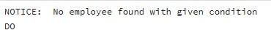

Learning Outcome
- Understand sequential row-by-row processing using cursors
- Implement cursor lifecycle correctly
- Apply complex business logic using procedural SQL
- Handle empty result sets and termination conditions
- Use cursors in enterprise scenarios like payroll and reporting

Result

This experiment demonstrates how cursors enable row-wise data processing in PostgreSQL.

Students learn cursor declaration, fetching, updating records, and proper resource management, which are essential for implementing complex business logic in enterprise-grade database a pplications.

