Experiment 2
Student Name: Suyash UID: 25MCI10054
Branch: MCA(AI/ML) Section/Group: 25MAM-1
Semester: 2nd Date of Performance: 13/1/2026
Subject Name: Technical Training Subject Code: 25CAP-652

1. Aim :

To implement and analyze SQL SELECT queries using filtering, sorting, grouping, and aggregation concepts in PostgreSQL for efficient data retrieval and analytical reporting

2. Tools Used

● PostgreSQL

3. Objective:
  - To retrieve specific data using filtering conditions
  - To sort query results using single and multiple attributes
  - To perform aggregation using grouping techniques
  - To apply conditions on aggregated data
  - To understand real‑world analytical queries commonly asked in placement interviews

4. Practical / Experiment Steps

Step 1: Database and Table Preparation
- Start the PostgreSQL server.
- Open the PostgreSQL client tool.
- Create a database for the experiment.
- Prepare a sample table representing customer orders containing details such as customer name, product, quantity, price, and order date.

- Insert sufficient sample records to allow meaningful analysis.
Query :
CREATE TABLE customer_orders (
order_id SERIAL PRIMARY KEY,
customer_name VARCHAR(50),
product VARCHAR(50),
quantity INT,
price NUMERIC(10,2),
order_date DATE
);
INSERT INTO customer_orders (customer_name, product, quantity, price, order_date) VALUES
('Amit', 'Laptop', 1, 60000, '2025-01-05'),
('Riya', 'Mobile', 2, 30000, '2025-01-06'),
('Suresh', 'Laptop', 1, 65000, '2025-01-07'),
('Neha', 'Tablet', 3, 15000, '2025-01-08'),
('Ankit', 'Mobile', 1, 20000, '2025-01-09'),
('Pooja', 'Tablet', 2, 12000, '2025-01-10');
Output
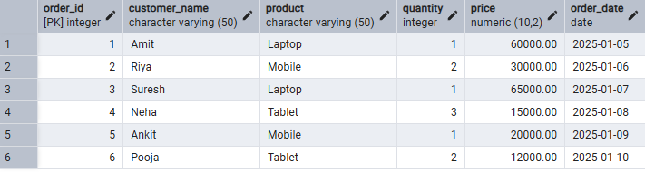

Step 2: Filtering Data Using Conditions
- Execute data retrieval operations to display only those records that satisfy specific conditions, such as higher-priced orders.

Query(Without case Statment)
SELECT *
FROM customer_orders
WHERE price > 25000;

Query with case statement:

SELECT *
FROM customer_orders
WHERE
CASE
WHEN Price > 25000 THEN 1
ELSE 0
END = 1;
Output
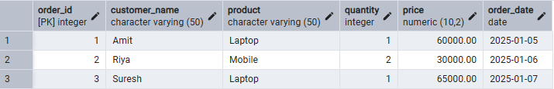

Step 3: Sorting Query Results
- Retrieve selected columns from the table and arrange the output based on numerical values such as price.
- Perform sorting using both ascending and descending order.
- Apply sorting on more than one attribute to understand priority-based ordering.
Sort by Price (Ascending)

SELECT customer_name, product, price
FROM customer_orders
ORDER BY price ASC;

Output

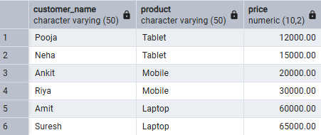

Sort by Price (Descending)

SELECT customer_name, product, price
FROM customer_orders
ORDER BY price DESC;

Output

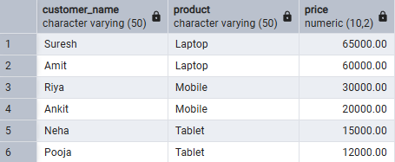

Sort by Product, then Price

SELECT customer_name, product, price
FROM customer_orders
ORDER BY product ASC, price DESC;

Output

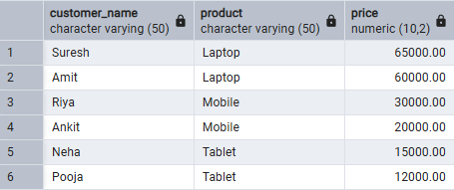

Step 4: Grouping Data for Aggregation
- Group records based on a common attribute such as product.
- Calculate aggregate values like total sales for each group.
- Analyze how multiple rows are combined into summarized results.
Total Sales Per Product
Query:
SELECT product, SUM(price * quantity) AS total_sales
FROM customer_orders
GROUP BY product;

Output
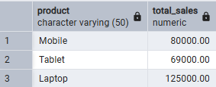

Step 5: Applying Conditions on Aggregated Data
- Apply conditions on grouped results to retrieve only those groups that satisfy specific aggregate criteria.
- Compare the difference between row-level filtering and group-level filtering.

Query:

SELECT product, SUM(price * quantity) AS total_sales
FROM customer_orders
GROUP BY product
HAVING SUM(price * quantity) > 50000;

Output

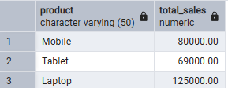

Step 6: Conceptual Understanding of Filtering vs Aggregation Conditions
- Analyze scenarios where conditions are incorrectly applied before grouping.
- Correctly apply conditions after grouping to avoid logical errors.

Incorrect usage:

Querry:
SELECT product, SUM(price)
FROM customer_orders
WHERE SUM(price) > 50000
GROUP BY product;

Correct Usage:

Querry:
SELECT product, SUM(price)
FROM customer_orders
GROUP BY product
HAVING SUM(price) > 50000;

Output
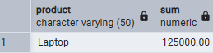

8. Learning Output
- Understand how to create relational database tables using appropriate data types and constraints
- Learn to retrieve required data from a table using row-level filtering with the WHERE clause.
- Gain the ability to apply column-level (group-level) filtering using the HAVING clause.
- Develop practical knowledge of using CASE statements for conditional logic in SQL queries.
- Understand the use of aggregate functions such as SUM(), AVG(), and COUNT() for analytical reporting.
- Clearly differentiate between row-level filtering and group-level filtering, and apply them correctly in real-world SQL scenarios.

