Worksheet 3

Student Name:Suyash UID:25MCI10054
Branch:MCA (AI&ML) Section/Group:MAM-1 A
Semester:2nd Date of Performance:27/01/2026
Subject Name:-DBMS Lab Subject Code:

1. Aim of the Session

To implement conditional decision-making logic in PostgreSQL using IF–ELSE constructs and CASE expressions for classification, validation, and rule-based data processing

2. Software Requirements
- PostgreSQL (Database Server)

3. Objective of the Session
- To understand conditional execution in SQL
- To implement decision-making logic using CASE expressions
- To simulate real-world rule validation scenarios
- To classify data based on multiple conditions
- To strengthen SQL logic skills required in interviews and backend systems

4. Practical / Experiment Steps
- Create a sample table representing Violation
- Insert realistic records into the table
- Classifying Data Using CASE Expression
- Applying CASE Logic in Data Updates
- Implementing IF–ELSE Logic Using PL/pgSQL
- Real-World Classification Scenario (Grading System)
- Using CASE for Custom Sorting

5. Procedure of the Practical

(i) Start the system and log in to the computer.

(ii) Open PostgreSQL software.

iii) Create and select the database.

(iv) Create table using DDL command.

CREATE TABLE Violations (

id INT PRIMARY KEY,

Entity_Name VARCHAR(100),

Violation_count INT

);

(v) Insert records into the table.

INSERT INTO Violations VALUES

(1, 'User_data', 13),

(2, 'Payment_data', 5),

(3, 'Audit_data', 22),

(4, 'Order_data', 0),

(5, 'Inventory_data', 0),

(6, 'Supplyer_data', 13);

(vi) Display all records.

SELECT*FROM Violations;

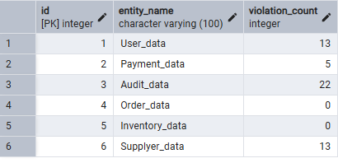

(vii) Classifying Data Using CASE Expression

SELECT

Entity_name,

Violation_count,

CASE

WHEN violation_count = 0 THEN 'No Violation'

WHEN violation_count BETWEEN 1 AND 5 THEN 'Minor Violation'

WHEN violation_count BETWEEN 6 AND 15 THEN 'Moderate Violation'

ELSE 'Critical Violation'

END AS Violation_Status

FROM Violations;

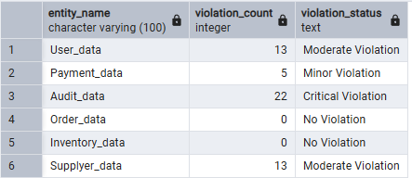

(viii) Applying CASE Logic in Data Updates

ALTER TABLE Violations

ADD COLUMN approval_status VARCHAR(30);

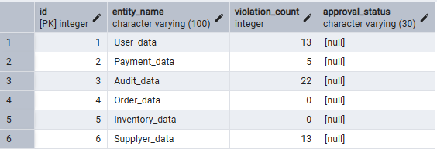

UPDATE Violations
SET approval_status =
CASE
WHEN violation_count = 0 THEN 'Approved'
WHEN violation_count BETWEEN 1 AND 15 THEN 'Needs Review'
ELSE 'Rejected'
END;
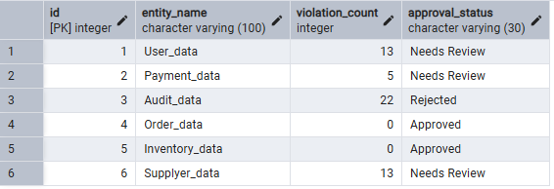

(ix) Implementing IF–ELSE Logic Using PL/pgSQL

DO $$
DECLARE
v_violation_count INT := 12; -- Change value to test output
BEGIN
IF v_violation_count = 0 THEN
RAISE NOTICE 'Status: Approved — No violations found';
ELSIF v_violation_count BETWEEN 1 AND 5 THEN
RAISE NOTICE 'Status: Needs Review — Minor violations detected';
ELSIF v_violation_count BETWEEN 6 AND 15 THEN
RAISE NOTICE 'Status: Needs Review — Moderate violations detected';
ELSE
RAISE NOTICE 'Status: Rejected — Critical violations detected';
END IF;
END $$;
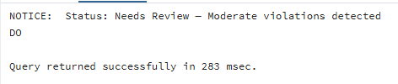

(x) Real-World Classification Scenario (Grading System)
- Table creation
CREATE TABLE Grades (
student_id SERIAL PRIMARY KEY,
student_name VARCHAR(50),
marks INT
);
- Data Insertion
INSERT INTO Grades (student_name, marks) VALUES
('Rohit', 95),
('Neha', 82),
('Sumit', 68),
('Priya', 91),
('Mehak', 56),
('Hemant', 45),
('Nikita', 77),
('Prince', 88),
('Atul', 35);
- Grading
SELECT
student_name,
marks,
CASE
WHEN marks >= 90 THEN 'A+ Grade'
WHEN marks BETWEEN 80 AND 89 THEN 'A Grade'
WHEN marks BETWEEN 70 AND 79 THEN 'B Grade'
WHEN marks BETWEEN 60 AND 69 THEN 'C Grade'
WHEN marks BETWEEN 40 AND 59 THEN 'D Grade'
ELSE 'Fail'
END AS Grade
FROM Grades;
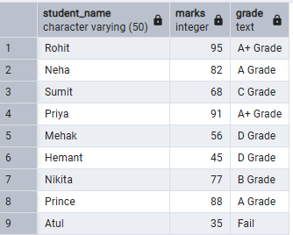

(xi) Using CASE for Custom Sorting
SELECT
entity_name,
violation_count,
CASE
WHEN violation_count > 15 THEN 'Critical Violation'
WHEN violation_count BETWEEN 6 AND 15 THEN 'Moderate Violation'
WHEN violation_count BETWEEN 1 AND 5 THEN 'Minor Violation'
ELSE 'No Violation'
END AS Violation_Severity
FROM Violations
ORDER BY
CASE
WHEN violation_count > 15 THEN 1
WHEN violation_count BETWEEN 6 AND 15 THEN 2
WHEN violation_count BETWEEN 1 AND 5 THEN 3
ELSE 4
END;
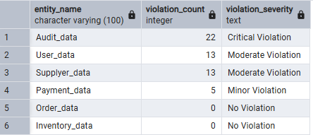

6. Learning Outcomes
This experiment demonstrates how conditional logic is implemented in PostgreSQL using CASE expressions and IF–ELSE constructs.
Students gain strong command over rule-based SQL logic, which is essential for:
- Backend systems
- Analytics
- Compliance reporting
- Placement and technical interviews

