Worksheet 4

Student Name:Suyash UID:25MCI10054
Branch:MCA (AI&ML) Section/Group:MAM-1 A
Semester:2nd Date of Performance:03/02/2026
Subject Name:- Technical Training -I Subject Code: 25CAP-652

Implementation of Iterative Control Structures using FOR, WHILE, and LOOP in PostgreSQL

Aim

To understand and implement iterative control structures in PostgreSQL conceptually, including FOR loops, WHILE loops, and basic LOOP constructs, for repeated execution of database logic.

Tools Used

● PostgreSQL

Objectives

● To understand why iteration is required in database programming

● To learn the purpose and behavior of FOR, WHILE, and LOOP constructs

● To understand how repeated data processing is handled in databases

● To relate loop concepts to real-world batch processing scenarios

● To strengthen conceptual knowledge of procedural SQL used in enterprise systems

Experiment Steps

Step 1: FOR Loop – Simple Iteration

CREATE TABLE employees (

emp_id int PRIMARY KEY,

emp_name VARCHAR(50),

salary int

);

INSERT INTO employees VALUES

(101, 'Sumit', 45000),

(102, 'Neha', 52000),

(103, 'Rahul', 38000),

(104, 'Priya', 60000),

(105, 'Karan', 48000);

do $$

begin

for i in 1..5 loop

raise notice 'Iteration Number: %', i;

end loop;

end;

$$ ;

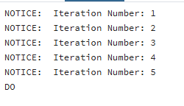

Example 2: FOR Loop with Query (Row-by-Row Processing)

do $$

declare

rec RECORD;

BEGIN

FOR rec IN (SELECT emp_id, emp_name FROM employees) LOOP

raise notice 'Employee ID: %, Name: %', rec.emp_id, rec.emp_name;

END LOOP;

END;

$$;

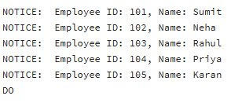

Example 3: WHILE Loop – Conditional Iteration

do $$

declare

counter INT := 1;

begin

while counter <= 5 loop

raise notice 'Counter value: %', counter;

counter := counter + 1;

end loop;

end;

$$ ;

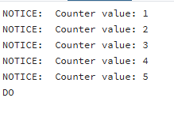

Example 4: LOOP with EXIT WHEN

do $$

declare

counter int := 1;

begin

loop

raise notice 'Counter value: %', counter;

counter := counter + 1;

exit when counter > 5;

end loop;

end;

$$ ;

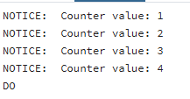

Example 5: Salary Increment Using FOR Loop

do $$

declare

rec RECORD;

begin

for rec in

select emp_id, salary from employees

loop

update employees

set salary = salary * 1.10

where emp_id = rec.emp_id;

raise notice 'Updated salary for Employee ID: %', rec.emp_id;

end loop;

end;

$$ ;

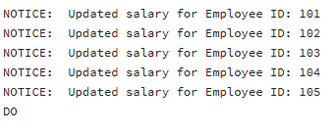

Example 6: Combining LOOP with IF Condition

do $$

declare

rec RECORD;

begin

for rec in

select emp_id, salary from employees

loop

if rec.salary > 50000 then

raise notice 'Employee ID % has salary more than 50000', rec.emp_id;

else

raise notice 'Employee ID % has salary less than 50000', rec.emp_id;

end if;

end loop;

end;

$$;

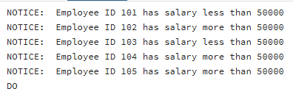

Learning Outcome
- Understand the need for iteration in database applications.
- Identify and use different loop types (FOR, WHILE, LOOP).
- Implement fixed and query-based repetition for row processing.
- Apply conditional and exit-controlled loops for automation tasks.
- Use PL/pgSQL loops in real-world scenarios like payroll, reporting, and batch processing.

Result

This experiment helps students understand how iterative control structures work in PostgreSQL at a conceptual level. Students learn where and why loops are used in database systems and gain foundational knowledge required for writing procedural logic in enterprise-grade applications.

