Worksheet 9

Student Name:Suyash UID:25MCI10054
Branch:MCA (AI&ML) Section/Group:MAM-1 A
Semester:2nd Date of Performance:07/04/2026
Subject Name:- Technical Training -I Subject Code: 25CAP-652

Aim

To implement database triggers in PostgreSQL to automatically calculate values and enforce constraints during data insertion operations.

Tools Used
- PostgreSQL
- pgAdmin
- Windows Operating System

Objectives
- Trigger Implementation: To understand how to create and use triggers in PostgreSQL.
- Automation: To automate calculation of total payable amount using triggers.
- Data Integrity: To enforce constraints using trigger conditions.
- Real-time Processing: To execute logic automatically before inserting data.

Theory

Triggers are special database objects that automatically execute a function when a specified event (INSERT, UPDATE, DELETE) occurs on a table. In PostgreSQL, triggers are associated with trigger functions written in PL/pgSQL. They help maintain data integrity, enforce business rules, and automate tasks.

Experiment Steps:

Step 1: Creating Table

Query:

CREATE TABLE employee (

emp_id INT PRIMARY KEY,

emp_name VARCHAR(50),

working_hours INT,

perhour_salary NUMERIC,

total_payable_amount NUMERIC

);

Step 2: Creating Trigger Function

Query:

CREATE OR REPLACE FUNCTION CACULATE_PAYABLE_AMOUNT()

RETURNS TRIGGER

AS

$$

BEGIN

NEW.total_payable_amount := NEW.perhour_salary * NEW.working_hours;

IF NEW.total_payable_amount > 25000 THEN

RAISE EXCEPTION 'INVALID ENTRY BEACUSE PAYABLE AMOUNT CAN

NOT BE GREATER THAN 25000';

END IF;

RETURN NEW;

END;

$$ LANGUAGE PLPGSQL;

Step 3: Creating Trigger

Query:

CREATE OR REPLACE TRIGGER

AUTOMATED_PAYABLE_AMOUNT_CALCULATION

BEFORE INSERT

ON employee

FOR EACH ROW

EXECUTE FUNCTION CACULATE_PAYABLE_AMOUNT();

Step 4: Inserting Valid Data

Query:

INSERT INTO EMPLOYEE(emp_id, emp_name, working_hours, perhour_salary)

VALUES (1, 'AKASH', 10, 1000);

Output:

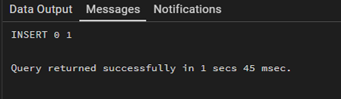

Step 5: Inserting Invalid Data (Exception Case)

Query:

INSERT INTO employee(emp_id, emp_name, working_hours, perhour_salary)

VALUES (2, 'Ankush', 8, 100000);

Output:

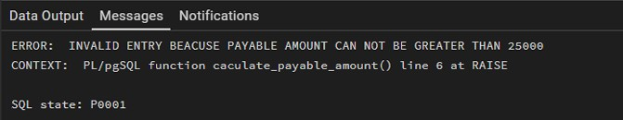

Step 6: Retrieving Data

Query:

SELECT * FROM EMPLOYEE;

Output:

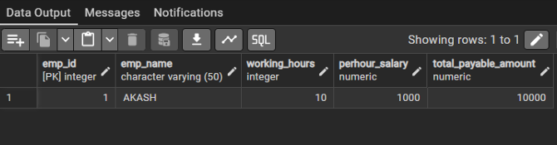

Learning Outcome
  - Students will be able to create and use triggers in PostgreSQL.
  - Students will understand how to automate calculations using triggers.
  - Students will enforce constraints using trigger conditions.
  - Students will understand real-time execution of database logic.

