Account:

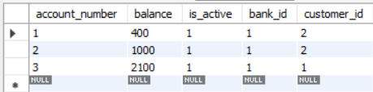

Admin:

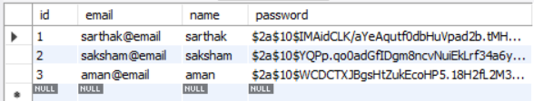

Bank:

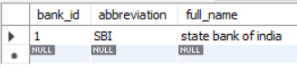

Customer:

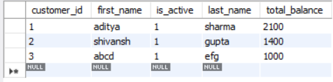

Roles:

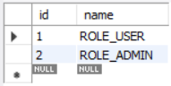

Transaction:

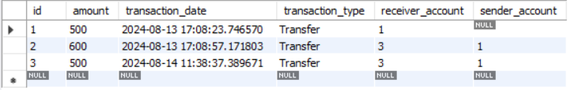

User roles:

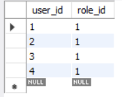

Users:

