Project Report

1. Project Title & Team Introduction
- Project Title: Intelligent Sustainability Assistant and Carbon Tracker
- Team Introduction: [Insert Team Member Names and Roles Here]

2. Domain Overview
Domain: Environmental Sustainability
The project “Intelligent Sustainability Assistant and Carbon Tracker” belongs to the domain of Environmental Sustainability , related to Subjects like Community Engagement System and Universal Human Values . This domain focuses on The domain focuses on empowering individuals to monitor and mitigate their environmental impact.
- It helps tracking daily activities across transportation, energy usage, food consumption, water usage, and shopping.
- Helps users gain insights into their carbon footprint (CO2e).
- It offers personalized decarbonization strategies and enhances user engagement through challenges, streaks, and badges.

3. Problem Statement
The consistent tracking and reduction of personal carbon emissions is often difficult without accessible tools and actionable insights. Therefore, there is a need to develop a web-based application that processes daily user activities using standardized emission factors to estimate their environmental impact. The system aims to provide a clear, interactive, and gamified approach to personal carbon footprint management.
Therefore, the problem is to design and develop a web-based Intelligent Sustainability Assistant and Carbon Tracker that:
- Accepts user activity logs across multiple categories (transportation, energy, food, water, and shopping)
- Calculates estimated CO2e emissions in real-time using standardized emission factors
- Displays visual analytics and historical trends of the user's carbon footprint

4. Literature Survey
- Carbon footprint tracking is a core concept in Environmental Sustainability.
- Explained in standard frameworks like the Greenhouse Gas (GHG) Protocol and IPCC guidelines.
- Used practically in corporate ESG reporting and raising personal environmental awareness.
- Limited interactive web-based platforms exist that seamlessly combine calculation, AI coaching, and gamification.
- This project provides a practical, intelligent, and gamified carbon tracking tool.

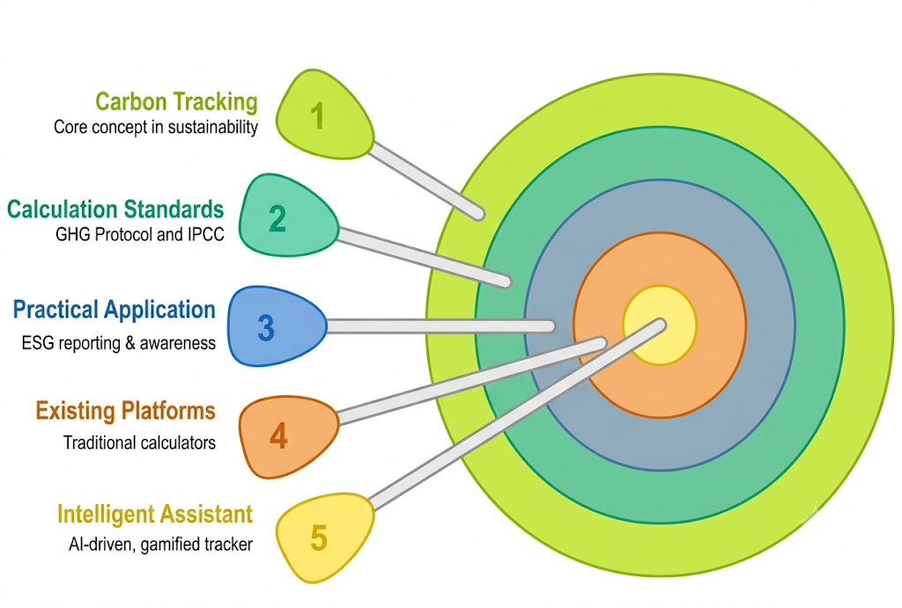

5. Comparative Analysis

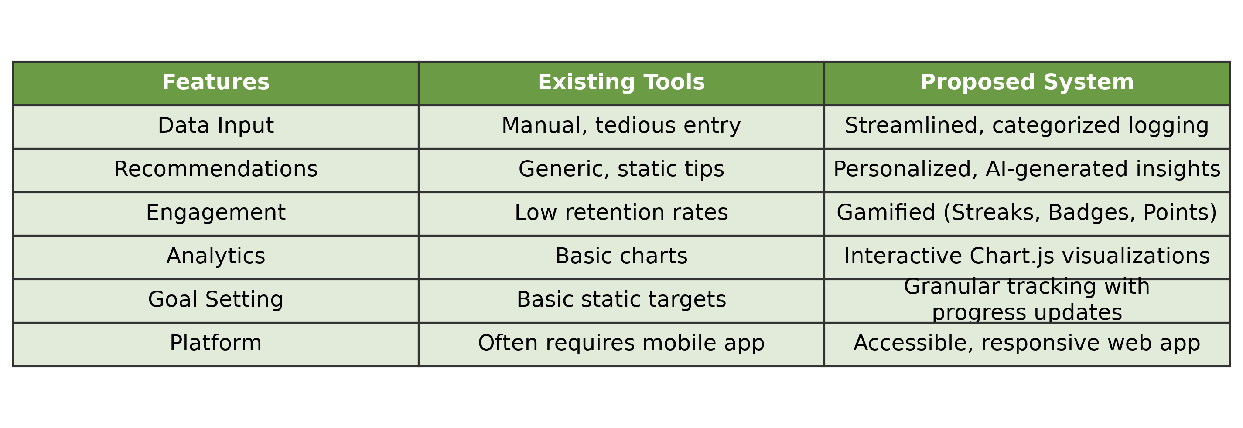

6. Proposed Methodology
1. Requirement Analysis :- a. Study carbon footprint calculation factors (IPCC/GHG Protocol). b. Identify system inputs (user activities) and outputs (CO2e, recommendations).
2. System Design :- a. Define database schema and authentication in Supabase. b. Design user interface layout using HTML and CSS.
3. Implementation :- a. Develop frontend using HTML, CSS, and Chart.js. b. Implement carbon calculation logic using JavaScript. c. Build gamification system (streaks, badges).
4. Integration & AI :- a. Integrate Supabase for backend. b. Integrate Google Gemini API for AI-driven insights. c. Process and structure user data for personalized prompting.
5. Testing and Validation :- a. Test with various user activity log inputs. b. Validate correctness of real-time emission calculations. c. Handle invalid inputs, API rate limits, and edge cases.

7. Software and Hardware Requirements

Hardware Requirements:
- Processor: Intel Core i3 / AMD Ryzen 3 or higher.
- RAM: 4 GB minimum (8 GB recommended).
- Storage: No space required – accessed using browser.
- Internet connection.

Software Requirements:
- Operating System: Windows 10/11, macOS, or Linux.
- Web Browser: Modern browser (Google Chrome, Mozilla Firefox, Safari).
- Development Environment: Visual Studio Code.
- Backend Services: Supabase account.
- API Services: Google Gemini API Key.

9. References
- Greenhouse Gas Protocol (GHG Protocol) Standards.
- Intergovernmental Panel on Climate Change (IPCC) Emission Factor Database.
- Google Gemini API Documentation for prompt engineering.
- Chart.js Documentation for data visualization.
- Supabase Documentation for backend and authentication.

