**Exercise 1: Setting Up Junit**

**Code:**

package Cognizant_training_week_2_modules.Cognizant_training_week_2_modules;

import static org.junit.Assert.*assertEquals*;

import org.junit.Test;

public class CalculatorTest {

*@Test*

public void testAddition() {

Calculator calc = new Calculator();

int result = calc.add(2, 3);

*assertEquals*(5, result);

}

}

**Output:**

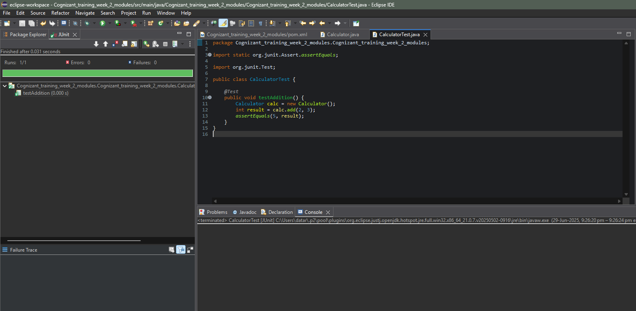

**Exercise 3: Assertions in JUnit  
  
Code:**

package Cognizant_training_week_2_modules.Cognizant_training_week_2_modules;

import org.junit.Test;

import static org.junit.Assert.*;

public class AssertionsTest {

*@Test*

public void testAssertions() {

// Assert equals

*assertEquals*("Sum should be 5", 5, 2 + 3);

// Assert true

*assertTrue*("5 should be greater than 3", 5 > 3);

// Assert false

*assertFalse*("5 should not be less than 3", 5 < 3);

// Assert null

Object obj1 = null;

*assertNull*("Object should be null", obj1);

// Assert not null

Object obj2 = new Object();

*assertNotNull*("Object should not be null", obj2);

}

}

**Output:**

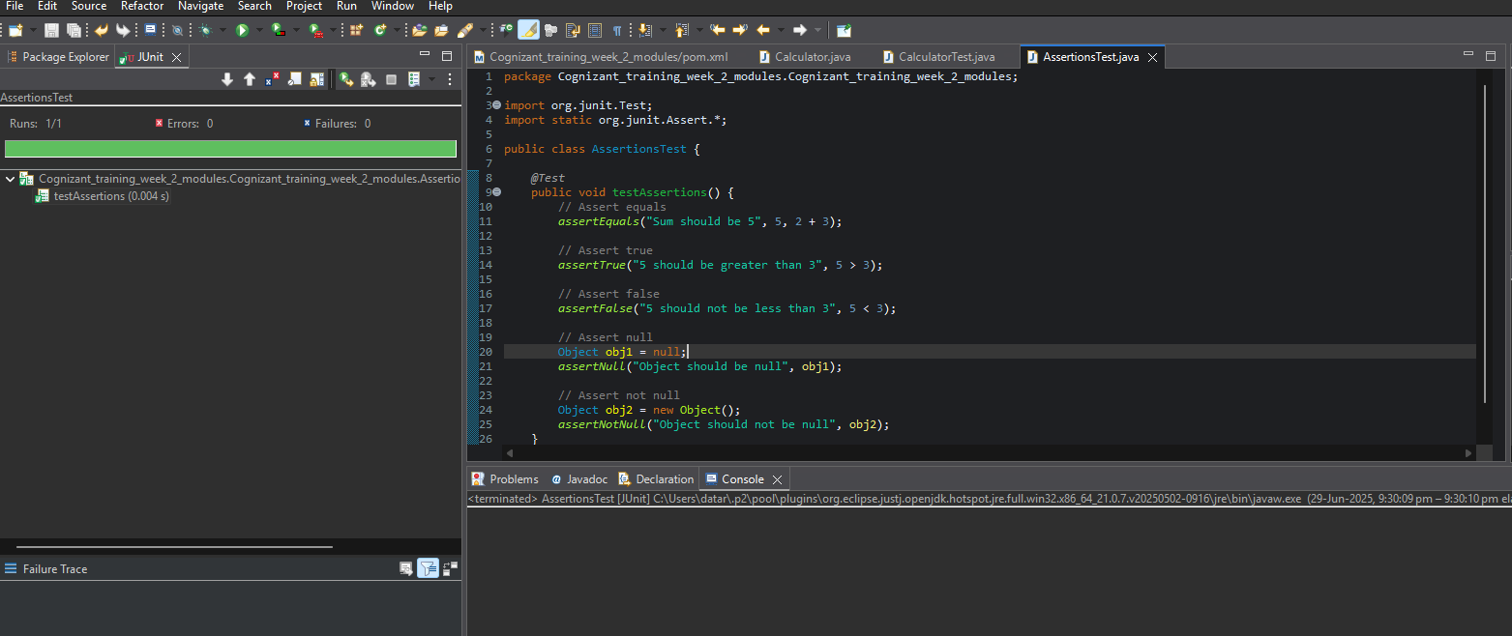

**Exercise 4: Arrange-Act-Assert (AAA) Pattern, Test Fixtures, Setup and Teardown Methods in Junit**  
**Code:**

package Cognizant_training_week_2_modules.Cognizant_training_week_2_modules;

import org.junit.Before;

import org.junit.After;

import org.junit.Test;

import static org.junit.Assert.*;

public class CalculatorTest {

private Calculator calculator;

// Setup method - runs before each test

*@Before*

public void setUp() {

calculator = new Calculator();

System.***out***.println("Setup: Calculator initialized.");

}

// Teardown method - runs after each test

*@After*

public void tearDown() {

calculator = null;

System.***out***.println("Teardown: Calculator cleaned up.");

}

*@Test*

public void testAddition() {

// Arrange

int a = 2;

int b = 3;

// Act

int result = calculator.add(a, b);

// Assert

*assertEquals*("Sum should be 5", 5, result);

}

*@Test*

public void testSubtraction() {

// Arrange

int a = 10;

int b = 4;

// Act

int result = calculator.subtract(a, b);

// Assert

*assertEquals*("Difference should be 6", 6, result);

}

}

**Output:**

