**Exercise 1: Configuring a Basic Spring Application**  
  
**Code:**

**pom.xml**

<?xml version="1.0" encoding="UTF-8"?>  
<project xmlns="http://maven.apache.org/POM/4.0.0"  
 xmlns:xsi="http://www.w3.org/2001/XMLSchema-instance"  
 xsi:schemaLocation="http://maven.apache.org/POM/4.0.0 http://maven.apache.org/xsd/maven-4.0.0.xsd">  
 <modelVersion>4.0.0</modelVersion>  
  
 <groupId>org.example</groupId>  
 <artifactId>LibraryManagement</artifactId>  
 <version>1.0-SNAPSHOT</version>  
  
 <properties>  
 <maven.compiler.source>22</maven.compiler.source>  
 <maven.compiler.target>22</maven.compiler.target>  
 <project.build.sourceEncoding>UTF-8</project.build.sourceEncoding>  
 </properties>  
 <dependencies>  
 <!-- Spring Core -->  
 <dependency>  
 <groupId>org.springframework</groupId>  
 <artifactId>spring-context</artifactId>  
 <version>6.2.8</version> <!-- Last known 5.3.x -->  
 </dependency>  
  
 <dependency>  
 <groupId>org.springframework</groupId>  
 <artifactId>spring-core</artifactId>  
 <version>6.2.8</version>  
 </dependency>  
  
 </dependencies>  
</project>

**applicationContext.xml**

<?xml version="1.0" encoding="UTF-8"?>

<beans xmlns="http://www.springframework.org/schema/beans"

xmlns:xsi="http://www.w3.org/2001/XMLSchema-instance"

xsi:schemaLocation="

http://www.springframework.org/schema/beans

http://www.springframework.org/schema/beans/spring-beans.xsd">

<!-- Repository Bean -->

<bean id="bookRepository" class="com.library.repository.BookRepository"/>

<!-- Service Bean with dependency injection -->

<bean id="bookService" class="com.library.service.BookService">

<property name="bookRepository" ref="bookRepository"/>

</bean>

</beans>

**BookRepository.java**

package com.library.repository;  
  
public class BookRepository {  
 public void saveBook(String bookName) {  
 System.*out*.println("Saving book to the repository: " + bookName);  
 }  
}

**BookService.java**

package com.library.service;

import com.library.repository.BookRepository;

public class BookService {

private BookRepository bookRepository;

// Setter for Dependency Injection

public void setBookRepository(BookRepository bookRepository) {

this.bookRepository = bookRepository;

}

public void addBook(String bookName) {

System.out.println("Adding book: " + bookName);

bookRepository.saveBook(bookName);

}

}

**App.java**

package com.library;

import com.library.service.BookService;  
import org.springframework.context.ApplicationContext;  
import org.springframework.context.support.ClassPathXmlApplicationContext;  
  
  
class LibraryApp {  
 public static void main(String[] args) {  
 ApplicationContext context = new ClassPathXmlApplicationContext("applicationContext.xml");  
  
 BookService bookService = context.getBean("bookService", BookService.class);  
 bookService.addBook("The Great Gatsby");  
 }  
}

**Output:**

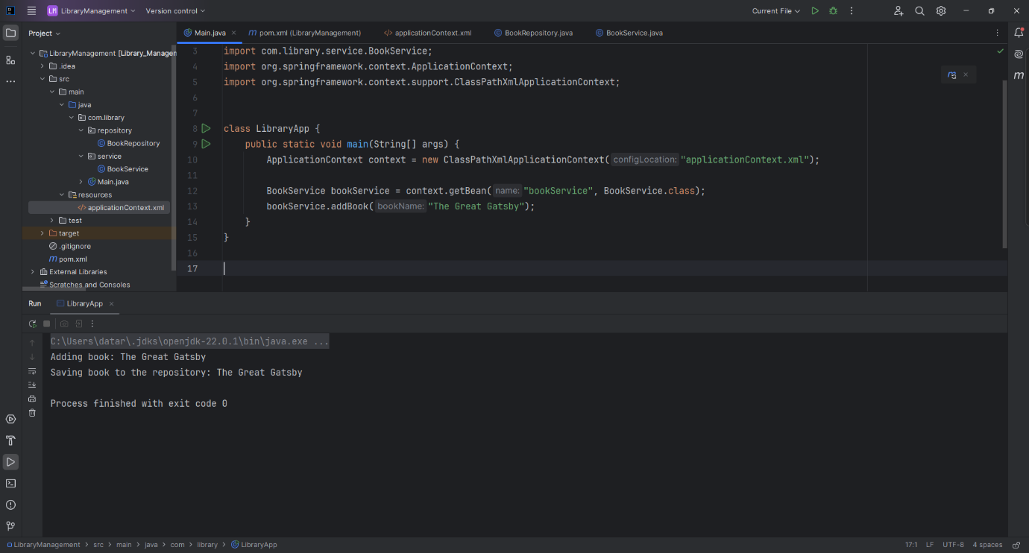

**Exercise 2: Implementing Dependency Injection**

**Code:**  
  
**pom.xml**

<?xml version="1.0" encoding="UTF-8"?>  
<project xmlns="http://maven.apache.org/POM/4.0.0"  
 xmlns:xsi="http://www.w3.org/2001/XMLSchema-instance"  
 xsi:schemaLocation="http://maven.apache.org/POM/4.0.0 http://maven.apache.org/xsd/maven-4.0.0.xsd">  
 <modelVersion>4.0.0</modelVersion>  
  
 <groupId>org.example</groupId>  
 <artifactId>LibraryManagement</artifactId>  
 <version>1.0-SNAPSHOT</version>  
  
 <properties>  
 <maven.compiler.source>22</maven.compiler.source>  
 <maven.compiler.target>22</maven.compiler.target>  
 <project.build.sourceEncoding>UTF-8</project.build.sourceEncoding>  
 </properties>  
 <dependencies>  
 <!-- Spring Core -->  
 <dependency>  
 <groupId>org.springframework</groupId>  
 <artifactId>spring-context</artifactId>  
 <version>6.2.8</version> <!-- Last known 5.3.x -->  
 </dependency>  
  
 <dependency>  
 <groupId>org.springframework</groupId>  
 <artifactId>spring-core</artifactId>  
 <version>6.2.8</version>  
 </dependency>  
  
 </dependencies>  
</project>

**applicationContext.xml**

<?xml version="1.0" encoding="UTF-8"?>

<beans xmlns="http://www.springframework.org/schema/beans"

xmlns:xsi="http://www.w3.org/2001/XMLSchema-instance"

xsi:schemaLocation="

http://www.springframework.org/schema/beans

http://www.springframework.org/schema/beans/spring-beans.xsd">

<!-- BookRepository bean -->

<bean id="bookRepository" class="com.library.repository.BookRepository"/>

<!-- BookService bean with dependency injection -->

<bean id="bookService" class="com.library.service.BookService">

<property name="bookRepository" ref="bookRepository"/>

</bean>

</beans>

**BookRepository.java**

package com.library.repository;  
  
public class BookRepository {  
 public void saveBook(String bookName) {  
 System.*out*.println("Saving book to the repository: " + bookName);  
 }  
}

**BookService.java**

package com.library.service;

import com.library.repository.BookRepository;

public class BookService {

private BookRepository bookRepository;

// Setter for Dependency Injection

public void setBookRepository(BookRepository bookRepository) {

this.bookRepository = bookRepository;

}

public void addBook(String bookName) {

System.out.println("Adding book: " + bookName);

bookRepository.saveBook(bookName);

}

}

**App.java**

package com.library;

import com.library.service.BookService;

import org.springframework.context.ApplicationContext;

import org.springframework.context.support.ClassPathXmlApplicationContext;

public class LibraryApp {

public static void main(String[] args) {

ApplicationContext context = new ClassPathXmlApplicationContext("applicationContext.xml");

BookService bookService = context.getBean("bookService", BookService.class);

bookService.addBook("1984 by George Orwell");

}

}

**Output:**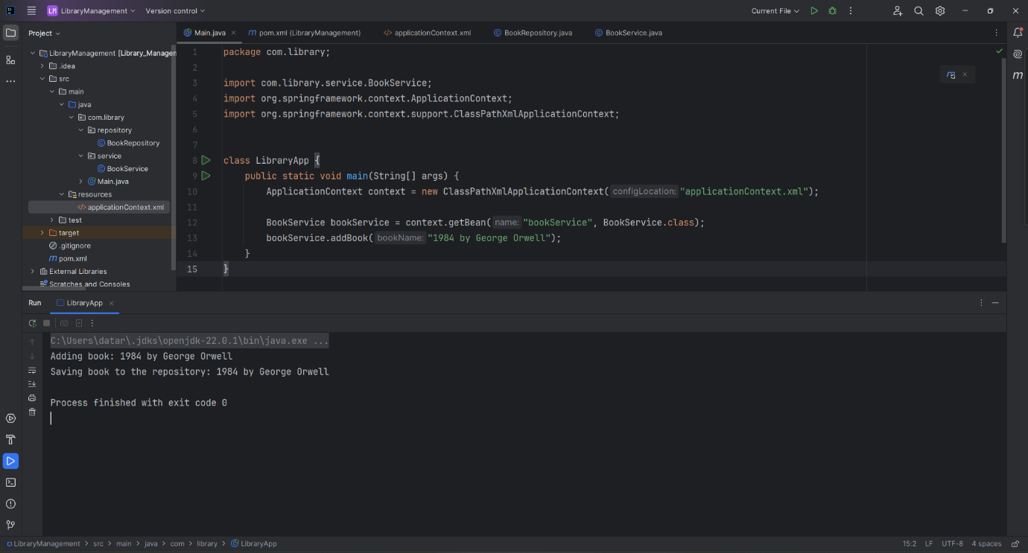

**Exercise 4: Implementing Dependency Injection**   
  
**Code:**

**pom.xml**

<?xml version="1.0" encoding="UTF-8"?>  
<project xmlns="http://maven.apache.org/POM/4.0.0"  
 xmlns:xsi="http://www.w3.org/2001/XMLSchema-instance"  
 xsi:schemaLocation="http://maven.apache.org/POM/4.0.0 http://maven.apache.org/xsd/maven-4.0.0.xsd">  
 <modelVersion>4.0.0</modelVersion>  
  
 <groupId>org.example</groupId>  
 <artifactId>LibraryManagement</artifactId>  
 <version>1.0-SNAPSHOT</version>  
  
 <properties>  
 <maven.compiler.source>22</maven.compiler.source>  
 <maven.compiler.target>22</maven.compiler.target>  
 <project.build.sourceEncoding>UTF-8</project.build.sourceEncoding>  
 </properties>  
 <repositories>  
 <repository>  
 <id>central</id>  
 <url>https://repo.maven.apache.org/maven2</url>  
 </repository>  
 </repositories>  
  
  
 <dependencies>  
 <!-- Spring Core -->  
 <dependency>  
 <groupId>org.springframework</groupId>  
 <artifactId>spring-context</artifactId>  
 <version>6.2.8</version>   
 </dependency>  
  
 <dependency>  
 <groupId>org.springframework</groupId>  
 <artifactId>spring-core</artifactId>  
 <version>6.2.8</version>  
 </dependency>  
  
 <dependency>  
 <groupId>org.springframework</groupId>  
 <artifactId>spring-aop</artifactId>  
 <version>6.2.8</version>  
 </dependency>  
  
 <!-- Spring WebMVC -->  
 <dependency>  
 <groupId>org.springframework</groupId>  
 <artifactId>spring-webmvc</artifactId>  
 <version>6.2.8</version>  
 </dependency>  
   
 <dependency>  
 <groupId>jakarta.servlet</groupId>  
 <artifactId>jakarta.servlet-api</artifactId>  
 <version>6.0.0</version>  
 <scope>provided</scope>  
 </dependency>  
  
  
 </dependencies>  
  
</project>

**Output:  
  
Folder Structure**

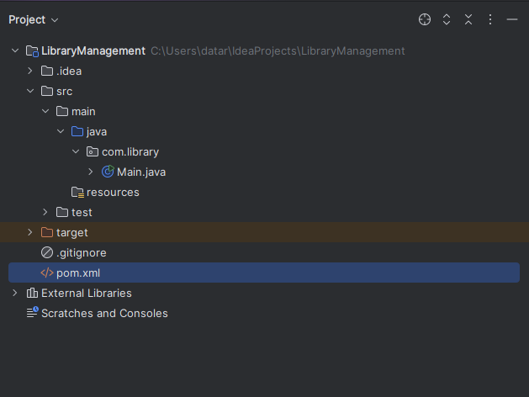

**pom.xml**

