**Hands on  
Creating Microservices for account and loan**

**1. Account Microservice**

**Code:**

**pom.xml**

<?xml version="1.0" encoding="UTF-8"?>

<project xmlns="http://maven.apache.org/POM/4.0.0" xmlns:xsi="http://www.w3.org/2001/XMLSchema-instance"

xsi:schemaLocation="http://maven.apache.org/POM/4.0.0 https://maven.apache.org/xsd/maven-4.0.0.xsd">

<modelVersion>4.0.0</modelVersion>

<parent>

<groupId>org.springframework.boot</groupId>

<artifactId>spring-boot-starter-parent</artifactId>

<version>3.5.3</version>

<relativePath/> <!-- lookup parent from repository -->

</parent>

<groupId>com.cognizant</groupId>

<artifactId>Account-Microservice</artifactId>

<version>0.0.1-SNAPSHOT</version>

<name>Account-Microservice</name>

<description>Demo project for Spring Boot</description>

<url/>

<licenses>

<license/>

</licenses>

<developers>

<developer/>

</developers>

<scm>

<connection/>

<developerConnection/>

<tag/>

<url/>

</scm>

<properties>

<java.version>21</java.version>

</properties>

<dependencies>

<dependency>

<groupId>org.springframework.boot</groupId>

<artifactId>spring-boot-starter-web</artifactId>

</dependency>

<dependency>

<groupId>org.springframework.boot</groupId>

<artifactId>spring-boot-devtools</artifactId>

<scope>runtime</scope>

<optional>true</optional>

</dependency>

<dependency>

<groupId>org.springframework.boot</groupId>

<artifactId>spring-boot-starter-test</artifactId>

<scope>test</scope>

</dependency>

</dependencies>

<build>

<plugins>

<plugin>

<groupId>org.springframework.boot</groupId>

<artifactId>spring-boot-maven-plugin</artifactId>

</plugin>

</plugins>

</build>

</project>

**AccountController.java**

package com.cognizant.Account.Microservice.Controller;

import org.slf4j.Logger;

import org.slf4j.LoggerFactory;

import org.springframework.web.bind.annotation.GetMapping;

import org.springframework.web.bind.annotation.PathVariable;

import org.springframework.web.bind.annotation.RestController;

import java.util.HashMap;

import java.util.Map;

*@RestController*

public class AccountController {

private static final Logger ***LOGGER*** = LoggerFactory.*getLogger*(AccountController.class);

*@GetMapping*("/accounts/{number}")

public Map<String, Object> getAccountDetails(*@PathVariable* String number) {

***LOGGER***.info("START - getAccountDetails() for account number: {}", number);

Map<String, Object> accountDetails = new HashMap<>();

accountDetails.put("number", number);

accountDetails.put("type", "current");

accountDetails.put("balance", 324254352);

***LOGGER***.info("END - getAccountDetails(), returning: {}", accountDetails);

return accountDetails;

}

}

**AccountApplication.java**

package com.cognizant.Account.Microservice;

import org.springframework.boot.SpringApplication;

import org.springframework.boot.autoconfigure.SpringBootApplication;

*@SpringBootApplication*

public class AccountMicroserviceApplication {

public static void main(String[] args) {

SpringApplication.*run*(AccountMicroserviceApplication.class, args);

}

}

**application.properties**

spring.application.name=Account-Microservice

**Output:**

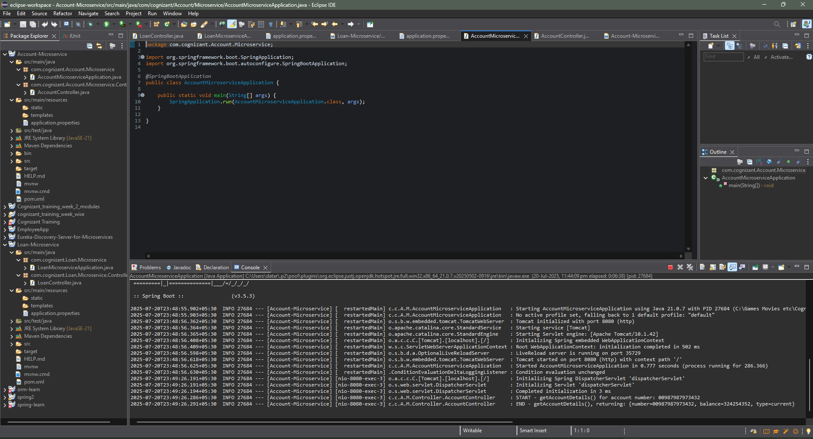

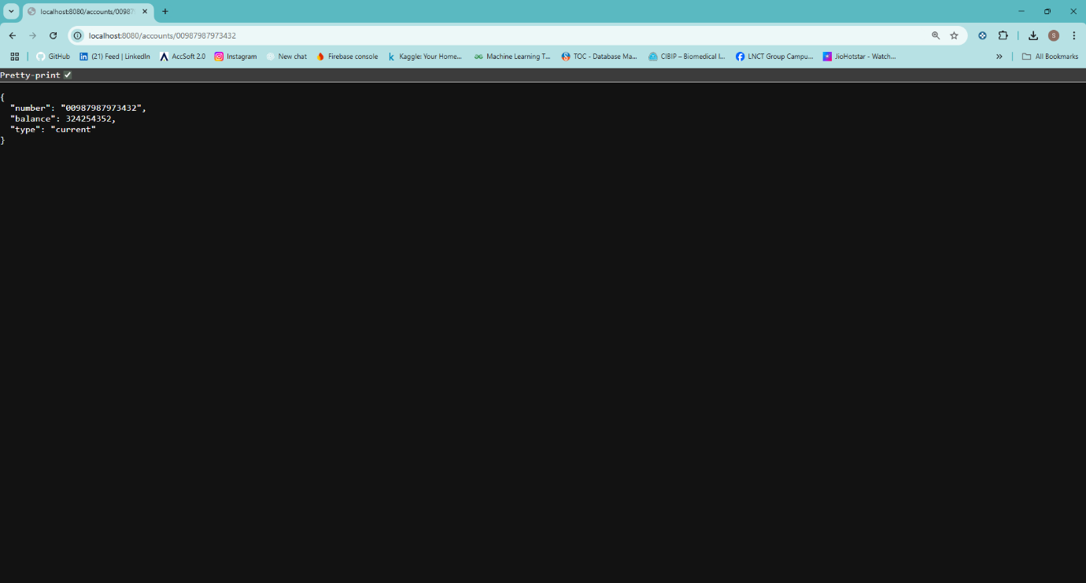

**2. Loan Microservice**

**Code:**

**pom.xml**

<?xml version="1.0" encoding="UTF-8"?>

<project xmlns="http://maven.apache.org/POM/4.0.0" xmlns:xsi="http://www.w3.org/2001/XMLSchema-instance"

xsi:schemaLocation="http://maven.apache.org/POM/4.0.0 https://maven.apache.org/xsd/maven-4.0.0.xsd">

<modelVersion>4.0.0</modelVersion>

<parent>

<groupId>org.springframework.boot</groupId>

<artifactId>spring-boot-starter-parent</artifactId>

<version>3.5.3</version>

<relativePath/> <!-- lookup parent from repository -->

</parent>

<groupId>com.cognizant</groupId>

<artifactId>Loan-Microservice</artifactId>

<version>0.0.1-SNAPSHOT</version>

<name>Loan-Microservice</name>

<description>Demo project for Spring Boot</description>

<url/>

<licenses>

<license/>

</licenses>

<developers>

<developer/>

</developers>

<scm>

<connection/>

<developerConnection/>

<tag/>

<url/>

</scm>

<properties>

<java.version>21</java.version>

</properties>

<dependencies>

<dependency>

<groupId>org.springframework.boot</groupId>

<artifactId>spring-boot-starter-web</artifactId>

</dependency>

<dependency>

<groupId>org.springframework.boot</groupId>

<artifactId>spring-boot-devtools</artifactId>

<scope>runtime</scope>

<optional>true</optional>

</dependency>

<dependency>

<groupId>org.springframework.boot</groupId>

<artifactId>spring-boot-starter-test</artifactId>

<scope>test</scope>

</dependency>

</dependencies>

<build>

<plugins>

<plugin>

<groupId>org.springframework.boot</groupId>

<artifactId>spring-boot-maven-plugin</artifactId>

</plugin>

</plugins>

</build>

</project>

**LoanController.java**

package com.cognizant.Loan.Microservice.Controller;

import org.slf4j.Logger;

import org.slf4j.LoggerFactory;

import org.springframework.web.bind.annotation.GetMapping;

import org.springframework.web.bind.annotation.PathVariable;

import org.springframework.web.bind.annotation.RestController;

import java.util.HashMap;

import java.util.Map;

*@RestController*

public class LoanController {

private static final Logger ***LOGGER*** = LoggerFactory.*getLogger*(LoanController.class);

*@GetMapping*("/loans/{number}")

public Map<String, Object> getLoanDetails(*@PathVariable* String number) {

***LOGGER***.info("START - getLoanDetails() for loan number: {}", number);

Map<String, Object> loanDetails = new HashMap<>();

loanDetails.put("number", number);

loanDetails.put("type", "home");

loanDetails.put("loan", 6000000);

loanDetails.put("emi", 35714);

loanDetails.put("tenure", 14);

***LOGGER***.info("END - getLoanDetails(), returning: {}", loanDetails);

return loanDetails;

}

}

**LoanApplication.java**

package com.cognizant.Loan.Microservice;

import org.springframework.boot.SpringApplication;

import org.springframework.boot.autoconfigure.SpringBootApplication;

*@SpringBootApplication*

public class LoanMicroserviceApplication {

public static void main(String[] args) {

SpringApplication.*run*(LoanMicroserviceApplication.class, args);

}

}

**application.properties**

spring.application.name=Loan-Microservice

server.port=8081

**Output:**

