Hands on 1

Output:

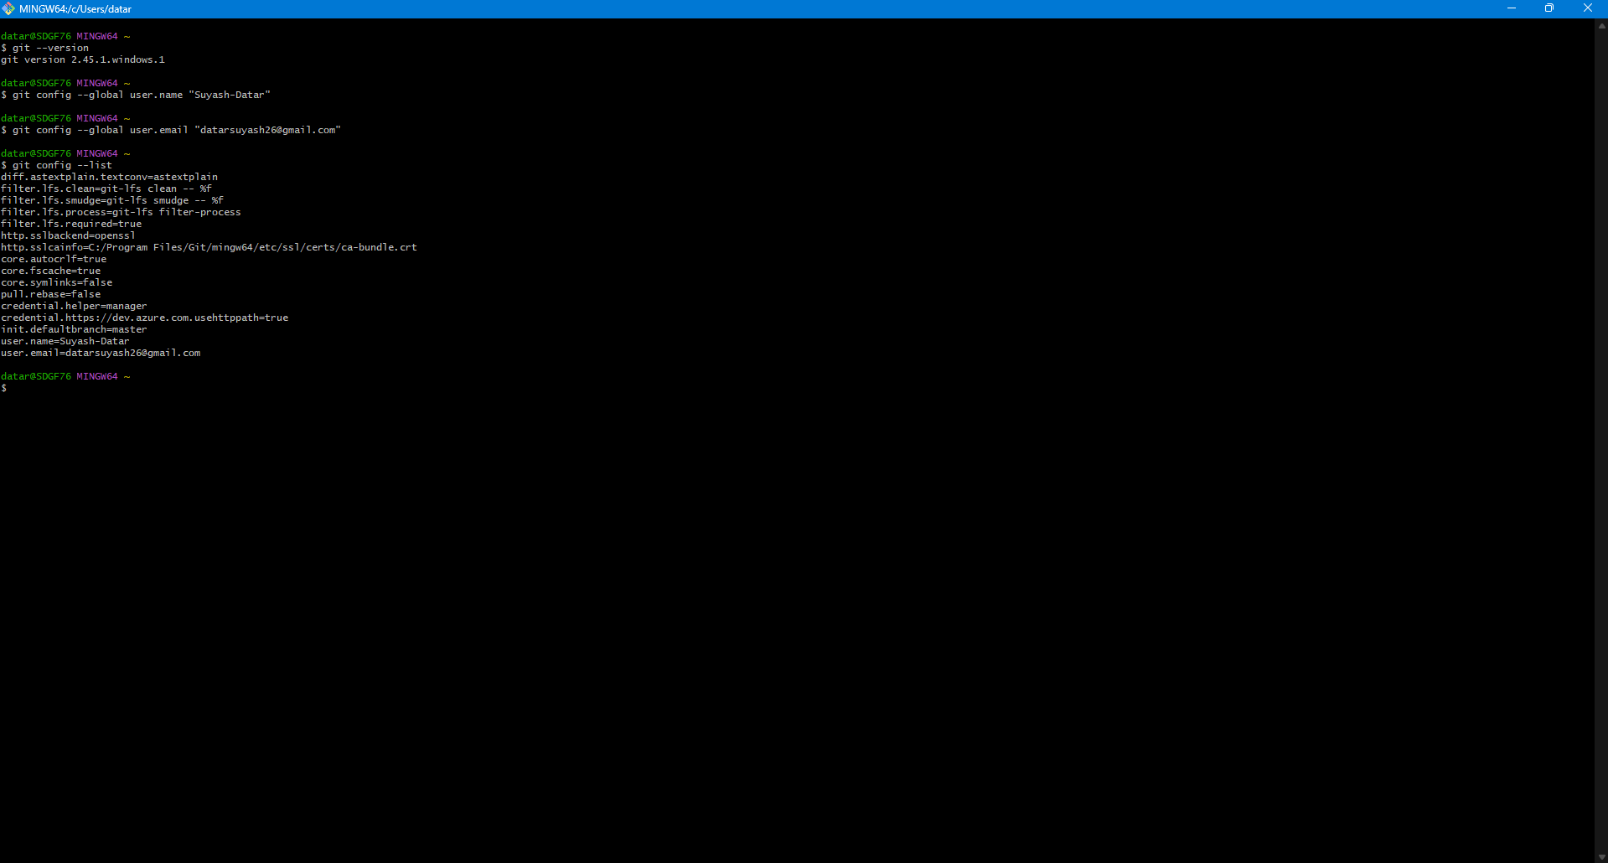

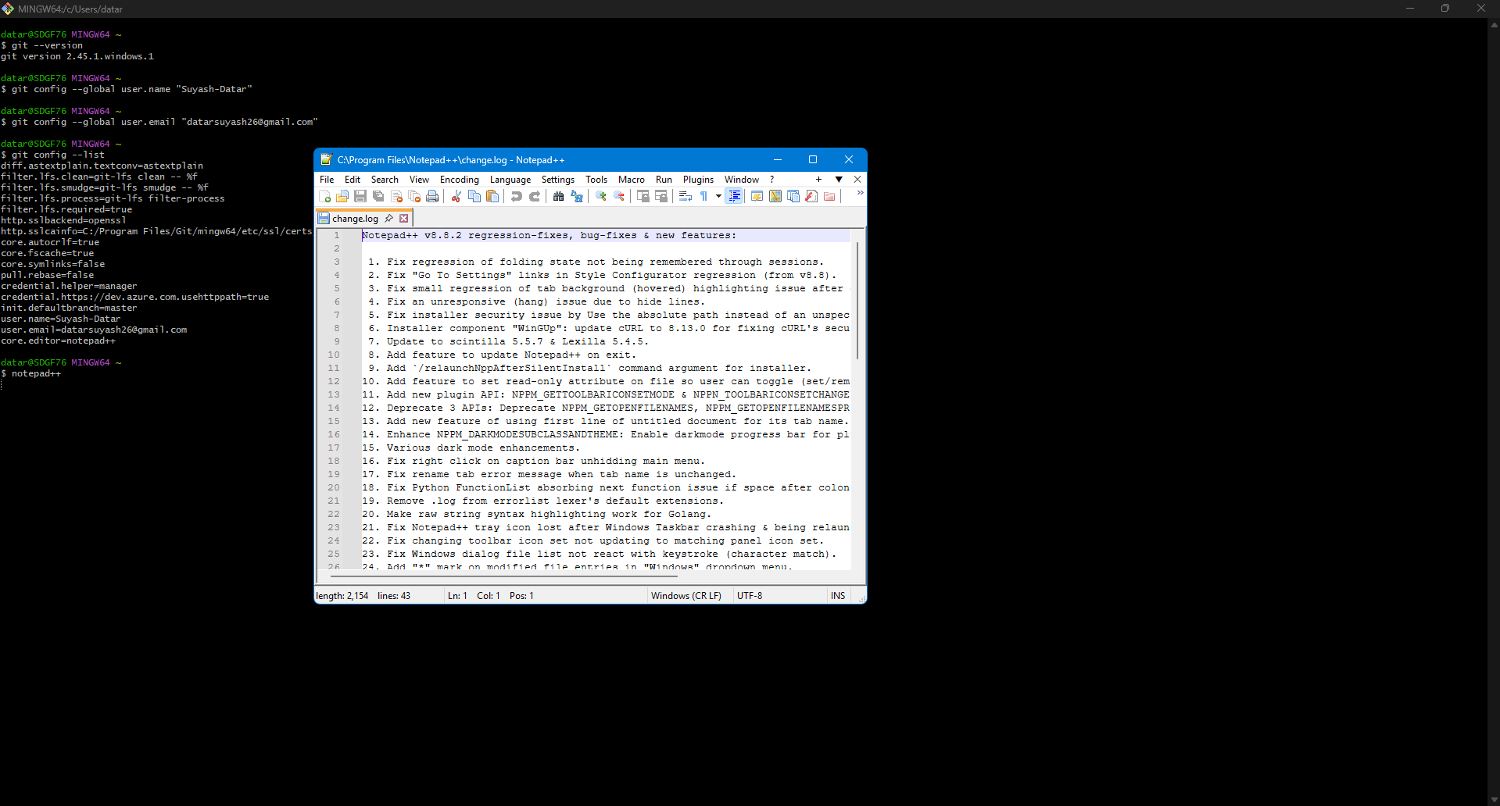

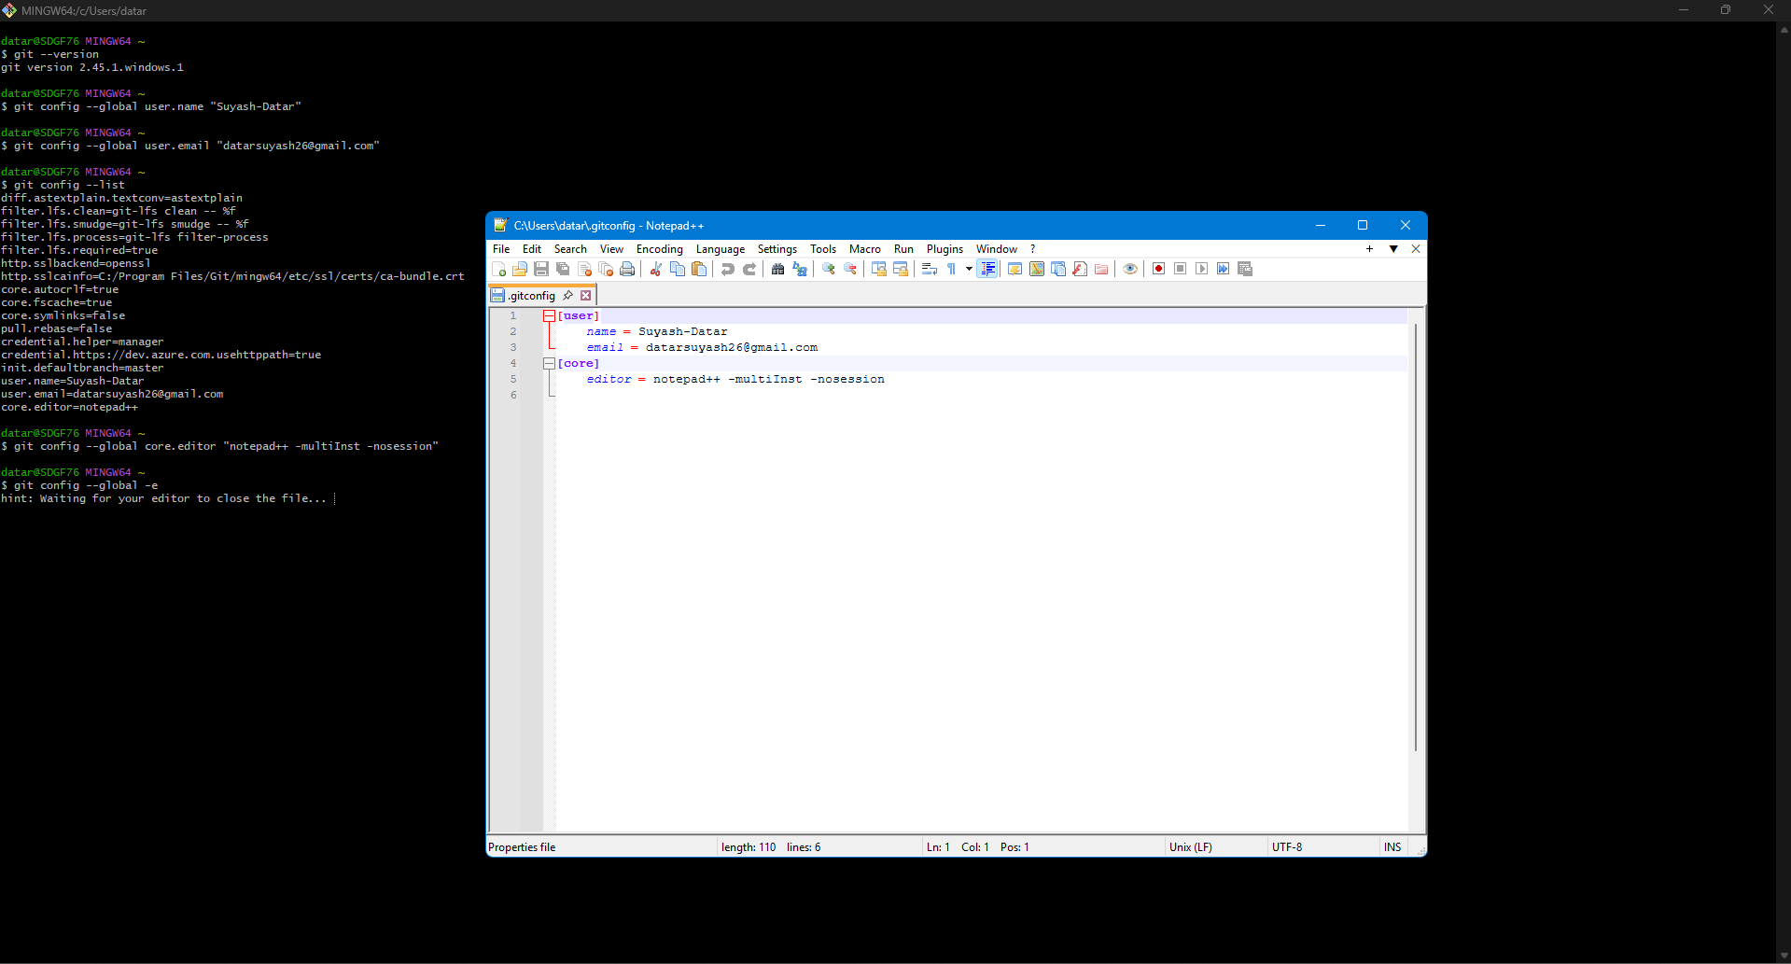

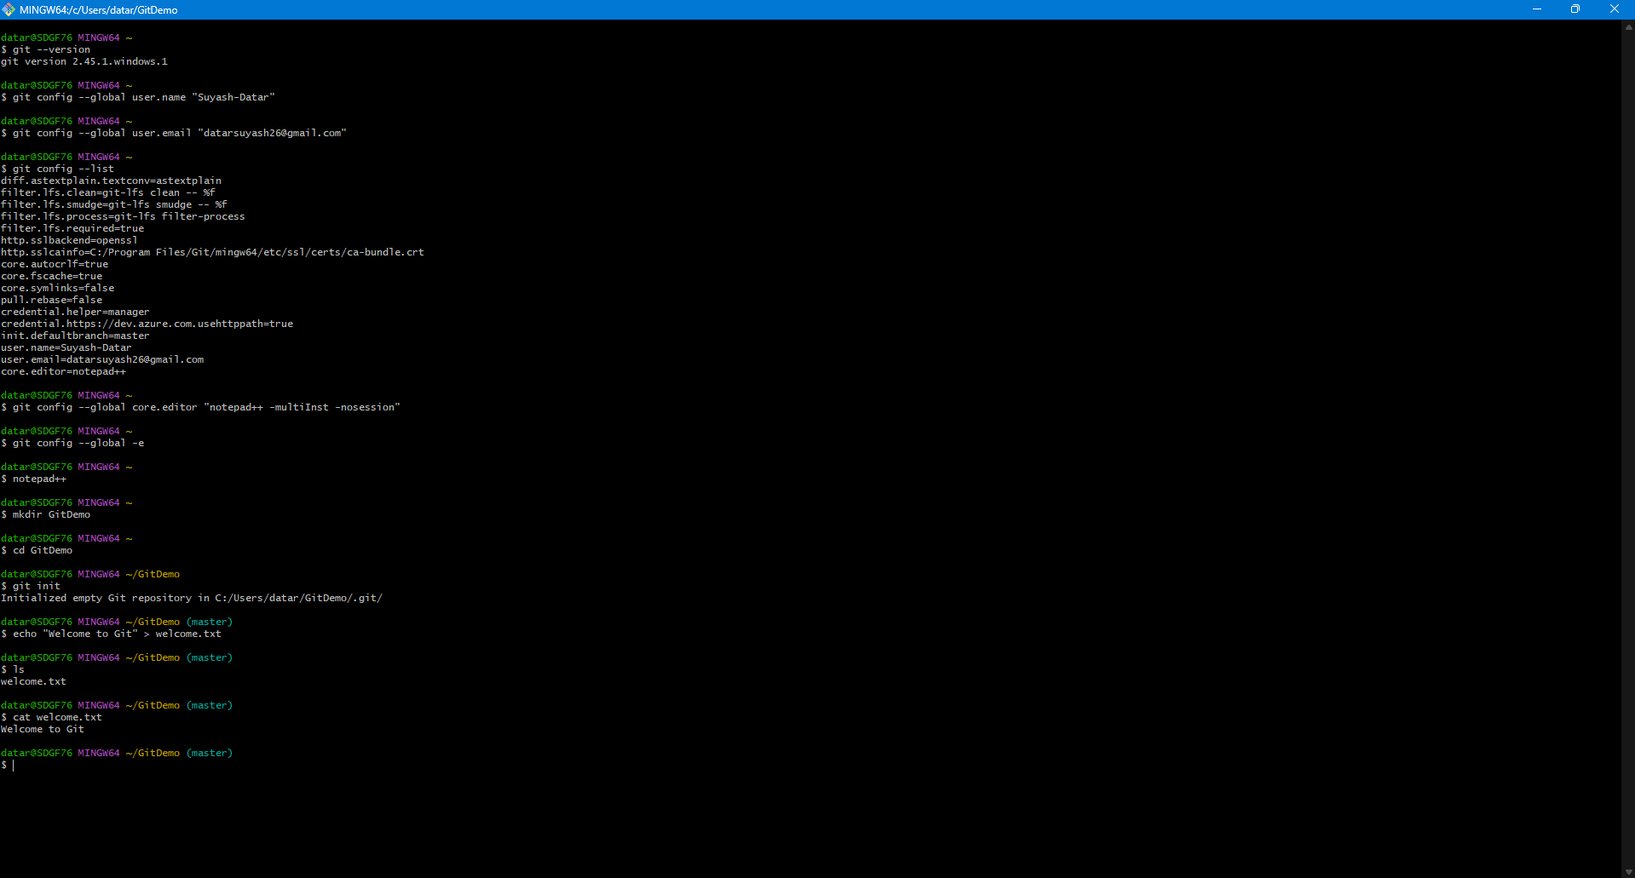

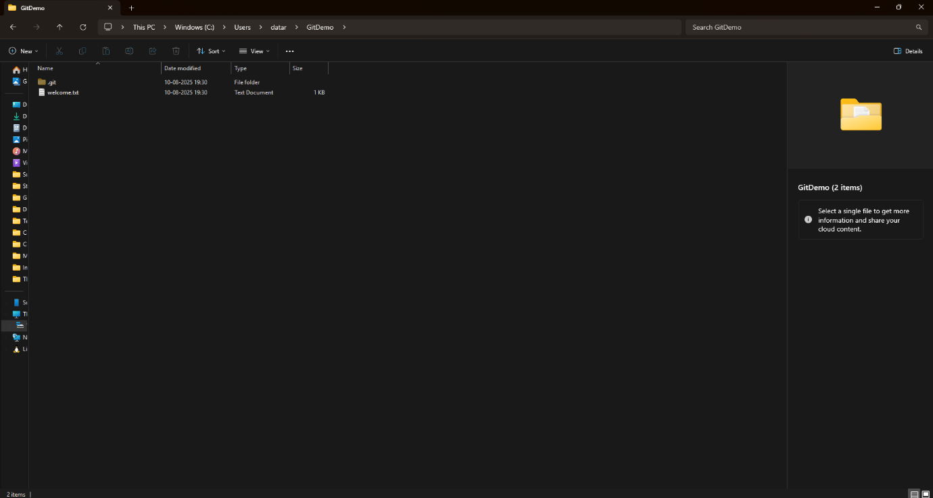

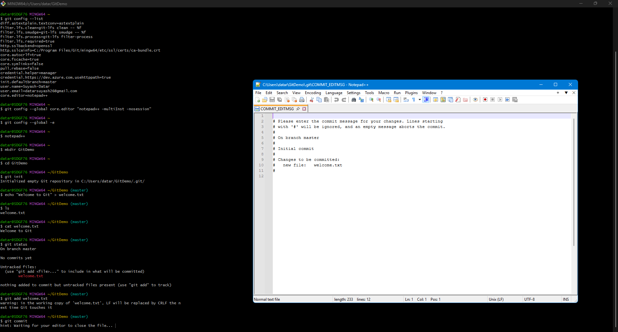

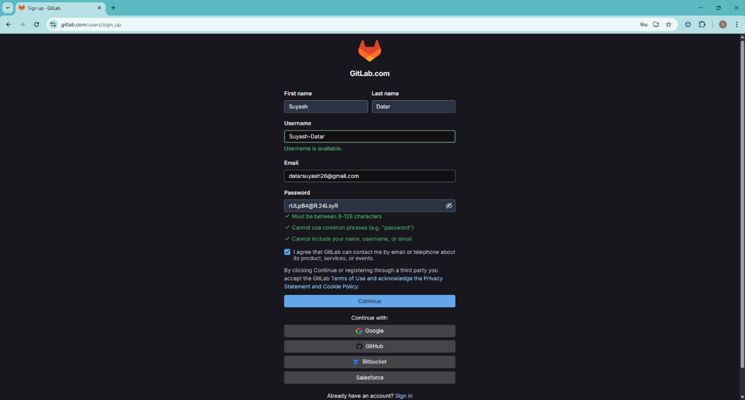

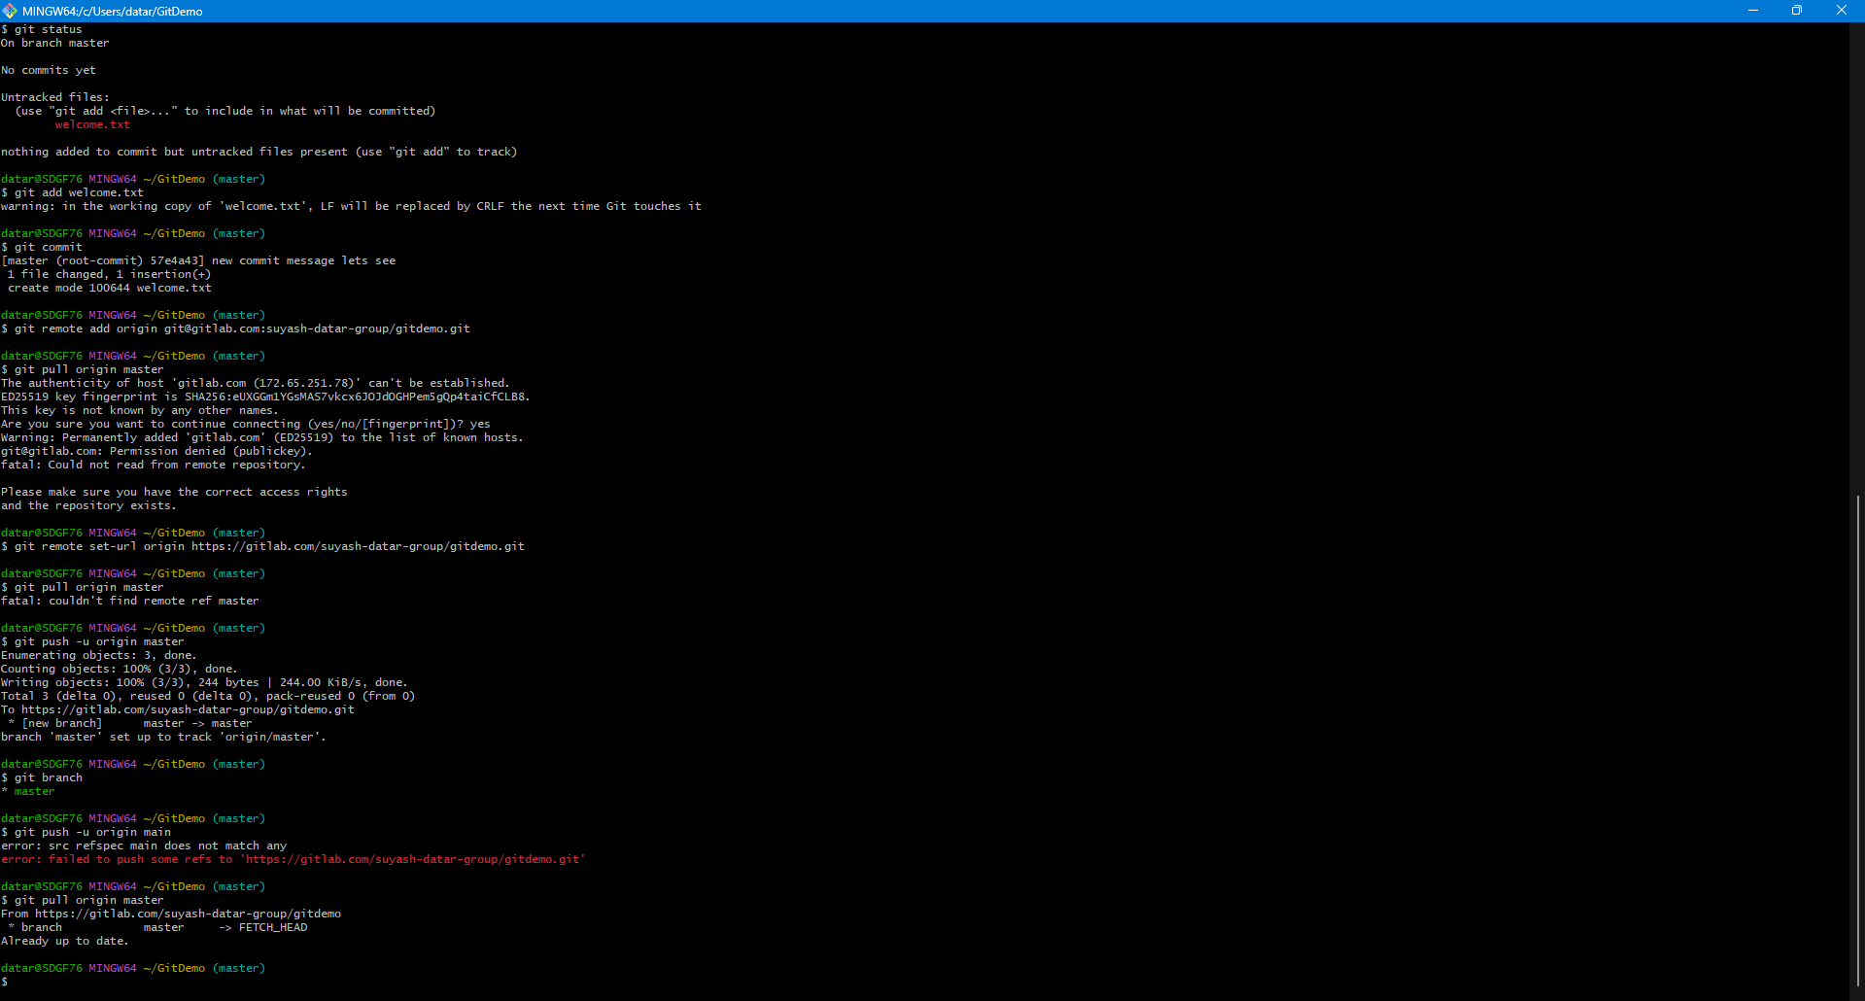

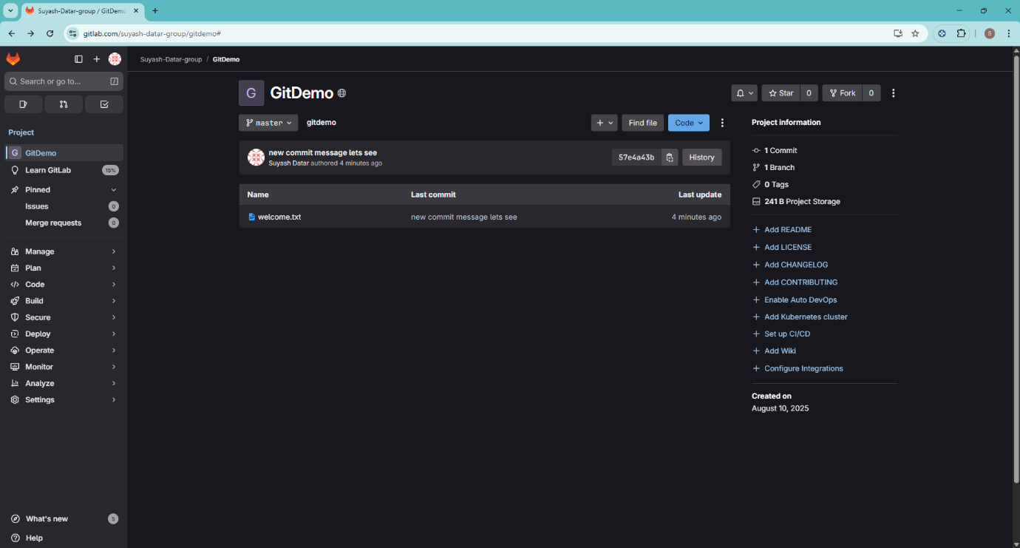

Hands on 2

Commands:
1. Create the files and folders to be ignored

$ cd GitDemo

$ touch error.log

$ mkdir log

$ touch log/debug.log

2. Check the repository status before creating .gitignore

$ git status

On branch master
Your branch is up to date with 'origin/master'.

Untracked files:
(use "git add <file>..." to include in what will be committed)
error.log
log/

nothing added to commit but untracked files present (use "git add" to track)

3. Create and edit the .gitignore file.

$ notepad++ .gitignore

On the Notepad++

# Ignore all files with a .log extension
*.log

# Ignore the log folder and all its contents
log/

4. Check the repository status after creating .gitignore

$ git status

On branch master
Your branch is up to date with 'origin/master'.

Untracked files:
(use "git add <file>..." to include in what will be committed)
.gitignore

nothing added to commit but untracked files present (use "git add" to track)

5. Add and commit the .gitignore file

$ git add .gitignore

$ git commit -m "Add .gitignore to ignore log files and folders"

[master 56fd68a] Add .gitignore to ignore log files and folders
1 file changed, 5 insertions(+)
create mode 100644 .gitignore

6. Verify the final status and push the changes

$ git status

On branch master
Your branch is ahead of 'origin/master' by 1 commit.
(use "git push" to publish your local commits)

nothing to commit, working tree clean

$ git push origin master

Enumerating objects: 4, done.
Counting objects: 100% (4/4), done.
Delta compression using up to 8 threads
Compressing objects: 100% (3/3), done.
Writing objects: 100% (3/3), 387 bytes | 387.00 KiB/s, done.
Total 3 (delta 0), reused 0 (delta 0)
remote:
remote: To create a merge request for master, visit:
remote: https://gitlab.com/Tarun-Rawat/gitdemo/-/merge_requests/new?merge_request%5Bsource_branch%5D=master
remote:
To https://gitlab.com/Tarun-Rawat/gitdemo.git
46a508b..56fd68a master -> master

Output:

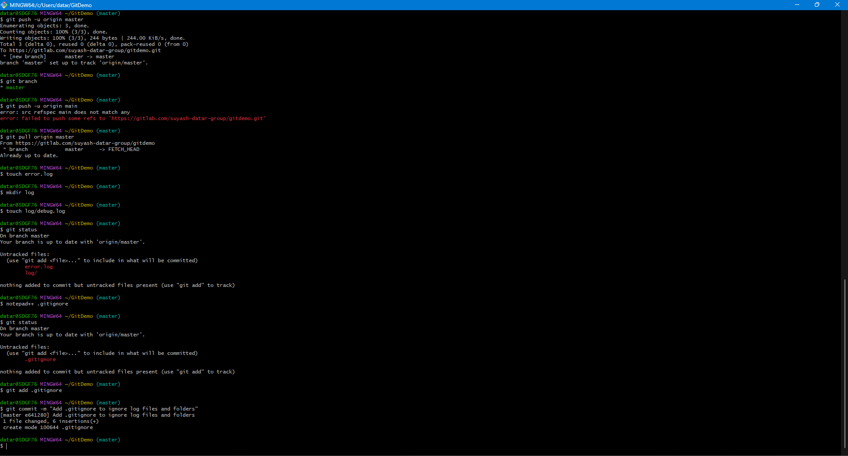

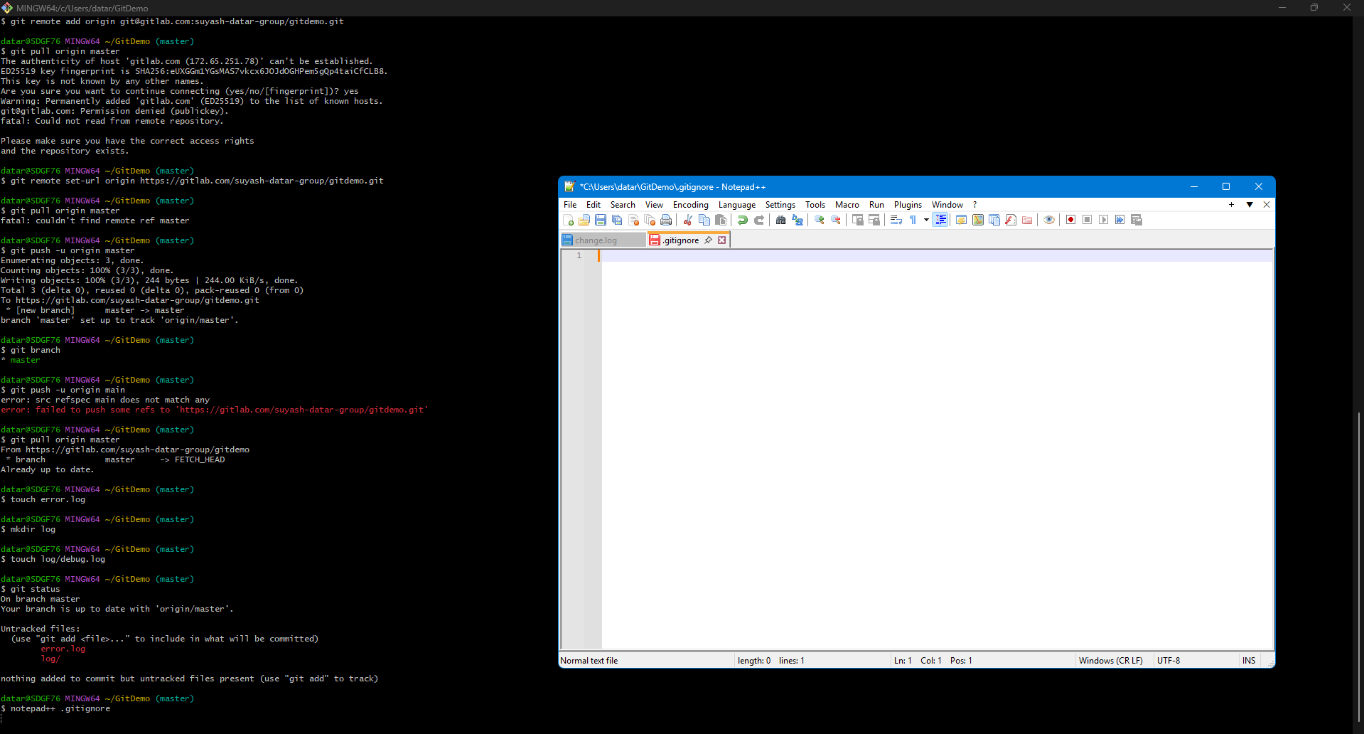

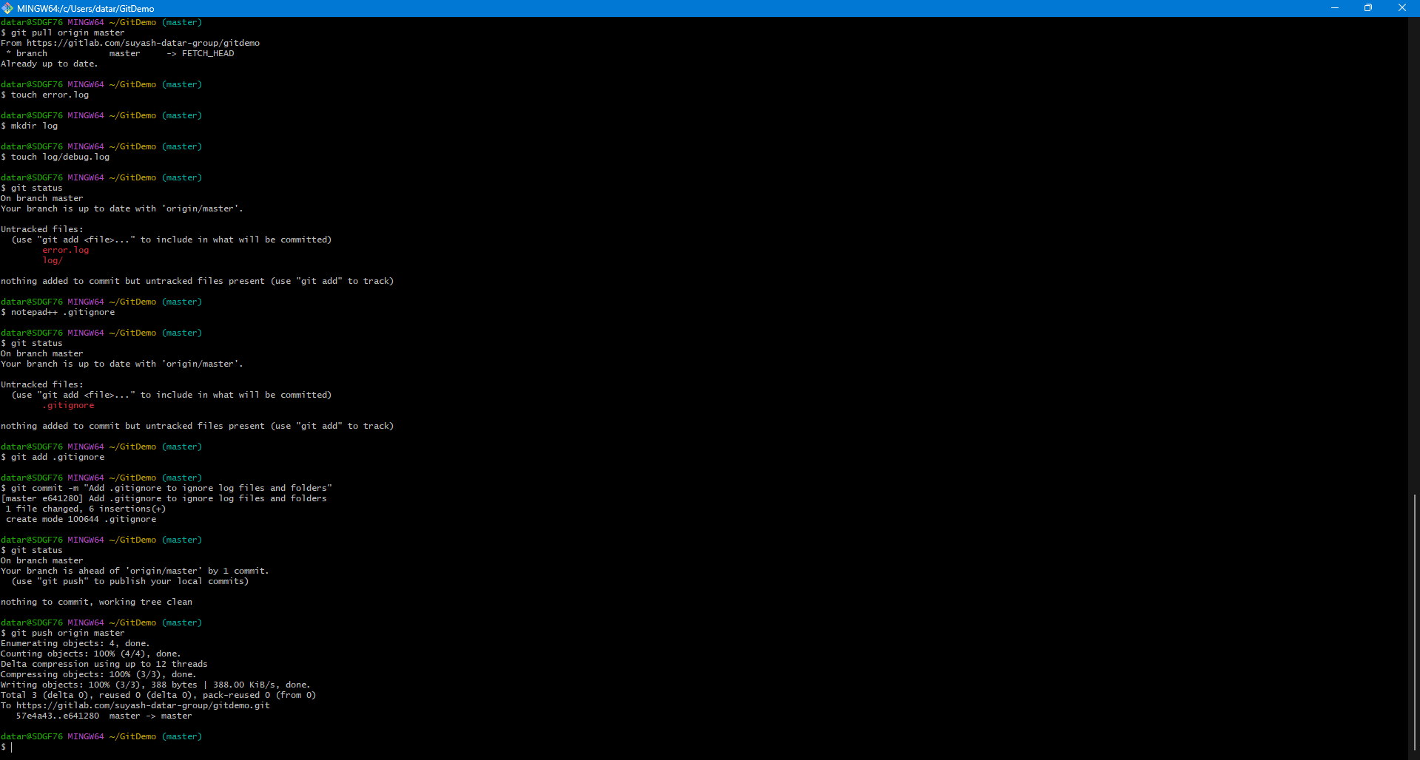

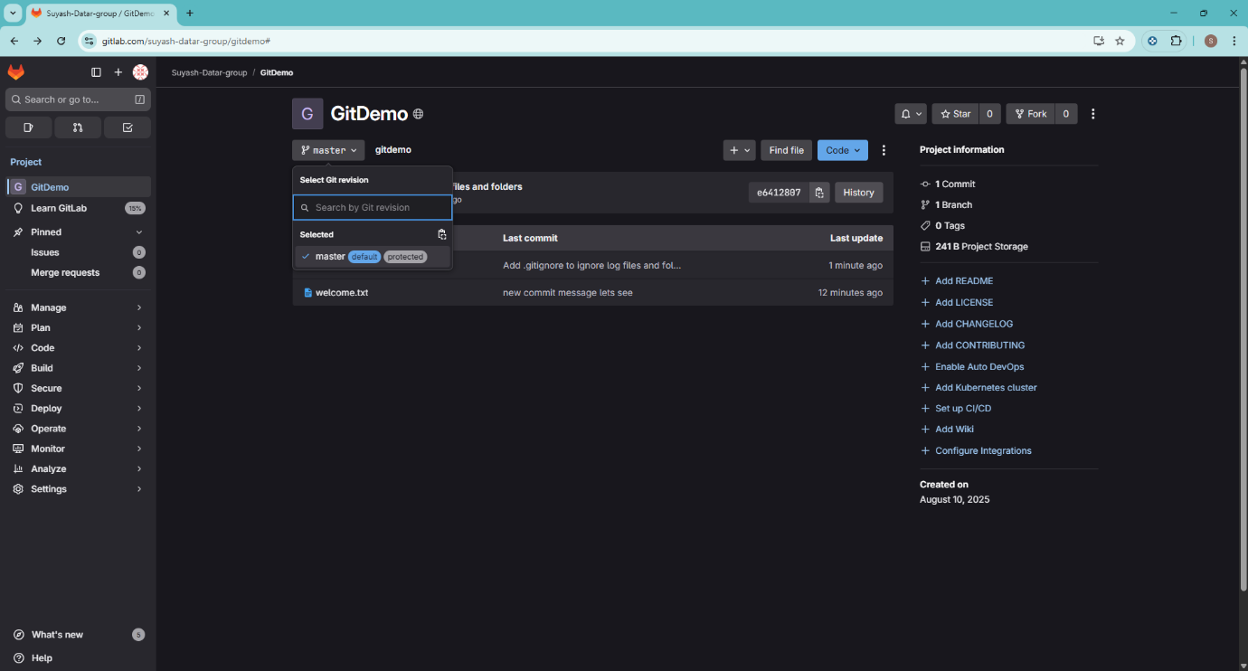

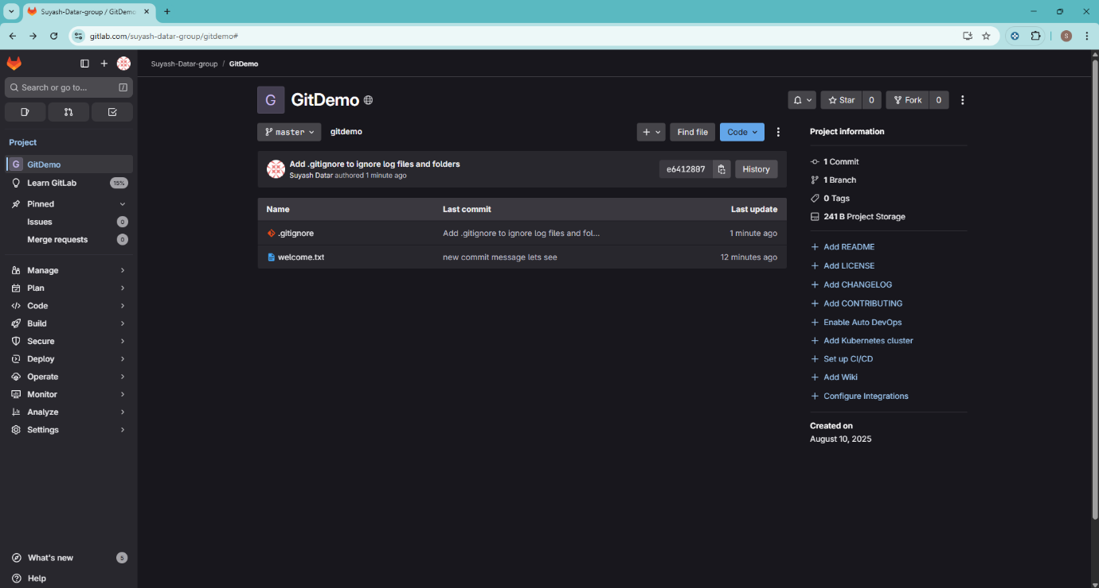

Hands on 3

Commands:
Prerequisites
$ git config --global diff.tool p4merge

$ git config --global difftool.p4merge.cmd "C:/Program\ Files/Perforce/p4merge.exe \"\$LOCAL\" \"\$REMOTE\""

$ git config --global mergetool.p4merge.cmd "C:/Program\ Files/Perforce/p4merge.exe \"\$BASE\" \"\$LOCAL\" \"\$REMOTE\" \"\$MERGED\""

$ git config --global mergetool.p4merge.trustExitCode false

$ git config --global mergetool.keepBackup false

1. Branching
1. Create a new branch

$ git branch GitNewBranch

2. Create a new branch

$ git branch -a

GitNewBranch
* master
remotes/origin/master

3. Switch to the new branch and add a file

$ git checkout GitNewBranch

Switched to branch 'GitNewBranch'

$ echo "This is a new file created in GitNewBranch" > newfile.txt

4. Commit the changes to the new branch

$ git add newfile.txt

warning: LF will be replaced by CRLF in newfile.txt.
The file will have its original line endings in your working directory

$ git commit -m "Add newfile.txt to GitNewBranch"

[GitNewBranch 2122d54] Add newfile.txt to GitNewBranch
1 file changed, 1 insertion(+)
create mode 100644 newfile.txt

5. Check the repository status

$ git status
On branch GitNewBranch
nothing to commit, working tree clean

Merging

1. Switch to the master branch

$ git checkout master

Switched to branch 'master'
Your branch is up to date with 'origin/master'.

2. List differences between branches

$ git diff master GitNewBranch

diff --git a/newfile.txt b/newfile.txt
new file mode 100644
index 0000000..e55e644
--- /dev/null
+++ b/newfile.txt
@@ -0,0 +1 @@
+This is a new file created in GitNewBranch

3. List visual differences using P4Merge

$ git difftool master GitNewBranch

4. Merge the source branch to the trunk

$ git merge GitNewBranch

Updating 56fd68a..2122d54
Fast-forward
newfile.txt | 1 +
1 file changed, 1 insertion(+)
create mode 100644 newfile.txt

5. Observe the logging after merging

$ git log --oneline --graph --decorate

* 2122d54 (HEAD -> master, GitNewBranch) Add newfile.txt to GitNewBranch
* 56fd68a (origin/master) Add .gitignore to ignore log files and folders
* 46a508b Initial commit

6. Delete the branch after merging

$ git branch -d GitNewBranch

Deleted branch GitNewBranch (was 2122d54).

$ git status

On branch master
Your branch is ahead of 'origin/master' by 1 commit.
(use "git push" to publish your local commits)

nothing to commit, working tree clean

$ git branch

* master

Output:

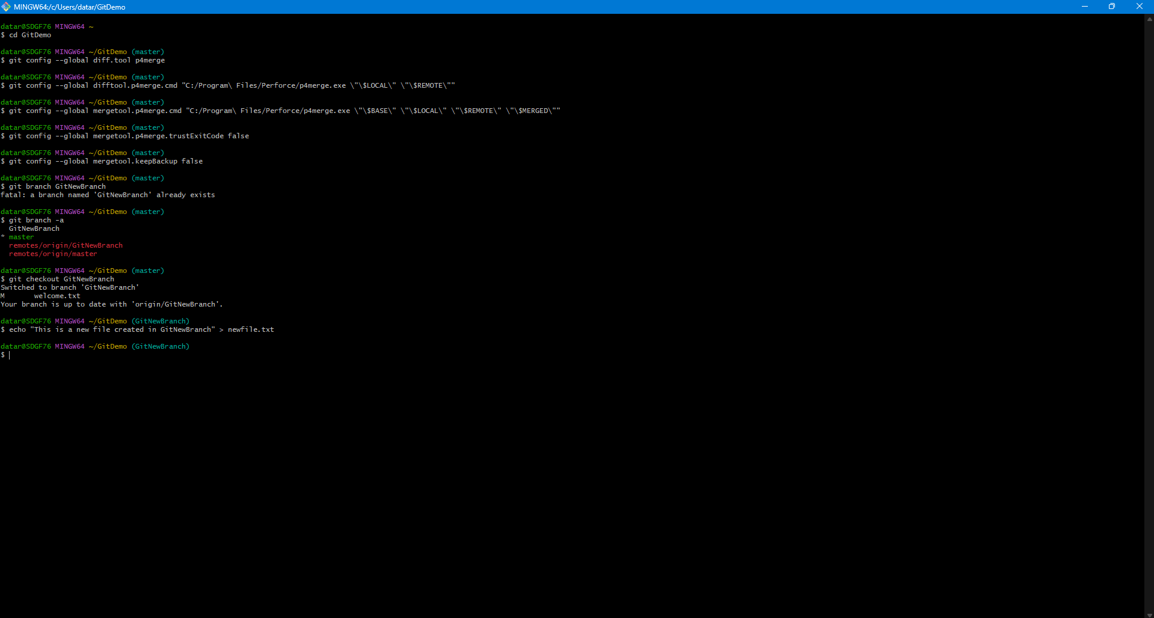

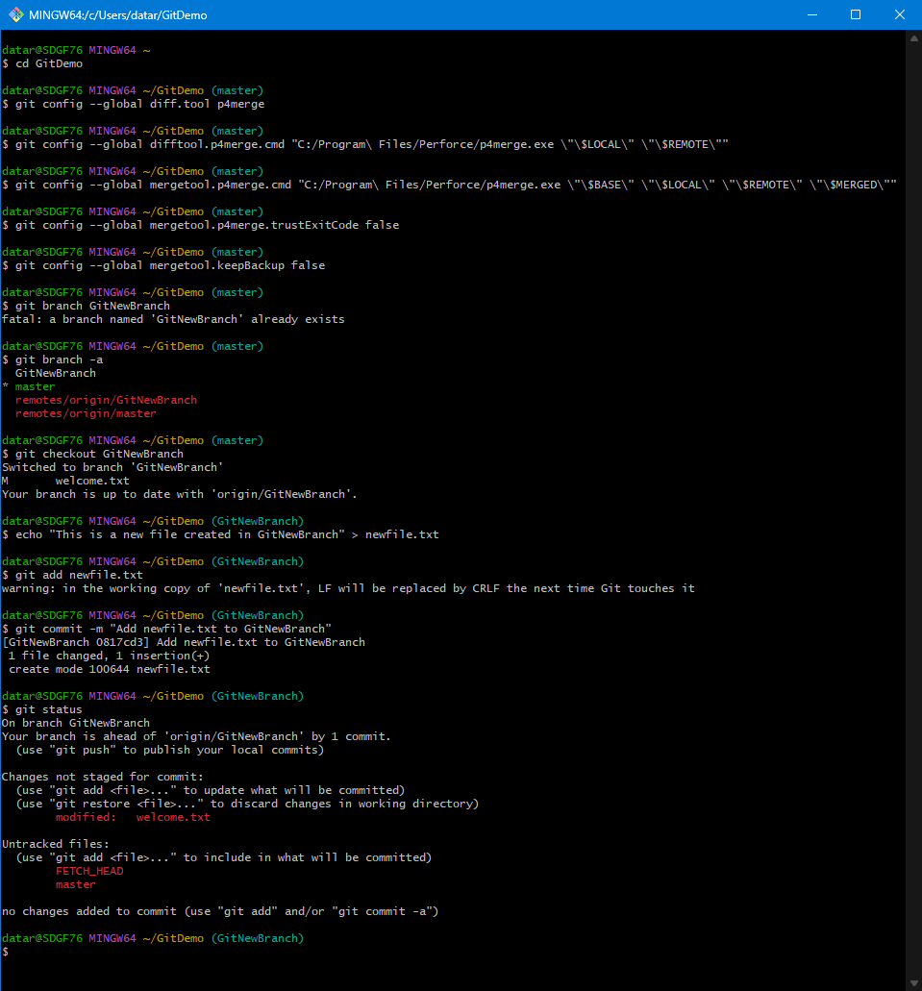

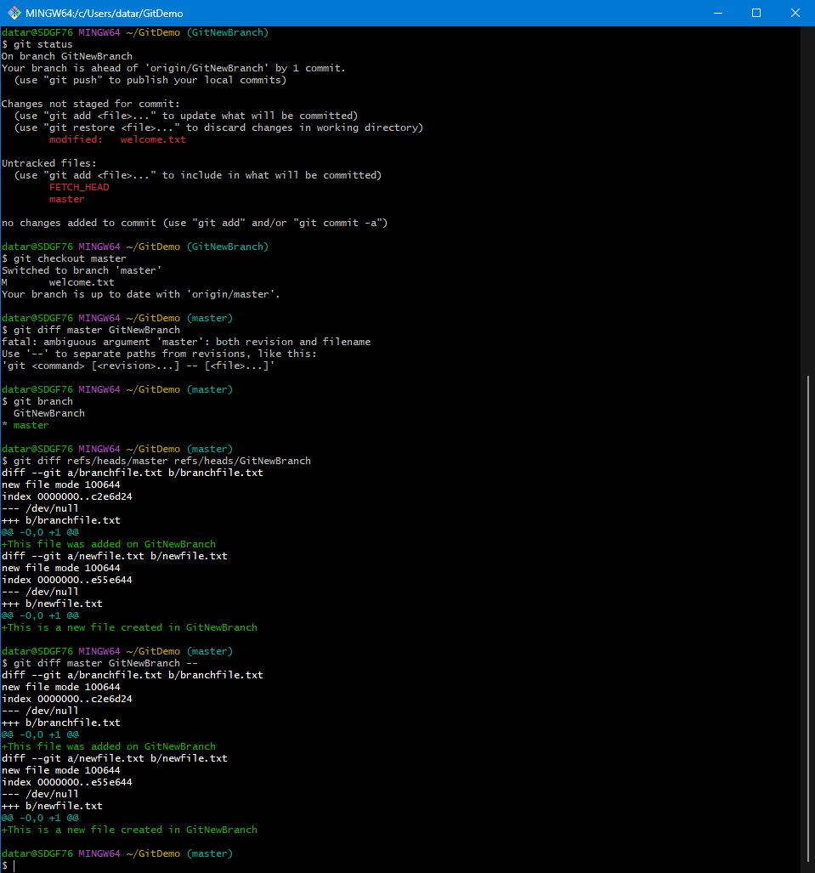

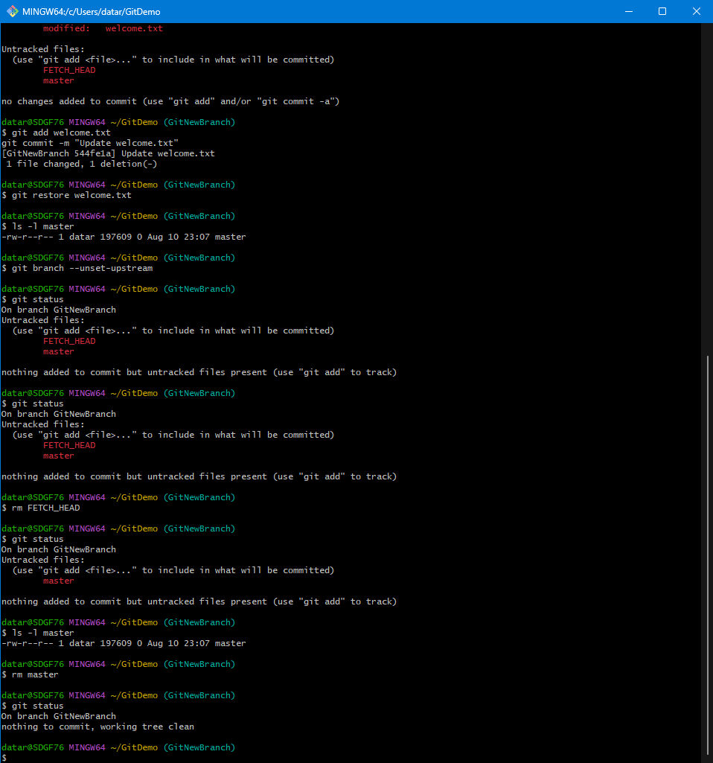
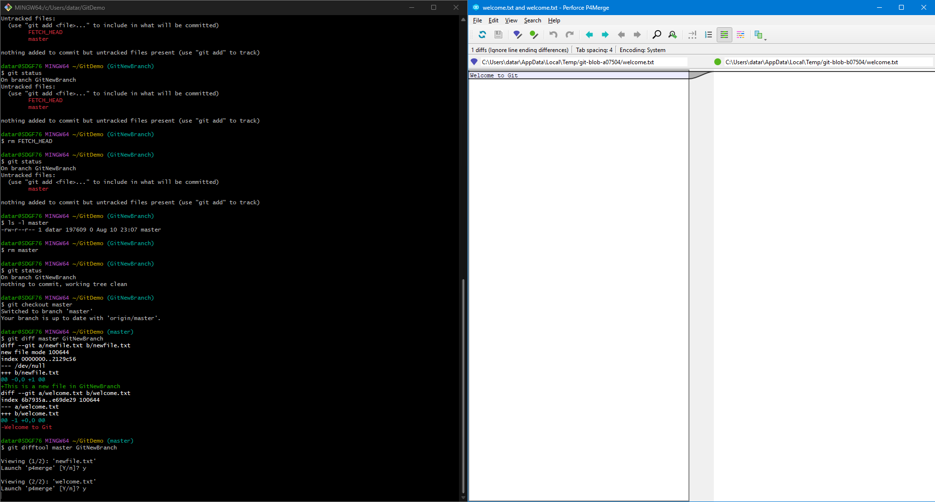

Hands on 4

Commands:
1. Verify if master is in a clean state

$ git status

On branch master
Your branch is ahead of 'origin/master' by 1 commit.
(use "git push" to publish your local commits)

nothing to commit, working tree clean

2. Create a branch "GitWork" and add a file

$ git checkout -b GitWork

Switched to a new branch 'GitWork'

$ echo "<message>Hello from GitWork branch</message>" > hello.xml

3. Update the content and commit

$ git add hello.xml

warning: LF will be replaced by CRLF in hello.xml.
The file will have its original line endings in your working directory

$ git commit -m "Add hello.xml on GitWork branch"

[GitWork 59794fe] Add hello.xml on GitWork branch
1 file changed, 1 insertion(+)
create mode 100644 hello.xml

4. Switch to master and create the conflict

$ git checkout master

Switched to branch 'master'
Your branch is ahead of 'origin/master' by 1 commit.
(use "git push" to publish your local commits)

$ echo "<message>Hello from master branch</message>" > hello.xml

5. Commit the changes to master

$ git add hello.xml

warning: LF will be replaced by CRLF in hello.xml.
The file will have its original line endings in your working directory

$ git commit -m "Add different hello.xml on master branch"

[master 948e037] Add different hello.xml on master branch
1 file changed, 1 insertion(+)
create mode 100644 hello.xml

6. Observe the log

$ git log --oneline --graph --decorate --all

* 948e037 (HEAD -> master) Add different hello.xml on master branch
| * 59794fe (GitWork) Add hello.xml on GitWork branch
|/
* 2122d54 Add newfile.txt to GitNewBranch
* 56fd68a (origin/master) Add .gitignore to ignore log files and folders
* 46a508b Initial commit

7. Check the differences with Git diff tool

$ git diff master GitWork

diff --git a/hello.xml b/hello.xml
index 82868a7..0bf4c19 100644
--- a/hello.xml
+++ b/hello.xml
@@ -1 +1 @@
-<message>Hello from master branch</message>
+<message>Hello from GitWork branch</message>

8. Use P4Merge tool to list out all the differences

$ git mergetool

Merging:
hello.xml

Normal merge conflict for 'hello.xml':
{local}: created file
{remote}: created file
error: invalid path './hello_BASE_1595.xml'

9. Commit the changes to master, once done with conflict

$ git add hello.xml

$ git commit -m "Resolved merge conflict and merged GitWork"

[master 5a980f6] Resolved merge conflict and merged GitWork

10. Observe the git status and add backup file to the .gitignore

$ git status

On branch master
Your branch is ahead of 'origin/master' by 4 commits.
(use "git push" to publish your local commits)

Untracked files:
(use "git add <file>..." to include in what will be committed)
hello.xml.orig

nothing added to commit but untracked files present (use "git add" to track)

$ echo "*.orig" >> .gitignore

11. Delete the branch after merging

$ git add .gitignore

warning: LF will be replaced by CRLF in .gitignore.
The file will have its original line endings in your working directory

$ git commit -m "Add .orig files to gitignore"

[master 2066aa1] Add .orig files to gitignore
1 file changed, 1 insertion(+), 1 deletion(-)

12. List out all the available branches

$ git branch -a

GitWork
* master
remotes/origin/master

13. Delete the branch

$ git branch -d GitWork

Deleted branch GitWork (was 32edfe0).

14. Observe the log

$ git log --oneline --graph --decorate

* 2066aa1 (HEAD -> master) Add .orig files to gitignore
* 5a980f6 Resolved merge conflict and merged GitWork
|\
| * 32edfe0 Add hello.xml on GitWork branch
* | 9bf4b38 Add hello.xml on master branch
|/
* 2122d54 Add newfile.txt to GitNewBranch
* 56fd68a (origin/master) Add .gitignore to ignore log files and folders
* 46a508b Initial commit

Output:

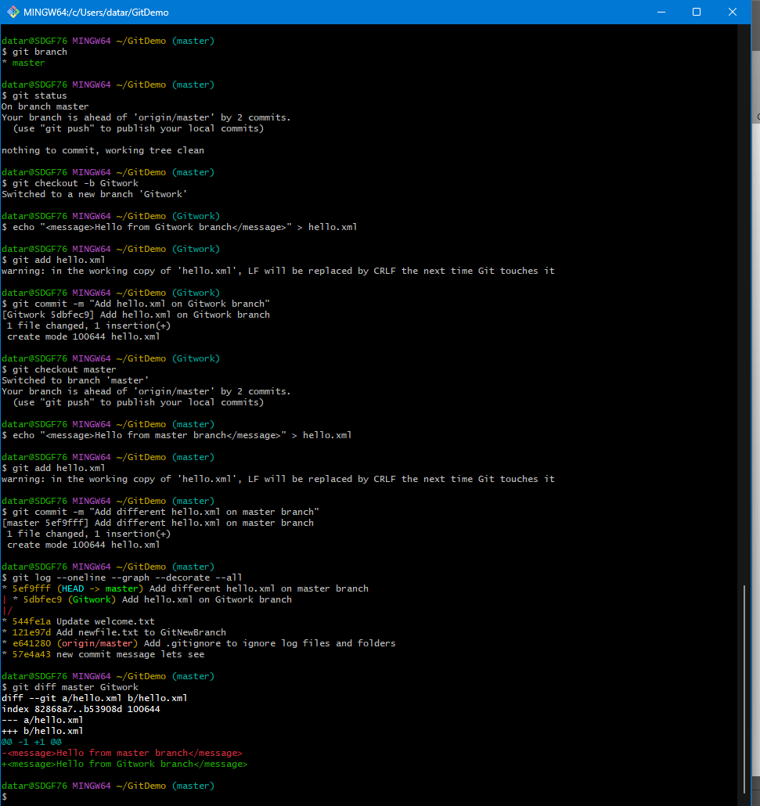

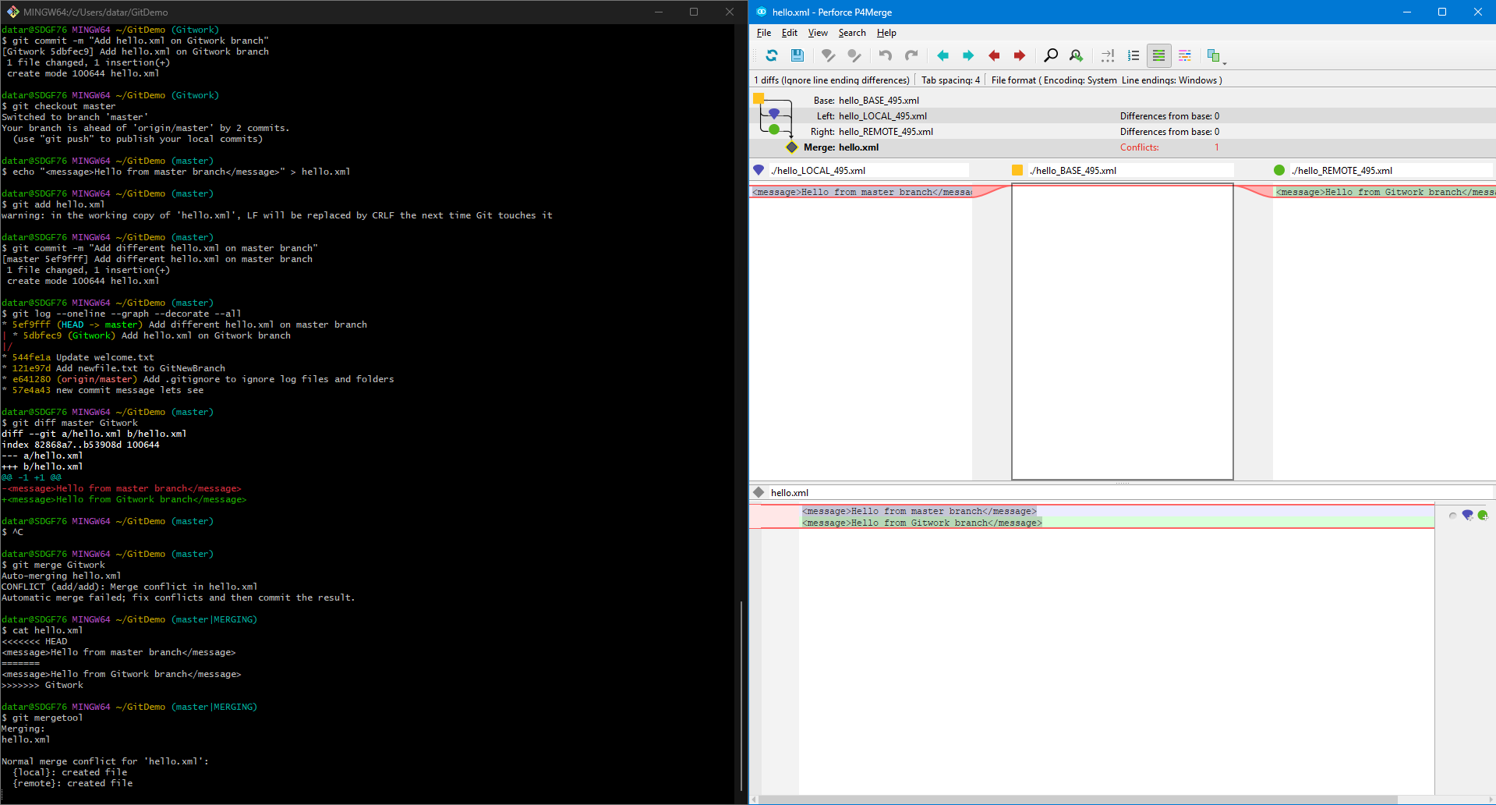

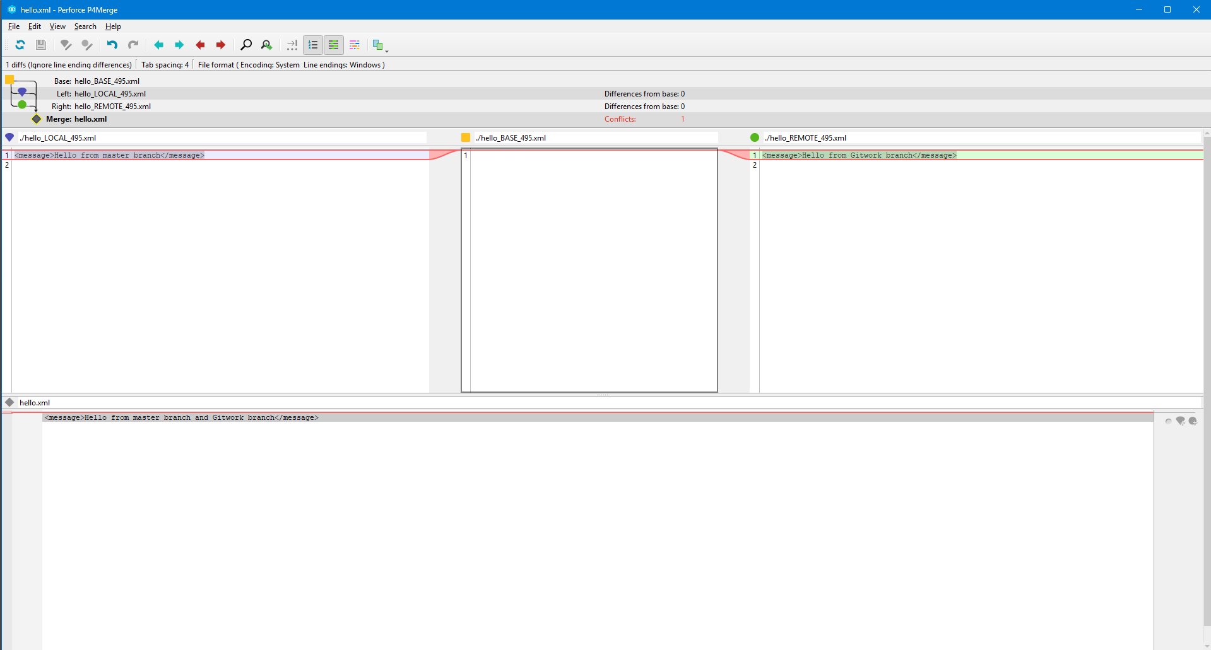
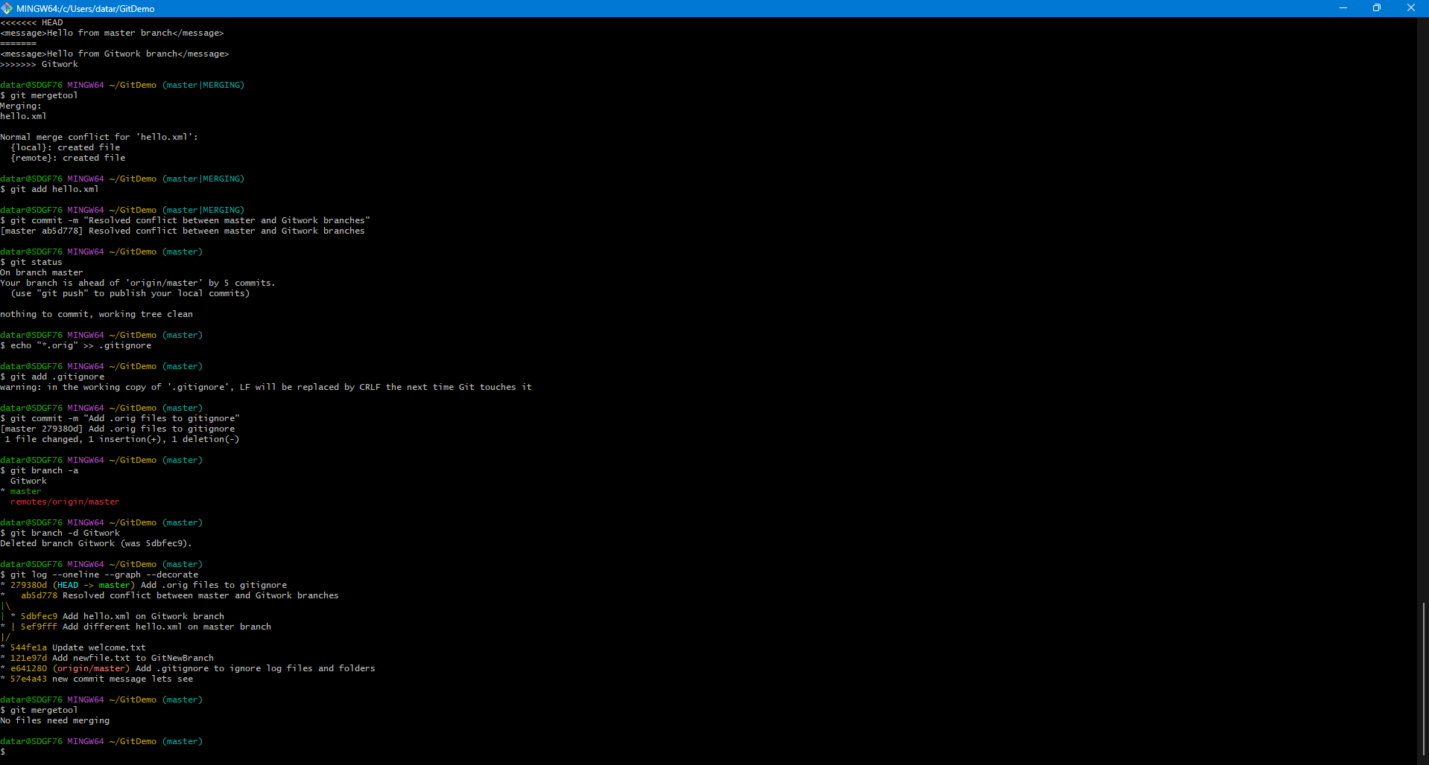

Hands on 5

Commands:

1. Verify if master is in a clean state

$ git status

On branch master
Your branch is up to date with 'origin/master'.

nothing to commit, working tree clean

2. List out all the available branches

$ git branch -a

* master
remotes/origin/master

3. Pull the remote git repository to the master

$ git pull origin master

From https://gitlab.com/Tarun-Rawat/gitdemo
* branch master -> FETCH_HEAD
Already up to date.

4. Push the changes to the remote repository

$ git push origin master

Everything up-to-date

Lenovo@LAPTOP-9GCKJ5AL MINGW64 ~/GitDemo (master)

5. Ignore the backup file and commit the change

$ git status

On branch master
Your branch is up to date with 'origin/master'.

nothing to commit, working tree clean

$ git log --oneline --graph --decorate --all

* 5d535b7 (HEAD -> master, origin/master) Add .orig files to gitignore
* 2066aa1 Add .orig files to gitignore
* 5a980f6 Resolved merge conflict and merged GitWork
|\
| * 32edfe0 Add hello.xml on GitWork branch
* | 9bf4b38 Add hello.xml on master branch
|/
* 2122d54 Add newfile.txt to GitNewBranch
* 56fd68a Add .gitignore to ignore log files and folders
* 46a508b Initial commit

Output:

