Hands on 9
Create a React Application named “cricketapp”.

Code:

App.js

import React from 'react';
import { ListofPlayers } from './components/ListofPlayers';
import { Scorebelow70 } from './components/Scorebelow70';
import { players } from './playersData';
import { OddPlayers } from './components/OddPlayers';
import { EvenPlayers } from './components/EvenPlayers';
import { ListofIndianPlayers, IndianPlayers } from './components/ListofIndianPlayers';

function App() {
const flag = false;

const IndianTeamNames = [
"Sachin1", "Dhoni2", "Virat3", "Rohit4", "Yuvraj5", "Raina6"
];

if (flag === true) {
return (
<div>
<h1>List of Players</h1>
<ListofPlayers players={players} />
<hr />
<h1>List of Players having Scores Less than 70</h1>
<Scorebelow70 players={players} />
</div>
);
} else {
return (
<div>
<h1>Indian Team</h1>
<h2>Odd Players</h2>
<OddPlayers players={IndianTeamNames} />
<hr />
<h2>Even Players</h2>
<EvenPlayers players={IndianTeamNames} />
<hr />
<h1>List of Indian Players Merged:</h1>
<ListofIndianPlayers IndianPlayers={IndianPlayers} />
</div>
);
}
}

export default App;
playersData.js

export const players = [
{ id: 1, name: "Jack", score: 50 },
{ id: 2, name: "Michael", score: 70 },
{ id: 3, name: "John", score: 40 },
{ id: 4, name: "Ann", score: 61 },
{ id: 5, name: "Elisabeth", score: 61 },
{ id: 6, name: "Sachin", score: 95 },
{ id: 7, name: "Dhoni", score: 100 },
{ id: 8, name: "Virat", score: 84 },
{ id: 9, name: "Jadeja", score: 64 },
{ id: 10, name: "Raina", score: 75 },
{ id: 11, name: "Rohit", score: 80 }
];

ListofPlayers.jsx

import React from 'react';

export const ListofPlayers = ({ players }) => {
return (
<div>
<ul>
{players.map(item => (
<li key={item.id}>
Mr. {item.name} <span>{item.score}</span>
</li>
))}
</ul>
</div>
);
};

ListofIndianPlayers.jsx

import React from 'react';

const T20Players = ['First Player', 'Second Player', 'Third Player'];
const RanjiTrophyPlayers = ['Fourth Player', 'Fifth Player', 'Sixth Player'];

export const IndianPlayers = [...T20Players, ...RanjiTrophyPlayers];

export const ListofIndianPlayers = ({ IndianPlayers }) => {
return (
<div>
<ul>
{IndianPlayers.map((player, index) => (
<li key={index}>Mr. {player}</li>
))}
</ul>
</div>
);
};

Scorebelow70.jsx

import React from 'react';

export const Scorebelow70 = ({ players }) => {
const playersBelow70 = players.filter(item => item.score <= 70);

return (
<div>
<ul>
{playersBelow70.map(item => (
<li key={item.id}>
Mr. {item.name} <span>{item.score}</span>
</li>
))}
</ul>
</div>
);
};

EvenPlayers.jsx

import React from 'react';

export function EvenPlayers({ players }) {
const [, second, , fourth, , sixth] = players;
return (
<div>
<ul>
<li>Second : {second}</li>
<li>Fourth : {fourth}</li>
<li>Sixth : {sixth}</li>
</ul>
</div>
);
}

OddPlayers.jsx

import React from 'react';

export function OddPlayers({ players }) {
const [first, , third, , fifth] = players;
return (
<div>
<ul>
<li>First : {first}</li>
<li>Third : {third}</li>
<li>Fifth : {fifth}</li>
</ul>
</div>
);
}

Output:

When flag = true

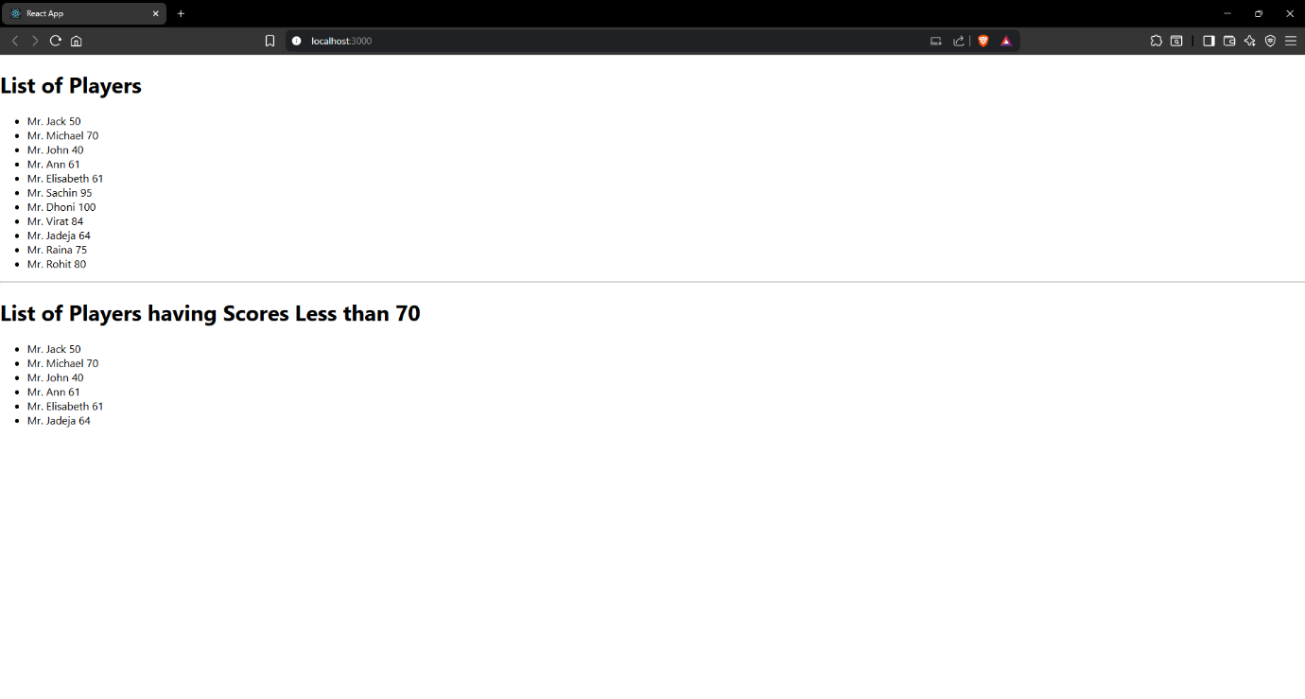

When flag = false

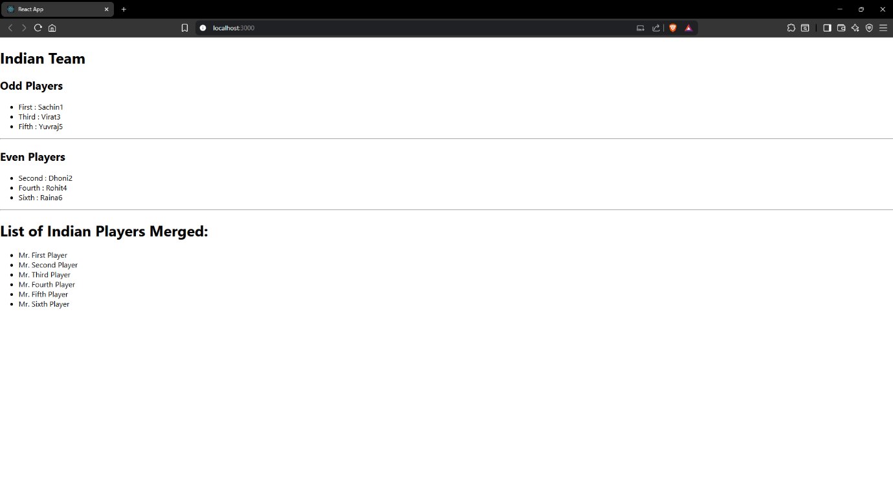

Hands on 10
Create a React Application named “officespacerentalapp” which uses React JSX to create elements, attributes and renders DOM to display the page.

Code:

App.js

import React from 'react';
import './App.css';

const OFFICE_IMAGE_URL = 'https://officebanao.com/wp-content/uploads/2024/06/office-with-lot-desks-computers.jpg';

const pageHeading = "Office Space";

const jsxatt = <img src={OFFICE_IMAGE_URL} width="25%" height="25%" alt="Office Space" />;

const ItemName = {
Name: "DBS",
Rent: 50000,
Address: "Chennai"
};

const officeItems = [
{ id: 1, name: "Tech Hub Co.", rent: 75000, address: "Bangalore" },
{ id: 2, name: "Innovate Space", rent: 45000, address: "Hyderabad" },
{ id: 3, name: "City Towers", rent: 60000, address: "Mumbai" },
{ id: 4, name: "Green Offices", rent: 59999, address: "Delhi" },
{ id: 5, name: "Skyline Suite", rent: 82000, address: "Pune" }
];

function App() {
const getRentStyle = (rent) => {
return {
color: rent <= 60000 ? 'red' : 'green',
fontWeight: 'bold'
};
};

return (
<div className="App">
<h1>{pageHeading}, at Affordable Range</h1>

{jsxatt}

<h1>Name: {ItemName.Name}</h1>
<h3 style={getRentStyle(ItemName.Rent)}>
Rent: Rs. {ItemName.Rent}
</h3>
<h3>Address: {ItemName.Address}</h3>

<hr style={{ margin: '30px 0' }} />

<h2>More Office Spaces:</h2>
{officeItems.map(office => (
<div key={office.id} style={{ marginBottom: '20px', border: '1px solid #ccc', padding: '15px', borderRadius: '8px' }}>
<h3>Name: {office.name}</h3>
<h3 style={getRentStyle(office.rent)}>
Rent: Rs. {office.rent}
</h3>
<h3>Address: {office.address}</h3>
</div>
))}
</div>
);
}

export default App;

Output:

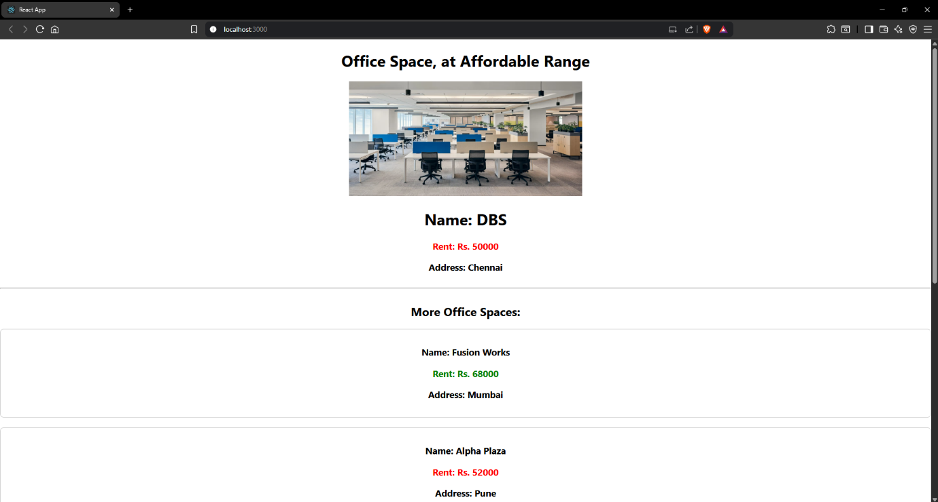

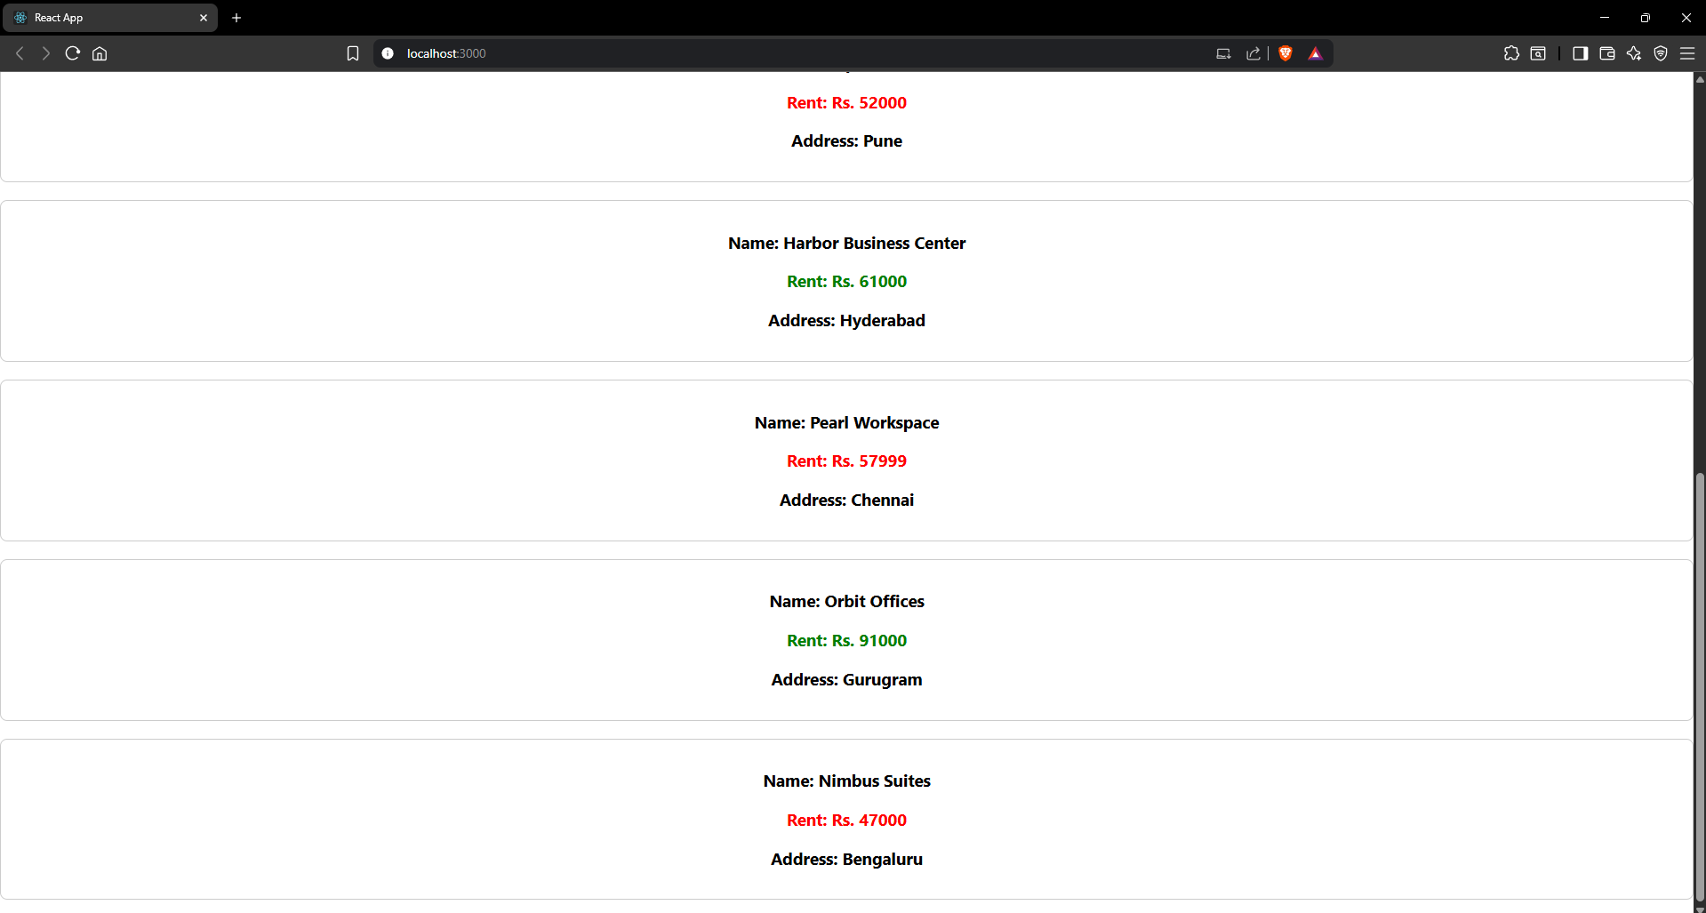

Hands on 11
Create a React Application “eventexamplesapp” to handle various events of the form elements in HTML.
Create a “CurrencyConvertor” component which will convert the Indian Rupees to Euro when the Convert button is clicked.

Code:

App.js

import React, { useState } from 'react';
import './App.css';

function App() {
const [count, setCount] = useState(0);
const [amount, setAmount] = useState('');
const [currency, setCurrency] = useState('');

const incrementCounter = () => {
setCount(prevCount => prevCount + 1);
};

const sayHello = () => {
alert("Hello! Member1");
};

const handleIncrementClick = () => {
incrementCounter();
sayHello();
};

const decrementCounter = () => {
setCount(prevCount => prevCount - 1);
};

const sayWelcome = (message) => {
alert(message);
};

const handleClickMe = (event) => {
console.log("Synthetic Event:", event);
console.log("Event type:", event.type);
alert("I was clicked");
};

const handleAmountChange = (e) => {
setAmount(e.target.value);
};

const handleCurrencyChange = (e) => {
setCurrency(e.target.value);
};

const handleSubmit = (e) => {
e.preventDefault();
const euroRate = 0.0099;
const convertedAmount = parseFloat(amount) * euroRate;
if (!isNaN(convertedAmount)) {
alert(`Converting to Euro Amount is ${convertedAmount.toFixed(2)}`);
} else {
alert("Please enter a valid amount.");
}
};

return (
<div className="App">
<h1>Counter: {count}</h1>
<div className="button-group">
<button onClick={handleIncrementClick}>Increment</button>
<button onClick={decrementCounter}>Decrement</button>
<button onClick={() => sayWelcome("Welcome")}>Say Welcome</button>
<button onClick={handleClickMe}>Click on me</button>
</div>
<h1 style={{ color: 'green', marginTop: '40px' }}>Currency Convertor!!!</h1>
<form onSubmit={handleSubmit} className="currency-form">
<div className="form-group">
<label htmlFor="amount">Amount:</label>
<input
type="number"
id="amount"
value={amount}
onChange={handleAmountChange}
placeholder="Enter amount in INR"
/>
</div>
<div className="form-group">
<label htmlFor="currency">Currency:</label>
<input
type="text"
id="currency"
value={currency}
onChange={handleCurrencyChange}
placeholder="e.g., Euro"
/>
</div>
<button type="submit">Submit</button>
</form>
</div>
);
}

export default App;

App.css

.App {
font-family: Arial, sans-serif;
padding: 20px;
}

.button-group button {
margin: 5px;
padding: 10px 15px;
font-size: 16px;
cursor: pointer;
border: 1px solid #ccc;
border-radius: 5px;
background-color: #f0f0f0;
}

.button-group button:hover {
background-color: #e0e0e0;
}

.currency-form {
display: flex;
flex-direction: column;
align-items: center;
gap: 15px;
margin-top: 20px;
padding: 20px;
border: 1px solid #eee;
border-radius: 8px;
max-width: 400px;
box-shadow: 0 2px 5px rgba(0,0,0,0.1);
}

.currency-form .form-group {
display: flex;
flex-direction: column;
align-items: flex-start;
width: 100%;
}

.currency-form label {
margin-bottom: 5px;
font-weight: bold;
}

.currency-form input {
width: 100%;
padding: 8px;
border: 1px solid #ccc;
border-radius: 4px;
font-size: 16px;
}

.currency-form button[type="submit"] {
padding: 10px 20px;
font-size: 18px;
background-color: #007bff;
color: white;
border: none;
border-radius: 5px;
cursor: pointer;
}

.currency-form button[type="submit"]:hover {
background-color: #0056b3;
}

Output:

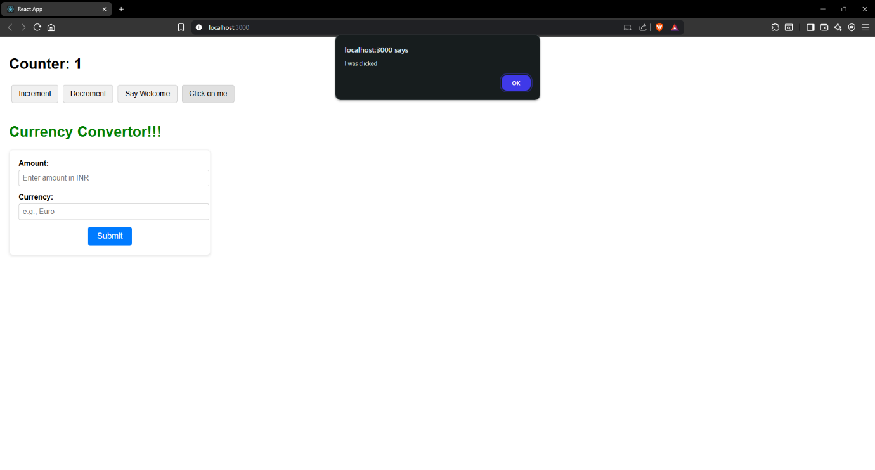
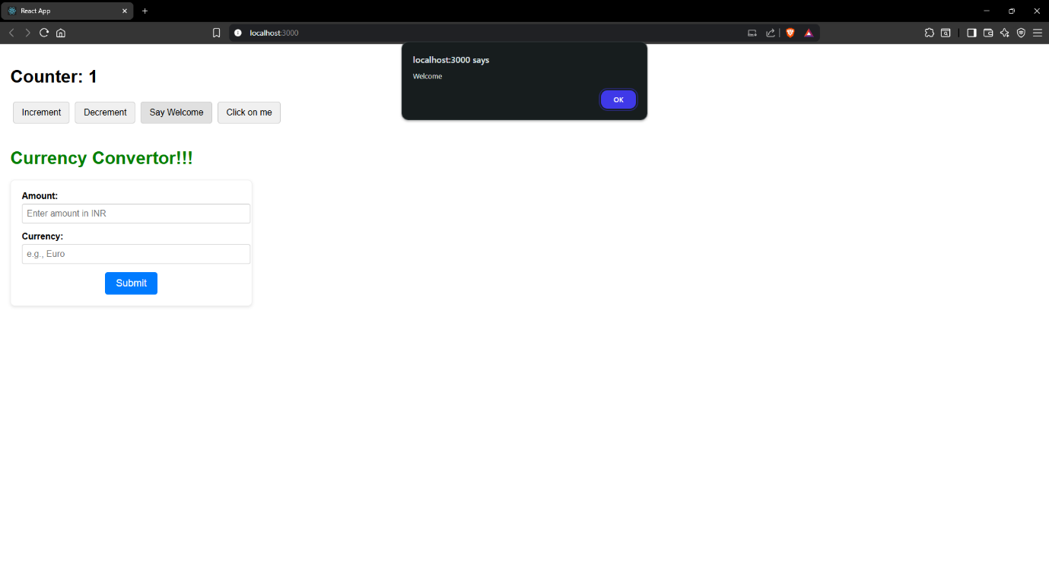

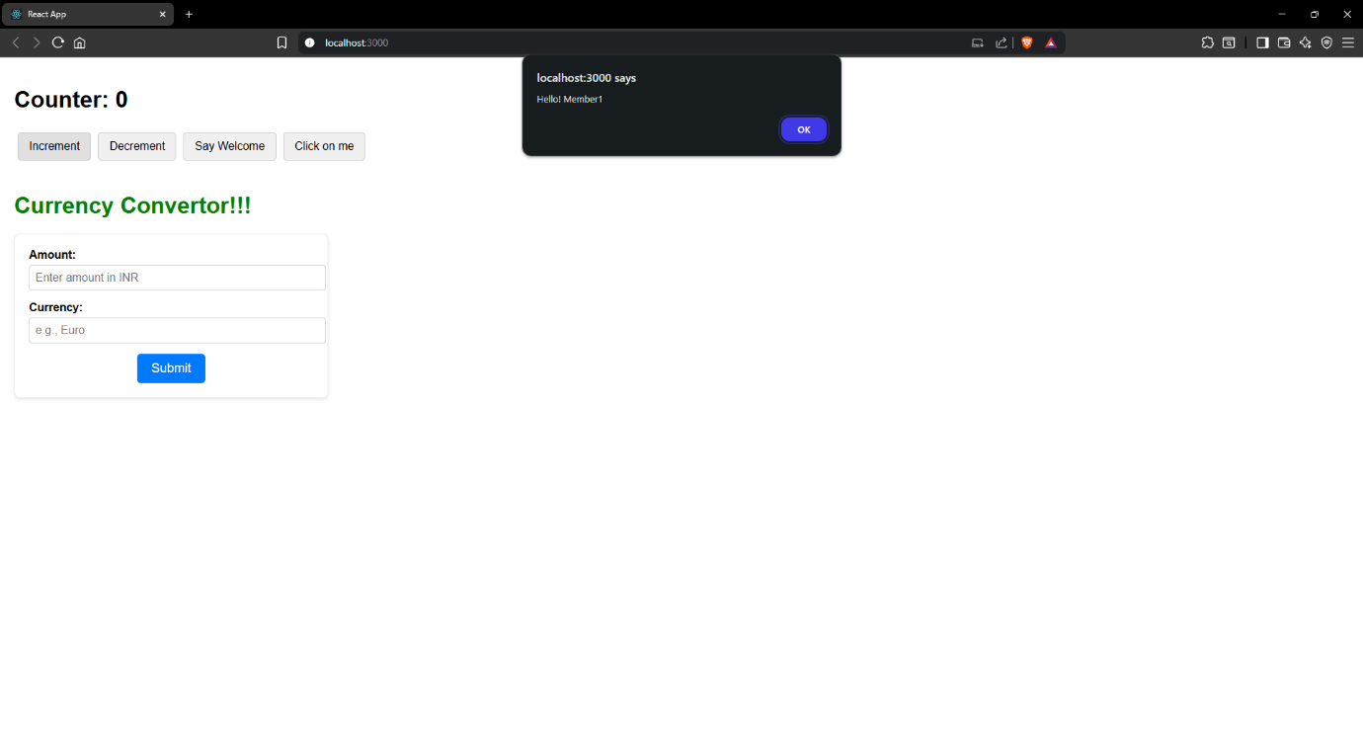
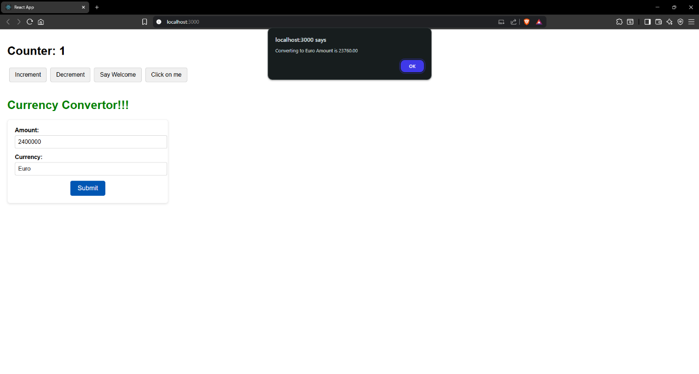

Hands on 12
Create a React Application named “ticketbookingapp” where the guest user can browse the page where the flight details are displayed whereas the logged in user only can book tickets.

Code:

LoginButton.jsx

import React from 'react';

function LoginButton(props) {
return (
<button onClick={props.onClick}>
Login
</button>
);
}

export default LoginButton;

LogoutButton.jsx

import React from 'react';

function LogoutButton(props) {
return (
<button onClick={props.onClick}>
Logout
</button>
);
}

export default LogoutButton;

UserGreeting.jsx

import React from 'react';

function UserGreeting() {
return <h1>Welcome back</h1>;
}

export default UserGreeting;

GuestGreeting.jsx
import React from 'react';

function GuestGreeting() {
return <h1>Please sign up.</h1>;
}

export default GuestGreeting;

Greeting.jsx

import React from 'react';
import UserGreeting from './UserGreeting';
import GuestGreeting from './GuestGreeting';

function Greeting(props) {
const isLoggedIn = props.isLoggedIn;
if (isLoggedIn) {
return <UserGreeting />;
}
return <GuestGreeting />;
}

export default Greeting;

App.js

import React, { useState } from 'react';
import Greeting from './components/Greeting';
import LoginButton from './components/LoginButton';
import LogoutButton from './components/LogoutButton';
import './App.css';

function App() {
const [isLoggedIn, setIsLoggedIn] = useState(false);

const handleLoginClick = () => {
setIsLoggedIn(true);
};

const handleLogoutClick = () => {
setIsLoggedIn(false);
};

let button;
if (isLoggedIn) {
button = <LogoutButton onClick={handleLogoutClick} />;
} else {
button = <LoginButton onClick={handleLoginClick} />;
}

return (
<div className="App">
<Greeting isLoggedIn={isLoggedIn} />
{button}
</div>
);
}

export default App;

App.css

.App {
font-family: Arial, sans-serif;
text-align: center;
padding: 50px;
display: flex;
flex-direction: column;
justify-content: center;
align-items: center;
}

h1 {
margin-bottom: 20px;
}

button {
padding: 10px 20px;
font-size: 16px;
margin-top: 20px;
cursor: pointer;
border: 1px solid #ccc;
border-radius: 5px;
background-color: #f0f0f0;
}

button:hover {
background-color: #e0e0e0;
}

Output:

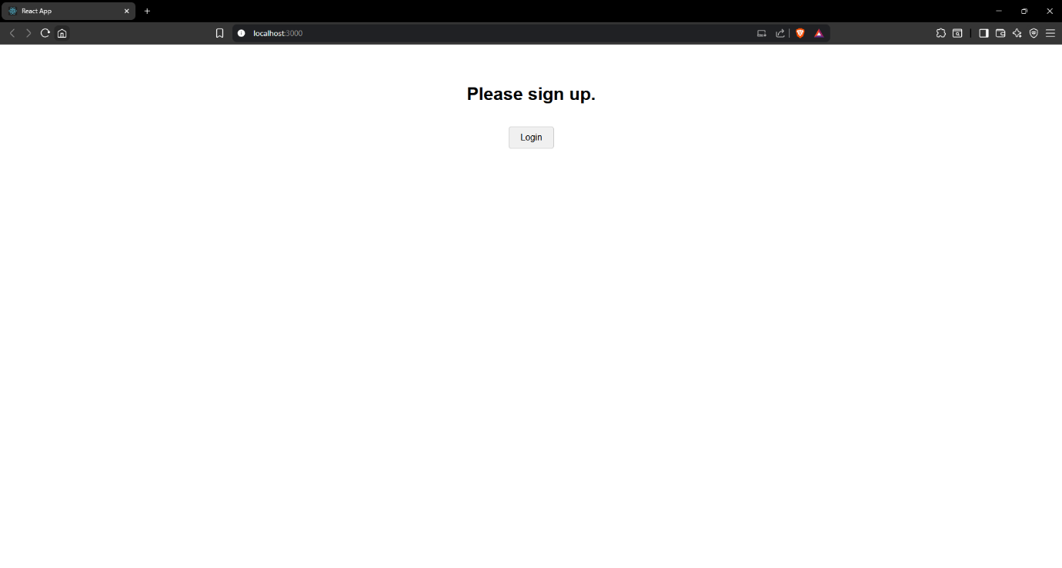
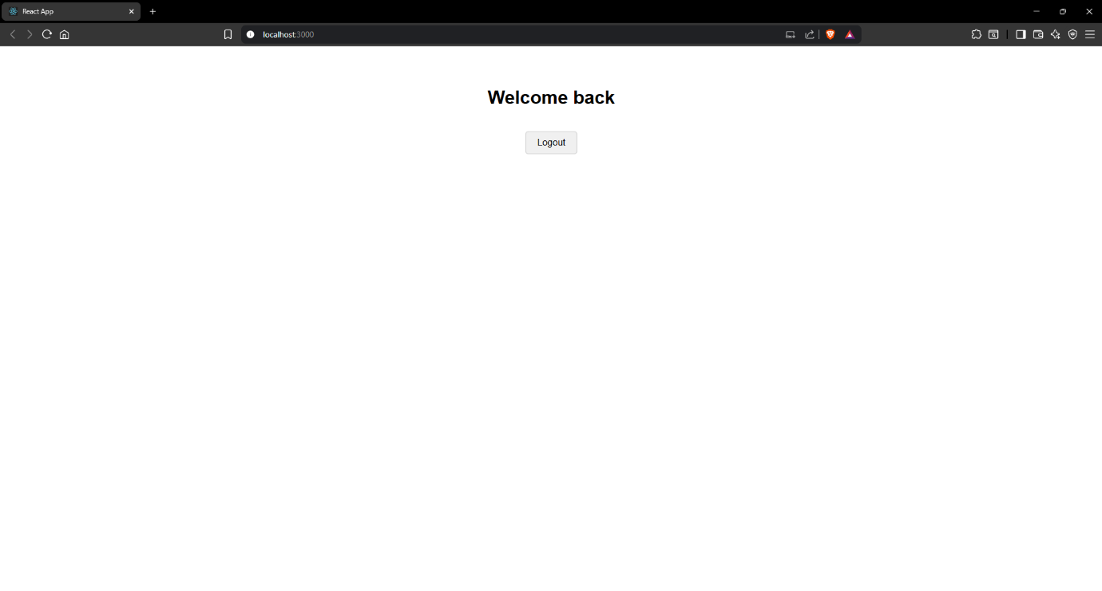
Hands on 13
Create a React App named “bloggerapp” in with 3 components.

1. Book Details
2. Blog Details
3. Course Details

Code:

booksData.js

export const books = [
{ id: 101, bname: 'Master React', price: 700 },
{ id: 102, bname: 'Deep Dive into Angular 11', price: 1000 },
{ id: 103, bname: 'Mongo Essentials', price: 400 },
];

blogsData.js

export const blogs = [
{ id: 201, title: 'React Learning', author: 'Stephen Biz', content: 'Welcome to learning React!' },
{ id: 202, title: 'Installation', author: 'Schewzdenier', content: 'You can install React from npm.' },
{ id: 203, title: 'Component Life Cycle', author: 'Jane Doe', content: 'Understanding component lifecycle methods.' },
];

coursesData.jsx

export const courses = [
{ id: 301, name: 'Angular', date: '12/08/2025' },
{ id: 302, name: 'React', date: '29/07/2025' },
{ id: 303, name: 'Vue.js', date: '1/08/2025' },
];

BookDetails.jsx

import React from 'react';

const BookItem = ({ book }) => (
<div>
<h3>{book.bname}</h3>
<h4>{book.price}</h4>
</div>
);

const BookDetails = ({ books }) => {
const bookdet = (
<ul>
{books.map(book => (
<li key={book.id}>
<BookItem book={book} />
</li>
))}
</ul>
);

return (
<div className="book-details">
<h1>Book Details</h1>
{bookdet}
</div>
);
};

export default BookDetails;

BlogDetails.jsx

import React from 'react';

const BlogItem = ({ blog }) => (
<div>
<h3>{blog.title}</h3>
<h4>{blog.author}</h4>
<p>{blog.content}</p>
</div>
);

const BlogDetails = ({ blogs }) => {
const content = (
<ul>
{blogs.map(blog => (
<li key={blog.id}>
<BlogItem blog={blog} />
</li>
))}
</ul>
);

return (
<div className="blog-details">
<h1>Blog Details</h1>
{content}
</div>
);
};

export default BlogDetails;

CourseDetails.jsx

import React from 'react';

const CourseItem = ({ course }) => (
<div>
<h3>{course.name}</h3>
<h4>{course.date}</h4>
</div>
);

const CourseDetails = ({ courses }) => {
const coursedet = (
<ul>
{courses.map(course => (
<li key={course.id}>
<CourseItem course={course} />
</li>
))}
</ul>
);

return (
<div className="course-details">
<h1>Course Details</h1>
{coursedet}
</div>
);
};

export default CourseDetails;

ConditionalRenderer.jsx

import React from 'react';

const ConditionalRenderer = ({ showType }) => {
let renderedContent;
if (showType === 'books') {
renderedContent = <p>Showing Books via if/else</p>;
} else if (showType === 'blogs') {
renderedContent = <p>Showing Blogs via if/else</p>;
} else if (showType === 'courses') {
renderedContent = <p>Showing Courses via if/else</p>;
} else {
renderedContent = <p>No specific type selected (if/else)</p>;
}

const showMessage = showType === 'all';

const isSpecialCase = showType === 'special';

return (
<div style={{ border: '1px dashed #666', padding: '15px', margin: '20px 0' }}>
<h2>Conditional Rendering Examples</h2>

<h3>1. If/Else (Element Variable)</h3>
{renderedContent}

<h3>2. Logical && Operator</h3>
{showMessage && <p>This message appears when 'all' is selected (Logical &&)</p>}

<h3>3. Ternary Operator</h3>
{isSpecialCase ? (
<p>This is a special case (Ternary True)</p>
) : (
<p>This is a normal case (Ternary False)</p>
)}

<h3>4. Preventing Component Rendering (returning null)</h3>
{showType === 'none' ? null : <p>This component renders unless 'none' is selected</p>}
</div>
);
};

export default ConditionalRenderer;

App.js

import React, { useState } from 'react';
import BookDetails from './components/BookDetails';
import BlogDetails from './components/BlogDetails';
import CourseDetails from './components/CourseDetails';
import ConditionalRenderer from './components/ConditionalRenderer';

import { books } from './data/booksData';
import { blogs } from './data/blogsData';
import { courses } from './data/coursesData';

import './App.css';

function App() {
const [activeSection, setActiveSection] = useState('all');

return (
<div className="App">
<h1>Blogger App Content</h1>

<div className="controls">
<button onClick={() => setActiveSection('books')}>Show Books</button>
<button onClick={() => setActiveSection('blogs')}>Show Blogs</button>
<button onClick={() => setActiveSection('courses')}>Show Courses</button>
<button onClick={() => setActiveSection('all')}>Show All Conditional</button>
<button onClick={() => setActiveSection('special')}>Show Special Conditional</button>
<button onClick={() => setActiveSection('none')}>Hide Conditional</button>
</div>

<div className="content-layout">
<div className="section st2">
<CourseDetails courses={courses} />
</div>
<div className="section v1">
<BookDetails books={books} />
</div>
<div className="section mystyle1">
<BlogDetails blogs={blogs} />
</div>
</div>

<ConditionalRenderer showType={activeSection} />
{activeSection === 'all' && (
<p style={{ marginTop: '20px', fontWeight: 'bold' }}>
You are viewing all conditional rendering examples.
</p>
)}
</div>
);
}

export default App;

App.css

body {
margin: 0;
font-family: Arial, sans-serif;
padding: 20px;
background-color: #f4f4f4;
}

.App {
text-align: center;
max-width: 1200px;
margin: 0 auto;
padding: 20px;
background-color: #fff;
box-shadow: 0 0 10px rgba(0, 0, 0, 0.1);
border-radius: 8px;
}

h1 {
color: #333;
margin-bottom: 5px;
}

h2 {
color: #555;
margin-top: 5px;
margin-bottom: 5px;
}

h3 {
color: #444;
font-size: 1.2em;
margin-bottom: 5px;
}

h4 {
color: #666;
font-size: 1em;
margin-bottom: 10px;
}

ul {
list-style: none;
padding: 0;
margin: 0;
}

li {
margin-bottom: 5px;
padding: 5px;
border-bottom: 1px dashed #eee;
}

li:last-child {
border-bottom: none;
}

.controls button {
margin: 5px;
padding: 10px 15px;
font-size: 16px;
cursor: pointer;
border: 1px solid #007bff;
border-radius: 5px;
background-color: #007bff;
color: white;
transition: background-color 0.3s ease;
}

.controls button:hover {
background-color: #0056b3;
}

.content-layout {
display: flex;
justify-content: space-around;
align-items: flex-start;
flex-wrap: wrap;
margin-top: 20px;
}

.section {
flex: 1;
min-width: 280px;
margin: 10px;
padding: 20px;
border: 1px solid #ddd;
border-radius: 8px;
background-color: #f9f9f9;
box-shadow: 0 2px 5px rgba(0,0,0,0.05);
}

.content-layout .section + .section {
border-left: 2px solid #28a745;
}

Output:

