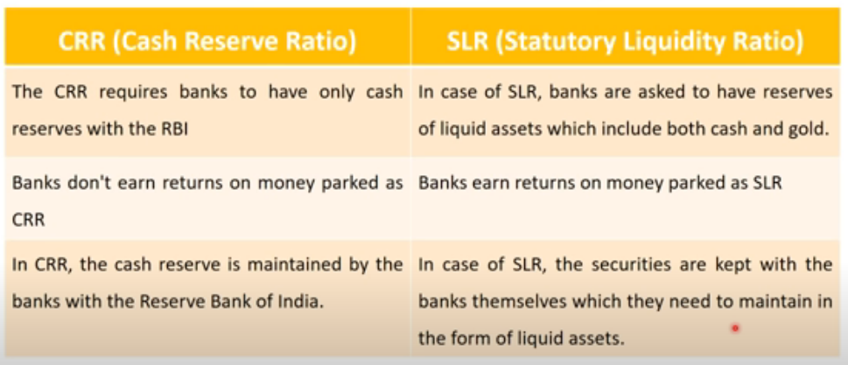

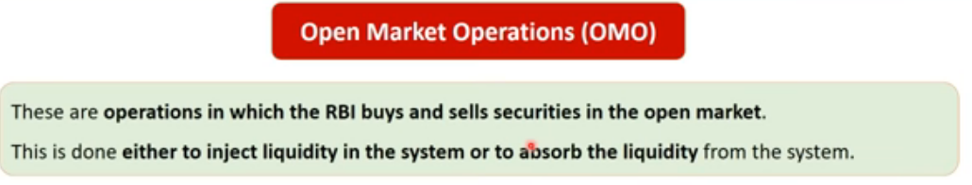

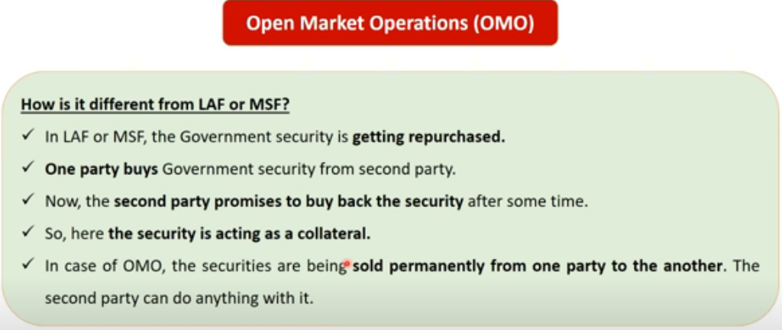

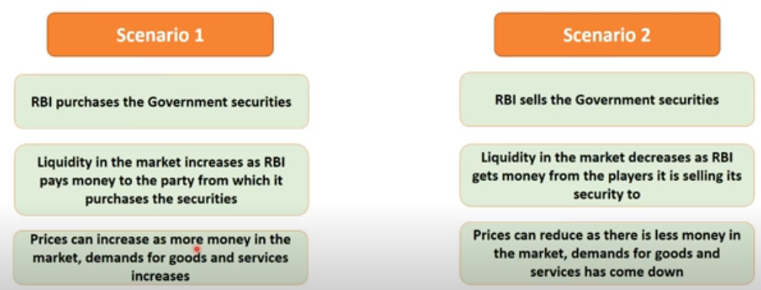

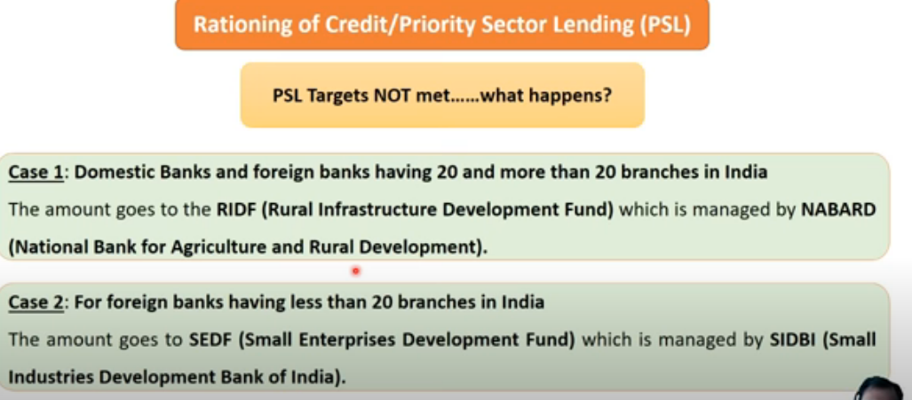

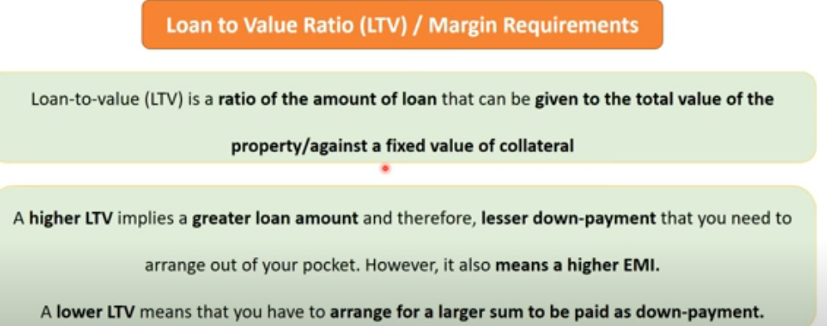

IFCI - 1948; ICICI - 1955; IDBI - 1964;NABARD- 1982

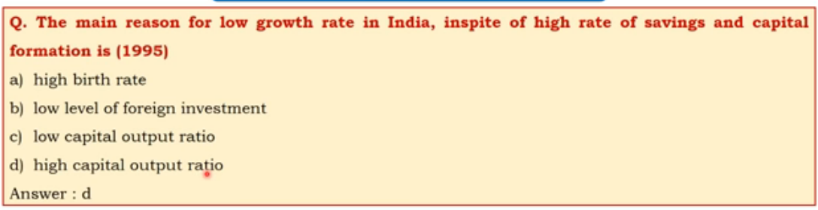

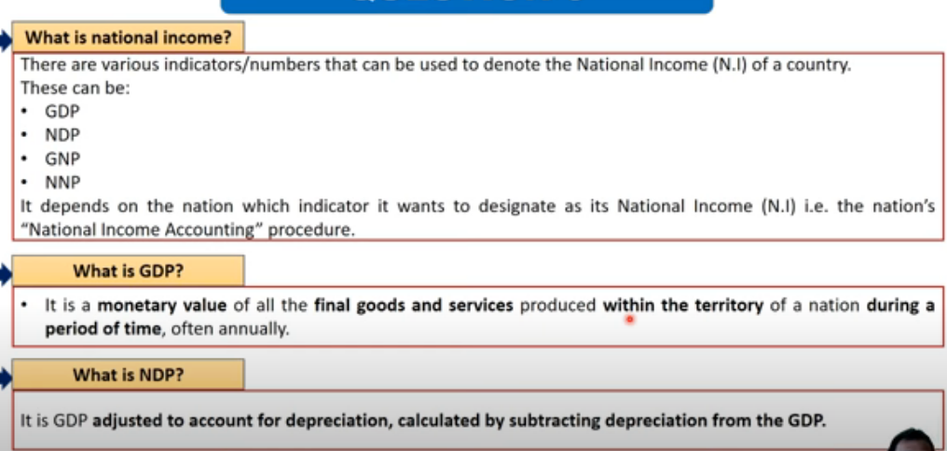

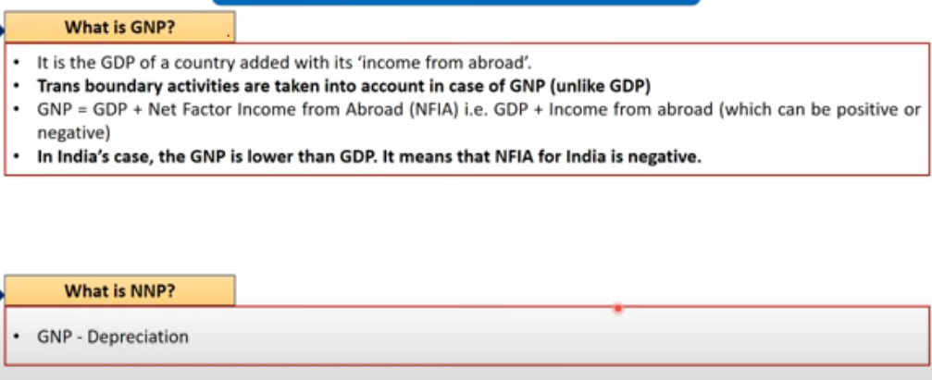

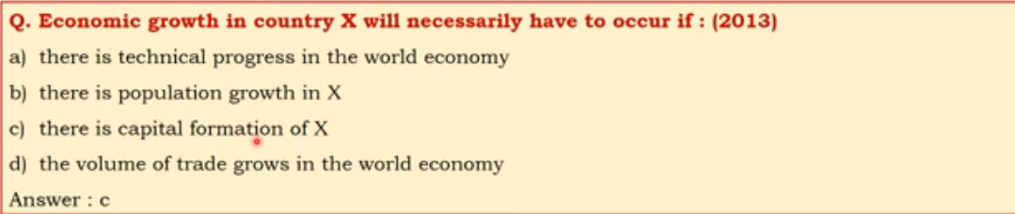

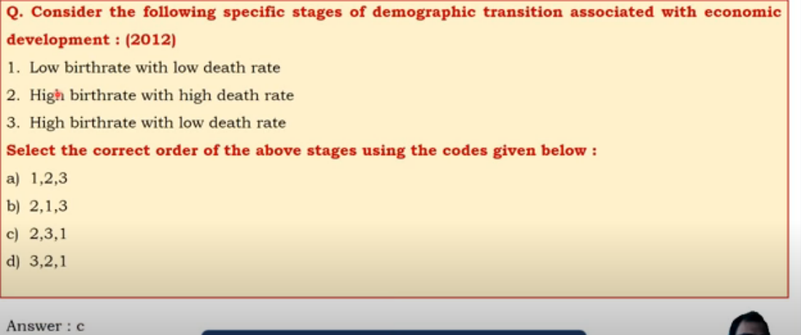

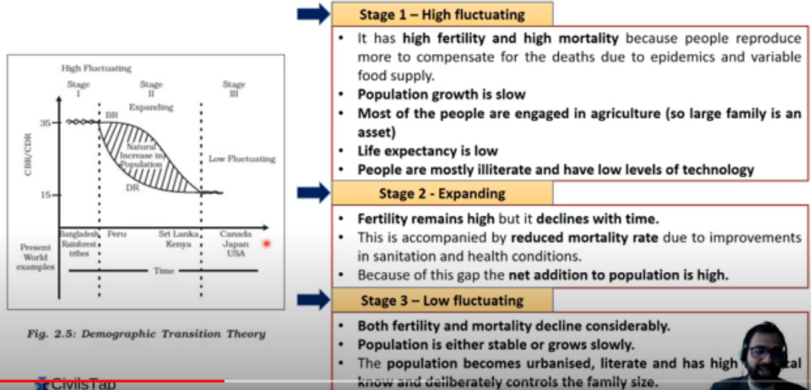

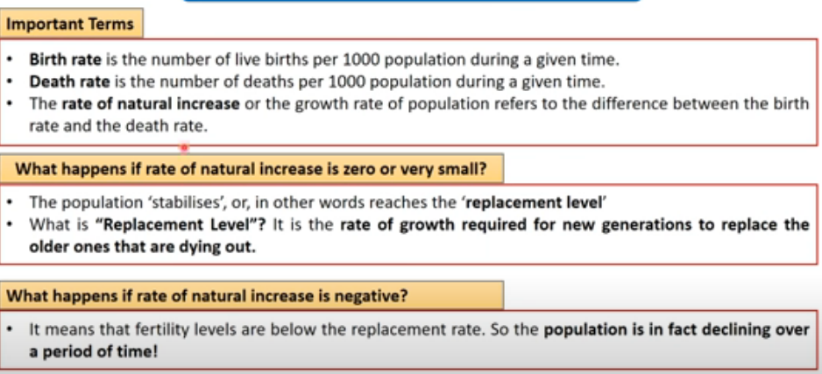

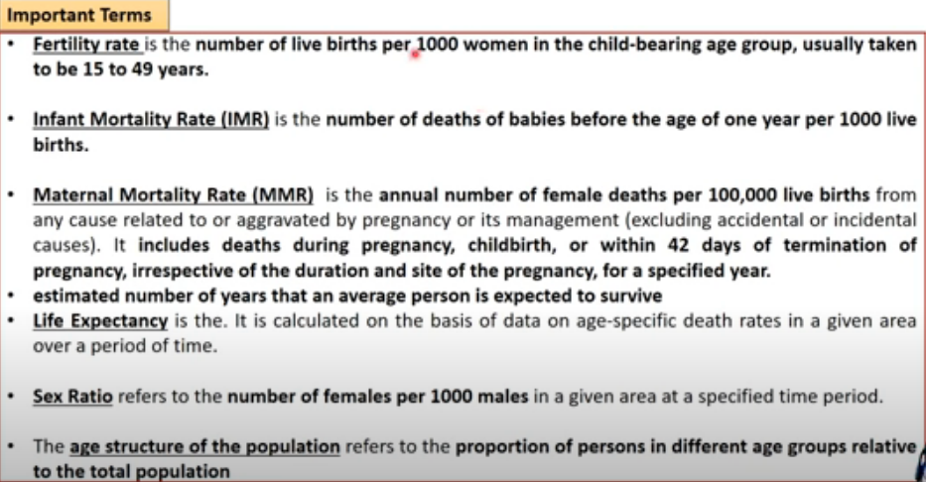

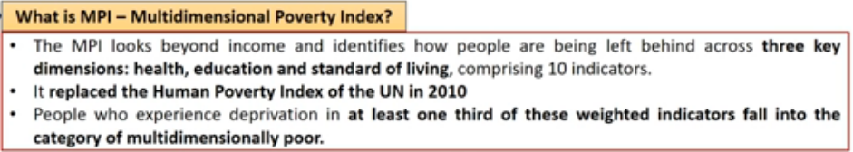

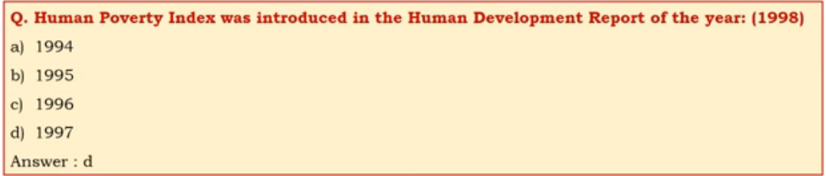

**WTO :**

Headquaters: **geneva switzland**

founded : 1 jan 1995

memebership : 164 memeber states

Leader : Roberto Azevedo

**GATT** : 30 oct 1947. sign by **23 nation**. Between **1946** and **1994**

Gatt provide framework multilateral trade negotiation

Then there was urugay round of confernece lasted between 1986-94. it was biggest negotiating mandate on trade ever agreed and thereby ending with the birth of WTO

The Final Act concluding the uruguay round and officially establishing the WTO regime was signed **15 april 1994.**

Meeting was at **Marrakesh, Morocco**. hence is know as the **Marrakesh Agreement**

Objective :

WTO has six key objectives:

1. To set and enforce rules for international trade

2. To provide a forum for negotiating and monitoring further trade liberalization

3. To resolve trade dispute.

4. To increased the transparency of ecision making process

5. to cooperate with other major international economic intstitution involved in global economic managment

6. To help developing countries countries benefit fully from the global trading system

Drawaback of GATT

- Basically **GATT** is a provisional agreement not an organization

- Less developed countries could get only littel benefit from GATT trade libralization was

confine mostly to the developed countries

- textile and clothing industries were exempted from GATT.

- **GATT** followed the principle of commodity base negotiation. Developing countries, mainly exporting primary products could not effectively bargain with developed countries

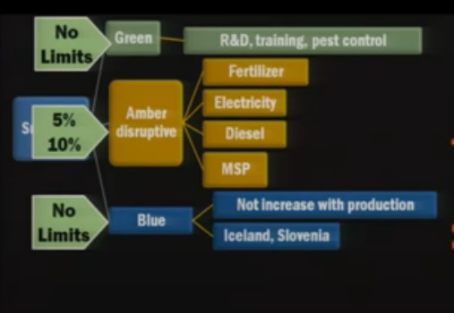

**Money :**

**Primary function of money :**

1. Medium of exchange

2. Measure of value

**Derivative function or secondary function:**

1. Store of value(Saving=> investment)

2. Transfer of value

3. Deferred Payment

**TAX :**

**Union Direct TAX :**

**Type#1 :**

1. Income tax

2. Corporate tax

3. intrest tax (on bank)!

4. Hotel receipt Tax!

5. FBT!

**Type#2 :**

Property tax,Assets,Capital Transaction

1. Security transaction Tax

2. Capital Gains Tax(profit on assets sale)

3. Wealth Tax(Jaitley)!

**Indirect Tax on expenditure:**

1. Service tax

**State Direct Tax :**

**Type#1 : Taxes on income**

1. Agriculture income tax

2.. Professional Tax

**Type#2: Taxes on properties**

1. Land revenue

2. Stamp duty/ registration duty

**Pros of Direct Tax :**

1. Progressive(richer person higher tax)

2. Inequality of income....reduce

3. Certainty(When and how)

4. Elasticity, quick results when raised/lowered

**Demerits of direct tax :**

1. Collection expensive(staff salary, database managment).

2. Therefore, Narrow base.

**Good tax system :**

Many principle , **Adam smith 4 canon**

1. Canon of **equality**: Proportionate to income.

2. Canon of **Certainity** : about deadline and rate.

3. Canon of **convenience** : to the tax payer

4. Canon of **economy**: collection cost should be minimum

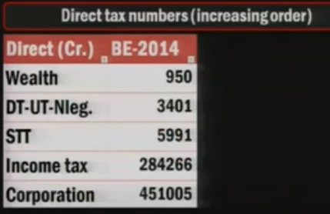

**Union Indirect Taxes:**

1. Custom duty(Import export)

2. Excise Dity(CENVAT system)

3. Service Tax

4. CST(But entirly given to states)

**Indirect Tax States :**

1. Sales tax/VAT(newspaper....X)

2. Excise on liquore, narcotics

3. Motor vehical tax, animal,boats,tolls

4. Luxury tax, betting gambling

5. Entertainment, Electricity tax

6. Advertisment tax(TV,radio,newspaper...)

**Merits of Indirect Taxes :**

1. Convenient. no additional paperwork for the customer.

2. Wider base.Everyone covered

3. less evasion, specially under VAT/GST.

4. Elastic. Small increase bring large revenue

**Demerits of indirect Taxs:**

1. Single point taxes = high level of corruption, evasion,cascading effect E.g sales tax

2. Regressive in nature

3. Both poor and rich taxed equally for the same item

