**S****uyash Misra**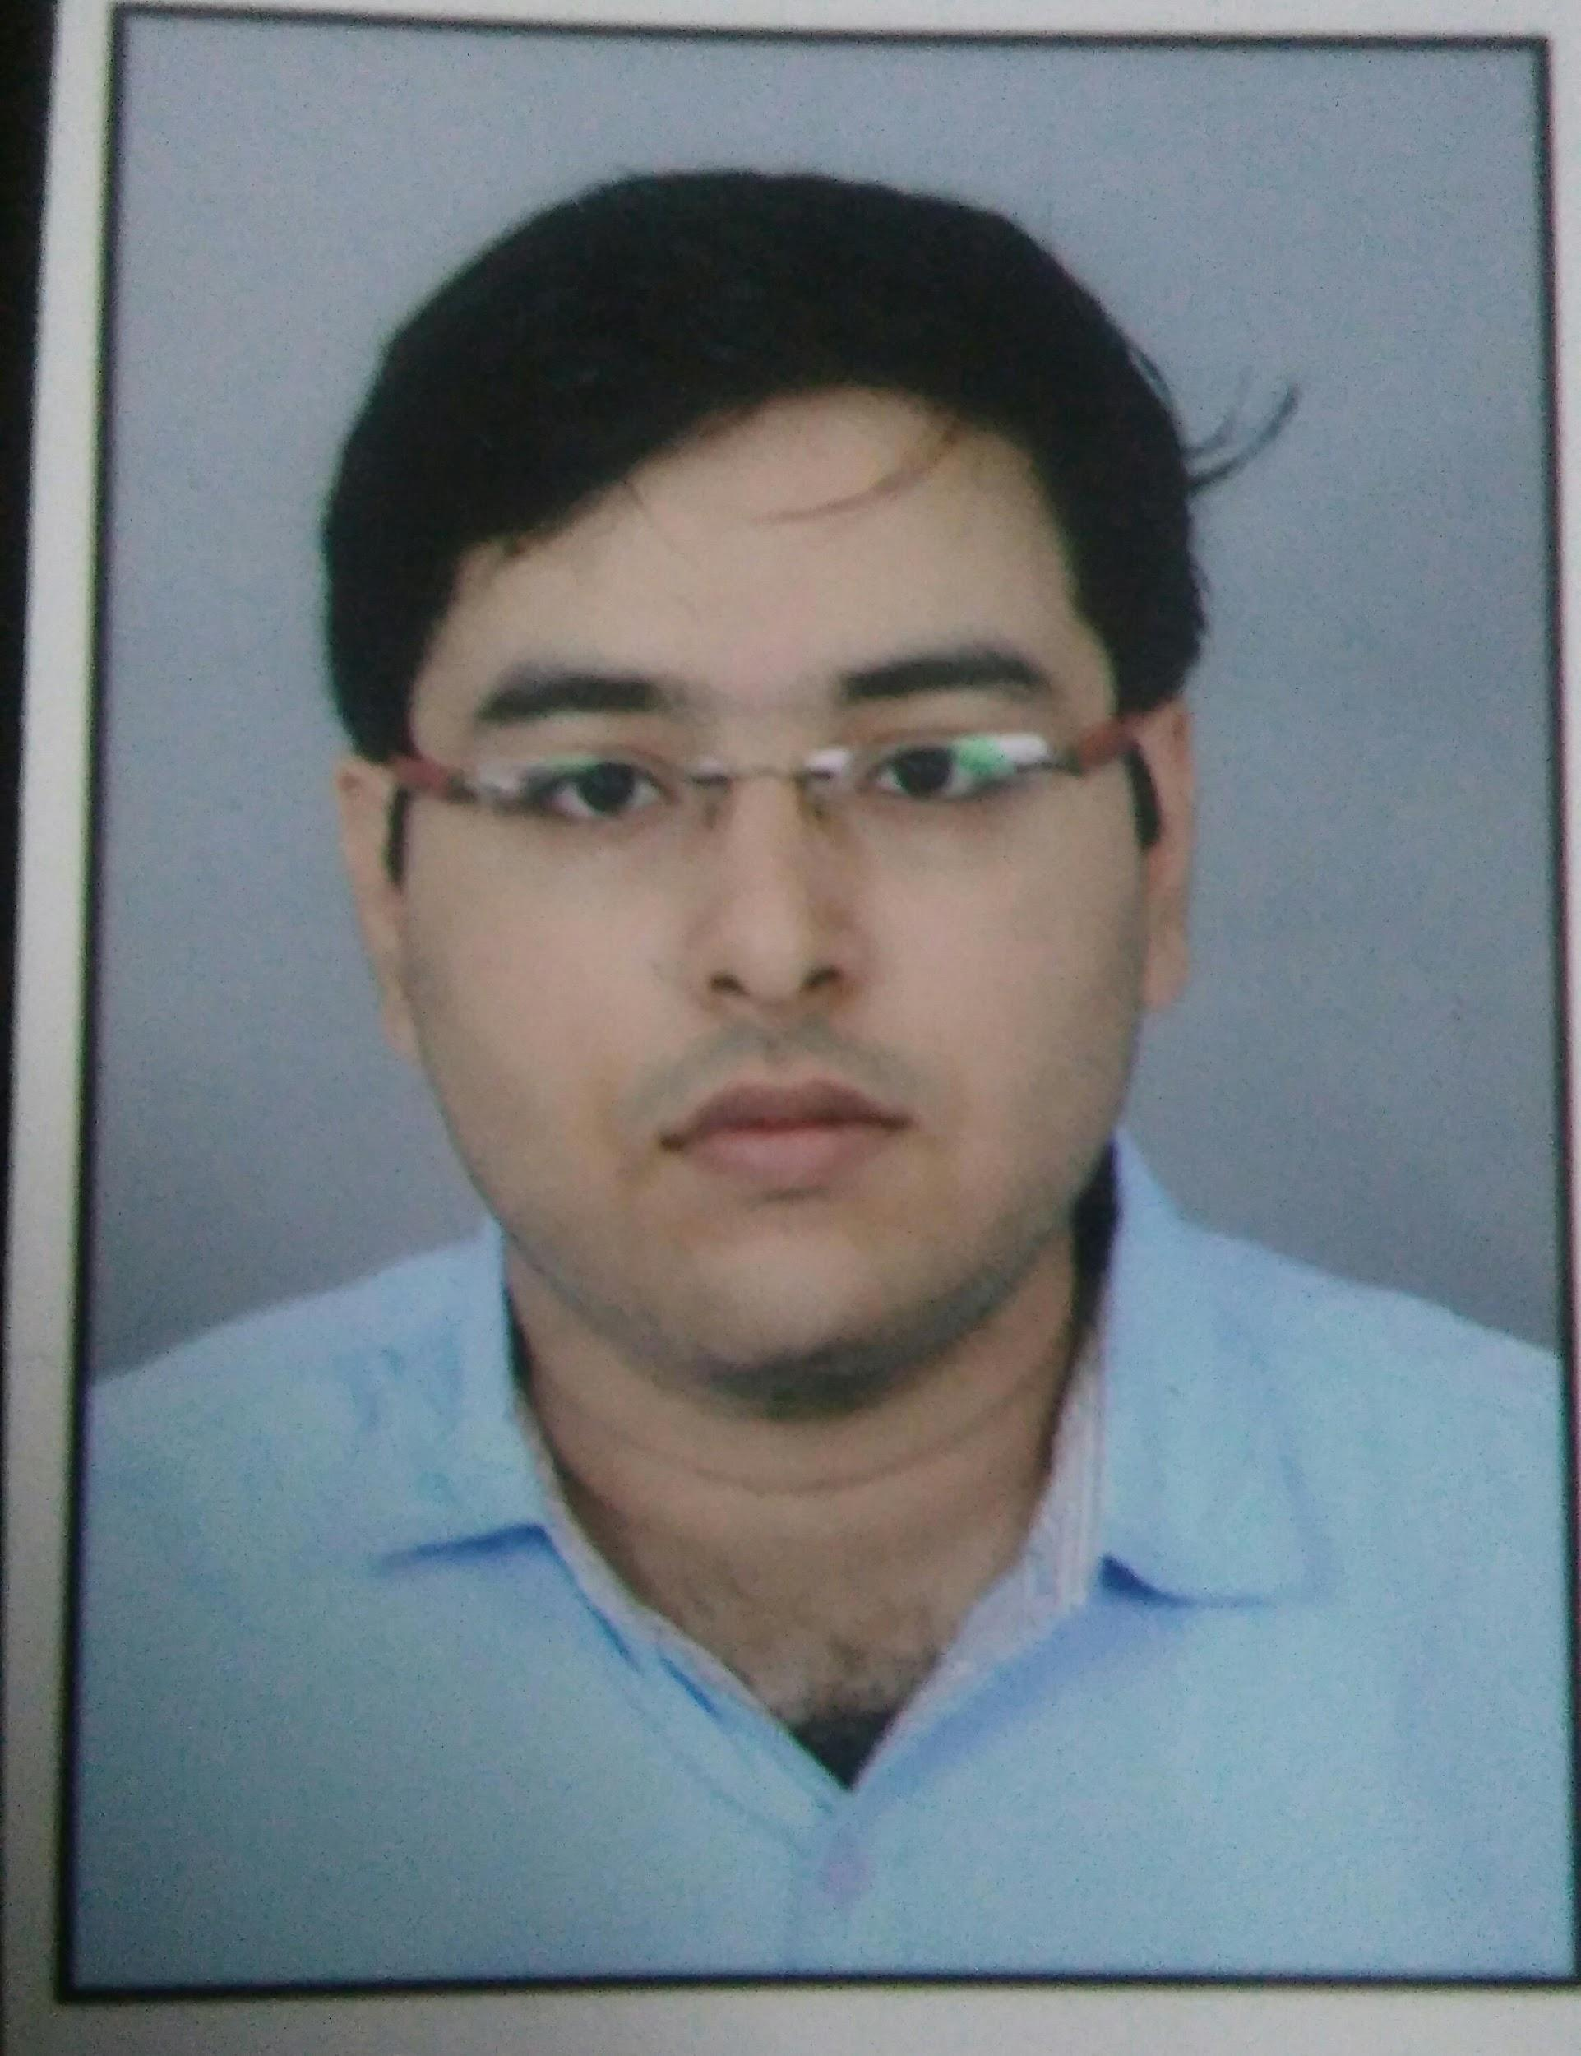

Men’s Hostel – H, University of Hyderabad, Gachibowli, Telangana – 500046

18mcmc15@uohyd.ac.in

[suyash686@gmail.com](mailto:suyash686@gmail.com)

* Up to 3rd Semester.

|  |  |  |  |  |
| --- | --- | --- | --- | --- |
| ACADEMIC QUALIFICATIONS | | | | |
| Examinations | **Name of Institute** | **Board / University** | **Year** | Marks |
| Master of Computer Application | School of Computer Information & Sciences | University of Hyderabad | Current (2021) | 8.18* CGPA |
| Bachelor of Computer Application | Dr. Virendra Swarup Institute of Computer Studies | Kanpur University | 2018 | 68.25% |
| AISSCE (12th) | Woodbine Gardenia School, Kanpur, Uttar Pradesh | Central Board of Secondary Education | 2015 | 73.6 % |
| AISSE (10th) | Woodbine Gardenia School, Kanpur, Uttar Pradesh | Central Board of Secondary Education | 2013 | 9.2 CGPA |

|  |
| --- |
| TECHNICAL SKILLS |

* **Programming Languages** : C, C++, Java
* **Web Technologies** : HTML, CSS, Bootstrap, JavaScript
* **Database** : MySQL
* **Operating System** : Linux | Windows

|  |
| --- |
| ACADEMIC PROJECTS |

* **My Portfolio**: A website built to showcase my portfolio to recruiters built using HTML, CSS, Bootstrap and JavaScript. GitHub: <https://github.com/SuyashMisra/SuyashMisra.github.io>
* **HotFlix**: A website to stream movies and TV series built using HTML, CSS, Bootstrap, JavaScript, PHP and MySQL. GitHub: https://github.com/SuyashMisra/HotFlix
* **Intelligent Mancala**: A board game built in Java that incorporates an AI agent which works on minimax algorithm to play against humans. GitHub: https://github.com/SuyashMisra/Mancala
* **Student Registration System**: A project built using Java and SQL that manages the details of students currently studying at an institution. GitHub: <https://github.com/SuyashMisra/Student-Registration-System>
* **Giphy Search Engine**: A Giphy search engine that uses the Giphy API to search for the desired GIFs and display them. GitHub: <https://github.com/SuyashMisra/Giphy-Search-Engine>
* **SoundCloud Player**: An audio streaming website that makes use of the SoundCloud API to search and play the desired songs. GitHub: https://github.com/SuyashMisra/SoundCloudPlayer

|  |
| --- |
| ACHIEVEMENTS |

* Achieved **AIR 558**(GEN) in **NIMCET-2018**.
* Secured **2nd position** in 2nd semester examinations (MCA) with a SGPA of **9.11**.
* Passed Software Lab-1 (CA406) course on Programming Methodology with **A+ grade** in MCA.
* Passed Software Lab (CA456) course on Object Oriented Programming with **A+ grade** in MCA.
* Passed DBMS Lab (CA505) course on SQL with **A+ grade** in MCA.
* Ranked **1st** in University of Hyderabad in Data Structures Practice on HackerRank as on 19/5/2020.
* Ranked **4th** in University of Hyderabad in Algorithms Practice on HackerRank as on 19/5/2020.
* **6 stars** **problem solving skill** on HackerRank.
* Selected as part of a 7-member team to represent University of Hyderabad in All India MCA Meet - Version’19 at NIT, Trichy.
* Won the title of **Mr. Sukoon-2019** in Sukoon 2019, the annual cultural fest of University of Hyderabad.

|  |
| --- |
| CERTIFICATIONS |

|  |  |  |  |
| --- | --- | --- | --- |
| * TCS iON Career Edge | * One Month - Learn HTML | * One Month - Learn Responsive Design | * One Month - Learn JavaScript |

|  |
| --- |
| AREAS OF INTEREST |

|  |  |  |  |
| --- | --- | --- | --- |
| * Algorithms | * Data Structures | * Software Development | * Web Development |

|  |
| --- |
| PERSONAL SKILLS |

|  |  |  |
| --- | --- | --- |
| * Good communication and presentation skills | * Writing clean and well-structured code | * Adept logical reasoning skills |
| * Innovative problem solving | * Ambitious | * Self-motivated |

|  |
| --- |
| EXTRA CO-CURRICULAR ACTIVITIES / HOBBIES |

|  |  |  |
| --- | --- | --- |
| * Singing | * Swimming | * Gaming |
| * Competitive Coding | * Watching movies/TV series/anime |  |