V2V SYSTEM GUIDE

Real-Time Cooperative Safety
  - Expanded technical design • component illustrations • research gaps • implementation and validation plan
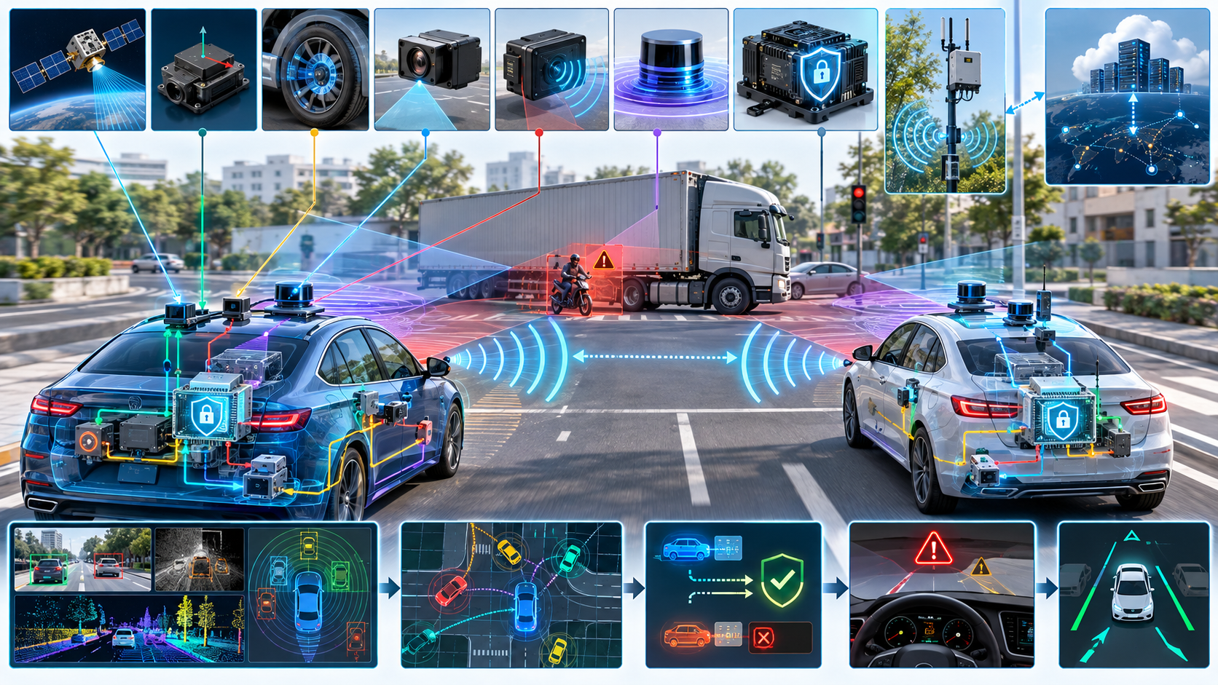
Concept art: connected vehicles combine onboard sensing, secure V2X communication, hazard evaluation, and driver alerts. Illustrative only; not a hardware schematic.
Document purpose
Turn the supplied V2V System Guide into a more implementation-ready research blueprint. The original scope is preserved: local V2V communication, message validation, sensor fusion, hazard warnings, optional V2I/backend services, and cooperative-perception research. New recommendations are explicitly framed as proposals, not established facts or safety certifications.
Revision date: 11 October 2026 | Status: research prototype design
Important: start with simulation and warning-only behaviour. No direct braking or steering control is in scope until an independent safety case and vehicle-level validation exist.

How to use this document
This is a technical guide and proposed implementation plan, not an AIS-230 compliance specification, a radio conformance profile, or a road-tested autonomous-driving system. The HTML demos described in the source are explanatory simulations. They do not establish that real radios, credentials, sensors, or actuator interfaces work.
Label | Meaning
Source-grounded baseline | Capabilities and caveats already stated in the supplied guide, such as local many-to-many exchange, message freshness checks, sensor fusion, warning-first response, and optional infrastructure.
Proposed engineering addition | A recommended design choice, interface, test, or project milestone intended to make implementation more systematic. It is not presented as a selected standard or validated threshold.
Research question | A testable hypothesis or gap that may be developed into an experiment or publication. It is not an established improvement.

Executive summary
The project should be built as a layered, fail-operational research prototype. Each vehicle publishes signed state or event messages over a selected local V2X profile; receivers verify, age-check, and plausibility-check those messages, maintain a local traffic map, fuse the reports with local sensing, and decide whether a bounded driver warning is warranted. A missing packet, a valid signature, or an AI-generated answer must never be treated as proof that a hazard is absent or that an event is true.
- The most important implementation gap is profile selection: jurisdiction, radio path, application message set, security envelope, certificate policy, timing limits, and interoperability test procedure are not yet frozen.
- The most important safety gap is a formally bounded decision path from incoming message to warning/advisory, including uncertainty, misbehavior detection, conflicts with local sensors, and safe fallback.
- The most useful research opportunity is robust asynchronous cooperative perception under packet loss, localization error, and adversarial or low-quality reports, evaluated on both simulated and real-world data.
- Keep an LLM/Graph-of-Thoughts module as an offline or non-authoritative research layer. It may explain or suggest; an independently validated safety policy must vet outputs before any vehicle action.

Suggested table of contents
- 1. Scope, goals, and design principles
- 2. Full system architecture
- 3. Component-by-component design and images
- 4. Message profiles, data contracts, and state lifecycle
- 5. Missing requirements and engineering gaps
- 6. Future research topics and publication plan
- 7. Implementation roadmap and repository structure
- 8. Verification, validation, and measurable metrics
- 9. Security, privacy, safety, and deployment gates
- 10. Current standards and reference reading
- 11. Completion checklist

1. Scope, goals, and design principles

1.1 Goal
Demonstrate that authenticated, time-bounded V2V reports can improve a receiver’s awareness of a relevant traffic hazard when local sensing is occluded or delayed, while quantifying the failure cases and safely degrading when messages are unavailable, stale, inaccurate, or untrusted.

1.2 First use cases
Use case | Shared evidence | Prototype response | Important limit
Hard braking ahead | Event location and time, sender motion state, deceleration context | Earlier driver warning if receiver path/time overlap indicates relevance | Do not infer braking is safe or command braking from packet alone.
Occluded intersection | Approach states or sensor-detected object reports with uncertainty | Visual/audio warning; optionally test speed/yield recommendation offline | Object association, coordinate alignment, and road priority are hard problems.
Road hazard beyond curve | Event type, affected region/direction, source time, validity, updates/cancellation | Warning and advisory to slow down in a simulation | Expired or mislocated reports must stop affecting the current decision.
Emergency vehicle approach | Profile-supported authenticated role and approach information | Alert and evaluate safe yield intent in simulation | Never trigger sudden lane change solely from received role/context.

1.3 Non-negotiable principles
- Direct safety exchange must not require internet connectivity. Backend services may provision trust material, distribute revocation information, support diagnostics, and deliver updates, but they are not in the immediate collision-warning loop.
- A valid signature identifies a credential; it does not prove that the sender’s sensor report is accurate or truthful.
- Every object/event should carry or inherit source time, uncertainty, identity/track context, validity, and coordinate-frame semantics.
- Use a conservative staged response: receive → authenticate → freshness/replay check → plausibility/misbehavior check → associate → fuse → predict risk → warn/advisory.
- No raw V2X packet or model output can directly command brakes, steering, or propulsion. Any future actuation path must be separately isolated, arbitrated, safety-assessed, and validated.
- All numerical thresholds introduced during research are configurable experimental parameters, not universal standards or safety guarantees.

2. Full system architecture
The architecture below makes the sender and receiver paths explicit. It also separates credential operations, optional roadside input, driver information, and any future ADAS connection. The diagram is logical; it is not a wiring diagram or a selected radio profile.
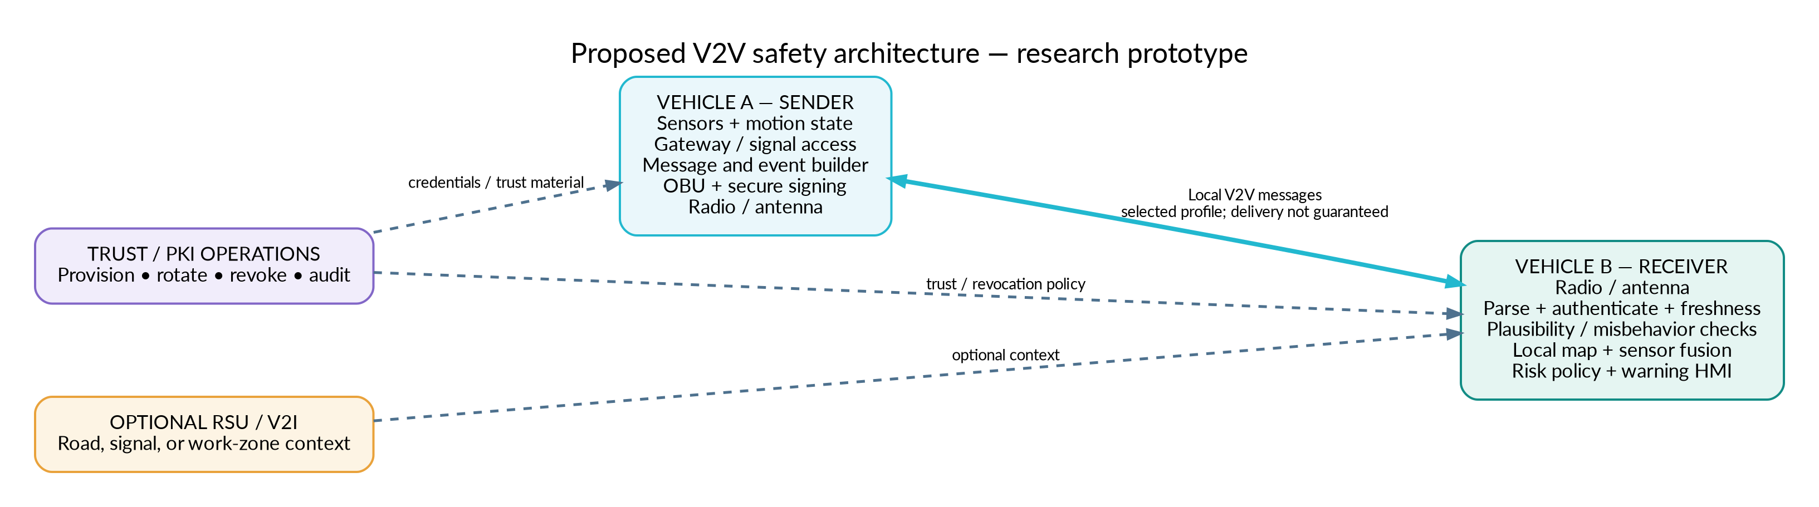
Figure 1. Proposed logical architecture. Dashed paths are supporting or gated interfaces, not the core direct-message path.

2.1 Sender path
1. Acquire approved sensor and motion signals through a defined gateway interface. Record measurement timestamps and confidence/uncertainty.
2. Generate the selected standards-compliant message type or event. Apply event-specific generation, update, cancellation, and expiry rules.
3. Pass the message to the OBU/radio stack using a defined serialization and security envelope. Protect the signing key through an appropriate secure element/HSM interface.
4. Track local transmit outcomes where available, but do not assume every broadcast will be received.

2.2 Receiver path
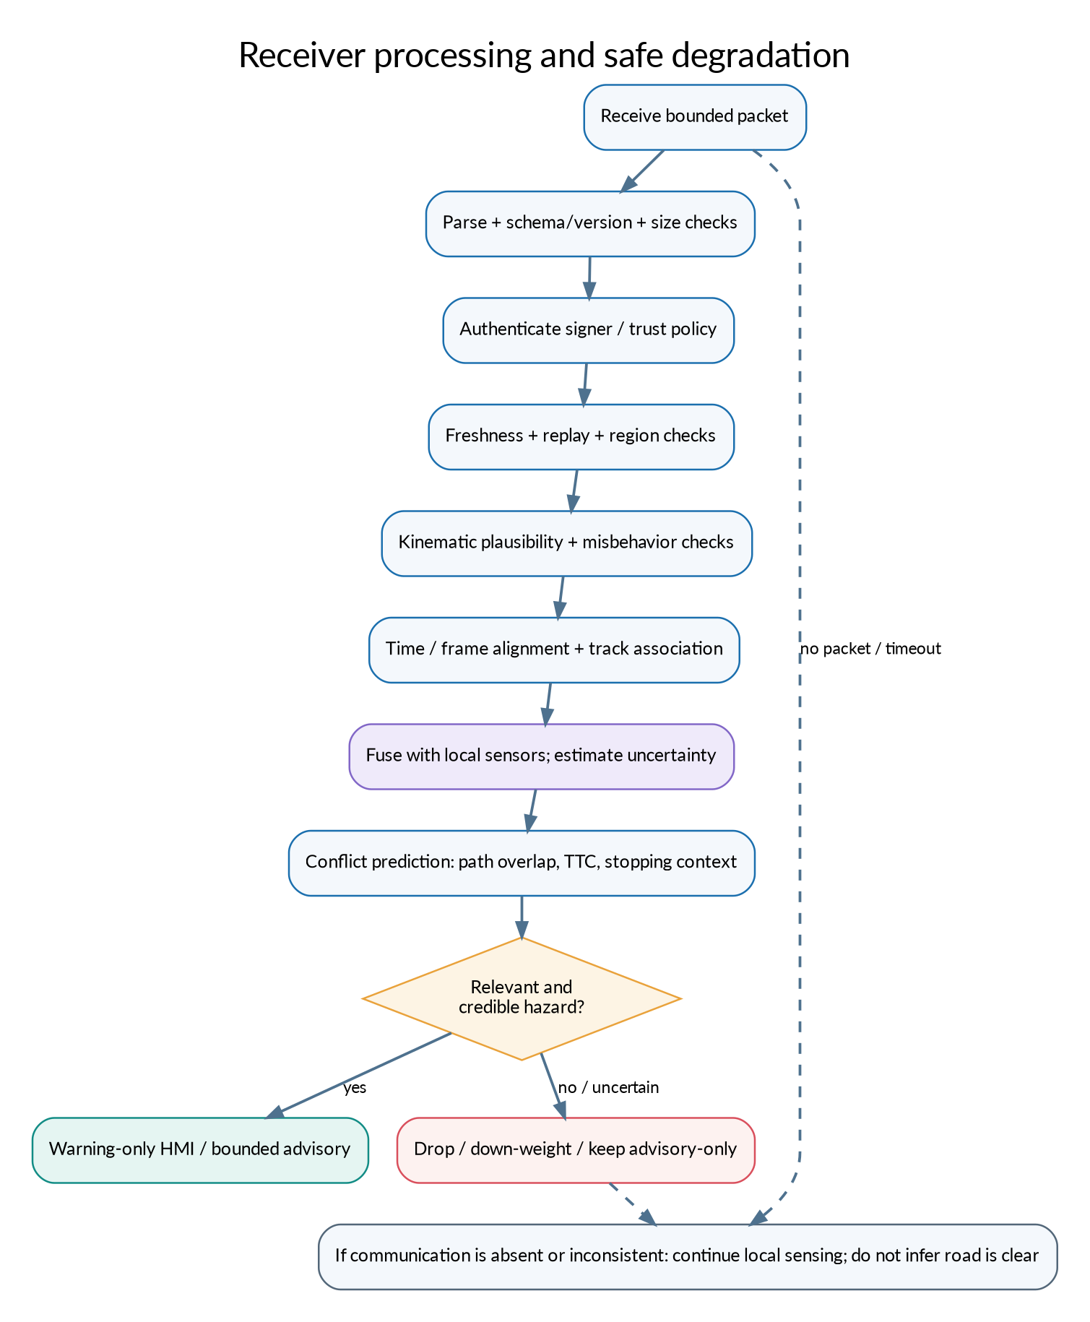
Figure 2. Receiver validation path and fallback behaviour.
1. Bound work before deep parsing: enforce packet size, field count, resource limits, and schema version.
2. Authenticate, enforce trust policy, check freshness and replay, then verify physical plausibility and consistency with previous sender reports.
3. Transform data into a common coordinate/time model; maintain object/event lifetimes and avoid duplicate tracks.
4. Fuse remote evidence with onboard tracks, explicitly propagating age and uncertainty. Evaluate conflict relevance rather than merely drawing every reported object.
5. Choose a bounded output. Uncertain or conflicting evidence should be down-weighted or presented as advisory. Communication silence must never be interpreted as an empty road.

2.3 Logical software modules
Module | Responsibility | Suggested boundary
signal_adapter | Maps approved simulated/vehicle signals into canonical state fields | No access to actuator commands; input validation at boundary.
message_builder | Creates periodic state or event messages from canonical state | Profile-specific strategy; rate control should be configurable.
security_adapter | Signing/verification provider and trust-policy integration | Interface hides certificate/HSM details from application logic.
transport_adapter | Send/receive API for simulator, socket, or selected radio | Must surface timestamps, loss, and delivery metadata where available.
message_validator | Syntax, schema, security, freshness, region, replay, plausibility checks | Fail closed for malformed/security failures; retain reasons in privacy-safe logs.
track_manager | Object association, duplicate suppression, expiry, coordinate transforms | Maintain source, age, confidence, and track history.
risk_engine | Conflict prediction and response-relevance estimation | Independent, deterministic baseline before ML/LLM augmentation.
policy_and_hmi | Alert levels, hysteresis, escalation/de-escalation, suppression | Human-factors evaluation; do not overwhelm users.
evaluation_harness | Scenario definitions, fault injection, metrics, result capture | Version data/config/seed and generate reproducible reports.

3. Component-by-component design and images
Each component below has its own illustration and implementation notes. The images are conceptual block illustrations; they are not vendor schematics, connector pinouts, or proof that the hardware has been selected.

3.1. Vehicle sensors and motion state
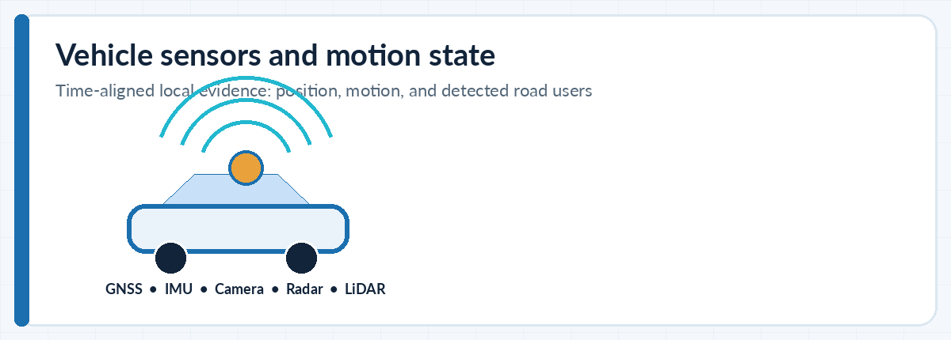
Figure 3.1. Component illustration: Vehicle sensors and motion state.
Purpose. Provide self-state and local road-user detections. Candidate inputs include GNSS/NavIC, IMU, wheel speed, steering/brake state, camera, radar, and lidar, depending on the test platform.
Key interfaces. A canonical state object should include source time, reference frame, position, velocity, heading, acceleration/yaw as supported, quality flags, and uncertainty. Object detections should preserve sensor/source provenance.
Failure / abuse cases. Do not fuse unsynchronized measurements as if simultaneous. Track missing sensors, degraded GNSS, multipath, obstruction, and sensor disagreement.
Verification ideas. Inject delayed and dropped measurements; test coordinate conversion, timestamp ordering, localization drift, and sensor disagreement.

3.2. Vehicle network and gateway
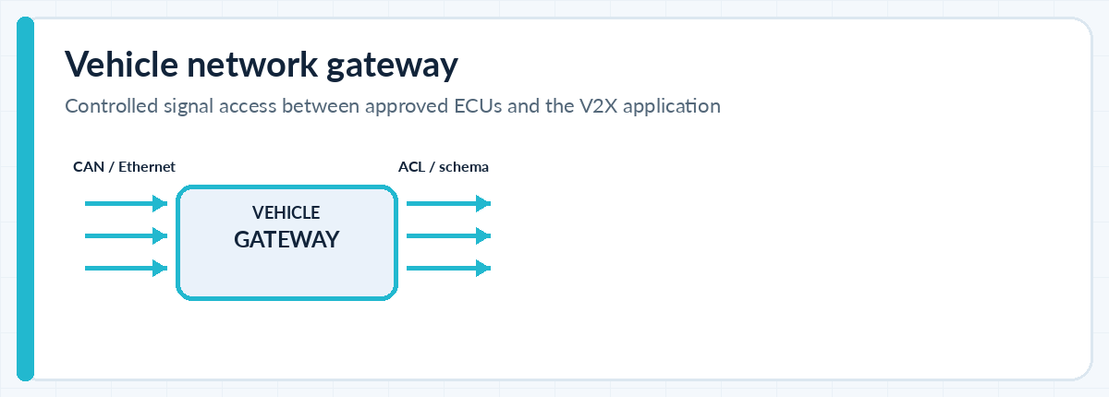
Figure 3.2. Component illustration: Vehicle network and gateway.
Purpose. Provide controlled access to permitted vehicle signals and keep application data separated from safety-critical buses.
Key interfaces. Define allowlisted signals, access-control policy, message rates, types/ranges, and explicit versioned API schemas. Simulated interfaces should mirror this boundary before hardware.
Failure / abuse cases. Malformed inputs, bus flooding, stale signals, unexpected IDs, and attempts to pass untrusted V2X content into a control bus.
Verification ideas. Unit-test allowlists and boundary validation; test fuzzed values, rate limits, rejected signal IDs, and loss of gateway connection.

3.3. V2X on-board unit (OBU)
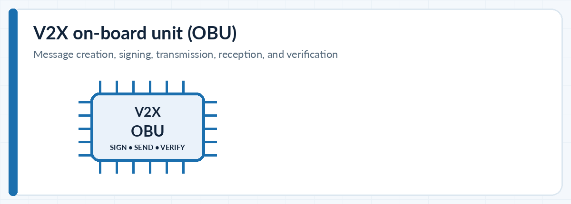
Figure 3.3. Component illustration: V2X on-board unit (OBU).
Purpose. Host the V2X service and connect message generation/verification to the local radio profile.
Key interfaces. Use adapters for message codec, security services, and radio transport so a simulation transport can be swapped for a real OBU only after profile/conformance work.
Failure / abuse cases. CPU overload, malformed payloads, security-provider failure, message queue backlog, and incompatible versions.
Verification ideas. Measure processing latency and queue growth; fuzz parsers; test version mismatch and controlled shutdown/recovery.

3.4. Radio and antenna system
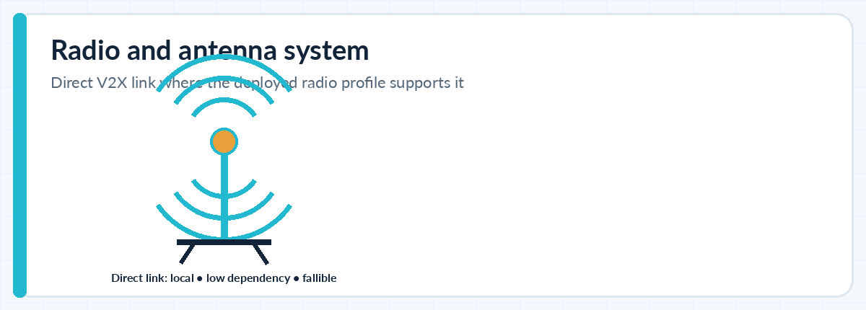
Figure 3.4. Component illustration: Radio and antenna system.
Purpose. Provide local transport for the configured V2X application. The chosen deployment may use a direct sidelink profile, cellular network path, or infrastructure-assisted path; these are not interchangeable.
Key interfaces. Freeze jurisdiction, spectrum/radio profile, channel/access policy, antenna placement, radio interface, message-priority/rate-control settings, and conformance tests before claiming interoperability.
Failure / abuse cases. Packet loss, shadowing by trucks/buildings, interference, congestion, antenna impairment, and mixed fleets without V2X.
Verification ideas. Begin with simulated delay/loss; later use channel/radio tests and controlled closed-course measurement. Report delivery and age distributions, not a single average.

3.5. GNSS and time source
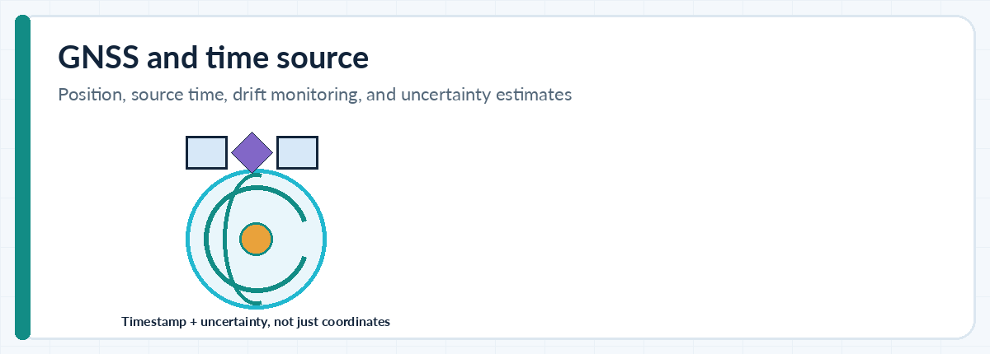
Figure 3.5. Component illustration: GNSS and time source.
Purpose. Supply position and source-time context to associate reports with local tracks and evaluate their age.
Key interfaces. Represent time quality and position uncertainty explicitly. Define clock-offset limits for experiments and a plan for monotonic local timers vs source/reference timestamps.
Failure / abuse cases. Multipath, spoofing/jamming, tunnel outage, stale fixes, clock jumps, and mismatched coordinate datums.
Verification ideas. Inject position bias, clock offset/drift, and GNSS outage; evaluate how quickly the system marks data uncertain and safely down-weights it.

3.6. Secure element / HSM
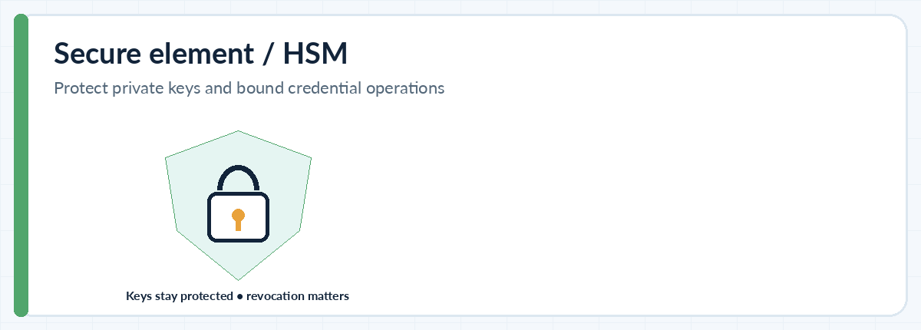
Figure 3.6. Component illustration: Secure element / HSM.
Purpose. Protect private keys and perform security operations within the chosen certificate and signing profile.
Key interfaces. Use an abstraction for key operations; specify provisioning, secure storage, certificate rotation where applicable, trust anchors, revocation, recovery, and decommissioning.
Failure / abuse cases. Stolen/expired/revoked credentials, key misuse, invalid chains, verifier overload, and unavailable trust material.
Verification ideas. Test invalid signatures, revoked/unknown credential, expired certificates, policy change, and offline behaviour using test credentials. Do not use production secrets.

3.7. V2X services and local dynamic map
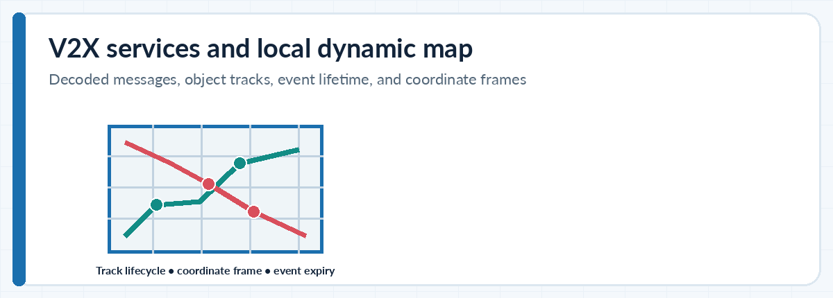
Figure 3.7. Component illustration: V2X services and local dynamic map.
Purpose. Decode messages and maintain nearby-object/event tracks with lifetimes.
Key interfaces. Define coordinate systems and transforms, duplicate identity handling, track confidence, maximum event lifetime, update/cancel semantics, region relevance, and provenance. Keep separate the reported object and the locally inferred fused object.
Failure / abuse cases. Stale tracks, duplicate vehicles, out-of-order updates, clock jumps, object ID reuse, and map/frame mismatch.
Verification ideas. Test ordering permutations, delayed cancellation, track expiry, duplicate suppression, and known coordinate-transform fixtures.

3.8. Message validation and misbehavior checks
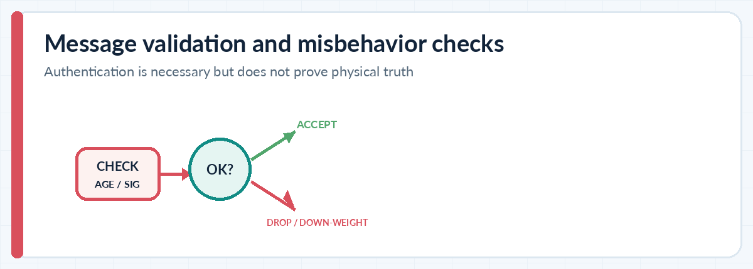
Figure 3.8. Component illustration: Message validation and misbehavior checks.
Purpose. Reduce malformed, replayed, physically implausible, or misleading reports before they influence a hazard decision.
Key interfaces. Separate protocol authentication from behavioural trust. Use layered checks: syntax, signer policy, age, replay cache, region/direction relevance, kinematics, consistency across time, and cross-sensor corroboration.
Failure / abuse cases. Validly signed but false position; abrupt impossible acceleration; identity changes; sybil-style reports; coordinated false events.
Verification ideas. Create attack/fault scenarios and report true-positive and false-positive rates; test benign outliers separately from adversarial reports.

3.9. Risk assessment and sensor fusion
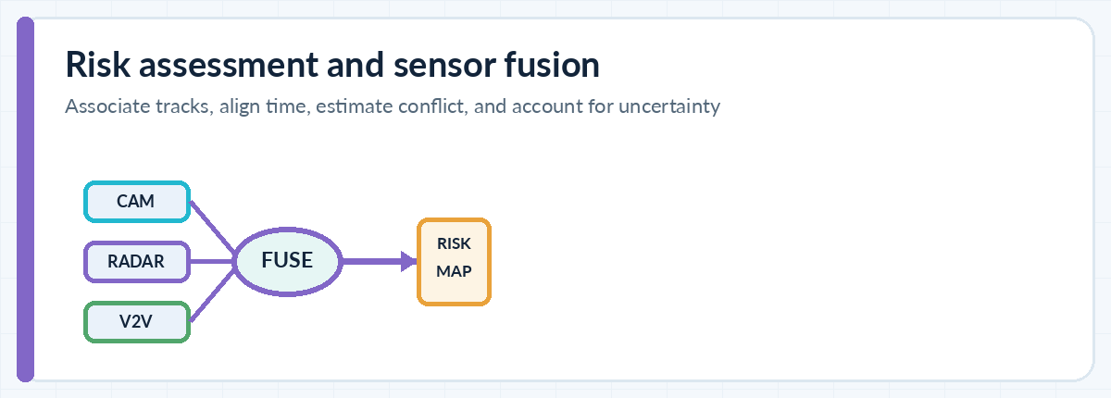
Figure 3.9. Component illustration: Risk assessment and sensor fusion.
Purpose. Combine local detections and accepted V2V evidence, estimate path conflicts, and provide a risk score with provenance.
Key interfaces. Start with a deterministic baseline and time-alignment rules. Estimate relative motion, path overlap, TTC/stopping context, and uncertainty. Calibrate per scenario; do not hard-code universal action thresholds.
Failure / abuse cases. Incorrect track association, uncertain lane geometry, sensor disagreement, stale object report, and confident but biased localization.
Verification ideas. Compare local-only vs V2V-assisted performance; measure TTC error, track errors, missed hazards, and false warnings under controlled communication faults.

3.10. Human-machine interface (HMI)
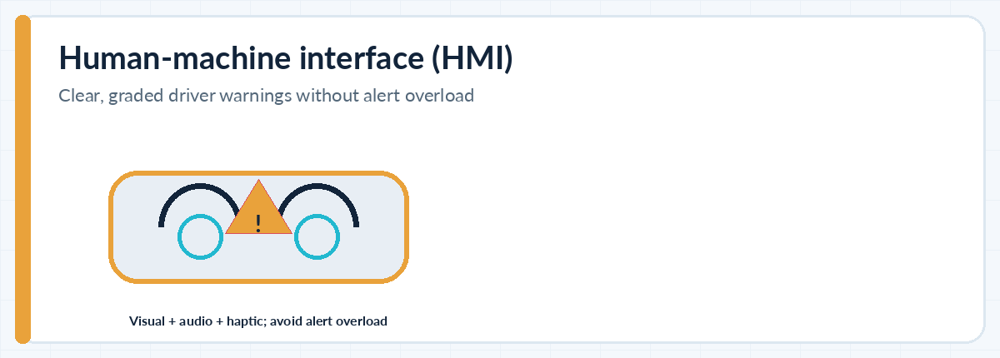
Figure 3.10. Component illustration: Human-machine interface (HMI).
Purpose. Present a clear driver alert when the evidence is relevant and credible.
Key interfaces. Define alert levels, visual/audio/haptic patterns where available, repetition suppression, cancellation/de-escalation, accessibility, and a logging scheme that minimizes sensitive data.
Failure / abuse cases. Alarm fatigue, ambiguous language, late warnings, warning flicker, and drivers over-trusting a warning.
Verification ideas. Conduct simulator-based human-factors review; measure comprehension, reaction time, false alarm burden, and correct alert cancellation.

3.11. ADAS/autonomy interface and safety controller
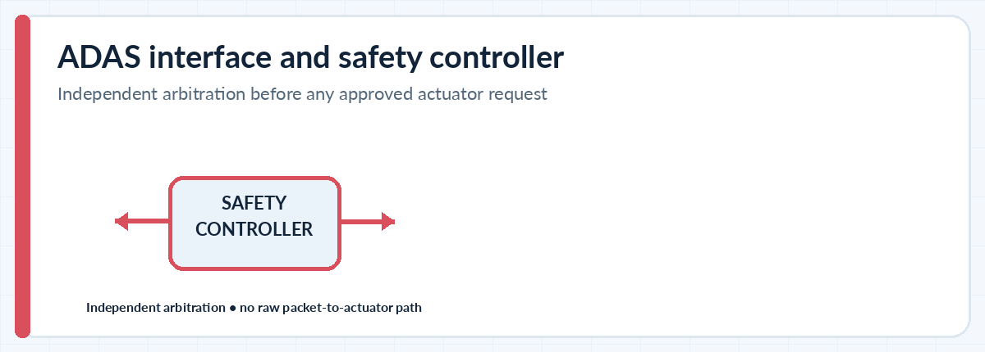
Figure 3.11. Component illustration: ADAS/autonomy interface and safety controller.
Purpose. Provide a future, tightly bounded advisory interface to an independently validated controller. Initial prototype should not actuate brakes or steering.
Key interfaces. Keep V2X reception outside direct actuator authority. A safety controller must independently arbitrate requests against local sensors, operating limits, diagnostics, driver state, and its own safety case.
Failure / abuse cases. Raw packet-to-actuator coupling, conflicting control demands, ECU compromise, unavailable local sensing, and operation outside the designed domain.
Verification ideas. For prototype, test only simulated policy/advisory outputs. Hardware actuation requires formal hazard analysis, independent review, and controlled vehicle-level validation.

3.12. Optional roadside unit (RSU)
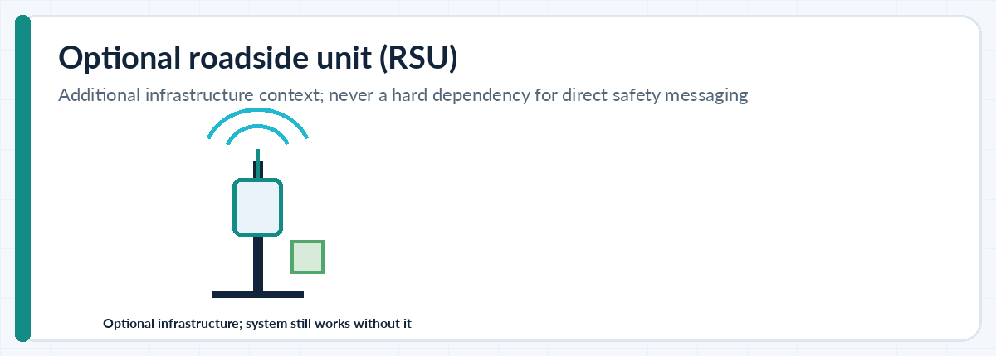
Figure 3.12. Component illustration: Optional roadside unit (RSU).
Purpose. Add infrastructure-derived context, such as signal phase, road works, or a locally detected hazard.
Key interfaces. Treat RSU input as an optional source with its own identity, time, area of validity, service/profile version, and confidence. Core V2V operation must remain useful when RSUs are absent.
Failure / abuse cases. Incorrect signal phase, stale work-zone report, lost RSU, compromised infrastructure, or incorrect geospatial coverage.
Verification ideas. Run the same freshness, signer, plausibility, and loss tests as vehicle-originated information; confirm no dependency on continuous RSU availability.

3.13. Backend trust and operations
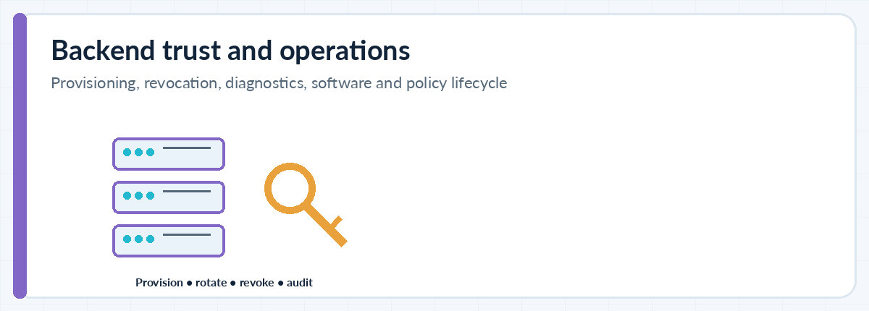
Figure 3.13. Component illustration: Backend trust and operations.
Purpose. Support credential provisioning/revocation distribution, software/configuration distribution, diagnostics, and fleet operations.
Key interfaces. Keep services off the immediate hazard-decision path. Design secure updates, rollback, access control, audit events, incident response, key rotation, and data retention before field trials.
Failure / abuse cases. Backend outage, bad configuration rollout, compromised signing process, excessive retention of movement traces, and stale revocation state.
Verification ideas. Demonstrate local operation during network loss; test update rollback, role/access restrictions, audit trail and retention deletion.

3.14. Message profile and data contract
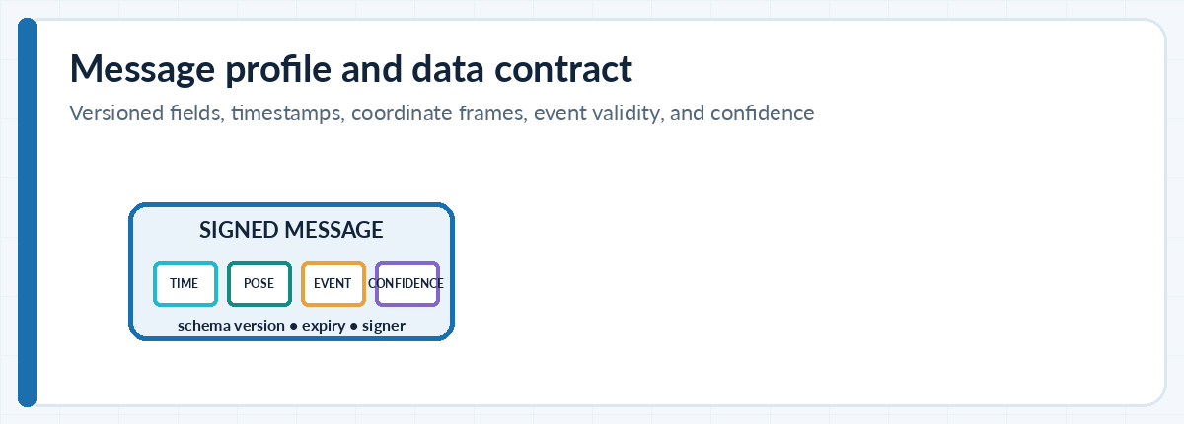
Figure 3.14. Component illustration: Message profile and data contract.
Purpose. Define the meaning and lifecycle of every field crossing module boundaries.
Key interfaces. Maintain a canonical internal schema that maps to the exact selected standard only at adapter boundaries. Version schemas; specify units, coordinate frame/datum, source and receive timestamps, uncertainty, event validity, and optional/mandatory fields.
Failure / abuse cases. Mixing ETSI CAM/DENM/CPM with SAE BSM without a justified mapping; unit ambiguity; schema drift; fields silently interpreted differently.
Verification ideas. Add schema conformance tests, round-trip encoding, golden test vectors, unknown-field handling and negative tests. Do not call the simulator JSON format standards-compliant.

3.15. Simulation, testing, and telemetry
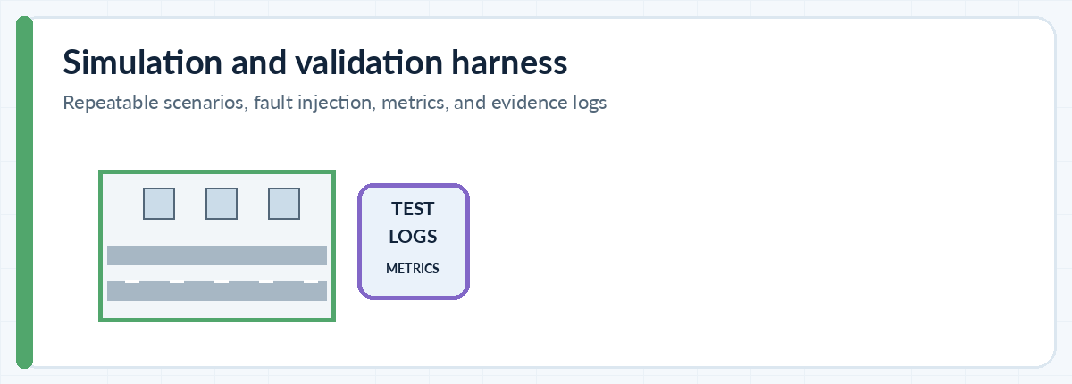
Figure 3.15. Component illustration: Simulation, testing, and telemetry.
Purpose. Make scenarios repeatable and quantify system behaviour under normal and degraded conditions.
Key interfaces. Version each scenario, software commit, config, random seed, dataset split, data preprocessing step, and metric script. Separate simulation claims from real-world validation.
Failure / abuse cases. Unreproducible results, benchmark leakage, unrealistically clean communication, hidden simulator assumptions, and metrics averaged over away dangerous edge cases.
Verification ideas. Run fault-injection sweeps, save per-run artifacts, report tail percentiles and confidence intervals, and keep a separate real-world validation plan.

3.16. Optional cooperative AI / LLM research layer
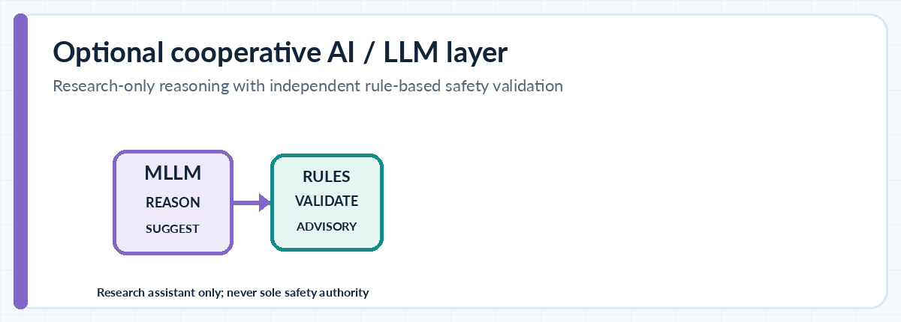
Figure 3.16. Component illustration: Optional cooperative AI / LLM research layer.
Purpose. Explore scene-level reasoning, object grounding, natural-language QA, or candidate trajectory generation using cooperative perception features.
Key interfaces. Treat this as a non-authoritative research worker. Inputs should be provenance-tagged; outputs should be structured, bounded, confidence-aware, and checked by a deterministic geometry/rules layer. Log prompt/model/data versions.
Failure / abuse cases. Hallucinated objects, invalid lane trajectories, prompt/data injection, delayed response, distribution shift, and uncalibrated confidence.
Verification ideas. Evaluate offline against fixed datasets; track grounding errors and unsafe candidate outputs. Inject latency and outages; verify deterministic fallback and prohibit direct actuator commands.

3.17. Development and operations lifecycle
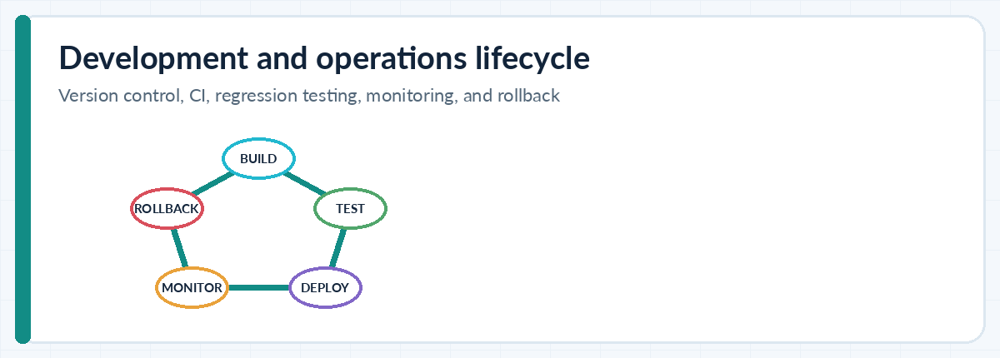
Figure 3.17. Component illustration: Development and operations lifecycle.
Purpose. Keep changes traceable and repeatable from experiment to demo.
Key interfaces. Use version control, code review, automated unit/regression tests, dependency pinning, containerized run environments where practical, signed artifacts for later deployment, and rollback.
Failure / abuse cases. Unreviewed message schema changes, vulnerable dependencies, leaked keys, irreproducible model weights, and test bypasses.
Verification ideas. CI should run parser/security/risk-engine tests, lint/schema checks, scenario smoke tests, dependency scanning, and package provenance checks.

4. Message profiles, data contracts, and state lifecycle

4.1 Do not mix message families without an explicit mapping
Family / role | Typical content | Use in this project | Implementation caution
Periodic awareness (e.g., ETSI CAM or market-specific BSM) | Time, position, speed, heading, acceleration/yaw as supported, vehicle context | Maintain nearby participant state | Message names, security envelopes, encodings, and field semantics differ across profiles.
Event notification (e.g., ETSI DENM or market equivalent) | Event type/location, detection/reference time, validity, affected direction/area, update/cancel | Hard braking / road hazard / emergency context when supported | Must expire; updates and cancellation must be idempotent and ordered safely.
Collective perception (e.g., ETSI CPM or equivalent) | Detected objects, perception regions/capabilities, object descriptors | Share non-line-of-sight observations | Bandwidth, object age, frame alignment, duplicate detections, and source confidence are key.
Intent / manoeuvre (if profile supports it) | Proposed path or manoeuvre context | Research-only planning context | An intention is not a guarantee that another vehicle will execute it.

Standards profile gate
Freeze the target market/jurisdiction, radio profile, message types, security envelope, certificate/trust model, update cadence, resource limits, and conformance test suite before describing the implementation as interoperable or standards-compliant. The source guide correctly warns against assuming a universal 10 Hz rate or a universal sub-100 ms guarantee.

4.2 Proposed canonical internal record
The following is a proposed application-level model for the simulator and fusion pipeline. It is not a replacement for the selected standard’s on-wire message definition.
Field group | Required semantics | Why it matters
Schema / profile | schema_version, source_profile, message_family, source_id/pseudonym | Prevents silent interpretation drift and allows profile adapters.
Time | source_timestamp, receive_timestamp, local_monotonic_receive_time, time_quality | Supports freshness, delay metrics, out-of-order handling, and clock-fault testing.
Geometry | coordinate_reference_system, datum, position, heading, velocity, units | Avoids silently mixing coordinates, degrees/radians, km/h/m/s, or frames.
Uncertainty / quality | position_uncertainty, velocity_uncertainty, confidence or quality flags, provenance | Allows uncertain/stale remote evidence to be down-weighted rather than treated as truth.
Event lifecycle | event_id, event_type, detection_time, valid_until, affected_area/direction, status/update/cancel | Prevents stale hazards and supports cancellation / idempotence.
Security state | signer reference, verification outcome, trust-policy version, revocation status/cache age | Separates signed credential validation from behavioural plausibility.
Diagnostics | validation_reason, drop/down-weight reason, processing timestamps | Supports debugging and transparent evaluation; avoid unnecessary personal data.

4.3 Lifecycle rules to implement early
- Define how a receiver handles duplicate, delayed, reordered, replayed, malformed, unknown-version, or expired messages.
- Use a bounded replay cache and duplicate-suppression policy; state how cache expiry interacts with pseudonym or identifier changes.
- Define track/event deletion and cancellation semantics. Expiration must be enforced even if no explicit cancellation arrives.
- Define coordinate transforms and a test fixture with known points, units, and sign conventions.
- Define resource limits: maximum payload/field sizes, queue depth, processing budget, rate control, and overload behaviour.
- Define time-offset and uncertainty handling. A valid timestamp does not necessarily imply an accurate clock.

5. Missing requirements and engineering gaps
These are the material areas that are either not yet specified by the supplied guide or need a concrete project decision before implementation. They should be logged as requirements or decision records rather than left as implicit assumptions.
Gap / missing decision | Why it matters | Recommended artifact / owner action | Priority
Deployment jurisdiction and radio/profile selection | Determines allowed spectrum, radios, message semantics, certification/conformance, and trust scheme. | Decision record: target market, radio path, standards profile/version, required lab testing. | P0
System requirements and operating domain | Without explicit use cases, speeds, scenarios, road types, and exclusions, metrics are not interpretable. | Requirement IDs, operational design domain (ODD), assumptions, exclusions, traceability matrix. | P0
Hazard analysis and safety concept | Warning-only vs intervention have materially different safety requirements. | Initial HARA/FMEA/STPA-style analysis, safe states, action boundaries, fallback rules. | P0
Threat model / trust policy | Signature validation does not detect all plausible but false reports. | Threat model, attack tree, misbehavior taxonomy, trust/revocation policy, test credentials. | P0
Canonical schema and time/coordinate model | Silent units/frame mismatches can invalidate collision prediction. | Versioned data contract, time model, frame conversion docs, golden test vectors. | P0
Radio communication model and congestion | Idealized communication hides packet loss, queueing, shadowing, and dense traffic effects. | Model parameters and evidence source; delay/loss/burst/congestion test matrix. | P0
Data quality and benchmark protocol | Data splits, preprocessing, ground truth, and simulator bias affect conclusions. | Dataset card, train/val/test separation, metrics definitions, reproducible config/seed. | P1
Interoperability and conformance testing | A local demo may not be decodable by another compliant implementation. | Codec tests, message profile mapping, conformance test plan, interoperability test plan. | P1
Privacy and retention | Vehicle trajectories and identifiers can expose movements and personal patterns. | Data minimization, pseudonym strategy per profile, retention/deletion policy, access log. | P1
Human factors and HMI evidence | An alert can be correct but too late, confusing, or over-frequent. | Alert taxonomy, suppression/hysteresis rules, simulator study, human factors review. | P1
Observability, telemetry, and incident analysis | Without structured logs, failures cannot be attributed to communications, localization, fusion, or policy. | Per-run event log, correlation IDs, diagnostic taxonomy, privacy-safe retention. | P1
Field-testing / hardware-in-loop gate | Simulation alone cannot establish radio performance or road safety. | Staged HIL and closed-course plan, hardware calibration and independent safety review. | P2
AI/LLM scope and fallback | LLM outputs can be delayed, unsupported, or unsafe, even when fluent. | Research-only interface, structured output, validation policy, latency/outage fallback. | P2

5.1 Requirements traceability template
Req ID | Requirement statement | Verification method | Evidence / status
SYS-001 | Receiver rejects malformed or oversized messages before expensive processing. | Unit + fuzz test | Test ID / build hash / pass-fail
SEC-001 | A message with an invalid signature or disallowed trust state cannot contribute to a safety warning. | Security negative test | Test credential + validation log
TIME-001 | Expired event state is removed or down-weighted according to explicit lifecycle policy. | Deterministic time simulation | Event timeline + output trace
FUS-001 | Receiver retains provenance and uncertainty when fusing remote reports with local tracks. | Unit + scenario test | Track output + uncertainty trace
SAFE-001 | Loss of V2V input does not suppress normal local perception or infer road clearance. | Fault injection | Local-only comparison results
HMI-001 | Warning policy suppresses repeated alerts according to configured escalation/de-escalation rules. | Scenario + usability test | Event log + user-study record

6. Future research topics and publication plan
The most defensible research contribution will be a clearly stated question, controlled baseline, ablation study, and failure analysis—not simply adding an LLM to a V2V diagram. Prioritize reproducibility, uncertainty, and robustness before more complex reasoning models.

6.1 Recommended research portfolio

R1 — Loss-aware asynchronous cooperative perception
Research question. How should remote object evidence be weighted when its age, packet loss, localization error, and source uncertainty change over time?
Hypothesis to test. A confidence-and-age-aware fusion strategy improves cooperative detection/tracking over late-fusion and local-only baselines under burst loss and timing offsets.
Method and data. OPV2V + V2V4Real; controlled simulated delay/loss/noise; compare local-only, late fusion, chosen baseline.
Metrics. 3D detection AP, tracking metrics, association error, warning lead time, bandwidth, degradation curve.
Priority. High

R2 — Misbehavior detection beyond signatures
Research question. Can temporal/physical consistency and cross-vehicle corroboration detect signed-but-false reports without rejecting many benign outliers?
Hypothesis to test. A layered detector reduces attack success compared with kinematic thresholds alone at an acceptable false-positive cost.
Method and data. Inject position jumps, impossible acceleration, replay, colluding reports, benign GNSS outliers into simulator; use a 2025 survey as context [R8].
Metrics. Detection precision/recall, time-to-detect, false positives per scenario, compute overhead.
Priority. High

R3 — Bandwidth-adaptive message/feature sharing
Research question. Can a sender select object reports/features based on predicted utility, uncertainty, and channel load while preserving hazard detection?
Hypothesis to test. Utility-aware prioritization lowers bandwidth while preserving detection/warning performance under congestion.
Method and data. Compare fixed-rate/all-object sharing, relevance thresholds, and adaptive policies.
Metrics. Bytes/s, packet delivery, AP/track metrics, tail warning delay, fairness across agents.
Priority. High

R4 — Safe integration of multimodal LLM / Graph-of-Thoughts
Research question. Can a cooperative reasoning layer improve grounding or explain why a hazard is relevant without becoming an unsafe authority?
Hypothesis to test. Structured model outputs plus a deterministic validator reduce ungrounded/unsafe recommendations compared with raw model output.
Method and data. Use V2V-LLM/V2V-GoT code/data offline; fixed prompts/models; latency/outage and opposite-lane trajectory tests. [R6, R7]
Metrics. Grounding accuracy, unsafe candidate rate, rule-validation rejection rate, latency, fallback correctness.
Priority. High, but bounded

R5 — Sim-to-real transfer for mixed Indian traffic
Research question. How do perception and communication methods generalize to two-wheelers, three-wheelers, dense intersections, occlusion, and varied road markings?
Hypothesis to test. A targeted domain adaptation and scenario augmentation set improves performance on held-out local scenes without hiding failure rates.
Method and data. Begin with public data; create a carefully consented, privacy-reviewed local dataset only if feasible; separate train/test locations and dates.
Metrics. Per-class AP/recall, occlusion performance, calibration, domain gap and subgroup results.
Priority. Medium-high

R6 — Privacy-preserving cooperative perception
Research question. Can collaborative features/representations reduce identity or trajectory leakage while maintaining useful hazard context?
Hypothesis to test. Feature minimization or privacy-preserving aggregation reduces linkage risk with a measurable task-performance trade-off.
Method and data. Threat-modelled synthetic traces; compare raw trajectories, object lists, compressed features, and candidate privacy methods.
Metrics. Task utility, re-identification/linkability risk, bytes, compute, latency.
Priority. Medium

R7 — Robust time and localization uncertainty
Research question. How should a receiver make conflict predictions when clocks drift and positions have biased uncertainty, not merely Gaussian noise?
Hypothesis to test. Explicit uncertainty propagation is more calibrated and less brittle than point-estimate fusion.
Method and data. Sweep source-time offset, drift, GNSS bias, multipath-like jumps and vehicle speed; compare point-estimate vs uncertainty-aware model.
Metrics. TTC error, calibration, false/missed warnings, confidence coverage.
Priority. High

R8 — Explainable, auditable safety warnings
Research question. Can each warning include a compact evidence trace that a tester can use to attribute the alert to sender report, local track, age, and conflict estimate?
Hypothesis to test. Evidence-trace generation improves error triage and does not materially increase latency.
Method and data. Attach provenance and rule identifiers to each alert; evaluate in scripted fault cases.
Metrics. Attribution accuracy, debugging time, warning latency, log volume and data minimization.
Priority. Medium

R9 — Edge/cloud partitioning under connectivity loss
Research question. Which perception/reasoning tasks can move to edge/cloud without putting safety output on a fragile network dependency?
Hypothesis to test. Only non-time-critical analysis should be offloaded; local warning quality remains stable during cloud outage.
Method and data. Compare local-only, edge-assisted, cloud-assisted non-authoritative reasoning with injected disconnects.
Metrics. Outage fallback, latency tails, bandwidth, compute, local-vs-assisted results.
Priority. Medium

R10 — Vulnerable road-user and fairness evaluation
Research question. Does cooperative perception help or harm motorcycles, cyclists, pedestrians, and vehicles with different sensor/connection capabilities?
Hypothesis to test. Stratified evaluation reveals whether aggregate metrics hide reduced benefit for vulnerable road users or non-connected participants.
Method and data. Stratify simulator and public-data evaluation by object class, range, occlusion, and equipped/un-equipped status.
Metrics. Per-class recall, false alerts, lead time, uncertainty and performance disparity.
Priority. Medium-high

6.2 Strongest initial paper direction
Proposed research title
Uncertainty-Aware and Misbehavior-Resilient Cooperative Perception Under Asynchronous V2V Communication
Why this is a good first study: it sits directly on the system’s core risk—remote information can be helpful but late, noisy, or false. It permits clear baselines, controlled communication fault injection, measurable trade-offs, and an explicit safe-fallback story. It can produce useful findings without claiming autonomous vehicle safety or requiring an immediate real-radio deployment.
Study element | Recommended choice
Problem statement | Remote object/event reports become less reliable as their age, localization error, and communication interruption increase; some reports may be deliberately or accidentally false.
Baselines | Local sensing only; naive late fusion; freshness-only filter; plausibility-only filter; proposed joint age/uncertainty/misbehavior-aware method.
Ablations | Remove time weighting, uncertainty, cross-sensor corroboration, replay handling, and loss-awareness one at a time.
Stress matrix | Delay, burst loss, position bias, clock offset, object density, occlusion, sender report contradictions, and mixed connected/non-connected traffic.
Evidence | Reproducible configs, fixed test splits, code commit, metrics script, per-scenario results, confidence intervals, qualitative failure cases.
Claim boundary | Improvement in the evaluated tasks/scenarios only; no claim that this certifies a vehicle or guarantees collision avoidance.

7. Implementation roadmap and repository structure
Figure 3. Proposed 16-week build sequence. Extend the schedule if data/hardware/conformance work is required.
Phase / weeks | Tasks | Deliverable / exit gate
0. Scope and safety boundary (W1–2) | Freeze two or three use cases; define ODD, assumptions, standards/profile decision record, threat model, requirements, metrics, and warning-only boundary. | Approved project brief, requirements traceability, hazard/threat register. No actuator integration.
1. Scenario and communication baseline (W3–4) | Create timestamped multi-vehicle trajectories; simulator transport; parameterized delay, packet loss, burst loss, clock error, position error; deterministic playback. | Repeatable baseline demo; per-run config/seed logs; local-only comparison.
2. Message and event lifecycle (W5–6) | Canonical schema; profile adapter; periodic state and event notification; expiry/cancel; coordinate transforms; tests for malformed and unknown-version messages. | Versioned schema, codec tests/golden vectors, lifecycle tests; simulator format explicitly labeled non-standard.
3. Receiver validation (W7–8) | Bounded parsing; security adapter with test credentials; freshness/replay; plausibility; region checks; duplicate suppression; misbehavior reason codes. | Pass/fail unit and fuzz suite; negative tests for invalid, stale, replayed, or impossible reports.
4. Risk engine and HMI (W9–10) | Track association; local-vs-remote fusion baseline; conflict relevance; TTC / stopping context; configurable warning policy; HMI simulation. | Warning-only end-to-end scenario with false-warning and missed-warning metrics.
5. Cooperative perception experiment (W11–12) | Run one or more public benchmarks; align metrics/splits; compare local-only and fusion baselines; record bandwidth and asynchronous-performance curve. | Reproducible table/plots; code version and environment; no test-data leakage.
6. Robustness and security (W13–14) | Inject burst loss, time skew, localization errors, signed-but-false reports, dense traffic, and outages; conduct ablations and statistical comparison. | Robustness report, error taxonomy, tail metrics, fail-safe evidence.
7. Consolidation and research output (W15–16) | Re-run key experiments from clean environment; improve diagrams/readme; document limitations; prepare demo and manuscript outline. | Reproducible repository tag, demo video, system guide, draft paper and limitations statement.

7.1 Recommended software stack
Layer | Pragmatic starting option | Notes
Scenario/traffic simulation | SUMO for traffic flow + CARLA where 3D perception/occlusion matters | Avoid adopting both before the minimum demo works; choose based on the first research question.
Network simulation | A packet-impairment layer in the first prototype; then OMNeT++/Veins or ns-3 if detailed radio/network behaviour is a research variable | Do not equate a simple delay/loss simulator with PC5/NR sidelink conformance.
App and evaluation logic | Python for rapid experiment orchestration; typed dataclasses/Pydantic-style validation or equivalent | Keep interface contracts and time/coordinate models explicit.
Middleware (optional) | ROS 2 if integration with robot/vehicle-style components or replay topics is useful | Not mandatory for the initial message simulator.
Dataset research | OPV2V for simulation and V2V4Real for real-world cooperative perception; add others only with a clear question | Check licences, release files, label semantics and preprocessing before benchmark claims.
Model research (optional) | Use V2V-LLM/V2V-GoT implementations only after a non-LLM baseline exists | Compute/dataset costs may be large; do not make the whole project depend on a model endpoint.
Experiment operations | Git, pinned environment, CLI configs, deterministic seeds, test reports, artifact manifest | Every chart should map to a commit, config, data split, and metric definition.

7.2 Suggested repository layout
v2v-cooperative-safety/
README.md
docs/
system_architecture.md
requirements_traceability.csv
threat_model.md
decisions/
safety_boundary.md
config/
scenarios/
communication_profiles/
risk_policy/
schemas/
canonical_message.schema.json
profile_mappings/
src/
signal_adapter/
message_builder/
security_adapter/
transport_adapter/
validator/
track_manager/
fusion/
risk_engine/
hmi/
evaluation/
tests/
unit/
fuzz/
scenarios/
regression/
datasets/README.md
experiments/
configs/
runs/
notebooks/
artifacts/
metrics/
plots/
reports/
scripts/
run_scenario.py
sweep_faults.py
summarize_metrics.py

7.3 First demonstrable milestone
Minimal end-to-end demo
Two simulated vehicles; a timestamped hard-braking event; direct local message transport; configurable delay/loss; message expiry and replay rejection; receiver compares the event with its own state; warning-only HMI; local-only fallback; and a report showing warning lead time, false alerts, missed alerts, message age, and the effect of injected faults.

7.4 Reuse the existing HTML concept demos
The supplied guide lists three explanatory pages under the repository V2V folder. Run a local server from the repository root; do not open the HTML file directly if it relies on relative assets.
python -m http.server 8000
Page | Purpose
http://localhost:8000/V2V/blind_crossing.html | Intersection / occlusion warning scenario.
http://localhost:8000/V2V/blind_braking.html | Hard-braking warning scenario.
http://localhost:8000/V2V/signal_path.html | Component-level message journey.

These are concept simulations, not implementations of a V2X radio, PKI, vehicle sensors, or actuation. Some assets load from CDNs, so internet access may be needed to display the full visuals.

8. Verification, validation, and measurable metrics

8.1 Test scenario matrix
Scenario family | Variants to cover | What it probes
Hard braking | Different speeds, gaps, braking severity, road friction assumptions, vehicle class | Event timeliness, risk estimation, warning lead time, false alerts.
Occlusion | Car or motorcycle behind truck/bus; blind intersection; curve; partial sensor view | Incremental value of cooperative evidence and object association.
Message freshness | Fresh, delayed, expired, reordered, duplicate, replayed, cancel-before-update | Track/event lifecycle correctness.
Localization/time | Position bias, clock offset/drift, GNSS dropout, map/frame offset, tunnel/urban-canyon-like outage | Uncertainty propagation, stale report filtering, degraded position operation.
Communication | Independent loss, burst loss, delay spikes, queue overload, radio shadow, dense traffic | Latency tail, packet delivery, queue behaviour, safe fallback.
Security/misbehavior | Invalid signature, revoked/unknown credential, valid-but-false state, impossible acceleration, conflicting peers | False trust, rejection logic, detection time, false-positive burden.
Mixed traffic | Most vehicles not connected; two-wheelers, cyclists, pedestrians, heavy vehicles; different sensing quality | System does not assume all road users send V2X; subgroup performance.
Infrastructure/cloud | RSU absent, stale, conflicting, or untrusted; internet/backend outage | Core local operation and fallback; backend is not in warning loop.
AI/LLM extension | Slow model, timeout, hallucinated object, out-of-lane candidate trajectory, prompt/input injection | Advisory guardrails and deterministic fallback only.

8.2 Metrics to report
Metric | Definition / reporting guidance | Avoid
Message delivery ratio | Received valid messages / eligible transmitted messages, with profile and scenario context. | Reporting only an aggregate average across all load conditions.
Message age and processing latency | Report p50/p95/p99 and max when meaningful; separate source-to-receive and processing time. | Claiming a universal sub-100-ms property without a specified profile/test.
Warning lead time | Time between warning and the defined ground-truth conflict/event point; state the definition. | Using one hand-picked successful example.
False-alert rate | False alerts per scenario, driving hour or distance unit; define labels and exposure. | Comparing rates without the same scenario mix.
Missed-event rate / recall | Relevant ground-truth hazards not warned about, including communication outage cases. | Hiding failures because local sensors eventually detected the event.
TTC / conflict error | Error versus a scenario-defined reference, with calibration and failure distribution. | Treating TTC as ground truth when motion/road geometry assumptions fail.
Detection / tracking quality | AP or precision/recall by class; track association metrics; include occluded and non-connected road users. | Only reporting a pooled number that hides vulnerable-road-user failures.
Resource footprint | Bytes/s, CPU/GPU, memory, queue length, energy if measurable. | Ignoring compute and bandwidth costs of cooperative feature sharing.
Safe degradation | Performance when remote reports are stale, missing, contradictory, or rejected. | Assuming no packet means no hazard.
AI grounding / unsafe outputs | Grounding quality, invalid candidate rate, rejection rate, timeout fallback correctness. | Using fluency or benchmark QA accuracy as a safety metric.

8.3 Experimental grid (researcher-defined, not a standard)
Use a reproducible sweep rather than one nominal run. The following is a starter grid; modify it based on simulator fidelity and the selected deployment profile. These levels are experiment settings, not regulatory requirements or universal radio-performance claims.
Factor | Starter levels | Purpose
One-way simulated delay | 0, 20, 50, 100, 200, 500 ms | Find sensitivity to age and tail delay; later calibrate from measured traces.
Independent packet loss | 0%, 1%, 5%, 10%, 20%, 40% | Characterize graceful degradation.
Burst interruption | 0.1, 0.5, 1, 2, 5 seconds | Test event expiry and recovery after coverage gaps.
Position perturbation | 0, 0.5, 1, 2, 5 m synthetic bias/noise levels | Stress association and risk sensitivity; document distribution.
Clock offset | 0, 10, 50, 100, 250, 500 ms | Test stale/future timestamp handling.
Sender reliability | valid, accidental outlier, replay, malicious false report, conflicting group reports | Separate benign faults and adversarial behaviour.

8.4 Minimum acceptance gates
Gate | Pass condition for the prototype | Evidence
G1 — deterministic core | Known fixture inputs give known parser, expiry, coordinate-transform, and policy outputs. | Unit tests + golden vectors.
G2 — safe rejection | Malformed, invalidly signed, stale, replayed, or out-of-policy messages cannot directly trigger a warning as trusted evidence. | Negative test suite and reason-coded logs.
G3 — fallback | No V2V packets, backend outage, RSU outage, or AI timeout does not disable local sensing or imply a clear road. | Fault-injection traces.
G4 — measurable benefit | On the declared scenario set, report whether V2V changes detection/warning performance and the cost in false alerts/bandwidth. A negative result is valid research. | Paired local-only vs V2V-assisted comparison with confidence intervals.
G5 — reproducibility | A clean environment can rerun key experiments from documented configuration and data split. | Tagged commit, environment manifest, scripts, and results.
G6 — release boundary | Demo/UI claims distinguish simulation, replay, real radio, and any real vehicle test. | README, demo script, and scope statement.

9. Security, privacy, safety, and deployment gates

9.1 Threat and failure taxonomy
Class | Example | Mitigation / test direction
Protocol / parser | Malformed payload, oversized fields, unknown schema version | Bounded parsing, fuzzing, reject reason codes.
Credential / trust | Invalid signature, expired/revoked/unknown credential, trust cache stale | Profile-specific certificate validation, revocation handling, offline mode tests.
Replay / freshness | Old valid message repeated; future timestamp; delay burst | Replay cache, source-age policy, monotonic local receive time, timestamp plausibility.
Physical plausibility | Impossible acceleration, discontinuous position, wrong road direction | Kinematic checks, temporal consistency, local sensor corroboration.
Coordinated misbehavior | Several senders repeat the same false hazard | Cross-source independence analysis; avoid naive majority vote when sources may collude.
Availability | Radio jamming/interference-like loss, congested channel, CPU overload | No-dependency local fallback, rate/resource limits, congestion-aware tests.
Localization/time | Spoofed GNSS, multipath, wrong datum, clock drift | Quality flags, uncertainty, independent time/position sanity checks and degradation.
Privacy | Persistent identity or over-retained movement traces | Use profile-approved privacy identifiers, minimise collection, retention schedule and access control.
Supply-chain/update | Malicious dependency or bad configuration rollout | Pinned dependencies, signed release artifacts where appropriate, staged rollout and rollback.
AI/model | Hallucinated object or unsafe generated path | No authority to actuate; structured outputs, geometry/rule validator, timeout fallback.

9.2 Safety boundary
- Prototype phase: simulation, offline dataset evaluation, and warning-only HMI.
- Next phase: software-in-the-loop and hardware-in-the-loop tests, with radio and security adapters exercised using test credentials.
- Later phase only: closed-course testing under an approved protocol, independent safety/cybersecurity review, and the relevant standards/conformance pathway.
- Any automated braking or steering integration needs a vehicle-specific hazard analysis, validated operating limits, safe-state/fallback design, system-level assurance, and a qualified safety controller. It is not a simple extension of the V2V parser.

9.3 India-specific regulatory decision
The supplied guide mentions AIS-230 but intentionally does not treat it as a settled implementation profile. A project in India should verify the current applicable automotive, telecom/spectrum, data protection, testing, and type-approval requirements with the relevant official bodies and qualified domain experts before radio procurement or road testing. TRAI published a consultation paper on a regulatory framework for V2X communication on 30 April 2026; its consultation page records a closing date of 4 June 2026. A consultation paper is not, by itself, proof that a final framework has been enacted [R4].

9.4 Standards and assurance references to map
Area | Reference in the source / research base | Project action
5G V2X architecture | 3GPP TS 23.287; official catalogue now lists Release 19 versions including 19.1.0 [R2]. | Select the exact release/profile supported by chosen equipment; do not equate specification availability with hardware support.
Awareness / events | ETSI CAM and DENM service specifications [R3]. | Choose a compatible profile and version; implement conformance tests.
Collective perception | ETSI TS 103 324; Release 2 work item was shown by ETSI as a stable draft in March 2026 [R1]. | Track publication/version status before using Release 2 as a normative dependency.
Functional safety / intended functionality | ISO 26262 and ISO 21448 cited in the source guide. | Use as part of a qualified safety process; this document is not a substitute for either standard.
Cybersecurity | UNECE R155 cited in the source guide. | Confirm applicable regulatory scope and current version; build threat analysis and cybersecurity lifecycle.
Conformance testing | ETSI ITS work includes CAM/DENM and GeoNetworking conformance testing materials [R9]. | Build protocol and interoperability tests around exact chosen profile.

10. Current standards and reference reading
The supplied guide remains the source for the system framing and original component list. The following web references were checked to clarify current research pointers and status-sensitive standards context on 11 October 2026. Always confirm the revision applicable to an actual deployment.
[R1] ETSI work item: Collective Perception Service, Release 2 (TS 103 324). Current status page showed stable draft v0.0.24 from 17 March 2026; this is a draft status record, not the final published standard. Open source
[R2] 3GPP TS 23.287: Architecture enhancements for 5G System (5GS) to support V2X services. Official ETSI work programme catalogue lists Release 19 version 19.1.0 as published. Open source
[R3] ETSI CAM and DENM base specifications referenced by the source guide. Open source
[R4] TRAI, Consultation Paper on the Regulatory Framework for V2X Communication, released 30 April 2026; consultation closed 4 June 2026. Open source
[R5] V2V4Real official project page: real-world multimodal V2V cooperative-perception dataset; reports 410 km of driving, 20K LiDAR, 40K RGB, and annotations for multiple vehicle classes. Open source
[R6] V2V-GoT official repository (ICRA 2026): multimodal cooperative driving with Graph-of-Thoughts; repository notes that earlier V2V-LLM code/data are merged into the follow-up project. Open source
[R7] V2V-LLM paper / project: multimodal large language models for cooperative autonomous driving and V2V-QA. Open source
[R8] Yüce et al. (2025), “Misbehavior Detection With Collective Perception in V2X Networks: A Survey,” Transactions on Emerging Telecommunications Technologies. Open source
[R9] ETSI Specialist Task Force 424: conformance testing for CAM, DENM, and GeoNetworking protocol families. Open source
[R10] Proceedings of the IEEE survey (2025), “Vehicle-to-Everything Cooperative Perception for Autonomous Driving,” covering fusion, agent selection, data alignment, uncertainty, privacy, and communication constraints. Open source
[R11] OPV2V paper: simulated cooperative-perception benchmark. Open source
[R12] V2V4Real paper: “V2V4Real: A large-scale real-world dataset for Vehicle-to-Vehicle Cooperative Perception.” Open source
[R13] Interruption-aware cooperative-perception research, useful for communication-loss experiments. Open source
[R14] Source guide references ISO 26262 (functional safety), ISO 21448 (SOTIF), UNECE Regulation No. 155 (cybersecurity), and ETSI TS 103 324 (collective perception). Open source

11. Completion checklist
☐ Target jurisdiction, radio, message/security profile, and exact standard revisions are recorded in a decision log.
☐ Use cases, operating domain, assumptions, exclusions, requirements, and warning-only safety boundary are documented.
☐ Component interfaces, schema versioning, units, frames, time semantics, uncertainty, and event expiry/cancel rules are implemented and tested.
☐ Malformed, stale, duplicate, replayed, impossible, invalidly signed, and conflicting reports are exercised by negative tests.
☐ Local sensing and conservative behaviour remain available during radio, internet, RSU, backend, and LLM outages.
☐ Simulation scenarios, communication faults, data splits, code versions, and seeds are reproducible.
☐ Results include tail latency, false alerts, missed events, uncertainty/track errors, bandwidth, and stratified object-class performance.
☐ At least one ablation and a local-only baseline are reported; negative results and failure examples are retained.
☐ A privacy plan covers identifiers, trajectory retention, access, and deletion before any field data collection.
☐ A hardware/closed-course test is not started until necessary permissions, hazard analysis, security review, and qualified oversight are in place.
☐ Any AI/LLM feature is non-authoritative and its unsafe output, outage, and fallback behaviour are tested.
☐ The final demo clearly states what is simulated, what is tested on actual hardware, and what has not been validated.
Final recommendation
Implement in this order: (1) profile and safety scope, (2) repeatable simulator and local-only baseline, (3) message lifecycle and secure validation, (4) risk engine and warning-only HMI, (5) loss/uncertainty/misbehavior experiments, and only then (6) advanced cooperative AI or real-radio/HIL work. That order creates evidence early and avoids designing around an unvalidated model or radio assumption.

