DIP PRACTICAL N0.

**1]CODE:**

**%Dnyaneshwari Jayprakash Ekhande**

**%Roll No:- 31132**

I = imread('pout.tif'); imshow(I)

whos I

figure imhist(I)

I2 = histeq(I);

figure imshow(I2)

figure imhist(I2) imwrite (I2, 'pout2.png'); imfinfo('pout2.png')  **OUTPUT**

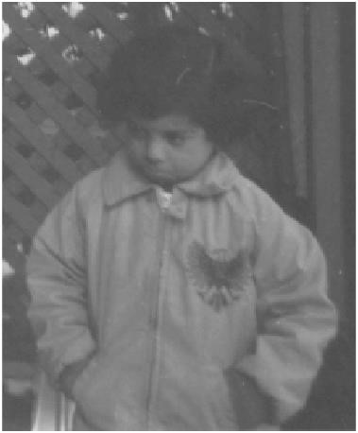

Histogram of original image

