# bit ALU :

## VHDL Code :

library IEEE;

use IEEE.STD_LOGIC_1164.ALL; use IEEE.STD_LOGIC_ARITH.ALL;

use IEEE.STD_LOGIC_UNSIGNED.ALL;

---- Uncomment the following library declaration if instantiating

---- any Xilinx primitives in this code.

--library UNISIM;

--use UNISIM.VComponents.all;

entity alu is

Port ( a : in STD_LOGIC_VECTOR (3 downto 0); b : in STD_LOGIC_VECTOR (3 downto 0);

s : in STD_LOGIC_VECTOR (2 downto 0);

y : out STD_LOGIC_VECTOR (3 downto 0)); end alu;

architecture Behavioral of alu is

begin process(a,b,s) begin

case s is

when "000"=>y<=a+b; when "001"=>y<=a-b;

when "010"=>y<=a and b; when "011"=>y<=a or b; when "100"=>y<=not b; when "101"=>y<=a xor b;

when others=>y<="0000"; end case;

end process;

end Behavioral;

## TestBench code :

LIBRARY ieee;

USE ieee.std_logic_1164.ALL; USE ieee.std_logic_unsigned.all; USE ieee.numeric_std.ALL;

ENTITY alu1247_vhd IS END alu1247_vhd;

ARCHITECTURE behavior OF alu1247_vhd IS

-- Component Declaration for the Unit Under Test (UUT) COMPONENT alu1447

PORT(

a : IN std_logic_vector(3 downto 0); b : IN std_logic_vector(3 downto 0); s : IN std_logic_vector(2 downto 0);

y : OUT std_logic_vector(3 downto 0)

);

END COMPONENT;

--Inputs

SIGNAL a : std_logic_vector(3 downto 0) := (others=>'0'); SIGNAL b : std_logic_vector(3 downto 0) := (others=>'0'); SIGNAL s : std_logic_vector(2 downto 0) := (others=>'0');

--Outputs

SIGNAL y : std_logic_vector(3 downto 0);

BEGIN

-- Instantiate the Unit Under Test (UUT) uut: alu1447 PORT MAP(

a => a, b => b, s => s, y => y

);

tb : PROCESS BEGIN

a<="1100"; b<="0000";

s<="000";

wait for 100 ns; s<="001";

waitfor 100 ns; s<="010";

wait for 100 ns;

-- Wait 100 ns for global reset to finish

--wait for 100 ns;

-- Place stimulus here

wait; -- will wait forever END PROCESS;

END;

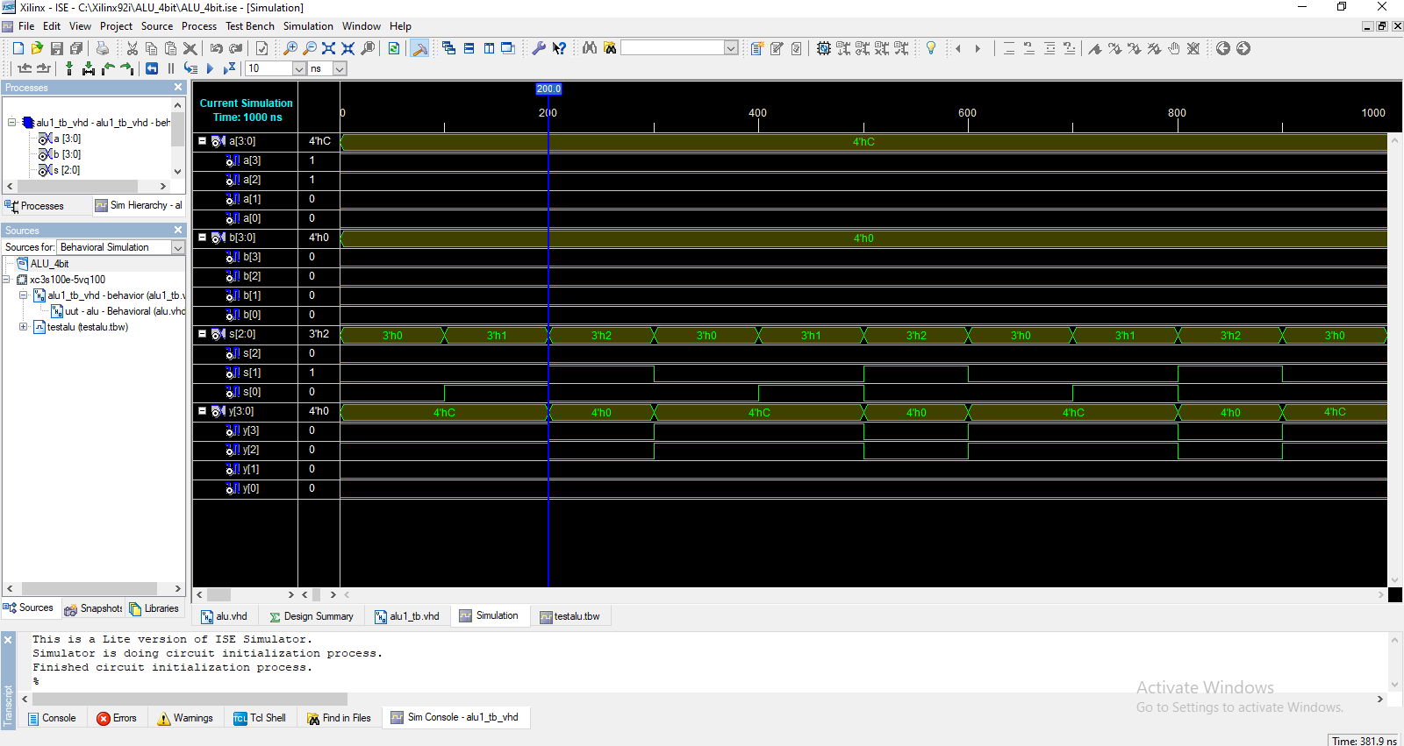

# CMOS Inverter Gate :

## CMOS Inverter :

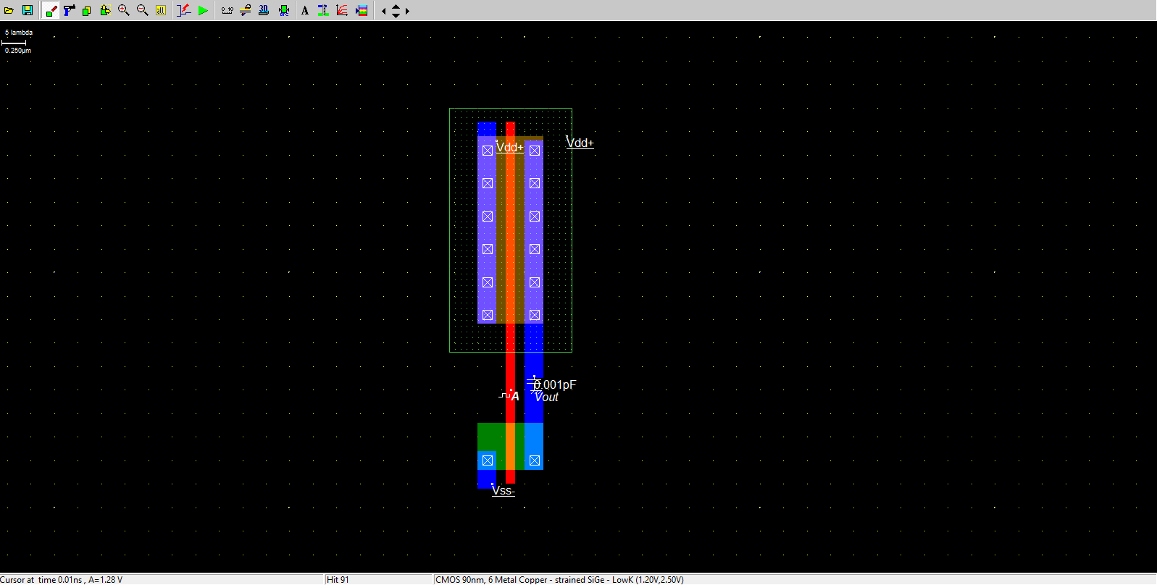

Voltage vs Time -

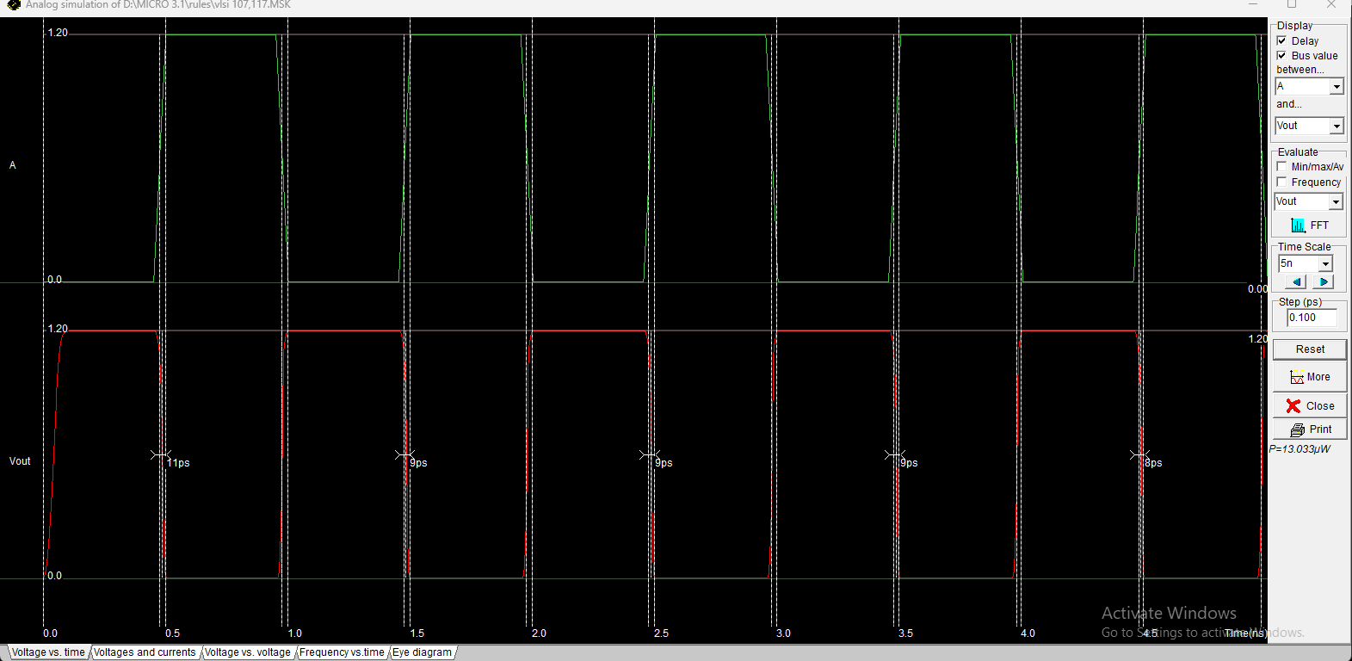

Voltage and Current -

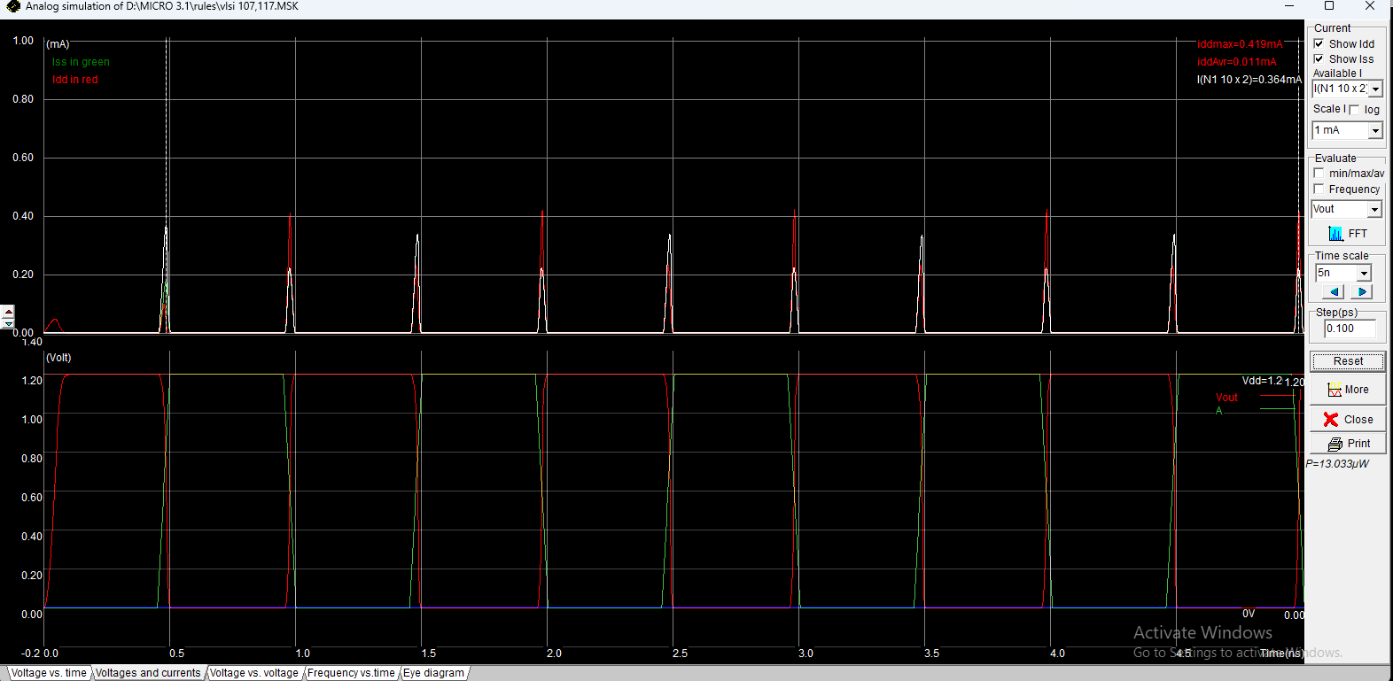

Voltage vs Voltage -

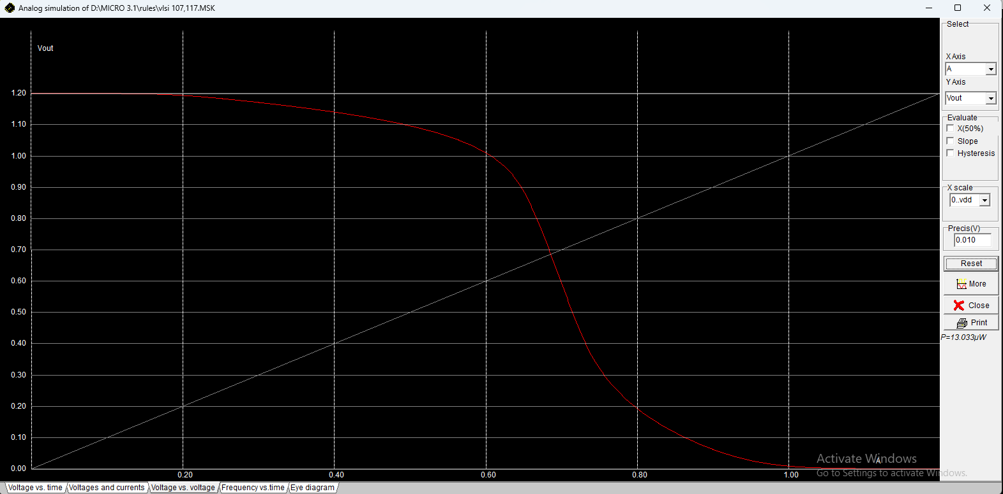

Freq vs time –

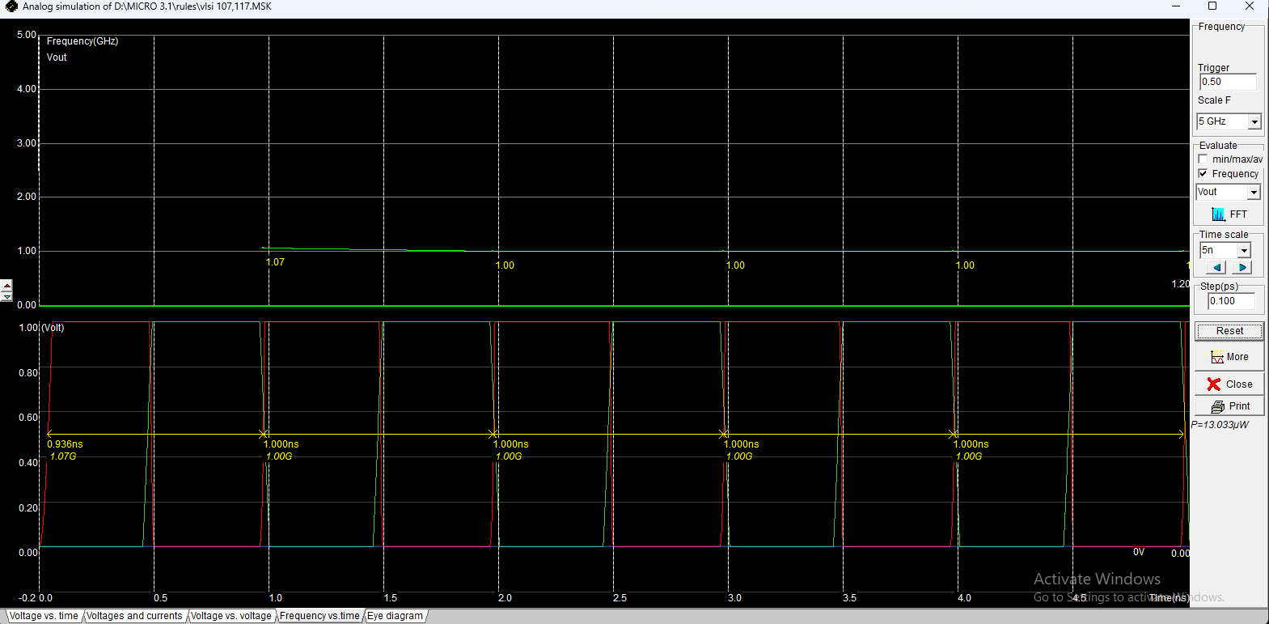

Eye diagram –

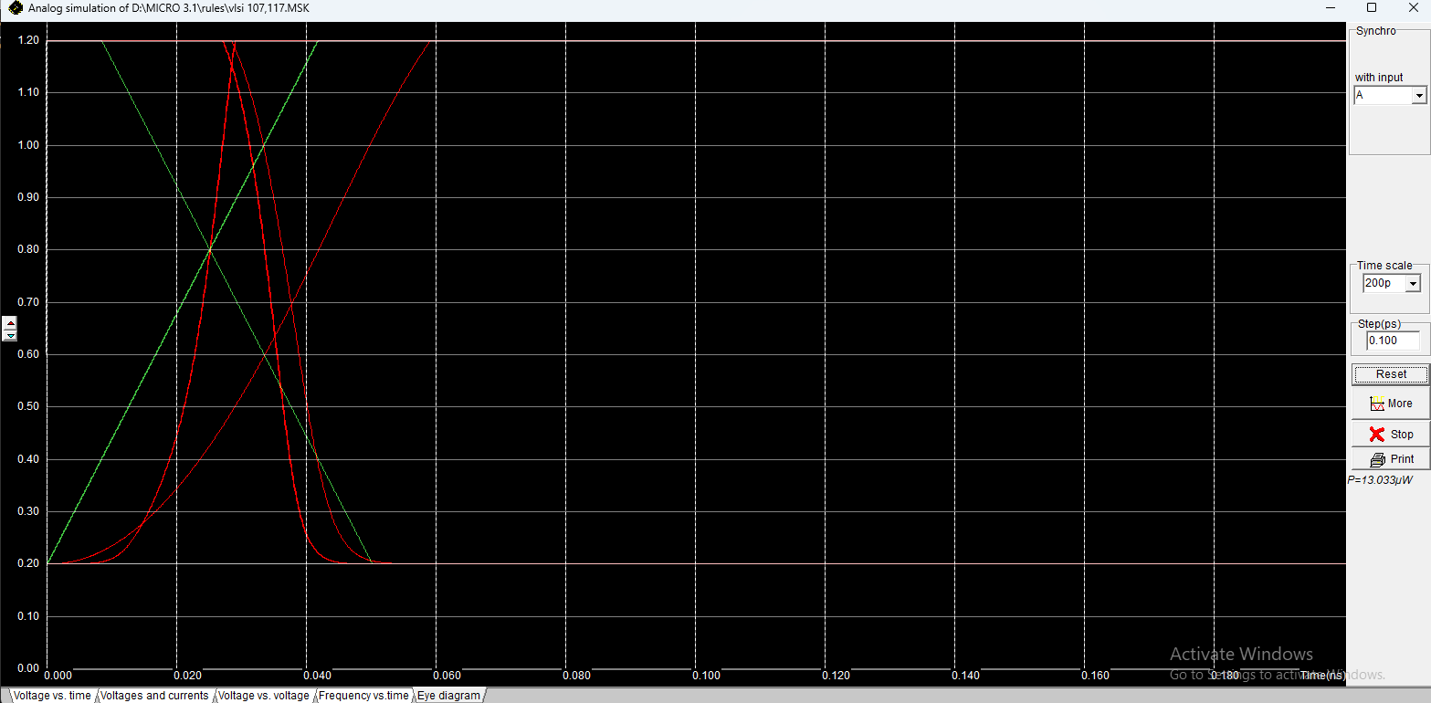

## CMOS NAND Gate :

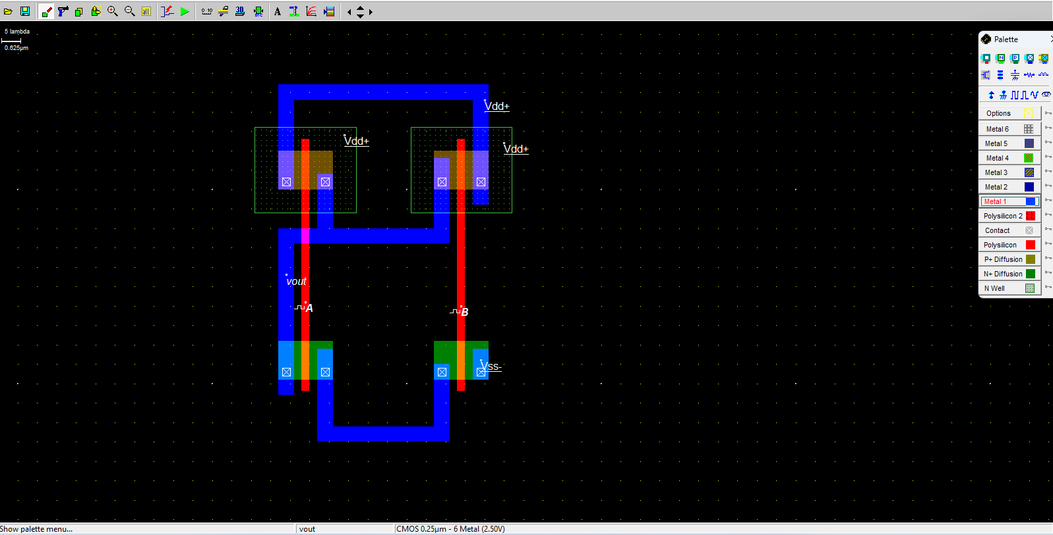

Voltage vs time -

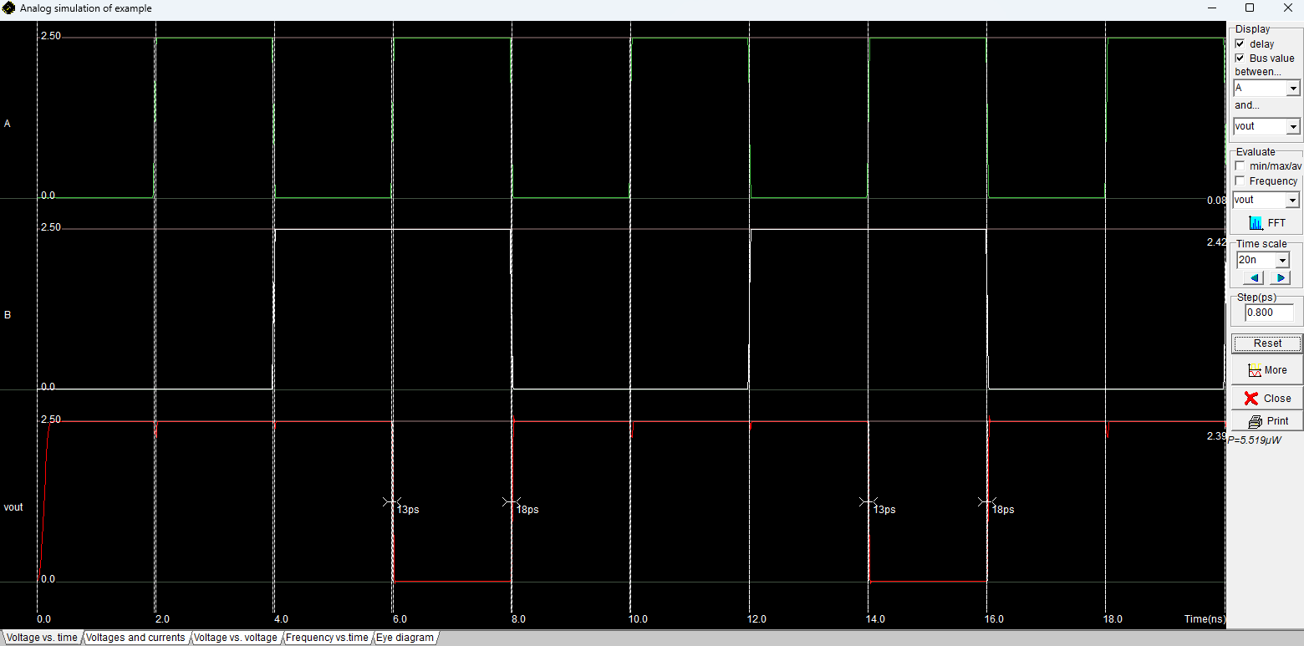

Voltages and current -

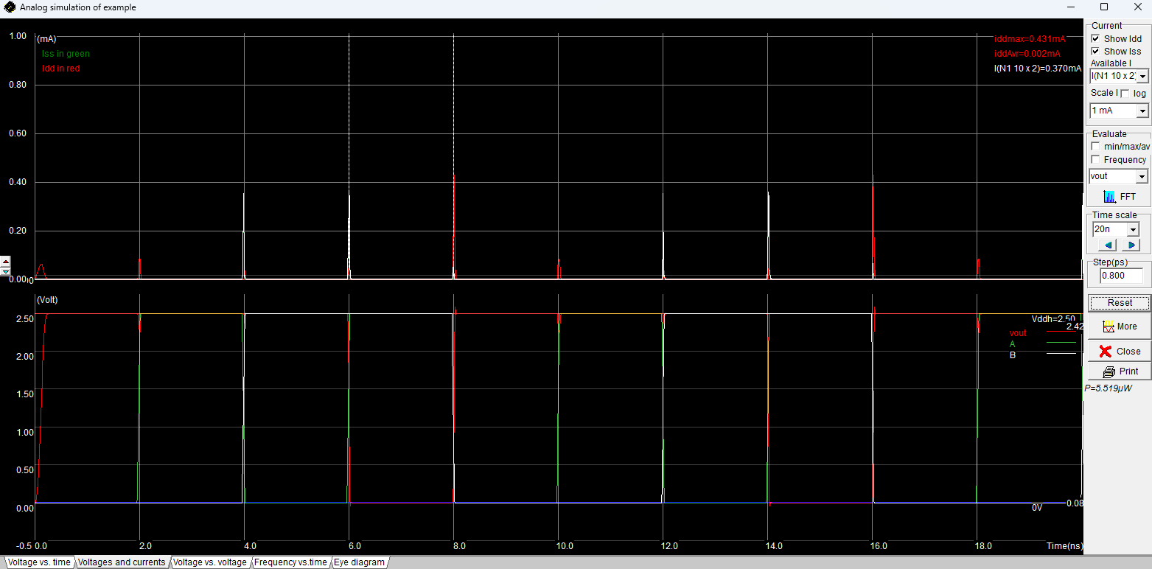

Voltage vs voltage -

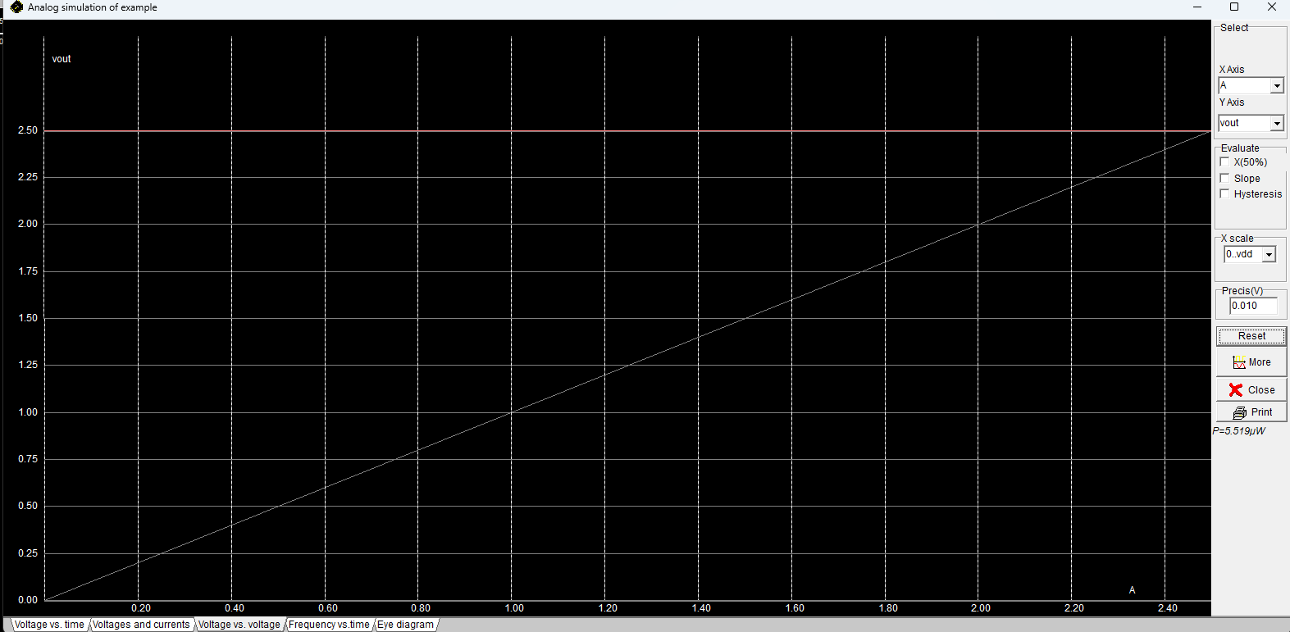

Frequency vs time -

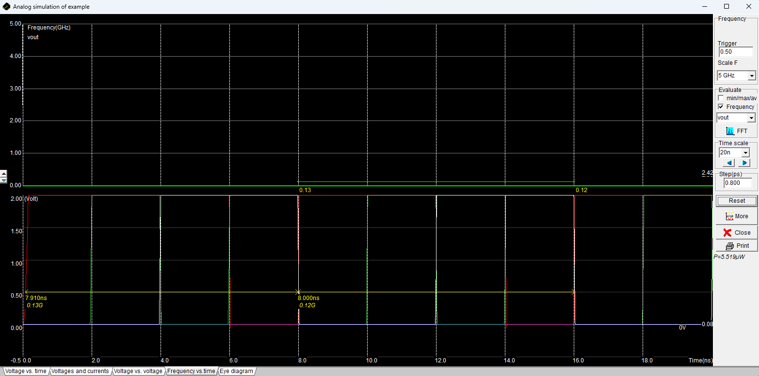

Eye diagram -

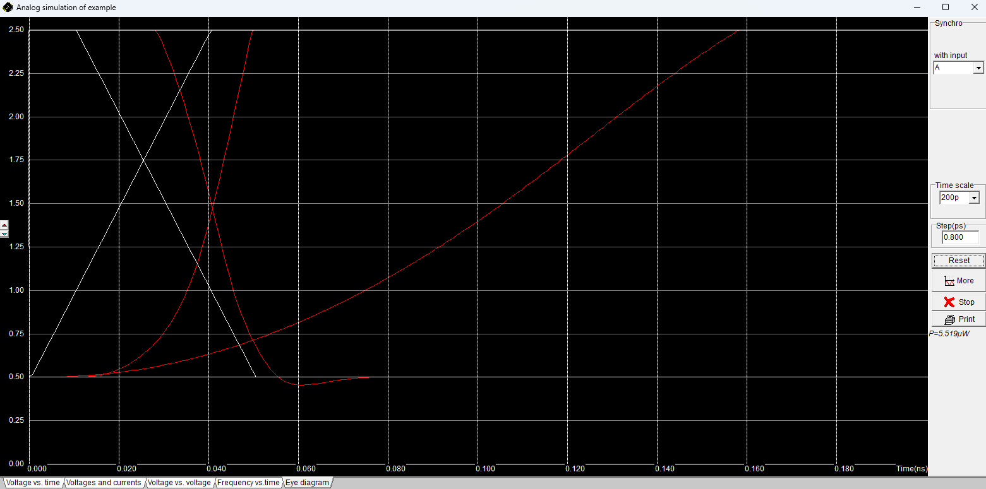

## CMOS NOR Gate :

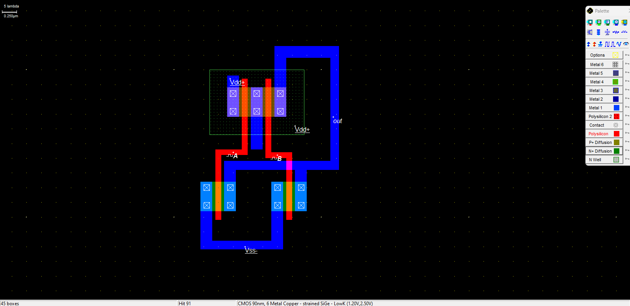

Voltage vs time –

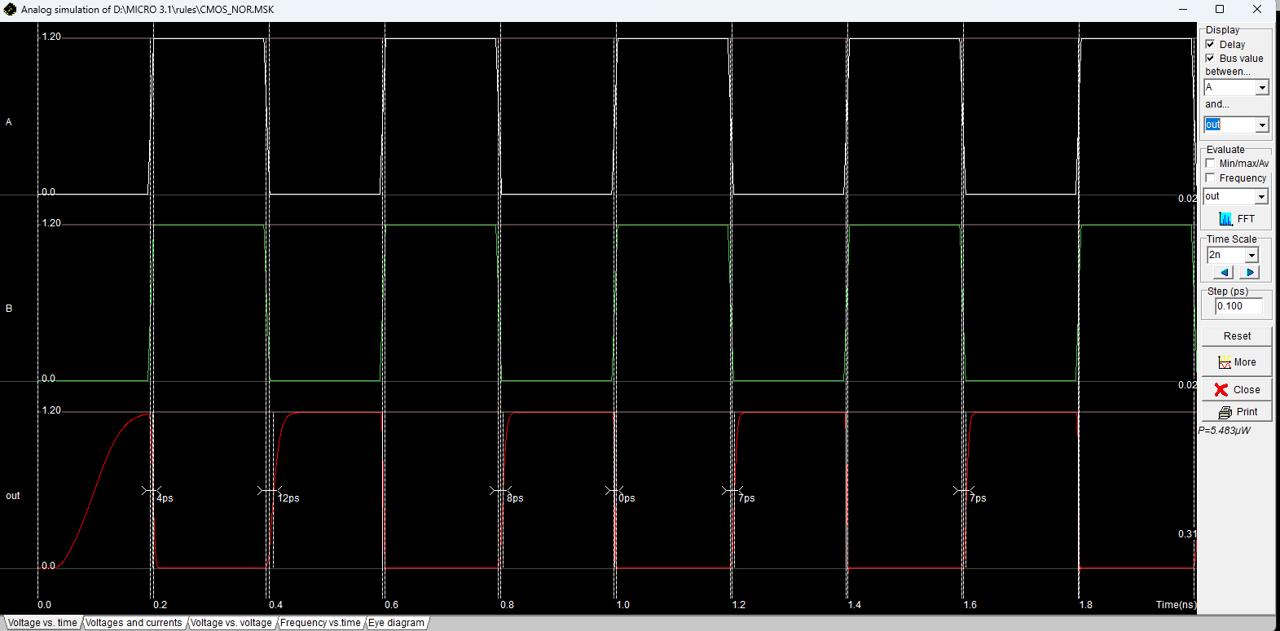

Voltage vs current –

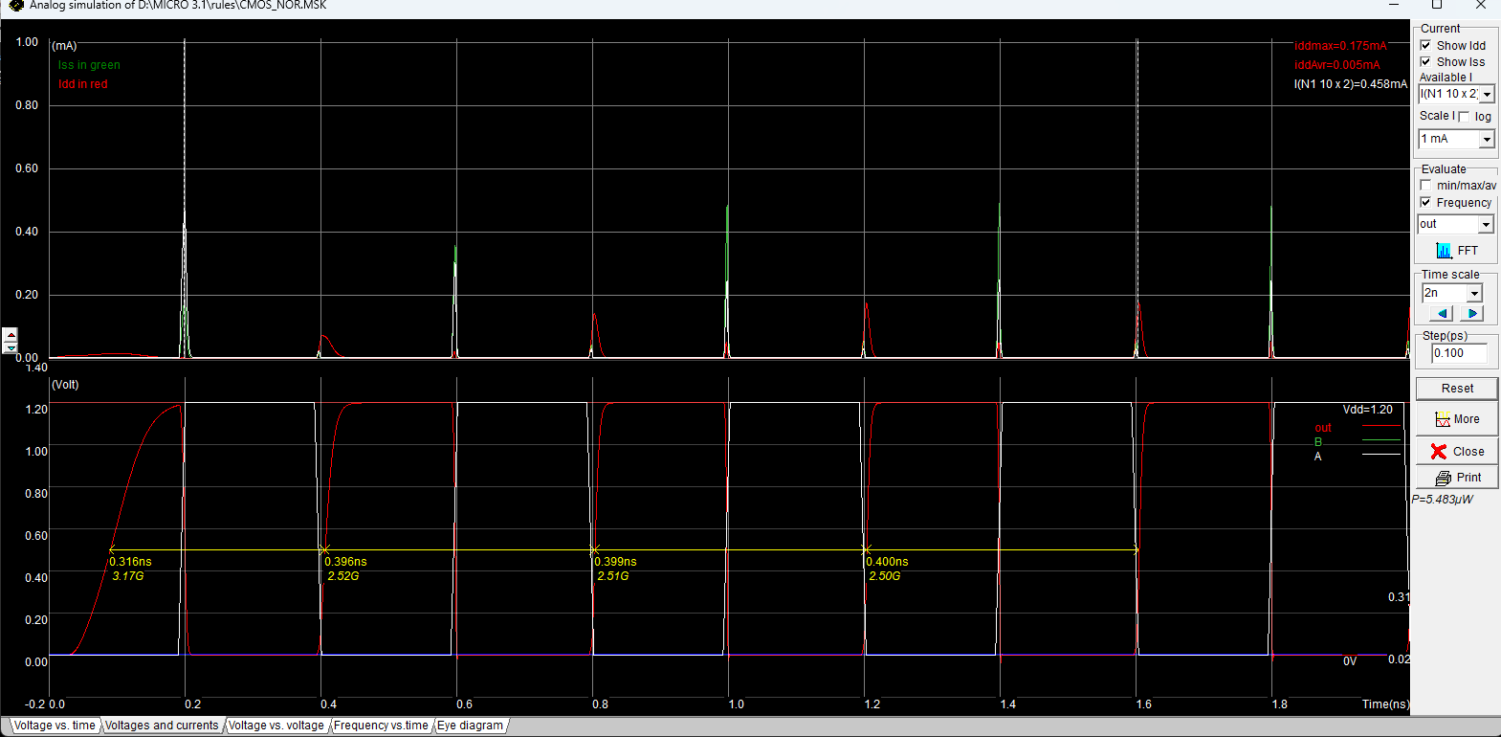

Voltage vs voltage –

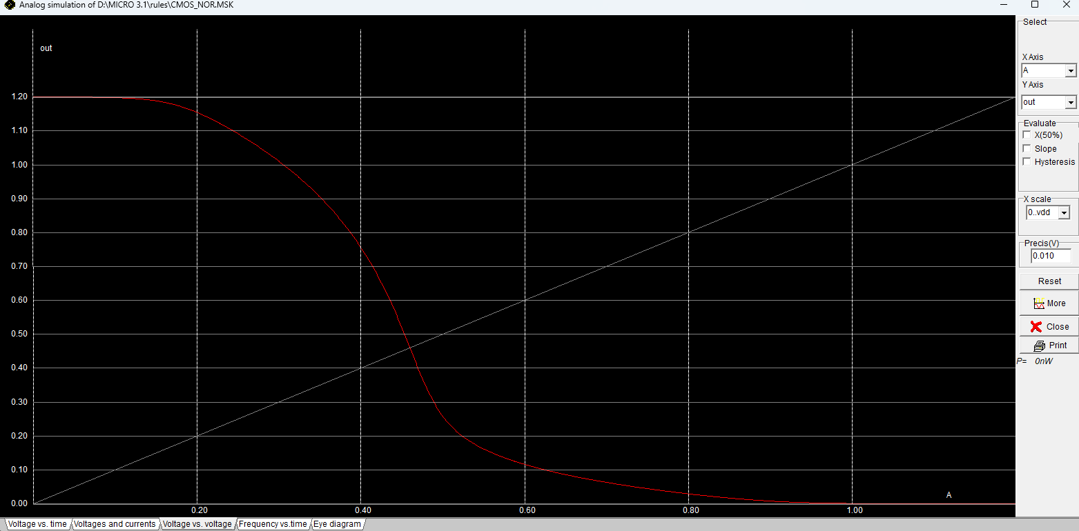

Freq vs time –

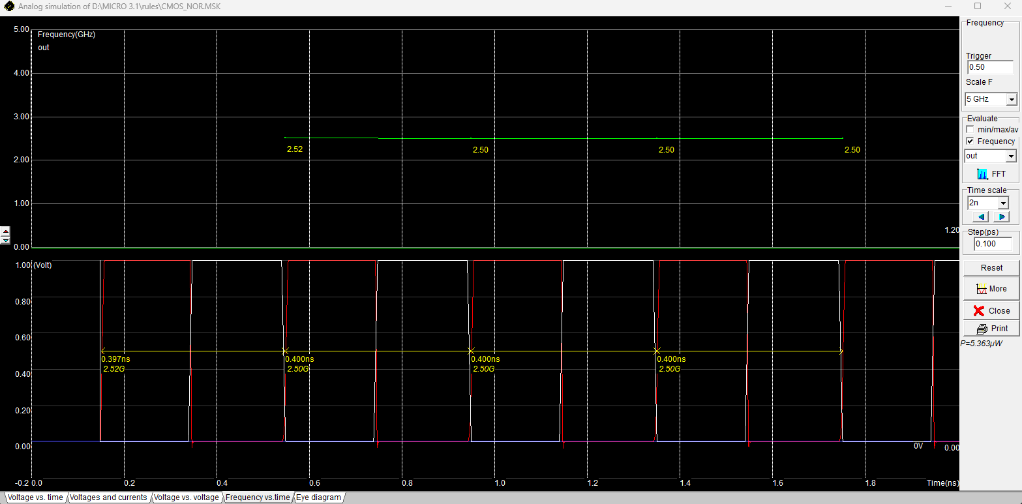

Eye diagram –

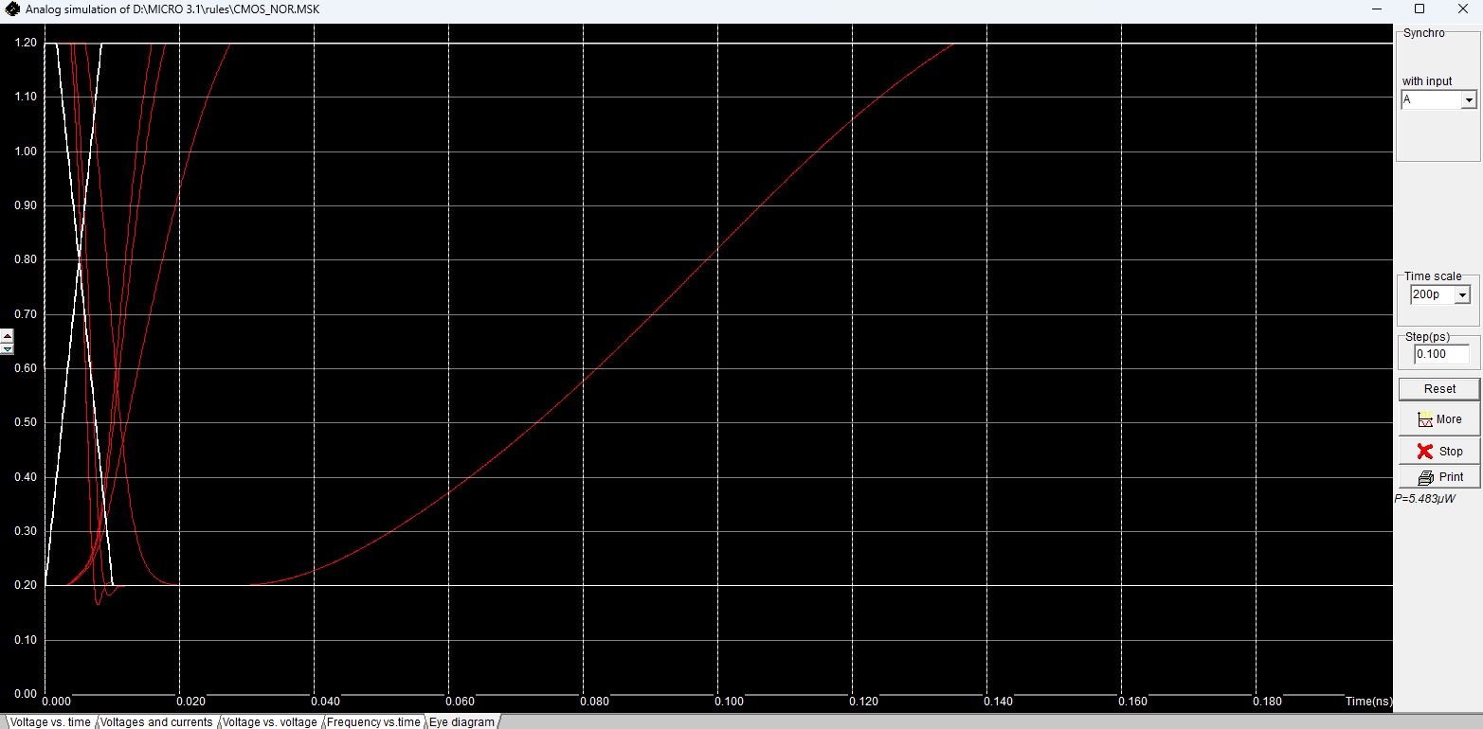

# 2:1 MUX using Transmission Gate and Logic gate :

## 2:1 MUX using Transmission Gate :

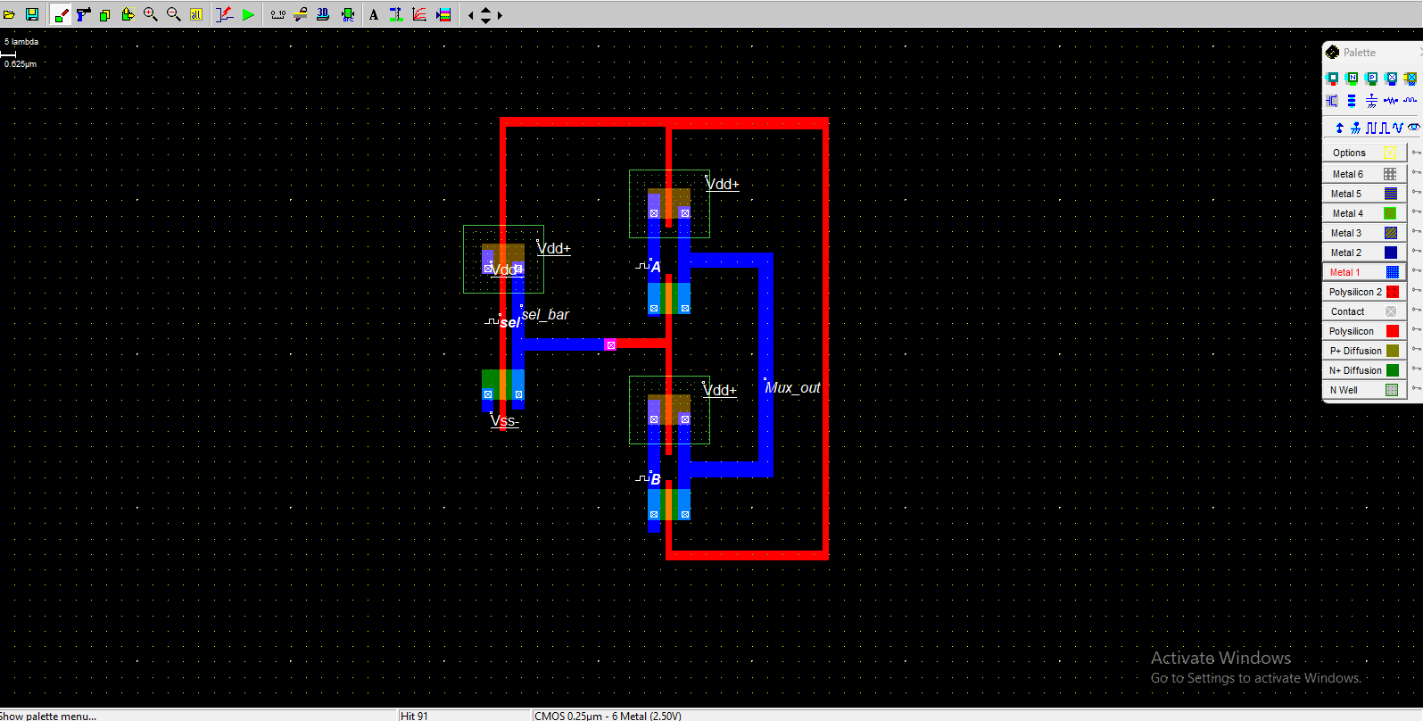

Voltage vs time –

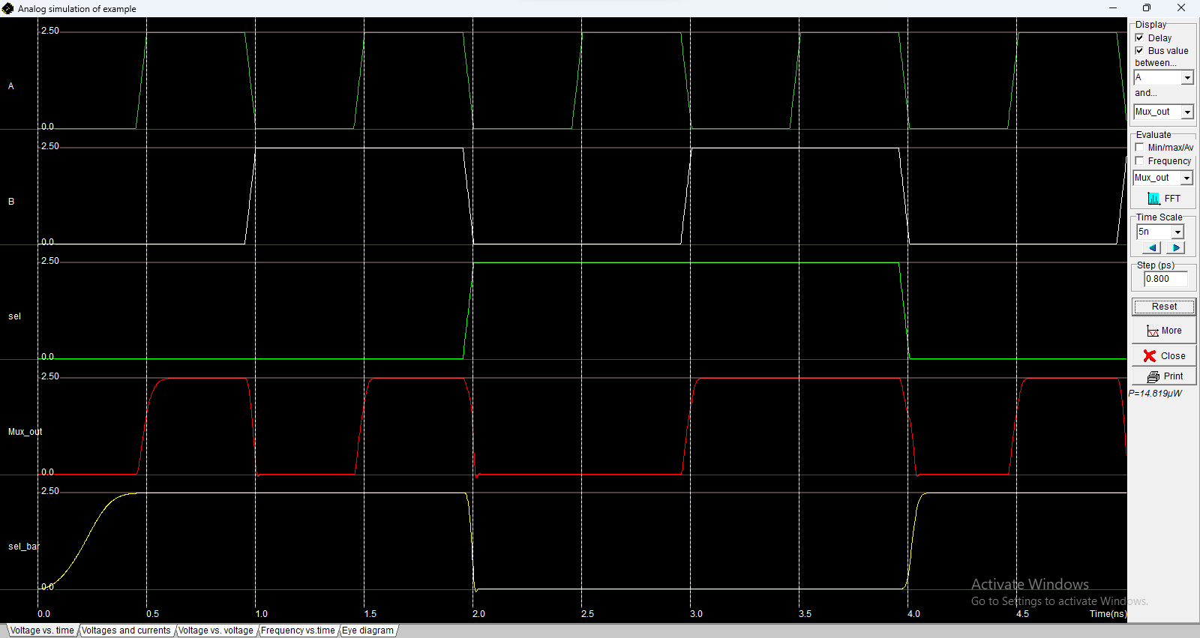

Voltage and current –

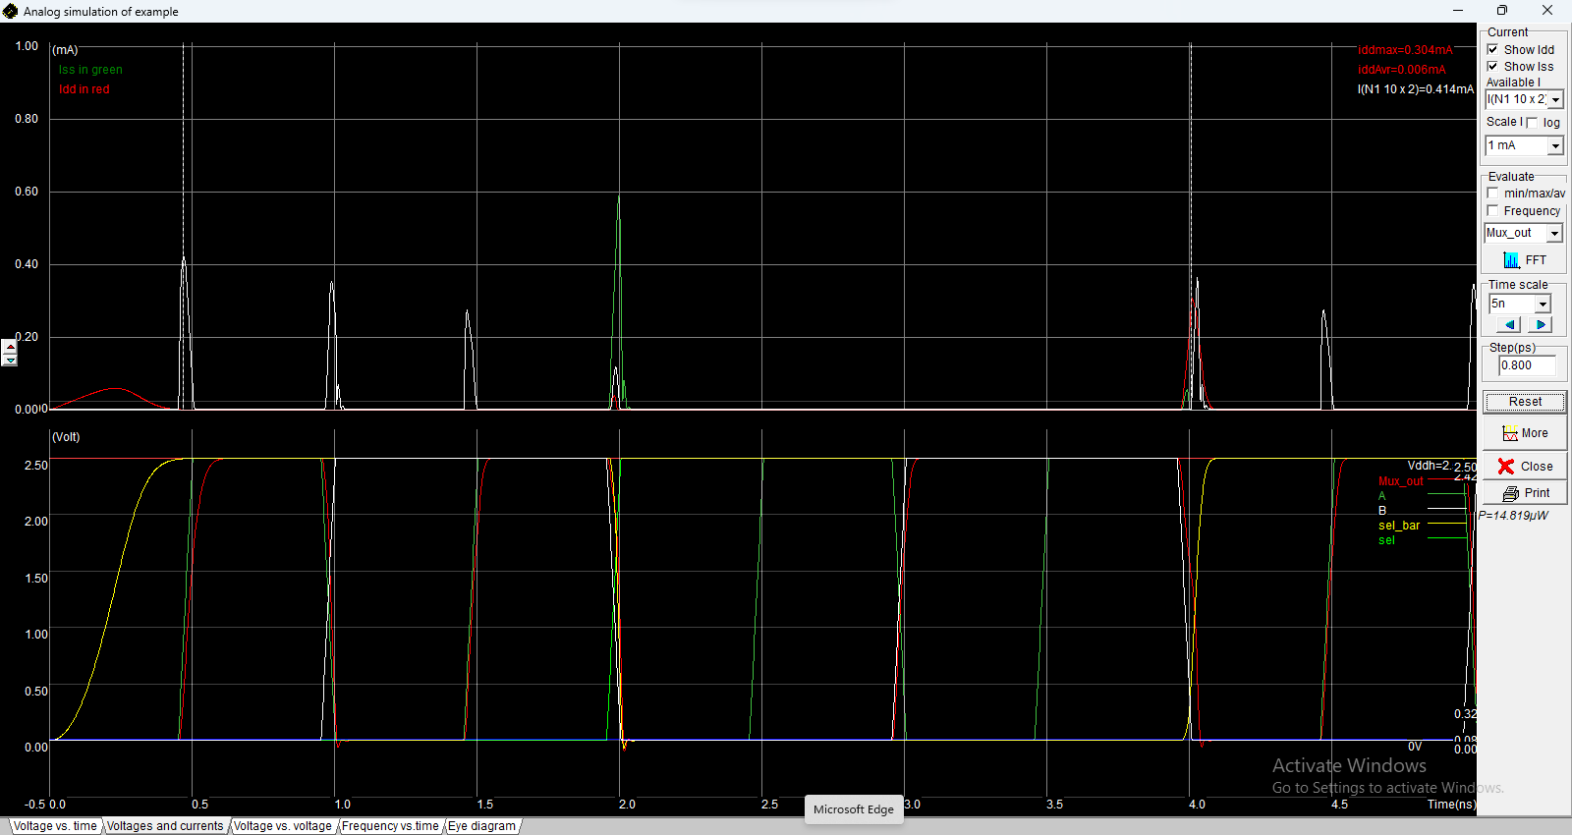

Voltage vs voltage –

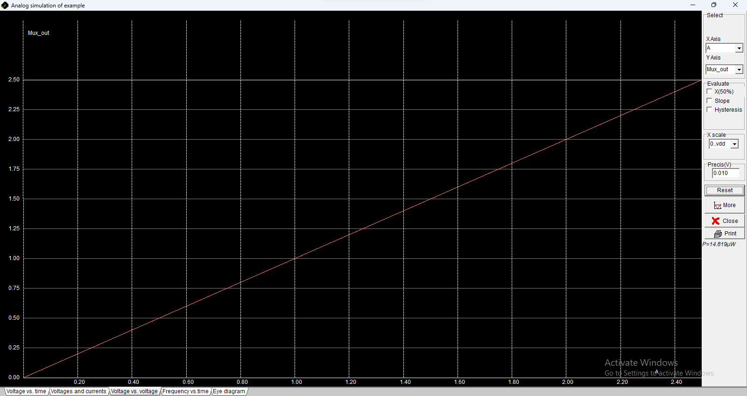

Freq vs time -

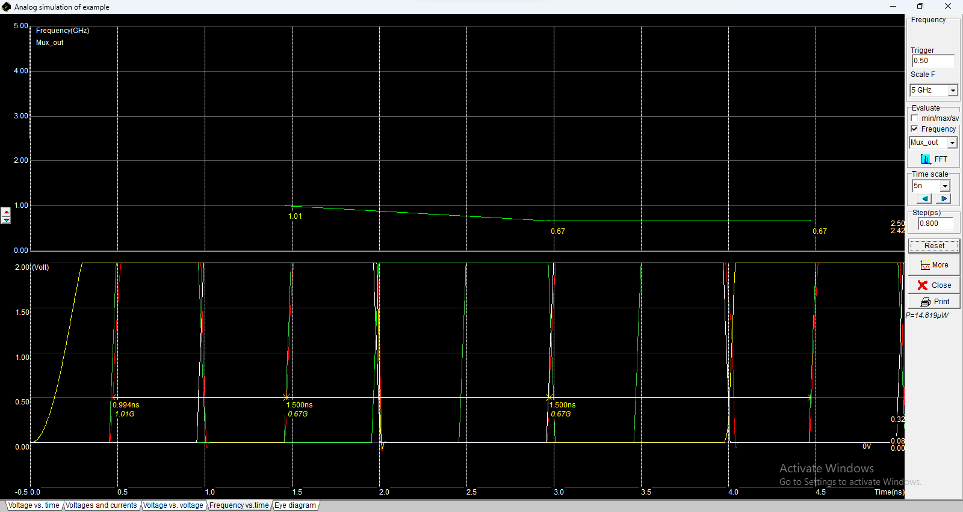

Eye diagram –

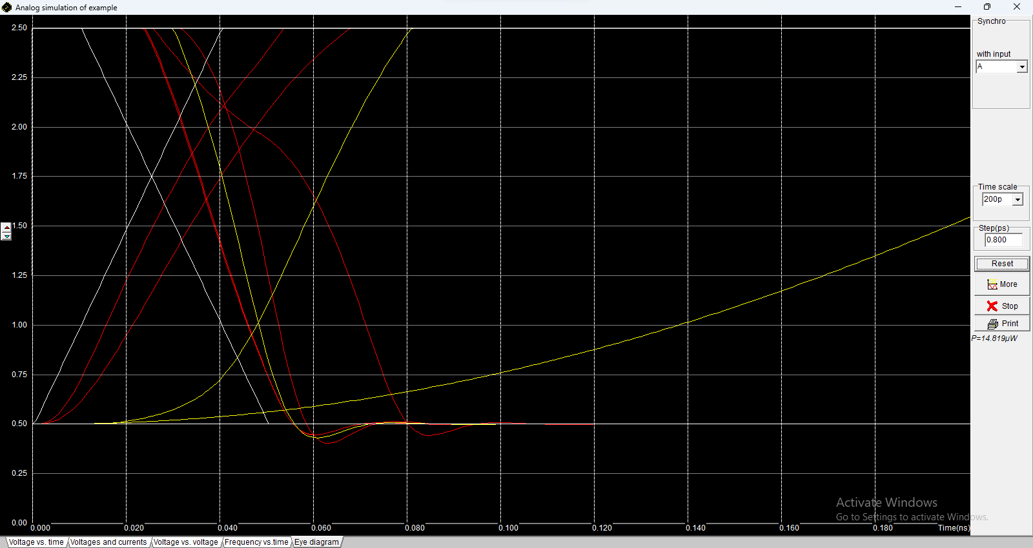

## 2:1 MUX using Logical gate (NAND) :

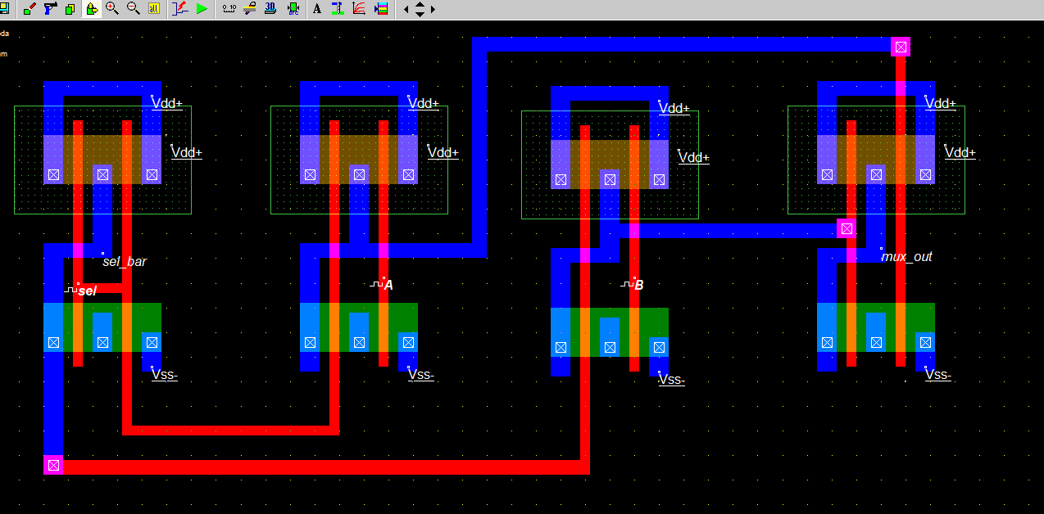

Voltage vs time –

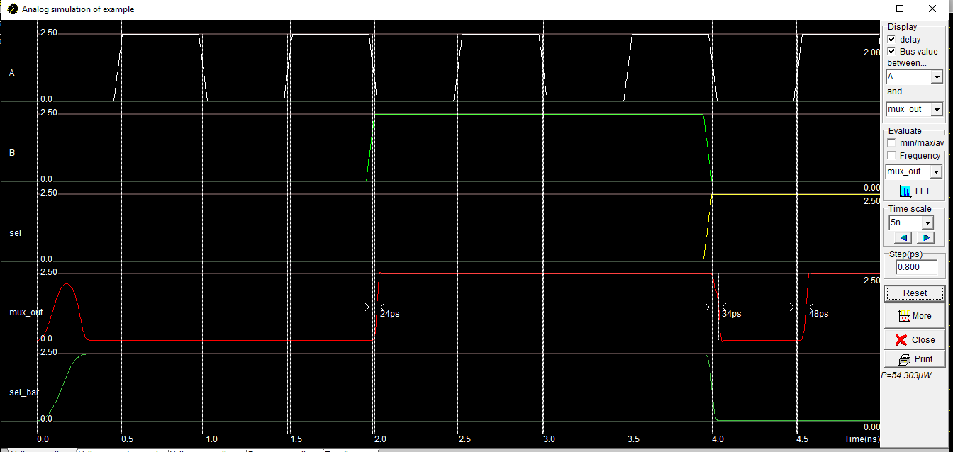

Voltage vs voltage –

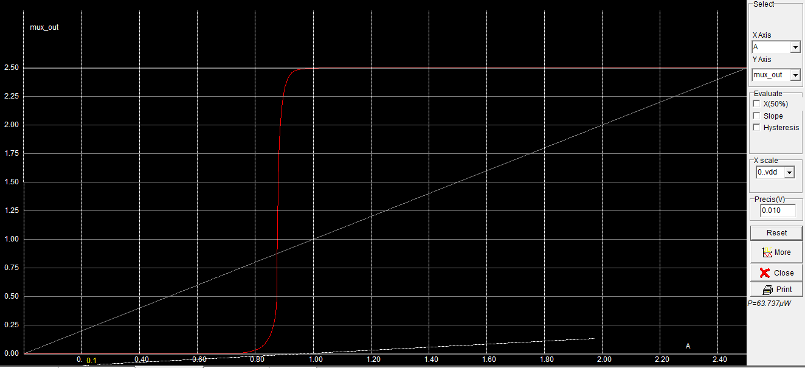

Freq vs time -

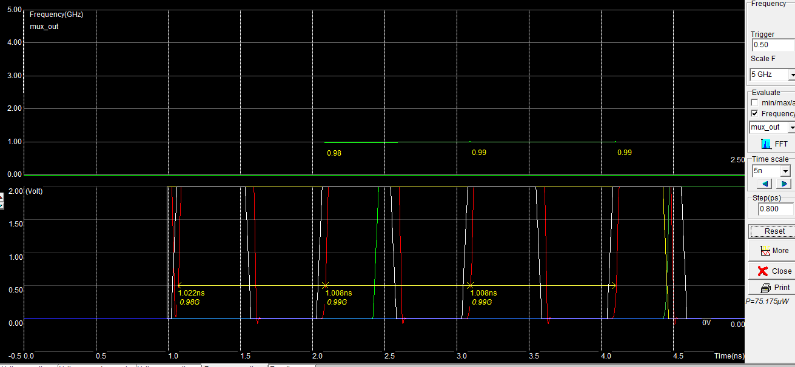

Eye diagram –

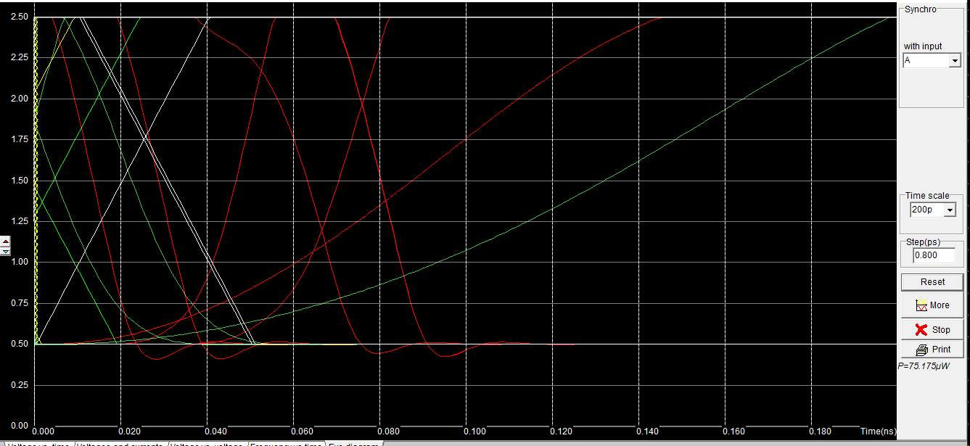

# Half Adder and Full Adder :

## Half Adder :

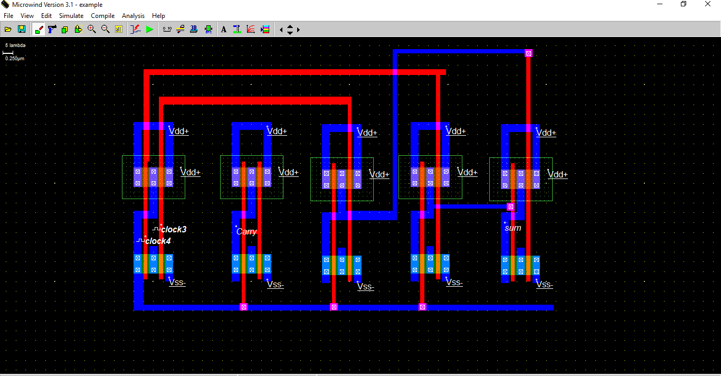

Voltage vs Time -

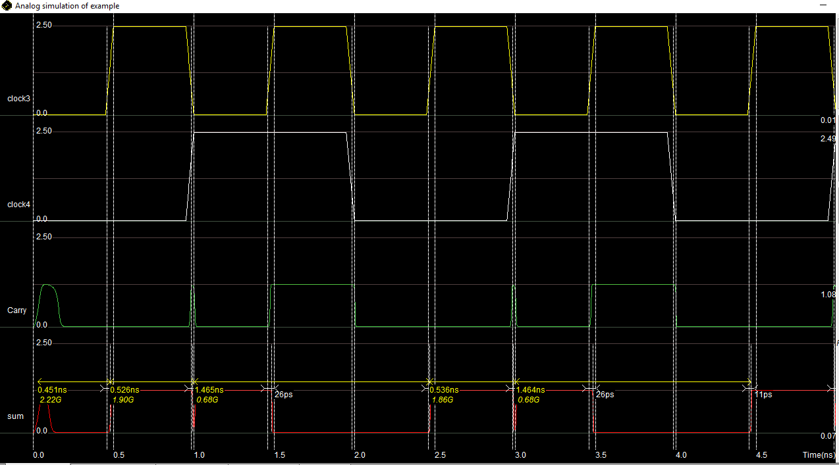

Voltages and Currents -

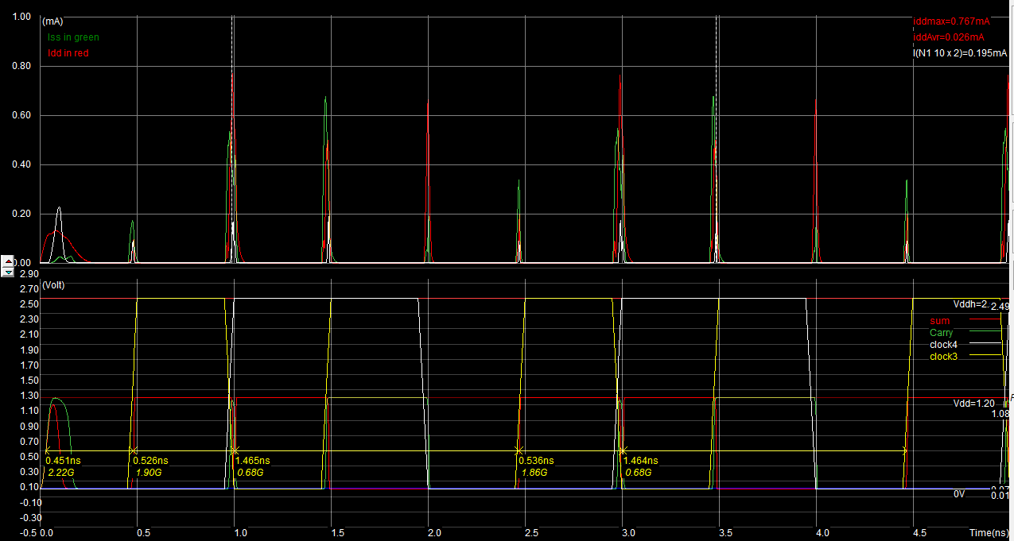

Voltage vs Voltage -

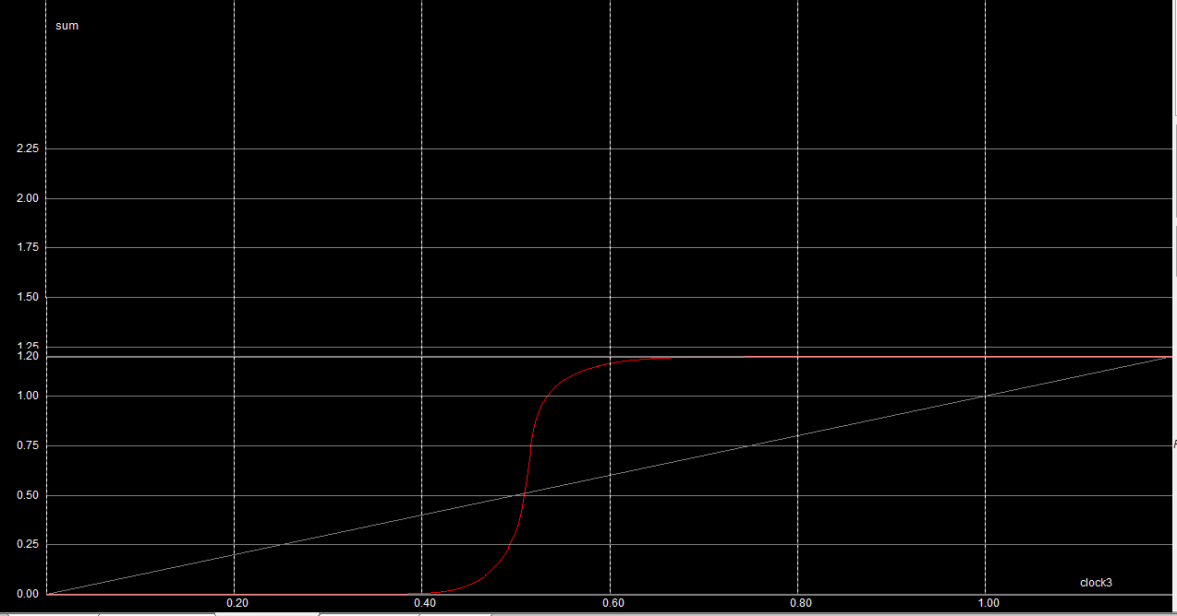

Frequency vs Time -

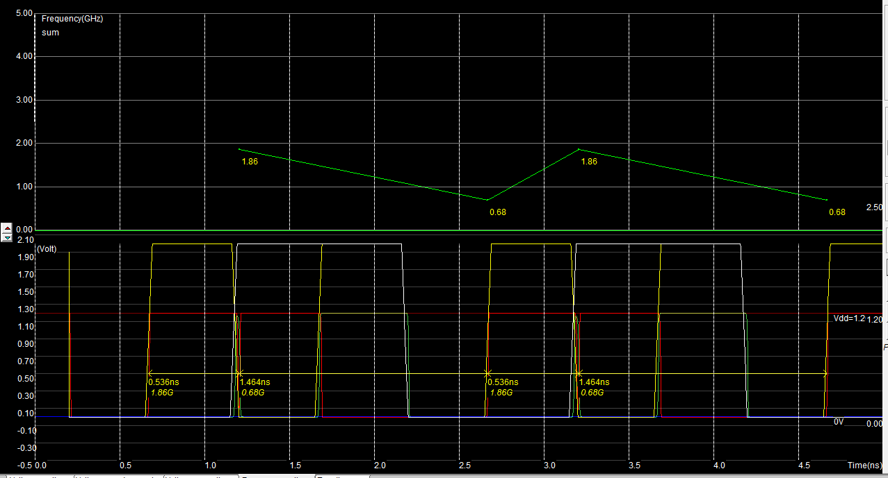

Eye Diagram -

