Table of Contents
Phase 1:-
1 Abstract and Architecture
  - Abstract
  - Architecture Overview

- Objectives Achieved
  - Infrastructure Monitoring
  - File Integrity Monitoring
  - Application Monitoring

- Custom Alerting Configuration
  - Agent Side Configuration
  - Custom Rule Creation
  - Custom Email Alerting
  - Custom Dashboards

- Implementation Details
  - Wazuh Installation
  - Agent Configuration
  - MySQL Monitoring
  - Custom Rule Engineering

- Results, Validation and Findings
  - Results and Validation
  - FIndings

- Phase 1 Follow- Up R&D Tasks and Findings
  - Dashboard Slowness --- R&D Findings
  - Dashboard Data Sync for Agents — MITRE Compliance Logging
  - Sync Interval Exploration
  - Custom Per – Agent Dashboards

Phase 2:-
1 Architectural Deep-Dive & Design Philosophy
1.1 Business Case & Cost Optimization
1.2 Kubernetes Logical Architecture & Namespaces

2 Network Topology & VPN Overlay System
2.1 Tailscale VPN Integration

3 The Three Security Data Pipelines
3.1 Pipeline A — Trivy Vulnerability Reports
3.2 Pipeline B — Falco Runtime Auditing
3.3 Pipeline C — Kubernetes Event Exporter

4 Deployment Specifications & Manifests
4.1 Application Workload & Sidecar Spec
4.2 Agent ConfigMap (ossec.conf + falco_listener.py)
4.3 RBAC for Trivy Bridge
4.4 Kubernetes Event Exporter
4.5 Falco Helm Values

5 Wazuh Manager Ingestion Engine
5.1 Custom JSON Decoders
5.2 Custom Alert Rules

6 Threat Auditing

PHASE 1

Implementation of Wazuh-Based Security Monitoring with Custom Dashboards and Alerting

SECTION 1
Abstract & Architecture

1.1 Abstract
We aimed to implement and evaluate a Security Information and Event Management (SIEM) solution using Wazuh for infrastructure and database monitoring. The system was deployed in a controlled virtualized lab environment consisting of:
- U1: Wazuh Manager + Indexer + Dashboard
- U2: Wazuh Agent + MySQL Server
The implementation successfully demonstrated:
- Authentication monitoring
- File Integrity Monitoring (FIM)
- MySQL log monitoring
- Custom alert rule creation
- Custom dashboard visualization
The solution validates real-time detection and centralized monitoring capabilities aligned with infrastructure security best practices.

1.2 Architecture Overview
The pipeline follows a simple agent-to-manager flow: the U2 host (Agent + MySQL) ships system logs, MySQL logs, and File Integrity Monitoring (FIM) events to the Wazuh Agent, which forwards them to the U1 Manager for rule processing, alert generation, and MITRE ATT&CK mapping. The Manager indexes results and renders them on custom dashboards.
U2 (Agent + MySQL) | Wazuh Agent | U1 (Manager)
System logs  MySQL logs  FIM monitoring | Receives local events and ships them to the Manager over the Wazuh agent protocol | Rule processing  Alert generation  MITRE mapping
Indexer | → | Dashboard (Custom Visualizations)
Stores parsed and enriched alert data from the Manager | → | Custom panels for authentication, FIM, MySQL, and MITRE-mapped alerts

https://documentation.wazuh.com/current/getting-started/components/index.html
SECTION 2
Objectives Achieved

2.1 Infrastructure Monitoring
- SSH authentication log monitoring
- Detection of failed login attempts
- Brute-force pattern identification
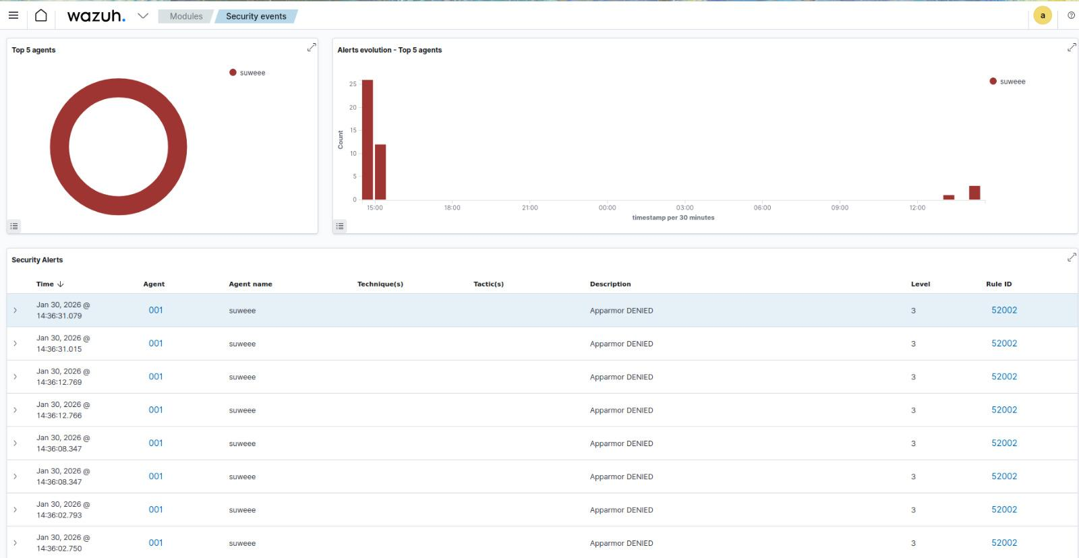

2.2 File Integrity Monitoring
- Monitoring of /etc/passwd
- Monitoring of /etc/sudoers
- Detection of file modification
# Bash: Simulate file modification on /etc/passwd
sudo cp /etc/passwd /etc/passwd.bak
sudo nano /etc/passwd
sudo touch /etc/passwd

# Bash: Simulate file modification on /etc/sudoers
sudo cp /etc/sudoers /etc/sudoers.bak
sudo touch /etc/sudoers

Expected result: each modification triggers a File Integrity Monitoring alert on the Wazuh dashboard, as shown below.
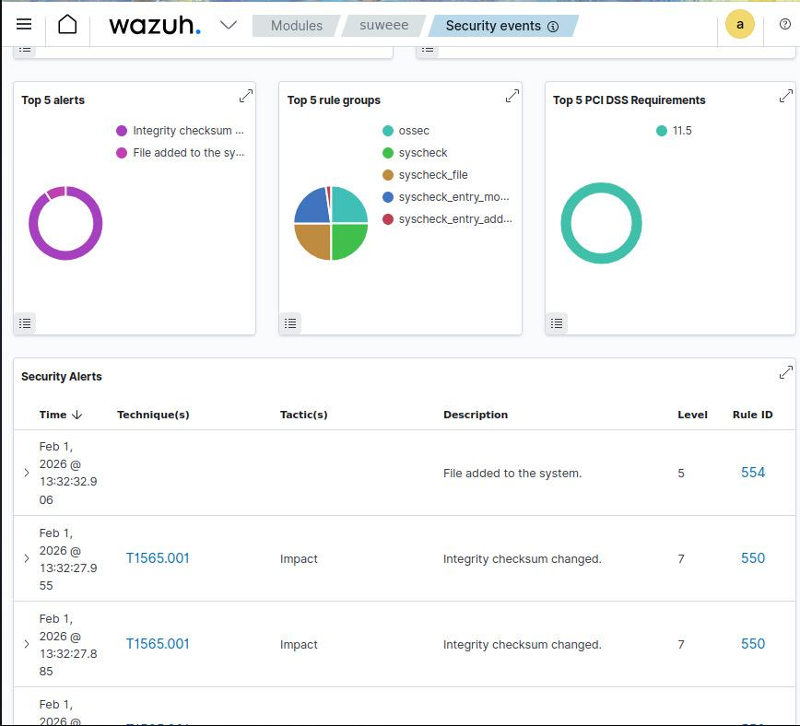
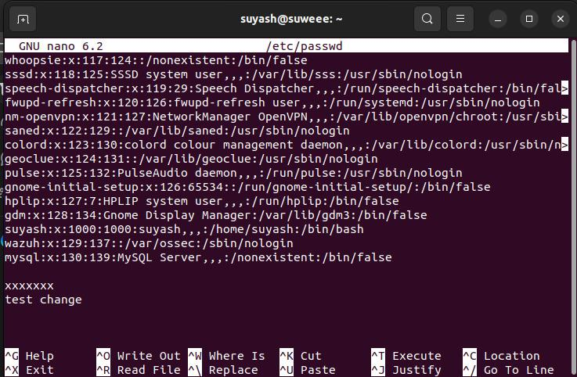
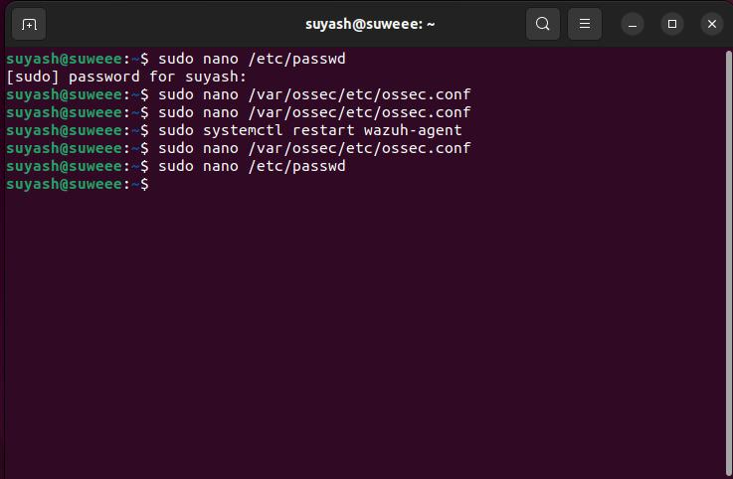
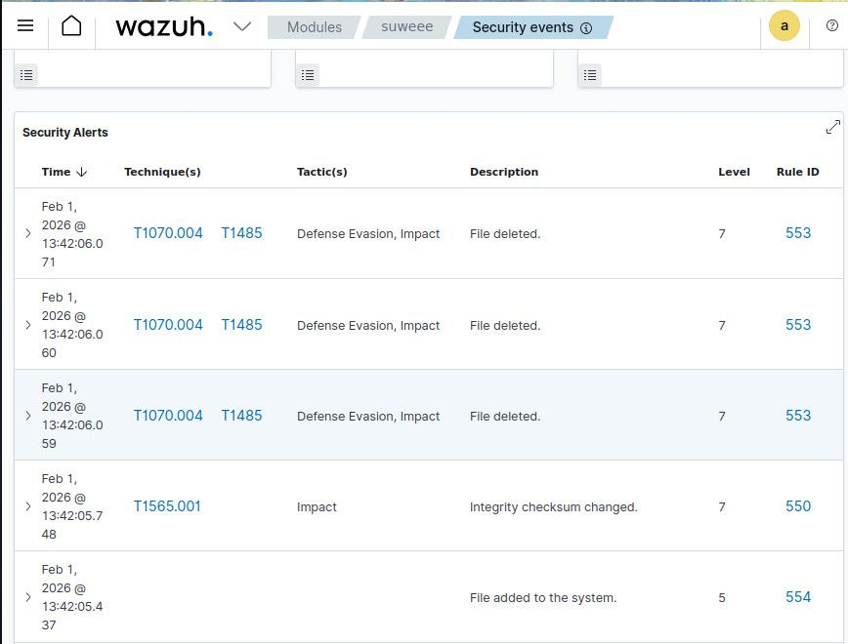

2.3 Application Monitoring
- MySQL error logs monitored
- MySQL query logs monitored
- Detection of:
  - Failed DB logins
  - Database creation
  - Table creation
  - Privilege modifications
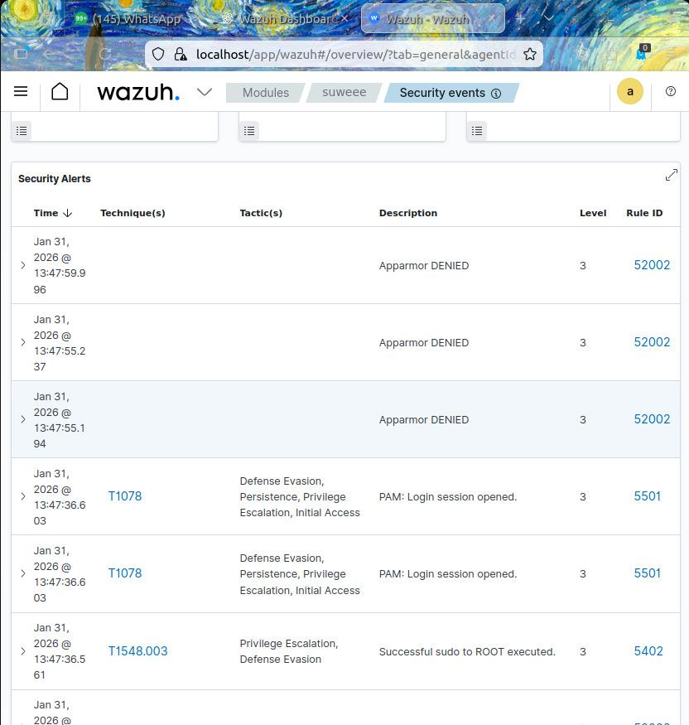
https://documentation.wazuh.com/current/user-manual/capabilities/file-integrity/index.html
https://dev.mysql.com/doc/refman/8.0/en/server-logs.html

SECTION 3
Custom Alerting Configuration

3.1 Agent-Side Configuration (U2)
# Bash: Edit agent configuration
sudo nano /var/ossec/etc/ossec.conf

Example for MySQL log monitoring:
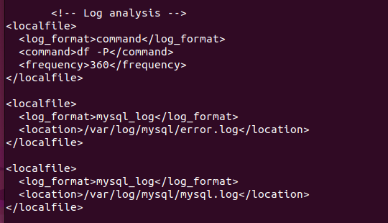
Example for File Integrity Monitoring:
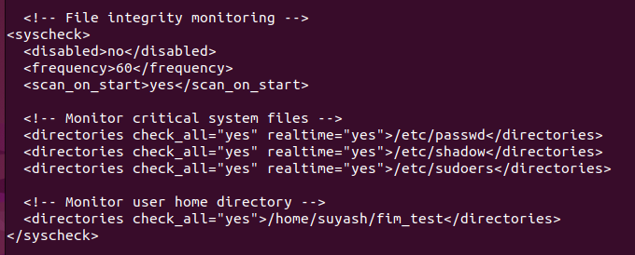
# Bash: Restart and verify the agent
sudo systemctl restart wazuh-agent
sudo /var/ossec/bin/wazuh-agentd -t

3.2 Custom Rule Creation (Manager — U1)

# Bash: Edit the local rules file
sudo nano /var/ossec/etc/rules/local_rules.xml

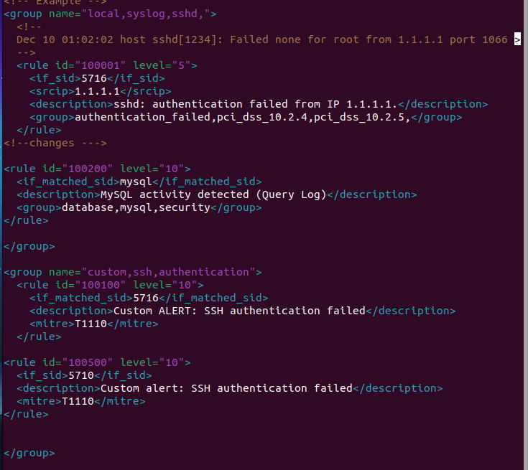

3.3 Custom Email Alerting
Custom email alerting is configured through the Wazuh dashboard UI rather than the configuration file directly:
Wazuh UI → Menu → Server Management → Settings → Edit Configuration
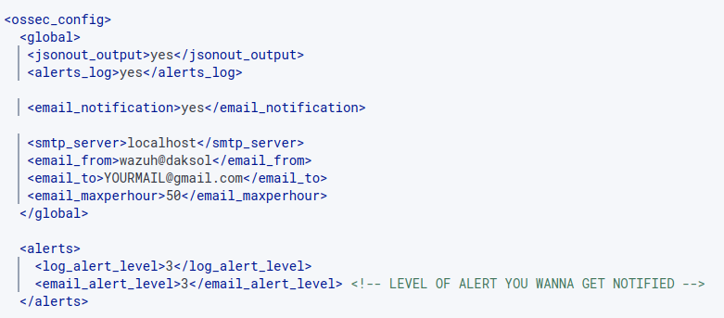
# Bash: Restart the manager to apply changes
sudo systemctl restart wazuh-manager

Output:
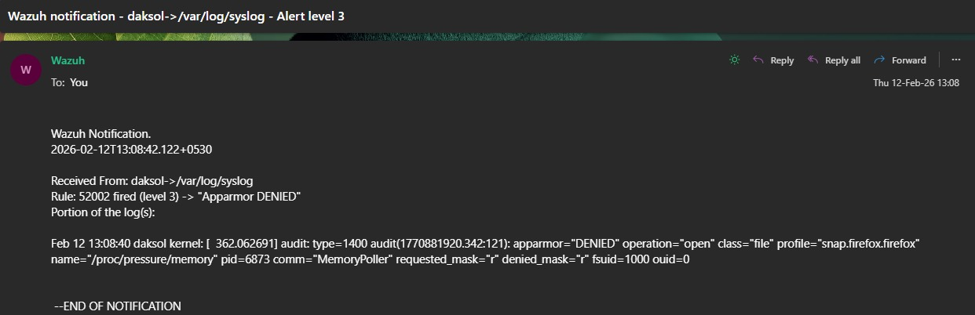
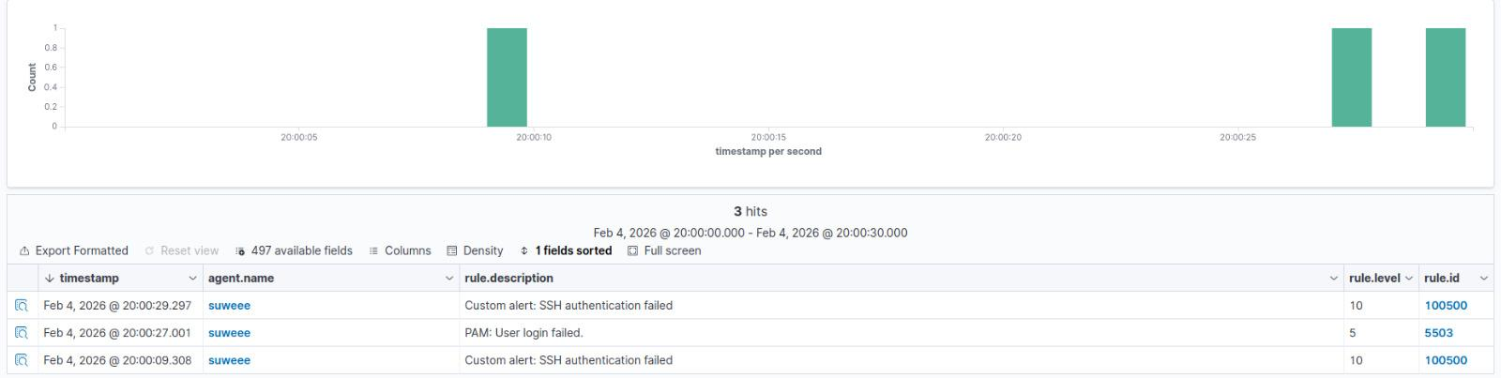

3.4 Custom Dashboards
Custom dashboards are created directly from the Wazuh dashboard UI:
Wazuh UI → Menu → Explore → Dashboards → Create Dashboards
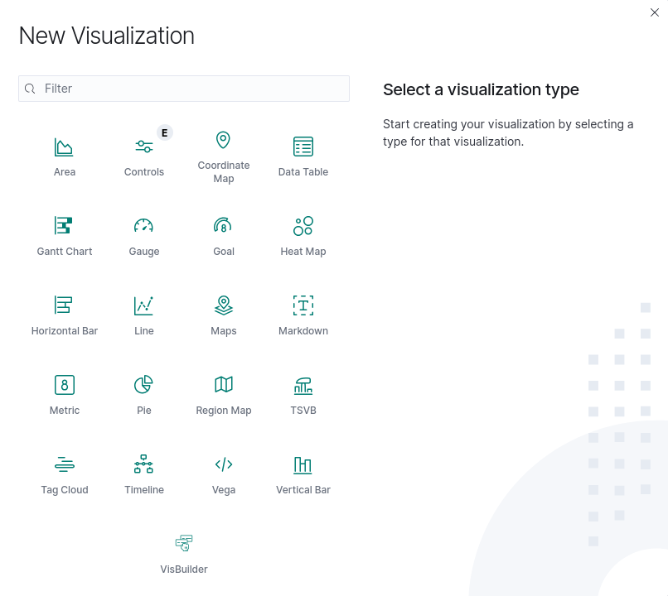
Select the required visualization type and configure the parameters as required.
Output:
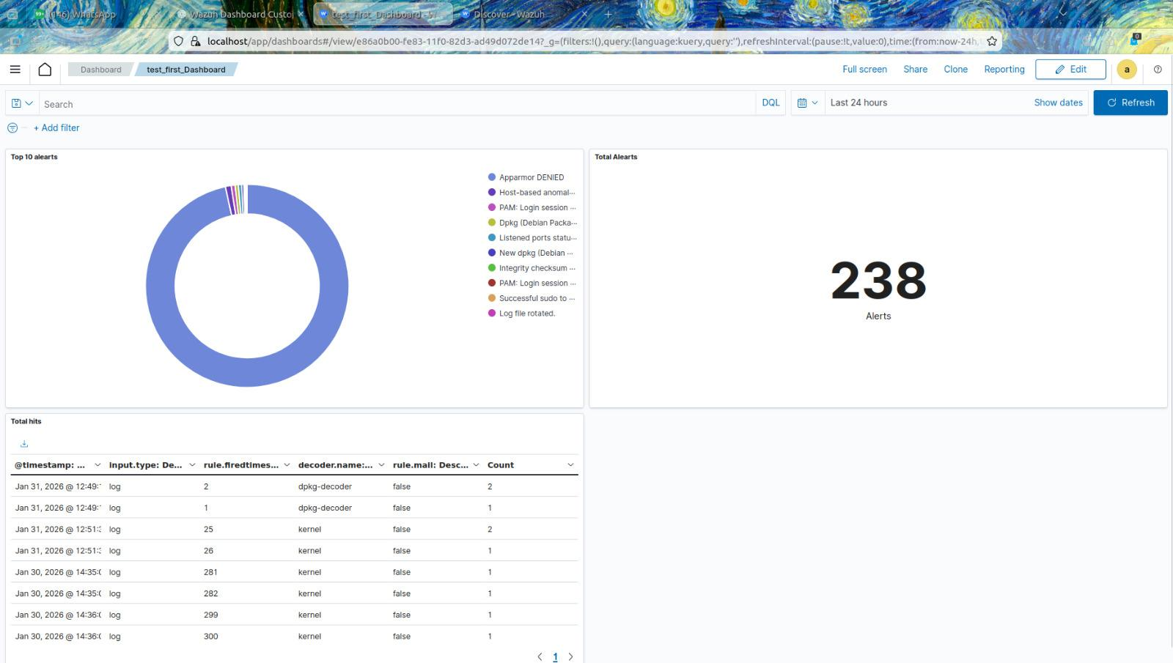
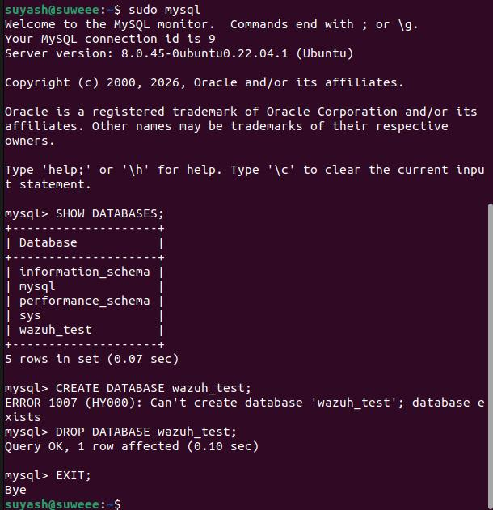

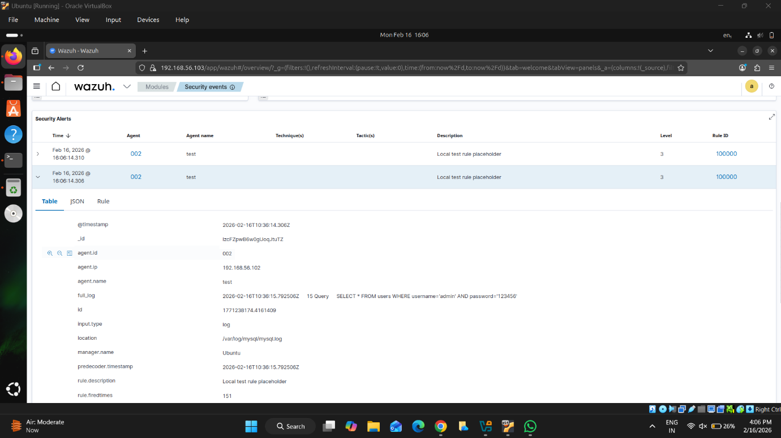
https://documentation.wazuh.com/current/user-manual/reference/ossec-conf/email-alerts.html
https://documentation.wazuh.com/current/user-manual/wazuh-dashboard/creating-custom-dashboards.html
https://documentation.wazuh.com/current/user-manual/ruleset/rules/custom.html

SECTION 4
Implementation Details

4.1 Wazuh Installation
Wazuh Manager, Indexer, and Dashboard were installed on U1.
4.2 Agent Configuration
Wazuh Agent installed on U2 and configured to send logs to U1.
4.3 MySQL Monitoring
Configured Wazuh Agent to monitor MySQL logs.
4.4 Custom Rule Engineering
Custom rules were created in:
# Path: Custom rules file
/var/ossec/etc/rules/local_rules.xml

Example rule — alerts when a MySQL CREATE TABLE statement is detected, mapped to MITRE ATT&CK technique T1078:
# XML: local_rules.xml — example rule
<rule id="100200" level="10">
<if_match>CREATE TABLE</if_match>
<description>MySQL table created</description>
<mitre>
<id>T1078</id>
</mitre>
</rule>

SECTION 5
Results, Validation & Findings

5.1 Results & Validation
Each detection was validated using the following process:
- Simulated security event
- Verified log generation
- Verified alert in alerts.json
- Confirmed visibility in dashboard
- Created visualization panel
The alerting pipeline functioned successfully end‑to‑end.

5.2 Findings
- Wazuh effectively detects authentication anomalies.
- File integrity monitoring generates medium-to-high severity alerts.
- MySQL query logging enables database activity visibility.
- Custom rule creation enhances detection capability.
- Dashboard customization improves operating visibility.
https://documentation.wazuh.com/current/getting-started/index.html

SECTION 6
Phase 1 Follow-Up — R&D Tasks & Findings
Tasks assigned per the meeting held on Wednesday, 25.02.2026:
- R&D on Wazuh dashboard slowness / prepare a document with the steps.
- Implementation of dashboard data sync for agents, including data logging for MITRE ATT&CK compliance events (prepare a document).
- Explore the sync time interval for logging and identify where the sync configuration is set for each agent.
- Explore any custom dashboard that can show each agent's data logging in a single view.

6.1 Dashboard Slowness — R&D Findings
- Tried using a direct IP address instead of DNS, but the page loaded even slower.
- Using the UDP protocol is forbidden by the client, so it was not possible to test whether the latency is due to the existing TCP protocol.
- A large number of disconnected agents may be utilizing unnecessary space on the server.
What can the client do?
- Switch to the UDP protocol.
- Lower the heap size on the indexer.
- Enable GZIP compression on Nginx (this reduces VPN data transfer).

6.2 Dashboard Data Sync for Agents — MITRE Compliance Logging
Why is the problem caused?
- The dashboards were not visible because there was no activity within the selected time range.
Solution:
- Generate test alerts to confirm the pipeline works.
- Ensure SCA and vulnerability detection are enabled.

6.3 Sync Interval Exploration
- The wazuh-alerts index suggests alerts are only occasionally generated.
- There may be no malicious activity or configuration changes occurring regularly.
- The histogram in Wazuh events shows continuous ingestion, indicating the sync interval operates near real time (in seconds).
Conclusion: Sync Interval ≈ near real time (seconds).

6.4 Custom Per-Agent Dashboards
A single-view dashboard was explored where each agent's data logging can be monitored together. Each panel below is created via Wazuh UI → Dashboard → Create New Dashboard.
Agent Overview
# Wazuh Dashboard: Agent Overview panel
Field: agent.status
Aggregation: Count
Filter: agent.status: active

Alerts per Agent (Bar Chart)
# Wazuh Dashboard: Alerts per Agent panel
Aggregation:
X-axis -> agent.name
Y-axis -> Count
# Shows which machine generates the most alerts.

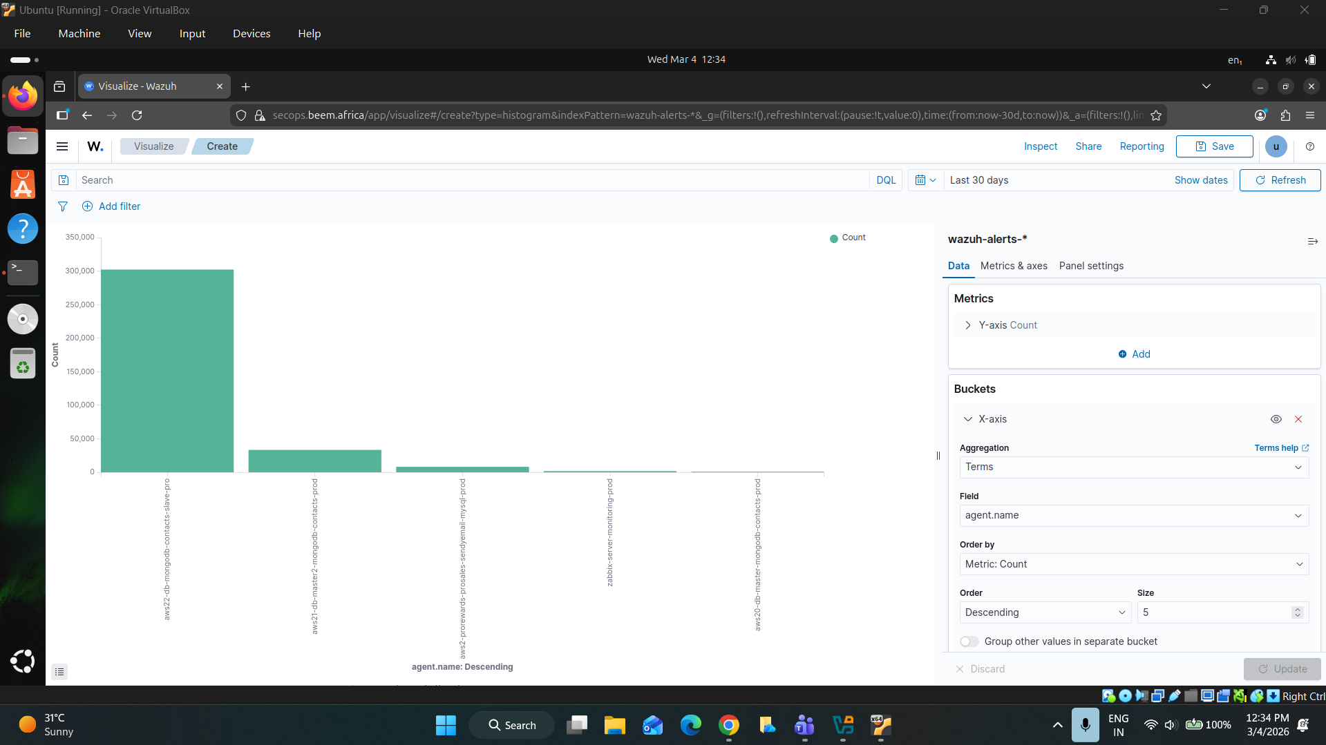

MITRE ATT&CK Per Agent
# Wazuh Dashboard: MITRE ATT&CK Per Agent panel
Split:
Terms -> agent.name
Sub aggregation -> rule.mitre.id
# Shows attack techniques triggered per agent.

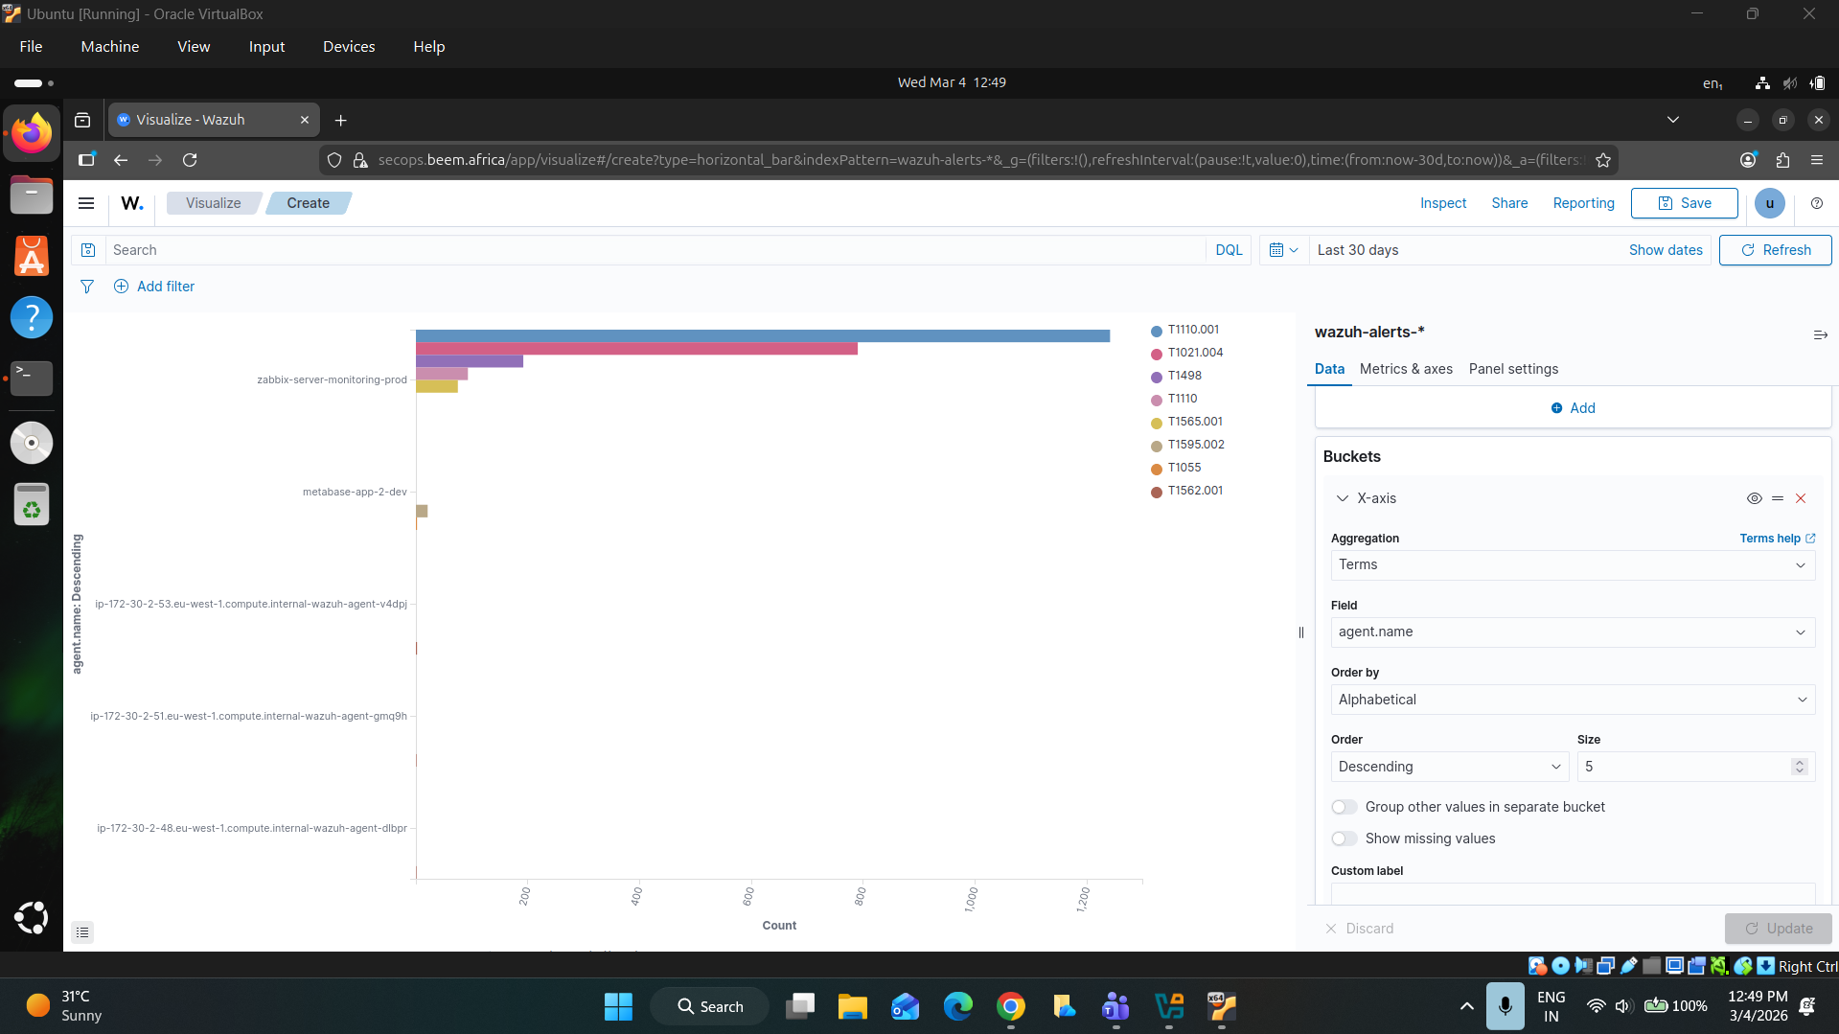

SCA Results Per Agent
# Wazuh Dashboard: SCA Results Per Agent panel
Field: agent.name
Sub aggregation: sca.policy

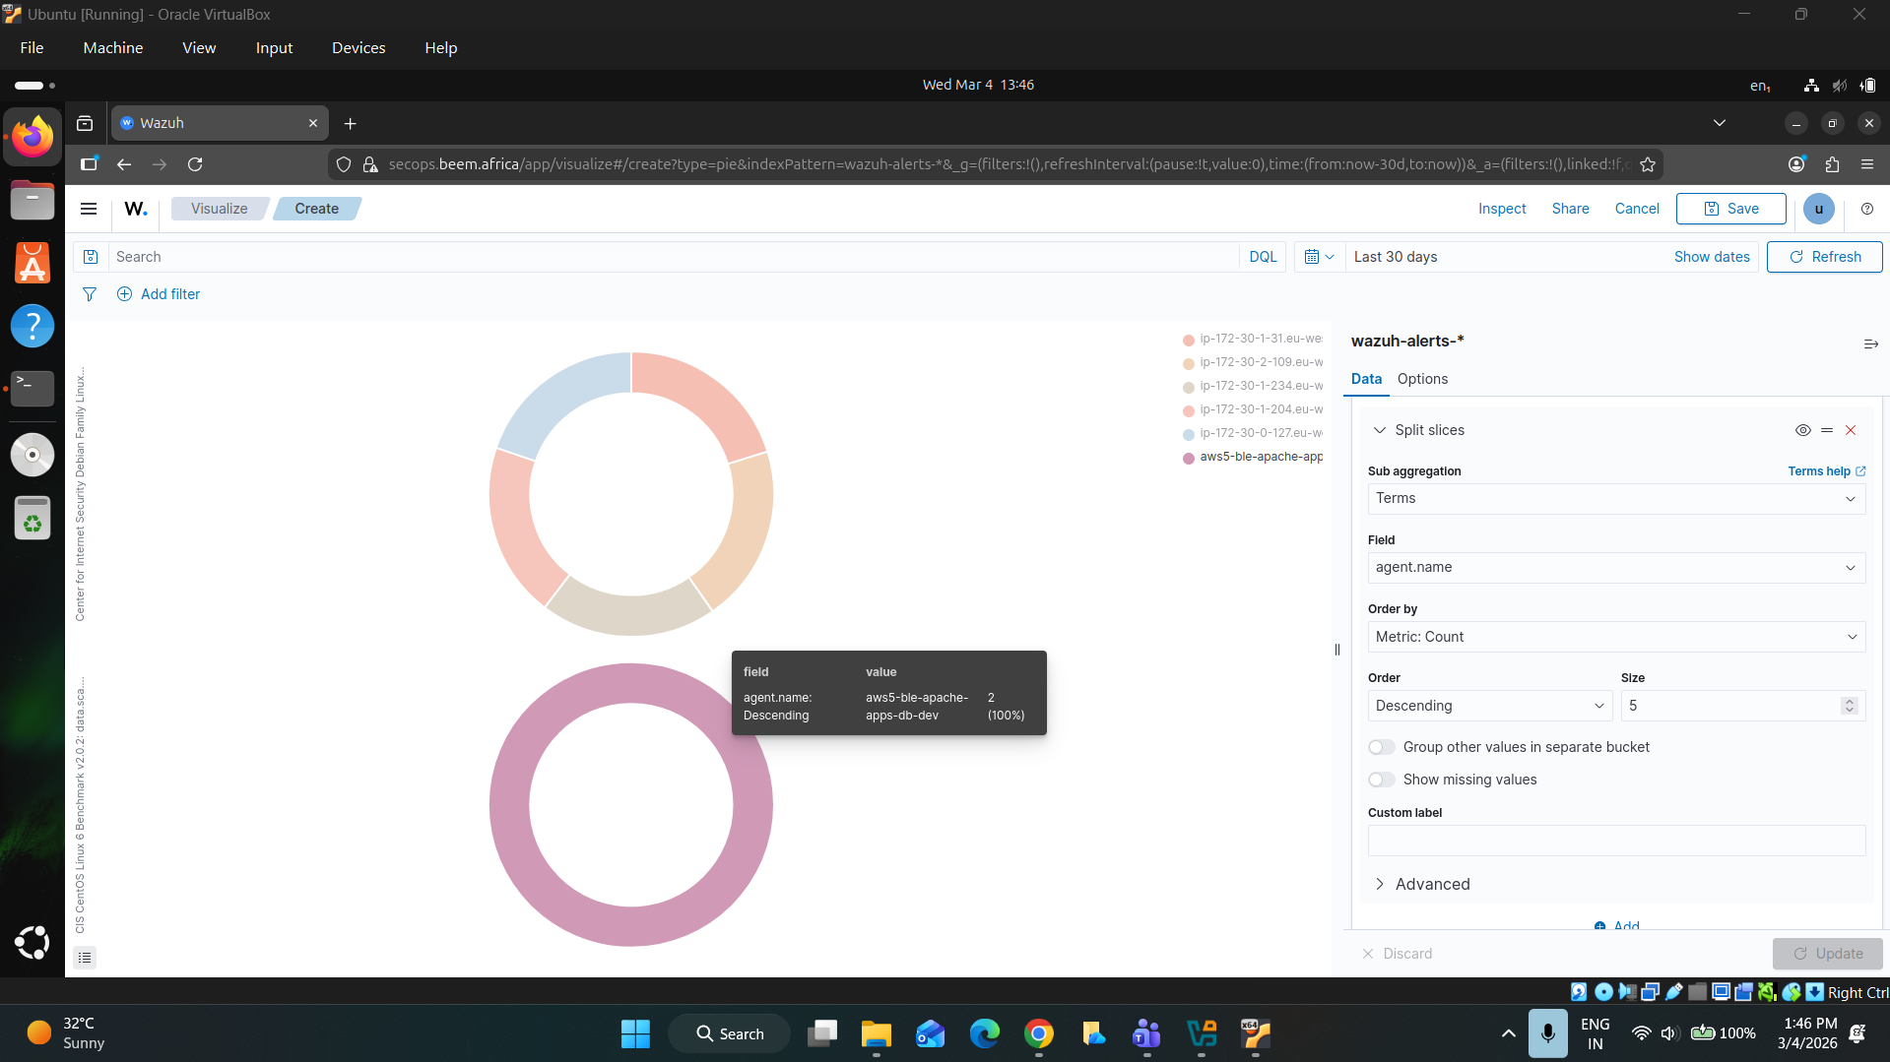

Authentication Failures Per Agent
# Wazuh Dashboard: Authentication Failures Per Agent panel
Filter: rule.groups: authentication_failed
Split by: agent.name

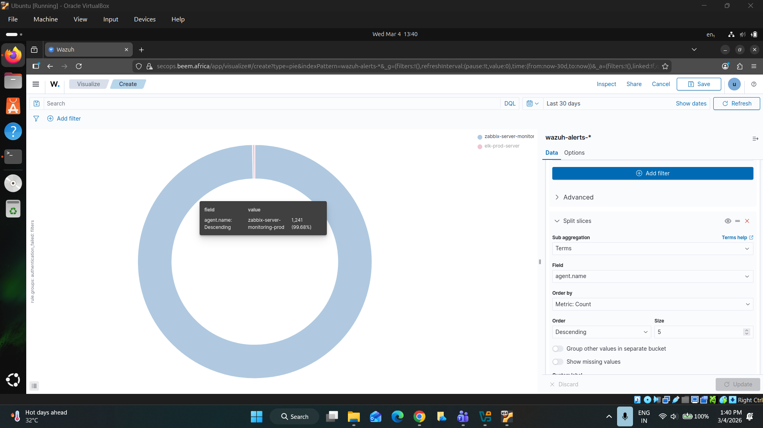

Vulnerabilities Per Agent
# Wazuh Dashboard: Vulnerabilities Per Agent panel
Field: agent.name
Sub aggregation: vulnerability.severity

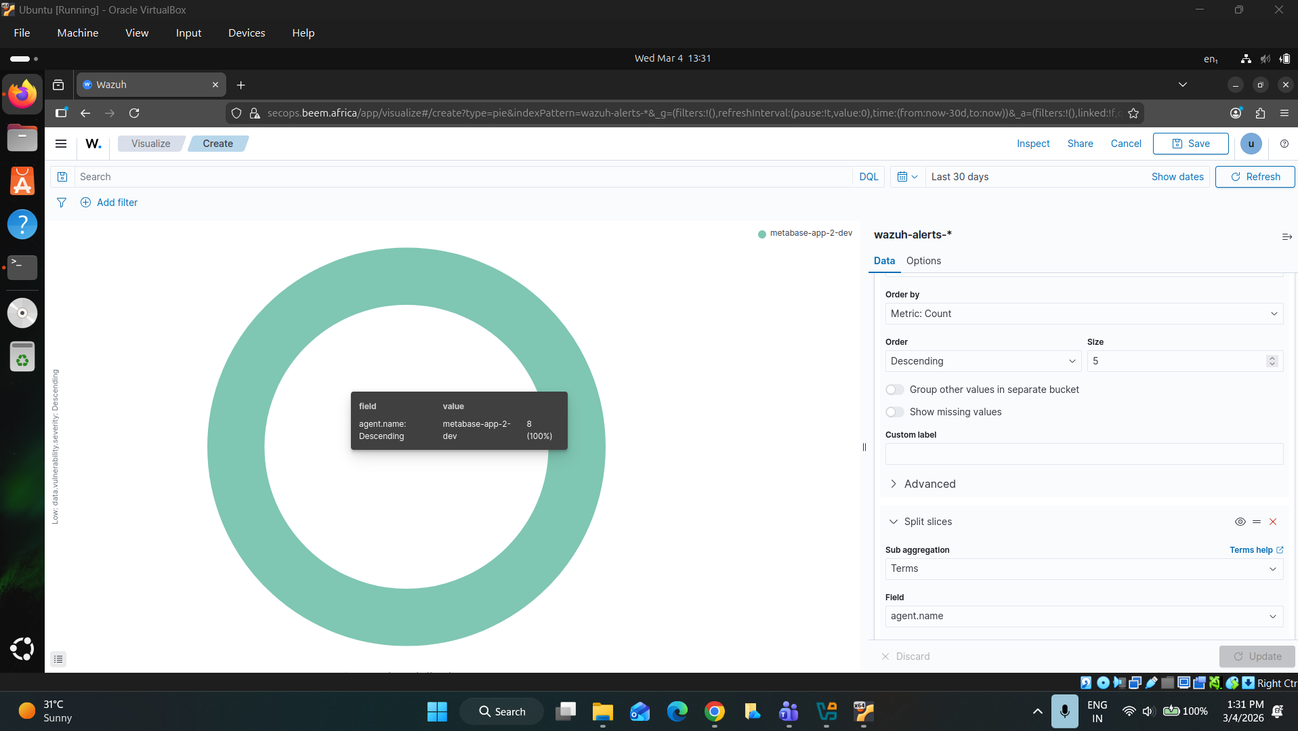
https://documentation.wazuh.com/current/getting-started/components/wazuh-dashboard.html
https://attack.mitre.org/
https://documentation.wazuh.com/current/user-manual/manager/alert-management.html

PHASE 2

SECTION 1

Design Philosophy

1.1 Business Case & Cost Optimization — Least CloudWatch Ingestion

- Enterprise container monitoring on Kubernetes presents a deceptively expensive cost centre when reliant on managed AWS log infrastructure.

- AWS CloudWatch Logs charges per-GB for ingestion ($0.50/GB in ap-south-1) and per-GB for storage, with Insights queries billed separately.

- A production EKS cluster generating Falco eBPF alerts, Trivy vulnerability scan results, Nginx access logs, and Kubernetes API audit events can produce tens of gigabytes of log data per day — making CloudWatch ingestion costs easily exceed EC2 compute costs for the cluster itself.

Cost Problem: A cluster generating just 20 GB/day of raw JSON logs incurs approximately $300/month in CloudWatch ingestion fees alone — before any Insights queries, dashboards, or metric alarms.

THE SOLUTION: Kubernetes Event Exporter (CloudWatch Alternative) & Tailscale VPN Bridge

• The Kubernetes Event Exporter is implemented as the direct alternative to
CloudWatch Logs for EKS control plane and audit events. It watches the
Kubernetes Events API, processes event streams, and forwards them directly
to the local Wazuh agent pipeline inside the EKS cluster.

• Tailscale functions purely as the connectivity bridge—establishing a secure,
private, peer-to-peer WireGuard VPN tunnel between the AWS EKS pod network
and the self-hosted Wazuh Manager running on an external Ubuntu VM. This
bypasses the need for CloudWatch logs, Kinesis, or public ingress ports.

Cost Driver | CloudWatch Architecture | This Pipeline
Log ingestion fees | $0.50/GB — escalates with workload | $0.00 — direct TCP agent shipping
Log storage | CloudWatch: $0.03/GB/month + S3 tiering | $0.00 — Wazuh Manager local disk
Query / analytics | CloudWatch Insights: $0.005/GB scanned | $0.00 — Wazuh built-in Lucene + dashboards
SIEM correlation | Requires additional service (OpenSearch/SIEM) | Native Wazuh rule engine — included
Alert routing | CloudWatch Alarms + SNS (per-alarm cost) | Wazuh Rules 100050-100062 — no additional cost
Estimated delta | ~$200-500/month for medium cluster | ~$0 incremental (EC2 + EBS for Wazuh only)

1.2 Kubernetes Logical Architecture & Namespaces
The pipeline spans three purpose-separated Kubernetes namespaces, each containing components with distinct security functions and least-privilege RBAC boundaries:

Namespace | Key Workloads | Security Function
wazuh | protected-nginx (4-container sidecar pod) kubernetes-event-exporter tailscale-auth Secret falco-receiver-svc Service | Application workload monitoring. Wazuh agent ships all telemetry to the central SIEM over Tailscale VPN. Event exporter watches cluster-level Kubernetes events.
falco | falco DaemonSet (eBPF driver) falco-falcosidekick Deployment | Runtime kernel-level threat detection. Falco intercepts system calls on all EKS nodes. Falcosidekick fans out alerts to the wazuh namespace UDP receiver.
trivy-system | trivy-operator Deployment VulnerabilityReport CRDs (cluster-wide) | Continuous image vulnerability scanning. The Trivy Operator scans all workload images and persists results as Kubernetes Custom Resources queryable by the trivy-bridge sidecar.

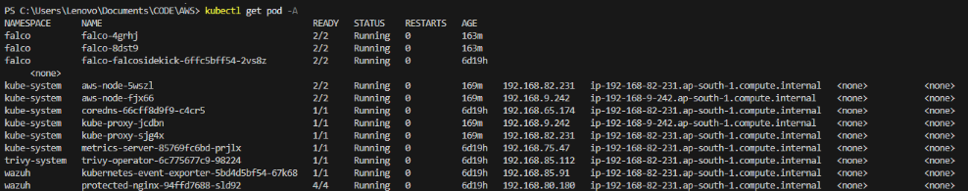

https://aws.amazon.com/cloudwatch/pricing/
https://kubernetes.io/docs/concepts/overview/working-with-objects/namespaces/

SECTION 2
Network Topology & VPN System

[FOR LOCAL TEST ENVIRONMENT, ONLY TO CONNECT WAZUH ON UBUNTU VM TO AWS EKS]

Tailscale WireGuard mesh — zero public port exposure

2.1 Tailscale VPN Integration
Tailscale creates a WireGuard-based peer-to-peer encrypted mesh network. Each node in the mesh receives a stable IP address in the 100.x.y.z range (CGNAT space) that is reachable by any other node in the same Tailscale tailnet — regardless of NAT, cloud VPC boundaries, or network topology.

Node | Hostname / Role | Tailscale IP | Ports Bound
Wazuh Manager VM | daksol — Central SIEM (EC2 instance) | 100.122.162.110 | 1514/TCP (agent data) 1515/TCP (enrollment)
EKS Pod (Tailscale sidecar) | protected-nginx — dynamic registration | 100.85.217.5 (example) | N/A (outbound only)

Pod Network Namespace Architecture

All four containers in the protected-nginx pod share a single Linux network namespace — meaning they all share the same IP address, loopback interface, and network routing table. This shared namespace is the architectural key that enables the security pipeline to function without inter-pod network hops:

● The tailscale container claims a WireGuard kernel interface (tailscale0) inside the shared pod namespace, establishing a tunnel to 100.122.162.110.
● The wazuh-agent container can route traffic to 100.122.162.110:1514 through this interface — traffic leaves the pod encrypted over WireGuard.
● The falco_listener.py process binds 0.0.0.0:5140/UDP inside the same namespace — receiving Falco alerts forwarded by the Kubernetes ClusterIP service falco-receiver-svc.
● The trivy-bridge container contacts the Kubernetes API via the standard in-cluster HTTPS path — its service account token (tailscale SA) is used for RBAC-controlled CRD reads.

https://tailscale.com/docs

SECTION 3

The Three Security Data Pipelines

Step-by-step data flows for Trivy, Falco, and Kubernetes Events

3.1 Pipeline A — Trivy Vulnerability Reports
The Trivy pipeline delivers enriched CVE intelligence from the Kubernetes CRD layer to the Wazuh SIEM dashboard with full workload context (namespace, kind, name, container).

Step 1: Discovery

The trivy-operator in the trivy-system namespace watches all pod scheduling events cluster-wide. When a new workload is detected or an image tag changes, the operator is triggered.

Step 2: Scan

The operator does a scan Job targeting the container image. Results are persisted as VulnerabilityReport Custom Resource Definitions (CRDs) under the aquasecurity.github.io API group, namespaced to the workload being scanned.

Step 3: Extraction & Enrichment

The trivy-bridge container (running inside the protected-nginx pod) executes kubectl get vulnerabilityreports -A every 300 seconds. It uses a go-template that extracts namespace, resource kind, resource name, container name, CVE ID, severity, and title — formatting each finding as a single flat JSON line. Output is written to /logs/trivy/reports.json in the shared emptyDir volume.

Step 4: Log Collection

The wazuh-agent container tails /logs/trivy/reports.json via the <localfile> directive in ossec.conf, using log_format json to parse each line as a structured JSON event.

Step 5: Shipment

The Wazuh agent ships all parsed events to 100.122.162.110:1514 via the Tailscale WireGuard tunnel using the proprietary Wazuh agent protocol (encrypted, TCP).

Step 6: Ingestion & Alerting

The Wazuh Manager applies the trivy JSON decoder (prematch: ^{"CVE") and fires Rule 100050 (Level 10): 'Trivy Scan: $(Severity) Vulnerability - $(CVE) in $(namespace)/$(name) (container: $(container))'.

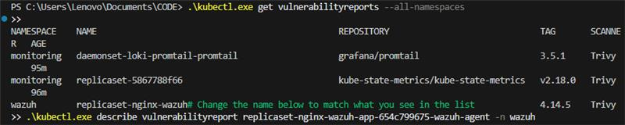

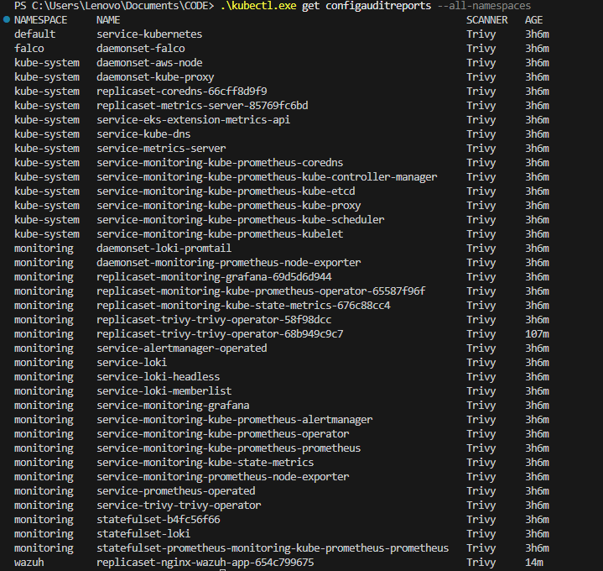

3.2 Pipeline B — Falco Container Runtime Auditing
The Falco pipeline delivers sub-second kernel-level threat detection from EKS worker nodes to the Wazuh SIEM, using eBPF for zero-overhead syscall interception.

Step 1: Syscall Interception

The falco DaemonSet loads a program into the Linux kernel on every EKS worker node. It attaches to kernel tracepoints for security-relevant syscalls. Every container process on the node is monitored at the kernel level.

Step 2: Detection

When a container process executes a syscall that matches a Falco rule condition (e.g., reading /etc/shadow, spawning a shell, contacting the K8s API server), Falco enriches the event with full Kubernetes context: pod name, namespace, container ID, image name, and image tag.

Step 3: Local Forwarding

Falco posts the enriched alert as a JSON HTTP payload to falco-falcosidekick running in the falco namespace on port 2801.

Step 4: Syslog-over-UDP Gateway

Falcosidekick's syslog output plugin processes the alert and sends a UDP datagram to falco-receiver-svc.wazuh.svc.cluster.local:5140. The Kubernetes DNS resolution routes this to the ClusterIP service in the wazuh namespace.

Step 5: Ingress & Buffering

The falco-receiver-svc ClusterIP Service forwards the UDP packet to port 5140 on the protected-nginx pod — received by the falco_listener.py Python script thread bound to 0.0.0.0:5140.

Step 6: Local Log Write

The Python script strips any syslog header (locating the first '{' character in the payload) and appends the clean JSON line to /var/ossec/logs/falco.log, flushing immediately.

Step 7: Shipment & Alert

The wazuh-agent logcollector tails falco.log and ships new lines to the Wazuh Manager, where the falco decoder (prematch: falco|uuid) fires Rule 100051 (Level 12 — Critical): 'Falco Alert: $(rule)'.

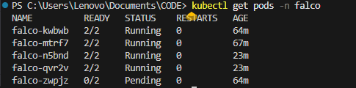

3.3 Pipeline C — Kubernetes Event Exporter
The Kubernetes Event Exporter pipeline provides SIEM visibility into the Kubernetes control plane layer — capturing scheduling failures, node events, deployment modifications, and configuration changes that are invisible to container-level monitoring.

Step 1: API Monitoring

The kubernetes-event-exporter deployment in the wazuh namespace continuously watches the Kubernetes Events API via a ClusterRole that grants list/watch access to all resource types across all API groups.

Step 2: Filtering

The exporter filters events per its config.yaml routing rules and POSTs matching events as JSON payloads to the local webhook endpoint: http://falco-receiver-svc.wazuh.svc.cluster.local:5141/. The payload layout includes message, reason, type, count, and involvedObject (kind + name).

Step 3: Ingress

The falco-receiver-svc Service forwards the HTTP POST to port 5141 on the protected-nginx pod — received by the WebhookHandler thread in falco_listener.py. The handler reads the POST body and appends it to /var/ossec/logs/k8s_events.log.

Step 4: Shipment & Alert

The wazuh-agent reads k8s_events.log (log_format json) and ships events to the Manager. Rule 100060 fires for all events; Rule 100061 (Level 8) escalates for type=Warning; Rule 100062 (Level 5) tracks config changes to Deployments, ConfigMaps, Secrets, and ReplicaSets.

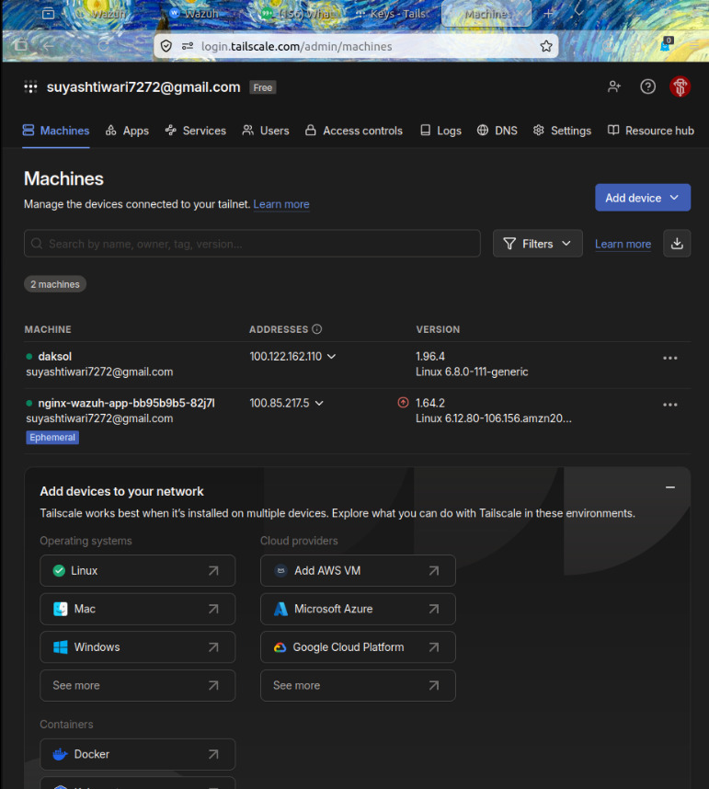

https://trivy.dev/

https://falco.org/docs/

https://kubernetes.io/docs/reference/access-authn-authz/rbac/

https://helm.sh/docs/intro/using_helm/

https://github.com/resmoio/kubernetes-event-exporter

SECTION 4
Deployment Specifications & Manifests

4.1 Wazuh Sidecar — wazuh-sidecar-final.yaml

# YAML: wazuh-sidecar-final.yaml
apiVersion: apps/v1
kind: Deployment
metadata:
name: protected-nginx
namespace: wazuh
spec:
replicas: 1
selector:
matchLabels:
app: protected-nginx
template:
metadata:
labels:
app: protected-nginx
spec:
serviceAccountName: tailscale
volumes:
- name: shared-logs
emptyDir: {}
- name: wazuh-config
configMap:
name: wazuh-agent-config
- name: tun
hostPath:
path: /dev/net/tun
containers:
# ── 1. Primary Application ─────────────────────────────────────────
- name: nginx
image: nginx:latest
volumeMounts:
- name: shared-logs
mountPath: /var/log/nginx
# ── 2. Wazuh Agent (SIEM Shipper) ──────────────────────────────────
- name: wazuh-agent
image: wazuh/wazuh-agent:4.14.5
lifecycle:
postStart:
exec:
command: ["/bin/sh", "-c",
"nohup python3 -u /var/ossec/falco_listener.py >/dev/null 2>&1 &"]
env:
- name: WAZUH_MANAGER
value: "100.122.162.110"
- name: WAZUH_REGISTRATION_SERVER
value: "100.122.162.110"
- name: WAZUH_AGENT_NAME
value: "nginx-eks-pod"
volumeMounts:
- name: shared-logs
mountPath: /logs/nginx
- name: shared-logs
mountPath: /logs/trivy
- name: wazuh-config
mountPath: /var/ossec/etc/ossec.conf
subPath: ossec.conf
- name: wazuh-config
mountPath: /var/ossec/falco_listener.py
subPath: falco_listener.py
# ── 3. Trivy-Bridge (CVE Data Extractor) ───────────────────────────
- name: trivy-bridge
image: bitnami/kubectl:latest
command: ["/bin/sh", "-c"]
args:
- |
while true; do
kubectl get vulnerabilityreports -A \
-o go-template='{{range .items}}{{$ns := .metadata.namespace}}{{$kind := index .metadata.labels "trivy-operator.resource.kind"}}{{$name := index .metadata.labels "trivy-operator.resource.name"}}{{$container := index .metadata.labels "trivy-operator.container.name"}}{{range .report.vulnerabilities}}{"namespace": "{{$ns}}", "kind": "{{$kind}}", "name": "{{$name}}", "container": "{{$container}}", "CVE": "{{.vulnerabilityID}}", "Severity": "{{.severity}}", "Title": "{{.title}}"}{{"\\n"}}{{end}}{{end}}' > /logs/trivy/reports.json 2>/dev/null
sleep 300
done
volumeMounts:
- name: shared-logs
mountPath: /logs/trivy
# ── 4. Tailscale VPN Gateway ────────────────────────────────────────
- name: tailscale
image: tailscale/tailscale:v1.64.2
securityContext:
capabilities:
add: ["NET_ADMIN"]
privileged: true
env:
- name: TS_AUTHKEY
valueFrom:
secretKeyRef:
name: tailscale-auth
key: TS_AUTHKEY
- name: TS_KUBE_SECRET
value: "tailscale-auth"
- name: TS_USERSPACE
value: "false"
- name: TS_ACCEPT_DNS
value: "false"
volumeMounts:
- name: tun
mountPath: /dev/net/tun
---
apiVersion: v1
kind: Service
metadata:
name: falco-receiver-svc
namespace: wazuh
spec:
selector:
app: protected-nginx
ports:
- name: falco
protocol: UDP
port: 5140
targetPort: 5140
- name: k8s-events
protocol: TCP
port: 5141
targetPort: 5141

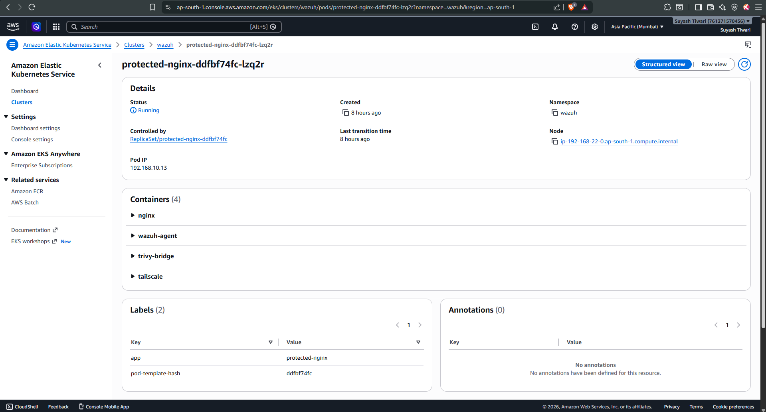

4.2 Local Agent ConfigMap — wazuh-agent-config-final.yaml

# YAML: wazuh-agent-config-final.yaml
apiVersion: v1
kind: ConfigMap
metadata:
name: wazuh-agent-config
namespace: wazuh
data:
ossec.conf: |-
<ossec_config>
<client>
<server>
<address>100.122.162.110</address>
<port>1514</port>
</server>
<enrollment>
<enabled>yes</enabled>
<manager_address>100.122.162.110</manager_address>
<agent_name>nginx-eks-pod</agent_name>
</enrollment>
</client>
<localfile>
<log_format>syslog</log_format>
<location>/logs/nginx/access.log</location>
</localfile>
<localfile>
<log_format>json</log_format>
<location>/logs/trivy/reports.json</location>
</localfile>
<localfile>
<log_format>syslog</log_format>
<location>/var/ossec/logs/falco.log</location>
</localfile>
<localfile>
<log_format>json</log_format>
<location>/var/ossec/logs/k8s_events.log</location>
</localfile>
</ossec_config>
falco_listener.py: |-
import socket
import threading
from http.server import HTTPServer, BaseHTTPRequestHandler
def listen_udp(port, log_path, name):
s = socket.socket(socket.AF_INET, socket.SOCK_DGRAM)
s.bind(('0.0.0.0', port))
print(f"{name} UDP listener started on port {port}...")
with open(log_path, 'a', encoding='utf-8') as f:
while True:
data, addr = s.recvfrom(65535)
log_line = data.decode('utf-8').strip()
if '{' in log_line:
log_line = log_line[log_line.find('{'):]
f.write(log_line + '\n')
f.flush()
class WebhookHandler(BaseHTTPRequestHandler):
def do_POST(self):
content_length = int(self.headers['Content-Length'])
post_data = self.rfile.read(content_length)
log_line = post_data.decode('utf-8').strip()
with open('/var/ossec/logs/k8s_events.log', 'a', encoding='utf-8') as f:
f.write(log_line + '\n')
f.flush()
self.send_response(200)
self.end_headers()
def log_message(self, format, *args):
return
def listen_http(port):
server = HTTPServer(('0.0.0.0', port), WebhookHandler)
print(f"Kubernetes Events HTTP webhook listener started on port {port}...")
server.serve_forever()
def main():
t1 = threading.Thread(target=listen_udp,
args=(5140, '/var/ossec/logs/falco.log', 'Falco'))
t2 = threading.Thread(target=listen_http, args=(5141,))
t1.daemon = True
t2.daemon = True
t1.start()
t2.start()
t1.join()
t2.join()
if __name__ == '__main__':
main()

4.3 RBAC — Trivy Bridge — trivy-rbac.yaml

# YAML: trivy-rbac.yaml — Principle of Least Privilege
apiVersion: rbac.authorization.k8s.io/v1
kind: ClusterRole
metadata:
name: tailscale-trivy-reader
rules:
- apiGroups: ["aquasecurity.github.io"]
resources: ["vulnerabilityreports"]
verbs: ["get", "list", "watch"]
---
apiVersion: rbac.authorization.k8s.io/v1
kind: ClusterRoleBinding
metadata:
name: tailscale-trivy-reader-binding
subjects:
- kind: ServiceAccount
name: tailscale
namespace: wazuh
roleRef:
kind: ClusterRole
name: tailscale-trivy-reader
apiGroup: rbac.authorization.k8s.io

4.4 Kubernetes Event Exporter — kubernetes-event-exporter.yaml

# YAML: kubernetes-event-exporter.yaml
apiVersion: v1
kind: ServiceAccount
metadata:
name: kubernetes-event-exporter
namespace: wazuh
---
apiVersion: rbac.authorization.k8s.io/v1
kind: ClusterRole
metadata:
name: kubernetes-event-exporter
rules:
- apiGroups: ["*"]
resources: ["*"]
verbs: ["get", "list", "watch"]
---
apiVersion: rbac.authorization.k8s.io/v1
kind: ClusterRoleBinding
metadata:
name: kubernetes-event-exporter
subjects:
- kind: ServiceAccount
name: kubernetes-event-exporter
namespace: wazuh
roleRef:
kind: ClusterRole
name: kubernetes-event-exporter
apiGroup: rbac.authorization.k8s.io
---
apiVersion: v1
kind: ConfigMap
metadata:
name: event-exporter-config
namespace: wazuh
data:
config.yaml: |
logLevel: info
logFormat: json
maxEventAgeSeconds: 60
kubeQPS: 100
kubeBurst: 500
route:
routes:
- match:
- receiver: wazuh-syslog
receivers:
- name: wazuh-syslog
webhook:
endpoint: "http://falco-receiver-svc.wazuh.svc.cluster.local:5141/"
layout:
message: "{{ .Message }}"
reason: "{{ .Reason }}"
type: "{{ .Type }}"
count: "{{ .Count }}"
involvedObject:
kind: "{{ .InvolvedObject.Kind }}"
name: "{{ .InvolvedObject.Name }}"
---
apiVersion: apps/v1
kind: Deployment
metadata:
name: kubernetes-event-exporter
namespace: wazuh
spec:
replicas: 1
selector:
matchLabels:
app: kubernetes-event-exporter
template:
metadata:
labels:
app: kubernetes-event-exporter
spec:
serviceAccountName: kubernetes-event-exporter
containers:
- name: exporter
image: ghcr.io/resmoio/kubernetes-event-exporter:latest
imagePullPolicy: IfNotPresent
args:
- -conf=/etc/event-exporter/config.yaml
volumeMounts:
- name: config
mountPath: /etc/event-exporter
resources:
requests:
cpu: 50m
memory: 64Mi
limits:
cpu: 100m
memory: 128Mi
volumes:
- name: config
configMap:
name: event-exporter-config

4.5 Falco Helm Values — falco-values.yaml

# YAML: falco-values.yaml (Helm install values)
driver:
kind: ebpf
falco:
json_output: true
json_include_output_property: true
log_stderr: true
log_syslog: false
log_level: info
stdout_output:
enabled: true
http_output:
enabled: true
url: "http://falco-falcosidekick.falco.svc.cluster.local:2801"
falcosidekick:
enabled: true
config:
debug: true
syslog:
host: falco-receiver-svc.wazuh.svc.cluster.local
port: 5140
protocol: udp
format: json
minimumpriority: notice
customfields:
source: "falco-eks"
cluster: "production-eks"

https://docs.aws.amazon.com/eks/latest/userguide/what-is-eks.html

SECTION 5

Wazuh Manager Configuration

5.1 Custom JSON decoders — local_decoder.xml

# XML: /var/ossec/etc/decoders/local_decoder.xml
<!-- Decoder: Trivy CVE reports — prematch on leading {"CVE" key -->
<decoder name="trivy">
<prematch>^{"CVE"</prematch>
<plugin_decoder>JSON_Decoder</plugin_decoder>
</decoder>
<!-- Decoder: Falco runtime alerts — prematch on 'falco' keyword or 'uuid' field -->
<decoder name="falco">
<prematch>falco|uuid</prematch>
<plugin_decoder>JSON_Decoder</plugin_decoder>
</decoder>

5.2 Custom Alert Rules — local_rules.xml

# XML: /var/ossec/etc/rules/local_rules.xml
<group name="local,">
<!-- Rule 100050: Trivy CVE alert with full workload context (Level 10 = High) -->
<rule id="100050" level="10">
<decoded_as>json</decoded_as>
<field name="CVE">\.+</field>
<description>Trivy Scan: $(Severity) Vulnerability - $(CVE)
in $(namespace)/$(name) (container: $(container))</description>
</rule>
<!-- Rule 100051: Falco runtime threat alert (Level 12 = Critical) -->
<rule id="100051" level="12">
<decoded_as>json</decoded_as>
<field name="output">\.+</field>
<field name="priority">\.+</field>
<field name="rule">\.+</field>
<description>Falco Alert: $(rule)</description>
</rule>
<!-- Rule 100060: Base K8s Event (all events, Level 3 = Informational) -->
<rule id="100060" level="3">
<decoded_as>json</decoded_as>
<field name="reason">\.+</field>
<description>Kubernetes Event: [$(involvedObject.kind)] [$(reason)] - $(message)</description>
</rule>
<!-- Rule 100061: K8s Warning Event — inherits 100060 (Level 8 = Warning) -->
<rule id="100061" level="8">
<if_sid>100060</if_sid>
<field name="type">^Warning$</field>
<description>Kubernetes Warning Event: [$(involvedObject.kind)] $(reason) - $(message)</description>
<group>k8s_warning,</group>
</rule>
<!-- Rule 100062: K8s Config Change Event (Level 5 = Notice) -->
<rule id="100062" level="5">
<if_sid>100060</if_sid>
<field name="involvedObject.kind">^Deployment$|^ConfigMap$|^Secret$|^ReplicaSet$</field>
<description>Kubernetes Config/Deployment Event: $(involvedObject.name) $(reason)</description>
<group>k8s_config,</group>
</rule>
</group>

Rule ID | Trigger Condition | Level | Description Pattern
100050 | JSON field CVE present | 10 — High | Trivy Scan: $(Severity) - $(CVE) in $(namespace)/$(name)
100051 | JSON fields output + priority + rule present | 12 — Critical | Falco Alert: $(rule)
100060 | JSON field reason present (any K8s event) | 3 — Info | Kubernetes Event: [Kind] [Reason] - Message
100061 | Parent 100060 + type=Warning | 8 — Warning | Kubernetes Warning Event: Kind Reason
100062 | Parent 100060 + involvedObject.kind in set | 5 — Notice | Kubernetes Config/Deployment Event

Custom rules - Rules · Wazuh documentation

SECTION 6

Threat Auditing

6.1 Falco Runtime Threat Simulation

Step 1: Execute the simulated attack
# PowerShell: Simulated attack — sensitive file read
& "C:\Program Files\Kubernetes\kubectl.exe" exec `
-n wazuh deployment/protected-nginx `
-c nginx `
-- cat /etc/shadow
# Note: 'Permission denied' is expected and acceptable.
# Falco fires on the openat() SYSCALL ATTEMPT, not on successful file access.
# The eBPF probe intercepts the syscall before kernel permission checks complete.

Step 2: Verify Falco captured the event
# Shell: Verify Falco alert in wazuh-agent container log
& "C:\Program Files\Kubernetes\kubectl.exe" exec `
-n wazuh deployment/protected-nginx `
-c wazuh-agent `
-- cat /var/ossec/logs/falco.log
# Expected entry (within ~2 seconds of attack command):
{
"uuid": "564a1a6f-9707-479a-827b-e66865dcaf9f",
"output": "Warning Sensitive file opened for reading by non-trusted program
| file=/etc/shadow evt_type=openat user=root
process=cat command=cat /etc/shadow
container_name=nginx k8s_pod_name=protected-nginx-xxx k8s_ns_name=wazuh",
"priority": "Warning",
"rule": "Read sensitive file untrusted",
"time": "2026-05-21T13:31:05.262988306Z"
}

Step 3: Verify alert in Wazuh SIEM dashboard
In the Wazuh dashboard, navigate to Security Events and search:
# Wazuh Dashboard: Alert verification search query
rule.id: 100051
# Expected alert fields:
# rule.description: Falco Alert: Read sensitive file untrusted
# rule.level: 12
# data.rule: Read sensitive file untrusted
# data.priority: Warning
# agent.name: nginx-eks-pod

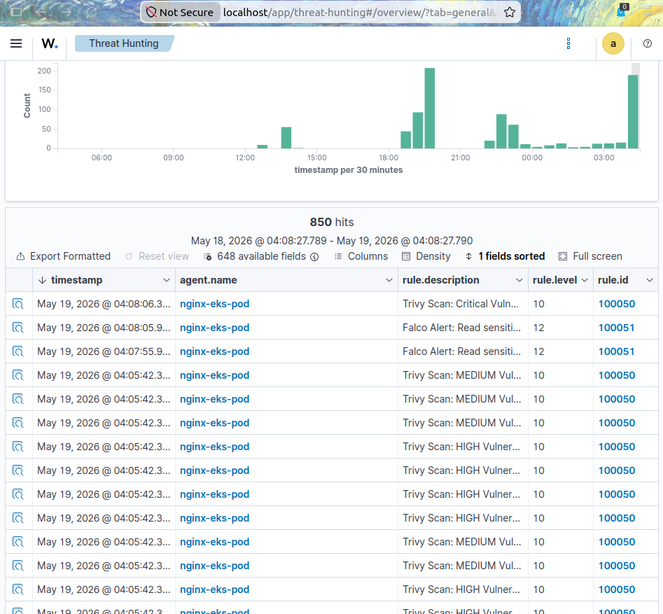

6.2 Trivy Vulnerability Report Verification

Step 1: Verify trivy-bridge is generating reports
# PowerShell: Inspect CVE report JSON in shared volume
& "C:\Program Files\Kubernetes\kubectl.exe" exec `
-n wazuh deployment/protected-nginx `
-c wazuh-agent `
-- cat /logs/trivy/reports.json
# Expected: one JSON line per CVE finding. Example:
{"namespace":"wazuh","kind":"Deployment","name":"protected-nginx",
"container":"nginx","CVE":"CVE-2023-44487","Severity":"HIGH",
"Title":"HTTP/2 Rapid Reset Attack"}

Step 2: Verify in Wazuh SIEM dashboard
Navigate to Security Events and search:
# Wazuh Dashboard: CVE alert verification search
rule.id: 100050
# Expected alert fields:
# rule.description: Trivy Scan: HIGH Vulnerability - CVE-2023-44487
# in wazuh/protected-nginx (container: nginx)
# rule.level: 10
# data.CVE: CVE-2023-44487
# data.Severity: HIGH
# data.namespace: wazuh
# data.name: protected-nginx
# data.container: nginx

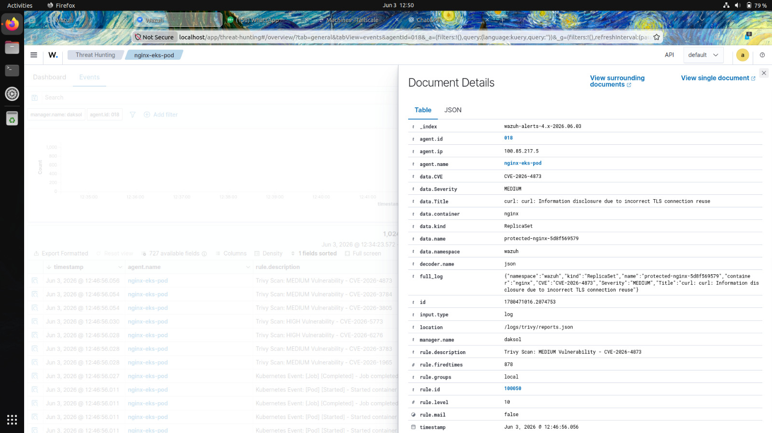



Check | Command / Location | Expected Result
Pods running (3 namespaces) | kubectl get pods -A | falco, trivy-operator, protected-nginx all Running
Tailscale connectivity | kubectl exec ... -- tailscale status | daksol peer (100.122.162.110) shown as active
Wazuh agent connected | kubectl logs ... -c wazuh-agent | grep Connected | Connected to server [100.122.162.110]:1514/tcp
Trivy reports generated | kubectl exec ... -- cat /logs/trivy/reports.json | One JSON line per CVE finding
Falco log populated | kubectl exec ... -- tail falco.log | JSON entries with uuid, output, priority, rule
Rule 100050 firing | Wazuh Dashboard -> Threat Hunting -> rule.id:100050 | Trivy CVE alerts visible
Rule 100051 firing | Wazuh Dashboard -> Threat Hunting -> rule.id:100051 | Falco threat alerts visible
K8s events flowing | Wazuh Dashboard -> Threat Hunting -> rule.id:100060 | Kubernetes event entries visible

https://github.com/resmoio/kubernetes-event-exporter

https://trivy.dev/

https://falco.org/docs/

