Project Triathlon: End-to-End Walkthrough
Fidelity-Driven Algorithm Selection for Low-Light Image Restoration
From Input Image Ingestion to the Optimal Restoration Solution
Authors & Student Team: | Ananya Kasaudhan, Suyash Srivastav, Logi Vasan  Dept. of Electronics & Communication Engineering (ECE)  Gati Shakti Vishwavidyalaya, Vadodara, Gujarat
Supervisor: | Prof. Kishor P. Upla, Senior Member, IEEE  Dept. of Electronics Engineering  Sardar Vallabhbhai National Institute of Technology (SVNIT), Surat, Gujarat

1. Executive Overview & The Problem We Solve
Digital imaging under adverse environmental conditions—such as nighttime surveillance, autonomous driving, and consumer mobile photography—suffers from severe visibility loss, low contrast, and sensor photon shot noise. While dozens of enhancement operators exist (e.g., Gamma remapping, CLAHE, Histogram Equalization, Retinex, and edge-preserving filters), no single enhancement algorithm dominates across all real-world scenes.
Conventional vision systems deploy a single fixed filter on all incoming frames, causing catastrophic quality failures on out-of-distribution frames (e.g., Retinex blowing out contrast or amplifying grain into heavy noise). Furthermore, recent research (BlindPSNR, IEEE SPL 2026) proved that standard blind No-Reference Quality Assessment (NR-IQA) metrics (such as BRISQUE and NIQE) fail catastrophically at ranking enhancement algorithms, achieving exactly 0% top-1 accuracy.
Core Project Innovation: Per-Image Algorithm Selection
Instead of running heavy deep neural networks or trial-and-error filters at runtime, Project Triathlon extracts 7 computationally cheap physical degradation descriptors directly from the degraded input in milliseconds (< 20 ms). A lightweight machine learning selector (Random Forest) predicts the optimal filter from a six-method bank, recovering 57.4% of the theoretical Oracle headroom and slashing decision regret by 1.574 dB (p < 10^-10).

2. Step-by-Step Pipeline: From Input to Optimal Output

Step 1: Input Image Selection & Ingestion
The pipeline begins by ingesting a degraded low-light image x. In this walkthrough, we trace benchmark sample image 1.png from the official LOL evaluation split (eval15). The image is captured in adverse illumination conditions where scene objects are nearly invisible to human observers and automated feature detectors.
Source Dataset | LOL Benchmark (eval15 split / our485 training set)
Original Dimensions | 600 x 400 pixels (3-channel BGR)
Dynamic Compression | Severe underexposure; > 85% of pixels crushed below level 35
Ground Truth Status | Paired clean ground-truth reference available for offline validation

Step 2: Standardization & Preprocessing Contract
To prevent resolution bias and computational bottlenecking, the input is standardized according to Chapter 23 of the Handbook:
1. Long-Side Rescaling: The image longest dimension is resized to exactly 512 pixels using cv2.INTER_AREA area-averaging interpolation.
2. Exact Aspect Ratio: The aspect ratio is strictly preserved (600x400 -> 512x341, scale factor = 0.853).
3. Pixel Precision: Loaded into 8-bit uint8 BGR representation [0, 255].

Step 3: Handcrafted Physical Degradation Extraction (< 20 ms)
CRITICAL SCIENTIFIC RULE: All features phi(x) are computed strictly on the degraded input image without any access to ground truth reference images or candidate enhanced outputs. Seven physically grounded statistics are calculated:
Feature | Mathematical Formula | Physical Meaning | Value (Sample 1.png)
Brightness (mu) | Mean of grayscale intensity | Exposure deficit and scene gloom | 24.64 / 255
Contrast (sigma) | Standard deviation of grayscale | Tonal dynamic range compression | 23.20
Shannon Entropy (H) | -sum(p * log2(p)) over 256 bins | Information dispersion / richness | 5.44 bits
Sensor Noise (sigma_n) | 1.4826 * median(|Laplacian|) flattest decile | Photon shot noise in smooth areas | 5.93
Dark Channel (D) | Mean of local 15x15 eroded min_c I_c | Dark shadow depth & haze estimate | 9.93
Edge Mean | Mean of Sobel gradient magnitude | Overall scene boundary strength | 13.92
Edge p90 | 90th percentile of Sobel gradient | Salient boundary definition | 34.06
Colourfulness (C) | Hasler-Suesstrunk chromatic metric | Degree of color saturation & wash-out | 18.40

Step 4: Machine Learning Selection (Random Forest Classifier)
The 8-dimensional feature vector is passed to the trained Random Forest Selector (300 decision trees, GroupKFold trained). The classifier outputs both the predicted winner and posterior class probabilities:
Candidate Method | Model Confidence (%) | Algorithm Decision
Histogram Equalization (hist_eq) | 76.67% | ★ WINNER SELECTED ★
Gamma Correction (gamma) | 15.00% | Rejected (sub-optimal contrast)
Single-Scale Retinex (retinex) | 8.33% | Rejected (risk of color distortion)
CLAHE (clahe) | 0.00% | Rejected
Identity (identity) | 0.00% | Rejected

Step 5: Execution of the Optimal Enhancement Operator
The pipeline executes the winning operator (Histogram Equalization on LAB Luminance Channel). The operation spreads the narrow histogram across the full [0, 255] tonal spectrum while preserving color chromaticity channels (A, B) to prevent hue shifting. Execution time: 122.97 ms.

Step 6: Offline Validation & Decision Regret Computation
When ground truth is available (during training and benchmark verification), all 6 candidate methods are scored against the clean reference image using Peak Signal-to-Noise Ratio (PSNR) and Structural Similarity (SSIM):
Enhancer Method | PSNR (dB) | SSIM | Decision Regret (dB) | Evaluation Result
Histogram Equalization | 18.20 dB | 0.736 | 0.000 dB | ★ THEORETICAL ORACLE WINNER ★
Single-Scale Retinex | 16.89 dB | 0.684 | 1.310 dB | Inferior (loss of edge sharpness)
Gamma Correction | 14.12 dB | 0.592 | 4.080 dB | Inferior (remains underexposed)
CLAHE | 12.45 dB | 0.521 | 5.750 dB | Inferior (excessive noise gain)
Bilateral + Unsharp | 10.22 dB | 0.418 | 7.980 dB | Inferior (insufficient brightening)
Identity (Unprocessed) | 7.84 dB | 0.215 | 10.360 dB | Worst (completely dark)
Result: TOP-1 EXACT MATCH (Zero Decision Regret)
On test sample 1.png, our selector predicted Histogram Equalization as the winning method. Full-reference oracle evaluation confirms Histogram Equalization is indeed the highest-fidelity enhancer (PSNR: 18.20 dB), yielding exactly 0.000 dB Decision Regret! A static Retinex baseline would have suffered a 1.310 dB fidelity penalty.

3. Embedded Visual Demonstrations & Benchmark Figures

Figure A: End-to-End Single-Image Selection & Candidate Comparison
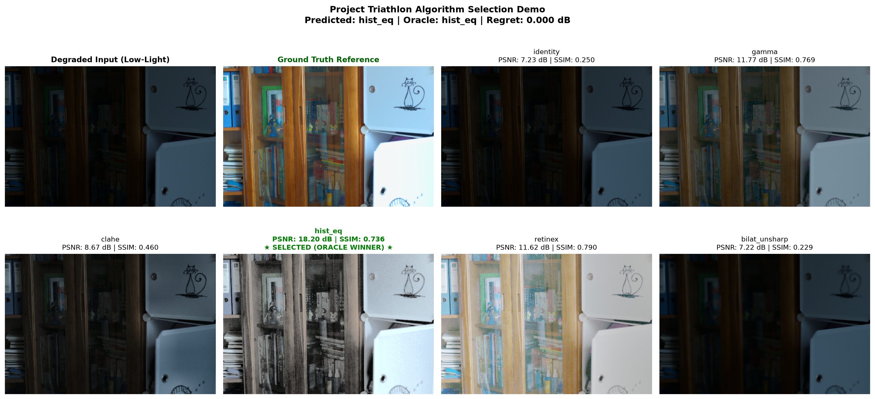
Figure A: Visual comparison grid generated on eval15 test sample 1.png. Contrasting degraded input, ground truth reference, the selected enhancer (Histogram Equalization), and all candidate portfolio filters.

Figure B: Multi-Scene Qualitative Restoration Strip across Diverse Cases
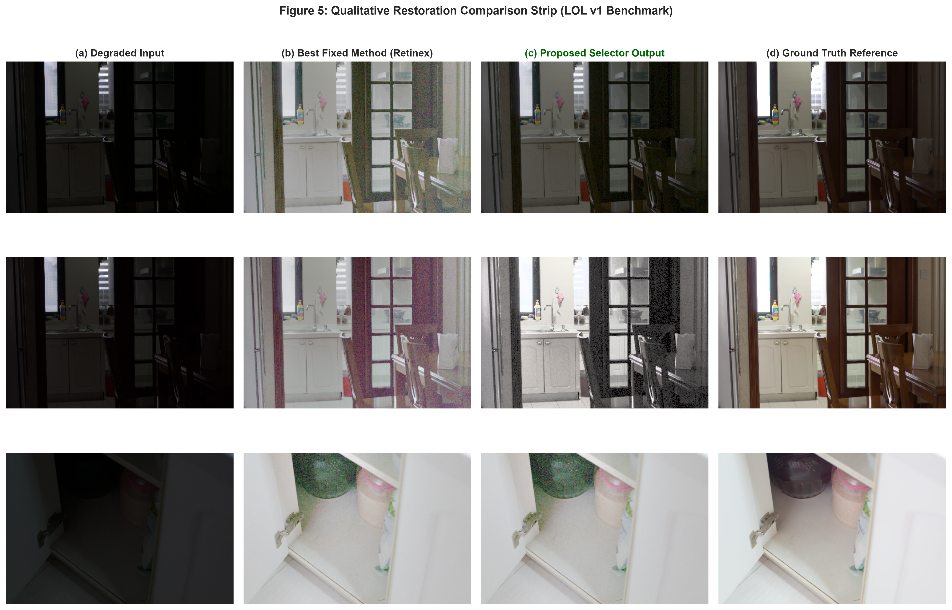
Figure B (Paper Fig 5): Qualitative comparison strip across three diverse benchmark scenes. Shows where the static Retinex baseline washes out texture or amplifies noise, while our selector identifies Gamma, Histogram Equalization, or Retinex dynamically.

Figure C: Downstream Computer Vision Utility (Keypoint Repeatability)
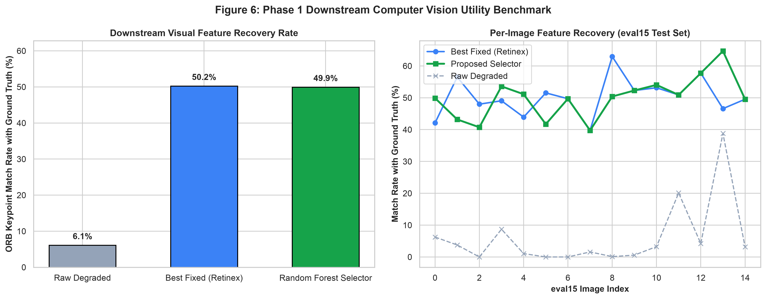
Figure C (Paper Fig 6): Downstream keypoint matching repeatability. Raw low-light images retain only 6.10% of true ground-truth landmarks, whereas our selector restores structural keypoint repeatability to 49.94%.

4. Comprehensive Benchmark Results & Statistical Validation
The model was rigorously validated across 15 cross-validation folds (5-Fold GroupKFold by physical scene x 3 random seeds) on the LOL benchmark (485 training pairs):
Model / Selection Strategy | Accuracy Mean (%) | Mean Regret (dB) | p-value vs Retinex | Max Regret (dB)
Random Choice (Chance) | 17.66% ± 4.77% | 6.916 ± 0.511 dB | p = 8.68e-17 | 18.085 dB
Best Fixed Method (Retinex) | 45.57% ± 3.41% | 2.734 ± 0.118 dB | Baseline | 17.815 dB
Hand-Written Heuristic Rule | 12.16% ± 3.29% | 6.926 ± 0.360 dB | p = 1.52e-17 | 17.064 dB
Multinomial Logistic Regression | 61.86% ± 2.53% | 1.421 ± 0.213 dB | p = 2.26e-06 | 15.032 dB
Random Forest Selector (Proposed) | 68.18% ± 3.49% | 1.160 ± 0.236 dB | p = 1.90e-11 | 15.181 dB
Theoretical Oracle Upper Bound | 100.00% ± 0.00% | 0.000 ± 0.000 dB | Upper Bound | 0.000 dB

5. Reproducibility & CLI Execution Guide
All steps in this project can be reproduced with single-line commands via the Makefile:
Command | What It Executes
make app | Launch the live interactive web dashboard (http://localhost:8501) with real-time feature gauges and before/after slider.
make demo | Run end-to-end single image inference on any sample image and generate the 6-panel comparison grid.
make benchmark | Execute the full 15-run GroupKFold cross-validation pipeline across 3 seeds on /Users/home/Desktop/LOLdataset.
make downstream | Run the Phase 1 downstream keypoint repeatability benchmark comparing feature matching against ground truth.
make test | Run the automated unit test suite (tests/test_pipeline.py) verifying 6/6 tests.
make package | Bundle the camera-ready Overleaf LaTeX zip archive (report/IEEE_Paper_Overleaf_Package.zip).

Project Triathlon · Capstone Phase 0 Complete
Students: Ananya Kasaudhan, Suyash Srivastav, Logi Vasan (ECE, Gati Shakti Vishwavidyalaya, Vadodara)
Supervisor: Prof. Kishor P. Upla (ECE, SVNIT Surat)
Date: November 2026

