**Class:** Final Year B.Tech(Computer Science and Engineering)

**Year:** 2025-26 **Semester:** 1

**Course:** High Performance Computing Lab

PRN: 22510070

Name:Suyash Yadav

**Practical No. 6**

**Exam Seat No:22510070**

**Title of practical:**

**Installation of MPI & Implementation of basic functions of MPI**

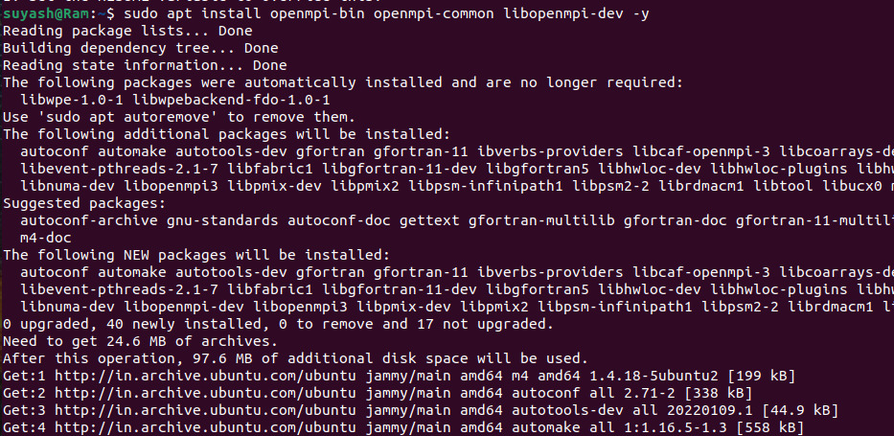

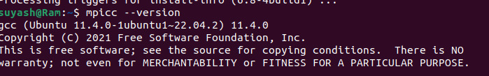

**Problem Statement 1:**

**Implement a simple hello world program by setting number of processes equal to 10**

**Screenshots:**

**#include <mpi.h>**

**#include <stdio.h>**

**int main(int argc, char** argv) {**

**int rank, size;**

**MPI_Init(&argc, &argv); // Initialize MPI**

**MPI_Comm_rank(MPI_COMM_WORLD, &rank); // Get process rank**

**MPI_Comm_size(MPI_COMM_WORLD, &size); // Get total number of processes**

**printf("Hello World from process %d out of %d\n", rank, size);**

**MPI_Finalize(); // Finalize MPI**

**return 0;**

**}**

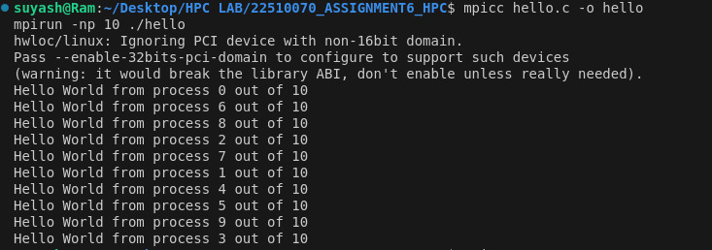

**Information 1:**

**• The Hello World program is the simplest way to test MPI.**

**• It ensures MPI installation and environment are working properly.**

**• Each process prints its rank and the total number of processes, showing parallel execution.**

**• The order of messages may vary due to concurrent execution.**

**Problem Statement 2:**

**Implement a program to display rank and communicator group of five processes**

**Screenshots:**

**#include <mpi.h>**

**#include <stdio.h>**

**int main(int argc, char *argv[]) {**

**MPI_Init(&argc, &argv);**

**int world_rank, world_size;**

**MPI_Comm_rank(MPI_COMM_WORLD, &world_rank);**

**MPI_Comm_size(MPI_COMM_WORLD, &world_size);**

**int color = (world_rank < (world_size + 1) / 2) ? 0 : 1;**

**MPI_Comm newcomm;**

**MPI_Comm_split(MPI_COMM_WORLD, color, world_rank, &newcomm);**

**int new_rank, new_size;**

**MPI_Comm_rank(newcomm, &new_rank);**

**MPI_Comm_size(newcomm, &new_size);**

**printf("World rank %d/%d -> color=%d -> newcomm rank %d/%d\n",**

**world_rank, world_size, color, new_rank, new_size);**

**MPI_Comm_free(&newcomm);**

**MPI_Finalize();**

**return 0;**

**}**

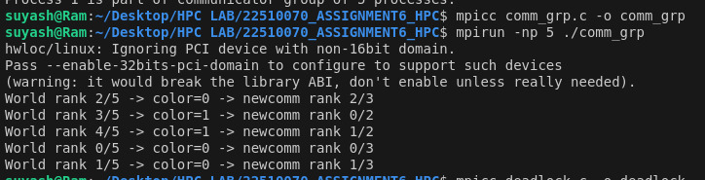

**Info:**

**• Rank identifies each process within its communicator.**

**• Communicator is a collection of processes that can communicate with each other.**

**• MPI_COMM_WORLD is the default communicator containing all processes.**

**• By running with 5 processes, we can confirm how MPI assigns ranks and handles groups.**

**• This problem helps understand process identification and group association in MPI**

**Q3: Implement a MPI program to give an example of Deadlock.**

**Program and screenshots**

**#include <mpi.h>**

**#include <stdio.h>**

**int main(int argc, char** argv) {**

**int rank;**

**MPI_Init(&argc, &argv);**

**MPI_Comm_rank(MPI_COMM_WORLD, &rank);**

**int data;**

**if (rank == 0) {**

**MPI_Send(&data, 1, MPI_INT, 1, 0, MPI_COMM_WORLD);**

**MPI_Recv(&data, 1, MPI_INT, 1, 0, MPI_COMM_WORLD, MPI_STATUS_IGNORE);**

**} else if (rank == 1) {**

**MPI_Send(&data, 1, MPI_INT, 0, 0, MPI_COMM_WORLD);**

**MPI_Recv(&data, 1, MPI_INT, 0, 0, MPI_COMM_WORLD, MPI_STATUS_IGNORE);**

**}**

**MPI_Finalize();**

**return 0;**

**}**

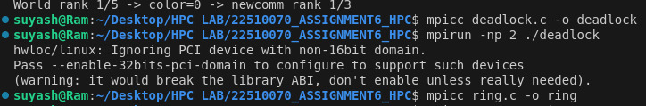

**Info:**

**• Deadlock is a state where two or more processes wait forever for each other to complete an operation.**

**• In MPI, deadlocks often occur if both processes use MPI_Send first, and no one is available to MPI_Recv.**

**• This exercise demonstrates what happens when communication is incorrectly ordered.**

**• It is useful for learning about safe communication patterns and how to avoid deadlocks in MPI programs.**

**Q4. Implement blocking MPI send & receive to demonstrate Nearest neighbor exchange of data in a ring topology.**

**Program and screenshots**

**#include <mpi.h>**

**#include <stdio.h>**

**int main(int argc, char** argv) {**

**int rank, size, send_val, recv_val;**

**MPI_Init(&argc, &argv);**

**MPI_Comm_rank(MPI_COMM_WORLD, &rank);**

**MPI_Comm_size(MPI_COMM_WORLD, &size);**

**send_val = rank; // each process sends its rank**

**int next = (rank + 1) % size;**

**int prev = (rank - 1 + size) % size;**

**MPI_Send(&send_val, 1, MPI_INT, next, 0, MPI_COMM_WORLD);**

**MPI_Recv(&recv_val, 1, MPI_INT, prev, 0, MPI_COMM_WORLD, MPI_STATUS_IGNORE);**

**printf("Process %d received %d from process %d\n", rank, recv_val, prev);**

**MPI_Finalize();**

**return 0;**

**}**

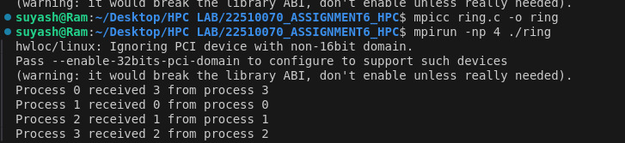

**Information / Theory:**

* **A ring topology is a structure where each process communicates with its immediate left and right neighbors.**
* **Each process sends its data to the right neighbor and receives from the left neighbor.**
* **This problem demonstrates blocking communication using MPI_Send and MPI_Recv.**
* **Such patterns are used in algorithms like distributed matrix multiplication, stencil computations, and scientific simulations.**

**Q5. Write a MPI program to find the sum of all the elements of an array A of size**

**n. Elements of an array can be divided into two equals groups. The first [n/2]**

**elements are added by the first process, P0, and last [n/2] elements the by second process, P1. The two sums then are added to get the final result.**

**Program and screenshots**

**#include <mpi.h>**

**#include <stdio.h>**

**int main(int argc, char** argv) {**

**int rank, size, n = 8; // array size (must be even)**

**int A[8] = {1,2,3,4,5,6,7,8};**

**int local_sum = 0, total_sum = 0;**

**MPI_Init(&argc, &argv);**

**MPI_Comm_rank(MPI_COMM_WORLD, &rank);**

**MPI_Comm_size(MPI_COMM_WORLD, &size);**

**if (size != 2) {**

**if(rank==0) printf("Run with 2 processes!\n");**

**MPI_Finalize();**

**return 0;**

**}**

**if (rank == 0) {**

**for (int i = 0; i < n/2; i++) local_sum += A[i];**

**} else {**

**for (int i = n/2; i < n; i++) local_sum += A[i];**

**}**

**MPI_Reduce(&local_sum, &total_sum, 1, MPI_INT, MPI_SUM, 0, MPI_COMM_WORLD);**

**if (rank == 0) {**

**printf("Final sum = %d\n", total_sum);**

**}**

**MPI_Finalize();**

**return 0;**

**}**

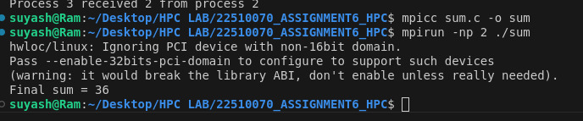

**Information / Theory:**

* **Parallel computation can divide work among processes for faster execution.**
* **Here, the array is split into two equal halves.**
  + **Process P0 adds the first half.**
  + **Process P1 adds the second half.**
* **The partial sums are combined using MPI_Reduce or explicit send/receive.**
* **Demonstrates how MPI enables divide-and-conquer strategies for data processing.**
* **Such patterns are useful in large-scale data analysis, simulations, and numerical computations.**

**Github Link: https://github.com/Suyashyadav07/HPC**