**Class:** Final Year B.Tech(Computer Science and Engineering)

**Year:** 2025-26 **Semester:** 1

**Course:** High Performance Computing Lab

PRN: 22510070

Name:Suyash Yadav

**Practical No. 7**

**Exam Seat No:22510070**

1. **Implement Matrix-Vector Multiplication using MPI. Use different number of processes and analyze the performance.**

#include <stdio.h>

#include <stdlib.h>

#include <mpi.h>

int main(int argc, char* argv[]) {

    int rank, size;

    int n;

    int *matrix = NULL, *vector = NULL, *result = NULL;

    int *local_matrix, *local_result;

    int rows_per_proc;

    MPI_Init(&argc, &argv);

    MPI_Comm_rank(MPI_COMM_WORLD, &rank);

    MPI_Comm_size(MPI_COMM_WORLD, &size);

    if (rank == 0) {

        printf("Enter size of square matrix (n): ");

        fflush(stdout);

        scanf("%d", &n);

    }

    MPI_Bcast(&n, 1, MPI_INT, 0, MPI_COMM_WORLD);

    if (n % size != 0) {

        if (rank == 0) {

            printf("Error: n (%d) must be divisible by number of processes (%d)\n", n, size);

        }

        MPI_Finalize();

        return 0;

    }

    rows_per_proc = n / size;

    if (rank == 0) {

        matrix = (int*)malloc(n * n * sizeof(int));

        vector = (int*)malloc(n * sizeof(int));

        result = (int*)malloc(n * sizeof(int));

        printf("Enter matrix (%d x %d):\n", n, n);

        for (int i = 0; i < n; i++)

            for (int j = 0; j < n; j++)

                scanf("%d", &matrix[i * n + j]);

        printf("Enter vector (%d elements):\n", n);

        for (int i = 0; i < n; i++)

            scanf("%d", &vector[i]);

    }

    local_matrix = (int*)malloc(rows_per_proc * n * sizeof(int));

    local_result = (int*)malloc(rows_per_proc * sizeof(int));

    if (rank != 0) vector = (int*)malloc(n * sizeof(int));

    MPI_Scatter(matrix, rows_per_proc * n, MPI_INT,

                local_matrix, rows_per_proc * n, MPI_INT,

                0, MPI_COMM_WORLD);

    MPI_Bcast(vector, n, MPI_INT, 0, MPI_COMM_WORLD);

    for (int i = 0; i < rows_per_proc; i++) {

        local_result[i] = 0;

        for (int j = 0; j < n; j++) {

            local_result[i] += local_matrix[i * n + j] * vector[j];

        }

    }

    MPI_Gather(local_result, rows_per_proc, MPI_INT,

               result, rows_per_proc, MPI_INT,

               0, MPI_COMM_WORLD);

    if (rank == 0) {

        printf("Result vector:\n");

        for (int i = 0; i < n; i++)

            printf("%d ", result[i]);

        printf("\n");

    }

    if (rank == 0) { free(matrix); free(vector); free(result); }

    else free(vector);

    free(local_matrix);

    free(local_result);

    MPI_Finalize();

    return 0;

}



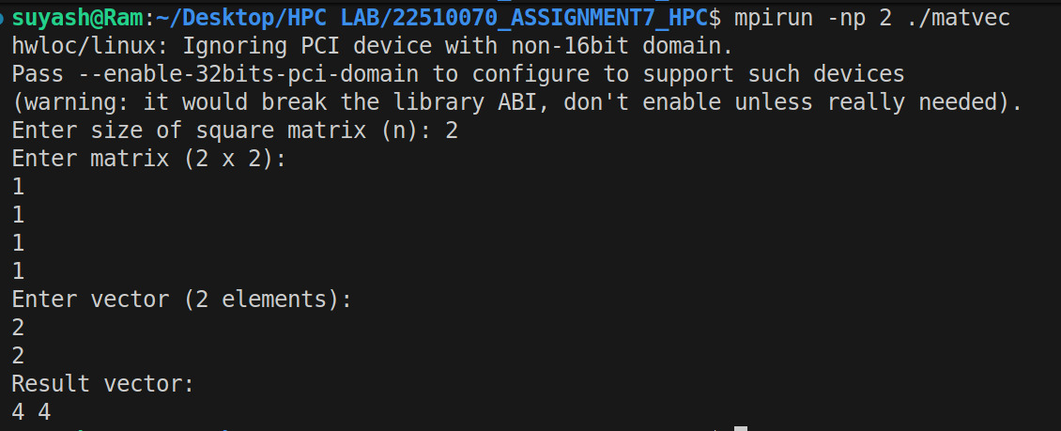

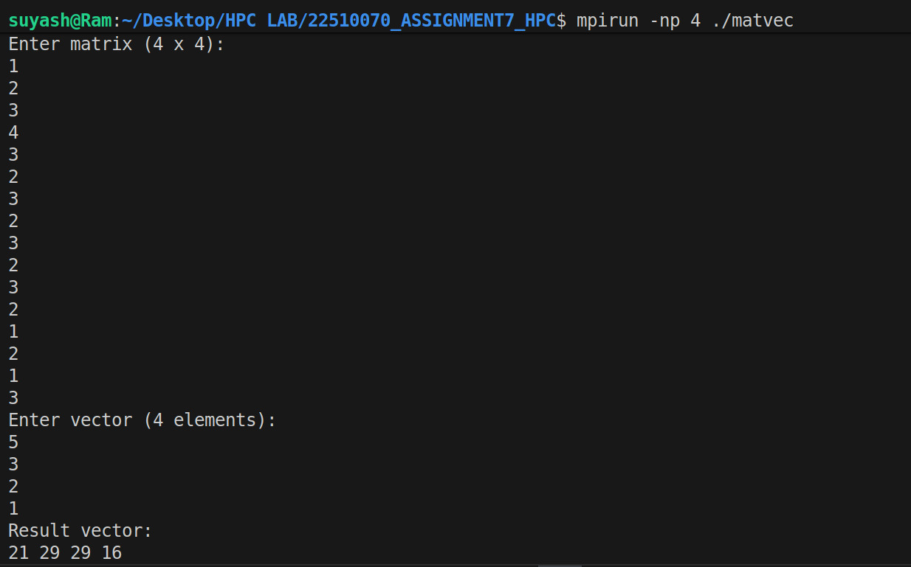

**1. Matrix-Vector Multiplication (MPI):**

**How it works:**

* **Scatter rows of matrix A to all processes.**
* **Broadcast vector v to all processes.**
* **Each process computes its part of result.**
* **Gather local results to root process.**

**Performance:**

* **More processes → faster computation.**
* **Communication overhead is low → good scaling for large matrices.**
* **Small matrices → speedup limited due to communication cost.**

**Implement Matrix-Matrix Multiplication using MPI. Use different number of processes and analyze the performance**

#include <stdio.h>

#include <stdlib.h>

#include <mpi.h>

int main(int argc, char* argv[]) {

    int rank, size;

    int n;

    int *A = NULL, *B = NULL, *C = NULL;

    int *local_A, *local_C;

    int rows_per_proc;

    MPI_Init(&argc, &argv);

    MPI_Comm_rank(MPI_COMM_WORLD, &rank);

    MPI_Comm_size(MPI_COMM_WORLD, &size);

    if (rank == 0) {

        printf("Enter size of square matrices (n): ");

        fflush(stdout);

        scanf("%d", &n);

    }

    MPI_Bcast(&n, 1, MPI_INT, 0, MPI_COMM_WORLD);

    if (n % size != 0) {

        if (rank == 0) {

            printf("Error: n (%d) must be divisible by number of processes (%d)\n", n, size);

        }

        MPI_Finalize();

        return 0;

    }

    rows_per_proc = n / size;

    if (rank == 0) {

        A = (int*)malloc(n * n * sizeof(int));

        B = (int*)malloc(n * n * sizeof(int));

        C = (int*)malloc(n * n * sizeof(int));

        printf("Enter matrix A (%d x %d):\n", n, n);

        for (int i = 0; i < n; i++)

            for (int j = 0; j < n; j++)

                scanf("%d", &A[i * n + j]);

        printf("Enter matrix B (%d x %d):\n", n, n);

        for (int i = 0; i < n; i++)

            for (int j = 0; j < n; j++)

                scanf("%d", &B[i * n + j]);

    }

    local_A = (int*)malloc(rows_per_proc * n * sizeof(int));

    local_C = (int*)malloc(rows_per_proc * n * sizeof(int));

    if (rank != 0) B = (int*)malloc(n * n * sizeof(int));

    MPI_Scatter(A, rows_per_proc * n, MPI_INT,

                local_A, rows_per_proc * n, MPI_INT,

                0, MPI_COMM_WORLD);

    MPI_Bcast(B, n * n, MPI_INT, 0, MPI_COMM_WORLD);

    for (int i = 0; i < rows_per_proc; i++) {

        for (int j = 0; j < n; j++) {

            local_C[i * n + j] = 0;

            for (int k = 0; k < n; k++) {

                local_C[i * n + j] += local_A[i * n + k] * B[k * n + j];

            }

        }

    }

    MPI_Gather(local_C, rows_per_proc * n, MPI_INT,

               C, rows_per_proc * n, MPI_INT,

               0, MPI_COMM_WORLD);

    if (rank == 0) {

        printf("Result matrix C:\n");

        for (int i = 0; i < n; i++) {

            for (int j = 0; j < n; j++)

                printf("%d ", C[i * n + j]);

            printf("\n");

        }

    }

    if (rank == 0) { free(A); free(B); free(C); }

    else free(B);

    free(local_A);

    free(local_C);

    MPI_Finalize();

    return 0;

}

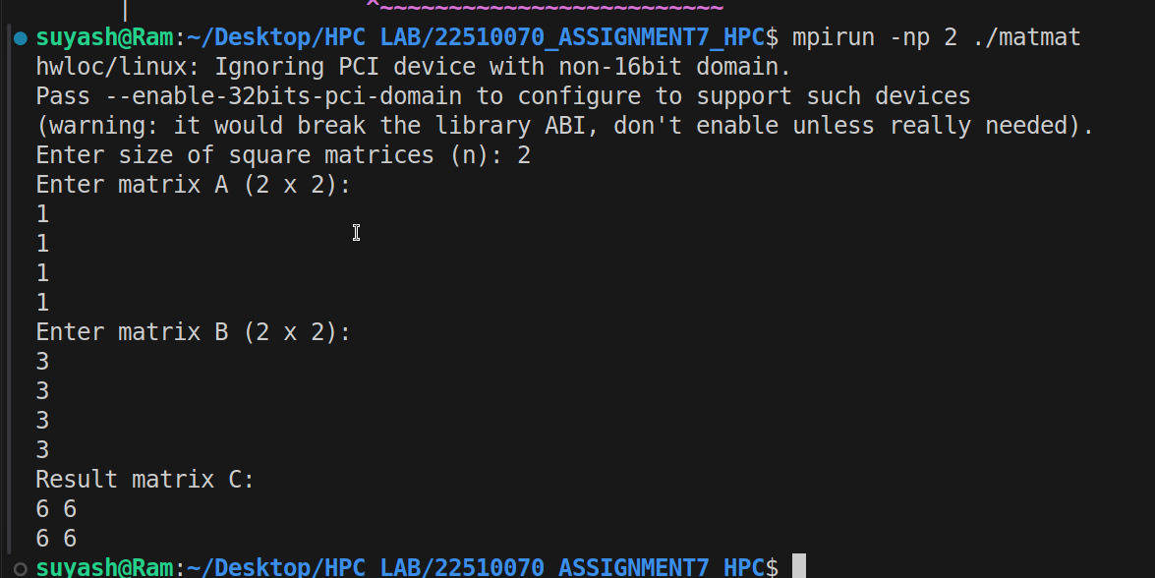

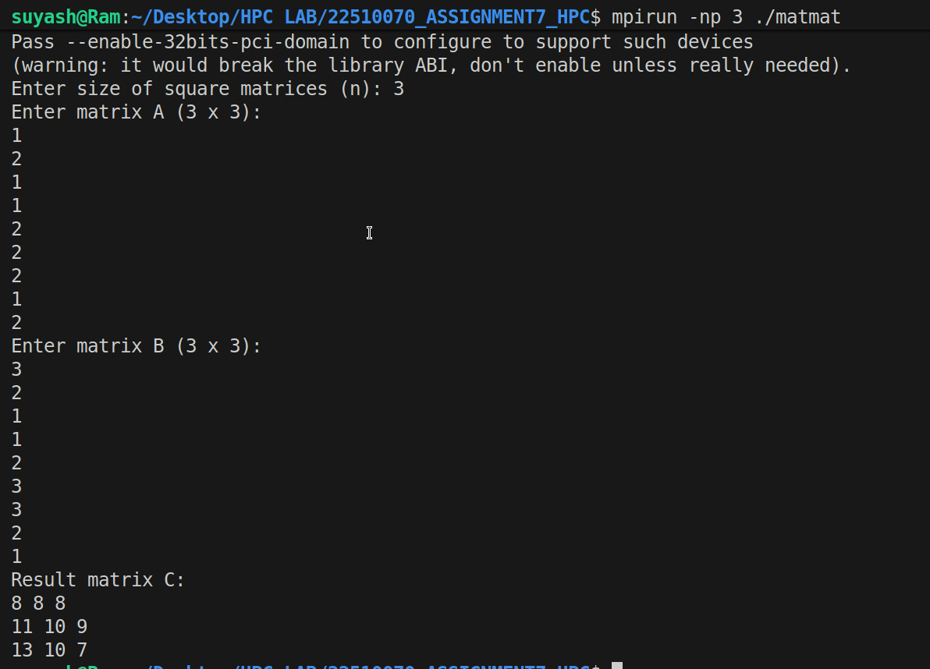

**2. Matrix-Matrix Multiplication (MPI)**

**How it works:**

* **Scatter rows of A to processes.**
* **Broadcast full matrix B to all processes.**
* **Each process computes its local rows of C.**
* **Gather local results to root process.**

**Performance:**

* **Computation is O(n³), so more processes give bigger speedup.**
* **Communication of B can dominate for large n → scaling is less ideal than matrix-vector.**
* **Small matrices → parallel overhead may reduce benefits.**

**Github Link: https://github.com/Suyashyadav07/HPC**