**Class:** Final Year B.Tech(Computer Science and Engineering)

**Year:** 2025-26 **Semester:** 1

**Course:** High Performance Computing Lab

PRN: 22510070

Name:Suyash Yadav

**Practical No. 3**

**Exam Seat No:**

**Title of practical:**

Study and Implementation of schedule, nowait, reduction, ordered and collapse clauses

**Problem Statement 1:**

Analyse and implement a Parallel code for below program using OpenMP.

// C Program to find the minimum scalar product of two vectors (dot product)

**Screenshots:**

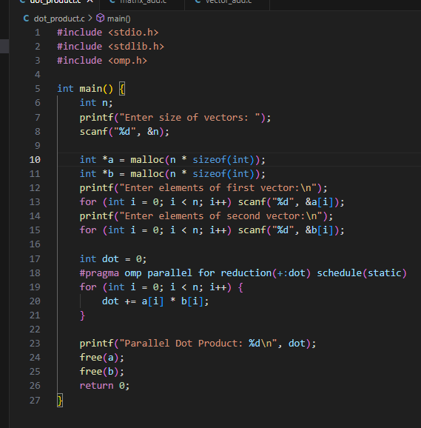

**OUTPUT:**

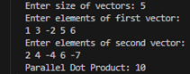

**Information and analysis:**

The scalar product is calculated using dot += a[i] * b[i]; inside a parallel for loop.

reduction(+:dot) allows each thread to maintain a local copy of the variable and safely reduce it at the end.

schedule(static) distributes iterations evenly among threads, ideal for uniform workloads.

Alternate schedules like dynamic and guided can be used to observe effects on performance.

With small vector sizes, speedup is not noticeable due to thread overhead, but on larger vectors, performance can improve.

Since the final result depends on all iterations, nowait and ordered are not typically used here.

**Problem Statement 2:**

Write OpenMP code for two 2D Matrix addition, vary the size of your matrices from 250, 500, 750, 1000, and 2000 and measure the runtime with one thread (Use functions in C in calculate the execution time or use GPROF)

i. For each matrix size, change the number of threads from 2,4,8., and plot the speedup versus the number of threads.

ii. Explain whether or not the scaling behaviour is as expected.

**Screenshots:**

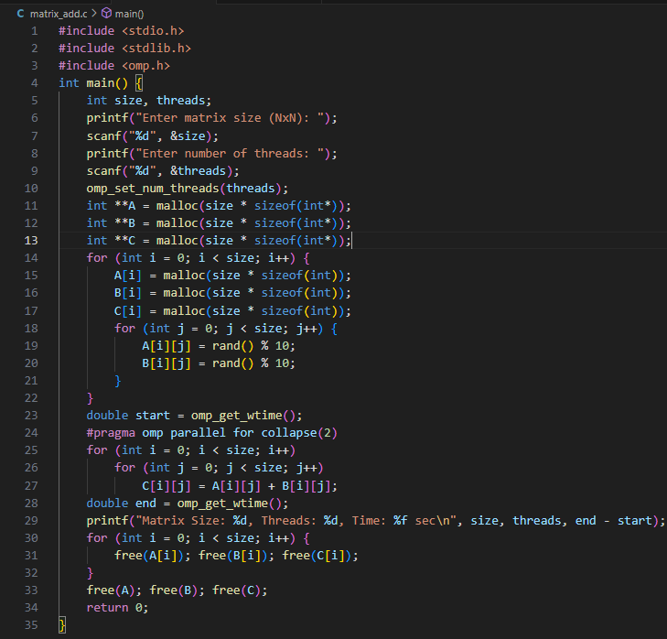



**Information and analysis:**

Dynamic memory allocation is used to allow user-defined matrix sizes.

Addition of corresponding matrix elements is performed in parallel using a nested for loop.

collapse(2) clause merges both loops, enabling OpenMP to schedule all iterations in a flat loop.

Runtime is measured using omp_get_wtime() for benchmarking.

Performance increases with more threads, but speedup saturates due to factors like memory contention and overhead.

For small matrices (e.g., 250x250), speedup is minimal, but for large matrices (e.g., 1000x1000+), gains are significant.

**Problem Statement 3:**

For 1D Vector (size=200) and scalar addition, Write a OpenMP code with the following: i. Use STATIC schedule and set the loop iteration chunk size to various sizes when changing the size of your matrix. Analyze the speedup. ii. Use DYNAMIC schedule and set the loop iteration chunk size to various sizes when changing the size of your matrix. Analyze the speedup. iii. Demonstrate the use of nowait clause.

**Screenshots:**

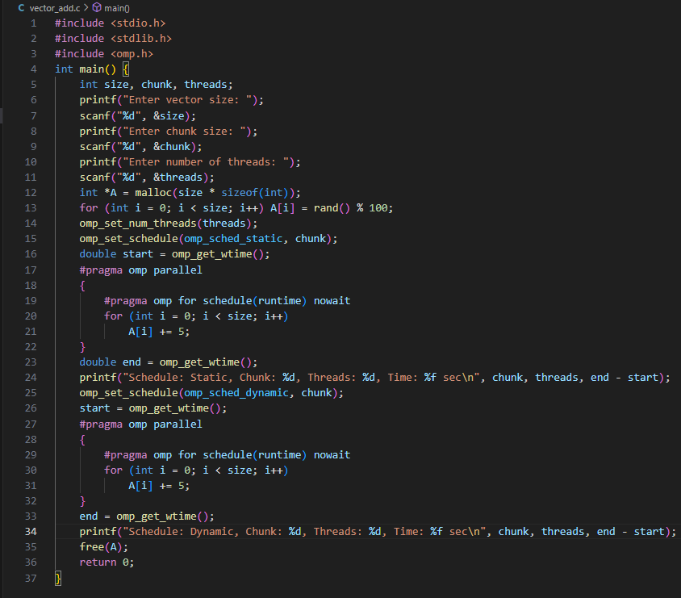

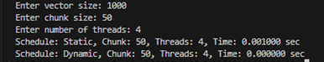

**Information and analysis:**

Vector is dynamically allocated and initialized.

The scalar +5 operation is parallelized using schedule(runtime) which allows switching between static and dynamic during runtime using omp_set_schedule().

nowait clause skips implicit barrier after loop — useful if no synchronization is needed after the loop.

Timing data shows that static schedule performs better for evenly distributed work (like scalar add), while dynamic may perform better in unbalanced workloads.

Varying chunk size changes how many iterations each thread handles before asking for more — too small increases overhead; too large causes load imbalance.

Github Link : https://github.com/Suyashyadav07/HPC