Class: Final Year B.Tech(Computer Science and Engineering)
Year: 2025-26 Semester: 1
Course: High Performance Computing Lab
PRN: 22510070
Name:Suyash Yadav
Practical No. 8

Exam Seat No:22510070

Problem Statement 1: Study and implement 2D Convolution using MPI. Use a different number of processes and analyze the performance.

#include <stdio.h>
#include <stdlib.h>
#include <assert.h>
#include <string.h>
#include <sys/time.h>
#include <mpi.h>

#define DEFAULT_ITERATIONS 1

int conv_column(int *, int, int, int, int *, int);
int conv(int *, int, int, int, int *, int);
int * check(int *, int, int, int *, int);

int conv_column(int * sub_grid, int i, int nrows, int DIM, int * kernel, int kernel_dim) {
int counter = 0;
int num_pads = (kernel_dim - 1) / 2;
for (int j = 1; j < (num_pads + 1); j++) {
counter = counter + sub_grid[i + j*DIM] * kernel[(((kernel_dim - 1)*(kernel_dim + 1)) / 2) + j*kernel_dim];
counter = counter + sub_grid[i - j*DIM] * kernel[(((kernel_dim - 1)*(kernel_dim + 1)) / 2) - j*kernel_dim];
}
counter = counter + sub_grid[i] * kernel[(((kernel_dim - 1)*(kernel_dim + 1)) / 2)];
return counter;
}

int conv(int * sub_grid, int i, int nrows, int DIM, int * kernel, int kernel_dim) {
int counter = 0;
int num_pads = (kernel_dim - 1) / 2;
//convolve middle column
counter = counter + conv_column(sub_grid, i, nrows, DIM, kernel, kernel_dim);

//convolve left and right columns
for (int j = 1; j < (num_pads + 1); j++) {
//get last element of current row
int end = (((i / DIM) + 1) * DIM) - 1;
if (i + j - end <= 0) { //if column is valid
counter = counter + conv_column(sub_grid, i + j, nrows, DIM, kernel, kernel_dim);
}
//get first element of current row
int first = (i / DIM) * DIM;
if (i - j - first >= 0) {
counter = counter + conv_column(sub_grid, i - j, nrows, DIM, kernel, kernel_dim);
}
}
return counter;
}

int * check(int * sub_grid, int nrows, int DIM, int * kernel, int kernel_dim) {
int val;
int num_pads = (kernel_dim - 1) / 2;
int * new_grid = calloc(DIM * nrows, sizeof(int));
for(int i = (num_pads * DIM); i < (DIM * (num_pads + nrows)); i++) {
val = conv(sub_grid, i, nrows, DIM, kernel, kernel_dim);
new_grid[i - (num_pads * DIM)] = val;
}
return new_grid;
}

int main ( int argc, char** argv ) {
// MPI Standard variable
int num_procs;
int ID, j;
int iters = 0;
int num_iterations;
int DIM;
int GRID_WIDTH;
int KERNEL_DIM;
int KERNEL_SIZE;

num_iterations = DEFAULT_ITERATIONS;
if (argc >= 3) {
DIM = atoi(argv[1]);
GRID_WIDTH = DIM * DIM;
KERNEL_DIM = atoi(argv[2]);
KERNEL_SIZE = KERNEL_DIM * KERNEL_DIM;
if (argc == 4) {
num_iterations = atoi(argv[3]);
}
} else {
printf("Invalid command line arguments");
MPI_Finalize();
exit(-1);
}
int main_grid[GRID_WIDTH];
memset(main_grid, 0, GRID_WIDTH*sizeof(int));
for(int i = 0; i < GRID_WIDTH; i++) {
main_grid[i] = 1;
}

int num_pads = (KERNEL_DIM - 1) / 2;

int kernel[KERNEL_SIZE];
memset(kernel, 0, KERNEL_SIZE*sizeof(int));
for(int i = 0; i < KERNEL_SIZE; i++) {
kernel[i] = 1;
}
// Messaging variables
MPI_Status status;

// MPI Setup
MPI_Init( NULL, NULL);
// if ( MPI_Init( &argc, &argv ) != MPI_SUCCESS )
// {
// printf ( "MPI_Init error\n" );
// }

MPI_Comm_size ( MPI_COMM_WORLD, &num_procs ); // Set the num_procs
MPI_Comm_rank ( MPI_COMM_WORLD, &ID );

double start_time = MPI_Wtime();
assert ( DIM % num_procs == 0 );

int upper[DIM * num_pads];
int lower[DIM * num_pads];
int * pad_row_upper;
int * pad_row_lower;
int start = (DIM / num_procs) * ID;
int end = (DIM / num_procs) - 1 + start;
int nrows = end + 1 - start;
int next = (ID + 1) % num_procs;
int prev = ID != 0 ? ID - 1 : num_procs - 1;
for ( iters = 0; iters < num_iterations; iters++ ) {

memcpy(lower, &main_grid[DIM * (end - num_pads + 1)], sizeof(int) * DIM * num_pads);
pad_row_lower = malloc(sizeof(int) * DIM * num_pads);
memcpy(upper, &main_grid[DIM * start], sizeof(int) * DIM * num_pads);
pad_row_upper = malloc(sizeof(int) * DIM * num_pads);

if(num_procs > 1) {
if(ID % 2 == 1) {
MPI_Recv(pad_row_lower, DIM * num_pads, MPI_INT, next, 1, MPI_COMM_WORLD, &status);
MPI_Recv(pad_row_upper, DIM * num_pads, MPI_INT, prev, 1, MPI_COMM_WORLD, &status);
} else {
MPI_Send(upper, DIM * num_pads, MPI_INT, prev, 1, MPI_COMM_WORLD);
MPI_Send(lower, DIM * num_pads, MPI_INT, next, 1, MPI_COMM_WORLD);
}
if(ID % 2 == 1) {
MPI_Send(upper, DIM * num_pads, MPI_INT, prev, 0, MPI_COMM_WORLD);
MPI_Send(lower, DIM * num_pads, MPI_INT, next, 0, MPI_COMM_WORLD);
} else {
MPI_Recv(pad_row_lower, DIM * num_pads, MPI_INT, next, 0, MPI_COMM_WORLD, &status);
MPI_Recv(pad_row_upper, DIM * num_pads, MPI_INT, prev, 0, MPI_COMM_WORLD, &status);
}
} else {
pad_row_lower = upper;
pad_row_upper = lower;
}

int sub_grid[DIM * (nrows + (2 * num_pads))];
if (ID == 0) {
memset(pad_row_upper, 0, DIM*sizeof(int)*num_pads);
}
if (ID == (num_procs - 1)) {
memset(pad_row_lower, 0, DIM*sizeof(int)*num_pads);
}
memcpy(sub_grid, pad_row_upper, sizeof(int) * DIM * num_pads);
memcpy(&sub_grid[DIM * num_pads], &main_grid[DIM * start], sizeof(int) * DIM * nrows);
memcpy(&sub_grid[DIM * (nrows + num_pads)], pad_row_lower, sizeof(int) * DIM * num_pads);
int * changed_subgrid = check(sub_grid, nrows, DIM, kernel, KERNEL_DIM);

if(ID != 0) {
MPI_Send(changed_subgrid, nrows * DIM, MPI_INT, 0, 11, MPI_COMM_WORLD);
MPI_Recv(&main_grid[0], DIM * DIM, MPI_INT, 0, 10, MPI_COMM_WORLD, &status);
} else {
for(int i = 0; i < nrows * DIM; i++) {
main_grid[i] = changed_subgrid[i];
}

for(int k = 1; k < num_procs; k++) {
MPI_Recv(&main_grid[DIM * (DIM / num_procs) * k], nrows * DIM, MPI_INT, k, 11, MPI_COMM_WORLD, &status);
}

for(int i = 1; i < num_procs; i++) {
MPI_Send(main_grid, DIM * DIM, MPI_INT, i, 10, MPI_COMM_WORLD);
}
}

// Output the updated grid state
if ( ID == 0 ) {
double end = MPI_Wtime();
// printf("Matrix DIM: %d\n", DIM);
// printf("Kernel DIM: %d", KERNEL_DIM);
// printf ( "\nConvolution Output: \n");
// for ( j = 0; j < GRID_WIDTH; j++ ) {
// if ( j % DIM == 0 ) {
// printf( "\n" );
// }
// printf ( "%d ", main_grid[j] );
// }
// printf( "\n" );

printf("Execution Time: %f\n",end - start_time);
}
}

if(num_procs >= 2) {
free(pad_row_upper);
free(pad_row_lower);
}

MPI_Finalize();
}

OUTPUT:

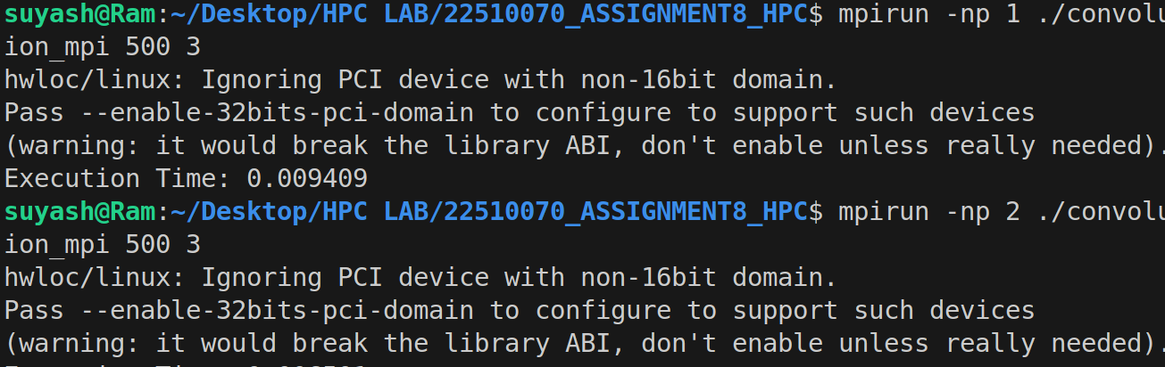

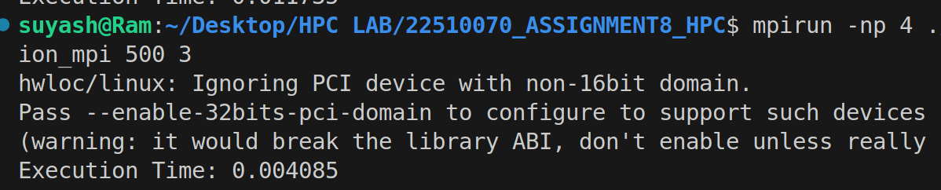

Concept
- Convolution is a core operation in image processing.
- Each output element is computed by multiplying a kernel (filter) matrix with the local region of the input matrix and summing the results.
- In parallel computing using MPI, the matrix is divided into chunks (rows) and distributed among processes.
- Each process computes convolution on its portion, communicates boundary rows (called ghost cells/pads) with neighbors, and sends the result back to the master process.

MPI Usage
- MPI_Init, MPI_Comm_rank, MPI_Comm_size — initialize and get process info.
- MPI_Send, MPI_Recv — exchange boundary rows between neighboring processes.
- MPI_Wtime() — measure execution time.
- MPI_Finalize() — cleanly exit MPI environment.

Analyse:

Processes (p) | Time (T_p) (s)
1 | 0.009409
2 | 0.006501
4 | 0.004085

From the above results, it is observed that as the number of processes increases, the execution time decreases. This indicates that the workload is being shared among multiple processes, leading to faster completion of the task. However, the decrease in execution time is not perfectly proportional to the number of processes, which suggests the presence of communication and synchronization overhead. Overall, the parallel implementation performs better than the single-process version and shows improved execution time with an increasing number of processes.

Problem Statement 2: Implement dot product using MPI. Use different number of processes and analyze the performance.

#include <stdio.h>
#include <mpi.h>
#include <unistd.h>
#include <stdlib.h>

#define N 100000000
#define MASTER 0
#define MAXPROCS 16

int dot_product();
void init_lst();
void print_lst();

int main()
{
int *vector_x, *vector_y;
int i, n;
int prod, sidx, eidx, size;
int pid, nprocs, rank;
double stime, etime;
MPI_Status status;
MPI_Comm world;

// n = 12;
// if (n > N)
// {
// printf("n=%d > N=%d\n", n, N);
// exit(1);
// }

MPI_Init(NULL, NULL);
world = MPI_COMM_WORLD;
MPI_Comm_size(MPI_COMM_WORLD, &nprocs);
MPI_Comm_rank(MPI_COMM_WORLD, &pid);

int portion = N / nprocs;
sidx = pid * portion;
eidx = sidx + portion;

vector_x = (int *)malloc(sizeof(int) * N);
vector_y = (int *)malloc(sizeof(int) * N);

init_lst(vector_x, N);
init_lst(vector_y, N);

int tmp_prod[nprocs];
for (i = 0; i < nprocs; i++)
tmp_prod[i] = 0;

stime = MPI_Wtime();

if (pid == MASTER)
{

// printf("%d, %d, %d\n", sidx, eidx, n);
prod = dot_product(sidx, eidx, vector_x, vector_y, N);
for (i = 1; i < nprocs; i++)
MPI_Recv(&tmp_prod[i - 1], 1, MPI_INT, i, 123, MPI_COMM_WORLD, &status);
}
else
{
// printf("%d, %d, %d\n", sidx, eidx, n);
prod = dot_product(sidx, eidx, vector_x, vector_y, N);
MPI_Send(&prod, 1, MPI_INT, MASTER, 123, MPI_COMM_WORLD);
}

if (pid == MASTER)
{
for (i = 0; i < nprocs; i++)
prod += tmp_prod[i];
}

if (pid == MASTER)
{
// print_lst(vector_x,n);
// print_lst(vector_y,n);
etime = MPI_Wtime();
printf("pid=%d: Dot Product = %d\n", pid, prod);
printf("pid=%d: elapsed = %f\n", pid, etime - stime);
}
MPI_Finalize();

free(vector_x);
free(vector_y);
}

int dot_product(int s, int e, int x[], int y[], int n)
{
int i, prod = 0;

for (i = s; i < e; i++)
prod = prod + x[i] * y[i];

return prod;
}

void init_lst(int *l, int n)
{
int i;
for (i = 0; i < n; i++)
*l++ = 1;
}
void print_lst(int *l, int n)
{
int i;

for (i = 0; i < n; i++)
{
printf("%d ", l[i]);
}
printf("\n");
}

OUTPUT:

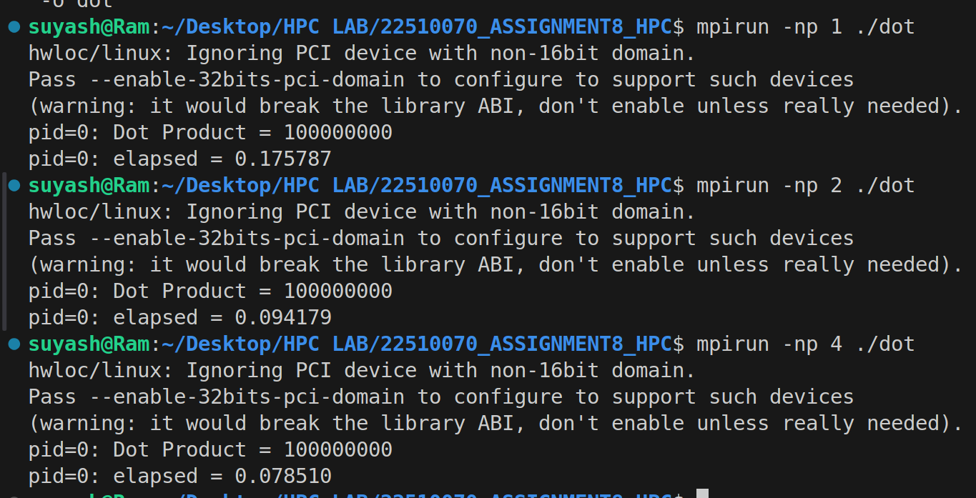

Number of processes | Execution time (seconds)
1 | 0.175787
2 | 0.094179
4 | 0.078510

Interpretation (based on execution times only)
- As the number of processes increases from 1 → 2 → 4, the execution time decreases (0.1758 → 0.0942 → 0.0785 s).
- The largest reduction appears when going from 1 to 2 processes; the improvement from 2 to 4 processes is smaller.
- This pattern indicates the dot-product workload is being parallelized effectively, but additional processes beyond a certain point give diminishing returns on runtime reduction.

Likely reasons (brief)
- Parallel work split reduces per-process computation, so total elapsed time drops.
- Diminishing returns from 2→4 processes suggest communication/coordination overhead, memory bandwidth limits, or increased context switching is starting to offset added parallelism.
- Running all ranks on the same physical machine (shared cores/cache) can limit scaling because of contention for CPU and memory bandwidth.

Github Link: https://github.com/Suyashyadav07/HPC

