Homework 4

***Yuwen(Suyi)Wu 5:45-7:45***

4/25/2019

# Part One

### Question 1

# Import Data  
dating <- read_delim("SpeedDating.csv", col_names=TRUE, delim=",")  
  
# Table Fill  
both_want <- length(which(dating$DecisionM == dating$DecisionF & dating$DecisionM == 1))  
both_not <- length(which(dating$DecisionM == dating$DecisionF & dating$DecisionM == 0))  
Female1Male0 <- length(which(dating$DecisionF == 1 & dating$DecisionM == 0))  
Female0Male1 <- length(which(dating$DecisionF == 0 & dating$DecisionM == 1))  
  
# Plot Table  
decision <- data.frame('Decision of Female (No)' = c(both_not,Female1Male0), 'Decision of Female (Yes)' = c(Female0Male1,both_want),row.names = c("Decision of Male (No)","Decision of Male (Yes)"))  
  
# Calculate Percentage  
both_want_percent <- both_want/nrow(dating)  
  
kable(decision)

|  |  |  |
| --- | --- | --- |
|  | Decision.of.Female..No. | Decision.of.Female..Yes. |
| Decision of Male (No) | 66 | 83 |
| Decision of Male (Yes) | 64 | 63 |

both_want_percent

## [1] 0.2282609

As the result, under calculation, there is 22.83% of dates ended with both people wanting a second date

### Question 2

# Add a new column  
second.date <- rep(0,nrow(dating))  
dating <- data.frame(dating, second.date)  
dating$second.date[which(dating$DecisionM == dating$DecisionF & dating$DecisionM == 1)] <- 1  
  
# setting pchs  
pchs <- rep(NA,nrow(dating))  
pchs[which(dating[,"second.date"] == 1)] <- 19  
pchs[which(dating[,"second.date"] == 0)] <- 4  
  
# setting colors  
color.setting <- rep(NA,nrow(dating))  
color.setting [which(dating[,"second.date"] == 1)] <- "hotpink"  
color.setting [which(dating[,"second.date"] == 0)] <- "royalblue"  
  
# Except Race Data  
numb <- seq(from = 3 , to = 21 ,by = 2)   
numb <- numb[-4]  
  
# Scatter Plots   
  
theme.info <- theme(plot.title = element_text(size=30, hjust=0.5),  
 axis.title = element_text(size=30),  
 axis.text = element_text(size=30),  
 legend.title = element_text(color = "black", size = 30),  
 legend.text = element_text(color = "black", size = 30))  
  
par(mfrow=c(3,3))  
colnames <- dimnames(dating)[[2]]  
  
  
# col.vector <- c("second date Yes"="hotpink","second date No"="royalblue")  
  
for (i in numb) {  
 plot(as.data.frame(dating)[,i], as.data.frame(dating)[,i+1], pch=pchs,col = color.setting,  
 main=paste("Scatterplot of" , colnames[i], "vs.",colnames[i+1]),xlab=colnames[i],  
 ylab=colnames[i+1],cex.main=1.0, cex.lab=0.8, cex.axis=0.8)+theme.info  
}  
  
legend("bottomright", legend=c("2nd date", "no 2nd date"), bty="n", col=c("hotpink", "royalblue"), pch= c(19,4), cex=1.4)

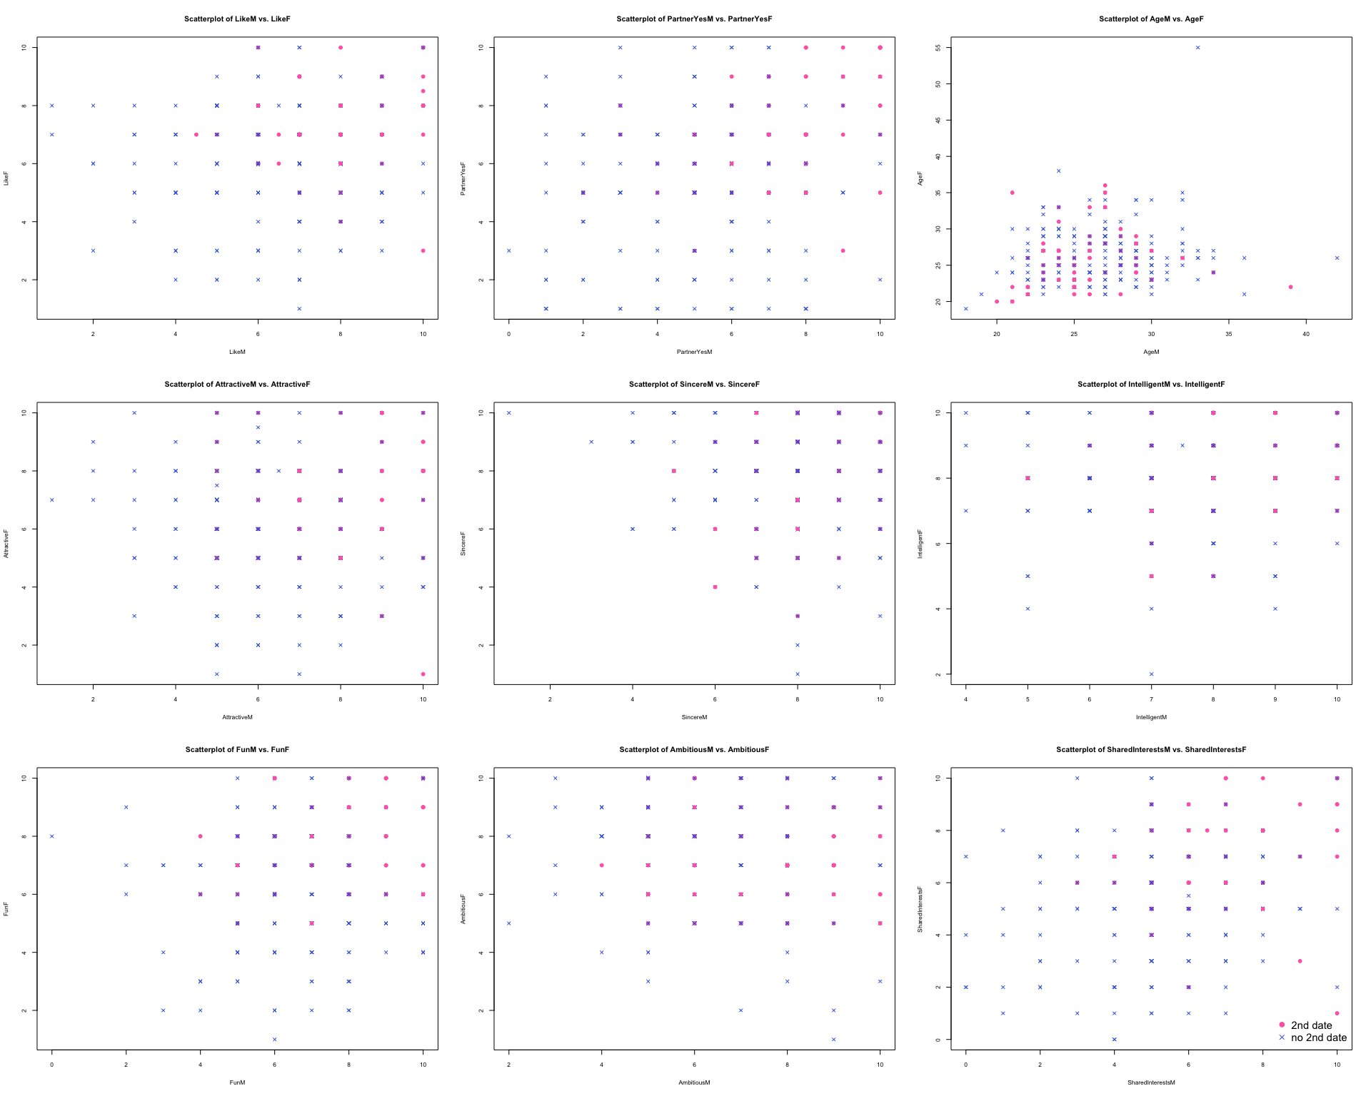

1. Like: Like indicator means how much you like this person.The hotpink dots cluster at top right of the scatter plot, indicating the higher “Like” score of M and F gives to the partner, a greater chance they will have a second date. However, there is still some conditions that people give high score to the partner but they don’t have second date. From the scatter plot, it seems people tend to give high score to the partner, all dots are clustered at top right, thus it may be the reason for people don’t have second date even high “Like” score of both.
2. PartnerYes: PartnerYes indicator means how probable do you think it is that this person will say “yes” to you. The hotpink dots are clustered at top right of the scatter plot, indicating the higher “PartnerYes” score of M and F gives to the partner, a greater chance they will have a second date.
3. Age: From the scatter plot, hotpink dots appears more close to the “Y=X” line, which means people are more willing to have a second date when they are at a similar age.
4. Attractive: Attractive is an indicator means attractiveness rate of partners on a scale of 1 to 10, hotpink dots appears in the topright region of the plot, where both gender gives the rate of “Attractive”(to the other person) higher than 5. Therefore, the higher both scores provided, the higher probability a second date will occur.
5. Sincere: Sincere is an indicator for partner to rate sincerity of partners on a scale of 1 to 10. From the scatter plot, most candidates provide scores between 6-10 and in most of time, people tends to show sincere in speed dating events to increase a second date chance. Thus, partner tends to provide high scores for sincerity rate. In scatter plot of Sincere F and Sincere M, it is not obvious that there is an relationship between sincere rate and possibility of a second date.
6. Intelligent : Intelligent is an indicator for partner to rate intelligence of another one in speed dating. From the scatter plot, most dots are on the up half picture which means almost all female provide score from 4 to 10. However, male provide scores are evenly distributed from 1 to 10. We can see that when both give each other with similar scores of “intelligence”, the higher chance they will have a second date.
7. Fun: Fun is an indicator for partner to rate how fun of the other on the scale of 1 to 10. We can see that if both feel the other is fun, which means high score or hotpink dots on the right top part, they will have high probability to have a second date.
8. Ambitious: Ambitious is an indicator for parnter to rate ambitious of the other on the scale of 1 to 10. From the scatter plot, it seems that male with high ambitious rate judged by female would be have higher probability to gain a second date.
9. SharedInterest: SharedInterest is an indicator for partner to rate whether he or she shared similar interest with the other. Most of the second date cases occur when both gender give a similar high score to their partner, which means they both regard each other has most similar interests with them.

### Question 3

# Check Range  
summary(dating)

## DecisionM DecisionF LikeM LikeF   
## Min. :0.000 Min. :0.0000 Min. : 1.000 Min. : 1.000   
## 1st Qu.:0.000 1st Qu.:0.0000 1st Qu.: 6.000 1st Qu.: 5.000   
## Median :1.000 Median :0.0000 Median : 7.000 Median : 7.000   
## Mean :0.529 Mean :0.4601 Mean : 6.682 Mean : 6.366   
## 3rd Qu.:1.000 3rd Qu.:1.0000 3rd Qu.: 8.000 3rd Qu.: 8.000   
## Max. :1.000 Max. :1.0000 Max. :10.000 Max. :10.000   
## NA's :2 NA's :4   
## PartnerYesM PartnerYesF AgeM AgeF   
## Min. : 0.000 Min. : 1.000 Min. :18.0 Min. :19.00   
## 1st Qu.: 5.000 1st Qu.: 5.000 1st Qu.:24.0 1st Qu.:23.00   
## Median : 6.000 Median : 6.000 Median :27.0 Median :26.00   
## Mean : 5.757 Mean : 5.835 Mean :26.6 Mean :26.19   
## 3rd Qu.: 7.000 3rd Qu.: 7.000 3rd Qu.:29.0 3rd Qu.:28.00   
## Max. :10.000 Max. :10.000 Max. :42.0 Max. :55.00   
## NA's :4 NA's :4 NA's :3 NA's :5   
## RaceM RaceF AttractiveM AttractiveF   
## Length:276 Length:276 Min. : 1.000 Min. : 1.000   
## Class :character Class :character 1st Qu.: 5.000 1st Qu.: 5.000   
## Mode :character Mode :character Median : 7.000 Median : 6.000   
## Mean : 6.687 Mean : 6.274   
## 3rd Qu.: 8.000 3rd Qu.: 8.000   
## Max. :10.000 Max. :10.000   
## NA's :3 NA's :2   
## SincereM SincereF IntelligentM IntelligentF   
## Min. : 1.000 Min. : 1.000 Min. : 4.000 Min. : 2.000   
## 1st Qu.: 7.000 1st Qu.: 7.000 1st Qu.: 7.000 1st Qu.: 7.000   
## Median : 8.000 Median : 8.000 Median : 8.000 Median : 8.000   
## Mean : 7.856 Mean : 7.784 Mean : 7.621 Mean : 7.923   
## 3rd Qu.: 9.000 3rd Qu.: 9.000 3rd Qu.: 8.250 3rd Qu.: 9.000   
## Max. :10.000 Max. :10.000 Max. :10.000 Max. :10.000   
## NA's :5 NA's :3 NA's :8 NA's :3   
## FunM FunF AmbitiousM AmbitiousF   
## Min. : 0.000 Min. : 1.000 Min. : 2.000 Min. : 1.000   
## 1st Qu.: 6.000 1st Qu.: 5.000 1st Qu.: 5.000 1st Qu.: 6.000   
## Median : 7.000 Median : 7.000 Median : 7.000 Median : 8.000   
## Mean : 6.863 Mean : 6.563 Mean : 6.768 Mean : 7.429   
## 3rd Qu.: 8.000 3rd Qu.: 8.000 3rd Qu.: 8.000 3rd Qu.: 9.000   
## Max. :10.000 Max. :10.000 Max. :10.000 Max. :10.000   
## NA's :6 NA's :6 NA's :17 NA's :10   
## SharedInterestsM SharedInterestsF second.date   
## Min. : 0.000 Min. : 0.00 Min. :0.0000   
## 1st Qu.: 4.000 1st Qu.: 4.00 1st Qu.:0.0000   
## Median : 5.000 Median : 6.00 Median :0.0000   
## Mean : 5.588 Mean : 5.47 Mean :0.2283   
## 3rd Qu.: 7.000 3rd Qu.: 7.00 3rd Qu.:0.0000   
## Max. :10.000 Max. :10.00 Max. :1.0000   
## NA's :27 NA's :30

# Adjust Range  
dating$PartnerYesM[which(dating$PartnerYesM==0)]<-1  
dating$FunM[which(dating$FunM==0)]<-1  
dating$SharedInterestsF[which(dating$SharedInterestsF==0)]<-1  
dating$SharedInterestsM[which(dating$SharedInterestsM==0)]<-1  
  
# Check Missing Data   
print(length(which(is.na(dating$RaceF)==TRUE)))

## [1] 4

print(length(which(is.na(dating$RaceM)==TRUE)))

## [1] 2

# Missing Data  
  
Missing_Data <- matrix(c(2,4,4,4,3,5,3,2,5,3,8,3,6,6,17,10,27,30), byrow = TRUE, ncol = 2)  
rownames(Missing_Data) <- c("Like","PartnerYes","Age","Attractive","Sincere","Intelligent",  
 "Fun","Ambitious","SharedInterest")  
colnames(Missing_Data) <- c("NA number (from response by Male)", "NA number (from response by Female)")  
print(Missing_Data)

## NA number (from response by Male)  
## Like 2  
## PartnerYes 4  
## Age 3  
## Attractive 3  
## Sincere 5  
## Intelligent 8  
## Fun 6  
## Ambitious 17  
## SharedInterest 27  
## NA number (from response by Female)  
## Like 4  
## PartnerYes 4  
## Age 5  
## Attractive 2  
## Sincere 3  
## Intelligent 3  
## Fun 6  
## Ambitious 10  
## SharedInterest 30

Since some data from 1 to 10 rather than instructed 0 to 10, these data should be adjused from data of 1 to 0.For the data of 0, it could be 10 mistakenly written as 0 as well.

From above summary, except the Decision M, Decision F and Second Date, all other variables are exist missing data, which represented as NAs in summary. There are 2 missing data for Like M, 4 missing data for LikeF, 4 missing data for PartnerYesM, 4 missing data for PartnerYesF, 3 missing data for Age M, 5 missing data for Age F, 3 missing data for Attractive M, 2 missing data for Attractive F, 5 missing data for Sincere M, 3 missing data for Sincere F, 8 missing data for Intelligent M, 3 missing data for Intelligent F, 6 missing data for FunM, 6 missing data for Fun F, 17 missing data for Ambitious M, 10 missing data for Ambitious F, 27 missing data for Shared Interests M, 30 missing data for SharedInterestsF.

Especially for Race data, for Race F, 4 missing data and for Race M, 2 missing data.

### Question 4

dating_check <- dating[!complete.cases(dating[,c("RaceF","RaceM")]),]  
# checking missing data of dating raceF and raceM   
print(dating_check)

## DecisionM DecisionF LikeM LikeF PartnerYesM PartnerYesF AgeM AgeF  
## 29 0 0 5 3 1 3 27 NA  
## 30 0 1 1 8 1 9 28 NA  
## 66 1 0 8 5 8 1 37 NA  
## 166 1 1 8 10 7 5 NA 34  
## 167 0 1 5 8 5 6 NA 36  
## 169 1 0 8 6 8 5 30 NA  
## RaceM RaceF AttractiveM AttractiveF SincereM SincereF IntelligentM  
## 29 Black <NA> 5 3 7 4 6  
## 30 Caucasian <NA> 4 8 7 8 4  
## 66 Asian <NA> 8 3 8 8 NA  
## 166 <NA> Asian 8 10 7 NA 7  
## 167 <NA> Black 4 8 8 10 6  
## 169 Caucasian <NA> 8 7 8 8 7  
## IntelligentF FunM FunF AmbitiousM AmbitiousF SharedInterestsM  
## 29 9 4 2 4 9 6  
## 30 9 2 9 3 7 1  
## 66 8 8 5 8 8 NA  
## 166 10 8 10 9 8 7  
## 167 9 5 8 5 8 7  
## 169 9 7 7 7 9 8  
## SharedInterestsF second.date  
## 29 6 0  
## 30 8 0  
## 66 1 0  
## 166 10 1  
## 167 5 0  
## 169 3 0

dating_full <- dating  
race_category_M <- dating_full %>% distinct(RaceM,.keep_all = FALSE)  
race_category_F <- dating_full %>% distinct(RaceF,.keep_all = FALSE)  
print(race_category_M)

## RaceM  
## 1 Caucasian  
## 2 Asian  
## 3 Latino  
## 4 Black  
## 5 Other  
## 6 <NA>

print(race_category_F)

## RaceF  
## 1 Caucasian  
## 2 Asian  
## 3 Other  
## 4 Black  
## 5 Latino  
## 6 <NA>

temp <- tibble(dating_full$RaceM,dating_full$RaceF)  
mosaicplot(table(temp),   
 main="Mosaic Plot with Female and Male Race",   
 xlab="RaceM", ylab="RaceF",   
 las=TRUE, cex.axis=1.2,color = c("#663A44", "#5F7880", "#CAA78D", "#2F4F4F","grey","gold"))

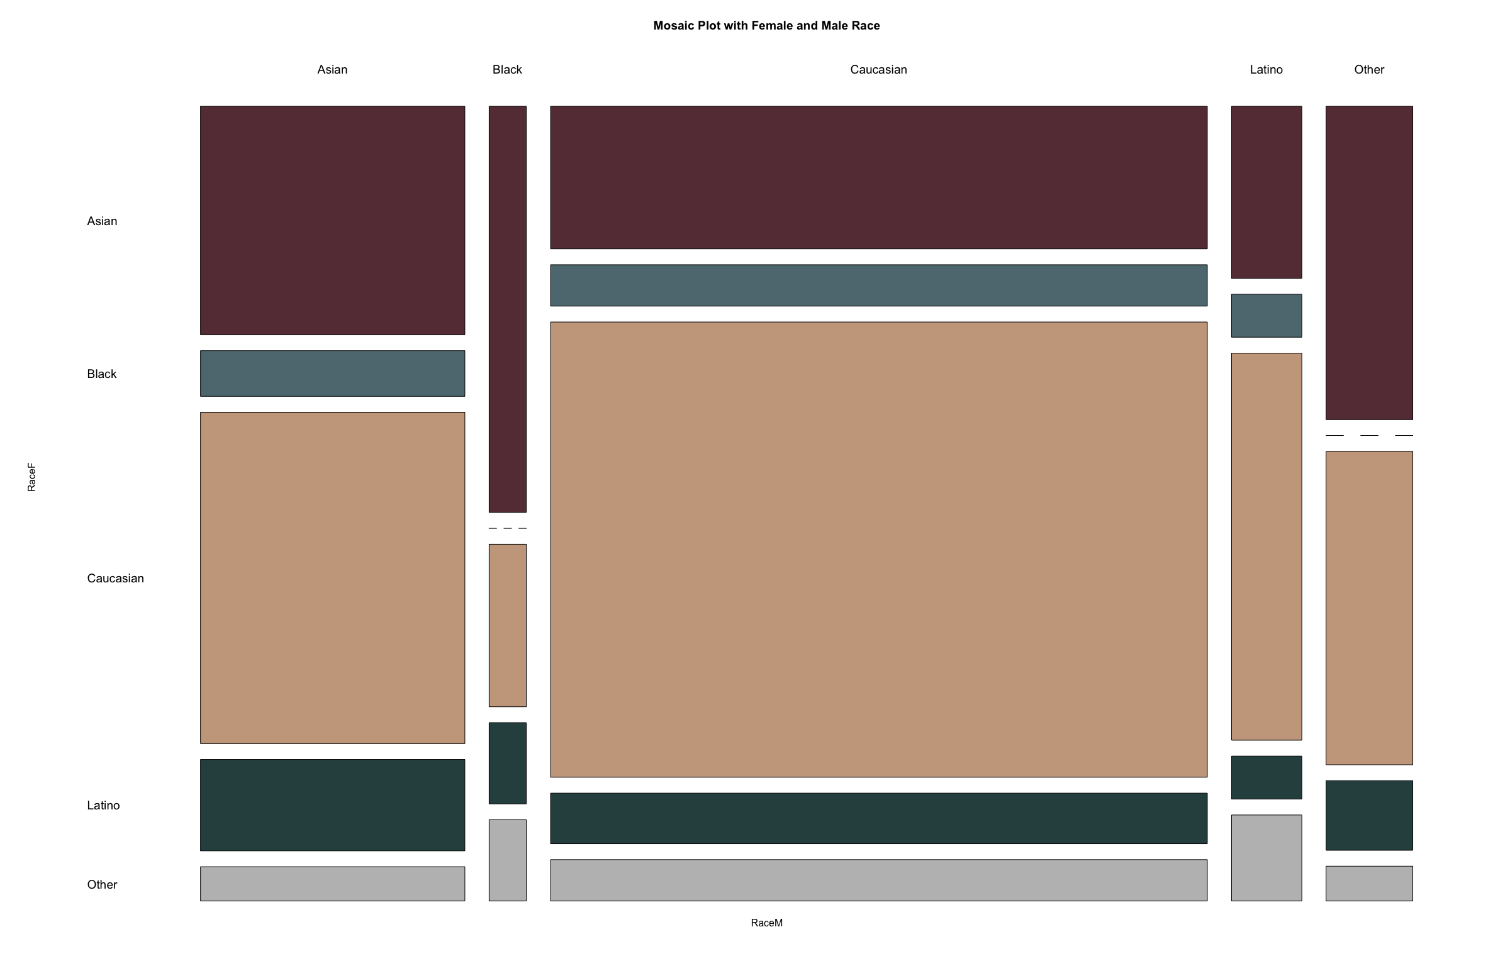

In this dataset, we have races of Caucasian, Asian, Latino, Black and other.

For Race F, 4 missing data and for Race M, 2 missing data. I would like to keep them in the dataset for Mosaic Plot (1) We are not sure whether we will use Race factor in the model, otherwise, missing data does not matter; (2) In the further logistic regression, missing data will be automatically remove;

From the mosaic plot: (1) Caucasian and Asian are the largest two portions of race in this dataset; (2) There is no date match group in this case, with two people’s races are combination of (a.) Black male + Black female, (b.) Other races male+Black female.

### Question 5

# Logit Regression Model  
  
logit.1 <- glm(formula=second.date~LikeM+LikeF+PartnerYesM+PartnerYesF+AttractiveM+AttractiveF  
 +SincereF+SincereM+IntelligentF+IntelligentM+FunF+FunM+SharedInterestsF+SharedInterestsM  
 +AmbitiousF+AmbitiousM,family = binomial(link="logit"),data = dating)  
summary(logit.1)

##   
## Call:  
## glm(formula = second.date ~ LikeM + LikeF + PartnerYesM + PartnerYesF +   
## AttractiveM + AttractiveF + SincereF + SincereM + IntelligentF +   
## IntelligentM + FunF + FunM + SharedInterestsF + SharedInterestsM +   
## AmbitiousF + AmbitiousM, family = binomial(link = "logit"),   
## data = dating)  
##   
## Deviance Residuals:   
## Min 1Q Median 3Q Max   
## -1.96483 -0.63326 -0.26903 -0.03685 2.66511   
##   
## Coefficients:  
## Estimate Std. Error z value Pr(>|z|)   
## (Intercept) -9.49915 2.11760 -4.486 7.26e-06 ***  
## LikeM 0.38445 0.23756 1.618 0.10559   
## LikeF 0.08385 0.21004 0.399 0.68973   
## PartnerYesM 0.37963 0.13410 2.831 0.00464 **   
## PartnerYesF 0.24581 0.12920 1.903 0.05710 .   
## AttractiveM 0.14035 0.21643 0.648 0.51667   
## AttractiveF 0.20143 0.14986 1.344 0.17889   
## SincereF -0.02187 0.18881 -0.116 0.90777   
## SincereM 0.02115 0.19644 0.108 0.91426   
## IntelligentF -0.06831 0.23694 -0.288 0.77312   
## IntelligentM -0.13001 0.24806 -0.524 0.60021   
## FunF 0.36379 0.18504 1.966 0.04930 *   
## FunM -0.24249 0.19179 -1.264 0.20609   
## SharedInterestsF 0.00451 0.13040 0.035 0.97241   
## SharedInterestsM 0.03209 0.14241 0.225 0.82168   
## AmbitiousF -0.25717 0.16024 -1.605 0.10851   
## AmbitiousM 0.17987 0.18040 0.997 0.31873   
## ---  
## Signif. codes: 0 '***' 0.001 '**' 0.01 '*' 0.05 '.' 0.1 ' ' 1  
##   
## (Dispersion parameter for binomial family taken to be 1)  
##   
## Null deviance: 223.67 on 205 degrees of freedom  
## Residual deviance: 148.00 on 189 degrees of freedom  
## (70 observations deleted due to missingness)  
## AIC: 182  
##   
## Number of Fisher Scoring iterations: 6

# Remove the factor of Sincere M and SharedInterestsF  
  
logit.2 <- glm(formula=second.date~LikeM+LikeF+PartnerYesM+PartnerYesF+AttractiveM+AttractiveF  
 +IntelligentF+IntelligentM+FunF+FunM+SharedInterestsM+SincereF  
 +AmbitiousF+AmbitiousM,family = binomial(link="logit"),data = dating)  
summary(logit.2)

##   
## Call:  
## glm(formula = second.date ~ LikeM + LikeF + PartnerYesM + PartnerYesF +   
## AttractiveM + AttractiveF + IntelligentF + IntelligentM +   
## FunF + FunM + SharedInterestsM + SincereF + AmbitiousF +   
## AmbitiousM, family = binomial(link = "logit"), data = dating)  
##   
## Deviance Residuals:   
## Min 1Q Median 3Q Max   
## -2.20700 -0.60543 -0.27923 -0.03452 2.49288   
##   
## Coefficients:  
## Estimate Std. Error z value Pr(>|z|)   
## (Intercept) -10.20389 2.06702 -4.937 7.95e-07 ***  
## LikeM 0.37402 0.21573 1.734 0.08297 .   
## LikeF 0.13242 0.19460 0.680 0.49622   
## PartnerYesM 0.36685 0.12762 2.875 0.00405 **   
## PartnerYesF 0.23940 0.11535 2.075 0.03794 *   
## AttractiveM 0.16362 0.20083 0.815 0.41523   
## AttractiveF 0.22985 0.14558 1.579 0.11437   
## IntelligentF -0.03606 0.22607 -0.160 0.87327   
## IntelligentM -0.10224 0.21707 -0.471 0.63765   
## FunF 0.31771 0.17091 1.859 0.06303 .   
## FunM -0.22664 0.17992 -1.260 0.20779   
## SharedInterestsM 0.03476 0.13233 0.263 0.79278   
## SincereF -0.08938 0.18512 -0.483 0.62922   
## AmbitiousF -0.18518 0.15148 -1.222 0.22153   
## AmbitiousM 0.21907 0.17395 1.259 0.20790   
## ---  
## Signif. codes: 0 '***' 0.001 '**' 0.01 '*' 0.05 '.' 0.1 ' ' 1  
##   
## (Dispersion parameter for binomial family taken to be 1)  
##   
## Null deviance: 244.64 on 218 degrees of freedom  
## Residual deviance: 161.80 on 204 degrees of freedom  
## (57 observations deleted due to missingness)  
## AIC: 191.8  
##   
## Number of Fisher Scoring iterations: 6

# Remove the factor of Intelligent F and SharedInterestsM  
  
logit.3 <- glm(formula=second.date~LikeM+LikeF+PartnerYesM+PartnerYesF+AttractiveM+AttractiveF  
 +IntelligentM+FunF+FunM+SincereF+AmbitiousF+AmbitiousM,family =  
 binomial(link="logit"),data = dating)  
summary(logit.3)

##   
## Call:  
## glm(formula = second.date ~ LikeM + LikeF + PartnerYesM + PartnerYesF +   
## AttractiveM + AttractiveF + IntelligentM + FunF + FunM +   
## SincereF + AmbitiousF + AmbitiousM, family = binomial(link = "logit"),   
## data = dating)  
##   
## Deviance Residuals:   
## Min 1Q Median 3Q Max   
## -2.06264 -0.66061 -0.27307 -0.03633 2.63767   
##   
## Coefficients:  
## Estimate Std. Error z value Pr(>|z|)   
## (Intercept) -9.8060 1.9192 -5.109 3.23e-07 ***  
## LikeM 0.4147 0.2032 2.041 0.04129 *   
## LikeF 0.1364 0.1892 0.721 0.47088   
## PartnerYesM 0.3720 0.1184 3.142 0.00168 **   
## PartnerYesF 0.2594 0.1095 2.368 0.01786 *   
## AttractiveM 0.1952 0.1895 1.030 0.30308   
## AttractiveF 0.2317 0.1445 1.603 0.10883   
## IntelligentM -0.1070 0.2078 -0.515 0.60654   
## FunF 0.3240 0.1711 1.894 0.05823 .   
## FunM -0.2134 0.1734 -1.231 0.21832   
## SincereF -0.1358 0.1533 -0.886 0.37588   
## AmbitiousF -0.2685 0.1416 -1.896 0.05790 .   
## AmbitiousM 0.1580 0.1603 0.985 0.32448   
## ---  
## Signif. codes: 0 '***' 0.001 '**' 0.01 '*' 0.05 '.' 0.1 ' ' 1  
##   
## (Dispersion parameter for binomial family taken to be 1)  
##   
## Null deviance: 258.08 on 234 degrees of freedom  
## Residual deviance: 173.11 on 222 degrees of freedom  
## (41 observations deleted due to missingness)  
## AIC: 199.11  
##   
## Number of Fisher Scoring iterations: 6

# Remove the factor of IntelligentM and LikeF  
  
logit.4 <- glm(formula=second.date~LikeM+PartnerYesM+PartnerYesF+AttractiveM+AttractiveF  
 +FunF+FunM+SincereF+AmbitiousF+AmbitiousM,family = binomial(link="logit"),  
 data = dating)  
summary(logit.4)

##   
## Call:  
## glm(formula = second.date ~ LikeM + PartnerYesM + PartnerYesF +   
## AttractiveM + AttractiveF + FunF + FunM + SincereF + AmbitiousF +   
## AmbitiousM, family = binomial(link = "logit"), data = dating)  
##   
## Deviance Residuals:   
## Min 1Q Median 3Q Max   
## -2.06945 -0.62579 -0.26170 -0.03199 2.77332   
##   
## Coefficients:  
## Estimate Std. Error z value Pr(>|z|)   
## (Intercept) -10.3057 1.8173 -5.671 1.42e-08 ***  
## LikeM 0.4179 0.2031 2.058 0.03960 *   
## PartnerYesM 0.3745 0.1171 3.198 0.00138 **   
## PartnerYesF 0.2780 0.1072 2.592 0.00954 **   
## AttractiveM 0.1816 0.1871 0.970 0.33193   
## AttractiveF 0.2657 0.1272 2.090 0.03662 *   
## FunF 0.3809 0.1609 2.367 0.01795 *   
## FunM -0.2455 0.1663 -1.476 0.13990   
## SincereF -0.1023 0.1479 -0.691 0.48931   
## AmbitiousF -0.2646 0.1403 -1.886 0.05929 .   
## AmbitiousM 0.1332 0.1448 0.920 0.35756   
## ---  
## Signif. codes: 0 '***' 0.001 '**' 0.01 '*' 0.05 '.' 0.1 ' ' 1  
##   
## (Dispersion parameter for binomial family taken to be 1)  
##   
## Null deviance: 262.58 on 238 degrees of freedom  
## Residual deviance: 174.60 on 228 degrees of freedom  
## (37 observations deleted due to missingness)  
## AIC: 196.6  
##   
## Number of Fisher Scoring iterations: 6

# Remove the factor of SincereF and AmbitiousM  
  
logit.5 <- glm(formula=second.date~LikeM+PartnerYesM+PartnerYesF+AttractiveM+AttractiveF  
 +FunF+FunM+AmbitiousF,family = binomial(link="logit"),data = dating)  
summary(logit.5)

##   
## Call:  
## glm(formula = second.date ~ LikeM + PartnerYesM + PartnerYesF +   
## AttractiveM + AttractiveF + FunF + FunM + AmbitiousF, family = binomial(link = "logit"),   
## data = dating)  
##   
## Deviance Residuals:   
## Min 1Q Median 3Q Max   
## -2.04245 -0.57863 -0.25492 -0.02681 2.77747   
##   
## Coefficients:  
## Estimate Std. Error z value Pr(>|z|)   
## (Intercept) -10.7142 1.7250 -6.211 5.26e-10 ***  
## LikeM 0.4611 0.2013 2.290 0.02200 *   
## PartnerYesM 0.3893 0.1146 3.397 0.00068 ***  
## PartnerYesF 0.2667 0.1060 2.516 0.01187 *   
## AttractiveM 0.1993 0.1808 1.103 0.27019   
## AttractiveF 0.2948 0.1280 2.304 0.02124 *   
## FunF 0.3655 0.1528 2.392 0.01675 *   
## FunM -0.2027 0.1605 -1.263 0.20653   
## AmbitiousF -0.3126 0.1356 -2.306 0.02112 *   
## ---  
## Signif. codes: 0 '***' 0.001 '**' 0.01 '*' 0.05 '.' 0.1 ' ' 1  
##   
## (Dispersion parameter for binomial family taken to be 1)  
##   
## Null deviance: 275.54 on 249 degrees of freedom  
## Residual deviance: 178.95 on 241 degrees of freedom  
## (26 observations deleted due to missingness)  
## AIC: 196.95  
##   
## Number of Fisher Scoring iterations: 6

# Remove the factor of AttractiveM and FunM  
  
logit.6 <- glm(formula=second.date~LikeM+PartnerYesM+PartnerYesF+AttractiveF  
 +FunF+AmbitiousF,family = binomial(link="logit"),data = dating)  
summary(logit.6)

##   
## Call:  
## glm(formula = second.date ~ LikeM + PartnerYesM + PartnerYesF +   
## AttractiveF + FunF + AmbitiousF, family = binomial(link = "logit"),   
## data = dating)  
##   
## Deviance Residuals:   
## Min 1Q Median 3Q Max   
## -2.1475 -0.5828 -0.2897 -0.0281 2.6552   
##   
## Coefficients:  
## Estimate Std. Error z value Pr(>|z|)   
## (Intercept) -10.5161 1.6410 -6.408 1.47e-10 ***  
## LikeM 0.4940 0.1345 3.673 0.000239 ***  
## PartnerYesM 0.3416 0.1029 3.321 0.000897 ***  
## PartnerYesF 0.2693 0.1039 2.592 0.009537 **   
## AttractiveF 0.2860 0.1211 2.361 0.018206 *   
## FunF 0.3486 0.1449 2.406 0.016140 *   
## AmbitiousF -0.3047 0.1284 -2.374 0.017618 *   
## ---  
## Signif. codes: 0 '***' 0.001 '**' 0.01 '*' 0.05 '.' 0.1 ' ' 1  
##   
## (Dispersion parameter for binomial family taken to be 1)  
##   
## Null deviance: 282.88 on 254 degrees of freedom  
## Residual deviance: 187.88 on 248 degrees of freedom  
## (21 observations deleted due to missingness)  
## AIC: 201.88  
##   
## Number of Fisher Scoring iterations: 6

# Using Forward Method for Logit Regression  
require(leaps)  
logit.fw <- regsubsets(second.date ~ LikeM+LikeF+PartnerYesM+PartnerYesF+AttractiveM+AttractiveF  
 +SincereF+SincereM+IntelligentF+IntelligentM+FunF+FunM+SharedInterestsF+SharedInterestsM  
 +AmbitiousF+AmbitiousM, data=dating, method="forward", nvmax=15)  
summary(logit.fw)

## Subset selection object  
## Call: regsubsets.formula(second.date ~ LikeM + LikeF + PartnerYesM +   
## PartnerYesF + AttractiveM + AttractiveF + SincereF + SincereM +   
## IntelligentF + IntelligentM + FunF + FunM + SharedInterestsF +   
## SharedInterestsM + AmbitiousF + AmbitiousM, data = dating,   
## method = "forward", nvmax = 15)  
## 16 Variables (and intercept)  
## Forced in Forced out  
## LikeM FALSE FALSE  
## LikeF FALSE FALSE  
## PartnerYesM FALSE FALSE  
## PartnerYesF FALSE FALSE  
## AttractiveM FALSE FALSE  
## AttractiveF FALSE FALSE  
## SincereF FALSE FALSE  
## SincereM FALSE FALSE  
## IntelligentF FALSE FALSE  
## IntelligentM FALSE FALSE  
## FunF FALSE FALSE  
## FunM FALSE FALSE  
## SharedInterestsF FALSE FALSE  
## SharedInterestsM FALSE FALSE  
## AmbitiousF FALSE FALSE  
## AmbitiousM FALSE FALSE  
## 1 subsets of each size up to 15  
## Selection Algorithm: forward  
## LikeM LikeF PartnerYesM PartnerYesF AttractiveM AttractiveF  
## 1 ( 1 ) "*" " " " " " " " " " "   
## 2 ( 1 ) "*" " " " " "*" " " " "   
## 3 ( 1 ) "*" " " " " "*" " " " "   
## 4 ( 1 ) "*" " " "*" "*" " " " "   
## 5 ( 1 ) "*" " " "*" "*" " " " "   
## 6 ( 1 ) "*" " " "*" "*" " " "*"   
## 7 ( 1 ) "*" " " "*" "*" " " "*"   
## 8 ( 1 ) "*" " " "*" "*" " " "*"   
## 9 ( 1 ) "*" " " "*" "*" " " "*"   
## 10 ( 1 ) "*" " " "*" "*" "*" "*"   
## 11 ( 1 ) "*" " " "*" "*" "*" "*"   
## 12 ( 1 ) "*" " " "*" "*" "*" "*"   
## 13 ( 1 ) "*" " " "*" "*" "*" "*"   
## 14 ( 1 ) "*" " " "*" "*" "*" "*"   
## 15 ( 1 ) "*" " " "*" "*" "*" "*"   
## SincereF SincereM IntelligentF IntelligentM FunF FunM  
## 1 ( 1 ) " " " " " " " " " " " "   
## 2 ( 1 ) " " " " " " " " " " " "   
## 3 ( 1 ) " " " " " " " " "*" " "   
## 4 ( 1 ) " " " " " " " " "*" " "   
## 5 ( 1 ) " " " " " " " " "*" " "   
## 6 ( 1 ) " " " " " " " " "*" " "   
## 7 ( 1 ) " " " " " " " " "*" " "   
## 8 ( 1 ) " " " " " " " " "*" "*"   
## 9 ( 1 ) " " " " " " " " "*" "*"   
## 10 ( 1 ) " " " " " " " " "*" "*"   
## 11 ( 1 ) " " " " " " " " "*" "*"   
## 12 ( 1 ) " " "*" " " " " "*" "*"   
## 13 ( 1 ) " " "*" "*" " " "*" "*"   
## 14 ( 1 ) "*" "*" "*" " " "*" "*"   
## 15 ( 1 ) "*" "*" "*" "*" "*" "*"   
## SharedInterestsF SharedInterestsM AmbitiousF AmbitiousM  
## 1 ( 1 ) " " " " " " " "   
## 2 ( 1 ) " " " " " " " "   
## 3 ( 1 ) " " " " " " " "   
## 4 ( 1 ) " " " " " " " "   
## 5 ( 1 ) " " " " " " "*"   
## 6 ( 1 ) " " " " " " "*"   
## 7 ( 1 ) " " "*" " " "*"   
## 8 ( 1 ) " " "*" " " "*"   
## 9 ( 1 ) " " "*" "*" "*"   
## 10 ( 1 ) " " "*" "*" "*"   
## 11 ( 1 ) "*" "*" "*" "*"   
## 12 ( 1 ) "*" "*" "*" "*"   
## 13 ( 1 ) "*" "*" "*" "*"   
## 14 ( 1 ) "*" "*" "*" "*"   
## 15 ( 1 ) "*" "*" "*" "*"

a<-data.frame("regression"=paste("trial",c(1:15),sep = "_"),  
 "RMSE"=round(sqrt(summary(logit.fw)$rss),digits = 4),  
 "adj.R^2"=round(summary(logit.fw)$adjr2, digits = 4),  
 "C.P"=round(summary(logit.fw)$cp, digits = 4),  
 "BIC"=round(summary(logit.fw)$bic, digits = 4), stringsAsFactors = FALSE)  
a

## regression RMSE adj.R.2 C.P BIC  
## 1 trial_1 5.6235 0.1368 30.1980 -20.6615  
## 2 trial_2 5.3876 0.2038 13.1287 -32.9866  
## 3 trial_3 5.2718 0.2339 6.0690 -36.6070  
## 4 trial_4 5.1784 0.2571 0.8989 -38.6473  
## 5 trial_5 5.1489 0.2619 0.6631 -35.6719  
## 6 trial_6 5.1240 0.2653 0.7835 -32.3427  
## 7 trial_7 5.1122 0.2650 1.8986 -27.9626  
## 8 trial_8 5.1002 0.2648 2.9931 -23.6092  
## 9 trial_9 5.0899 0.2640 4.2277 -19.1084  
## 10 trial_10 5.0845 0.2618 5.8237 -14.2185  
## 11 trial_11 5.0812 0.2589 7.5753 -9.1604  
## 12 trial_12 5.0782 0.2560 9.3526 -4.0746  
## 13 trial_13 5.0766 0.2526 11.2304 1.1202  
## 14 trial_14 5.0740 0.2494 13.0365 6.2370  
## 15 trial_15 5.0737 0.2456 15.0183 11.5450

# Using Backward Method for Logit Regression  
logit.bw <- regsubsets(second.date ~ LikeM+LikeF+PartnerYesM+PartnerYesF+AttractiveM+AttractiveF  
 +SincereF+SincereM+IntelligentF+IntelligentM+FunF+FunM+SharedInterestsF+SharedInterestsM  
 +AmbitiousF+AmbitiousM, data=dating, method="backward", nvmax=15)  
summary(logit.bw)

## Subset selection object  
## Call: regsubsets.formula(second.date ~ LikeM + LikeF + PartnerYesM +   
## PartnerYesF + AttractiveM + AttractiveF + SincereF + SincereM +   
## IntelligentF + IntelligentM + FunF + FunM + SharedInterestsF +   
## SharedInterestsM + AmbitiousF + AmbitiousM, data = dating,   
## method = "backward", nvmax = 15)  
## 16 Variables (and intercept)  
## Forced in Forced out  
## LikeM FALSE FALSE  
## LikeF FALSE FALSE  
## PartnerYesM FALSE FALSE  
## PartnerYesF FALSE FALSE  
## AttractiveM FALSE FALSE  
## AttractiveF FALSE FALSE  
## SincereF FALSE FALSE  
## SincereM FALSE FALSE  
## IntelligentF FALSE FALSE  
## IntelligentM FALSE FALSE  
## FunF FALSE FALSE  
## FunM FALSE FALSE  
## SharedInterestsF FALSE FALSE  
## SharedInterestsM FALSE FALSE  
## AmbitiousF FALSE FALSE  
## AmbitiousM FALSE FALSE  
## 1 subsets of each size up to 15  
## Selection Algorithm: backward  
## LikeM LikeF PartnerYesM PartnerYesF AttractiveM AttractiveF  
## 1 ( 1 ) "*" " " " " " " " " " "   
## 2 ( 1 ) "*" " " " " " " " " " "   
## 3 ( 1 ) "*" " " "*" " " " " " "   
## 4 ( 1 ) "*" " " "*" "*" " " " "   
## 5 ( 1 ) "*" " " "*" "*" " " " "   
## 6 ( 1 ) "*" " " "*" "*" " " "*"   
## 7 ( 1 ) "*" " " "*" "*" " " "*"   
## 8 ( 1 ) "*" " " "*" "*" " " "*"   
## 9 ( 1 ) "*" " " "*" "*" " " "*"   
## 10 ( 1 ) "*" " " "*" "*" "*" "*"   
## 11 ( 1 ) "*" " " "*" "*" "*" "*"   
## 12 ( 1 ) "*" " " "*" "*" "*" "*"   
## 13 ( 1 ) "*" " " "*" "*" "*" "*"   
## 14 ( 1 ) "*" " " "*" "*" "*" "*"   
## 15 ( 1 ) "*" " " "*" "*" "*" "*"   
## SincereF SincereM IntelligentF IntelligentM FunF FunM  
## 1 ( 1 ) " " " " " " " " " " " "   
## 2 ( 1 ) " " " " " " " " "*" " "   
## 3 ( 1 ) " " " " " " " " "*" " "   
## 4 ( 1 ) " " " " " " " " "*" " "   
## 5 ( 1 ) " " " " " " " " "*" " "   
## 6 ( 1 ) " " " " " " " " "*" " "   
## 7 ( 1 ) " " " " " " " " "*" " "   
## 8 ( 1 ) " " " " " " " " "*" "*"   
## 9 ( 1 ) " " " " " " " " "*" "*"   
## 10 ( 1 ) " " " " " " " " "*" "*"   
## 11 ( 1 ) " " " " " " " " "*" "*"   
## 12 ( 1 ) " " "*" " " " " "*" "*"   
## 13 ( 1 ) " " "*" "*" " " "*" "*"   
## 14 ( 1 ) "*" "*" "*" " " "*" "*"   
## 15 ( 1 ) "*" "*" "*" "*" "*" "*"   
## SharedInterestsF SharedInterestsM AmbitiousF AmbitiousM  
## 1 ( 1 ) " " " " " " " "   
## 2 ( 1 ) " " " " " " " "   
## 3 ( 1 ) " " " " " " " "   
## 4 ( 1 ) " " " " " " " "   
## 5 ( 1 ) " " " " " " "*"   
## 6 ( 1 ) " " " " " " "*"   
## 7 ( 1 ) " " "*" " " "*"   
## 8 ( 1 ) " " "*" " " "*"   
## 9 ( 1 ) " " "*" "*" "*"   
## 10 ( 1 ) " " "*" "*" "*"   
## 11 ( 1 ) "*" "*" "*" "*"   
## 12 ( 1 ) "*" "*" "*" "*"   
## 13 ( 1 ) "*" "*" "*" "*"   
## 14 ( 1 ) "*" "*" "*" "*"   
## 15 ( 1 ) "*" "*" "*" "*"

b<-data.frame("regression"=paste("trial",c(1:15),sep = "_"),  
 "RMSE"=round(sqrt(summary(logit.fw)$rss),digits = 4),  
 "adj.R^2"=round(summary(logit.fw)$adjr2, digits = 4),  
 "C.P"=round(summary(logit.fw)$cp, digits = 4),  
 "BIC"=round(summary(logit.fw)$bic, digits = 4), stringsAsFactors = FALSE)  
b

## regression RMSE adj.R.2 C.P BIC  
## 1 trial_1 5.6235 0.1368 30.1980 -20.6615  
## 2 trial_2 5.3876 0.2038 13.1287 -32.9866  
## 3 trial_3 5.2718 0.2339 6.0690 -36.6070  
## 4 trial_4 5.1784 0.2571 0.8989 -38.6473  
## 5 trial_5 5.1489 0.2619 0.6631 -35.6719  
## 6 trial_6 5.1240 0.2653 0.7835 -32.3427  
## 7 trial_7 5.1122 0.2650 1.8986 -27.9626  
## 8 trial_8 5.1002 0.2648 2.9931 -23.6092  
## 9 trial_9 5.0899 0.2640 4.2277 -19.1084  
## 10 trial_10 5.0845 0.2618 5.8237 -14.2185  
## 11 trial_11 5.0812 0.2589 7.5753 -9.1604  
## 12 trial_12 5.0782 0.2560 9.3526 -4.0746  
## 13 trial_13 5.0766 0.2526 11.2304 1.1202  
## 14 trial_14 5.0740 0.2494 13.0365 6.2370  
## 15 trial_15 5.0737 0.2456 15.0183 11.5450

From above Backward and Forward Regression Method, we can see that model with lowest BIC is tril 4 which is factor with LikeM/ FunF / PartnerYesM / PartnerYesF. But the model with highest Adjusted R^2 is tirl 6 with factor of AttractiveF/LikeM/ FunF/ PartnerYesM / PartnerYesF/AmbitiousM.

logit.7 <- glm(formula=second.date~LikeM+PartnerYesM+PartnerYesF+AttractiveF  
 +FunF+AmbitiousM,family = binomial(link="logit"),data = dating)  
summary(logit.7)

##   
## Call:  
## glm(formula = second.date ~ LikeM + PartnerYesM + PartnerYesF +   
## AttractiveF + FunF + AmbitiousM, family = binomial(link = "logit"),   
## data = dating)  
##   
## Deviance Residuals:   
## Min 1Q Median 3Q Max   
## -2.23966 -0.61304 -0.29576 -0.05487 2.23686   
##   
## Coefficients:  
## Estimate Std. Error z value Pr(>|z|)   
## (Intercept) -11.7211 1.6757 -6.995 2.66e-12 ***  
## LikeM 0.4220 0.1545 2.731 0.00631 **   
## PartnerYesM 0.3285 0.1089 3.018 0.00254 **   
## PartnerYesF 0.2354 0.1004 2.346 0.01900 *   
## AttractiveF 0.2379 0.1170 2.034 0.04196 *   
## FunF 0.2511 0.1324 1.896 0.05796 .   
## AmbitiousM 0.1037 0.1285 0.807 0.41945   
## ---  
## Signif. codes: 0 '***' 0.001 '**' 0.01 '*' 0.05 '.' 0.1 ' ' 1  
##   
## (Dispersion parameter for binomial family taken to be 1)  
##   
## Null deviance: 272.67 on 248 degrees of freedom  
## Residual deviance: 186.17 on 242 degrees of freedom  
## (27 observations deleted due to missingness)  
## AIC: 200.17  
##   
## Number of Fisher Scoring iterations: 6

# Since this factor AmbitiousM & FunF is not significance, we should get rid of it   
logit.8 <- glm(formula=second.date~LikeM+PartnerYesM+PartnerYesF+AttractiveF  
 ,family = binomial(link="logit"),data = dating)  
summary(logit.8)

##   
## Call:  
## glm(formula = second.date ~ LikeM + PartnerYesM + PartnerYesF +   
## AttractiveF, family = binomial(link = "logit"), data = dating)  
##   
## Deviance Residuals:   
## Min 1Q Median 3Q Max   
## -2.09987 -0.60706 -0.32265 -0.06487 2.36191   
##   
## Coefficients:  
## Estimate Std. Error z value Pr(>|z|)   
## (Intercept) -10.88106 1.47959 -7.354 1.92e-13 ***  
## LikeM 0.48336 0.12932 3.738 0.000186 ***  
## PartnerYesM 0.35057 0.10151 3.454 0.000553 ***  
## PartnerYesF 0.27993 0.09566 2.926 0.003430 **   
## AttractiveF 0.35039 0.10223 3.427 0.000610 ***  
## ---  
## Signif. codes: 0 '***' 0.001 '**' 0.01 '*' 0.05 '.' 0.1 ' ' 1  
##   
## (Dispersion parameter for binomial family taken to be 1)  
##   
## Null deviance: 292.30 on 267 degrees of freedom  
## Residual deviance: 203.73 on 263 degrees of freedom  
## (8 observations deleted due to missingness)  
## AIC: 213.73  
##   
## Number of Fisher Scoring iterations: 6

summary(logit.6)

##   
## Call:  
## glm(formula = second.date ~ LikeM + PartnerYesM + PartnerYesF +   
## AttractiveF + FunF + AmbitiousF, family = binomial(link = "logit"),   
## data = dating)  
##   
## Deviance Residuals:   
## Min 1Q Median 3Q Max   
## -2.1475 -0.5828 -0.2897 -0.0281 2.6552   
##   
## Coefficients:  
## Estimate Std. Error z value Pr(>|z|)   
## (Intercept) -10.5161 1.6410 -6.408 1.47e-10 ***  
## LikeM 0.4940 0.1345 3.673 0.000239 ***  
## PartnerYesM 0.3416 0.1029 3.321 0.000897 ***  
## PartnerYesF 0.2693 0.1039 2.592 0.009537 **   
## AttractiveF 0.2860 0.1211 2.361 0.018206 *   
## FunF 0.3486 0.1449 2.406 0.016140 *   
## AmbitiousF -0.3047 0.1284 -2.374 0.017618 *   
## ---  
## Signif. codes: 0 '***' 0.001 '**' 0.01 '*' 0.05 '.' 0.1 ' ' 1  
##   
## (Dispersion parameter for binomial family taken to be 1)  
##   
## Null deviance: 282.88 on 254 degrees of freedom  
## Residual deviance: 187.88 on 248 degrees of freedom  
## (21 observations deleted due to missingness)  
## AIC: 201.88  
##   
## Number of Fisher Scoring iterations: 6

# From above 2 logit model, which all factors are significant, we compared the AIC and other criterions   
  
AIC <- c(summary(logit.6)$aic, summary(logit.8)$aic)  
dev.null <- c(summary(logit.6)$null.deviance, summary(logit.8)$null.deviance)  
dev <- c(summary(logit.6)$deviance, summary(logit.8)$deviance)  
def.null <- c(summary(logit.6)$df.null, summary(logit.8)$df.null)  
criterion <- data.frame("AIC"=AIC,"Null Deviance"=dev.null,"Deviance"=dev,  
 "Null d.f"=def.null )  
rownames(criterion) <- c("best by Original","best by Backward/Forward")  
library(knitr)  
kable(t(criterion))

|  |  |  |
| --- | --- | --- |
|  | best by Original | best by Backward/Forward |
| AIC | 201.8814 | 213.7257 |
| Null.Deviance | 282.8813 | 292.3000 |
| Deviance | 187.8814 | 203.7257 |
| Null.d.f | 254.0000 | 267.0000 |

From Above Table, we can see that logit.8 has higher AIC but some variables at logit.6 will be unsignificant when alpha been set at 0.01

final.model<- logit.8  
summary(final.model)

##   
## Call:  
## glm(formula = second.date ~ LikeM + PartnerYesM + PartnerYesF +   
## AttractiveF, family = binomial(link = "logit"), data = dating)  
##   
## Deviance Residuals:   
## Min 1Q Median 3Q Max   
## -2.09987 -0.60706 -0.32265 -0.06487 2.36191   
##   
## Coefficients:  
## Estimate Std. Error z value Pr(>|z|)   
## (Intercept) -10.88106 1.47959 -7.354 1.92e-13 ***  
## LikeM 0.48336 0.12932 3.738 0.000186 ***  
## PartnerYesM 0.35057 0.10151 3.454 0.000553 ***  
## PartnerYesF 0.27993 0.09566 2.926 0.003430 **   
## AttractiveF 0.35039 0.10223 3.427 0.000610 ***  
## ---  
## Signif. codes: 0 '***' 0.001 '**' 0.01 '*' 0.05 '.' 0.1 ' ' 1  
##   
## (Dispersion parameter for binomial family taken to be 1)  
##   
## Null deviance: 292.30 on 267 degrees of freedom  
## Residual deviance: 203.73 on 263 degrees of freedom  
## (8 observations deleted due to missingness)  
## AIC: 213.73  
##   
## Number of Fisher Scoring iterations: 6

Assumptions Checking

#### Checking Outlier #####  
  
dating.q5 <- dating[,c("LikeM","AttractiveF","PartnerYesM","PartnerYesF")]  
plot(dating.q5,pch=20,col = "deeppink")

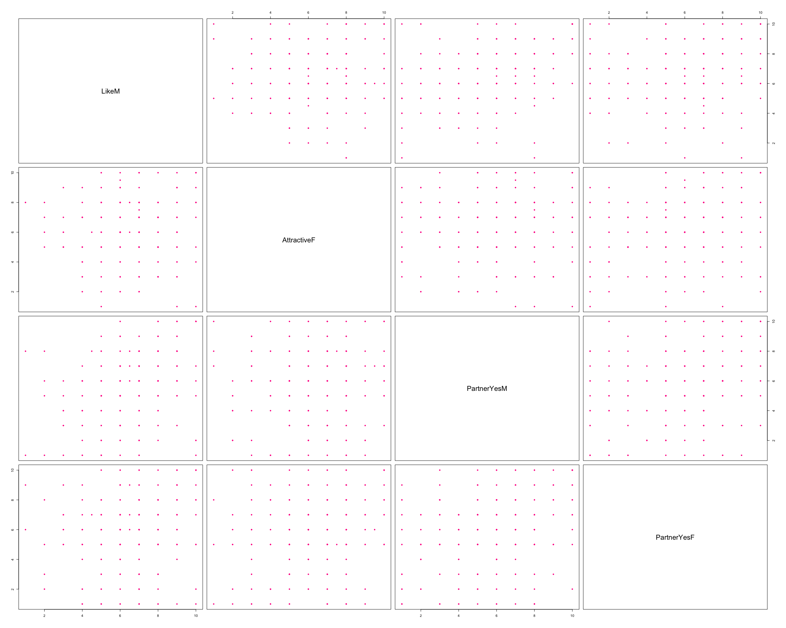

print(round(range(cooks.distance(final.model)),digits = 4))

## [1] 0.000 0.069

#### Checking Multicollinearity #####  
library(usdm)  
vif(dating.q5[complete.cases(dating.q5),])

## Variables VIF  
## 1 LikeM 1.185748  
## 2 AttractiveF 1.055724  
## 3 PartnerYesM 1.239319  
## 4 PartnerYesF 1.139508

##### Check Sample Size ######  
print(nrow(dating.q5))

## [1] 276

##### Computing P-value #####  
pchisq(summary(final.model)$null.deviance-summary(final.model)$deviance,  
 df=summary(final.model)$df.null - summary(final.model)$df.residual, lower.tail=FALSE)

## [1] 2.644361e-18

1. explanatory variables are measured without error: No measurement error in X variables, assumption satisfied.
2. model is correctly specified (no extraneous variables, all important variables included, etc.): model cannot be known as correctly specified! There may be variables that weren’t collected which are relevant; perhaps a transformation may have been the “correct” model, etc., assumption unsatisfied.
3. outcomes not completely linearly separable: Every candidates give one specific result of second.date, therefore observations can be determined completely linearly separable. And we can do glm() in R, which also means this assumption is satisfied.
4. no outliers: The range of Cook’s distance is (0.000, 0.0069). And no observations that has Cook’s distance larger than critical value.
5. observations are independent: Data collected from individals attending speed dating randomly, assumption satisfied.
6. collinearity/multicollinearity: VIFs are close to 1, multicollinearity assumption satisifed.
7. sample size, n: #rule of thumb: at least 10 observations for each outcome (0/1) per predictor in your model.

Just looking at overall sample size is not enough because, in theory, 276 rows of data could have 170 observations with 0 as the outcome and only 6 with 1 as the outcome.  
You have 4 predictors, so you need 10*4=40 observations for each outcome and you have 205 and 63 observations for 0 and 1 outcomes. Therefore, the sample size assumption is satisfied.

##### Model Evaluation

1. log-likelihood for overall model  
   H0 : βTempF=0 Ha : βTempF̸=0 α = 0.05

# test statistic:  
pchisq(summary(final.model)$null.deviance - summary(final.model)$deviance,   
 df=summary(final.model)$df.null - summary(final.model)$df.residual,  
 lower.tail=FALSE)

## [1] 2.644361e-18

The calculated p-value is 2.644361e-18, which much smaller than 0.05, we can reject H0 and thus, the remaining variables are all significant in the model.

1. z-test for slopes for each variable, Ho: slope(beta) is equal to 0 H1: slope(beta) is not 0

print(summary(final.model)$coefficient)

## Estimate Std. Error z value Pr(>|z|)  
## (Intercept) -10.8810596 1.47959180 -7.354096 1.922240e-13  
## LikeM 0.4833617 0.12932106 3.737687 1.857208e-04  
## PartnerYesM 0.3505688 0.10151054 3.453521 5.533193e-04  
## PartnerYesF 0.2799276 0.09565936 2.926296 3.430245e-03  
## AttractiveF 0.3503902 0.10223424 3.427328 6.095532e-04

The p-value for each variables are all smller than 0.01, they are all significant to reject the null hypothesis.

To conclude, this model seems to be a good fit for the data. And my final model is P(have a second date | LikeM, PartnerYesM, PartnerYesF, AttractiveF)= exp^(-10.8811 + 0.4834LikeM + 0.3506PartnerYesM + 0.2799PartnerYesF + 0.3504AttractiveF)/ (1+exp^(-10.8811 + 0.4834LikeM + 0.3506PartnerYesM + 0.2799PartnerYesF + 0.3504AttractiveF))

### Question 6

# Final Model Dataset  
dating.q6 <- dating[complete.cases(dating[,c("LikeM","AttractiveF","PartnerYesM","PartnerYesF")]),]  
# Table Fill   
both_want_fm <- length(which(dating.q6$DecisionF == 1 & dating$DecisionM == 1))  
both_not_fm <- length(which(dating.q6$DecisionF ==0 & dating$DecisionM == 0))  
Female1Male0_fm <- length(which(dating.q6$DecisionF == 1 & dating.q6$DecisionM == 0))  
Female0Male1_fm <- length(which(dating.q6$DecisionF == 0 & dating.q6$DecisionM == 1))  
  
# Plot Table   
decision_fm <- data.frame('Decision of Female (No)' = c(both_not_fm,Female1Male0_fm), 'Decision of Female (Yes)' = c(Female0Male1_fm,both_want_fm),row.names = c("Decision of Male (No)","Decision of Male (Yes)"))  
  
print(decision_fm)

## Decision.of.Female..No. Decision.of.Female..Yes.  
## Decision of Male (No) 69 81  
## Decision of Male (Yes) 61 66

# Checking Sample Size  
print(nrow(dating.q6))

## [1] 268

Q6 <- rep(0, times=nrow(dating.q6))  
Q6[which(dating.q6$DecisionF==1 & dating.q6$DecisionM==1)] <- 1  
print(table(Q6))

## Q6  
## 0 1   
## 205 63

The sample size is 268, and the number of explanatory variables in final model does not follow rule of thumb since both has second dating is 63 but the other group without second dating is 205.

### Question 7

# all coefficient   
print(summary(final.model)$coefficient)

## Estimate Std. Error z value Pr(>|z|)  
## (Intercept) -10.8810596 1.47959180 -7.354096 1.922240e-13  
## LikeM 0.4833617 0.12932106 3.737687 1.857208e-04  
## PartnerYesM 0.3505688 0.10151054 3.453521 5.533193e-04  
## PartnerYesF 0.2799276 0.09565936 2.926296 3.430245e-03  
## AttractiveF 0.3503902 0.10223424 3.427328 6.095532e-04

# all ranges   
print(summary(dating.q6[,c("second.date","LikeM","PartnerYesM","PartnerYesF","AttractiveF")])[c(1,6),])

## second.date LikeM PartnerYesM PartnerYesF   
## Min. :0.0000 Min. : 1.000 Min. : 1.000 Min. : 1.00   
## Max. :1.0000 Max. :10.000 Max. :10.000 Max. :10.00   
## AttractiveF   
## Min. : 1.00   
## Max. :10.00

# When all variables are Zero  
print(exp(-10.8811)/(1+exp(-10.8811)))

## [1] 1.881006e-05

# For LikeM Increase   
print(exp(exp(summary(final.model)$coefficient[2,1])/(1+exp(summary(final.model)$coefficient[2,1])))-1)

## [1] 0.8562185

# For PartnerYesM Increase   
print(exp(exp(summary(final.model)$coefficient[3,1])/(1+exp(summary(final.model)$coefficient[3,1])))-1)

## [1] 0.7981449

# For PartnerYesF Increase   
print(exp(exp(summary(final.model)$coefficient[4,1])/(1+exp(summary(final.model)$coefficient[4,1])))-1)

## [1] 0.7674335

# For Attractive F Increase   
print(exp(exp(summary(final.model)$coefficient[5,1])/(1+exp(summary(final.model)$coefficient[5,1])))-1)

## [1] 0.798067

1. Intercept When all variables are zero, the probability that the two persons will have second date is exp(-10.8811)/(1+exp(-10.8811)), or 1.88*10^-5. However, the rating levels are range from 1 to 10. Therefore, the condition of “LikeM = AttractiveF = PartnerYesM = PartnerYesF = 0” is impossible. Thus, the interpretation of intercept is meaningless.
2. LikeM When LikeM ranking score increases by 1,holding all other x’s fixed, the odds of having a second date increases by 85.62%.
3. Partner Yes M When PartnerYesM ranking score increases by 1, holding all other x’s fixed, the odds of having a second date increases by 79.81%.
4. PartnerYesF When PartnerYesF ranking score increases by 1, holding all other x’s fixed, the odds of having a second date increases by 76.74%.
5. AttractiveF If AttractiveF ranking score increases by 1, holding all other x’s fixed, the odds of having a second date increases by 79.81%.

All the independent variables in the final model would increase the probability of a second date. It is consistant with my expectation. In the final model, the variables such as LikeM or AttractiveF, the more attractive they score of their partners, the higher probability for the second date. Therefore, the final model could be considered reasonable.

### Question 8

require(pROC)  
dating.q8 <- dating.q6[,c("second.date","LikeM","AttractiveF","PartnerYesM","PartnerYesF")]  
rownames(dating.q8) <- 1:nrow(dating.q8)  
# plot ROC   
roc(response=dating.q8$second.date, predictor=final.model$fitted.values,  
 plot=TRUE, las=TRUE, legacy.axes=TRUE, lwd=5,  
 main="ROC Curve", cex.main=1.6, cex.axis=1.3, cex.lab=1.3,xlab = "1-Specificity\n (false positive rate)",ylab = "Sensitivity\n(true positive rate)")+theme.info

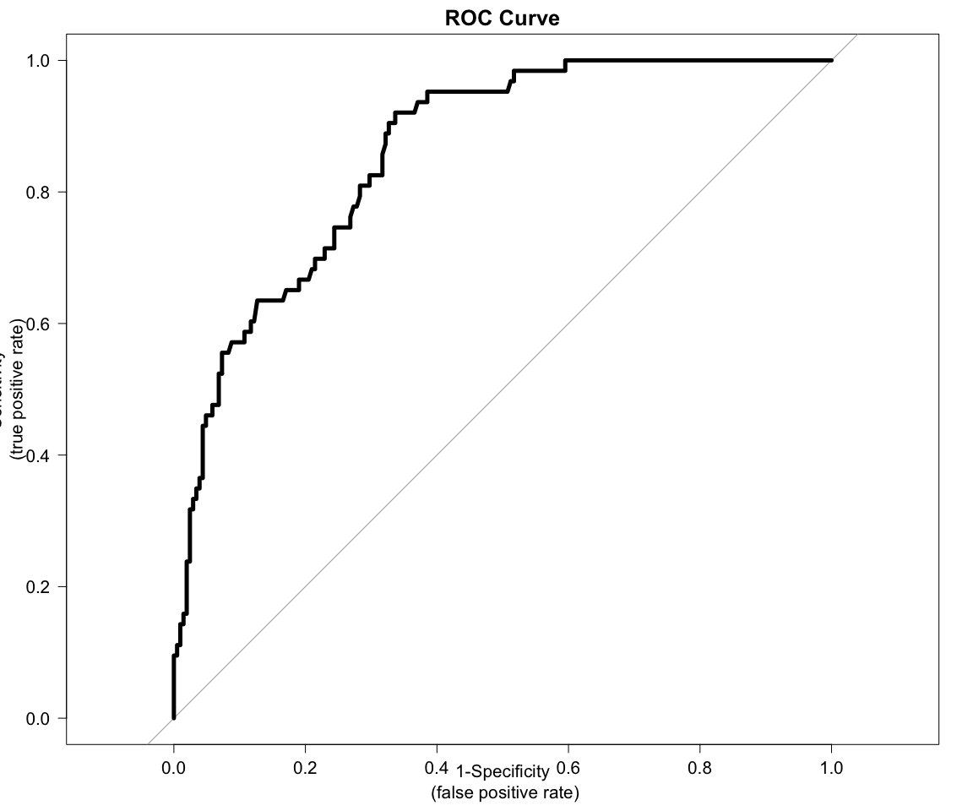

## NULL

# get AUC   
print(auc(response=dating.q8$second.date, predictor=final.model$fitted.values))

## Area under the curve: 0.8602

The AUC of the ROC curve is 0.8602. In this case, we want to decrease false positive rate, which is predicting a group will have a second dating but in fact they don’t want to have a second date, and we want increase true negative(TN) predictions, which is predicting a group will have a second dating and they actually have.

# save ROC curve into an object   
roc.info <- roc(response=dating.q8$second.date, predictor=final.model$fitted.values)  
# sensitivity and specificity for the threshold with highest sensitivity + specificity  
print(coords(roc.info, x="best", ret=c("threshold", "specificity", "sensitivity")))

## threshold specificity sensitivity   
## 0.1653049 0.6634146 0.9206349

# sensitivity and specificity for a wide range of thresholds  
# use t() to transpose output from coords() for easier use  
pi.range <- t(coords(roc.info, x="all", ret=c("threshold", "specificity", "sensitivity")))  
dim(pi.range)

## [1] 244 3

# plot sum of sensitivity and specificity against threshold  
par(mfrow=c(1,2))  
# plot ROC with best Threshold  
roc(response=dating.q8$second.date, predictor=final.model$fitted.values,  
 plot=TRUE, las=TRUE, lwd=3, legacy.axes=TRUE,   
 main="ROC for Second Date Analysis", cex.main=1.3, cex.axis=1.1, cex.lab=1.1,xlab = "1-Specificity\n (false positive rate)",ylab = "Sensitivity\n(true positive rate)")+theme.info

## NULL

# adding best sum of Threshold to ROC plot   
best <- as.data.frame(t(coords(roc.info, x="best", ret=c("threshold", "specificity", "sensitivity"))))  
points(best$specificity, best$sensitivity, pch=19, col="firebrick")  
legend("bottomright", legend=paste("AUC=", round(roc.info$auc, digits=3), sep=" "),  
 pch=19, col="firebrick", bty="n", cex=1.9, y.intersp = 1.3)  
  
# plot pi range   
plot(pi.range[2:243, "threshold"], pi.range[2:243, "sensitivity"] + pi.range[2:243, "specificity"],   
 type="l", las=TRUE, xlab=expression(paste("Threshold, ", pi^"*", sep="")), ylab="Sensitivity + Specificity",   
 main="Sensitivity + Specificity Against Threshold", cex.axis=1.1, cex.lab=1.1,   
 cex.main=1.3, lwd=2, xlim=c(0, 1))+theme.info

## NULL

# adding best sum to plot   
points(best$threshold, best$specificity + best$sensitivity, pch=19, col="firebrick")  
legend("topright", legend=paste("best threshold =", round(best$threshold, digits=4)),  
 pch=19, col="firebrick", bty="n", cex=1.9)

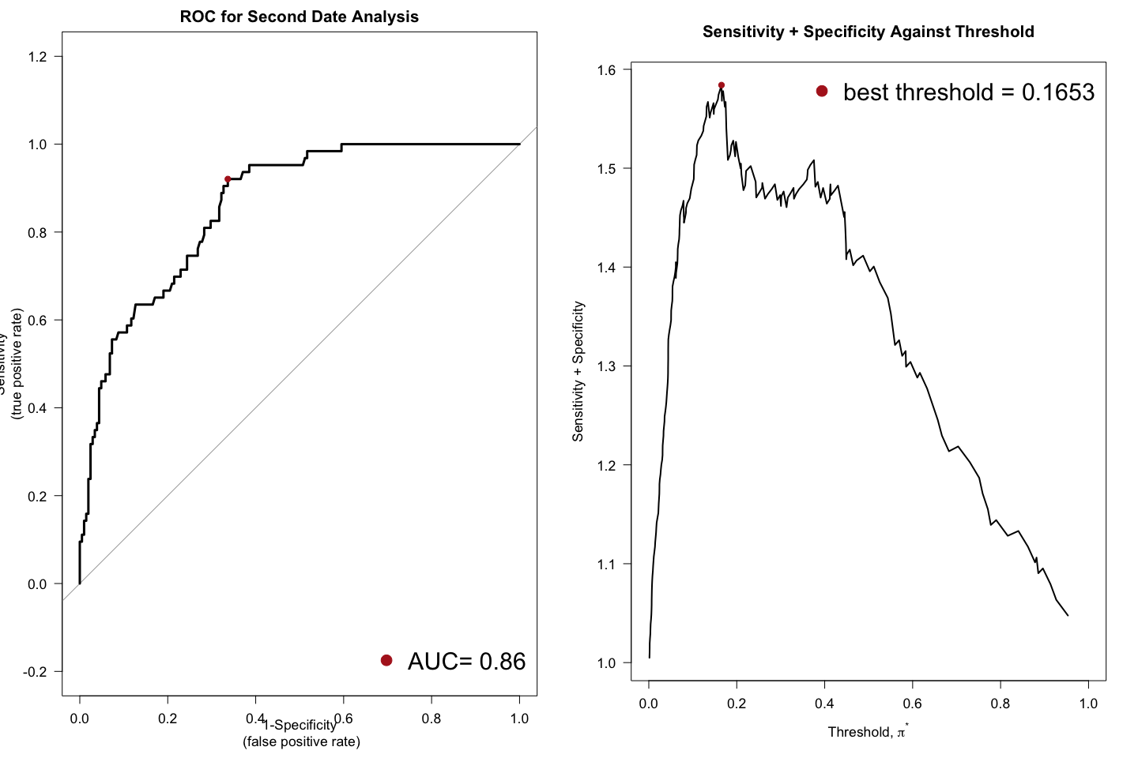

# compute accuracy   
temp <- dating.q8  
rownames(temp) <- 1:nrow(temp)  
temp <- data.frame(temp, "fitted.values"=round(final.model$fitted.values, digits=3))  
  
  
actual.sec <- rep("second.date", times=nrow(temp))  
actual.sec[temp$second.date == 0] <- "no second.date"  
  
classify.best <- rep("second.date", times=nrow(temp))  
classify.best[temp$fitted.values < coords(roc.info, x="best", ret="threshold")] <- "no second.date"  
  
print(table(classify.best, actual.sec))

## actual.sec  
## classify.best no second.date second.date  
## no second.date 136 5  
## second.date 69 58

print(coords(roc.info, x="best", ret=c("threshold","accuracy", "specificity", "sensitivity")))

## threshold accuracy specificity sensitivity   
## 0.1653049 0.7238806 0.6634146 0.9206349

The threshold should be adjusted to best shreshold which is 0.1653049, in this case, the accuracy is 0.7238806, the specificity is 0.6634146 and the sensitivit is 0.9206349.

# Part Two

### Question 9 Code

# Import Data  
require(readxl)  
kudzu_data<-read_excel("kudzu.xls")  
# Response Variable   
kudzu_data$BMD

## [1] 0.228 0.207 0.234 0.220 0.217 0.228 0.209 0.221 0.204 0.220 0.203  
## [12] 0.219 0.218 0.245 0.210 0.211 0.220 0.211 0.233 0.219 0.233 0.226  
## [23] 0.228 0.216 0.225 0.200 0.208 0.198 0.208 0.203 0.250 0.237 0.217  
## [34] 0.206 0.247 0.228 0.245 0.232 0.267 0.261 0.221 0.219 0.232 0.209  
## [45] 0.255

The response variable is BMD, which is bone mineral density.

### Question 10

# Check Factor   
print(table(kudzu_data$Treatment))

##   
## Control HighDose LowDose   
## 15 15 15

The two factors are HighDoes group and LowDose group. The levels are HighDoes, LowDoes and Control.

### Question 11

There are only 2 factors, there are 3 kinds of treatments.

### Question 12

completely randomized design

### Question 13

# summary statistics  
Sample.Size <- "15"  
# compute mean for each treatment group  
mean.kudzu<-aggregate(kudzu_data$BMD, by=list(kudzu_data$Treatment), mean)  
  
# compute standard deviation for each treatment group  
sd.kudzu<-aggregate(kudzu_data$BMD, by=list(kudzu_data$Treatment), sd)  
  
treatment.group <- data.frame("Sample Size"=Sample.Size,"Mean(in grams per square centimeter)"=mean.kudzu$x,"Standard Deviation(in grams per square centimeter)"=sd.kudzu$x )  
rownames(treatment.group) <- c("Control","HighDose","LowDose")  
colnames(treatment.group) <- c("Sample Size","Mean(in grams per square centimeter)","Standard Deviation(in grams per square centimeter)")  
print(kable(t(treatment.group)))

##   
##   
## Control HighDose LowDose   
## --------------------------------------------------- ----------- ----------- -----------  
## Sample Size 15 15 15   
## Mean(in grams per square centimeter) 0.2188667 0.2350667 0.2159333   
## Standard Deviation(in grams per square centimeter) 0.01158735 0.01877105 0.01151066

### Question 14

# side-by-side boxplots with connecting means ######  
theme.info <- theme(plot.title = element_text(size=16, hjust=0.5),  
 axis.title = element_text(size=14),  
 axis.text = element_text(size=14))  
  
kudzu_data %>%   
 ggplot(aes(Treatment,BMD)) +   
 geom_boxplot() +  
 stat_summary(fun.y=mean, geom="line", aes(group=1), lwd=2, col="cadetblue") +  
 stat_summary(fun.y=mean, geom="point", pch=19, size=2, col="firebrick") +  
 ggtitle("Boxplots of BMD by Treatment Group\nWith Connected Means") +  
 labs(x="treatment group",   
 y="bone mineral density\n(in grams per square centimeter)") +  
 theme.info

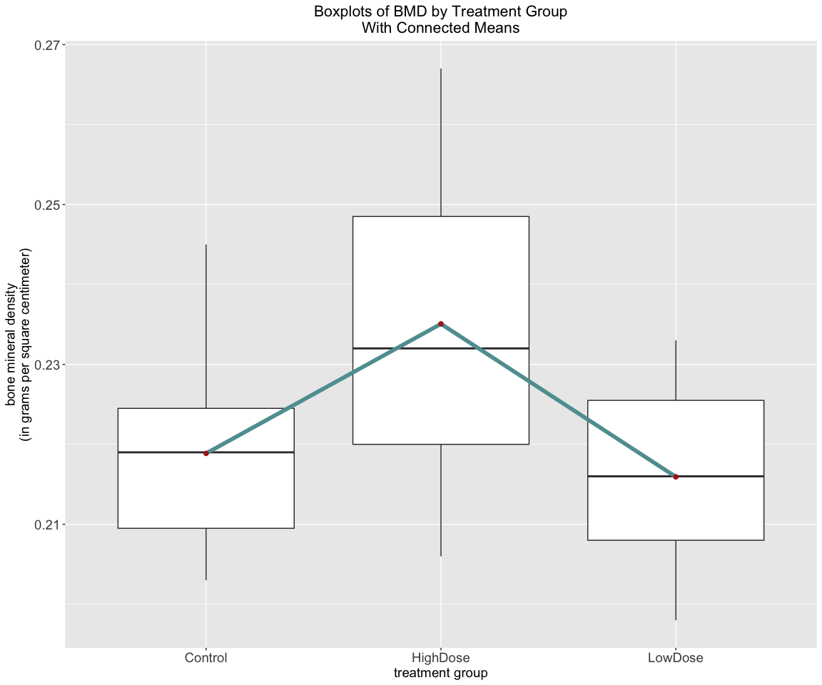

From above side-by-side boxplot, we can see that treatment group with HighDose will bring higher Born Mineral Density. But if the treatment for mice is LowDose, the Born Mineral Density would be lower than even control group. Therefore, the HighDose may bring positive effect, and LowDose may bring negative effects.

### Question 15

# for balanced designs only  
print(aov(BMD ~ Treatment, data=kudzu_data))

## Call:  
## aov(formula = BMD ~ Treatment, data = kudzu_data)  
##   
## Terms:  
## Treatment Residuals  
## Sum of Squares 0.003185644 0.008667600  
## Deg. of Freedom 2 42  
##   
## Residual standard error: 0.01436563  
## Estimated effects may be unbalanced

print(summary(aov(BMD ~ Treatment, data=kudzu_data)))

## Df Sum Sq Mean Sq F value Pr(>F)   
## Treatment 2 0.003186 0.0015928 7.718 0.0014 **  
## Residuals 42 0.008668 0.0002064   
## ---  
## Signif. codes: 0 '***' 0.001 '**' 0.01 '*' 0.05 '.' 0.1 ' ' 1

# looking for normal distribution   
temp <- kudzu_data %>%  
 group_by(Treatment) %>%  
 summarize(mean(BMD))  
left_join(kudzu_data, temp) %>%  
 mutate(residuals = BMD - `mean(BMD)`) %>%  
 ggplot(aes(sample=residuals)) +  
 stat_qq() +  
 stat_qq_line() +  
 ggtitle("Normal Quantile Plot of the\nOne-Way ANOVA Model Residuals") +  
 theme.info

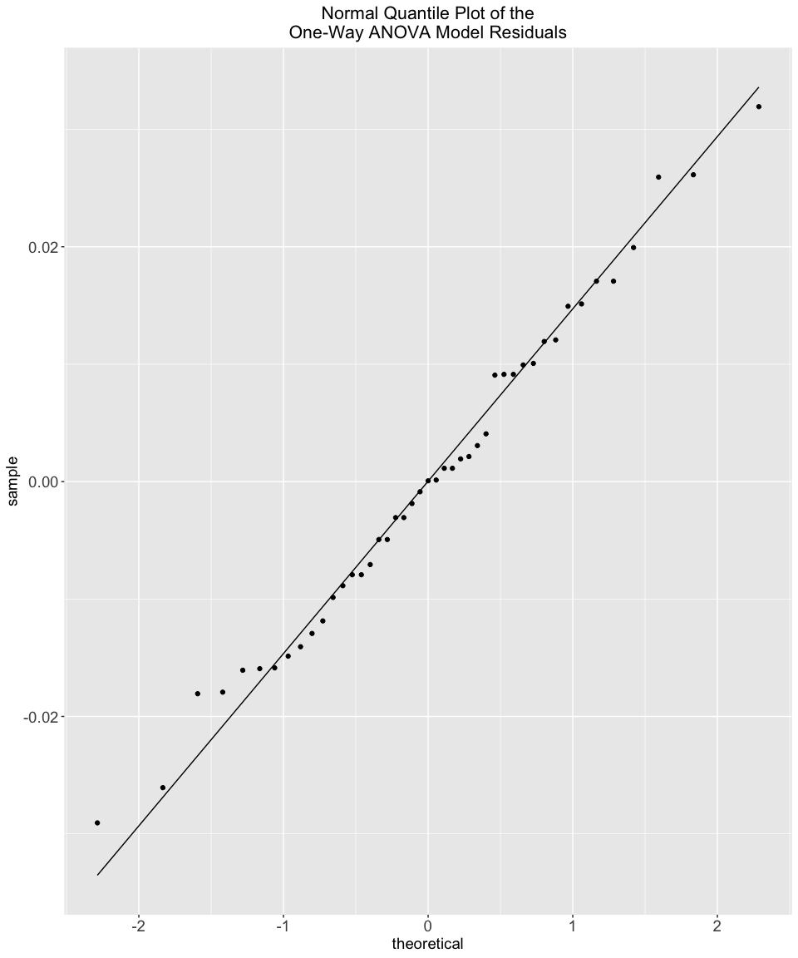

# looking at response by treatment group  
kudzu_data %>%  
 ggplot(aes(sample=BMD)) +  
 facet_grid(~ Treatment) +  
 stat_qq() +   
 stat_qq_line() +  
 ggtitle("Normal Quantile Plots by Treatment Group") +  
 theme.info

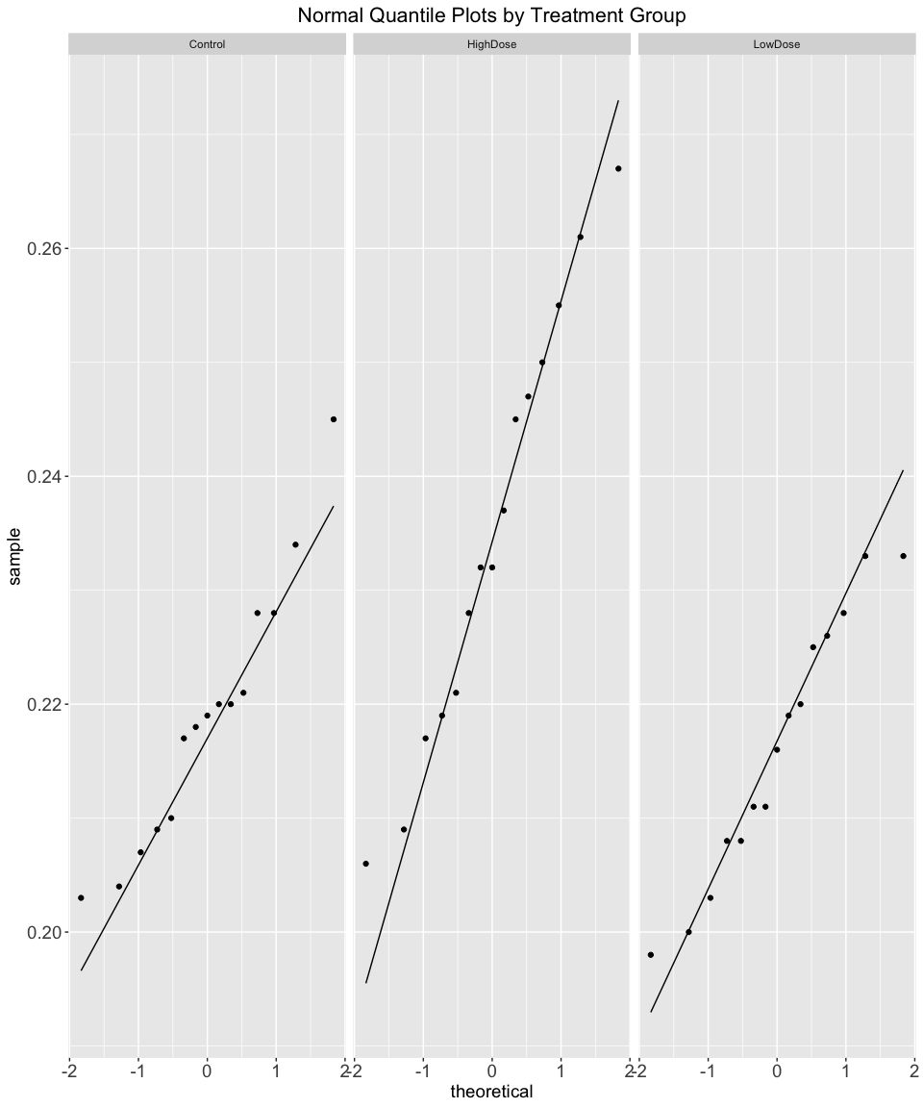

Assumptions:

1. independent observations : Since sample is randomly selected, assumption Satisfied.

2）balanced design: Satisfied.

1. assume εij are normally distributed with mean 0 and standard deviation σ i.e.,εij ∼N(0,σ), From above qq-plot, it could be seem that our residules satisifed this assumption.

4）constant variance: rule of thumb about group standard deviations check the variance is constant. Assumption Satisfied.

1. normally distributed measurements in each group with the same population standard deviation, Assumption Satisfied.

### Question 16

print(aov(BMD ~ Treatment, data=kudzu_data))

## Call:  
## aov(formula = BMD ~ Treatment, data = kudzu_data)  
##   
## Terms:  
## Treatment Residuals  
## Sum of Squares 0.003185644 0.008667600  
## Deg. of Freedom 2 42  
##   
## Residual standard error: 0.01436563  
## Estimated effects may be unbalanced

print(summary(aov(BMD ~ Treatment, data=kudzu_data)))

## Df Sum Sq Mean Sq F value Pr(>F)   
## Treatment 2 0.003186 0.0015928 7.718 0.0014 **  
## Residuals 42 0.008668 0.0002064   
## ---  
## Signif. codes: 0 '***' 0.001 '**' 0.01 '*' 0.05 '.' 0.1 ' ' 1

print(oneway.test(kudzu_data$BMD ~ kudzu_data$Treatment, var.equal=TRUE))

##   
## One-way analysis of means  
##   
## data: kudzu_data$BMD and kudzu_data$Treatment  
## F = 7.7182, num df = 2, denom df = 42, p-value = 0.001397

estimate of error standard deviation −→ s = 0.01436563 in grams per square centimeter (i.e., RMSE) H0 : μcontrol = μhighdose = μlowdose Ha : at least two means are different α = 0.01 test statistic:F = 7.7182, num df = 2, denom df = 42, p-value = 0.001397 p-value= 0.001397 < 0.01 = α −→ reject null hypothesis H0 −→ at least two means are different

### Question 17

print(pairwise.t.test(x=kudzu_data$BMD, g=kudzu_data$Treatment, p.adjust="none"))

##   
## Pairwise comparisons using t tests with pooled SD   
##   
## data: kudzu_data$BMD and kudzu_data$Treatment   
##   
## Control HighDose  
## HighDose 0.00356 -   
## LowDose 0.57900 0.00073   
##   
## P value adjustment method: none

print(pairwise.t.test(x=kudzu_data$BMD, g=kudzu_data$Treatment, p.adjust="bonferroni"))

##   
## Pairwise comparisons using t tests with pooled SD   
##   
## data: kudzu_data$BMD and kudzu_data$Treatment   
##   
## Control HighDose  
## HighDose 0.0107 -   
## LowDose 1.0000 0.0022   
##   
## P value adjustment method: bonferroni

# Tukey's HSD  
  
result <- aov(BMD ~ Treatment, data=kudzu_data)  
  
print(TukeyHSD(result, conf.level=0.95))

## Tukey multiple comparisons of means  
## 95% family-wise confidence level  
##   
## Fit: aov(formula = BMD ~ Treatment, data = kudzu_data)  
##   
## $Treatment  
## diff lwr upr p adj  
## HighDose-Control 0.016200000 0.003455877 0.028944123 0.0097645  
## LowDose-Control -0.002933333 -0.015677456 0.009810789 0.8423308  
## LowDose-HighDose -0.019133333 -0.031877456 -0.006389211 0.0020537

par(mar=c(5, 14, 4, 2))  
plot(TukeyHSD(result, conf.level=0.95), las=TRUE)+theme.info

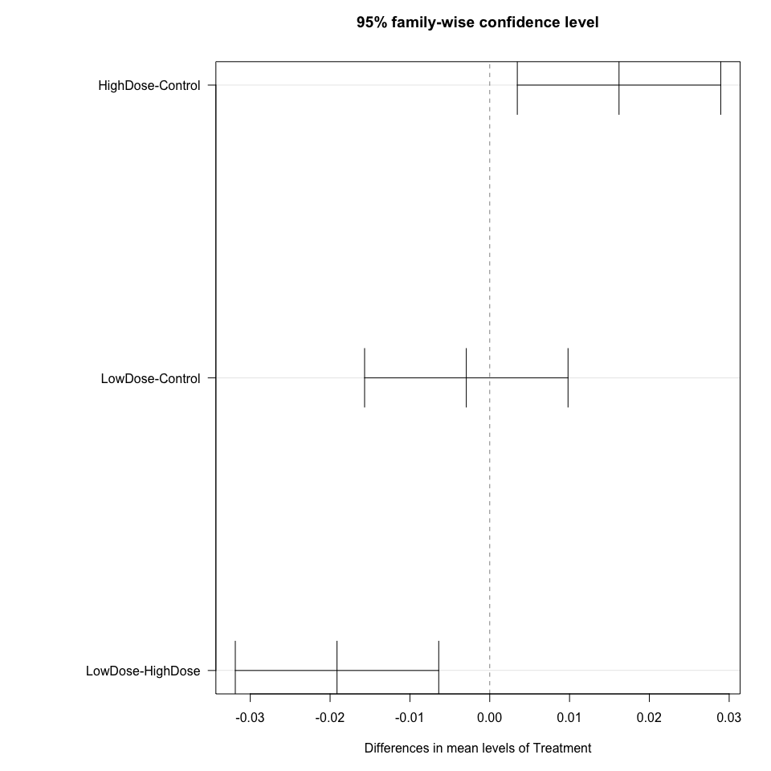

## NULL

Tukey’s multiple-comparisons methodH0 :

H0 : μcontrol = μhighdose

H0 : μhighdose = μlowdose

H0 : μcontrol = μlowdose

From “none” method and “bonferroni” method, HighDose is significantly different from LowDose Group and Control Group.

From Tukey’s multiple-comparisons method,significantly different pairs have confidence intervals which do not include 0, which are LowDose-HighDose and HighDose - Control.