Assignment1

SDGB 7844, Prof. Nagaraja

Yuwen (Suyi) Wu, 330-530PM

9/22/2018

## Question 1.a

Solution:

class(state.area)

## [1] "numeric"

class(state.name)

## [1] "character"

class(state.region)

## [1] "factor"

## Question 1.b What is the longest state name (including spaces)? How long is it?

Solution:

state.name[nchar(state.name)==max(nchar(state.name))]

## [1] "North Carolina" "South Carolina"

nchar(state.name[nchar(state.name)==max(nchar(state.name))])

## [1] 14 14

## Question 1.c

Compute the average area of the states which contain the word “New” at the start of the state name. Use the function substr().

Solution:

mean(state.area[substr(state.name, start=1, stop=3)=="New"])

## [1] 47095.5

## Question 1.d

Use the function table() to determine how many states are in each region. Use the function kable() to include the table in your solutions. (Notes: you will need the R package knitr to be able to use kable(). See the RMarkdown example in the Assignments folder on Blackboard for an example.)

Solution:

z<-table(state.region)  
kable(z)

|  |  |
| --- | --- |
| state.region | Freq |
| Northeast | 9 |
| South | 16 |
| North Central | 12 |
| West | 13 |

## Question 2.a

Solution:

num.perfect<-2  
count<-1 ## change the begin number to get first two perfect number rather than first three perfect number  
iter<-2  
  
  
while(count<=num.perfect){  
 divisor<-1  
 for(i in 2:iter){ ## when i in 2:iter , i could be the divisor of iter  
 if(iter%%i==0 & iter!=i) ## the i could not be the iter in order to get correct sum of i   
 divisor<-c(divisor,i)  
 i<-i+1## add this line to iterrate add the i , and make this loop could be finished   
 }# end for loop  
   
 if(sum(divisor)==iter){  
 print(paste(iter,"is a perfect number",sep=" ")) ## leave a blank space between number and string  
 count<-count+1  
 }#end if  
   
 iter<-iter+1  
}#end while loop

## [1] "6 is a perfect number"  
## [1] "28 is a perfect number"

## Question 2.b.1

Solution:

date()

## [1] "Wed Jan 1 17:40:55 2020"

num.perfect<-2  
count<-1 ## change the begin number to get first two perfect number rather than first three perfect number  
iter<-2  
  
  
while(count<=num.perfect){  
 divisor<-1  
 for(i in 2:iter){ ## when i in 2:iter , i could be the divisor of iter  
 if(iter%%i==0 & iter!=i) ## the i could not be the iter in order to get correct sum of i   
 divisor<-c(divisor,i)  
 i<-i+1## add this line to iterrate add the i , and make this loop could be finished   
 }# end for loop  
   
 if(sum(divisor)==iter){  
 print(paste(iter,"is a perfect number",sep=" ")) ## leave a blank space between number and string  
 count<-count+1  
 }#end if  
   
 iter<-iter+1  
}#end while loop

## [1] "6 is a perfect number"  
## [1] "28 is a perfect number"

date()

## [1] "Wed Jan 1 17:40:55 2020"

1 sec

## Question 2.b.2

Solution:

date()

## [1] "Wed Jan 1 17:40:55 2020"

num.perfect<-4  
count<-1 ## change the begin number to get first two perfect number rather than first three perfect number  
iter<-2  
  
  
while(count<=num.perfect){  
 divisor<-1  
 for(i in 2:iter){ ## when i in 2:iter , i could be the divisor of iter  
 if(iter%%i==0 & iter!=i) ## the i could not be the iter in order to get correct sum of i   
 divisor<-c(divisor,i)  
 i<-i+1## add this line to iterrate add the i , and make this loop could be finished   
 }# end for loop  
   
 if(sum(divisor)==iter){  
 print(paste(iter,"is a perfect number",sep=" ")) ## leave a blank space between number and string  
 count<-count+1  
 }#end if  
   
 iter<-iter+1  
}#end while loop

## [1] "6 is a perfect number"  
## [1] "28 is a perfect number"  
## [1] "496 is a perfect number"  
## [1] "8128 is a perfect number"

date()

## [1] "Wed Jan 1 17:41:06 2020"

v<-1:4  
time.sec<-c(1,1,1,37)  
time.sec

## [1] 1 1 1 37

runTime<-cbind(v,time.sec)  
runTime

## v time.sec  
## [1,] 1 1  
## [2,] 2 1  
## [3,] 3 1  
## [4,] 4 37

colnames(runTime) <- c("No.perfect number", "waiting time (s)")  
runTime

## No.perfect number waiting time (s)  
## [1,] 1 1  
## [2,] 2 1  
## [3,] 3 1  
## [4,] 4 37

kable(runTime, caption="Run Time Result")

Run Time Result

|  |  |
| --- | --- |
| No.perfect number | waiting time (s) |
| 1 | 1 |
| 2 | 1 |
| 3 | 1 |
| 4 | 37 |

[1] “Sat Sep 15 00:27:16 2018” [1] “6 is a perfect number” [1] “28 is a perfect number” [1] “496 is a perfect number” [1] “8128 is a perfect number” [1] “Sat Sep 15 00:28:04 2018”

## Question 2.c

Solution:

theme.info <- theme(plot.title = element_text(size=30, face = "bold", hjust=0.5),  
 axis.title = element_text(size=12),  
 axis.text=element_text(size=20, face = "bold"))   
x<-1:4  
y<-c(1,1,1,37)  
plot(x,y,pch=20,type = "b",  
 xlab = "number of perfect numbers discovered",  
 ylab = "cumulative length of time (in seconds)",  
 main = "Cumulative Run Times to Discover Perfect Numbers",  
 las=TRUE)+theme.info

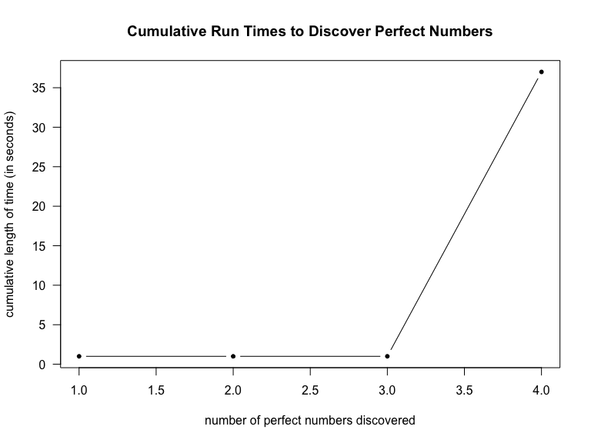

## NULL

Not Linear, it seems exponent function.

## Question 3.a

Solution:

x<-c(4,67,3)  
x<-x[!is.na(x)]   
sum.x<-1  
x

## [1] 4 67 3

for (i in 1:length(x)){  
 if(x[i]<=0){  
 print('error')  
 sum.x<-NaN  
 break  
   
 }  
 else{  
 sum.x<-sum.x*x[i]  
   
 }  
 }  
geometric.mean<-sum.x^(1/length(x))   
geometric.mean

## [1] 9.298624

## Question 3.b.1

Solution:

x<-c(NA,4,67,3)  
x<-x[!is.na(x)]   
sum.x<-1  
x

## [1] 4 67 3

for (i in 1:length(x)){  
 if(x[i]<=0){  
 print('error')  
 sum.x<-NaN  
 break  
   
 }  
 else{  
 sum.x<-sum.x*x[i]  
   
 }  
 }  
geometric.mean<-sum.x^(1/length(x))   
geometric.mean

## [1] 9.298624

## Question 3.b.2

Solution:

x<-c(0,NA,6)  
x<-x[!is.na(x)]   
sum.x<-1  
x

## [1] 0 6

for (i in 1:length(x)){  
 if(x[i]<=0){  
 print('error')  
 sum.x<-NaN  
 break  
   
 }  
 else{  
 sum.x<-sum.x*x[i]  
   
 }  
 }

## [1] "error"

geometric.mean<-sum.x^(1/length(x))   
geometric.mean

## [1] NaN

## Question 3.b.3

Solution:

x<-c(67,3,Inf)  
x<-x[!is.na(x)]   
sum.x<-1  
x

## [1] 67 3 Inf

for (i in 1:length(x)){  
 if(x[i]<=0){  
 print('error')  
 sum.x<-NaN  
 break  
   
 }  
 else{  
 sum.x<-sum.x*x[i]  
   
 }  
 }  
geometric.mean<-sum.x^(1/length(x))   
geometric.mean

## [1] Inf

## Question 3.b.4

x<-c(67,3,-Inf)  
x<-x[!is.na(x)]   
sum.x<-1  
x

## [1] 67 3 -Inf

for (i in 1:length(x)){  
 if(x[i]<=0){  
 print('error')  
 sum.x<-NaN  
 break  
   
 }  
 else{  
 sum.x<-sum.x*x[i]  
   
 }  
 }

## [1] "error"

geometric.mean<-sum.x^(1/length(x))   
geometric.mean

## [1] NaN