Homework 5

SDGB 7844, Prof. Nagaraja

Yuwen Wu 3:30-5:30

12/05/2018

## Question 1

Solution:

# read data  
data.x<-read_delim("asset_data.txt", delim=",", col_names=TRUE)  
# check date  
head(data.x)

## # A tibble: 6 x 4  
## date close.spy close.tlt fed.rate  
## <date> <dbl> <dbl> <dbl>  
## 1 2003-01-02 91.1 86.3 NA   
## 2 2003-01-03 91.4 86.5 NA   
## 3 2003-01-06 93.0 86.2 NA   
## 4 2003-01-07 92.7 86.6 NA   
## 5 2003-01-08 91.4 87.0 1.2  
## 6 2003-01-09 92.8 85.3 NA

# extract only the observations where the federal funds rate is available   
data.clean<-data.x[complete.cases(data.x),]  
# start date of data.clean  
head(data.clean) ## the start date is 2003-01-08

## # A tibble: 6 x 4  
## date close.spy close.tlt fed.rate  
## <date> <dbl> <dbl> <dbl>  
## 1 2003-01-08 91.4 87.0 1.2   
## 2 2003-01-15 92.4 86.4 1.26  
## 3 2003-01-22 88.2 87.9 1.23  
## 4 2003-01-29 86.5 87.2 1.24  
## 5 2003-02-05 84.8 87.5 1.29  
## 6 2003-02-12 82.1 88.1 1.22

# end date of data.clean  
tail(data.clean) ## the end date is 2014-10-29

## # A tibble: 6 x 4  
## date close.spy close.tlt fed.rate  
## <date> <dbl> <dbl> <dbl>  
## 1 2014-09-24 200. 115. 0.09  
## 2 2014-10-01 194. 118. 0.09  
## 3 2014-10-08 197. 119. 0.09  
## 4 2014-10-15 186. 123. 0.09  
## 5 2014-10-22 193. 121. 0.09  
## 6 2014-10-29 198. 119. 0.09

# Graph the federal funds interest rate as a time series.  
  
theme.info <- theme(plot.title = element_text(size=30, face = "bold", hjust=0.5),  
 axis.title = element_text(size=20, face = "bold"),  
 axis.text=element_text(size=20, face = "bold"),  
 legend.title=element_blank(),  
 legend.text = element_text(size = 20),  
 legend.position = "top")  
  
  
p <- data.clean %>% ggplot(aes(x=date,y=fed.rate))+   
 geom_line(color="#663A44")+  
 ggtitle("Time Series of Federal Rate") +  
 labs(y="Federal Rate(%)", x="Date") +  
 theme.info  
  
p

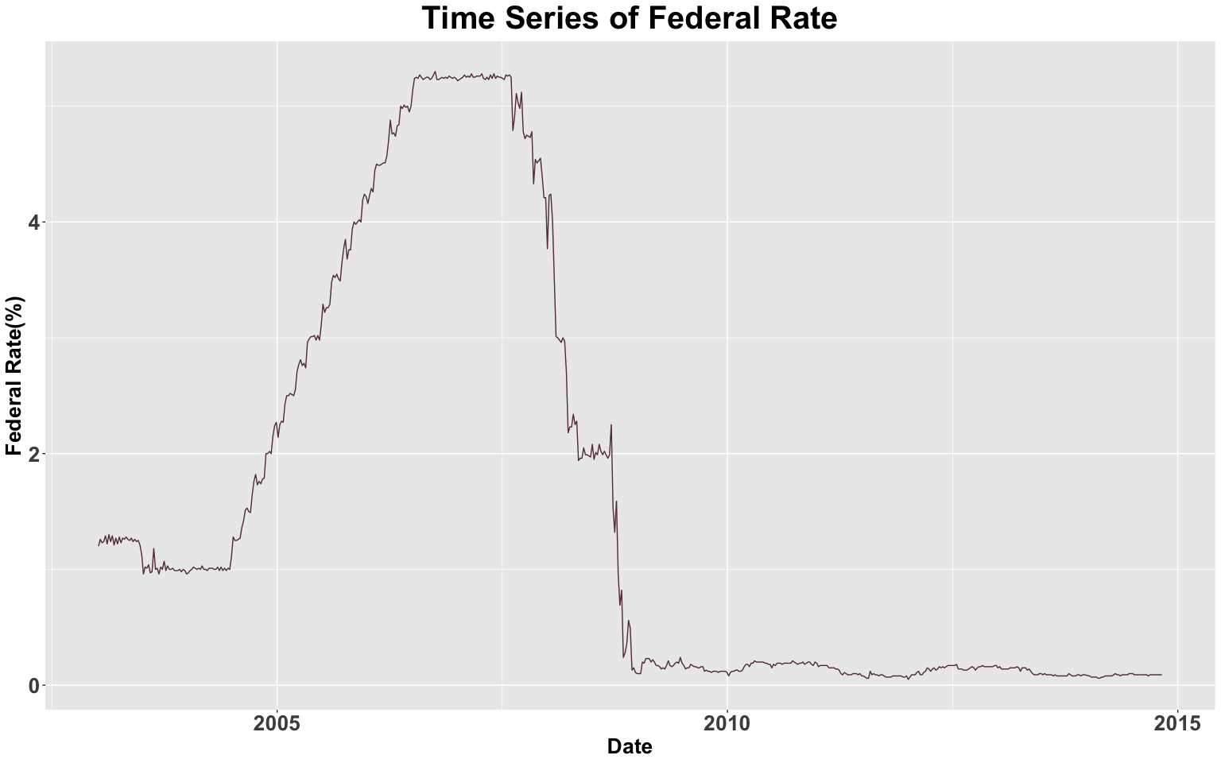

The start date of cleaned dataset is 2003-01-08 and the end date is 2014-10-29.

From the Federal Rate Time Series plot, it could be seen that the federal Rate increased from 2004 to 2008 and dramatically decreased from 2008 to 2009 and then stay in low federal rate approximately to zero from 2009 to 2014.

During the 2017 to 2018, the financial crisis happened. In order to increase the liquidity of the financial market, the FED decreased the fed rate to stable the market and install liquidity.

## Question 2

Solution:

# split data into two parts by using specific date  
# set the date  
a=ymd("2014-01-01")  
# set the training data  
tr.data <- filter(data.clean,date < a)  
# check data  
head(tr.data)

## # A tibble: 6 x 4  
## date close.spy close.tlt fed.rate  
## <date> <dbl> <dbl> <dbl>  
## 1 2003-01-08 91.4 87.0 1.2   
## 2 2003-01-15 92.4 86.4 1.26  
## 3 2003-01-22 88.2 87.9 1.23  
## 4 2003-01-29 86.5 87.2 1.24  
## 5 2003-02-05 84.8 87.5 1.29  
## 6 2003-02-12 82.1 88.1 1.22

# set the test data  
te.data <- filter(data.clean,date > a)  
# check data  
head(te.data)

## # A tibble: 6 x 4  
## date close.spy close.tlt fed.rate  
## <date> <dbl> <dbl> <dbl>  
## 1 2014-01-08 184. 103. 0.08  
## 2 2014-01-15 185. 104. 0.07  
## 3 2014-01-22 184. 105. 0.07  
## 4 2014-01-29 177. 108. 0.07  
## 5 2014-02-05 175. 107. 0.07  
## 6 2014-02-12 182. 106. 0.06

# check the observation number in training data  
nrow(tr.data)

## [1] 570

# check the observation number in test data  
nrow(te.data)

## [1] 43

## Question 3

# convert federal rate to decimal  
tr.data$fed.rate<-tr.data$fed.rate/100  
# compute the return of sp500 and ETF  
n<-length(tr.data$close.spy)   
spy<-NA  
tlt<-NA   
for(i in 2:n){   
 r1 <- (tr.data$close.spy[i] - tr.data$close.spy[i-1])/tr.data$close.spy[i-1]  
 r2 <- (tr.data$close.tlt[i] - tr.data$close.tlt[i-1])/tr.data$close.tlt[i-1]  
 # calculate return by function  
 spy <- c(spy,r1)  
 tlt <- c(tlt,r2) # combine them together   
}#end for loop  
tr.data <- tr.data %>% mutate(total_return_of_close_spy = spy,  
 total_return_of_close_tlt = tlt)  
  
# check data  
  
head(tr.data)

## # A tibble: 6 x 6  
## date close.spy close.tlt fed.rate total_return_of… total_return_of…  
## <date> <dbl> <dbl> <dbl> <dbl> <dbl>  
## 1 2003-01-08 91.4 87.0 0.012 NA NA   
## 2 2003-01-15 92.4 86.4 0.0126 0.0111 -0.00678  
## 3 2003-01-22 88.2 87.9 0.0123 -0.0458 0.0171   
## 4 2003-01-29 86.5 87.2 0.0124 -0.0192 -0.00808  
## 5 2003-02-05 84.8 87.5 0.0129 -0.0188 0.00390  
## 6 2003-02-12 82.1 88.1 0.0122 -0.0324 0.00663

p1 <- tr.data %>% ggplot(aes(x=date,y=total_return_of_close_spy))+   
 geom_line(color="#663A44")+  
 ggtitle("Time Series of Total Return of SP500 ETF") +  
 labs(y="Total Return (%)", x="Date") +  
 theme.info  
  
p1

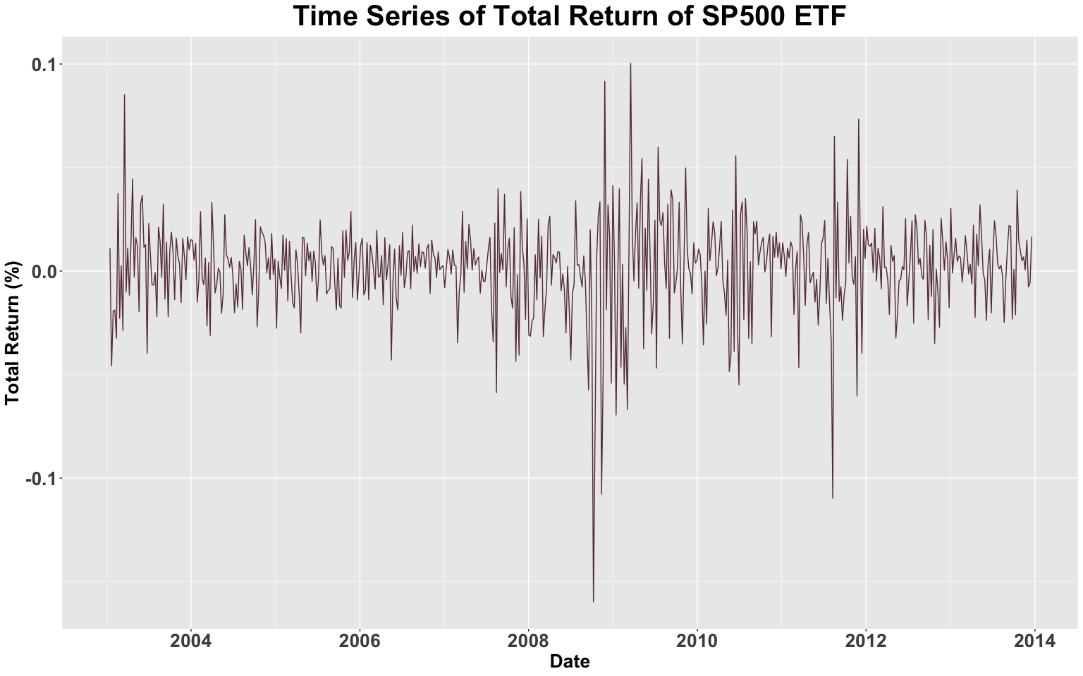

p2 <- tr.data %>% ggplot(aes(x=date,y=total_return_of_close_tlt))+   
 geom_line(color="#663A44")+  
 ggtitle("Time Series of Total Return of Long Term Treasury ETF") +  
 labs(y="Total Return (%)", x="Date") +  
 theme.info  
  
p2

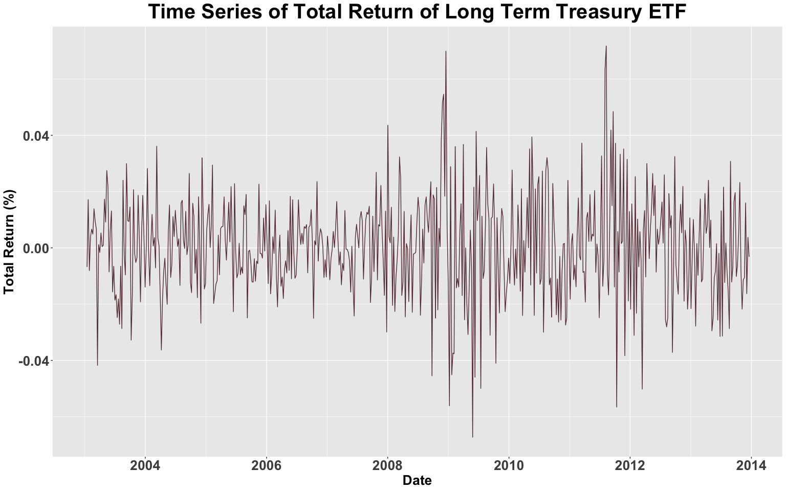

plot=grid.arrange(p1, p2, nrow = 2)

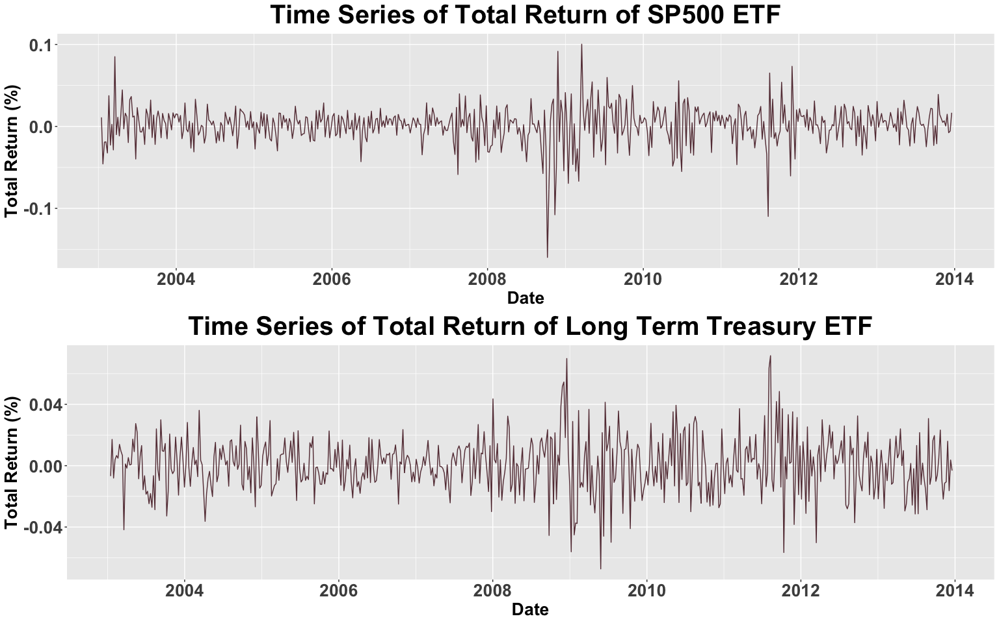

p3 <- ggplot()+  
 geom_line(data = tr.data, aes(x = date, y = total_return_of_close_spy, color = "Total Return of SP500 ETF"))+  
 geom_line(data = tr.data, aes(x = date, y = total_return_of_close_tlt, color = "Total Return of Treasury Bond ETF"))+  
 geom_hline(yintercept=0, linetype=3, color="#663A44",size = 1) +  
 ggtitle("Time Series of Total Return") +  
 labs(x='Date',y='Total Return (%)')+  
 theme.info  
  
p3

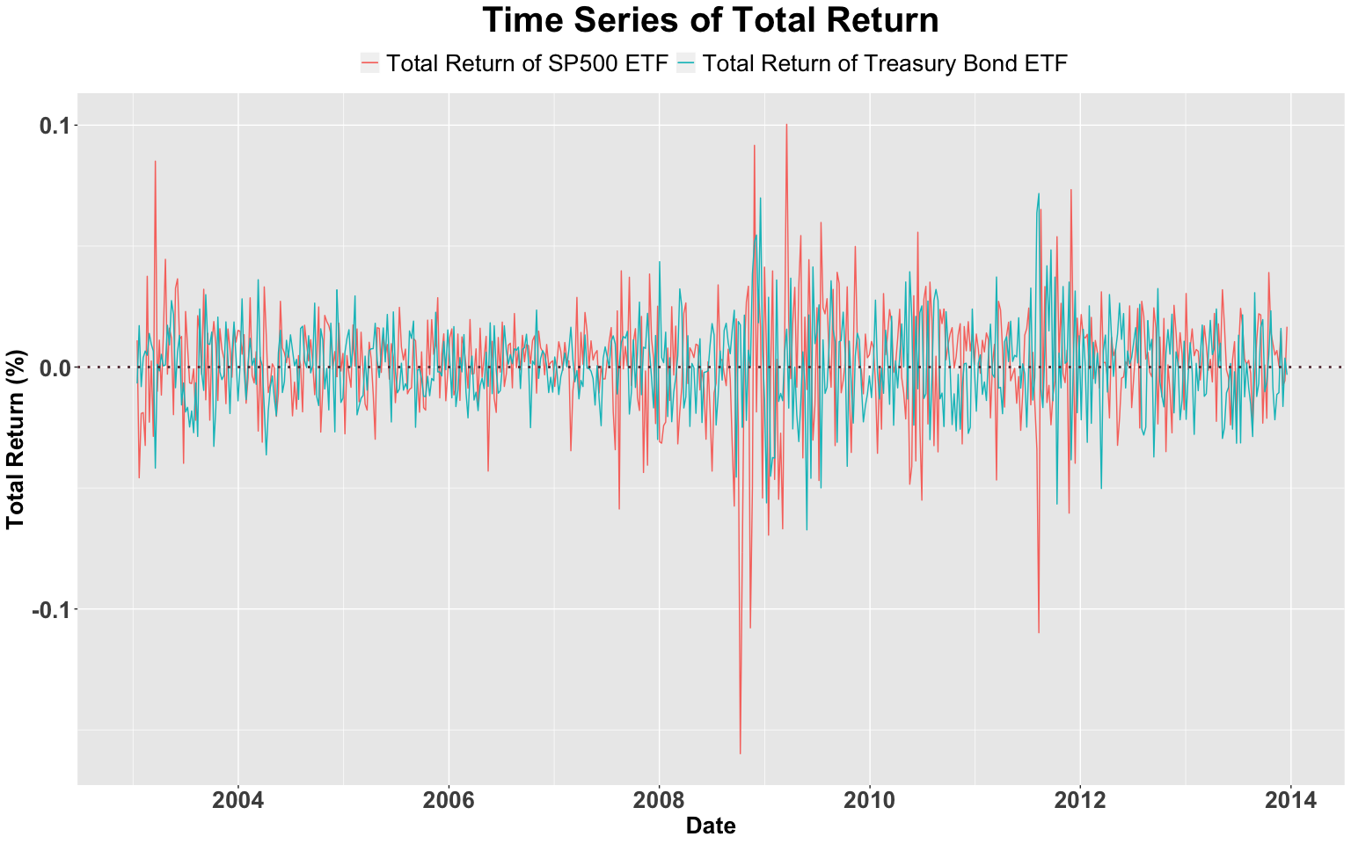

From above time series plot , we can see that the S&P500 ETF was more fluctuated than long term treasury bond. In other words, The long term treasury bond has lower variance than S&P500. From 2008 to 2009, the total return decreased large from positive to negative because of the financial crisis in 2008 and in 2009.

## Question 4

#qqplot for S&P500 ETF total return  
qq.1 <- tr.data %>% ggplot(aes(sample = total_return_of_close_spy)) +  
 stat_qq() +  
 stat_qq_line() +  
 ggtitle("Normal Q-Q Plots of \nS&P500 ETF total return") +  
 theme.info  
#qqplot for Long Term Treasury Bond ETF total return  
qq.2 <- tr.data %>% ggplot(aes(sample = total_return_of_close_tlt)) +  
 stat_qq() +  
 stat_qq_line() +  
 ggtitle("Normal Q-Q Plots of \nLong Term Treasury Bond ETF total return") +  
 theme.info  
  
grid.arrange(qq.1, qq.2, nrow = 1)

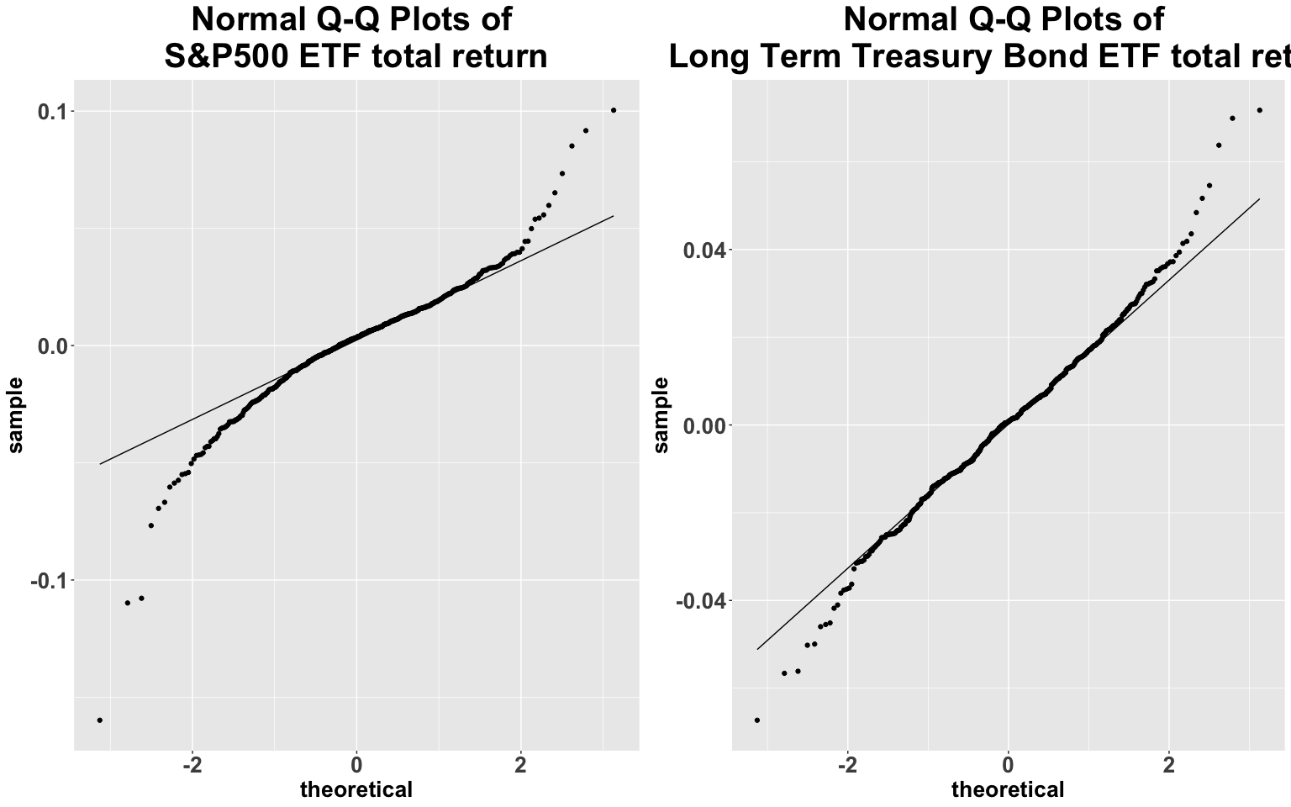

The Sharpe ratio calculation assumes that returns are normally distributed. From the above plots, we could see that these two datasets have fat(heavy) tailed and some outliers. The total return of SP500 ETF and total return of treasury bond ETF do not correspond to normal distribution. However, according to the Central Limit Theorem, when number of observations larger than 30, we can assume the data distribution is normally distributed.

## Question 5

# Compute the correlation between S&P500 and Long Term Treasury Bond ETF returns in the training set  
cor(tr.data$total_return_of_close_spy,tr.data$total_return_of_close_tlt, use="complete.obs")

## [1] -0.3439013

# Compute the total number we need to loop  
n <- nrow(tr.data)-23  
  
# Compute the rolling-window correlations  
Corr<-NULL   
for (i in 1:n){   
 corr<-cor(tr.data[i:(i+23),5],tr.data[i:(i+23),6],  
 use = "complete.obs")  
 Corr<-c(Corr,corr)   
}#end loop  
  
head(Corr)

## [1] -0.5828004 -0.5054171 -0.5160272 -0.4710266 -0.4419905 -0.4023793

tr.data.p <- tr.data[24:570,] %>% mutate(correlation = Corr)  
head(tr.data.p)

## # A tibble: 6 x 7  
## date close.spy close.tlt fed.rate total_return_of… total_return_of…  
## <date> <dbl> <dbl> <dbl> <dbl> <dbl>  
## 1 2003-06-18 102. 94.3 0.0125 0.0127 -0.0157   
## 2 2003-06-25 97.5 93.7 0.0121 -0.0398 -0.00658  
## 3 2003-07-02 99.8 91.9 0.0113 0.0230 -0.0186   
## 4 2003-07-09 101. 90.4 0.00960 0.00812 -0.0166   
## 5 2003-07-16 99.9 88.2 0.0102 -0.00656 -0.0248   
## 6 2003-07-23 99.2 86.6 0.0101 -0.00681 -0.0182   
## # … with 1 more variable: correlation <dbl>

p4 <- tr.data.p %>% ggplot(aes(x=date,y=correlation))+   
 geom_line(color="#663A44")+  
 ggtitle("Time Series of Correlation Between SP500 and Treasury Bond") +  
 labs(y="Correlation", x="Date") +  
 geom_hline(yintercept=0, linetype=3, color="grey",size=2) +  
 theme.info  
  
p4

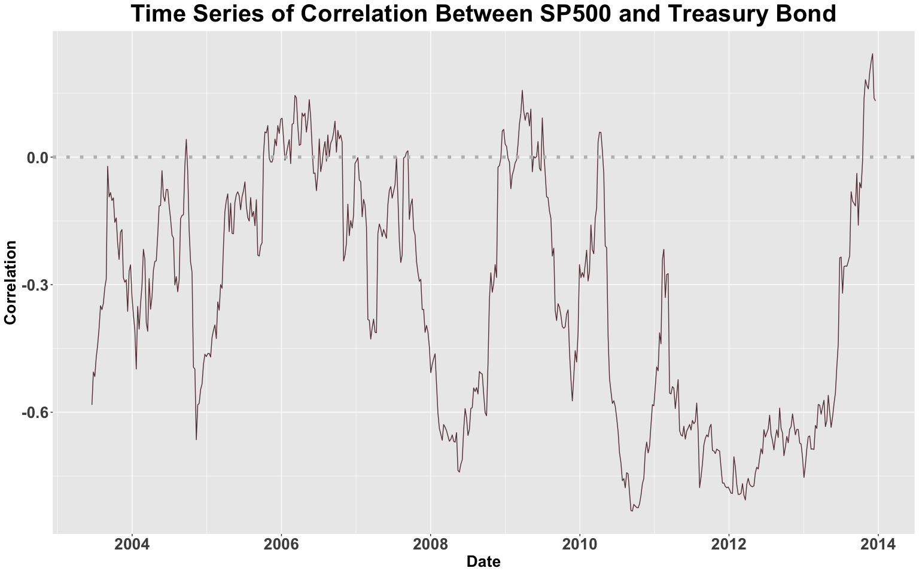

The correlation between this two portfolios is -0.3379974, which is negative, and the negative correlation presents the negative relationship between these two portfolios.

The rolling-window correlations would be the better way to describe the relationship between these two assets because in the different period the correlation would be change with the fluctuation of markets.

The one time correlation could not reflect the change of the correlation between these two assets. For example, in the financial crisis, the correlation decreased a lot since the Treasury Bonds’ ETF is the subtitute of the SP500 ETF. When the return decreased in the SP500 ETF, more and more investors would buy Treasury Bonds as their risk free assets.

In this case, the rolling window correlations could be more representative.

## Question 6

# step0:  
rt_spy<- tr.data$total_return_of_close_spy  
rt_tlt<- tr.data$total_return_of_close_tlt  
yt <- tr.data$fed.rate  
# step1:  
# excess return  
excess_return_spy <- NA  
excess_return_tlt <- NA  
n <- length(tr.data$total_return_of_close_spy)  
for(i in 2:n){   
 et1<-rt_spy[i]-(yt[i-1]/52)  
 et2<-rt_tlt[i]-(yt[i-1]/52)  
 excess_return_spy <- c(excess_return_spy,et1)  
 excess_return_tlt <- c(excess_return_tlt,et2)  
}#end for loop  
  
# step2:  
# excess return index  
excess_return_index_spy<-c(100)  
excess_return_index_tlt<-c(100)  
for(i in 2:n){   
 gt1<-(excess_return_index_spy[i-1])*(1+(excess_return_spy[i]))  
 gt2<-(excess_return_index_tlt[i-1])*(1+(excess_return_tlt[i]))  
 excess_return_index_spy<-c(excess_return_index_spy,gt1)  
 excess_return_index_tlt<-c(excess_return_index_tlt,gt2)  
}#end for loop  
  
# step3:  
# compute years  
year_number<-(nrow(tr.data)-1)/52  
year_number

## [1] 10.94231

# step4:   
# Compute CAGR  
cagr_spy<-((excess_return_index_spy[n]/excess_return_index_spy[1])^(1/year_number))-1  
cagr_spy

## [1] 0.04721991

cagr_tlt<-((excess_return_index_tlt[n]/excess_return_index_tlt[1])^(1/year_number))-1  
cagr_tlt

## [1] -0.001429458

# step5:  
# annualized volatility  
excess_return_spy <- tibble(excess_return_spy)  
excess_return_tlt <- tibble(excess_return_tlt)  
head(excess_return_spy)

## # A tibble: 6 x 1  
## excess_return_spy  
## <dbl>  
## 1 NA   
## 2 0.0108  
## 3 -0.0460  
## 4 -0.0194  
## 5 -0.0191  
## 6 -0.0327

sd(excess_return_spy$excess_return_spy,na.rm = TRUE)

## [1] 0.02332673

volatility_spy<-sqrt(52)*sd(excess_return_spy$excess_return_spy,na.rm = TRUE)  
  
volatility_tlt<-sqrt(52)*sd(excess_return_tlt$excess_return_tlt,na.rm = TRUE)  
  
# step6:  
# Compute Sharp Ratio  
sharp_spy<-cagr_spy/volatility_spy  
sharp_tlt<-cagr_tlt/volatility_tlt  
  
# check data  
head(sharp_spy)

## [1] 0.2807176

head(sharp_tlt)

## [1] -0.01095925

The sharp ratio of SP500 ETF is 0.28072, and the sharp ratio of Long Term Treasury Bonds ETF is -0.0109. Considering the term of sharp ratio, which is measuring the excess return per unit the risk take, the SP500 ETF would be a better choice in this period.

## Question 7

port<-function(x,   
 asset1=tr.data$total_return_of_close_spy,   
 asset2=tr.data$total_return_of_close_tlt,  
 ffr=tr.data$fed.rate){  
 if((x>=0)&(x<=1)){ # the weight of assets must be in [0,1]  
 portfolio_return <-(x*asset1)+((1-x)*asset2) # portifolio return function  
 excess_return<-NA # excess return   
 excess_index_return<-100 # excess index return  
 for(i in 2:570){  
 et<-portfolio_return[i]-(ffr[i-1]/52)  
 excess_return<-c(excess_return,et)  
 }  
 for(j in 2:570){  
 gt<-excess_index_return[j-1]*(1+excess_return[j])  
 excess_index_return<-c(excess_index_return,gt)  
 }  
   
 year_number <-(570-1)/52  
 cagr_portfolio<-(excess_index_return[570]/excess_index_return[1])^(1/year_number)-1  
 volatility_portfolio<-sqrt(52)*sd(excess_return,na.rm=TRUE)  
 sharp_ratio_portfolio<-cagr_portfolio/volatility_portfolio  
 return("Sharp Ratio"= sharp_ratio_portfolio) ## return list of sharpe ratio of portfolio  
 }else{  
 return("ERROR: x should be between 0 and 1")  
 } # print error when x is not between o and 1  
}  
  
# Check the Sharp Ratio of Function  
port(0.2)

## [1] 0.132891

#use "vectorized" function to change the result to a vector in order for we to make the plot  
port.vectorized <- Vectorize(port, vectorize.args="x")  
#make plot of the portfolio curve  
  
plot <- ggplot(tibble(x = c(0, 1)), aes(x = x)) +  
 stat_function(fun = port.vectorized)+  
 ggtitle("Sharp Ratio Trend of Portfolio") +  
 labs(y="Sharp Ratio", x="Weight of Asset SP500 ETF")+  
 theme.info  
plot

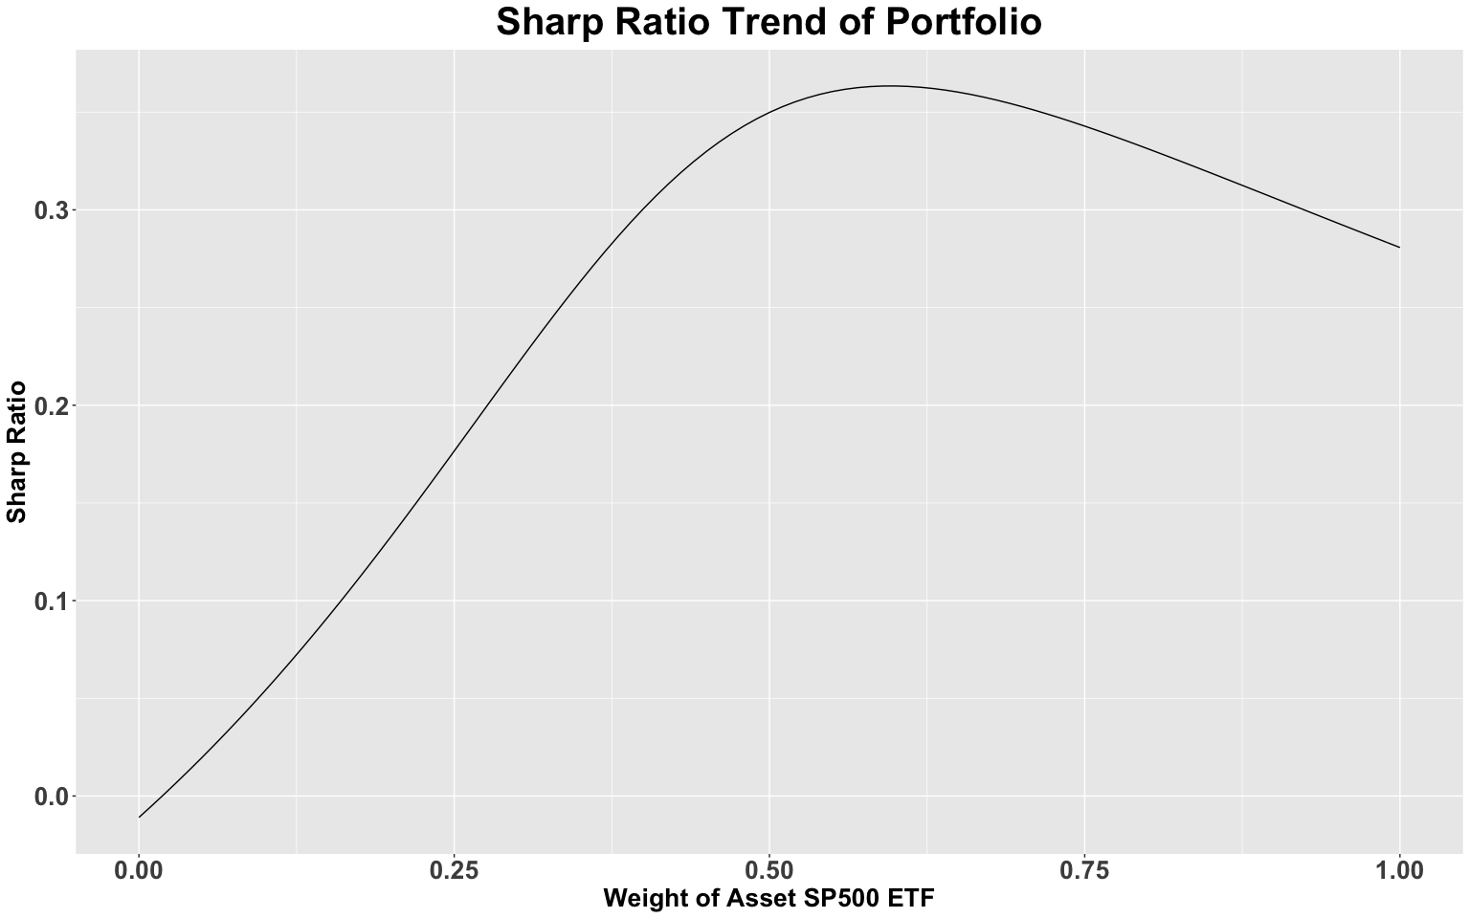

port(0.6)

## [1] 0.3633928

From the above plot, when the portfolio asset 1 weight nearly 0.6, the Sharp Ratio would approximate to the largest value in 0.3633928.

## Question 8

Solution:

## optimum weight for each asset with the function optimize  
optimize(port.vectorized,lower=0,upper=1,maximum = TRUE)

## $maximum  
## [1] 0.5958502  
##   
## $objective  
## [1] 0.3634139

## The weight for asset one   
optimize(port.vectorized,lower=0,upper=1,maximum = TRUE)$maximum

## [1] 0.5958502

## 0.5958502  
  
## The weight for asset two  
1-optimize(port.vectorized,lower=0,upper=1,maximum = TRUE)$maximum

## [1] 0.4041498

## 0.4041498  
  
## optimum sharp ratio  
optimize(port.vectorized,lower=0,upper=1,maximum = TRUE)$objective

## [1] 0.3634139

## 0.3634139  
  
## All invest in Long Term Treasury Bond ETF  
port(0)

## [1] -0.01095925

## All invest in SP500 ETF  
port(1)

## [1] 0.2807176

From above function, the optimum weight of SP500 ETF is 59.585% and the optimum weight of Long Term Treasury Bond ETF is 40.41%. In this case, the optimum sharp ratio should be 0.3634139.

According above analysis, I think we should invest in this optimum ratio becasuse in this ratio, we could earn highest excess return with the unit risk. If we invest all fund in Long Term Treasury Bond ETF, the sharp ratio would be -0.01095925, and if we invest all fund in SP500 ETF, the sharp ratio would be 0.2807176. These two sharp ratio all less than portfolio best allocation. Therefore, I would invest in portfolio to maximize the return and minimize the risk.

## Question 9

Solution:

# change federal rate to decimal form in testing data  
te.data$fed.rate<-te.data$fed.rate/100  
  
# step1:  
# total return for SP500 and Treasury Bonds ETF  
  
n_test<-length(te.data$close.spy)   
spy_test<-NA  
tlt_test<-NA   
for(i in 2:n_test){   
 r1 <- (te.data$close.spy[i] - te.data$close.spy[i-1])/te.data$close.spy[i-1]  
 r2 <- (te.data$close.tlt[i] - te.data$close.tlt[i-1])/te.data$close.tlt[i-1]  
 # calculate return by function  
 spy_test <- c(spy_test,r1)  
 tlt_test <- c(tlt_test,r2) # combine them together   
}#end for loop  
te.data <- te.data %>% mutate(total_return_of_close_spy_test = spy_test,  
 total_return_of_close_tlt_test = tlt_test)  
  
###############################  
# step2:  
# excess return for SP500 and Treasury Bonds ETF  
rt_spy_test<- te.data$total_return_of_close_spy_test  
rt_tlt_test<- te.data$total_return_of_close_tlt_test  
yt_test <- te.data$fed.rate  
  
excess_return_spy_test <- NA  
excess_return_tlt_test <- NA  
for(i in 2:n_test){   
 et1<-rt_spy_test[i]-(yt_test[i-1]/52)  
 et2<-rt_tlt_test[i]-(yt_test[i-1]/52)  
 excess_return_spy_test <- c(excess_return_spy_test,et1)  
 excess_return_tlt_test <- c(excess_return_tlt_test,et2)  
}#end for loop  
  
# step3:  
# excess returns index for SP500 ETF and Long Term Treasury Bond ETF  
  
excess_return_index_spy_test<-c(100)  
excess_return_index_tlt_test<-c(100)  
for(i in 2:n_test){   
 gt1<-(excess_return_index_spy_test[i-1])*(1+(excess_return_spy_test[i]))  
 gt2<-(excess_return_index_tlt_test[i-1])*(1+(excess_return_tlt_test[i]))  
 excess_return_index_spy_test<-c(excess_return_index_spy_test,gt1)  
 excess_return_index_tlt_test<-c(excess_return_index_tlt_test,gt2)  
}#end for loop  
  
te.data <- te.data %>% mutate(excess_return_spy_test = excess_return_index_spy_test,  
 excess_return_tlt_test = excess_return_index_tlt_test,  
 excess_return_index_spy = excess_return_index_spy_test,  
 excess_return_index_tlt = excess_return_index_tlt_test)  
  
  
# step 4:   
# testing data portfolio  
  
port.return<-function(x, #write function with four input  
 asset1=te.data$total_return_of_close_spy_test,  
 asset2=te.data$total_return_of_close_tlt_test,  
 ffr=te.data$fed.rate){  
 if((x>=0)&(x<=1)){ # the weight of assetmust be in the internal of [0,1]  
 return_port<-(x*asset1)+((1-x)*asset2) #portfolio rate  
 excess_return<-rep(NA,43)  
 index<-rep(NA,43)  
 index[1]<-100  
 for(i in 2:n_test){  
 excess_return[i]<-return_port[i]-(ffr[i-1]/52)  
 }#end for loop  
 for(j in 2:43){   
 index[j]<-index[j-1]*(1+excess_return[j])  
 }# end for loop  
 return(index) #return excess index return  
 }else{  
 return("ERROR: x should be between 0 and 1")  
 }  
}  
# use the optimum portfolio weight to calculate the test portfolio return   
index_test<-port.return(optimize(port.vectorized,lower=0,upper=1,maximum = TRUE)$maximum)  
# add the test portfolio return to test data  
te.data <- te.data %>% mutate(index_test = index_test)  
# check data  
head(te.data)

## # A tibble: 6 x 11  
## date close.spy close.tlt fed.rate total_return_of… total_return_of…  
## <date> <dbl> <dbl> <dbl> <dbl> <dbl>  
## 1 2014-01-08 184. 103. 0.0008 NA NA   
## 2 2014-01-15 185. 104. 0.0007 0.00621 0.0172   
## 3 2014-01-22 184. 105. 0.0007 -0.00195 0.00920  
## 4 2014-01-29 177. 108. 0.0007 -0.0377 0.0244   
## 5 2014-02-05 175. 107. 0.0007 -0.0123 -0.00658  
## 6 2014-02-12 182. 106. 0.000600 0.0394 -0.0116   
## # … with 5 more variables: excess_return_spy_test <dbl>,  
## # excess_return_tlt_test <dbl>, excess_return_index_spy <dbl>,  
## # excess_return_index_tlt <dbl>, index_test <dbl>

# plot the time series plot of these three assets  
p5 <- te.data %>% ggplot()+  
 geom_line(aes(x = te.data$date, y = te.data$excess_return_index_spy, color = "Total Return Index of SP500 ETF"))+  
 geom_line(aes(x = te.data$date, y = te.data$excess_return_index_tlt, color = "Total Return Index of Treasury Bond ETF"))+  
 geom_line(aes(x = te.data$date, y = te.data$index_test, color = "Total Return Index of Portfolio"))+  
 geom_hline(yintercept=100, linetype=3, color="red",size = 1) +  
 ggtitle("Time Series of Total Return Index") +  
 labs(x='Date',y='Total Return Index (100 base)')+  
 theme.info  
  
p5

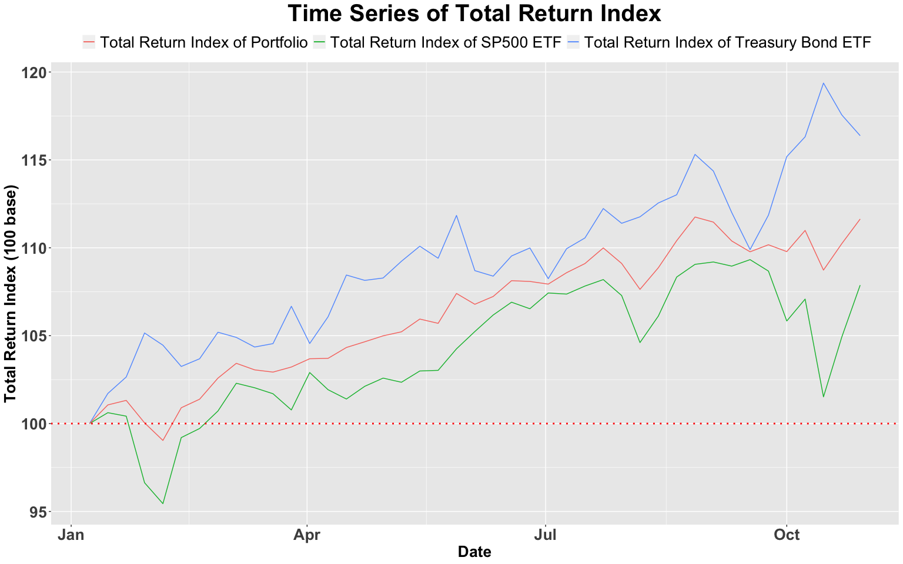

From the plot above, we can see that the return of SP500 ETF and Long Term Treasury ETF are positive, which means we will receive more money than we invested at the end of investment period.

From the above picture, we also could see that the Long Term Treasury Bonds could bring the highest return index than our portfolio and SP500 ETF.

The portfolio return index is in the middle of other two ETF return index becasue the portfolio is combined of these two assets.

## Question 10

Solution:

# Check the perfermance at the end of the test period for each asset in addition to the risk-free interest rate  
  
# SP500ETF  
te.data$excess_return_index_spy[n_test]

## [1] 107.8763

# Long Term Treasury ETF  
te.data$excess_return_index_tlt[n_test]

## [1] 116.376

# Portfolio  
te.data$index_test[n_test]

## [1] 111.6367

The 107.8763 we would be have if we invest all in SP500 ETF. The 116.376 we would be have if we invest all in Long Term Treasury Bonds ETF. The 111.6367 we would have if we invest with optimum weight in SP500 ETF and Treasury Bond ETF.

From above analysis, I think the optimum weight of portfolio in the trainining data is not good in test data and the portfolio is not good performed in the test period than Long Term Treasury Bonds ETF. Additionally, the sharp ratio is based on risk or variance, in other words, the optimum portfolio is the portfolio with the highest excess return based on the risk or variance. Futhermore, in this case, we cannot sell out product, which means we cannot build the portfolio which has better return than the better one of these two assets. Also, the best weight is calculated on training data, and this would not good for test data to use because the variance and return are changing everyday and the best weight also change.