**Contents**

|  |  |
| --- | --- |
| **Sr. No.** | **Name** |
| 1 | Home Screen |
| 2 | Live Attendance |
| 3 | Today’s Attendance |
| 4 | Navigation Menu |
| 5 | Student’s Data |
| 6 | Unit Test Marks |
| 7 | Submission |
| 8 | Utility |
| 9 | Settings |
| 10 | Steps for uploading file |
| 11 | Steps for creating CSV file from excel file |

**1.** **Home Screen**

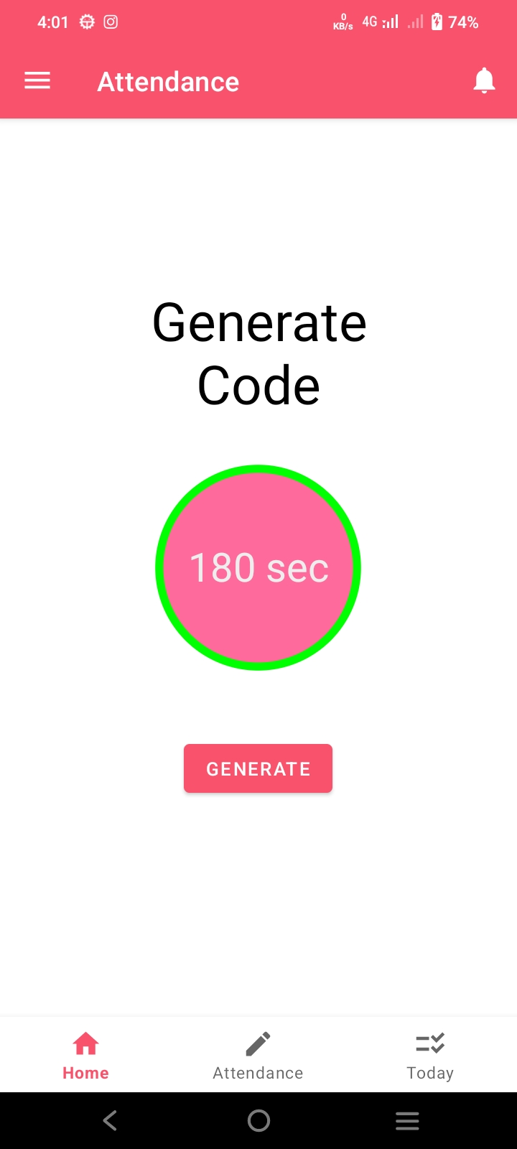

1. Notifications

2. Timer

3. Generate code

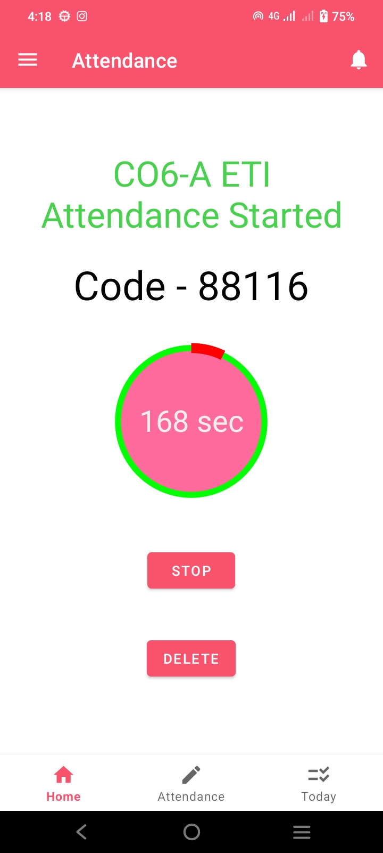

7. Delete Attendance

6. Stop Attendance

5. Code

4. Status

**Description** : Attendance is started, stopped or deleted from here.

**1. Notifications** : Teacher can see notifications history and send notification from here.

**2. Timer** : Timer starts when attendance code is generated. Maximum time to take attendance is three minutes, After it attendance is automatically stopped.

**3. Generate code** : “GENERATE” button is used to generate attendance code by selecting semester, division and subject.

**4. Status** : It shows which semester, division and subject attendance has started.

**5. Code** : This is attendance code which is random number of five digits which changes every time new attendance is started. Teacher should share this code with students.

**6. Stop Attendance** : When attendance is completed teacher can manually stop attendance by clicking “STOP” button else attendance will automatically stop after three minutes.

**7. Delete Attendance** : In case teacher want to reject currently started attenance, It can be done by clicking on “DELETE” button.

**2.** **Live Attendance**

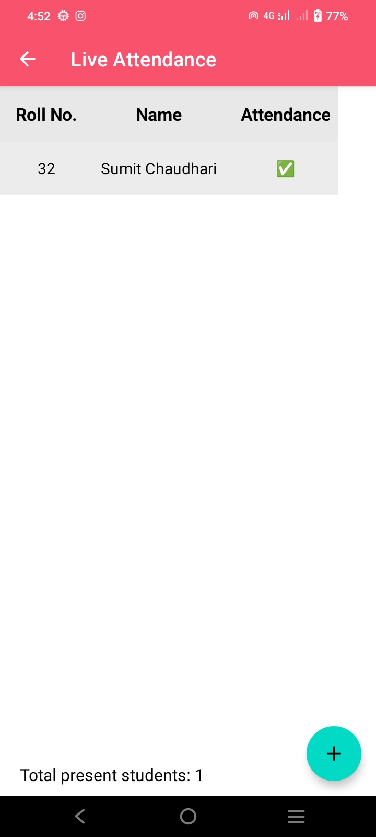

3. Total

2. Add Student

1. Student

**Description** : Teacher can see realtime attendance of students who are currently marking their attendance.

**1. Student** : When student enters attendance code their roll no. and name appears here.

**2. Add Student** : In case teacher want to manually add student to attendance it can be done by clicking on “+” button and entering student roll no.

**NOTE** : If teacher sees message like “Roll no. not found!”, Then that student should create account first. (If app is not supported on student’s device then student can create account on any device of family member).

**3. Total** : It shows number of total students who has marked their attendance.

**3.** **Today’s Attendance**

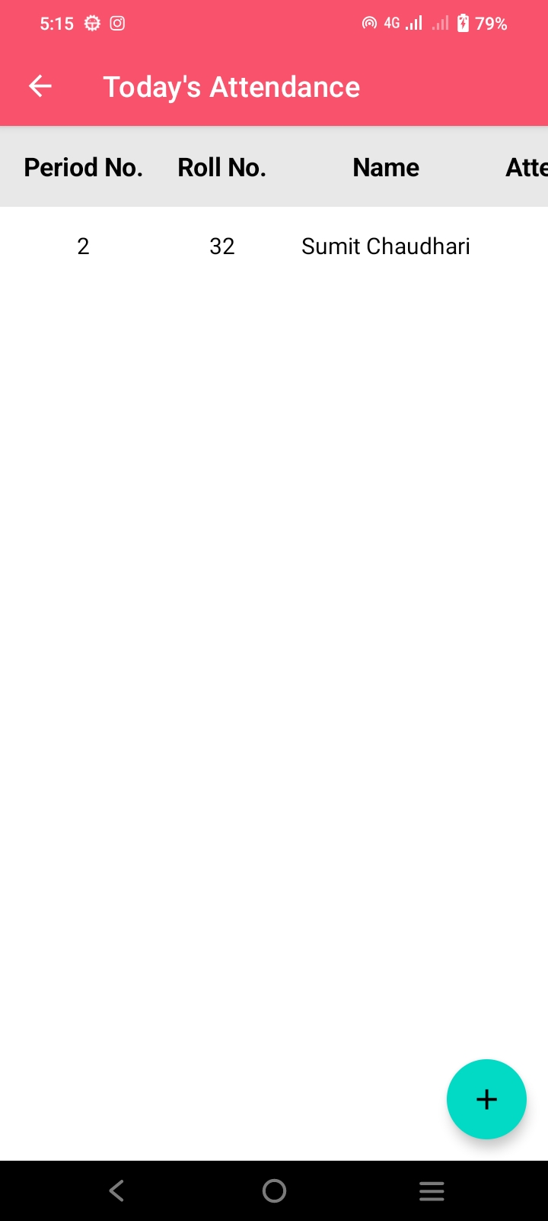

2. Add Student

1. Student

**Description** : Teacher can all the attendances of that day here.

**1. Student** : All the present students will be shown here.

**2. Add Student** : If teacher wants to manually add student to attendance it can be done by clicking on “+” button and entering student roll no. and period no.

**NOTE** : If teacher sees message like “Roll no. not found!”, Then that student should create account first. (If app is not supported on student’s device then student can create account on any device of family member).

**4.** **Navigation Menu**

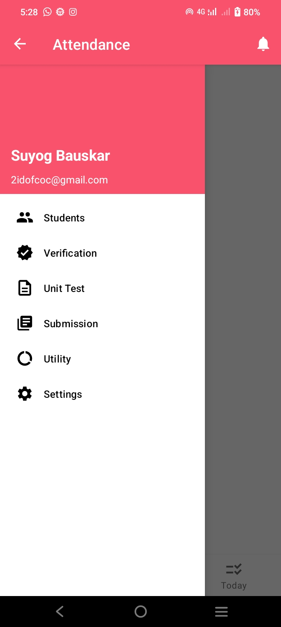

6. Settings

5. Utility

4. Submission

3. Unit Test

2. Verification

1. Students

**Description** : Teacher can navigate to other options from here.

**1. Students** : All registered students data is shown here.

**2. Verification** : Teacher can verify new students who just created their account from here. Teacher has to check student details if details are correct click on student and click verify else long press student and delete it and ask student to recreate account with correct details.

**3. Unit test** : Teacher can upload unit test marks from here.

**4. Submission** : Teacher can see student submission status and download detention list from here.

**5. Utility** : It provides additional features and operations for teacher.

**6. Settings** : App settings are available here.

**5.** **Student’s Data**

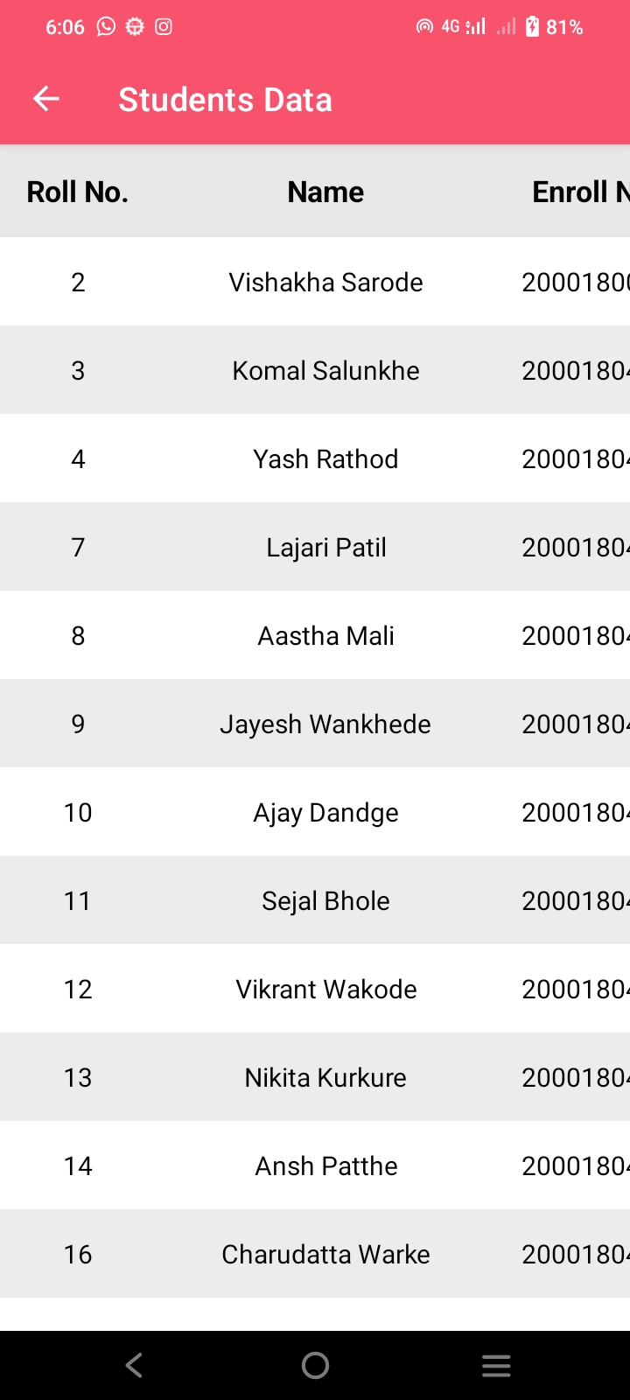

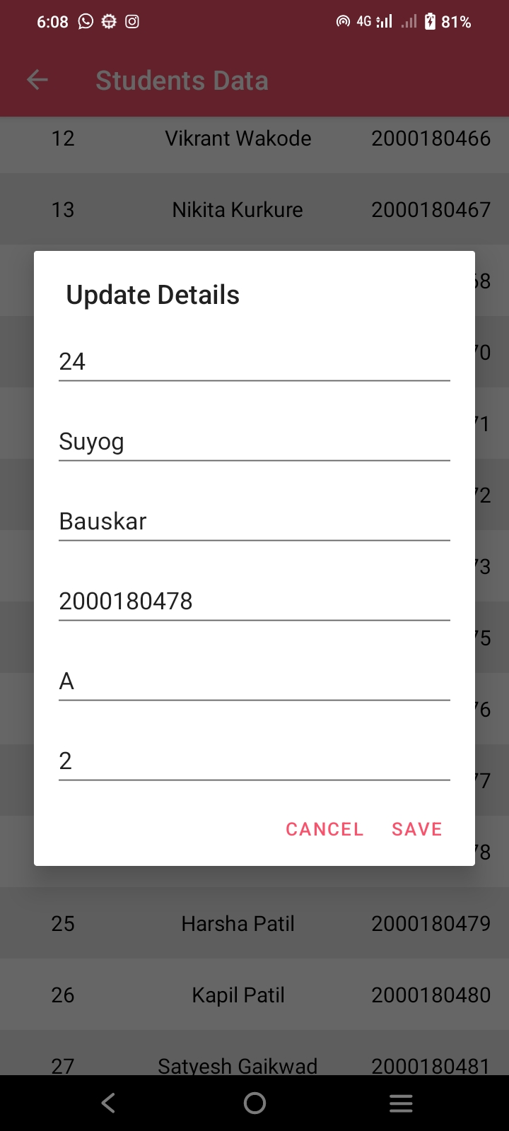

6. Batch

5. Division

4. Enroll No.

3. Lastname

2. Firstname

1. Roll No.

**Description** : Teacher can see all students data and update it by clicking on student.

**NOTE** : Student’s semester can’t be changed from here. To change semester go to Utility -> Update All Students Details.

**1. Roll No.** : Student’s roll no. can be changed from here.

**2. Firstname** : Student’s firstname can be changed from here.

**3. Lastname** : Student’s lastname can be changed from here.

**4. Enroll No.** : Student’s enroll no. can be changed from here.

**5. Division** : Student’s division can be changed from here.

**6. Batch** : Student’s batch can be changed from here.

**6.** **Unit Test Marks**

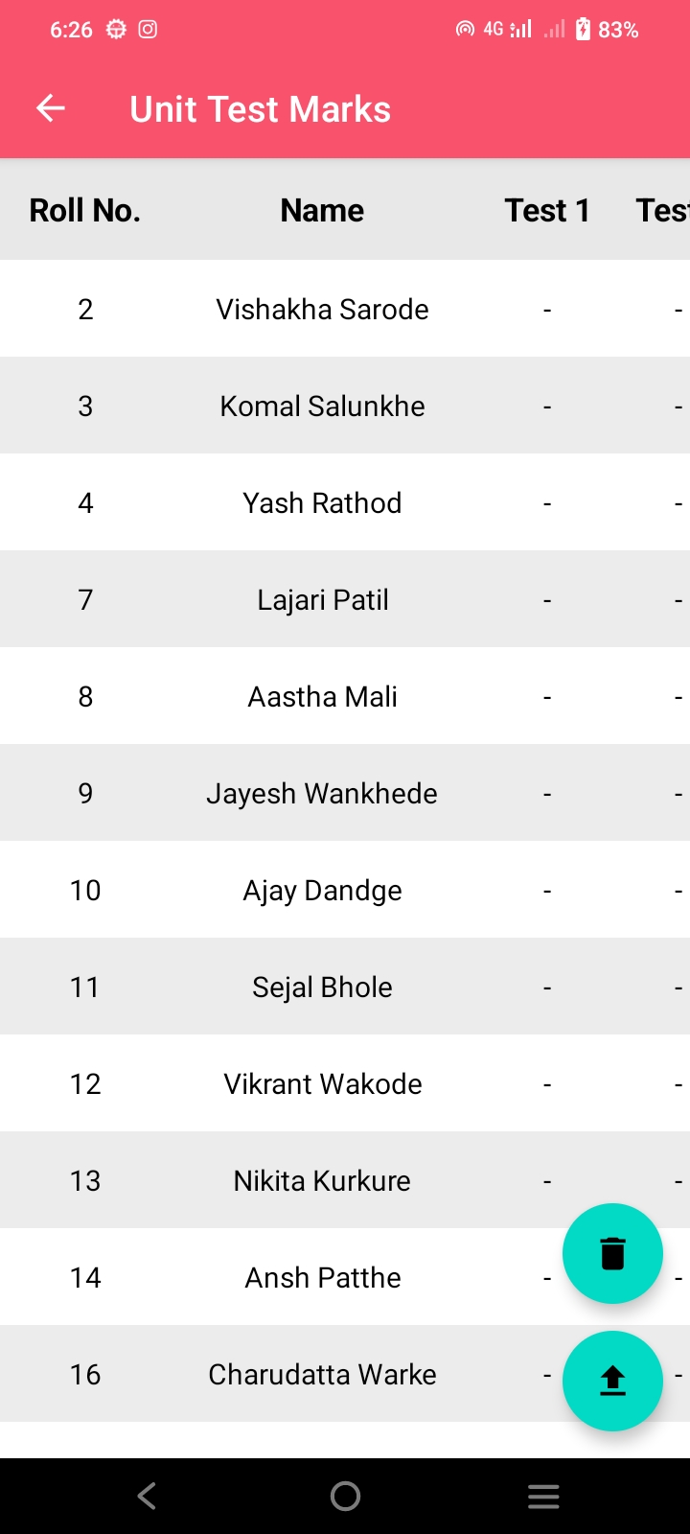

1. Remove

2. Upload

**Description** : Teacher can see and upload unit test marks here.

**NOTE** : After uploading or deleting marks please wait for few seconds to complete operation. Only “.csv” file can be uploaded and format must be same as “sample_unit_test_marks.csv” file sent on WhatsApp group. If there are no marks then enter “-1” as marks.

Click here to know how to convert excel file to csv file.

**1. Remove** : Both unit test marks can be removed from here.

**2. Upload** : Unit test marks can be uploaded from here.

Click here to know how to upload file.

**7.** **Submission**

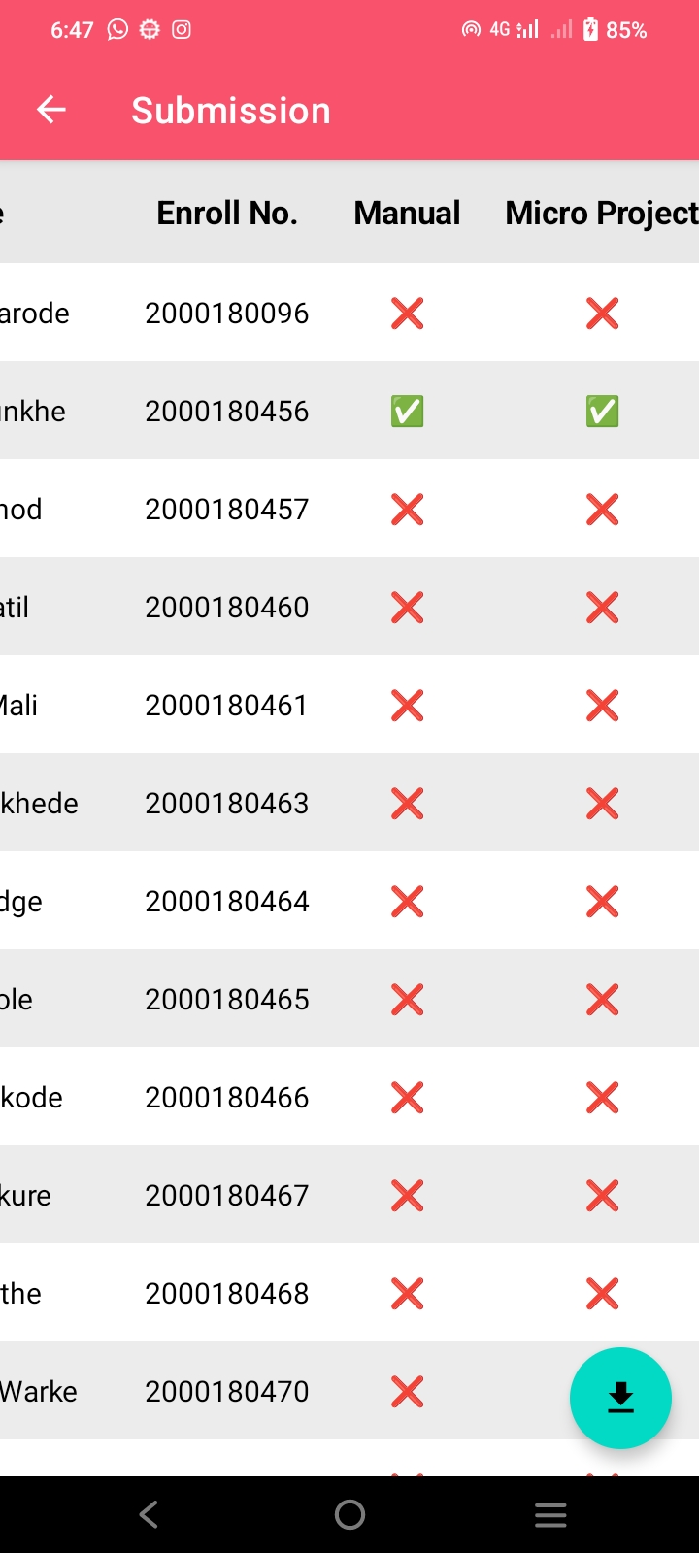

1. Download

**Description** : Teacher can see submission of students and download detension list. To change submission status click on student select checkbox and click done.

**1. Download** : Detension list can be downloaded from here.

**8.** **Utility**

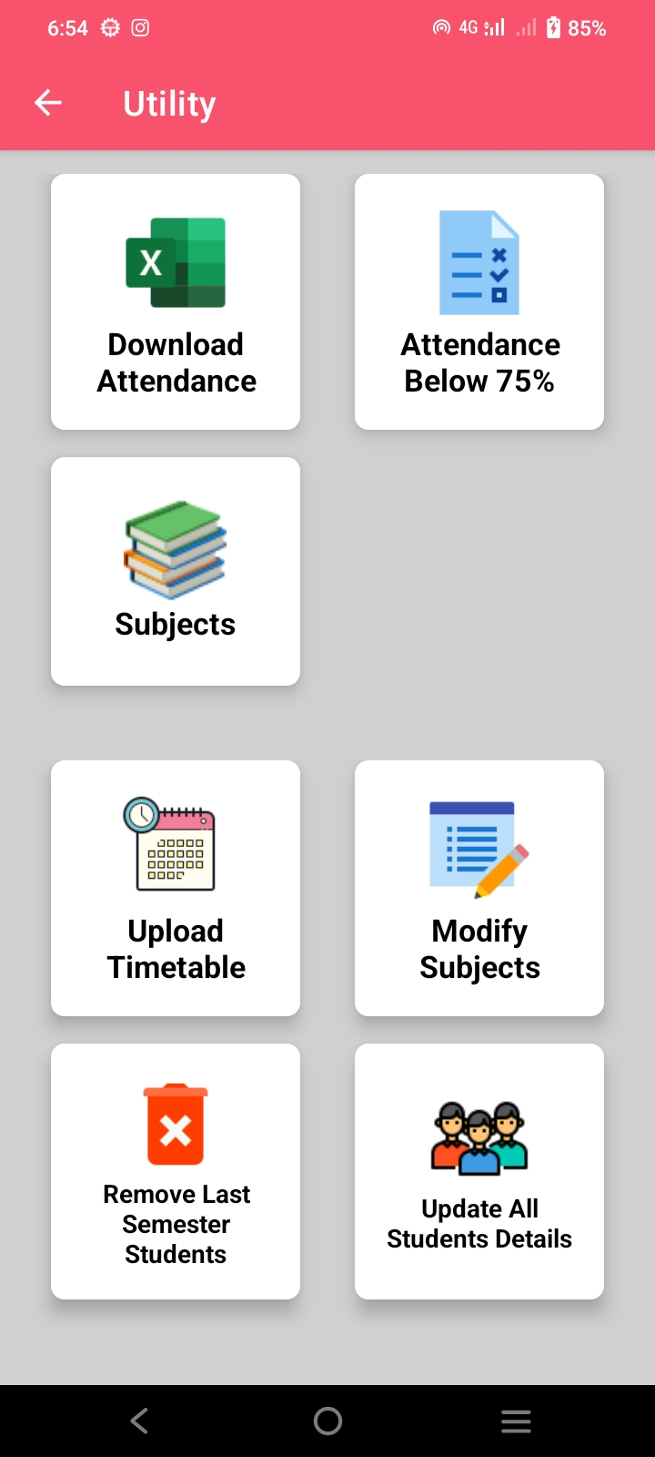

**NOTE** : Upload Timetable, Modify Subjects, Remove Last Semester Students and Update All Students Details options are only available to HOD.

**1. Download Attendance** : Whole year attendance can be downloaded in excel file.

**2. Attendance Below 75%** : By selecting this option teacher can find students whose attendance is below 75%. Teacher has to select starting and ending month for which they want to find students attendance below 75%.

**3. Subjects** : Teacher can see their subjects details from here.

**4. Upload timetable** : Timetable for students can be uploaded from here. File must be csv and format must be same as “sample_timetable.csv” file sent in WhatsApp group.

Rules for timetable file : If no lecture is scheduled then enter “-” character instead of leaving blank. For theory lectures enter course name and for practicals enter “- pr” as a suffix to course name.

**5. Modify Subjects** : HOD can modify subjects details, remove or add subjects of teacher from here. To modify subject details click on that subject. To remove subject long press it and click Delete. To add subject click on “+” button in bottom right corner.

**6. Remove Last Semester Students** : When sixth semester students are passed out from the college HOD can remove them from this option.

**7.Update All Students Details** : All fields of student like roll no., name, enroll no., etc. can be changed from this option. Semester can also be changed when students are promoted to next semester from here. Csv file must be uploaded with same format as “students_details.csv” file sent in WhatsApp group.

**9.** **Settings**

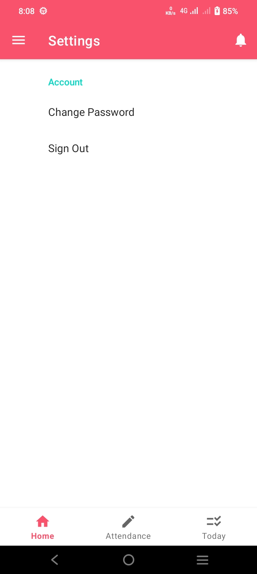

2. Sign Out

1. Change Password

**1. Change Password** : Teacher can change their account password using this option. Password reset link will be sent on registered email.

**2. Sign out** : Account can be sign out from app using this option.

* Steps for uploading file

1. Click on upload button.

2. Select left menu from file chooser.

3. Select google drive.

4. Navigate to the file, click on file and wait until its uploaded (Uploading depends on your upload speed).

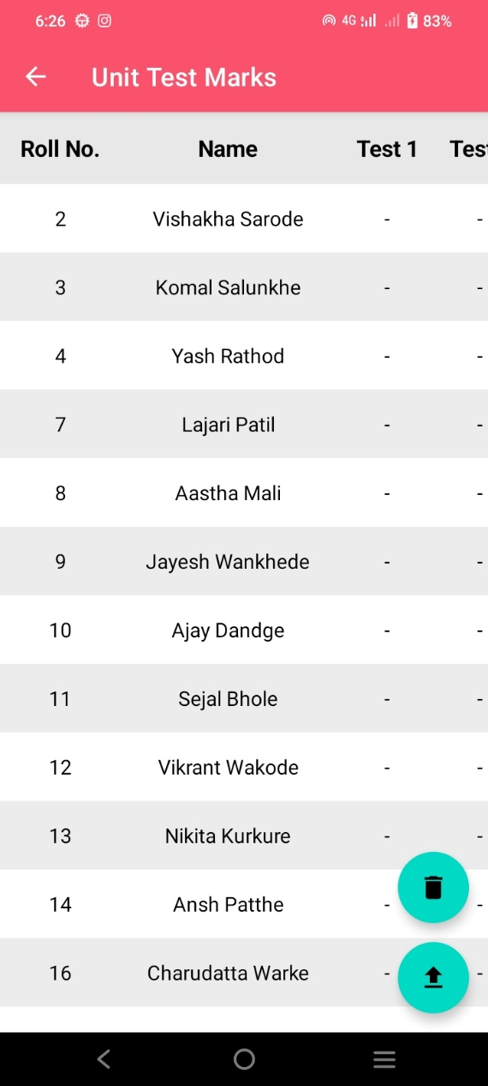 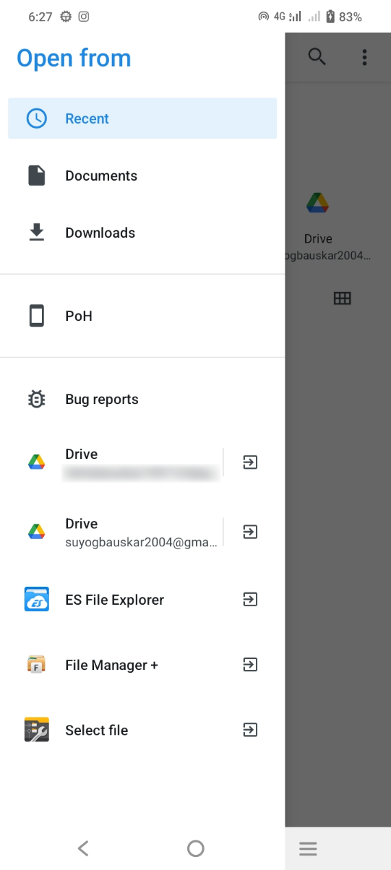

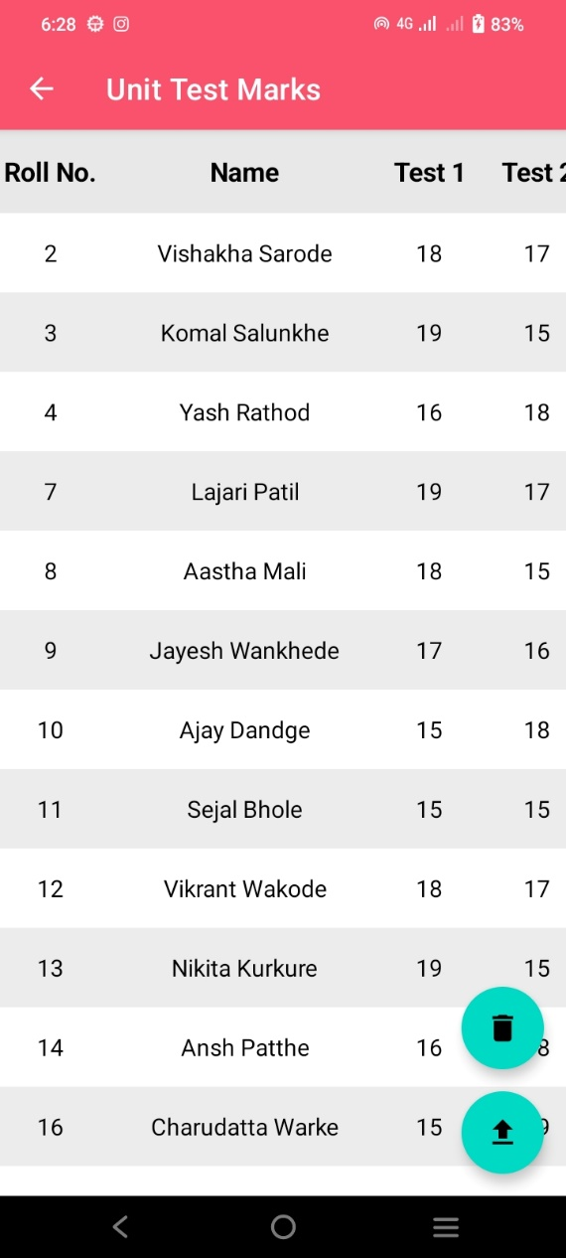 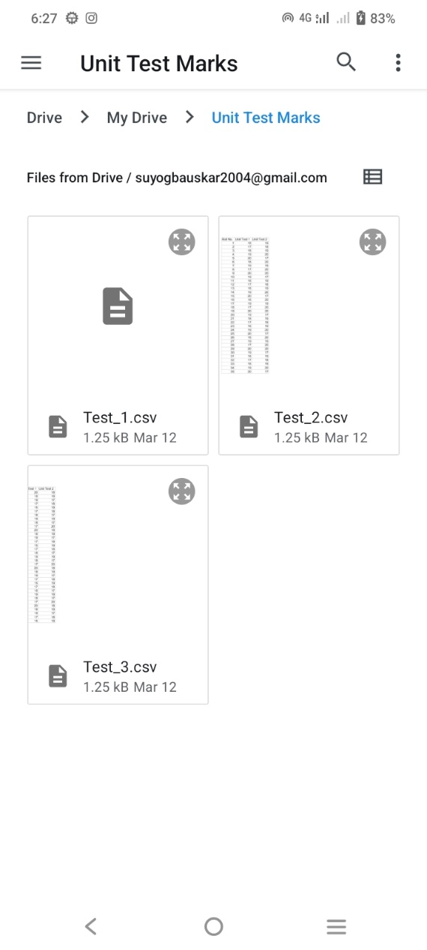

* Steps for creating CSV file from excel file

1. Open excel file in MS Excel.

2. Click on File.

3. Click on Save As and select Browse.

4. Select location where you want to save file, Enter file name and select “CSV (Comma delimited)” as file type.

5. Click Save, Now you can upload this CSV file to app.