**Name: Suyog Bodke**

**Roll no. : 381006**

**PRN : 22310072**

**Assignment 3: Perform Parsing of Family Tree Using Knowledge Base**

**Problem Statement**

The goal of this assignment is to parse a family tree using a knowledge base and infer relationships such as parent, sibling, or cousin. By applying logical reasoning, you will deduce various familial connections.

**Objectives**

* Understand knowledge representation and reasoning in artificial intelligence.
* Use inference rules to parse and deduce relationships within a family tree.

**Theory**

**Knowledge Representation**

Knowledge representation is a crucial aspect of artificial intelligence that involves defining entities (such as family members) and their relationships in a format that a computer can utilize to perform reasoning.

**Inference**

Inference is the process of deriving new information or relationships from existing facts using defined rules. In the context of a family tree, this involves applying logical rules to determine familial relationships.

**Methodology**

1. **Represent Family Members and Relationships**:
   * Use facts to represent family members and their direct relationships. For example, you might define facts like:
     + parent(John, Mary). (John is a parent of Mary)
     + parent(John, David). (John is a parent of David)
     + parent(Mary, Sara). (Mary is a parent of Sara)
2. **Define Rules for Inferring Relationships**:
   * Establish rules that define how to infer new relationships from existing ones. For instance:
     + sibling(X, Y) :- parent(Z, X), parent(Z, Y), X \= Y. (X and Y are siblings if they share at least one parent and are not the same person)
     + cousin(X, Y) :- parent(A, X), parent(B, Y), sibling(A, B). (X and Y are cousins if their parents are siblings)
3. **Apply Rules to Infer New Relationships**:
   * Implement a reasoning engine that applies the defined rules to the facts in the knowledge base. This can be done using logic programming languages like Prolog or through custom implementations in Python.

**Working Principle / Algorithm**

Here’s a simple outline of the steps to parse the family tree:

1. **Input the Family Data**:
   * Populate the knowledge base with facts representing family members and their direct relationships.
2. **Define Inference Rules**:
   * Write rules that enable inference of new relationships (e.g., sibling, cousin).
3. **Query the Knowledge Base**:
   * Use queries to extract information about relationships. For example, asking for all siblings of a particular individual or identifying all cousins.
4. **Output Inferred Relationships**:
   * Display the relationships that have been inferred from the knowledge base.

**Advantages**

* **Complex Reasoning**: This method allows for advanced reasoning capabilities and the ability to deduce intricate relationships that may not be immediately obvious.
* **Flexibility**: The knowledge base can be easily modified or expanded to include more facts or rules.

**Disadvantages / Limitations**

* **Complexity**: As the family tree grows in size and complexity, managing and querying the knowledge base may become increasingly difficult.
* **Performance**: Inference over a large set of rules and facts can lead to performance issues, especially if the rules are not optimized.

**Diagram**

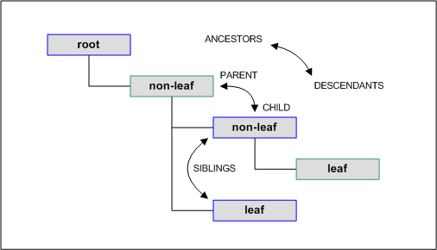

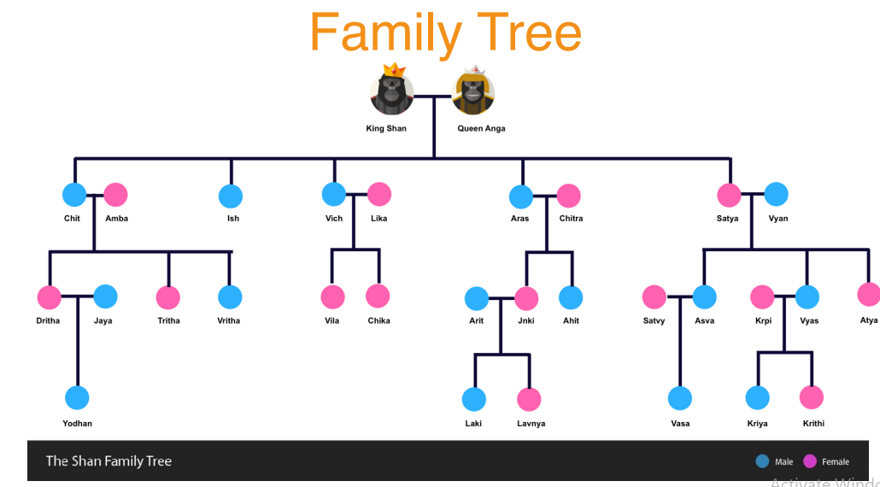

**Conclusion**

Using a knowledge base combined with inference rules provides a structured and effective way to parse and deduce relationships within a family tree. This approach enhances our ability to reason about familial connections, enabling a clearer understanding of the family structure.