**Name: Pranay Harne**

**Roll no. : 381008**

**PRN : 22310103**

**Assignment - 6**

**Implementation of Basic Search Strategies: 8-Queens Problem**

**Aim -** To explore and implement basic search strategies for solving the 8-Queens problem, thereby enhancing understanding of backtracking and search algorithms in artificial intelligence.

**Objectives -**

1. To understand the fundamentals of the 8-Queens problem.
2. To implement backtracking as a search strategy for solving the problem.
3. To analyze the efficiency of the algorithm in terms of time and space complexity.
4. To visualize the solution and discuss the implications of search strategies in AI.

**Theory -**

1. **What is the 8-Queens Problem?**

The 8-Queens problem is a classic combinatorial problem in chess and computer science. The objective is to place eight queens on an 8x8 chessboard so that no two queens threaten each other. This means that no two queens can occupy the same row, column, or diagonal. The problem serves as a benchmark for testing various search algorithms and understanding concepts like backtracking and constraint satisfaction. The 8-Queens problem can be generalized to N-Queens for any N-sized board.

1. **What is the Backtracking algorithm?**

Backtracking is a systematic method for exploring all possible configurations of a problem to find a solution. It involves building candidates for solutions incrementally and abandoning candidates ("backtracking") as soon as it determines that they cannot lead to a valid solution. The backtracking algorithm is particularly useful for constraint satisfaction problems, such as the 8-Queens problem, where the goal is to find configurations that meet specific constraints.

1. **Significance of Backtracking algorithm**

The backtracking algorithm is significant for several reasons:

1. **Optimality:** It finds one or more valid solutions to problems with constraints.
2. **General Applicability:** The algorithm can be applied to various problems beyond the 8-Queens problem, such as Sudoku, graph coloring, and scheduling.
3. **Problem-Solving Technique:** It serves as a fundamental problem-solving technique in computer science, particularly in artificial intelligence.
4. **Implementation steps**
5. **Initialize an Empty Board:** Start with an 8x8 chessboard represented by a data structure (e.g., a list or array).
6. **Place Queens Recursively:** Begin placing queens row by row.

* For each row, iterate through each column:
* Check if the column is safe (i.e., if placing a queen does not lead to a conflict).
* If safe, place the queen and proceed to the next row (recursive call).
* If placing the queen leads to a conflict, backtrack (remove the queen and try the next column).

1. **Check for Completion:** If all queens are successfully placed, store or print the configuration.
2. **Backtrack:** If all columns are exhausted for a particular row, backtrack to the previous row and try the next column.
3. **Workflow diagram**

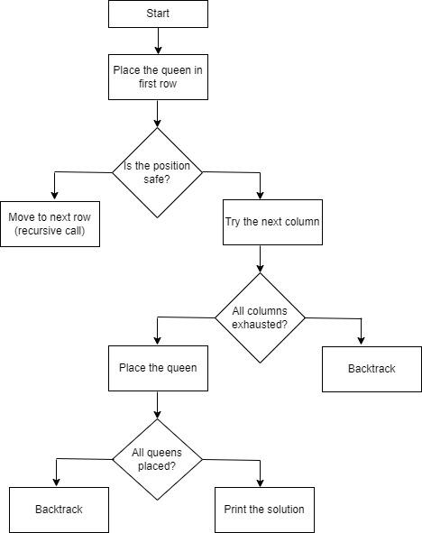

1. **Time complexity of Backtracking algorithm**

The time complexity of the backtracking algorithm for the 8-Queens problem is O(N!), where N is the number of queens. This is due to the fact that there are N possible columns for the first queen, (N-1) for the second, and so on, resulting in a factorial growth in the number of configurations to explore. However, the backtracking approach prunes many of these configurations, making it more efficient than a naive brute-force search.

1. **Space complexity of Backtracking algorithm**

The space complexity of the backtracking algorithm is O(N), where N is the number of queens. This accounts for the recursion stack and the storage of the current state of the board (i.e., the placement of queens). The depth of the recursion corresponds to the number of queens being placed.

1. **Applications of Backtracking algorithm**
2. **Artificial Intelligence:** Used in solving puzzles and games that require constraint satisfaction.
3. **Graph Theory:** Applied in problems such as graph coloring and Hamiltonian paths.
4. **Scheduling:** Helps in scheduling tasks where constraints are involved.
5. **Combinatorial Optimization:** Used in problems like the traveling salesman problem and resource allocation.
6. **Advantages of Backtracking algorithm**
7. **Efficient Search:** It prunes the search space, reducing the number of configurations that need to be explored compared to exhaustive search methods.
8. **Flexibility:** The algorithm can be adapted to various problems with similar constraint structures.
9. **Simplicity:** The concept is straightforward and the implementation is relatively simple.
10. **Limitations of Backtracking algorithm**
11. **Time Complexity:** Although it is more efficient than brute force, backtracking can still exhibit exponential time complexity in the worst-case scenarios, particularly as the size of N increases.
12. **Space Complexity:** The algorithm requires additional memory for maintaining the recursion stack and the state of the board, which can be substantial for larger problems.
13. **No Guarantee of Optimal Solutions:** The algorithm finds valid solutions but does not ensure that these solutions are the best or optimal.
14. **Sample Example**

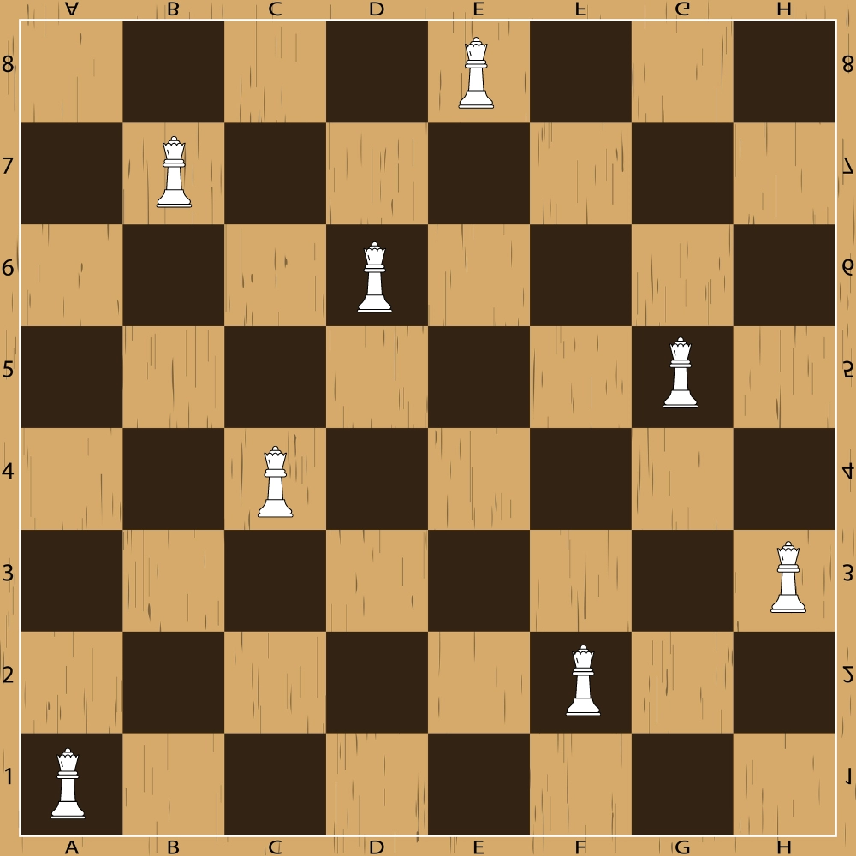

One possible solution to the 8 queens problem using backtracking is shown below. In the first row, the queen is at E8 square, so we have to make sure no queen is in column E and row 8 and also along its diagonals. Similarly, for the second row, the queen is on the B7 square, thus, we have to secure its horizontal, vertical, and diagonal squares. The same pattern is followed for the rest of the queens.

**Output -**

**0 0 0 0 1 0 0 0**

**0 1 0 0 0 0 0 0**

**0 0 0 1 0 0 0 0**

**0 0 0 0 0 0 1 0**

**0 0 1 0 0 0 0 0**

**0 0 0 0 0 0 0 1**

**0 0 0 0 0 1 0 0**

**1 0 0 0 0 0 0 0**

**Brute Force Approach -**

One brute-force approach to solving this problem is as follows:

* Generate all possible permutations of the numbers 1 to 8, representing the columns on the chessboard.
* For each permutation, check if it represents a valid solution by checking that no two queens are in the same row or diagonal.
* If a valid solution is found, print the board layout.

While this approach works for small numbers, it quickly becomes inefficient for larger sizes as the number of permutations to check grows exponentially. More efficient algorithms, such as backtracking or genetic algorithms, can be used to solve the problem in a more optimized way.

**Backtracking Approach**

This approach rejects all further moves if the solution is declined at any step, goes back to the previous step and explores other options.

### **Algorithm**

Let's go through the steps below to understand how this algorithm of solving the 8 queens problem using backtracking works:

* **Step 1:** Traverse all the rows in one column at a time and try to place the queen in that position.
* **Step 2:** After coming to a new square in the left column, traverse to its left horizontal direction to see if any queen is already placed in that row or not. If a queen is found, then move to other rows to search for a possible position for the queen.
* **Step 3:** Like step 2, check the upper and lower left diagonals. We do not check the right side because it's impossible to find a queen on that side of the board yet.
* **Step 4:** If the process succeeds, i.e. a queen is not found, mark the position as '1' and move ahead.
* **Step 5:** Recursively use the above-listed steps to reach the last column. Print the solution matrix if a queen is successfully placed in the last column.
* **Step 6:** Backtrack to find other solutions after printing one possible solution.

**Conclusion -**

The 8-Queens problem exemplifies the utility of basic search strategies in computer science, particularly through the application of backtracking. This approach effectively reduces the search space and provides solutions to complex constraint satisfaction problems. Understanding the principles behind these algorithms lays the groundwork for more advanced studies in artificial intelligence and algorithm design.