Lab1: DSAP 075BCT092

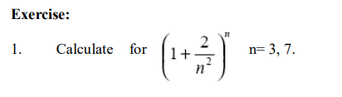

**Code:**

n= 3

func = power((1 + (2./(n*n))),n)

n=7

func = power((1 + (2./(n*n))),n)

**Output:**

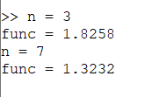



**Code:**

a = 2;

w = 5;

t = 0:0.1:10;

func = exp(-a*t).*cos(w*t);

xlabel('t');

ylabel('y');

plot(t,func);

**Output:**

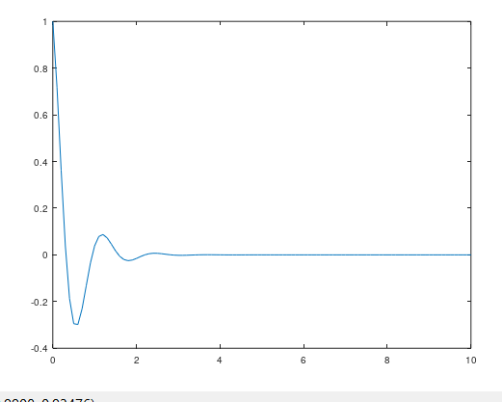



**Code:**

num(1)=0;

num(2)=1;

temp=3;

num(temp)=0;

even=1;

odd=0;

fprintf('%d\n',num(1));

while((num(temp-2)+num(temp-1))<10000)

if rem(num(temp-1),2)==0

even += 1;

else

odd += 1;

end

fprintf('%d\n',num(temp-1));

num(temp)=num(temp-2)+num(temp-1);

temp=temp+1;

end

fprintf("Even number total counts: %d\n",even);

fprintf("odd number total counts: %d\n",odd);

result = num(1:temp-2);

plot(result);

**Output:**

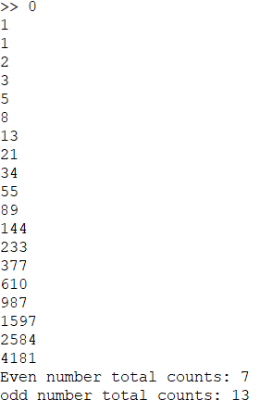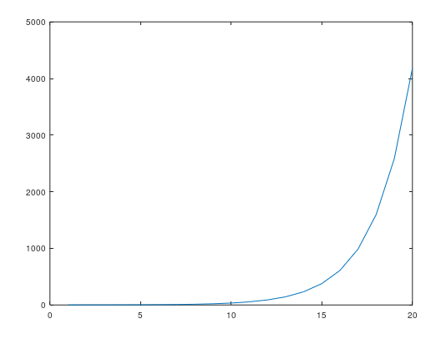



**Code:**

x=0:0.1:100;

fx=(x.*x + 2*x + 3)./(x + 3);

xlabel('x');

ylabel('f(x)');

plot(x,fx);

**Output:**

