Lab2: DSAP 075BCT092

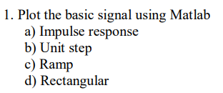

1. **Code:**

t=-10:10;

s = (t==0);

stem(t,s);

title('075bct092');

**Output:**

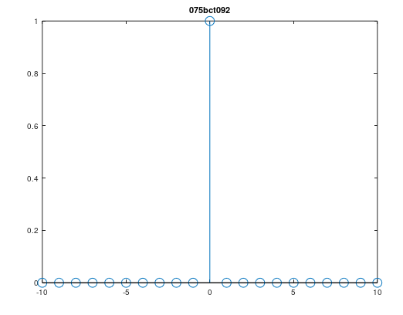

1. **Code:**

t=-10:0.1:10;

s = (t>=0);

plot(t,s,'LineWidth',2);

title('075bct092');

**Output:**

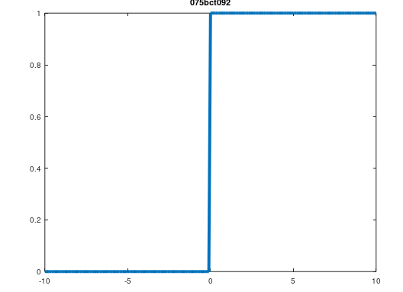

1. **Code:**

t=-10:0.1:10;

a=1;

s = a*t.*(t>=0);

plot(t,s,'LineWidth',2);

title('075bct092');

**Output:**

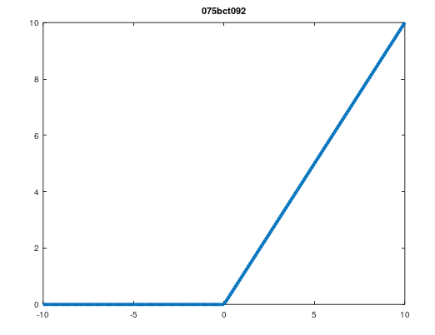

1. **Code:**

t=-10:0.1:10;

a=3;

s = (abs(t)<=a);

plot(t,s,'LineWidth',2);

title('075bct092');

**Output:**

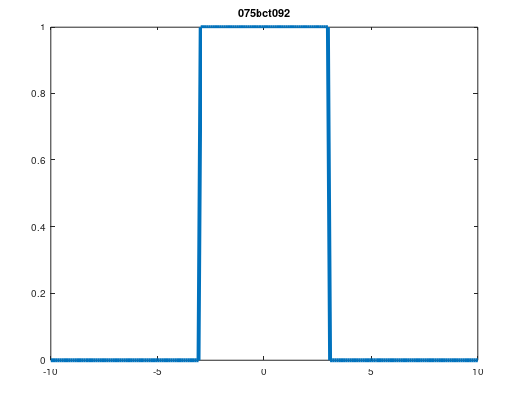

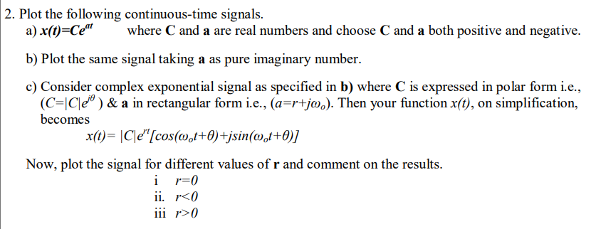

1. **Code:**

t = -10:0.1:10;

c = .5;

a = .5;

x = c*exp(a*t);

subplot(2,2,1);

plot(t,x,'LineWidth',2);

title('075bct092 - c>0, a>0');

a = -.5;

x = c*exp(a*t);

subplot(2,2,2);

plot(t,x,'LineWidth',2);

title('c>0, a<0');

c = -.5;

a = .5;

x = c*exp(a*t);

subplot(2,2,3);

plot(t,x,'LineWidth',2);

title('c<0, a>0');

a = -.5;

x = c*exp(a*t);

subplot(2,2,4);

plot(t,x,'LineWidth',2);

title('c<0, a<0');

**Output:**

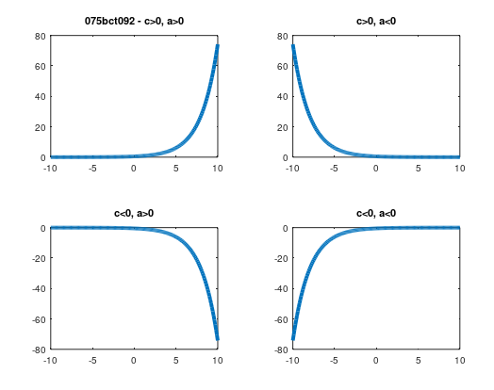

1. **Code:**

t = -10:0.1:10;

c = .5;

a = .5i;

x = c*exp(a*t);

subplot(2,2,1);

plot(t,x,'LineWidth',2);

title('075bct092 c>0, img(a)>0');

a = -.5i;

x = c*exp(a*t);

subplot(2,2,2);

plot(t,x,'LineWidth',2);

title('c>0, img(a)<0');

c = -.5;

a = .5i;

x = c*exp(a*t);

subplot(2,2,3);

plot(t,x,'LineWidth',2);

title('c<0, img(a)>0');

a = -.5i;

x = c*exp(a*t);

subplot(2,2,4);

plot(t,x,'LineWidth',2);

title('c<0, img(a)<0');

**Output:**

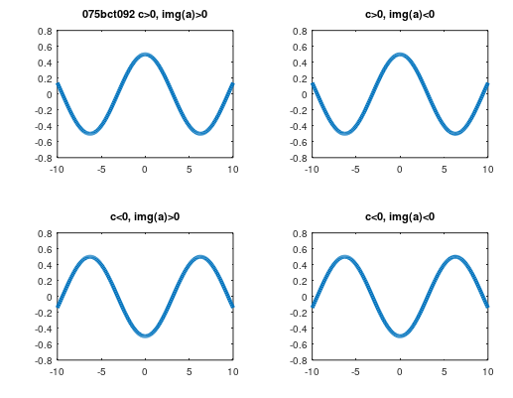

1. **Code:**

t = -4:0.1:4;

c = 4;

r = 0;

w0 = 2*pi/4;

theta = pi/4;

x = abs(c)*exp(r*t).*(cos(w0*t+theta)+1i*sin(w0*t+theta));

subplot(1,3,1);

plot(t,x,'LineWidth',2);

title('075bct092 - r=0');

r = -5;

x = abs(c)*exp(r*t).*(cos(w0*t+theta)+1i*sin(w0*t+theta));

subplot(1,3,2);

plot(t,x,'LineWidth',2);

title('r<0');

r = 5;

x = abs(c)*exp(r*t).*(cos(w0*t+theta)+1i*sin(w0*t+theta));

subplot(1,3,3);

plot(t,x,'LineWidth',2);

title('r>0');

**Output:**

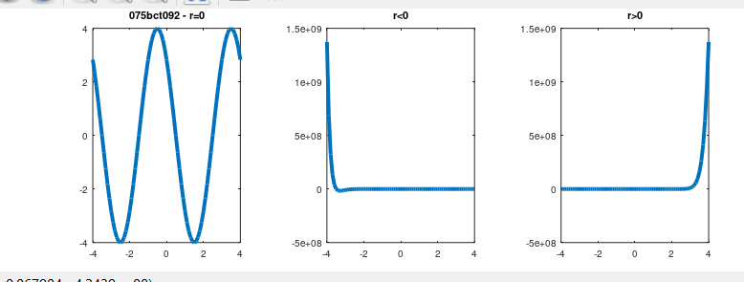

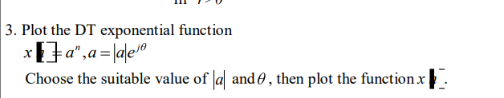

Code:

n= -10:10;

a= 3;

theta = pi/3;

func = power(abs(a)*exp(i*theta),n);

stem(n,func,'LineWidth',2);

title('075ct092');

**Output:**

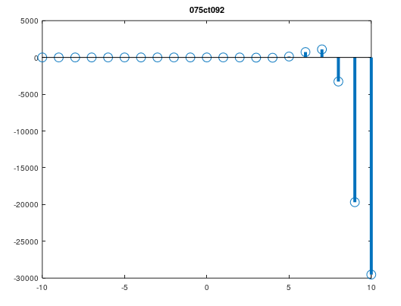



**Code:**

C = [1/3, 1/2, 1/4, 1, 1/4, 1/2, 1/3];

n= -10:0.1:10;

w= 2*pi/10;

x=zeros(size(n));

for k = -3:3

x = x + (k+4)*exp(i*k*w*n);

end

plot(n,x,'LineWidth',2);

title('075bct092');

**Output:**

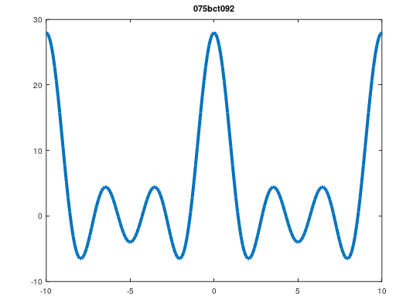



**Code:**

t=-10:0.1:10;

w0=2*pi/5;

y1=sin(w0*t);

subplot(3,2,1);

plot(t,y1,'LineWidth',2);

title('075bct092 - y_1(t)=sin(w0*t)');

y2=sin(2*w0*t);

subplot(3,2,2);

plot(t,y2,'LineWidth',2);

title('y_2(t)=sin(2*w0*t)');

y3=sin(3*w0*t);

subplot(3,2,3);

plot(t,y3,'LineWidth',2);

title('y_3(t)=sin(3*w0*t)');

y4=sin(4*w0*t);

subplot(3,2,4);

plot(t,y4,'LineWidth',2);

title('y_4(t)=sin(4*w0*t)');

y5=sin(5*w0*t);

subplot(3,2,5);

plot(t,y5,'LineWidth',2);

title('y_5(t)=sin(5*w0*t)');

y=y1+y2+y3+y4+y5;

subplot(3,2,6);

plot(t,y,'LineWidth',2);

title('y(t)=y_1(t)+y_2(t)+y_3(t)+y_4(t)+y_5(t)');

**Output:**

